Supplementary Material
Environmental Science and Pollution Research
Green synthesis of carbon quantum dots from Phragmites communis and protective effect on Artemia salina under copper stress
Zhenlin Wei ^{1,*}
¹Biological sciences department, Dezhou University, Dezhou City, Shandong Province, China;
*Correspondence: wzl19741028@163.com.

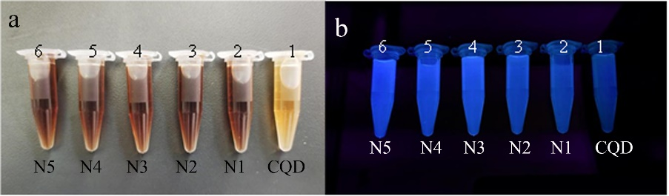
Fig.S1 Color and fluorescence of CQDs and N-CQDs solutions under visible and UV light

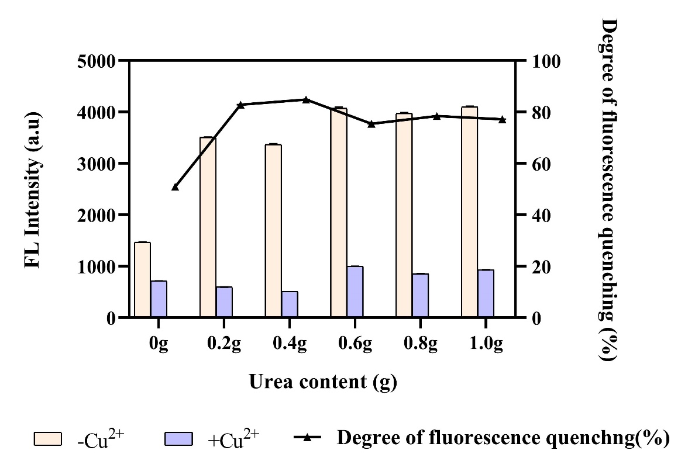
Fig.S2 Effects of different urea additions on the sensitivity of Cu²⁺ ions detection

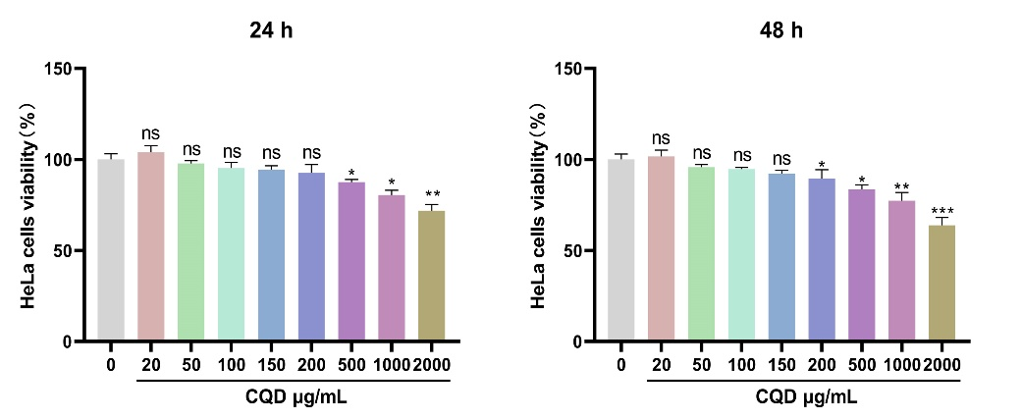
Fig.S3 Cytotoxicity of N2-CQDs on HeLa cell

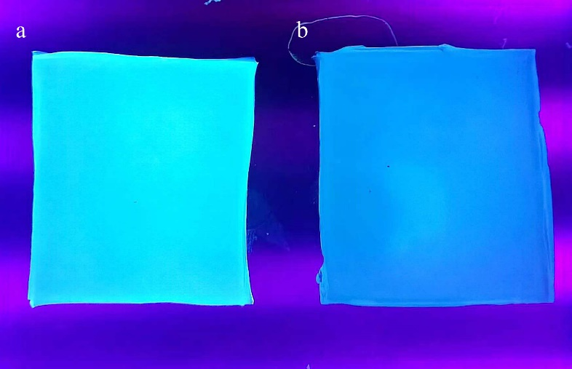
Fig.S4 Effects of immersion on the FL intensity of gels containing N2-CQDs
(a) The gels containing 100 µg/mL under exciting by Uv light, (b) the same gel after immersion into seawater containing Cu²⁺ at 100 mg/L for 3 minutes, the FL intensity was almost invisible.

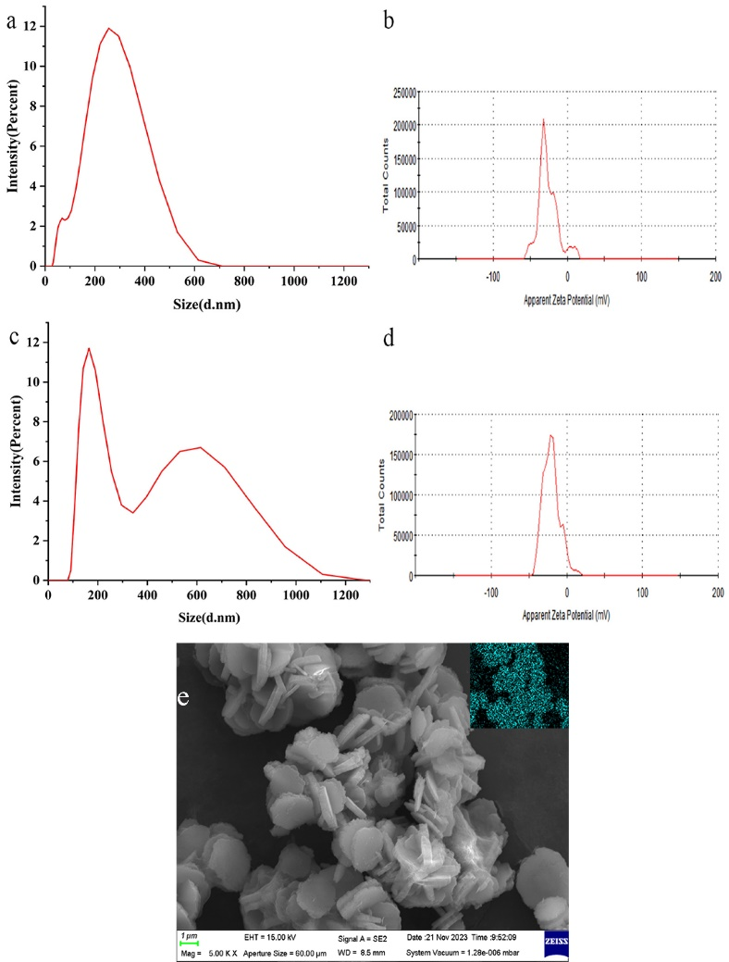
Fig.S5 The change of particle size distribution and zeta potential of N2-CQDs without or with Cu²⁺ ions
(a) and (c) are the results of particle size distribution and zeta potential of N2-CQDs before and after Cu²⁺ was mixed, while (b) and (d) denote the results after Cu²⁺ introduction, (e) the SEM image of N2-CQDs-Cu²⁺ complex when 100 µg/mL N2-CQDs mixed with 500 µg/mL Cu²⁺ ions. The inset on panel e is the EDS result of the N2-CQDs-Cu complex, showing the Cu atom present in the complex.

