Figure S1. Generation and validation of tagged hiPSC lines.
a) Schematic for Cas9 induction by doxycycline treatment in iCas9 IMR90 hiPSCs.
b) Genotyping PCR of 1042 bp amplicon (upon knock-in) from primer pairs inside and outside the donor cassette flanking the left homology arm observed on gel, Lane 1: 1kb DNA ladder;.Lane 2: Negative (Water control); Lane 3: IMR90-iCas9_Clone 1;.Lane 4: IMR90-iCas9_Clone 2;.Lane 5: IMR90 iPS_WT.
c) Genotyping PCR gel for knock-in validation from primer pair across right homology arm in Clone1 and 2 of IMR90-iCas9 (Lane 2 and 3 respectively), expected size of 2107 bp upon successful HDR while no amplification in Lane 4: IMR90 iPS_WT and Lane 5: Negative control.
d) Immunostaining of iCas9-IMR90 colonies for pluripotency markers, SOX2 and OCT4 with DAPI staining the nucleus. Magnification 10x, Scale: 10 µm.
e) PCR genotyping showed 870 bp amplicon upon successful knock-in while no amplification in un-transfected control (UT). Forward primer used was designed outside the left homology arm on the genome and reverse primer is from mClover.
f) Immunofluorescence staining at day 25 showing neural stem cells (Nestin, red) in both control and GAD1-mClover knock-in neuronal cultures, DAPI marks nuclei (blue). Scale, 100 µm.
g) Immunofluorescence staining at day 50 cells in culture for MGE progenitor marker (NKX2.1, red) in both control and GAD1-mClover knock-in neuronal cultures while mClover signal (anti-GFP antibody) was only seen in GAD1-mClover knock-in cells. Scale, 50 µm.

Figure S2.
a) Schematic of Cas9 based genome editings done in hiPSCs in this study to generate ECG-hiPSCs.
b) Phase contrast images of WT and ERBB4^{-/-} hiPSCs.
c) Immunostaining for pluripotency markers, NANOG and SSEA4 in the selected ERBB4 knockout clone.
d) Representative image of ERBB4^{-/-} neurons in culture (day 35) showing mClover+ signal. Scale bar: 100 μm.
e) Patterning of dorsal and ventral forebrain identity during neural induction using Inhibitor of WNT pathway (IWP2), CyclopamineA (CycA) and Smoothened Agonist (SAG).
f) Methodological overview and timeline of organoid generation with phase contrast (Scale bars: 100 μm) and bright-field (organoid; Scale bar: 1 mm) representative images of each stage.
g) Dorsal and Ventral specified organoids at the base of a 1.5ml MCT with media. Zone of fusion (red arrowhead) two days post fusion. Scale bar: 500 μm.
h) Expression of mClover (endogenous reporter labeling for GABAergic interneurons) in VFO (Day 30) while no signal in DFO (Day 30). Scale: 200 μm
i) qPCR analysis for the indicated lineage markers in dorsal organoids, ventral organoids and ventral:dorsal (fused) assembloids, day 35 culture. Values are plotted as log2 fold change expression w.r.t. hiPSCs and normalized to the reference gene GAPDH. Data represents mean ± S.D (n=3).
j) Representative images of day 2 and day 6 embryoid bodies patterned to the dorsal and ventral lineage from ERBB4 KO hiPSCs. Scale: 50 μm
k) Immunofluorescence images of WT and ERBB4 KO ventral forebrain organoid sections stained for GAD67 marker. DAPI stains the nucleus, Scale: 200 μm.

Figure S3.
a) Schematic showing approaches of visualization of GABAergic interneuron migration in 3D cultures of forebrain assembloids.
b) Time lapse sequence of fluorescent images from long term imaging of organotypic slice culture of assembloid.
c) SPIM imaging of 3D spheroids with 18% Iodixanol supplementation in media. Endogenous eGFP signal in green, Hoechst stains nucleus in blue and Cell Mask Deep Red Plasma Membrane stain in red. Detection objective: Nikon 16x 0.8 NA, illumination objective:10x, 0.3 NA. 3D rendering software: Imaris, Scale: 200 μm.
d) Schematic for the migration assay of mClover positive interneurons from ventral forebrain organoids adhered on PLO-Laminin coated cultureware.
e) Mean diameters (μm) of the VFOs used for quantification of migration length outside rim (10 VFOs each for WT and ERBB4^{-/-}).
f) mClover+ cortical interneurons migrating from ERBB4^{-/-} VFO plated on coverslip. Scale bar: 50 μm.
g) Phase contrast image of a WT VFO plated on coverslip to observe migration dynamics in a field of view (yellow rectangle) over time. Scale: 100 μm. On right representative phase contrast images at two time frames (hr:min) showing the extent of overall interneuron migration in from 0 to 26 hours, Scale: 100 μm.
h) Scanning electron microscopy (SEM) images of 500nm diameter nano-fibers manufactured using non-electrospinning STEP technique.
i) Scanning electron microscopy (SEM) images of the fiber networks: Crosshatch fiber scaffold (left, Scale bar: 100 μm), Aligned fiber scaffolds (right, Scale bar: 50 μm)
j) Immunofluorescence micrographs of WT VFOs on crosshatch scaffold (upper panel) and migration scaffold (lower panel) immunostained for GAD67 (red) and mClover/GFP (green), Scale: 50 μm
k) Immunofluorescence micrographs of ERBB4^{-/-} VFOs on scaffold immunostained for GAD67 (red) and mClover/GFP (green), upper panel at 10x magnification and lower panel of the same sample at 20x magnification showing visible neuron projections within the confinement of organoid boundary. Scale: 50 μm.
l) Individual neuron (yellow arrowhead) moving out of the ERBB4^{-/-} VFO along a fiber on the same scaffold through time.
m) Representative phase images from time frames (hr:min) of a single interneuron migrating on 500nm thick fibers displaying switch to neighboring fiber. Scale: 50 μm
n) Time frame micrographs show a single WT CIN coiling around a parallel fiber and making a helical forward motion.
o) ERBB4^{-/-} cortical interneuron shows helical motion on parallel fiber across time frames.

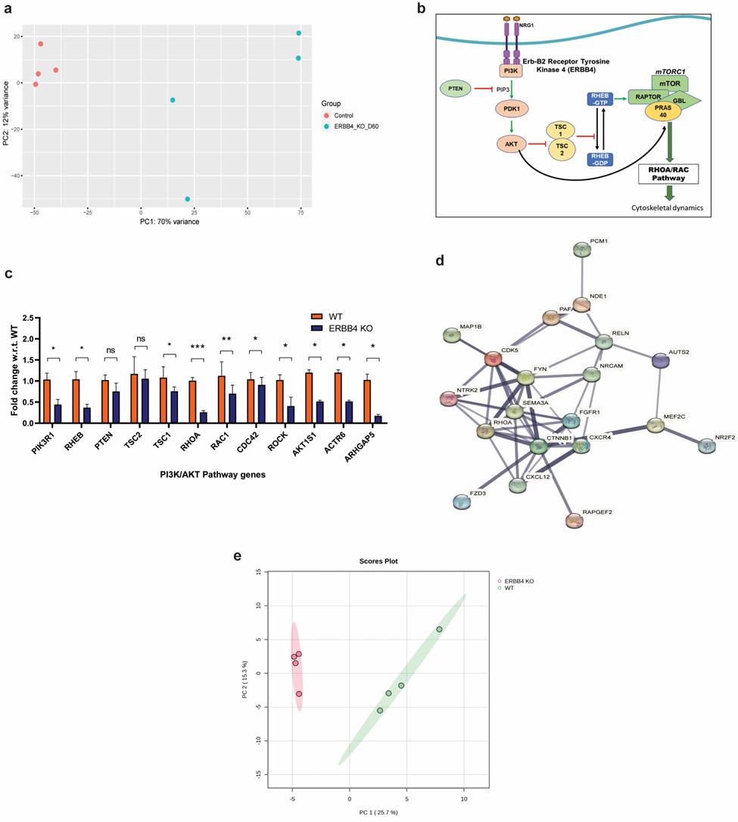

Figure S4.
a) PCA showing distinct separation of samples from WT and ERBB4^{-/-} indicated by different color on plot.
b) Schematic showing PI3K/AKT pathway stimulation by ERBB4 mediated signaling upstream of the mTOR pathway and RHOA/RAC pathway important for regulation of cytoskeletal dynamics and migration.
c) Validation of RNA-seq data by qRT-PCR in WT and ERBB4 KO assembloids. qRT-PCR was performed on a few selected genes from: PI3K/AKT and mTOR pathway (PIK3R1, RHEB, PTEN, TSC2, TSC1, AKT1S1) and RHO/RAC pathway (RHOA, RAC1, CDC42, ROCK, ACTR6, ARHGAP5). Data represents mean ± S.D. from five samples per group of three independent experiments. Significance is indicated by * for p-value ≤ 0.05 and ** for p-value ≤ 0.01 and *** for p-value ≤ 0.001.
d) Functional interactions among proteins from genes shortlisted from the downregulated term: neuron migration (GO:0001764) in the GO analysis data, explored using STRING online database.
e) PCA showing distinct separation of samples from WT and ERBB4^{-/-} indicated by different color on plot.

