Supplementary Table 1 The soil bulk density and field water capacity of the 0-20 cm, 20-40 cm and 40-60 cm.
Soli layer (cm) | Soil Bulk density (g cm⁻³) | Field capacity (%)
0-20 | 1.33 | 34.9
20-40 | 1.52 | 35.2
40-60 | 1.53 | 35.3

Supplementary Table 2 The names and authorized numbers of the different cotton varieties.
No. | Variety | Authorized number | No. | Variety | Authorized number
1 | Jifeng 554 | Jishenmian 2009003 | 41 | Hanwu 216 | Jishenmian 2014010
2 | Jifeng 103 | Jishenmian 20190008 | 42 | Zhongmian 100 | Guoshenmian 2016003
3 | Jifeng 522 | Jishenmian 20050552 | 43 | Zhongmiansuo 79 | Yushenmian 2010006
4 | Jifeng 908 |  | 44 | Cangmian 666 | Lushenmian 20160030
5 | Jifeng 914 | Guoshenmian 2015003 | 45 | Han 6203 | Guoshenmian 2015002
6 | Jifeng 1982 | Jishenmian 2014001 | 46 | Shikang 126 | Guoshenmian 2008002
7 | Jifeng 4 | Guoshenmian 20210020 | 47 | Cang 198 | Jishenmian 2007006
8 | 7886 | GSM08003 | 48 | Ji 228 | Guoshenmian 2008003
9 | Cangmian 268 | Lushenmian 20160030 | 49 | Guoxinmian 9 | Guoshenmian 2009004
10 | Jimian 315 | Jishenmian 20190010 | 50 | K836 | Lushenmian 2012018
11 | Han 218 | Jishenmian 2015003 | 51 | Lumian 522 | Lushenmian 20170041
12 | Hannong 12 |  | 52 | Lumian 5172
13 | Han 8266 | Guoshenmian 2014001 | 53 | K638 | Lushenmian 2010010
14 | Han 258 | Jishenmian 2015009 | 54 | Guoxin 4 | Jishenmian 2006008
15 | Han 686 | Yushenmian 2011010 | 55 | Jifeng1187 | Jishenmian 20200005
16 | YM111 | Guoshenmian 20170002 | 56 | Jifeng 1458 | Jishenmian 20200004
17 | Nongda KZ05 | Jishenmian 2013006 | 57 | Jifeng 103 | Guoshenmian 20190014
18 | Nongdamian 10 | Jishenmian 2015007 | 58 | Jifeng 914 | Guoshenmian 2015003
19 | Nongdamian 12 | Jishenmian 2014011 | 59 | Jifeng 965
20 | Lumianyan 28 | Guoshenmian 2006012 | 60 | MH335223 | Jishenmian 20190018
21 | Xuzhou 1818 | I3A01080 | 61 | Guoxinmian 11 | Guoshenmian 2009001
22 | Zhongmiansuo 41 | Guoshenmian 2002001 | 62 | Zhongmiansuo 17 | xinshemmian19980071991
23 | Shandongxiamian11-42 |  | 63 | Chunbeibao
24 | Zhongmiansuo 12 | Lushenmian 0064 | 64 | Zhongmiansuo 60 | Zheshenmian 2007002
25 | Yumian 19 | Guoshenmian 2001002 | 65 | CG3020-3
26 | Ejing 1 | GS08002-1991 | 66 | Jimian 2016 | Jishenmian 20199002
27 | Zhongmiansuo 35 | Guoshenmian 990005 | 67 | Ji 1518 | Jishenmian 2014005
28 | Zhongmiansuo 60 | Shanshenmian 2013001 | 68 | Jihang 8 | Jishenmian 20190009
29 | Xinshi 71143 | Guoshenmian 2014004 | 69 | Jimian 262 | Jishenmian 20200002
30 | Xinza 15 | Jishenmian 2014007 | 70 | Ji 178 | Jishenmian 2015010
31 | Xinshi 17 | Jishenmian 2015004 | 71 | Ji 172 | Jishenmian 20210003
32 | GK39 | Guoshenmian 2015008 | 72 | Yuzaomian 9110 | Yushenmian 2012006
33 | 0 shi |  | 73 | Dexiamian 1 | Lushenmian 0220
34 | Zhongmiansuo 94A915 | Jinshenmian 2016002 | 74 | Jicai 6913
35 | Lumianyan 36 | Lushenmian 2009022 | 75 | Zhongmiansuo 23 | Guoshenmian 980007
36 | DP33B |  | 76 | Zhongmiansuo 50 | Guoshenmian 2007013
37 | Guoxinmian01 | Yushenmian 2009004 | 77 | Ji668 | Guoshenmian 2001001
38 | Guoxinmian02 |  | 78 | Zhibao 86-1 | GS08009-1984
39 | Guoxinmian03 | Guoshenmian 2006003 | 79 | Jimian 958 | Guoshenmian 2006005
40 | Guoxinmian05 | Guoshenmian 2006003 | 80 | Jifeng 1271 | Jishenmian 2012002

Supplementary Table 3 Root traits obtained from WinRHIZO and RootNav.
Trait | Data obtained by | Description
Total root length | WinRHIZO REG2009 | Cumulative length of all the roots per plant (cm)
Projected area | WinRHIZO REG2009 | Projected area of all roots per plant (cm²)
Superficial area | WinRHIZO REG2009 | Superficial area of all roots per plant (cm²)
Average diameter | WinRHIZO REG2009 | Average diameter of all roots per plant (mm)
Average volume | WinRHIZO REG2009 | Average volume of all roots per plant (cm³)
Average lateral root emergence angle | RootNav | Root angles along all lateral root ranges (°)
Average lateral root tip angle | RootNav | Root angle of lateral apical root (°)
Average length-all roots | RootNav | The average length of all primary and lateral roots (cm)
Average length-lateral roots | RootNav | Mean length of all lateral roots in centimeters (cm)
Lateral root count | RootNav | The number of all lateral root (NO. plant)
Maximum width | RootNav | The maximum horizontal width of the whole RSA (cm)
Maximum depth | RootNav | The maximum vertical distance reached by the root system (cm)
Width/depth ratio | RootNav | The ratio of maximum width to deep (Ratio)
Fresh root/shoot ratio | Calculated | $\frac{Fresh weight under ground}{Fresh weight above ground}$ (%)
Dry root/shoot ratio | Calculated | $\frac{Under ground dry weight}{Above ground dry weight}$ (%)
Water loss rate of shoot | Calculated | $1 -\frac{ Dry weight of above ground}{Fresh weight of above ground}$
Water loss rate of root | Calculated | $1 -\frac{ Dry weight of under ground}{Fresh weight of under ground}$
Specific root surface area | Calculated | $\frac{Total root surface area}{Root dry weight}$ (cm g⁻²)
Specific root volume | Calculated | $\frac{Total root volume}{Root dry weight}$ (cm g ⁻³)
Specific root length | Calculated | $\frac{Total root length}{Root dry weight}$ (cm g⁻¹)
Root tissue density | Calculated | $\frac{Dry root mass}{ Total root volume}$ (g cm⁻³)

Supplementary Table 4 Effects of drought stress on above-ground and root traits of cotton in 2021.
Index¹⁾ | Range |  | Mean |  | CV (%) |  | DC
Index¹⁾ | WW | DS | WW | DS | WW | DS | DC
Leaf area | 301.45-1991.98 | 18.10-886.59 | 895.82±125.30 | 409.74±56.59 | 34.96 | 13.25 | 0.48
Plant height | 12.33-54.83 | 12.17-41.67 | 37.68±0.90 | 24.33±0.91 | 2.66 | 3.88 | 0.67
SPAD | 38.63-51.63 | 24.33-47.00 | 46.09±1.47 | 36.30±1.51 | 3.17 | 4.30 | 0.79
Canopy temperature | 27.43-34.83 | 29.87-39.10 | 30.03±0.45 | 32.67±0.72 | 1.47 | 2.17 | 1.09
Leaf water potential; | 3.33-5.35 | 6.31-9.02 | 4.34±0.63 | 7.47±0.91 | 14.65 | 12.24 | 1.74
Relative water content | 0.74-0.96 | 0.41-0.92 | 0.84±0.08 | 0.71±0.12 | 9.06 | 17.58 | 0.81
Root dry weight; | 0.80-8.34 | 0.35-3.83 | 4.06±1.39 | 2.16±0.63 | 37.19 | 31.12 | 0.62
Fresh root/shoot ratio | 0.04-0.86 | 0.03-0.71 | 0.19±0.10 | 0.22±0.11 | 50.07 | 45.39 | 1.41
Dry root/shoot ratio | 0.09-0.38 | 0.07-0.25 | 0.13±0.02 | 0.15±0.04 | 17.34 | 23.84 | 1.21
Water loss rate of shoot | 0.17-0.92 | 0.23-1.36 | 0.73±0.11 | 0.75±0.11 | 17.69 | 16.81 | 1.12
Water loss rate of root | 0.03-0.94 | 0.13-1.51 | 0.68±0.14 | 0.71±0.12 | 23.79 | 18.63 | 1.46
Total root length | 15.07-700.53 | 14.06-666.89 | 212.25±107.48 | 119.24-52.02 | 51.16 | 45.90 | 1.18
Projection area | 5.11-547.93 | 4.26-207.41 | 75.47±54.38 | 35.53±17.52 | 57.74 | 47.85 | 1.17
Surface area | 7.86-274.14 | 4.07-128.13 | 69.19±45.07 | 34.32±16.68 | 55.91 | 46.99 | 0.87
Average diameter | 0.31-0.78 | 0.15-0.63 | 0.46±0.06 | 0.40±0.06 | 12.52 | 15.20 | 0.89
Average volume | 0.60-34.49 | 0.30-9.01 | 5.53±3.94 | 2.35±1.10 | 57.40 | 44.77 | 0.76
Average lateral root emergence angle | 51.39-84.66 | 47.46-76.17 | 67.35±5.95 | 64.03±6.66 | 9.04 | 10.52 | 0.96
Average lateral root tip angle | 32.32-74.83 | 22.68-73.22 | 54.74±7.53 | 48.78±8.68 | 14.31 | 18.42 | 0.92
Average length - all roots | 3.23-12.85 | 3.69-12.33 | 7.47±1.50 | 7.60±1.99 | 19.25 | 27.54 | 1.14
Average length - all lateral roots | 1.71-11.37 | 2.24-11.18 | 6.15±1.57 | 6.43±1.79 | 26.85 | 28.90 | 1.29
Lateral root count | 9-20 | 5-18 | 14±3 | 11±3 | 17.89 | 24.17 | 0.77
Maximum width | 3.44-26.74 | 4.84-25.22 | 14.57±3.47 | 11.61±3.22 | 25.96 | 31.75 | 0.88
Maximum depth | 7.32-30.01 | 11.35-29.74 | 22.84±3.69 | 20.77±3.57 | 18.11 | 18.48 | 0.94
Width/depth ratio | 0.18-1.34 | 0.18-1.51 | 0.65±0.18 | 0.60±0.20 | 28.93 | 34.20 | 1.03
Specific root length | 14.21-301.74 | 16.03-415.54 | 57.71±32.12 | 60.55±28.64 | 47.83 | 37.42 | 1.37
Specific root surface area | 4.35-94.22 | 5.79-56.21 | 17.67±10.57 | 16.39±7.29 | 45.18 | 37.70 | 1.15
Specific root volume | 0.24-5.75 | 0.21-3.02 | 1.28±0.75 | 1.10±0.47 | 45.76 | 38.79 | 1.05
Root tissue density | 0.32-5.22 | 0.07-3.82 | 1.47±0.65 | 1.30±0.49 | 41.89 | 39.93 | 0.97
¹⁾ Range, range of amplitude; Mean, mean value; CV, coefficient of variation; WW, well-watered; DS, drought stress; DC, drought tolerant coefficient.

Supplementary Table 5 Effects of drought stress on above-ground and root of cotton in 2022.
Index¹⁾ | Range |  | Mean |  | CV (%) |  | DC
Index¹⁾ | WW | DS | WW | DS | WW | DS | DC
Leaf area | 1093.08-5496.96 | 508.34-2379.74 | 2461.86±515.54 | 1206.49±286.19 | 20.81 | 23.67 | 0.54
Plant height | 32.00-68.50 | 23.67-56.90 | 53.42±2.22 | 42.22±2.20 | 4.27 | 5.44 | 0.80
SPAD | 47.43-56.70 | 36.03-54.10 | 52.22±1.13 | 49.07±1.38 | 2.17 | 2.88 | 0.94
Canopy temperature | 25.00-29.13 | 26.50-30.50 | 27.78±0.20 | 29.04±0.20 | 0.75 | 0.70 | 1.05
Leaf water potential; | 3.44-6.43 | 6.24-9.39 | 4.93±0.36 | 7.79±0.54 | 7.32 | 7.06 | 1.62
Relative water content | 0.79-1.29 | 0.54-0.92 | 0.88±0.06 | 0.76±0.05 | 6.06 | 6.94 | 0.87
Root dry weight; | 2.97-8.71 | 1.50-5.82 | 4.85±0.87 | 3.18±0.69 | 18.29 | 22.20 | 0.68
Fresh root/shoot ratio | 0.05-0.42 | 0.06-0.76 | 0.16±0.04 | 0.18±0.06 | 21.93 | 31.13 | 1.19
Dry root/shoot ratio | 0.04-0.49 | 0.06-0.58 | 0.16±0.05 | 0.20±0.09 | 27.70 | 39.14 | 1.29
Water loss rate of shoot | 0.30-0.98 | 0.07-0.93 | 0.70±0.08 | 0.70±0.12 | 13.64 | 19.81 | 1.01
Water loss rate of root | 0.60-0.92 | 0.59-0.86 | 0.73±0.07 | 0.73±0.07 | 9.58 | 10.08 | 1.00
Total root length | 54.52-1238.44 | 94.51-1485.64 | 485.09±170.99 | 486.55±202.18 | 43.33 | 40.19 | 1.42
Projection area | 63.23-319.58 | 70.55-263.32 | 178.83±29.95 | 136.86±23.25 | 16.87 | 17.15 | 0.80
Surface area | 104.78-1431.75 | 68.45-1866.58 | 525.26±270.78 | 489.82±248.35 | 60.44 | 51.43 | 1.27
Average diameter | 0.10-0.67 | 0.10-0.50 | 0.35±0.06 | 0.32±0.04 | 21.82 | 14.20 | 1.01
Average volume | 7.25-157.21 | 6.72-352.78 | 53.20±23.22 | 45.82±23.48 | 54.74 | 49.31 | 1.23
Average lateral root emergence angle | 54.36-78.93 | 36.22-79.24 | 68.22±5.62 | 65.70±4.78 | 8.35 | 7.66 | 0.97
Average lateral root tip angle | 38.97-73.01 | 28.27-70.83 | 54.78±5.83 | 49.95±6.01 | 10.87 | 12.17 | 0.93
Average length - all roots | 4.53-13.95 | 4.99-13.45 | 7.99±0.93 | 8.22±1.80 | 12.38 | 23.22 | 1.06
Average length - all lateral roots | 3.67-12.99 | 5.18-14.27 | 7.33±0.96 | 8.05±1.88 | 14.12 | 23.98 | 1.13
Lateral root count | 10-39 | 7-42 | 20±3 | 17±3 | 15.55 | 18.16 | 0.89
Maximum width | 6.96-29.73 | 6.68-24.64 | 17.56±3.25 | 13.92±2.93 | 20.89 | 22.19 | 0.84
Maximum depth | 14.66-27.70 | 9.67-25.53 | 21.77±2.03 | 19.78±1.88 | 9.86 | 9.72 | 0.92
Width/depth ratio | 0.35-2.03 | 0.26-1.77 | 0.83±0.19 | 0.75±0.18 | 22.94 | 26.18 | 1.02
Specific root length | 30.23-211.76 | 38.55-356.32 | 105.25±30.78 | 148.91±51.19 | 32.83 | 34.54 | 1.66
Specific root surface area | 22.55-385.48 | 22.08-530.52 | 113.46±50.00 | 159.90±75.84 | 51.21 | 49.23 | 1.66
Specific root volume | 2.34-25.89 | 3.08-55.24 | 11.41±4.28 | 13.62±6.43 | 43.31 | 45.28 | 1.30
Root tissue density | 0.03-0.29 | 0.03-0.67 | 0.11±0.03 | 0.13±0.06 | 26.48 | 40.70 | 1.27
¹⁾ Range, range of amplitude; Mean, mean value; CV, coefficient of variation; WW, well-watered; DS, drought stress; DC, drought tolerant coefficient.

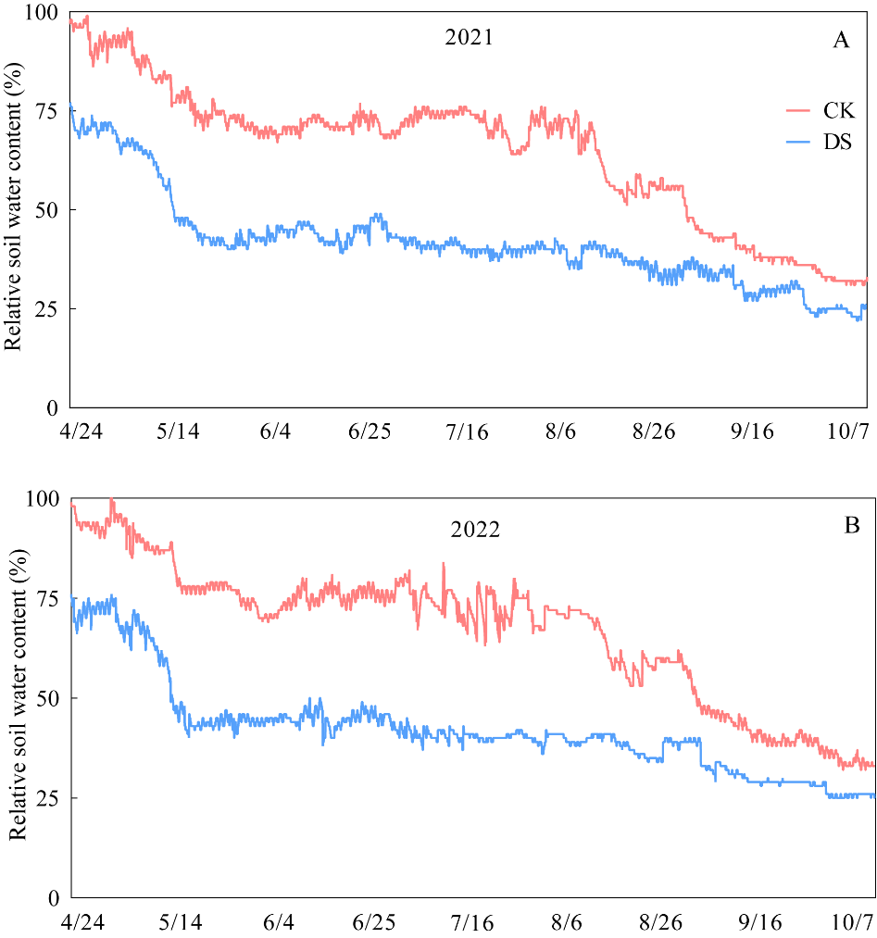
Supplementary Fig. 1. The soil relative water content in 2021 (A) and 2022 (B) in the experimental fields. WW, well-watered; DS, drought stress.

