Supplementary Information
1. Materials and Methods
Materials. Unless otherwise stated, materials were used in the form they were received. Gyroidal and hexagonal supports were structure directed using one of two poly(isoprene-block-styrene-block-ethylene oxide) (PI-b-PS-b-PEO or ISO in short) triblock terpolymers synthesized using approaches detailed elsewhere [19]: ISO-1 (113 kg/mol; 30.3/63.1/6.6 (I/S/O vol%); PDI: 1.06) for synthesizing alternating gyroid supports, or ISO-2 (105 kg/mol; 17.2/36.9/45.9 (I/S/O vol%); PDI: 1.14) for preparing hexagonal cylindrical and double gyroid supports. A poly(isoprene-block-styrene-block-4-vinyl-pyridine) (PI-b-PS-b-P4VP or ISV in short) triblock terpolymer (ISV-1) (113 kg/mol; 29.0/59.0/12.0 (I/S/V vol%); PDI: 1.3) was used for asymmetric SNIPS-based TiO₂ membrane supports, as described elsewhere [20]. Detailed polymer characterization information is listed in Supplementary Table 1. Tetrahydrofuran (THF, Sigma-Aldrich, anhydrous, ≥99.9%, inhibitor-free) and (for ISV-solutions only) dioxane (DOX, Sigma-Aldrich, anhydrous, ≥99.9%, inhibitor-free) were used as described below to prepare various polymer solutions. The TiO₂ and Ta₂O₅ sols were synthesized using hydrochloric acid (HCl, VWR, BDH, ACS Grade, 36.5-38%), THF, and either titanium isopropoxide (TTIP, Sigma-Aldrich, 99.999% trace metals basis or Alfa Aesar, 99.995% trace metals basis) or tantalum ethoxide (Sigma-Aldrich 99.98% trace metals basis). Rhodium co-catalysts were hydrothermally deposited on the supports as rhodium chloride hydrate (Sigma-Aldrich 99.98% trace metals basis), before in-situ reduction to rhodium metal during catalytic evaluation. For comparison to SA based nanostructured materials, tantalum oxide (Beantown Chemical, ≥99% trace metals basis) and anatase titanium oxide (Sigma-Aldrich ≥99.8 trace metals basis) powders were used as supports. These non-structured powders were employed as received and underwent identical addition of the rhodium co-catalyst (see below).
Preparation of photocatalytic oxide sols: The TiO₂ sol was prepared in a vial via a hydrolytic sol-gel route adapted from a previously reported process [21]. 1.0 mL titanium isopropoxide (TTIP) was added to 0.3 mL 37% HCl in a septum vial and stirred vigorously for 5 min. After that time, 2 mL of THF was added. Then the mixture was again stirred for 5 min before being added to the casting solution of ISO dissolved in THF, or an ISV solution in THF and DOX, see details below. The Ta₂O₅ sol was synthesized similarly, derived from a protocol described earlier [22]. To that end, 0.33 mL of 37% HCl and 0.79 mL of THF were combined in a septum-capped vial. 0.79 mL of tantalum ethoxide was added and stirred vigorously for 5 min. Then, 1 mL THF was rapidly injected into the sol solution, which was then allowed to stir for another 5 min before being added to ISO casting solutions dissolved in THF, see details below.
Gyroidal and Hexagonal Support preparation: Sol solutions were added to solutions of ISO-1 or ISO-2 dissolved in THF (5 wt% polymer) in varying fractions to synthesize different mesostructured materials. Volume fractions refer to fractions of isoprene, styrene, and ethylene oxide with TiO₂ or Ta₂O₅ clusters, excluding solvent. O block + oxide (the combined volume of poly(ethylene oxide) and TiO₂ or Ta₂O₅ additive) fractions were calculated using the following densities, d_{TiO₂} = 4.23 g/mL and d_{Ta₂O₅} = 8.2 g/mL, and assuming complete conversion of oxide precursors to oxides in the sol. Oxide sol was added to ISO-1 to achieve 13-15 vol% O block + oxide for alternating gyroid morphologies. Sol was added to ISO-2 to achieve 50-53 vol% O + oxide for double gyroids, or 53-55 vol% O + oxide for hexagonal cylinder morphologies. For example, to synthesize a Ta₂O₅ alternating gyroid, 0.165 mL of Ta₂O₅ sol was added to 50mg of ISO-1 dissolved in 2mL of THF to achieve 13.25 vol% O block + oxide. The ISO/oxide casting solutions were stirred vigorously for 12 hours before casting.
The solutions were cast in poly(tetrafluoroethylene) (PTFE) dishes. The dishes were placed under a glass dome and heated to 40°C overnight to evaporate the solvent (THF) for EISA. Solidified ISO/oxide hybrid materials were subsequently heat processed at 130°C for 5 hours in a vacuum oven to remove remaining THF. Then the hybrid materials were calcined in a tube furnace open to air to create free-standing porous nanostructured oxides. To that end, films were heated at a rate of 1°C/min to 550°C for TiO₂, or 700°C for Ta₂O₅, and held for 3 hours, and then allowed to passively cool to ambient temperature.
SNIPS TiO₂ membrane preparation: The SNIPS technique to create asymmetrically porous TiO₂ membranes has been described elsewhere [16,20]. For this work, 100mg of ISV-1 polymer was dissolved in 0.39 mL dioxane (DOX) and 0.19 mL tetrahydrofuran (THF) under stirring. 0.583 mL of TiO₂ sol (described earlier) was added and stirred for 24hr. Solution viscosity would initially increase, before returning to a thick honey-like consistency after 24hr. After 24hr, the solution was pipetted onto a glass slide, and leveled with a doctor blade to 0.3-0.38 mm. The solution was allowed to evaporate for 60s in air, before being plunged into a deionized water bath to halt self-assembly and induce phase inversion. The film de-adhered from the glass slide in water and was transferred to an alumina furnace boat. Each film was dried at 100°C for 2hr before calcination at 550°C for 3hr in a tube furnace open to air with a 1°C/min heating rate.
Addition of rhodium co-catalyst: Gyroid, hexagonal, and non-structured powder catalyst supports were added to a PTFE-lined pressure vessel with 15 mL of deionized water and 15 wt% Rh (wt% refers to Rh metal mass, after reduction from RhCl₃∙H₂O) relative to the oxide support mass. The pressure vessel was sealed and heated to 180°C for 12 hours. After heating, catalyst material was collected from the solution, dried, and ground in a mortar and pestle. Catalyst material was passed through a <50 µm metal mesh to establish maximum pellet size, chosen to maintain a Thiele modulus less than 2 (Supplementary Fig. 11).
SNIPS film supports were infiltrated with rhodium via immersion in a rhodium chloride solution. 15 wt% Rh relative to the film mass (as RhCl₃∙H₂O) was dissolved in 10 mL methanol, and the intact film was loaded into a glass vial with the rhodium chloride solution. The methanol was evaporated at 80°C over a hot plate, and the infiltrated film was removed.
Prior to catalytic testing, catalyst material was loaded into the reactor, and illuminated under a 300W Newport Xe lamp (see Supplementary Fig. 6 for spectrum) under a 20mL/min 1%/1%/98% CH₄/CO₂/Ar flow to reduce rhodium chloride hydrate to rhodium metal; this was accompanied by a quick color change of the material from orange to black. Initial reduction occurred rapidly under any flow rate tested, typically 20 mL/min. After reduction, catalytic performance was measured.
Characterization
Polymer characterization: A combination of proton nuclear magnetic resonance (¹H NMR; using a 500 MHz Bruker AVIII HD spectrometer with BBO Prodigy cryoprobe and deuterated chloroform as solvent), and gel permeation chromatography (GPC; with an Agilent 1100 series chromatograph) was employed to determine the ISO or ISV total number-average molar mass (Mn), block volume fractions, and polydispersity index (PDI). Polymer densities used for calculations were d_{poly(isoprene)} = 0.91 g/mL, d_{poly(styrene)} = 1.05 g/mL, d_{poly(ethylene oxide)} = 1.12 g/mL, and d_{poly(vinyl-pyridine)} = 1.15 g/mL.
X-ray Diffraction: Wide-angle X-ray powder diffraction patterns were collected on a Bruker D8 ECO powder diffractometer using λ = 0.154nm CuK-α radiation. For powder XRD, catalyst powders were placed into quartz glass wells, then measured. Patterns were analyzed and matched to references using JADE analysis software. All XRD patterns were collected after catalytic evaluation. Due to limited synchrotron access, SAXS patterns for TiO₂-G^{D} and Ta₂O₅-G^{A} were collected at the Cornell High-Energy Synchrotron Source (CHESS) beamline ID-3B over a range of q = 8.5∙10⁻³ – 4.7∙10⁻¹ Å⁻¹, where q = 4πsin(θ)/λ. All other SAXS patterns were collected at NSLS-II, beamline 11-BM (CMS) over a range of q = 8.5∙10⁻⁴ – 1.8∙10⁻¹ Å⁻¹. For SAXS, catalyst powders were mounted on scotch-tape and contained within a rubber multi-well sample holder.
SEM Analysis: Scanning electron microscopy (SEM) micrographs were obtained using either a TESCAN MIRA3 field emission (FE)-SEM (in-lens detector, accelerating voltage of 5 kV) or a ZEISS Gemini 500 Scanning Electron Microscope (accelerating voltage of 2 kV). The samples were either left uncoated or coated with gold-palladium prior to imaging using a Denton Vacuum Desk II. After collection, micrographs shown in Figure 2b-i were adjusted to higher contrast and brightness for visibility in ImageJ analysis software, and scale bars were added. SEM imaging was performed on bare supports, prior to rhodium addition. Characteristic spacings for specific lattices were determined by averaging results from 10-20 measurements per sample. Associated error bars provided in the main text represent the 95% confidence interval of the results of these multiple measurements.
TEM Analysis: Transmission electron microscopy (TEM) micrographs were obtained using an FEI Titan S/TEM operated at 300kV. For imaging, catalyst powders were dispersed in deionized water, then dropped onto carbon-coated Cu foils and dried. Images were adjusted to higher contrast and brightness for visibility using ImageJ analysis software, and scale bars were added. Catalyst supports were imaged after catalytic testing was completed.
Nitrogen Sorption: Nitrogen adsorption-desorption isotherms were recorded using a Micromeritics ® ASAP 2020 surface area and porosity analyzer at -196°C. For sorption experiments, 100mg of catalyst support material was loaded into a quartz glass tube, then degassed under 120°C heating overnight. The degassed sample and tube were then attached to the analysis port of the instrument, immersed in liquid nitrogen, and analyzed. The Brunauer-Emmett-Teller (BET) method was used to obtain the specific surface areas of the various oxides. The pore size distributions were obtained using the Barrett-Joyner-Halenda (BJH) analysis of the desorption curves [23]. The standard deviation of the full-width at half-maximum (FWHM) is a result of fitting the pore size distribution with a least-squares fit using a Gaussian function in Igor Pro.
X-ray Photoemission Spectroscopy: X-ray photoemission spectroscopy (XPS) spectra were collected on a Thermo Scientific Nexsa G2 X-Ray Photoelectron Spectrometer. A sample of each catalyst type was collected after catalytic testing, (and one sample prior to catalytic testing), ground into a powder, and submitted for measurement. Spectra were collected over a binding energy range of 0 – 1350 eV and processed via CasaXPS software to report atomic composition.
Catalytic Testing: Catalytic performance was measured on an Agilent 990 Micro-GC gas chromatograph, and products were measured in a CP-Molsieve 5Å 10m, 0.25mm diameter column (Supplementary Fig. 7). Either 1%/1%/98% or 10%/10%/80% CH₄/CO₂/Ar was fed into a flow-through quartz glass reactor (mesoporous powders, Supplementary Fig. 4a) or top-loading flow-through brass reactor (thin films, Supplementary Fig. 4b) over a range of flow rates (10-100 mL/min), comprising a total measurement range of 0.25-25 mmol / hr CH₄/CO₂. An additional test was conducted using a Ta₂O₅-Hex catalyst in the thin-film brass reactor to quantify any differences in the two reactors for the same catalyst (Supplementary Fig. 12). The quartz glass reactor exhibited higher performance for the same material, likely due to a larger cross-sectional area (0.125 cm² vs 0.07 cm²) . 0.25-2.15 mmol / hr flow rates correspond to 1%/1%/98% gas, and 2.5-25 mmol / hr flow rates correspond to 10%/10%/80% gas. Gas flowed through a 7.5mg stack of catalyst powder granules (<50 μm particle size, chosen based on Thiele modulus calculation (Supplementary Fig. 11)), or a single piece of TiO₂ film, illuminated by a 300 W Newport Xe lamp creating a 0.125 cm² illuminated spot on the powder reactor, or a 0.07 cm² spot on the film reactor at 40 mW/m²∙nm irradiance (at 0.5 m), from λ = 250-2400 nm (see Supplementary Fig. 6 for full spectrum). All testing used either 7.5mg of gyroid or hexagonal catalyst powder, or the actual mass of a 0.05 cm² monolithic TiO₂ film (0.145 mg). Percentages of components in the effluent gas measured by the GC were converted to mmol / (hr∙g_{catalyst}) using the measured reactant gas flow rate, where g_{catalyst} refers to the combined mass of Rh and oxide support. GC calibration curves were generated using MESA VGM-1, VGM-3, and VGM-7 calibration gas, a 1%/2%/97% CO/H₂/Ar cylinder from Airgas, as well as the two CH₄/CO₂/Ar reactant gas mixtures from Airgas. GC calibration curves and example raw data are provided in Supplementary Fig. 7. Production rates are expressed as the average of CO and H₂ production, normalized by catalyst mass, with CO/H₂ ratios reported separately. No external heating was applied to the reactor for any catalytic testing.
Simulation Methods
Gyroid and hexagonal simulation method: A rescaled geometry was simulated for the gyroidal and hexagonal structures through random orientations of the lattices (Figure 5). The alternating gyroid structure was described by the surface, 10*[cos(x)sin(y) + cos(y)sin(z) + cos(z)sin(x)] – 0.5*[(cos(2x)cos(2y) + cos(2y)cos(2z) + cos(2z)cos(2x)] = 10.5 [24]. The double-gyroid structure was described as the surface created by the intersection of a volume described by M = (R * (R>0)) + (L * (L>0)) and a constant value, such that the resulting surface spanned 45% of the total volume. R is the alternating gyroid surface described above, and L a shell around the struts described as 10*[(cos(x)sin(-y) + cos(y)sin(-z) + cos(z)sin(-x))] – 0.5*[(cos(2x)cos(2y) + cos(2y)cos(2z) + cos(2z)cos(2x)]. The double gyroid materials used in this work consist of the matrix (polyethylene oxide and semiconductor) around these core-shell struts (polyisoprene and polystyrene) Constants were chosen to give the same percentage porosity and relative volume fractions of each network as experimental materials. Five cubic cells of these lattices were aligned axially, each rotated by a unique angle. This is an approximation of a large lattice with multiple unit cells, randomly oriented. To maintain the alignment of the orthogonal sides of the cube and stack them together, the structures were generated by rotating the field governing the distribution of the material while keeping the cube fixed in space. ANSYS Fluent® was used to set up the three-dimensional finite element simulation for a low Reynolds number flow through each geometry. To address the numerical instability in simulating a complex geometry, an unstructured mesh was used as localized regions in the model required a higher resolution mesh. The mesh and the solution of the equations were split into multiple partitions that were assigned to different computer nodes to enable faster processing. The streamlines between the inlet and the outlet of the lattice arrays were simulated. The path integral of the axial distance variable along the $n$ streamlines, $l_{s}=\sum_{i}^{n}{\int_{i}{xds}}$, and the displacement of these streamlines, $l=\sum_{i}^{n}{\int_{i}{ds}}$, was calculated. The tortuosity for each flow was calculated as $l_{s}/l$ and provided an estimation of the elongation of the flow path through the porous media.
Film simulation method: To estimate the membrane tortuosity, a stochastic pore network model (SPNM) was used. Stochastic pore network modeling is a popular approach in porous media modeling that uses statistical properties of the void space of a porous medium, such as pore size distribution, pore connectivity and pore density, to generate a network model of its pore structure. The resulting network can then be used to simulate flow and transport in a porous medium and to calculate physical characteristics such as permeability and tortuosity.
A typical pore network model consists of pore bodies and pore throats. Pore bodies represent the large pores in the system and pore throats represent the flow path between each pair of pores. The number of pore throats emanating from each pore body is called coordination number. From a graph theory point of view, pore bodies can be thought of as nodes, pore throats as links and coordination numbers as node degrees; which together form undirected graph.
The SPNM used in this study is an irregular SPNM, as opposed to the regular SPNM used in Riasi, et al. [18]. Instead of employing a regular cubic grid, the nodes, which represent pore bodies, are distributed randomly within a three-dimensional (3D) domain. Subsequently, the pore throats, or links, are derived through a Delaunay triangulation of the 3D node set. [25] To match the desired coordination number distribution, the excess pore throats are removed at random. Following the creation of the initial pore network model, cylindrical vertical fingers are excavated within the domain by removing nodes that intersect with the finger structure. To enable fluid exchange between the main pore network and the axis of the fingers, radial auxiliary links are introduced connecting the circumferential pores of the fingers to their respective nodes on the axis of the fingers. Since the sole purpose of these auxiliary links is to facilitate transport to and from the fingers, they are assumed to have negligible length (extremely high hydraulic conductivity). Supplementary Fig. 10a-b shows an example of a sample SPNM with 8 fingers.
The statistical properties used in SPNM generation are as follows. Based on the SEM images of the membrane top surface and its cross-section (Figure 3e,i), it is assumed that, in the absence of fingers, pores are uniformly distributed throughout the membrane with no apparent gradient in pore size and pore density. Segmenting and analyzing the top surface SEM image yielded a normal distribution of 26.9 ± 7.7 nm for the pore diameter, and pore density of 2×10¹⁴ pores/m². These values are assumed apply to the entire membrane domain. The cross-sectional image reveals a ~ 100 µm thick membrane with fingers penetrating the membrane up to 9-11 µm from the top surface. Based on this image, it is assumed that the finger diameters follow a uniform distribution of 7.82 ± 1.70 µm (bounded between 6 µm and 11 µm). This study further assumes that all fingers are vertical and do not intersect. In addition to these observations, the average pore coordination number (number of links connected to a pore) is assumed to be ~3.37 (same average value as in our previous study) [26].
Two types of tortuosity measures were studied here: geometric tortuosity and hydraulic tortuosity. Geometric tortuosity, τ_{g}, is defined as the ratio of the average length of the geometric path (shortest distance), (L_{path}), between a pore at the top surface of the membrane and the outlet, divided by the depth of the medium (L_{membrane}). Similarly, the hydraulic tortuosity, τ_{h}, can be defined as the shortest flow path, (L_{flow path}), between a pore at the top surface of the membrane and the outlet, divided by the depth of the medium, L_{membrane}. [18]
To measure the geometric tortuosity, 20 pores were randomly chosen from the top surface of the pore network and the shortest distance from each one of these pores to the outlet was calculated. The average of these distances was then divided by the depth of the network model, resulting in the geometric tortuosity value. For the hydraulic tortuosity analysis, the first step involved simulating steady-state incompressible flow within the pore network model of the membrane [25]. Then, the flow travel time was calculated for each link in the network by dividing the link length by the flow velocity within that link. By considering the computed travel time and the flow direction within each link, the shortest flow path between the 20 pores on the top surface and the outlet was determined. Finally, the average flow path length was divided by the depth of the network model to derive the hydraulic tortuosity value. Supplementary Fig. 10c shows the calculated geometric and hydraulic tortuosity values for membrane depths ranging from 8 μm (no fingers) to 100 μm. As shown in this figure, both geometric and hydraulic tortuosity approach unity as the membrane depth increases.

2. Supplementary Discussion
Nitrogen sorption experiments and results: To characterize the porosity of the seven supports studied, nitrogen adsorption-desorption measurements were performed and associated pore size distributions derived from BJH analysis (Supplementary Fig. 1) [23]. All isotherms follow type IV(a) behavior according to IUPAC classification, typical for regular mesoporous materials, with variations in the types of hysteresis loops [27]. The single narrow hysteresis loops (likely type H1) of the G^{A}, G^{D}, and TiO₂-Film curves suggest a single pore size population without necking or constrictions. While the G^{D} and TiO₂-Film curves (Supplementary Fig. 1b, d, f) lack the high-pressure plateau typical of H1 hysteresis, the absorption and desorption curves lack the sharp intersection at medium pressure or the wide hysteresis pressure range of alternatives like H3, leaving H1 as the most likely assignment. The sorption curves fail to capture the large size (>>50 nm) of the TiO₂-Film’s macropores, and instead only capture the relatively uniform mesopores of the top surface and wall structures. The wider hysteresis loop (type H2b) of TiO₂-Hex suggests constriction in the pore necks or blocking of pores over a range of pore widths, which has also been observed in mesoporous silicas following hydrothermal treatment [27]. Variations in access to the hexagonal cylinder pore entrances could slow the desorption of nitrogen gas. Ta₂O₅-Hex shows a narrow hysteresis, which closes at a lower P/P_{o} compared to the other isotherms and lacks a saturation plateau at P/P_{o}=1. This hysteresis is believed to exhibit H4 behavior at 0.45 < P/P_{o} < 0.85, while at higher pressures it exhibits H3 behavior. This compound hysteresis loop could be due to morphological imperfections, such as grain boundaries, resulting in slit-like rather than the dominant cylindrical pores, contributing to an H3 hysteresis [28].
Pore volume was larger in gyroid structures as compared to hexagonal structures of the same oxides (Table 1). The measured pore volumes are consistent with the expected structures formed from BCP-SA, with the O-block+oxide minority network of the G^{A} structure only occupying ~15 vol% of the hybrid material, while occupying >50 vol% in the case of the G^{D} and Hex structures (majority components). This results in the highest pore volume associated with the TiO₂-G^{A} structure. BET derived surface areas follow the same trend, with the highest surface area of 123.8 m²/g associated with sample TiO₂-G^{A}, and the lowest of 11.7 m²/g associated with sample Ta₂O₅-Hex. Nitrogen sorption experiments do not capture the complete porosity of the TiO₂ film and its 20-30 µm macropores, although the contribution to surface area from macropores is expected to be small. Based on the mass and dimensions of the measured TiO₂ film catalyst (Supplementary Fig. 5), the density of the film is approximately 0.3 g/cm³, corresponding to a porosity of 93%. All results of the quantitative sorption/desorption analyses are summarized in Table 1.
DRM product ratio and side-reactions: Under 1%/1% CH₄/CO₂ flow, all catalyst materials exhibit a CO/H₂ ratio between 0.65 and 0.9. In high-temperature DRM literature, an excess of H₂ in the product stream had been ascribed to either methane decomposition (CH₄ → C + 2H₂ ΔH = +75 kJ/mol) or steam reforming (CH₄ + H₂O → 3H₂ + CO ΔH = +206 kJ/mol) [29]. Water may be present in small amounts on the surface of the mesoporous materials, since these catalysts undergo no pre-heating or vacuum treatment before testing. Since little carbon accumulation is measured in any materials (Supplementary Table 2), any carbon accumulated via methane decomposition may eventually be released as CO by reacting with lattice oxygen, or via carbon gasification by water (C + H₂O → H₂ + CO ΔH = +131 kJ/mol) [29]. In addition to water, the lattice oxygen in semiconductor oxides could play a role. Previous studies have reported the generation of isotopic carbon monoxide in strontium titanate with isotopically labeled lattice oxygen and subsequently conducting DRM [14]. This suggests that lattice oxygen plays a role in the photocatalytic DRM process by reacting with CH₄ to produce CO and H₂. Under steady-state conditions, this reaction is akin to the partial oxidation of methane by lattice oxygen (CH₄ + O_{lattice} → CO + 2H₂), where the oxygen consumption is balanced by the lattice oxygen generation via CO₂ or CO dissociation. This creates a state of dynamic equilibrium between the consumption and generation rates; however, on the way to this steady state, a significant amount of lattice oxygen could be utilized early on (as the oxygen vacancy concentration at steady state may be higher than the starting material, making the oxygen vacancy creation appearing net positive at the onset of the experiment.) In such cases, the reaction would be lopsided to the partial oxidation of methane by lattice oxygen to produce excess hydrogen. Further studies to disentangle side reactions within photocatalytic DRM is required to understand the competition between side-reactions to determine the origin of the observed stoichiometry ratio.
Under a flow of 10%/10% CH₄/CO₂ the CO/H₂ ratio is universally greater than 1, with TiO₂ materials diverging with increasing flow rate. In this regime, because the feed gas contains a significantly larger amount of oxygen via CO₂, the situation is reversed from the 1%/1% case that is oxygen starved. Notably, the rich CO₂ concentration becomes a source of oxygen to facilitate CO production via side-reactions like the Sabatier reaction (Sabatier: CO₂ + 4H₂ → CH₄ + 2H₂O ΔH = -165kJ/mol) or reverse water-gas-shift (rWGS: CO₂ + H₂ → CO + H₂O ΔH = +41kJ/mol).
To examine which reaction is more prevalent, a subset of the catalysts was measured under illumination with a 5%/5% CO₂/H₂ feed gas. As shown in Supplementary Table 4, the Sabatier reaction appears to be more active over these materials than rWGS, where the Sabatier reaction would consume four equivalents of H₂ to produce CH₄ and H₂O, leading to an increased CO/H₂ ratio. The TiO₂-G^{A} catalyst was notably more active for both Sabatier and rWGS than the Ta₂O₅-G^{A} catalyst, with increasing yield for increasing flow rate. This may explain the high CO/H₂ ratio of TiO₂-G^{A} in particular, which exhibits increasing CO/H₂ ratio with flow rate and diverges more than other catalysts in the study. The Hex catalysts were more active than both gyroids for Sabatier, with less feed rate dependence. During photo-DRM, the relative concentration of each gas species and the residence time of products likely modifies the prevalence of these side-reactions. But considering that both Sabatier and rWGS are active over these materials, they may explain CO/H₂ ratios greater than 1. In thermal DRM, it is common for the CO/H2 ratio to exceed 1, reaching values as high as 2 or 3 [26,30]. Therefore, it is not surprising for the CO/H2 ratio to exceed 1 in photo-DRM. What is noteworthy is that in the high-flow regime the ratio remains in the range of 1 to 1.4, with the most active catalyst, TiO₂-Film, exhibiting near 1:1 CO/H₂ stoichiometry. This is believed to be due to the presence of macro size asymmetric pore structures, which have a high dispersion capacity. While the mentioned side reactions consume the generated H₂, they can be suppressed by intentionally lowering the local partial pressure of H₂. In the case of TiO₂-Film, the hydrogen generated in nano-sized pores is gradually released into micro-sized pores, leading to a rapid decrease in partial pressure and the inhibition of side reactions. The observed CO/H₂ ratio of TiO₂-Film highlights not just the benefit of the asymmetric pore structure on the product stoichiometry, but also the potential to tune the catalytic environment via pore connectivity to either enhance or suppress the local partial pressure through rational design of the pore network.

3. Supplementary Tables and Figures
Supplementary Tables

Supplementary Table 1: Triblock terpolymer structural information for ISO-1, ISO-2, and ISV-1.

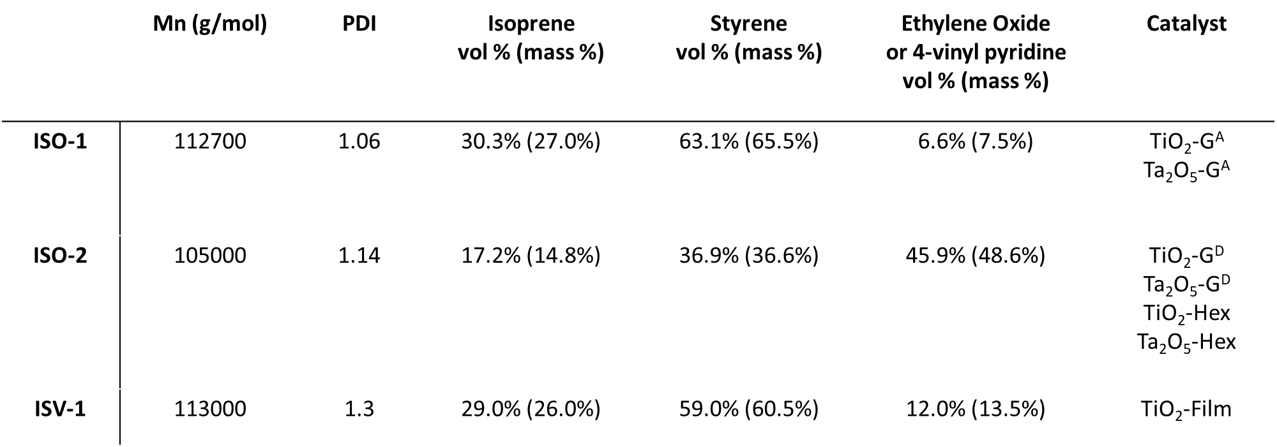

Supplementary Table 2: Quantitative XPS results for metal oxide elements, rhodium, and carbon. The presence of around 10% carbon was also detected in the control sample (not used for catalysis). Carbon results may therefore to a large extent reflect environmental contamination rather than accumulation during catalysis.

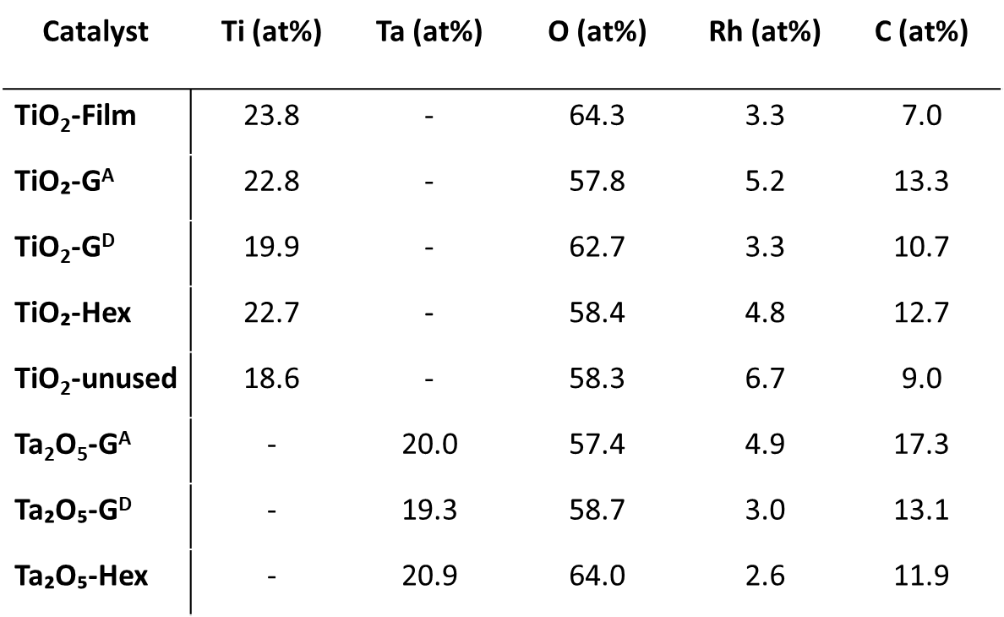

Supplementary Table 3: Comparison of results from this work (top section – highest production; middle section – highest conversion) with published photo-thermal and photocatalytic DRM results.
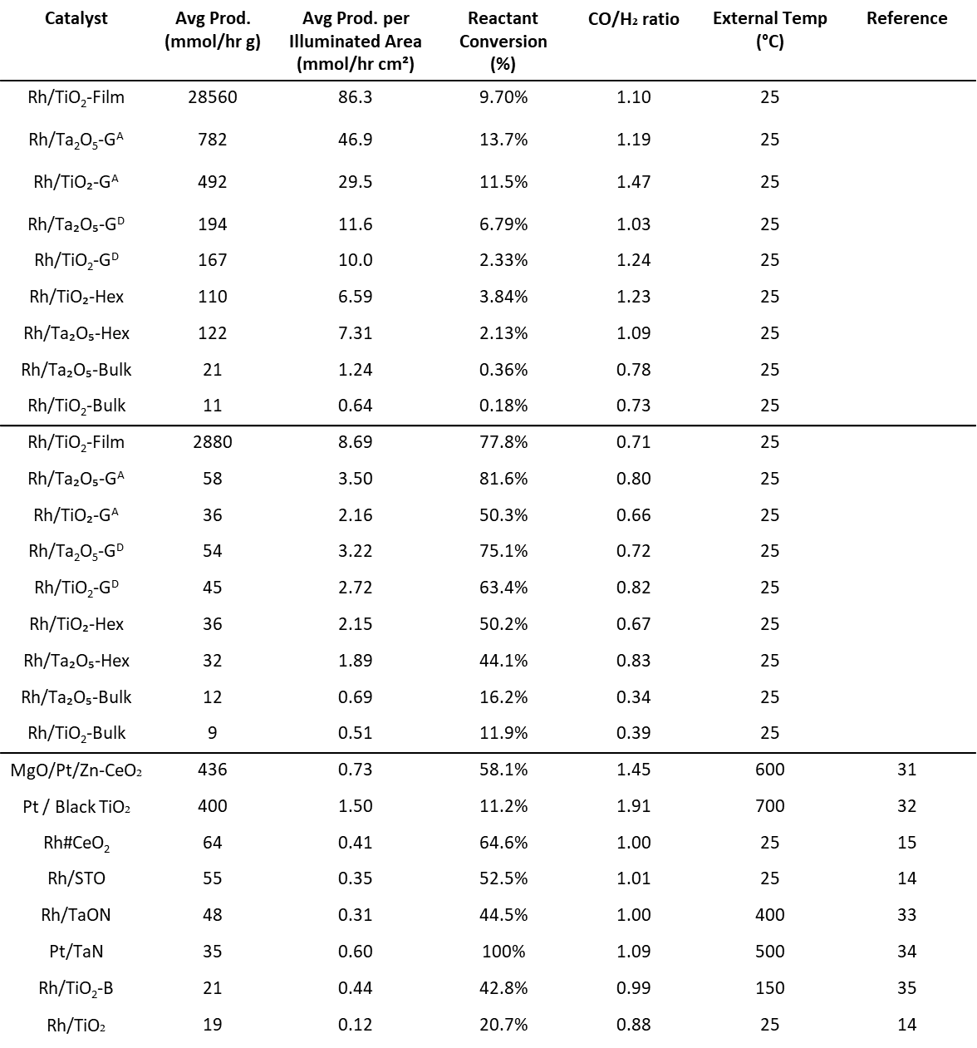

Supplementary Table 4: Products produced by selected photocatalysts under a 5% CO₂ / 5% H₂ (balance N₂) flow to investigate Sabatier (CO₂ + 4H₂ CH₄ + 2H₂O) or reverse water gas shift (CO₂ + H₂ CO + H₂O) activity. Both reactions lead to an excess of CO over H₂ in the product stream.

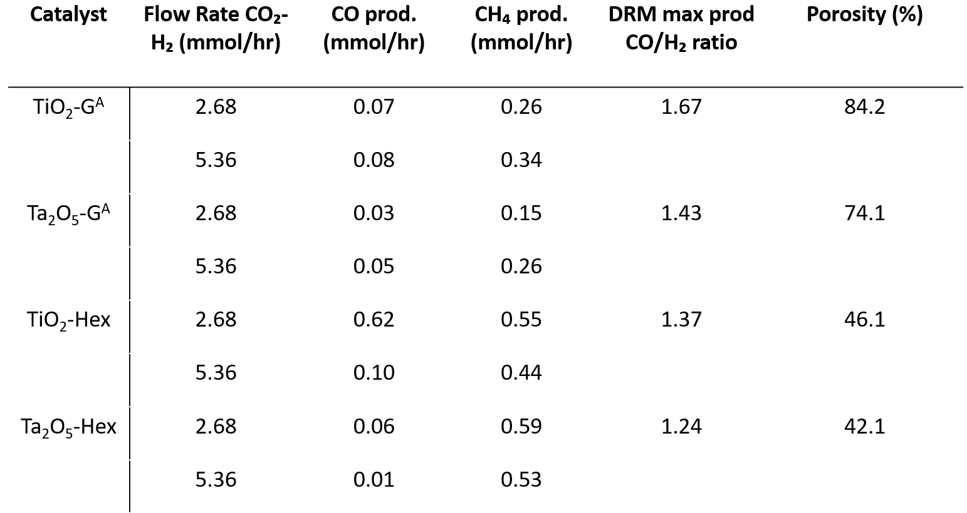

Supporting Figures

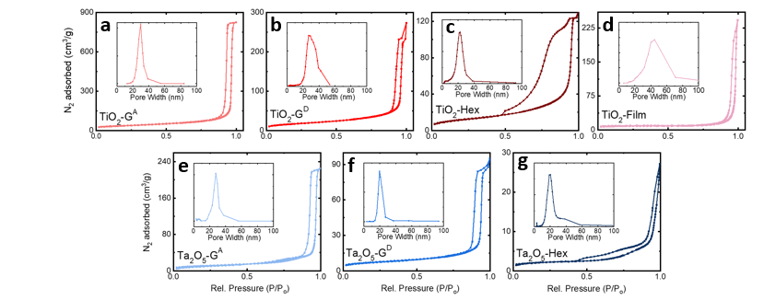
Supplementary Fig. 1: (a-g) Nitrogen adsorption-desorption isotherms of the seven oxide supports (as labeled) with insets showing the associated pore size distributions derived from BJH analysis.

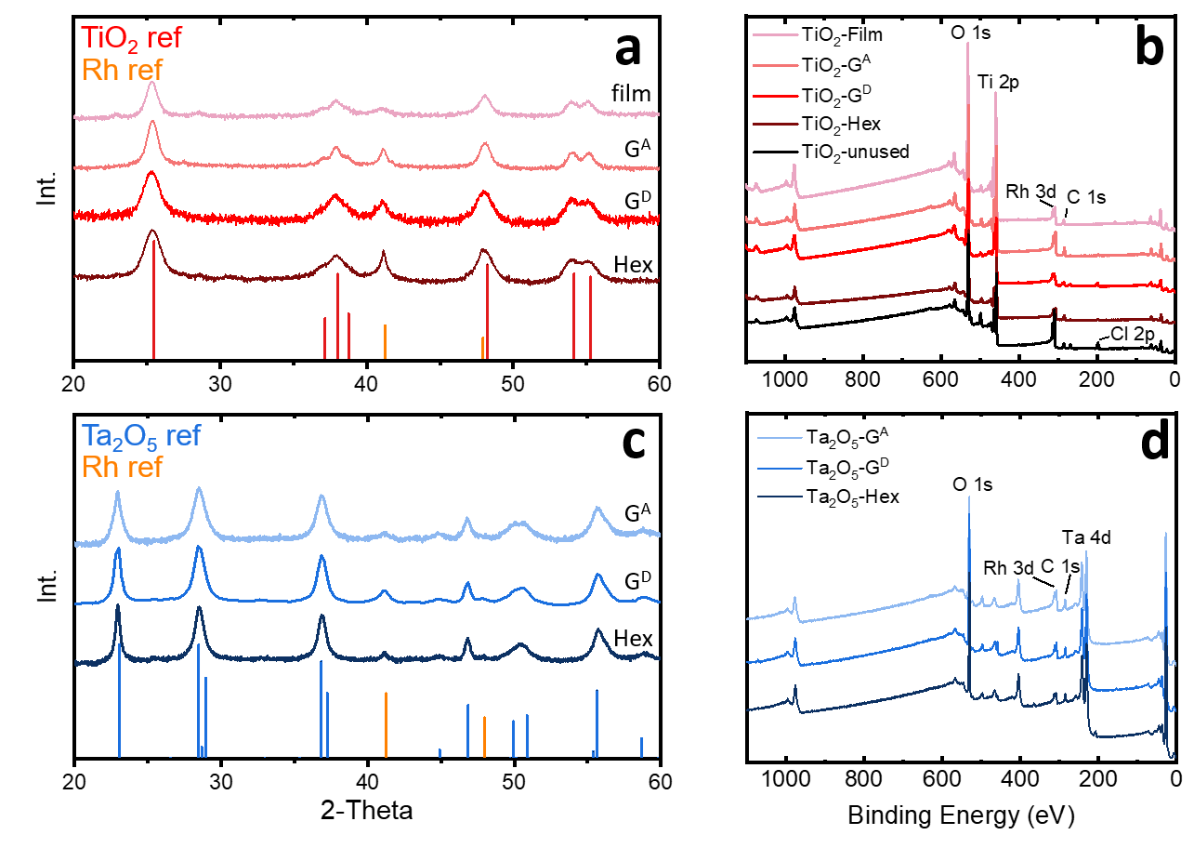
Supplementary Fig. 2: XRD patterns for (a) TiO₂ and (b) Ta₂O₅ catalysts decorated with Rh particles. XRD reference pattern peak locations and relative intensities are indicated by drop lines at the bottom of each panel, corresponding to tantalum oxide (PDF: 01-071-0639), anatase titania (PDF: 01-086-1157), and rhodium (PDF: 00-005-0685). (b, d) XPS spectra for catalysts after photocatalytic evaluation, as well as one TiO₂ G^{A} catalyst before evaluation with RhCl₃ present before reduction to Rh. Results of quantitative XPS analysis are summarized in Supplementary Table 2.

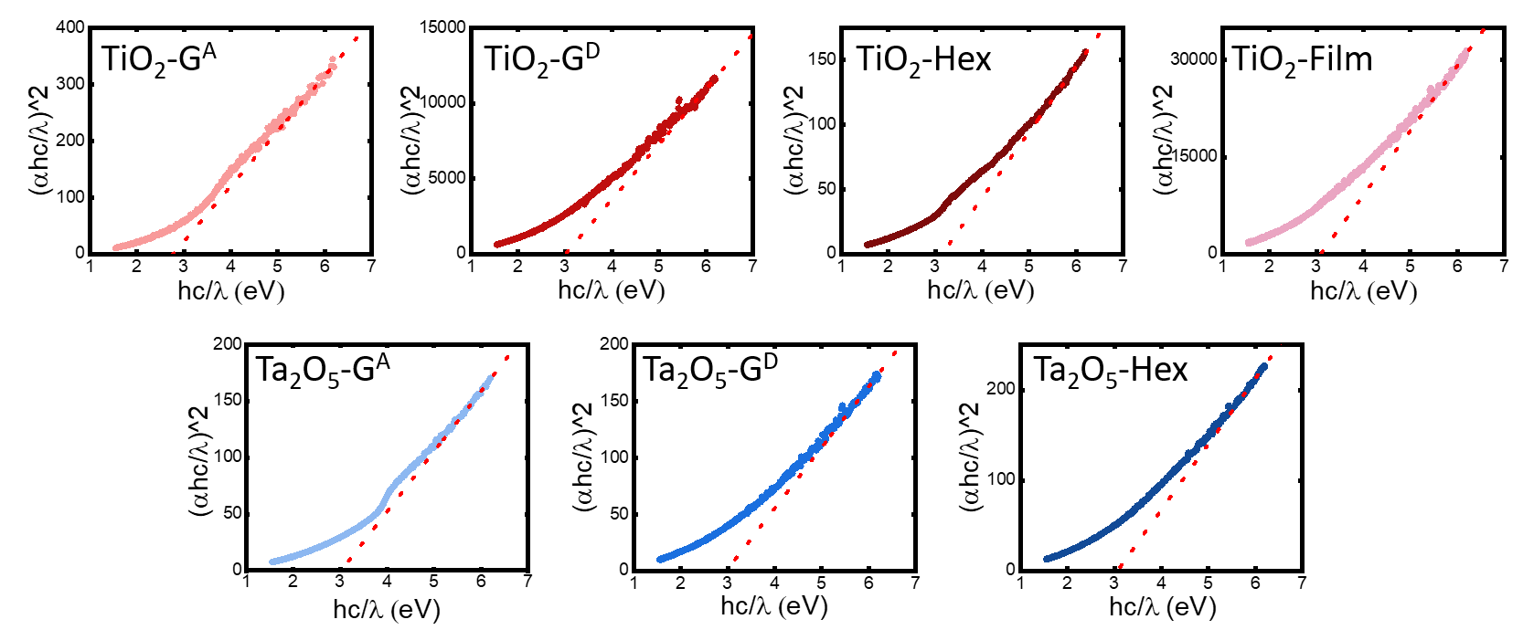

Supplementary Fig. 3: UV-vis data together with fits for calculations of the band gap for each material. All supports were found to have approximately 3eV band gaps. Trendlines are tangential to the steepest slope of each curve, according to convention.

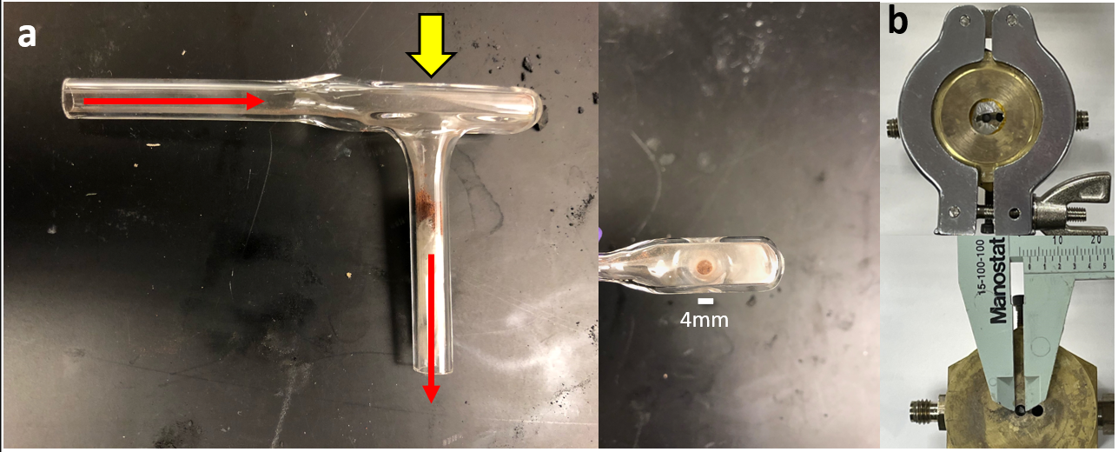
Supplementary Fig. 4: (a) The quartz glass reactor used for testing of catalysts with periodic gyroid and hexagonal mesostructure. Side view, test gas flow direction is marked by long red arrows, while illumination direction is marked by wide yellow arrow. Top view, illumination was perpendicular to the 4mm diameter circular cross-section of catalyst powder, corresponding to a 0.125 cm² illuminated area. Catalyst powder is held in position by glass wool. (b) The top-loading reactor for testing asymmetric thin films, constructed of brass with a central quartz window. A catalytic film is placed in the 3mm diameter outlet, suspended by glass wool. Films tested were typically 2-2.5 mm square.

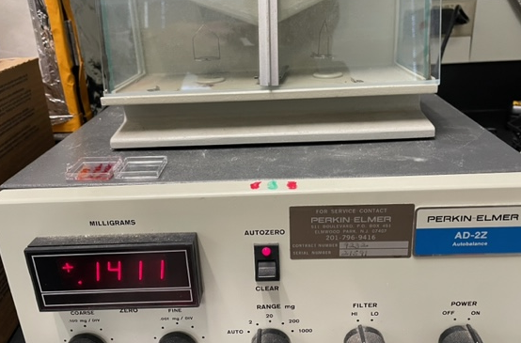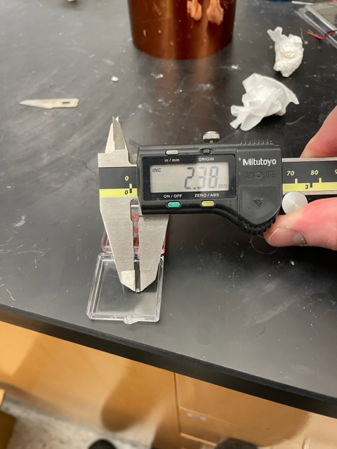

Supplementary Fig. 5: (Left) Mass of the TiO₂ film sample, taken with a Perkin-Elmer AD-2Z autobalance. The reported value (0.145 mg) is an average of five measurements. (Right) The size of the TiO₂ film sample, approximately 2.4 x 2 mm, for an area of 0.048 cm². The single piece was loaded into the top-loading reactor (Supplementary Fig. 4b) for testing.

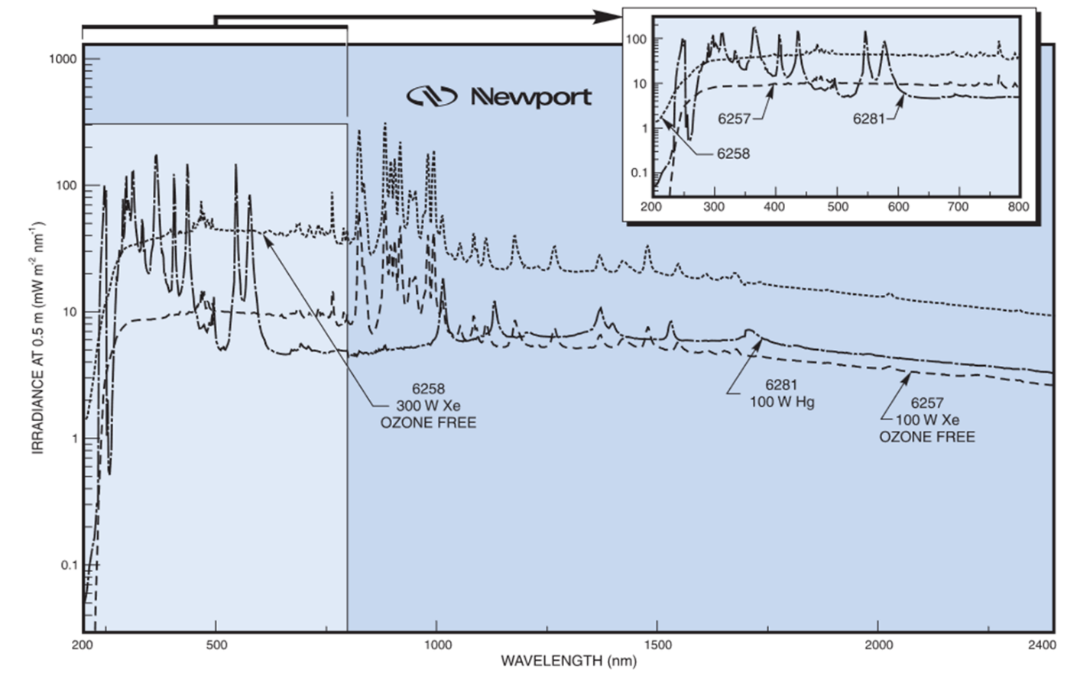
Supplementary Fig. 6: Spectrum of 300W Xe lamp used for catalytic testing (6258 300W Xe Ozone Free). [36]

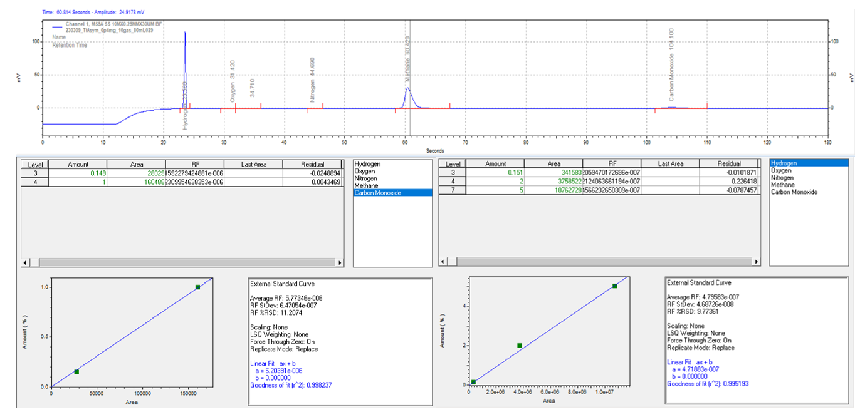

Supplementary Fig. 7: (Top) Raw data for the asymmetric TiO₂ film (0.145 mg) at 21.4 mmol / hr CH₄/CO₂ flow rate (80 mL/min of 10%/10%/80% CH₄/CO₂/Ar gas), corresponding to 9.7% conversion of reactants to products, with 1.81% H₂ and 1.99% CO detected, for an average production of 28,563 mmol / (hr·g). Calibration curves for (bottom left) carbon monoxide and (bottom right) hydrogen, based on MESA VGM-3 & VGM-7 calibration gases, as well as a 1%/2%/98% CO/H₂/Ar cylinder from Airgas.

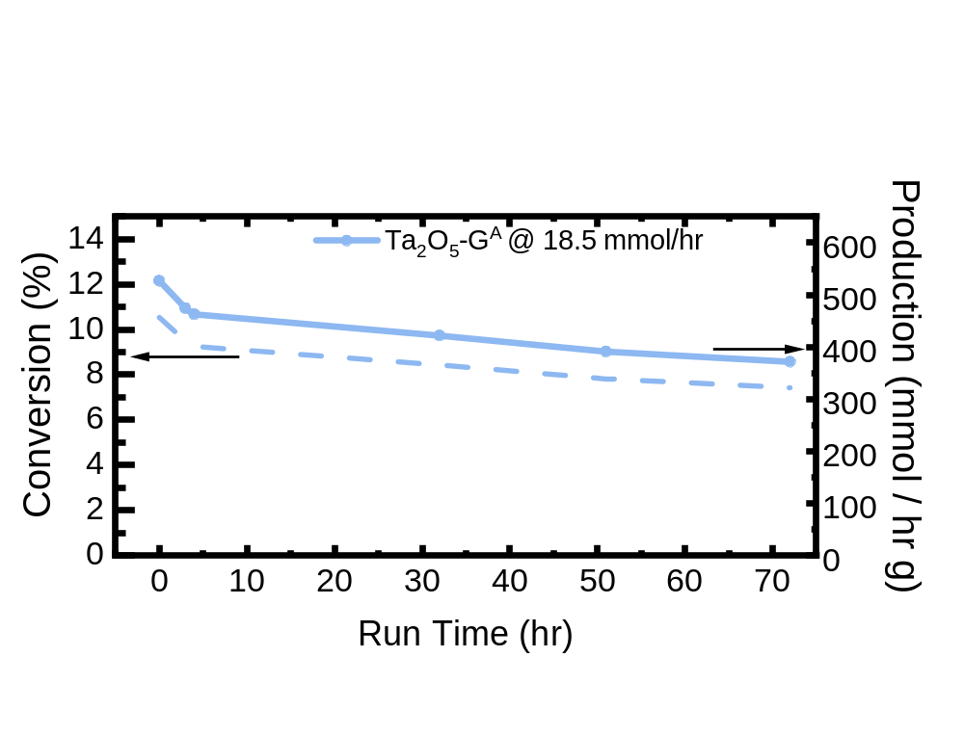
Supplementary Fig. 8: DRM results over 72hr of continuous operation of 7.5mg of Ta₂O₅-G^{A} catalyst under 18.5 mmol / hr feed rate (70 mL/min 10/10/80 CO₂/CH₄/Ar). 30.074 mol of CO/H₂ were produced (average) over 72hr, over 1.09·10⁻⁵ mol Rh (15 wt%), for a turnover frequency of 38,320 / hr or 10.6 / s. A separate G^{A} sample was used for this durability test than for the main data set (Figure 5), resulting in slightly different initial conversion values.

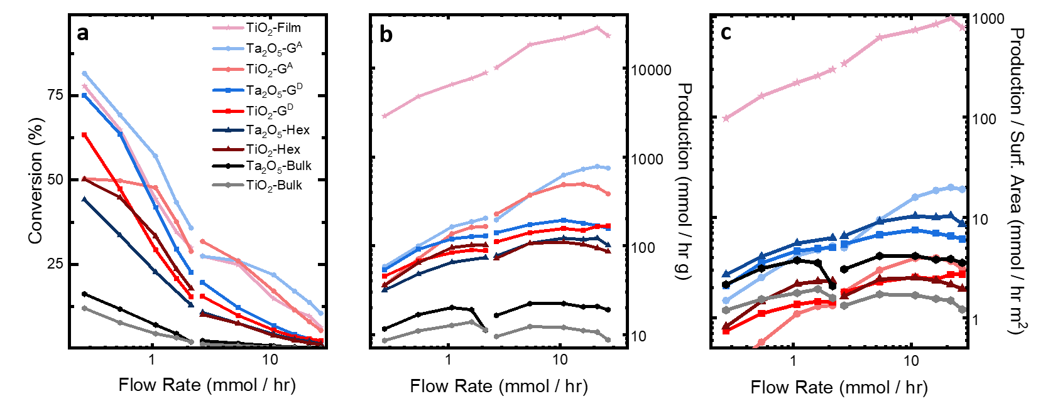
Supplementary Fig. 9: Reproduction of Figure 4 with a non-mesoporous commercial “bulk” Ta₂O₅ powder (5.36 m²/g surface area) and non-mesoporous anatase “bulk” TiO₂ powder (7.13 m²/g surface area) decorated with Rh nanoparticles for comparison. Advantages of mesoporous catalysts are most clear in panel c, where even when normalized by surface area, all mesoporous catalysts outperform non-structured counterparts, corroborating that the performance improvement of mesoporous materials lies in improving transport of species through the catalyst, rather than simply increasing surface area.

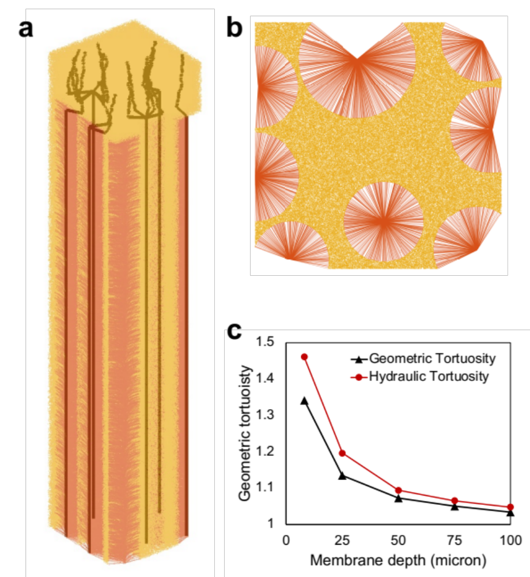
Supplementary Fig. 10: (a,b) Additional views of the simulated asymmetric TiO₂-Film structure are provided. Auxiliary links and axis nodes of the macropores are shown in red. (b) A view of the bottom macroporous film structure is given. (c) Geometric and hydraulic tortuosity values measured using stochastic pore network models (SPNMs) with cross-sectional area of 20×20 μm² and depths of 8, 25, 50, 75 and 100 μm. The 8 μm pore network only includes the upper mesoporous layer, whereas the remaining SPNMs incorporate an increasingly thicker layer containing macroporous channels (“fingers”).

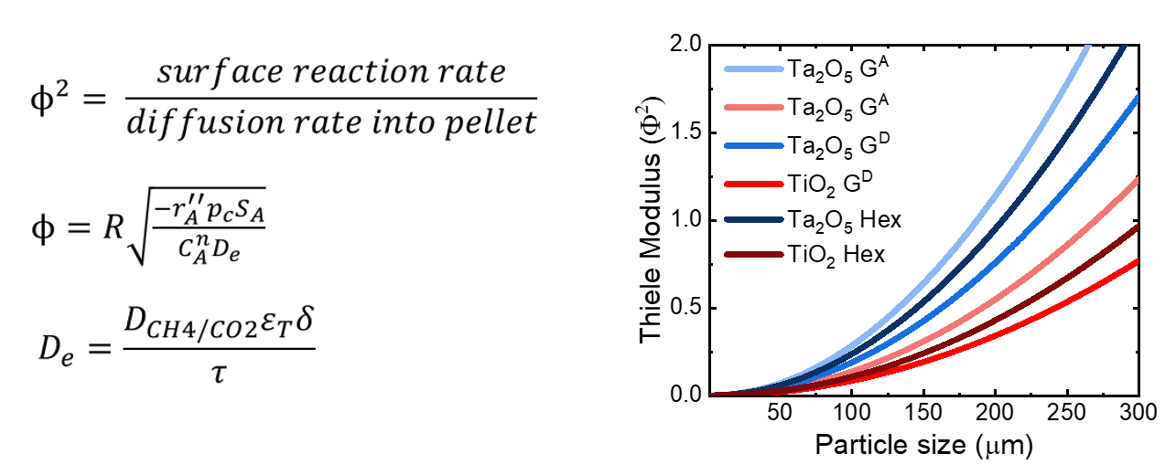
Supplementary Fig. 11: Calculation of Thiele modulus versus particle size for periodically structured catalyst materials with either gyroid or hexagonal mesostructured (as indicated), at the maximum surface-area-normalized production rate. 50 µm pellet sizes were used for catalytic testing, which is well within the regime of good diffusion into catalyst pellet pore spaces. For this calculation, D_{CH4/CO2} = 0.19 cm²/s, constrictivity (δ) was assumed to be 1. Tortuosity (τ) values are taken from the structure simulations (Figure 5). All other values are derived from the main text. [37]

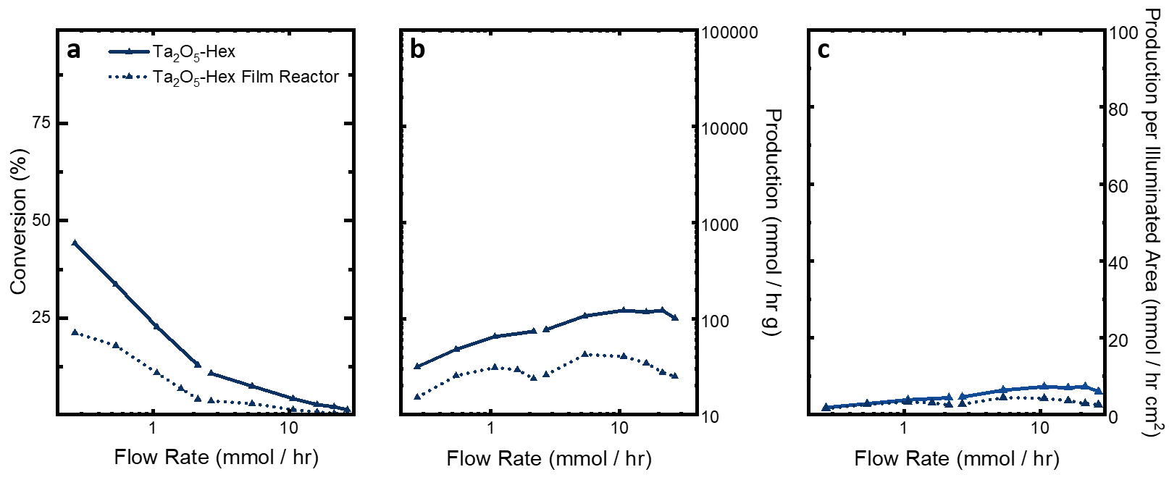
Supplementary Fig. 12: A comparison of Ta₂O₅-Hex catalysts in the quartz powder reactor (Supplementary Fig. 4a) or the top-loading film reactor (Supplementary Fig. 4b). Performance in the film reactor is uniformly lower due to a smaller cross-sectional area (0.07 cm² for the film reactor, 0.125 cm² for the powder reactor) and perhaps less efficient illumination due to a thicker quartz window. This comparison suggests that record thin-film performance is due to material architecture changes, rather than reactor geometry differences.

