Appendices A: Supplementary data

A comprehensive review of machine learning prediction
in the production of bio-oil from lignocellulose via pyrolysis

Hyojin Lee ^{a,**} , Il-Ho Choi ^{b}, Kyung-Ran Hwang ^{b},*

ª Carbon Conversion Research Laboratory, Korea Institute of Energy Research, Daejeon 34129, Republic of Korea
^{b} Bioenergy and Resource Upcycling Research Laboratory, Korea Institute of Energy Research, Daejeon 34129, Republic of Korea

* Corresponding author: Tel.: +82 428603504; Fax: +82 428603496.
* Co-corresponding author: Tel.: +82 428603443; Fax: +82 428603496
E-mail address: hkran@kier.re.kr (K.-R. Hwang), hyojinlee@kier.re.kr (H. Lee)

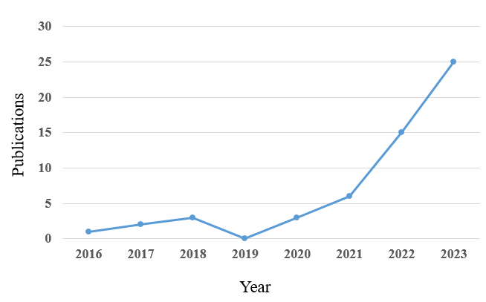
Fig S1. ML research for bio-oil production from lignocellulosic biomass in the last 10 years

