Supplementary material

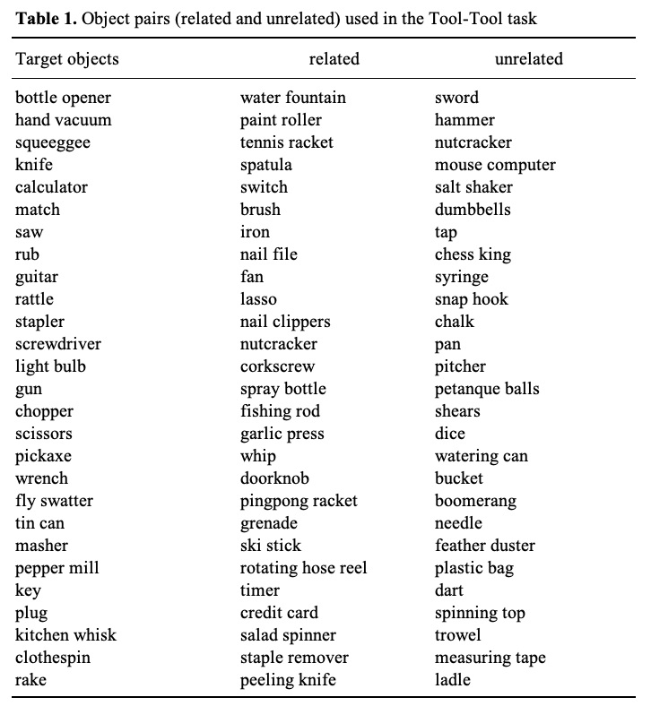

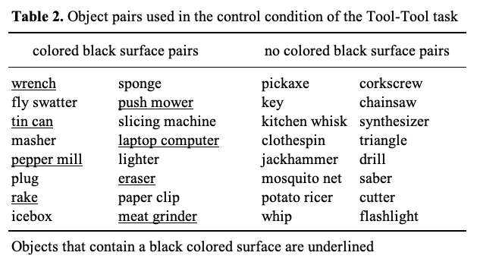

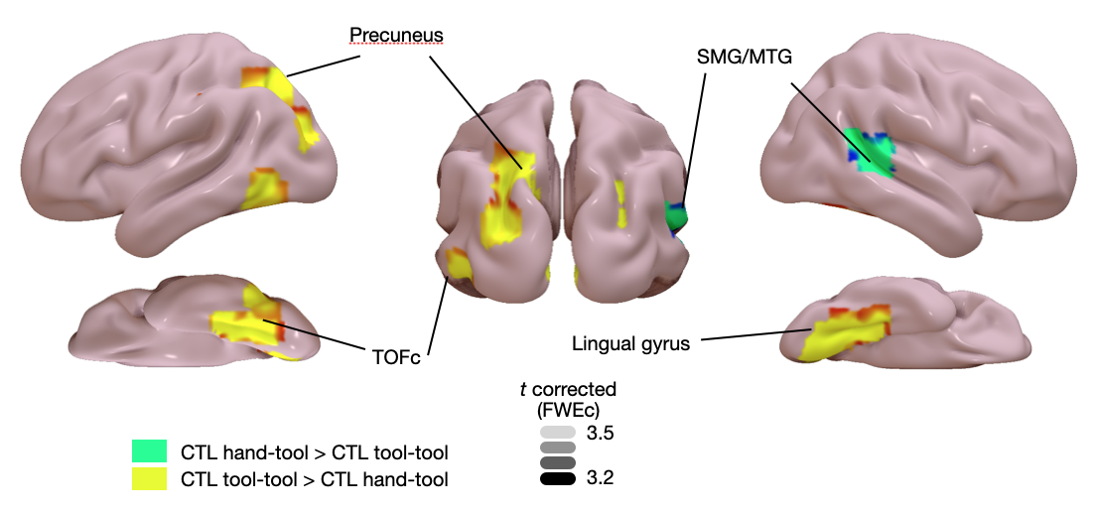
Figure 1. Statistical maps for the comparison between control conditions. Control_Hand-Tool > Control_Tool-Tool and Control_Tool-Tool > Control_Hand-Tool contrasts are projected on MNI cortical surface and are FWE-corrected (p < .05) for multiple comparisons across the whole-brain at the cluster level. SMG: supramarginal gyrus; MTG: middle temporal gyrus; TOFc: temporal occipital fusiform cortex.

