Extended Data.
Table S1. Global potential Fractional Vegetation Cover per biome.
Biomes | Tree (Mha) | Short Vegetation (Mha) | Bare ground (Mha)
Tropical and Subtropical moist forests | 1614.55 | 290.36 | 31.91
Tropical and Subtropical dry forests | 194.54 | 93.19 | 5.89
Tropical and Subtropical coniferous forests | 37.6 | 26.1 | 6.07
Temperate Broadleaf Mixed forests | 747.96 | 421.38 | 87.56
Temperate coniferous forests | 181.76 | 136.61 | 83.68
Boreal forests/ Taiga | 612.32 | 718.71 | 169.64
Tropical and Subtropical grasslands | 768.48 | 1039.55 | 201.56
Temperate grasslands | 403.87 | 456.92 | 145.23
Flooded grasslands | 46.24 | 55.61 | 5.92
Montane grassland | 76.42 | 121.91 | 319.21
Tundra | 241.01 | 384.72 | 155.3
Mediterranean forests and woodlands | 102.78 | 133.9 | 73.38
Deserts | 390.6 | 1020.47 | 1361.05
Mangroves | 20.06 | 3.59 | 0.49

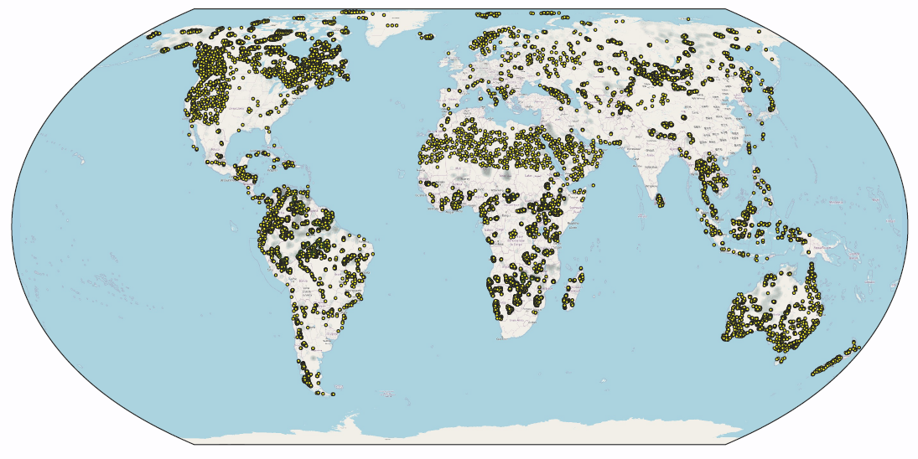
Fig S1. Spatial distribution of the photo-interpreted land cover database. The database consists of a total of 18,411 0.5-hectare plots, systematically distributed following a 20 x 20 km grid within protected areas of IUCN (category I, II, and III) and hyperarid drylands. For each plot, the percent of bare ground, short vegetation and tree cover were assessed through augmented photo-interpretation using Collect Earth as part of the global dryland assessment of FAO ³⁶ and the global tree restoration potential ⁴ (supplementary Data S1).

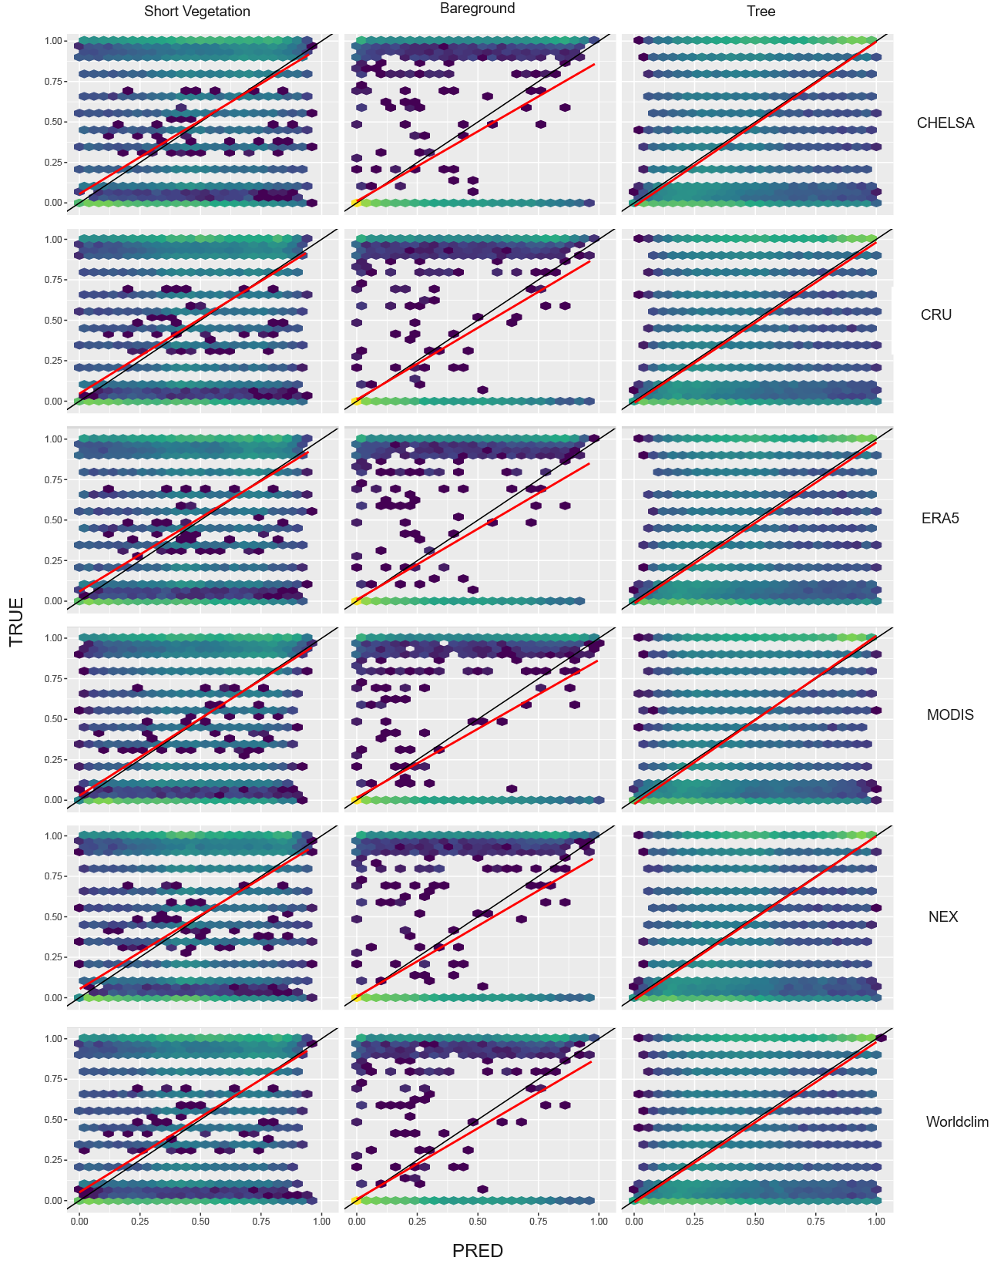
Fig S2. Observed vs. Predicted land cover. The figure illustrates an initial evaluation of the quality of the different model produced considering each land cover type (short vegetation, bare ground, and tree) and each climate reference dataset (from top to bottom: CHELSA, CRU, ERA5, MODIS, NEX and Worldclim). The figure shows that the models yielded good results.

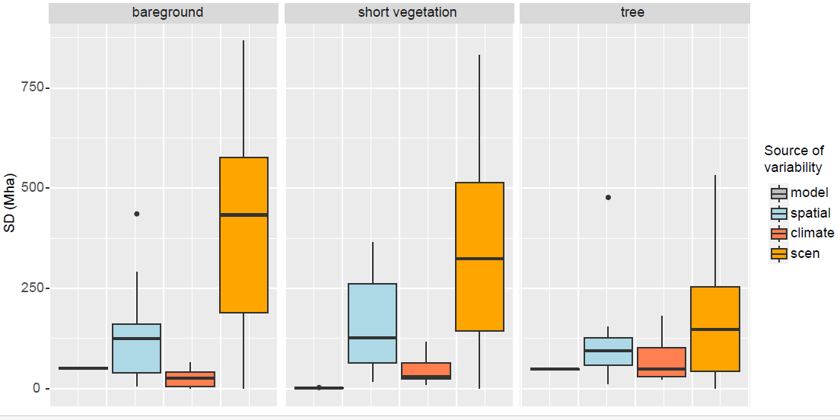
Fig S3. Sensitivity analysis. The boxplots illustrates the standard deviation of the prediction of the total area covered by each land cover (bare ground, short vegetation, and tree) and divided by considering respectively the uncertainty of the model (in grey), the uncertainty associated to the spatial structure of the calibrating dataset (in blue), the sensitivity associated to the choice of a given climate dataset (in red) and finally, the sensitivity associated to the fire and herbivory scenario (in orange). The figure shows that the variability associated to the choice of the scenario (scen) is much more important than the other sources of uncertainties. Yet, the variability associated to the spatial structure should not be neglected.

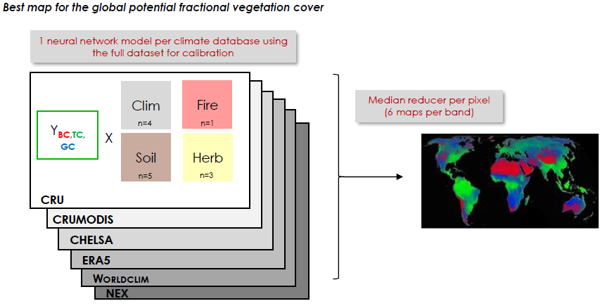
Fig S4 Flow chart used to generate the median potential fractional vegetation cover. n corresponds to the number of variables. This process was used to generate Figure 1.

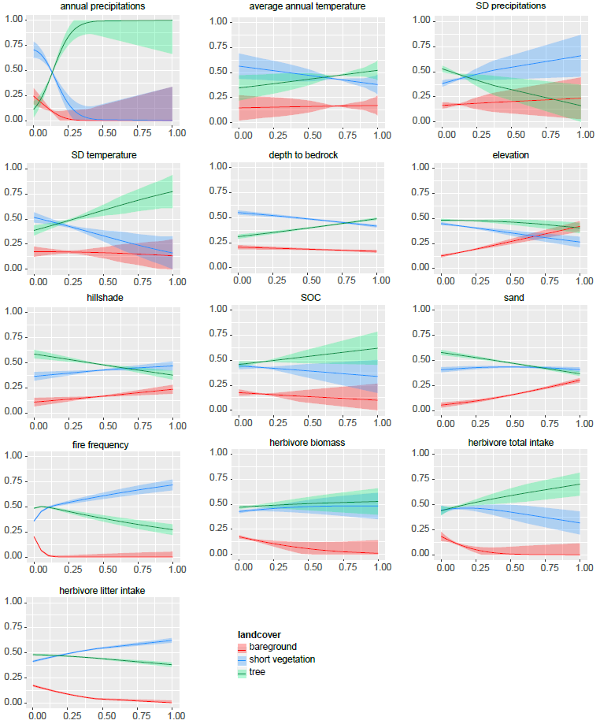
Fig S5. Model parts profiles. The figure illustrates the response of the proportion of each land cover type to the variation of each standardized variable at a global level.

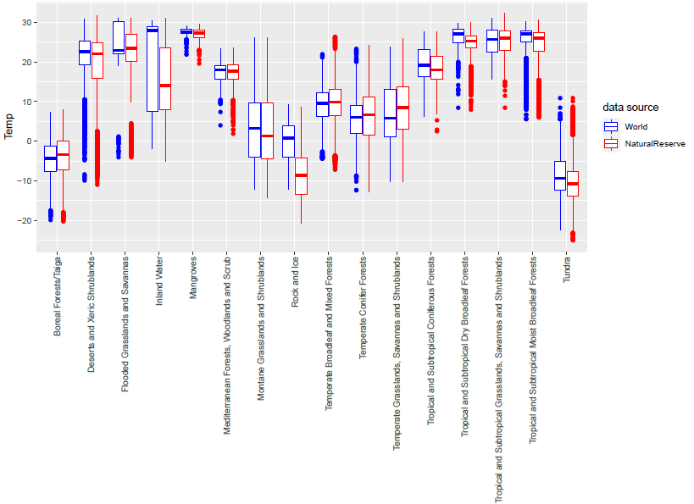
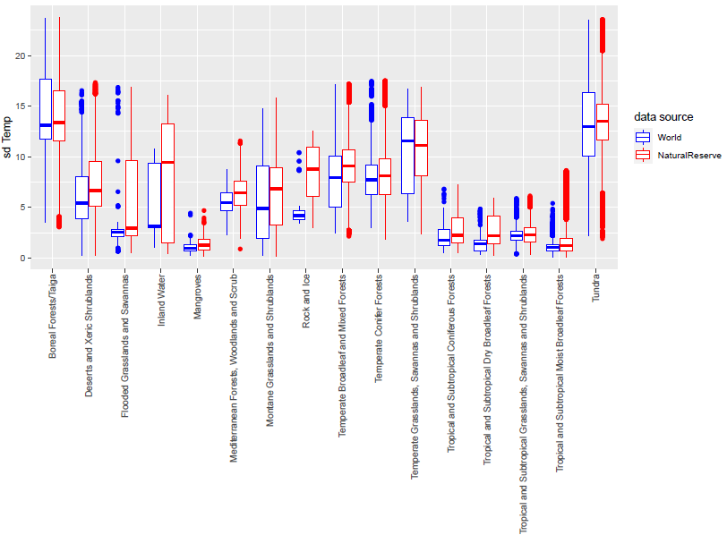Fig S6. Evaluation of climate domain. Variability of annual mean temperatures observed globally vs. protected areas for each biome. Illustration using the historical NEX climate dataset.
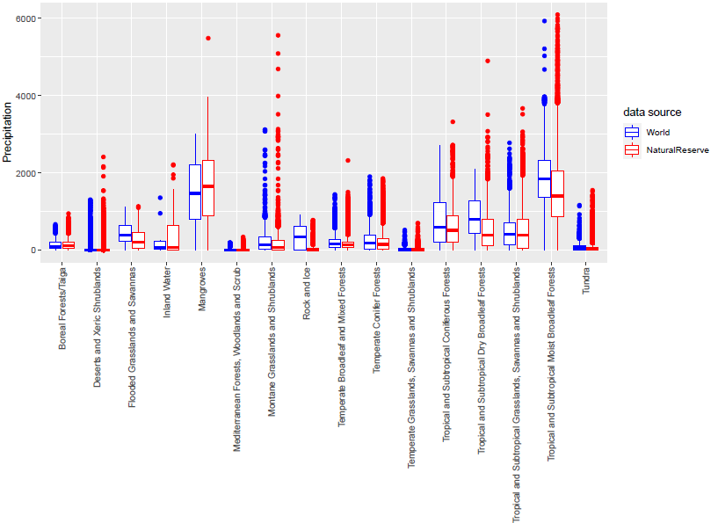
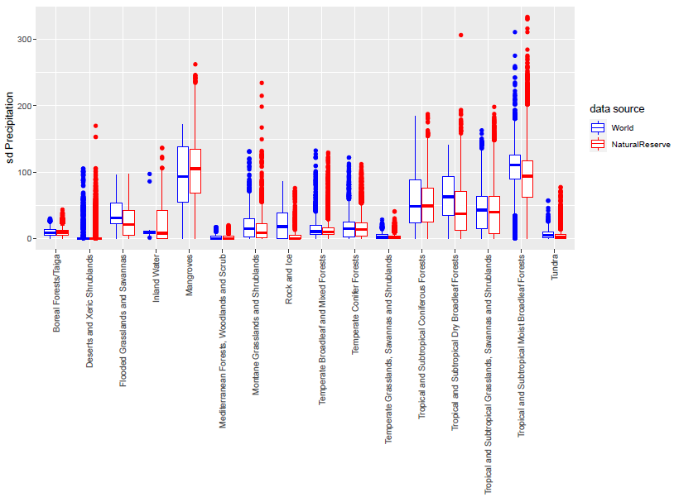
Fig S7. Evaluation of climate domain. Variablity of annual precipitations observed globally vs. protected areas for each biome. Illustration using the historical NEX climate dataset.
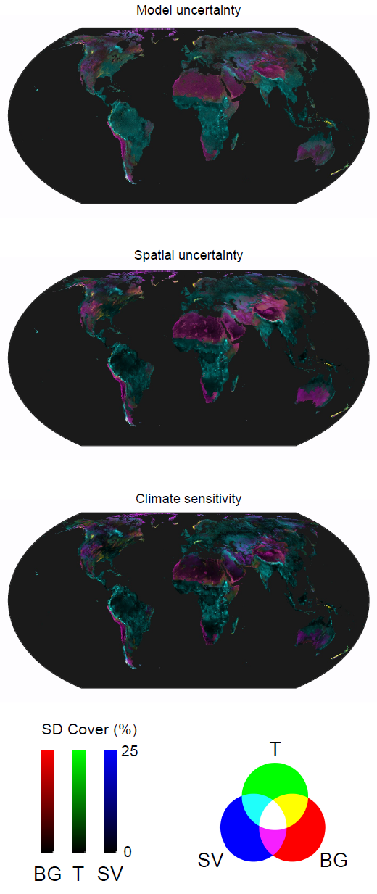
Fig S8. Uncertainty maps. The three maps illustrate respectively the standard deviation of the prediction of bare ground (red), tree (green) and short vegetation (blue) considering model uncertainty (top), the spatial structure of the calibrating dataset (middle) and the choice of the climate dataset (bottom).

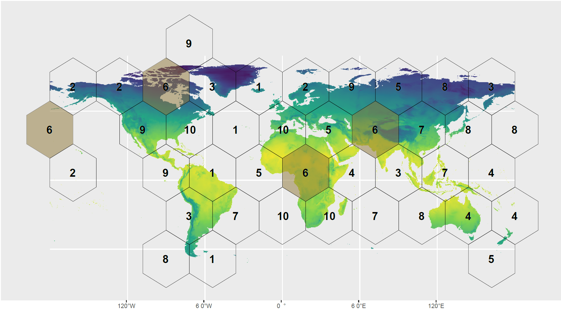
Fig S9. The distribution of the 10 folds identified by the blockCV approach for spatial and environmental cross-validation. In this example, we highlight the distribution of the block “6” to facilitate the understanding of the figure. The ‘BlockCV’ package generates spatially and environmentally separated folds based on the spatial distribution of the training points and their coverage of the environmental parameters considered in the model. The blockCV is here illustrated over a map of the historical annual mean temperature from the NEX historical climate dataset.

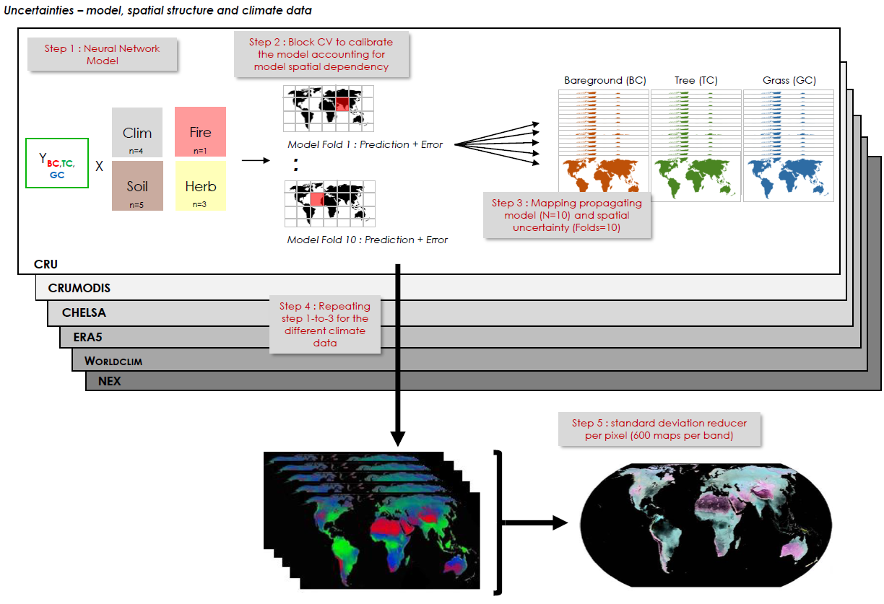
Fig S10. Flow chart to generate the map synthesizing all the sources of uncertainties and variability. n corresponds to the number of variables.

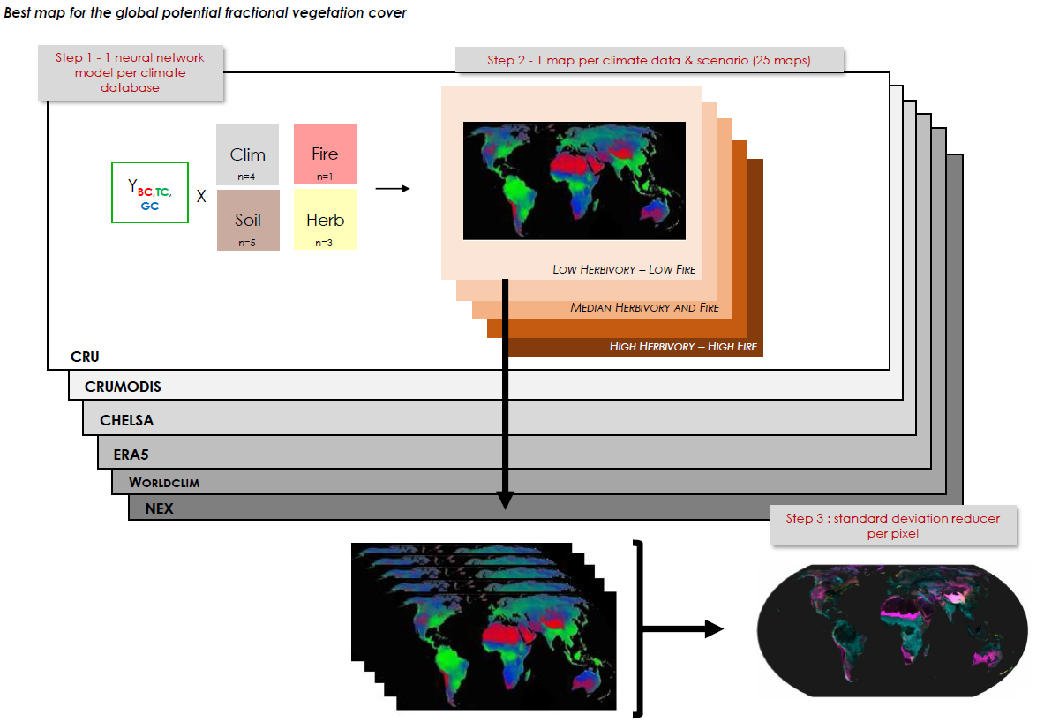Fig S11. Flow chart to generate the alternative potential ecosystems map. n corresponds to the number of variables. This process was used to generate Figure 2.

