Supplementary SymProFold

Table S1. Available experimental structure of assembled S-layers and fragments of SLPs.
Organism | Protein / Accession | PDB Code | Note | Reference

Gram-positive
Lactobacillus acidophilus | SlpA (P35829) | 7QLD, 7QFL, 7QLE, 7QFG, 8ALU, 8BT9 | Crystal structures of fragments | -
Lactobacillus acidophilus | SlpX (Q5FLN0) | 7QFI, 7QFJ, 7QFK, 8AOL | Crystal structures of fragments | -
Lactobacillus amylovorus | SlpA (E4SK47) | 7QLH, 7QEC, 7QEH, 8Q1O | Crystal structures of fragments | -
Geobacillus stearothermophilus | SbsB (Q45664) | 4AQ1 | Assembly proposed based on EM projection map | ¹
Geobacillus stearothermophilus | SbsC (O68840) | 2RAI, 4UIC, 4UID, 4UIE, 4UJ6, 4UJ7, 4UJ8, 5FTX, 5FTY | Crystal structures of fragments | ^{2–5}
Bacillus anthracis | Sap (P49051) | 3PYW, 6BT4, 6QX4, 6HHU | Crystal structures of fragments | ^{6–8}
Bacillus anthracis | EA1 | 8OPR (unreleased PDB entry) |  | ⁻
Clostridium difficile | SlpA (Q183M8) | 3CVZ, 7ACV, 7ACW, 7ACX, 7ACY, 7ACZ, 7QGQ, 8BBY | Full model, assembly seen in X-ray structures, fits to cryoET data | ^{9,10}

Gram-negative
Deinococcus radiodurans | SlpA (Q9RRB6) | 7ZGX, 7ZGY, 8AE1, 8ACQ, 8AGD |  | ^{11,12}
Deinococcus radiodurans | HPI (P56867) | 8CKA |  | ¹³
Caulobacter cresentus (Caulobacter vibrioides) | RsaA (P35828) | 5N8P, 6P5T, 6T72, 6Z7P, 7PEO, 8BQE, 5N97 | Full model, assembly seen in X-ray structures, fits to cryoET data | ^{14–17}

Archaea
Haloferax volcanii (Halobacterium volcanii) | csg (P25062) | 7PTP, 7PTR, 7PTT, 7PTU | Full model, cryoEM, cryoET | ¹⁸
Methanosarcina mazei | ORF492 (Q50245) | 1L0Q |  | ¹⁹
Methanosarcina acetivorans | Major S-layer protein (Q8TSG7) | 3U2H, 3U2G | Full model, Assembly seen in X-ray structures | ²⁰
Sulfolobus acidocaldarius | SlaA (Q4J6E5) | 8AN2, 8AN3, 7ZCX | Full model, cryoEM, cryoET | ²¹
Sulfolobus acidocaldarius | SlaA/SlaB | 8QOX (unreleased PDB entry) |  | ⁻

Domain Identification using Domain_Separator
We tested Domain_Separator on 500 randomly selected structures between 800 and 2000 amino acids from the AlphaFold Protein Structure Database ²² . In Figure S1, the protein A0A0C5WNU2 is shown as an example. The Domain_Separator reliably identifies in several iterations the different domains and colors them accordingly (Figure S1B). Then, the linker regions between the domains, colored red, are cut after the blue amino acid (circled in Figure S1B), and the sequences of the individual domains are written in a fasta file output in separated lines (Figure S1C). This file can be used as the direct input for SymProFold. In our test cases, Domain_Separator achieved comparable results, with slight differences in linker length, as we would have split the domains manually. The fasta file output from Domain_Separator can still be manually modified before starting SymProFold.
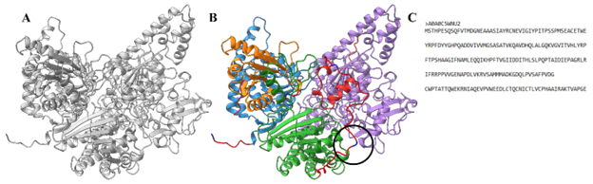
Figure S1: Output of Domain_Separator. Domain_Separator uses a predicted structure A) and creates a ChimeraX session with the found domains colored separately B). Linker regions are colored red, and amino acid, where the sequence gets cut, is colored blue (circled in B). C) shows the output of Domain_Ssparator, a fasta file with the sequence separated by line breaks. Each line equals one domain.
Subchain Sets
A set of subchains is defined, each subchain covering a different range of domains of the protein (Table S1). All subchains start and end at previously defined domain boundaries. The standard subchain set includes 5 subchains, including the full length (FL) sequence, a subchain without the N-terminus, a subchain without the C-terminus, the first third of the domains, and the last third of the domains. To mitigate the effects of very large or small domains, minimum lengths were defined. The extended subchain set additionally contains a subchain with the middle third of domains.
Table S2: Predefined sets of subchains covering different parts of the full-length protein. x is the number of amino acids that cover a full domain as defined in the fasta input.
Subchain name | Subchain definition | Example with  6 domains | Example with  3 domains | Predefined  subchain  set
full-length | Full-length (FL) sequence | [i]-[ii]-[iii]-[iv]-[v]-[vi] | [i]-[ii]-[iii] | standard
w/o  N-terminus | Removal of 10 % + x (sequence length) from the N-terminus. | [ii]-[iii]-[iv]-[v]-[vi] | [ii]-[iii] | standard
w/o C-terminus | Removal of 10 % + x (sequence length) from the C-terminus. | [i]-[ii]-[iii]-[iv]-[v] | [i]-[ii] | standard
first  1/3 | First third of domains.  At least 20 % + x (sequence length)  from the N-terminus. | [i]-[ii] | [i] | standard
last  1/3 | Last third of domains.  At least 20 % + x (sequence length)  from the C-terminus. | [v]-[vi] | [iii] | standard
middle  1/3 | Middle third of domains.  Full length less “first 1/3” and  “last 1/3”. | [iii]-[iv] | [ii] | extended

Clustering via Interfaces
Calculation of Interface Matrix
For all individual symmetry complexes, an interface matrix D is created. The matrix elements d_{ij} represent the distances between the interface residues i, j of two adjacent monomers of the symmetry complex.
The interface residues are determined using the command interface in the ChimeraX ¹ function library. The indices of each matrix element d_{ij} correspond to the residue indices i, j of both monomers. Values of the matrix elements d_{ij} are the intermolecular C_{α} atom distances in Angstrom. Matrix elements between non-interface residues or distances larger than a cutoff value of 10 Å are set to zero, as well as matrix elements denoted by at least one empty residue or at least one residue of a N- or C-terminus.

Calculation of Correlation Coefficient
Interface matrices as defined in this study are generally asymmetric but can be symmetric in special cases. The order of the axes in both interface matrices D^{k} and D^{l} can be different reflecting the exchangeable order of the underlying interface monomers. Therefore, correlations between two interface matrices D^{k} and D^{l} must be determined for both possible pairwise transposition states $\left(D^{k},D^{l}\right)$ and $\left(D^{k},D^{l^{\text{T}}}\right)$. For the same transposition state of both matrices D^{k} and D^{l}, the correlation $\text{corr}\left(D^{k},D^{l}\right)$ is calculated as the sum of all ratios of twice non-zero matrix elements d^{k}_{ij} and d^{l}_{ij} with a scaling factor. The indices k, l label different symmetry complexes (nodes), the indices i, j are the residue indices within the respective monomers.
$$\text{corr}\left(D^{k},D^{l}\right)=\frac{1}{n}\sum_{d_{ij }^{k}≠0 ∧ d_{ij }^{l}≠0}^{ }{\frac{\min\left(d_{ij }^{k},d_{ij }^{l}\right)}{\max\left(d_{ij }^{k},d_{ij }^{l}\right)}}$$
n: number of matrix elements that are non-zero in D^{k} and D^{l}
$$n=\sum_{d_{ij }^{k}≠0 ∧ d_{ij }^{l}≠0}^{ }{1}$$
The correlation for the opposite transposition state $\text{corr}\left(D^{k},D^{l^{\text{T}}}\right)$ is calculated accordingly with transposed residue indices of d^{l}_{ji}.
The resulting correlation c_{kl} is determined as the maximum correlation of both transposition states.
$$c_{kl}=\max\left[\text{corr}\left(D^{k},D^{l}\right),\text{corr}\left(D^{k},D^{l^{\text{T}}}\right)\right]$$

Parameter for Partitioning using the Louvain Method
Louvain partitioning ²³ is performed using the implementation in the python-louvain library. The edge weights A_{kl} are set proportional to the correlation coefficients c_{kl} using a proportionality constant of α=1.
$$A_{kl}=αc_{kl}$$

Symmetry Complex Clustering
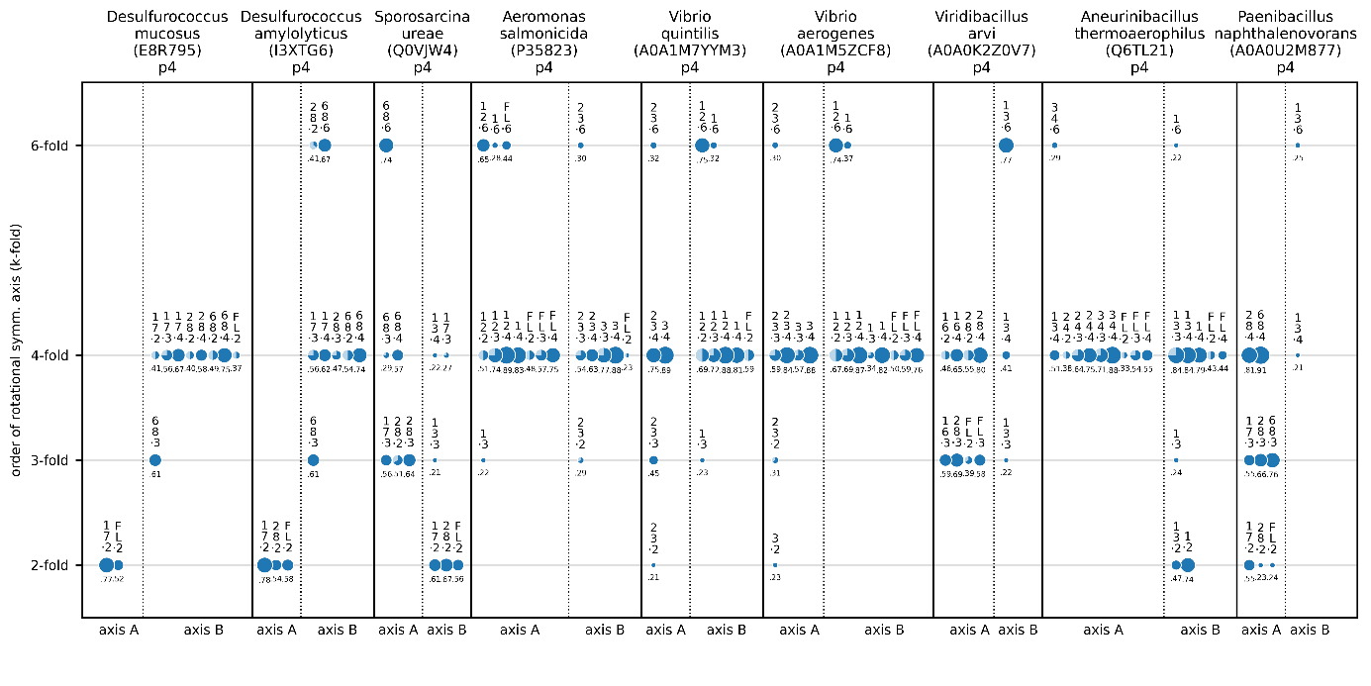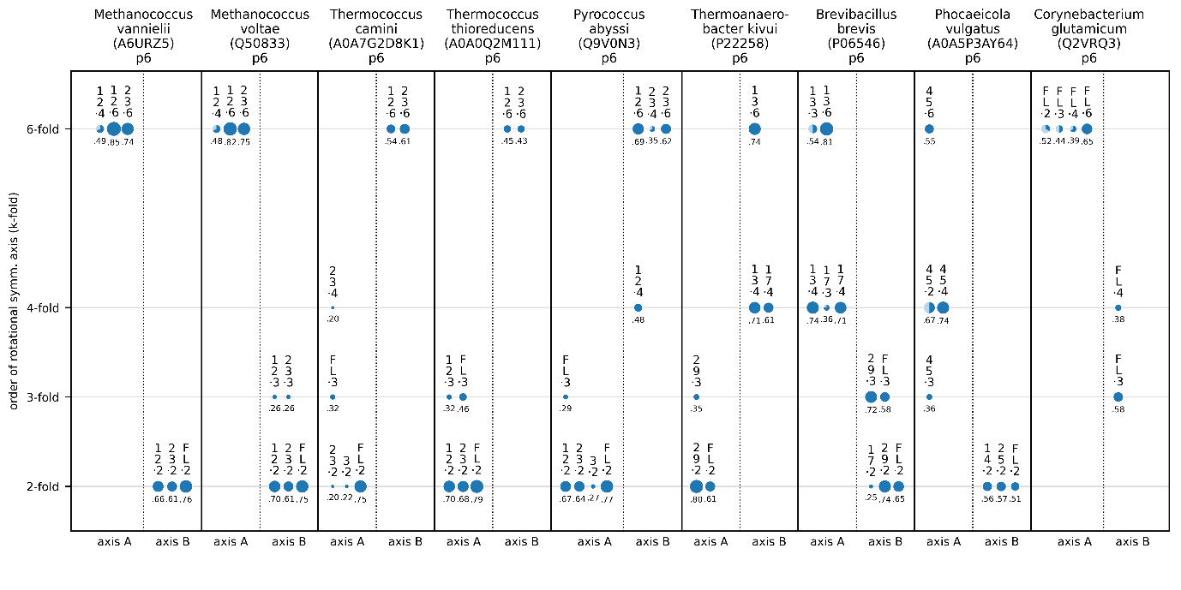Figure S2. Clustering of predicted symmetry complexes for different S-layer species. Comparison of symmetry axis orders (fold) determined by ab initio prediction. The circle diameters represent the respective ranking score. In this Figure, for each species two clusters with non-coinciding symmetry axes and the highest ipTM+pTM scores are shown. For each subchain, the symmetry complex with the highest ipTM+pTM score is shown.

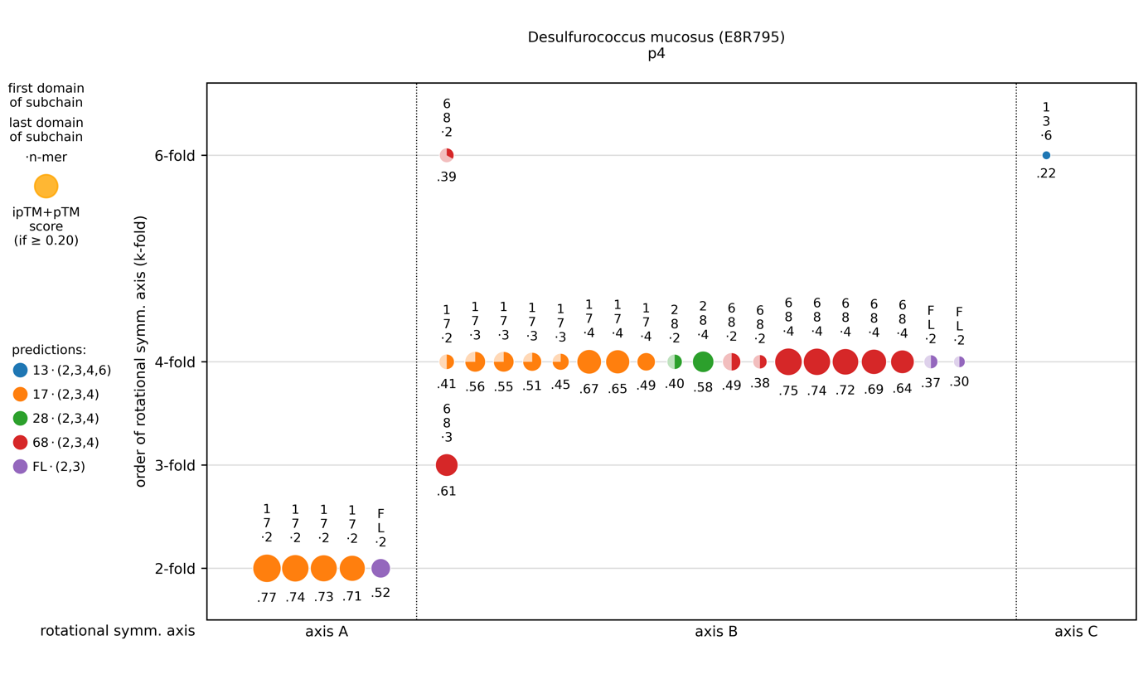Figure S3. Clustering of predicted symmetry complexes for Desulfurococcus mucosus S-layer (E8R795). The circle diameters represent the respective ranking scores, each color represents a subchain. For axis A cluster, prediction scores clearly indicate a 2-fold symmetry, for axis B a 4-fold symmetry axis. The 4-fold symmetry for cluster B is also supported insofar as the same subchain leads to the same order of symmetry (k-fold) for different molecule counts (n-mer) in the prediction.
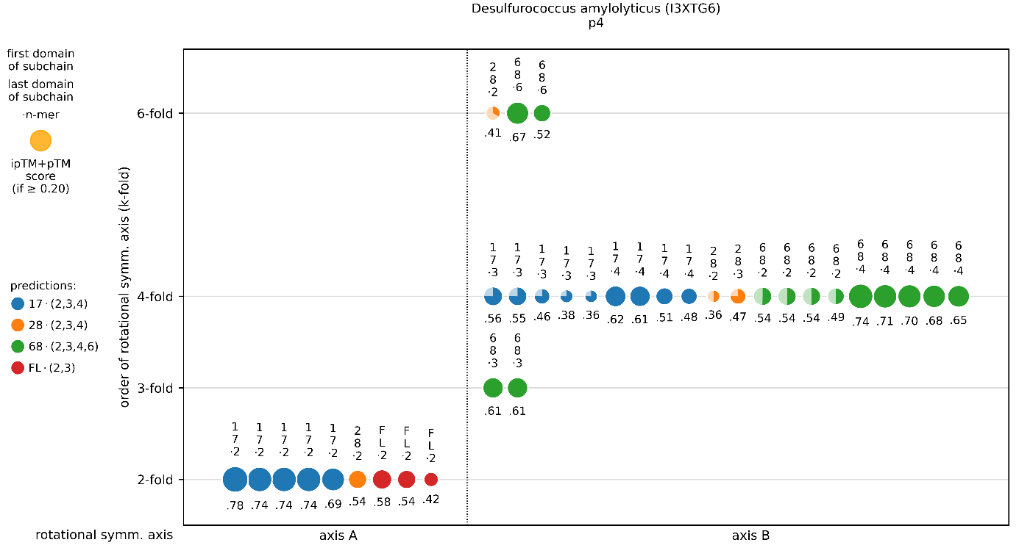Figure S4. Clustering of predicted symmetry complexes for Desulfurococcus amylolyticus S-layer (I3XTG6). The circle diameters represent the respective ipTM+pTM scores, each color represents a subchain. For axis A cluster, prediction scores clearly indicate a 2-fold symmetry, for axis B a 4-fold symmetry axis. The 4-fold symmetry for cluster B is also supported insofar as the same subchain leads to the same order of symmetry (k-fold) for different molecule counts (n-mer) in the prediction.
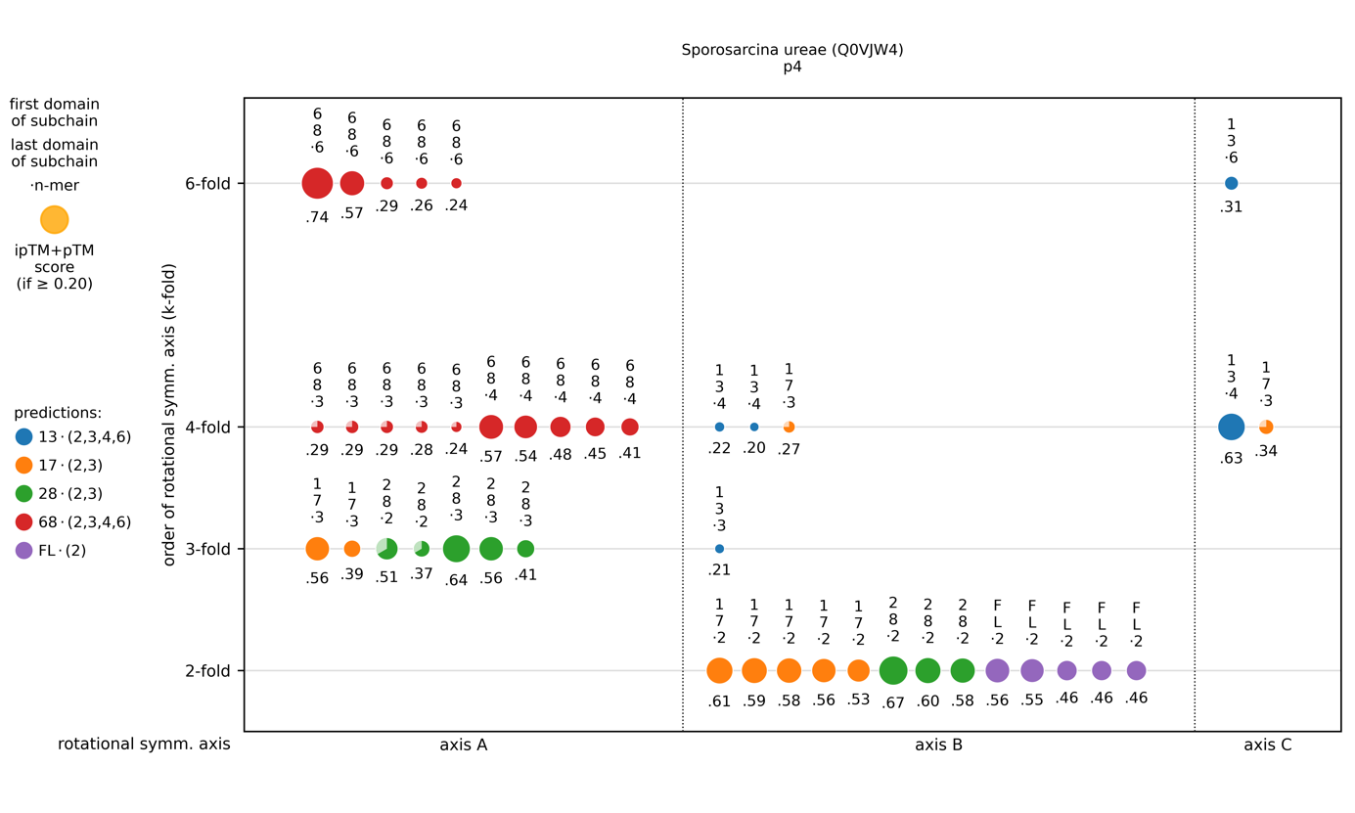Figure S5. Clustering of predicted symmetry complexes for Sporosarcina ureae S-layer (Q0VJW4). The circle diameters represent the respective ipTM+pTM scores, each color represents a subchain. For axis B cluster, prediction scores indicate a 2-fold symmetry. For axis A cluster, prediction scores indicate a 6-fold symmetry axis as first, then a 3-fold and a 4-fold symmetry. A 4-fold symmetry for cluster A is supported insofar as the same subchain leads to the same order of symmetry (4-fold) for different molecule counts (3-mer, 4-mer) in the prediction. A 6-fold symmetry for cluster A is not supported by different molecule counts in the prediction. Layer assembly without large number of clashes is possible with a 4-fold symmetry for cluster A, not for 6-fold symmetry.
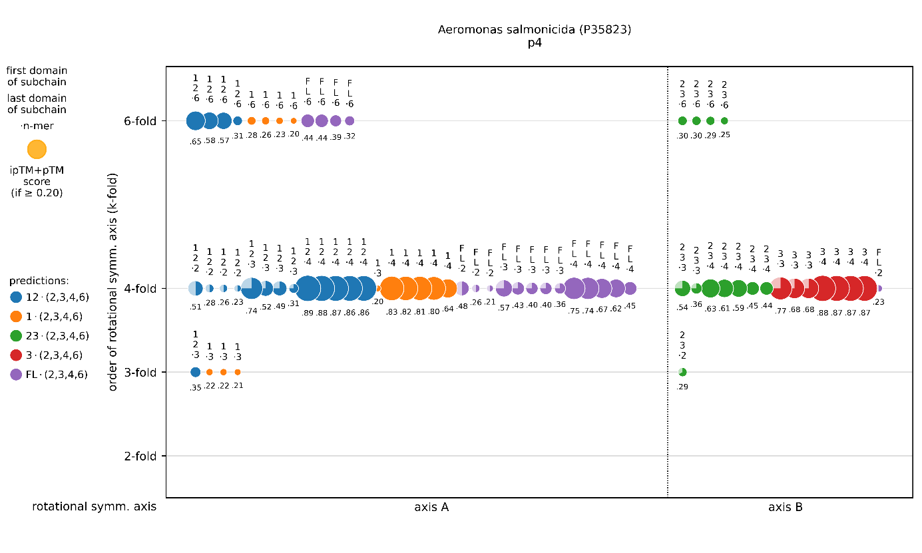Figure S6. Clustering of predicted symmetry complexes for Aeromonas salmonicida S-layer (P35823). The circle diameters represent the respective ipTM+pTM scores, each color represents a subchain. For axis A cluster and axis B cluster, prediction scores clearly indicate a 4-fold symmetry axis each. Both 4-fold symmetries are also supported insofar as the same subchains lead to the same order of symmetry (4-fold) for different molecule counts (n-mer) in the prediction.
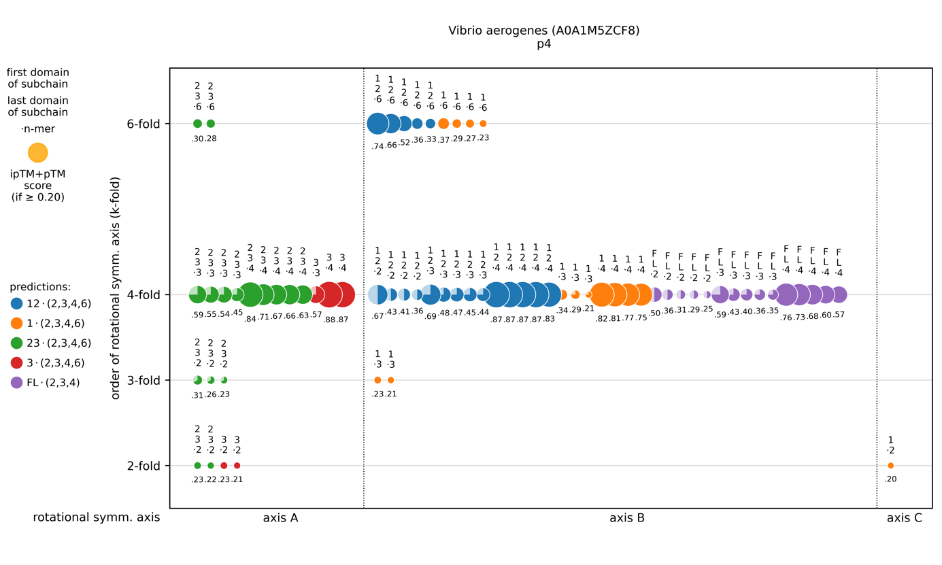Figure S7. Clustering of predicted symmetry complexes for Vibrio aerogenes S-layer (A0A1M5ZCF8). The circle diameters represent the respective ipTM+pTM scores, each color represents a subchain. For axis A cluster and axis B cluster, prediction scores clearly indicate a 4-fold symmetry axis each. Both 4-fold symmetries are also supported insofar as the same subchains lead to the same order of symmetry (4-fold) for different molecule counts (n-mer) in the prediction.
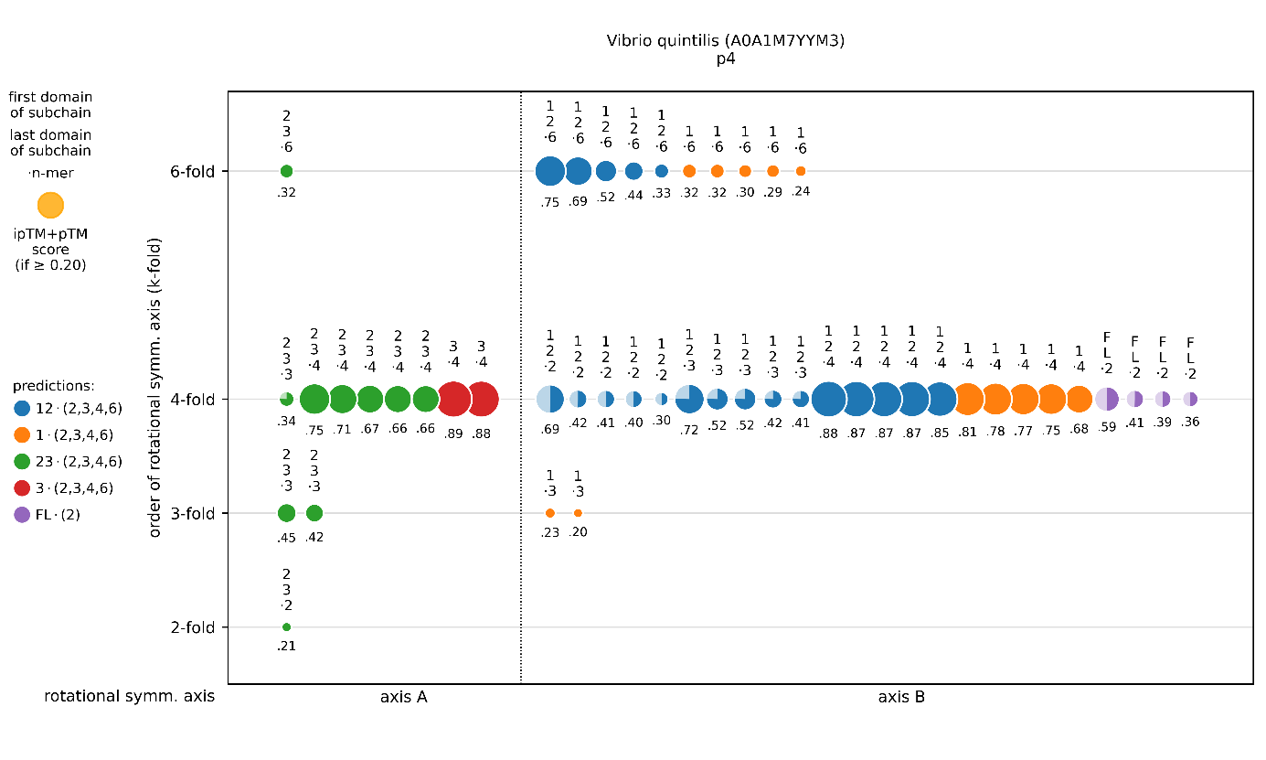Figure S8. Clustering of predicted symmetry complexes for Vibrio quintilis (A0A1M7YYM3). The circle diameters represent the respective ranking scores, each color represents a subchain. For axis A cluster and axis B clusters, prediction scores clearly indicate a 4-fold symmetry axis each. Both 4-fold symmetries are also supported insofar as the same subchains lead to the same order of symmetry (4-fold) for different molecule counts (n-mer) in the prediction.
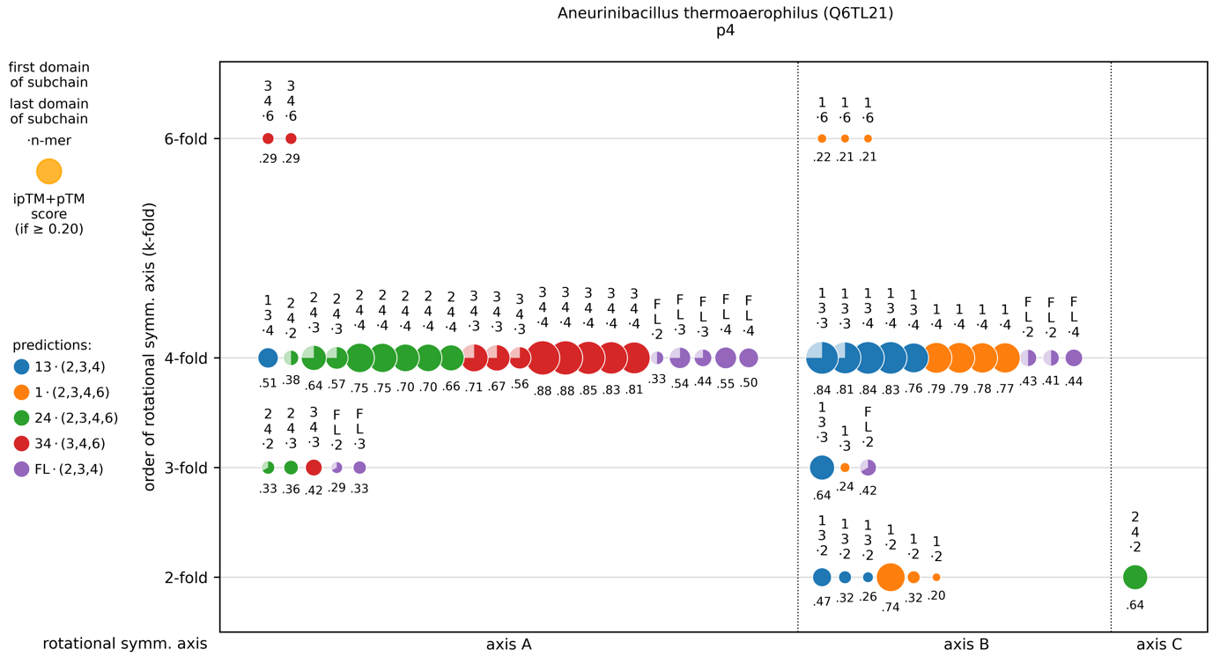Figure S9. Clustering of predicted symmetry complexes for Aneurinibacillus thermoaerophilus S-layer (Q6TL21). The circle diameters represent the respective ipTM+pTM scores, each color represents a subchain. Axis A cluster and axis B cluster show the highest prediction scores, clearly indicating a 4-fold axis each. Both 4-fold symmetries are also supported insofar as the same subchains lead to the same order of symmetry (4-fold) for different molecule counts (n-mer) in the prediction.
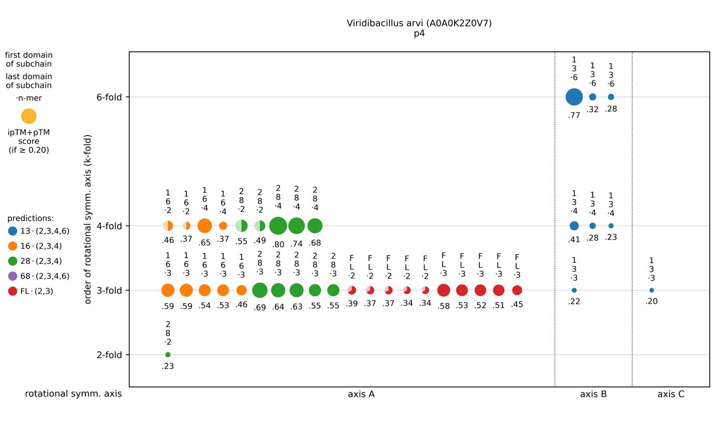Figure S10. Clustering of predicted symmetry complexes for Viridibacillus arvi S-layer (slp1, A0A0K2Z0V7). The circle diameters represent the respective ipTM+pTM scores, each color represents a subchain. For axis A cluster, prediction scores indicate a 4-fold symmetry axis as first and a 3-fold symmetry as second. For axis B cluster, prediction scores indicate a 6-fold symmetry as first and a 4-fold symmetry as second.
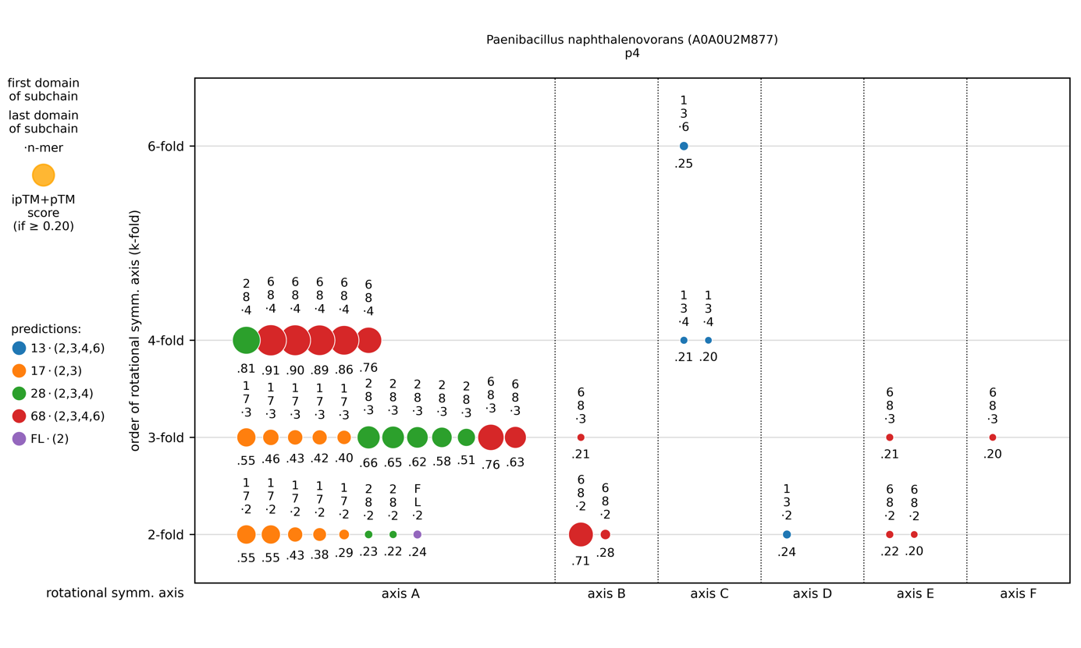Figure S11. Clustering of predicted symmetry complexes for Paenibacillus naphthalenovorans S-layer (A0A0U2M877). The circle diameters represent the respective ipTM+pTM scores, each color represents a subchain. Axes A and B coincide, prediction scores indicate a 4-fold symmetry axis. Layer assembly is possible with a 4-fold symmetry for cluster C.
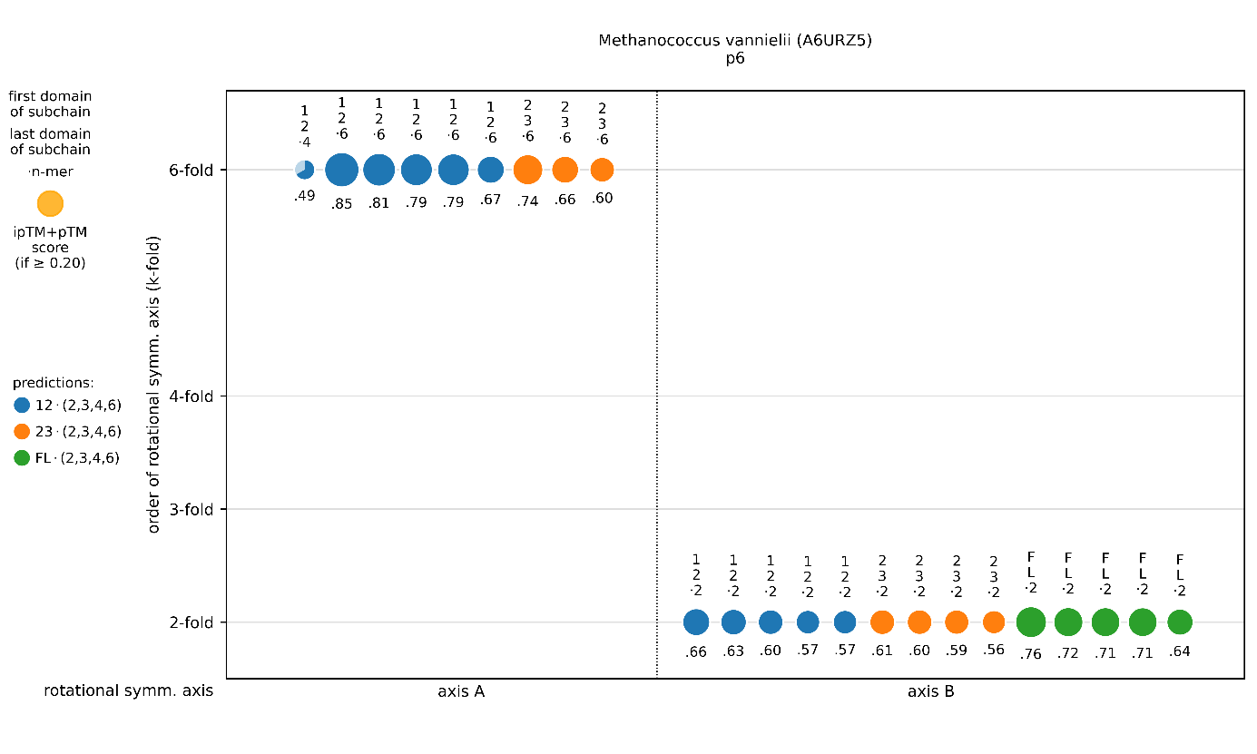Figure S12. Clustering of predicted symmetry complexes for Methanococcus vannielii S-layer (A6URZ5). The circle diameters represent the respective ipTM+pTM scores, each color represents a subchain. For axis A cluster, prediction scores clearly indicate a 6-fold symmetry, for axis B clearly a 2-fold symmetry axis. The 6-fold symmetry for cluster A is also supported insofar as the same subchain leads to the same order of symmetry (6-fold) for different molecule counts (4-mer, 6-mer) in the prediction.
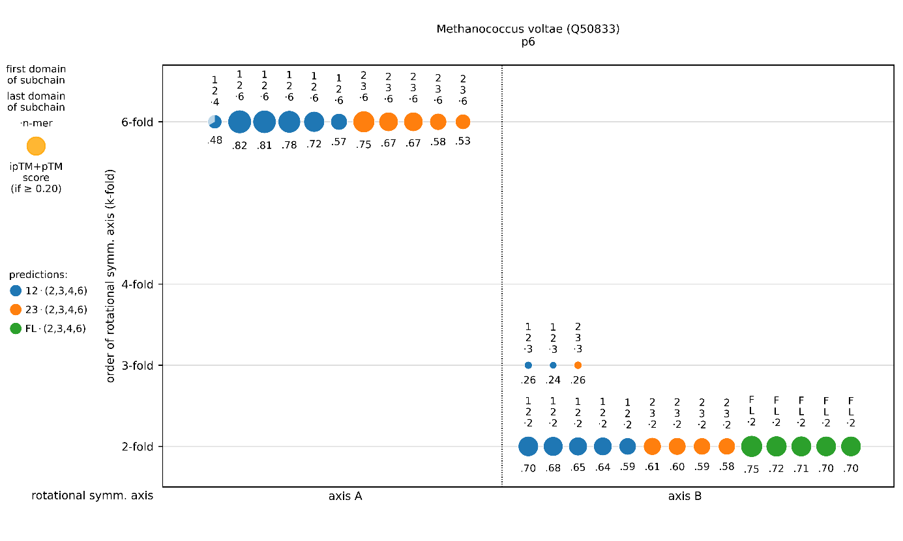Figure S13. Clustering of predicted symmetry complexes for Methanococcus voltae S-layer (Q50833). The circle diameters represent the respective ipTM+pTM scores, each color represents a subchain. For axis A cluster, prediction scores clearly indicate a 6-fold symmetry, for axis B clearly a 2-fold symmetry axis. The 6-fold symmetry for cluster A is also supported insofar as the same subchain leads to the same order of symmetry (6-fold) for different molecule counts (4-mer, 6-mer) in the prediction.
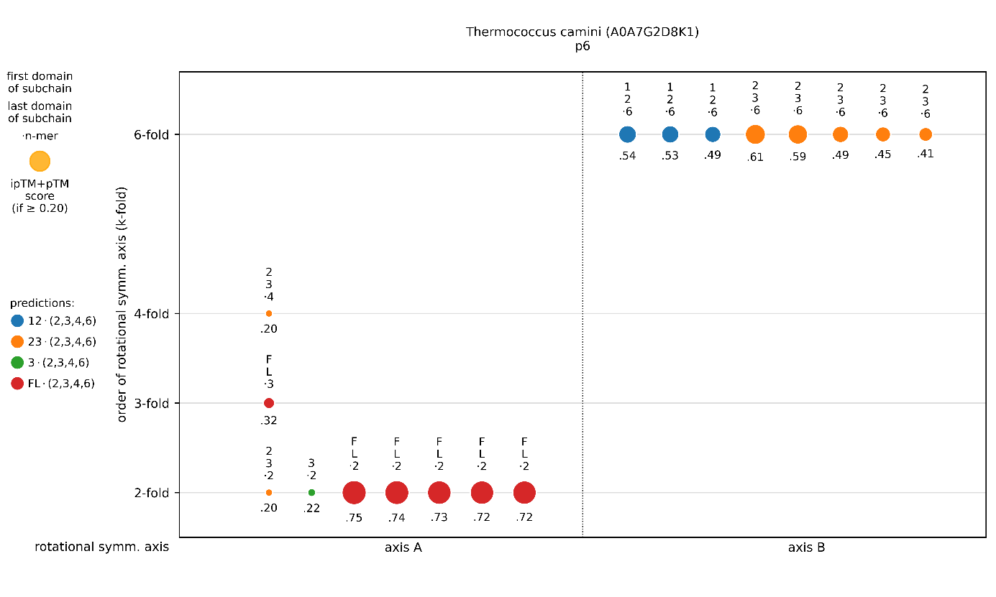Figure S14. Clustering of predicted symmetry complexes for Thermococcus camini S-layer (A0A7G2D8K1). The circle diameters represent the respective ipTM+pTM scores, each color represents a subchain. For axis A cluster, prediction scores clearly indicate a 2-fold symmetry, for axis B clearly a 6-fold symmetry axis.
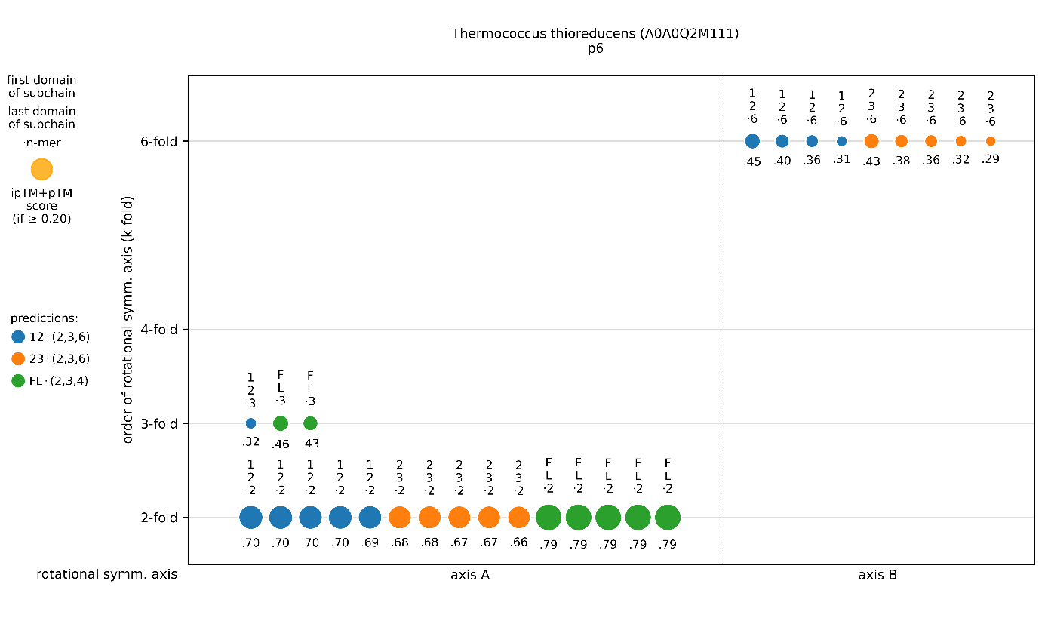Figure S15. Clustering of predicted symmetry complexes for Thermococcus thioreducens S-layer (A0A0Q2M111). The circle diameters represent the respective ipTM+pTM scores, each color represents a subchain. For axis A cluster, prediction scores indicate a 2-fold symmetry axis. For axis B cluster, prediction scores clearly indicate a 6-fold symmetry.
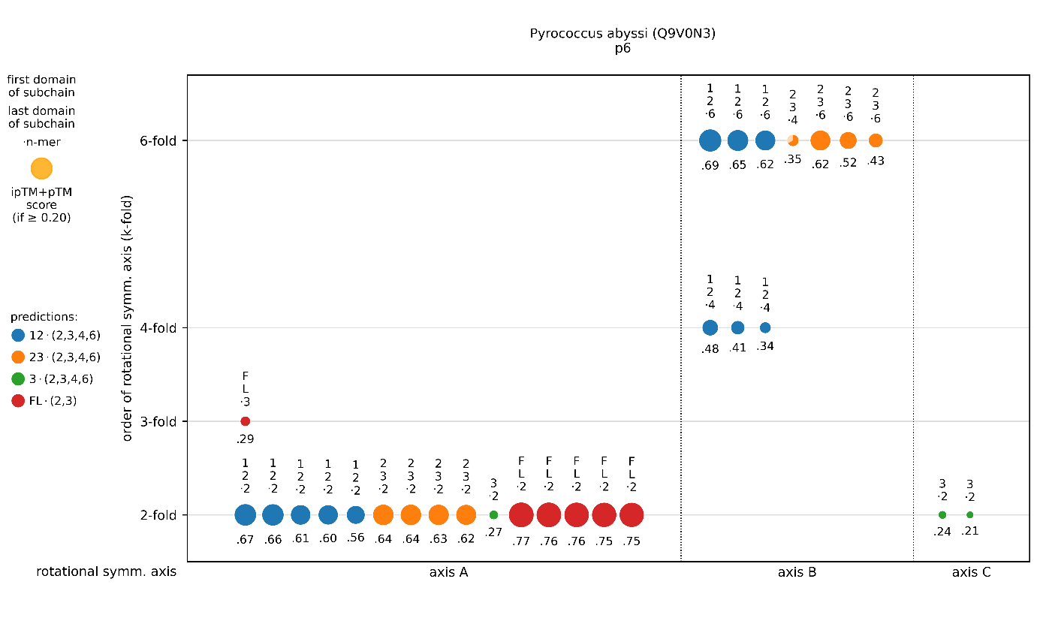Figure S16. Clustering of predicted symmetry complexes for Pyrococcus abyssi S-layer (Q9V0N3). The circle diameters represent the respective ipTM+pTM scores, each color represents a subchain. For axis A cluster, prediction scores clearly indicate a 2-fold symmetry. For axis B cluster, prediction scores clearly indicate a 6-fold symmetry.
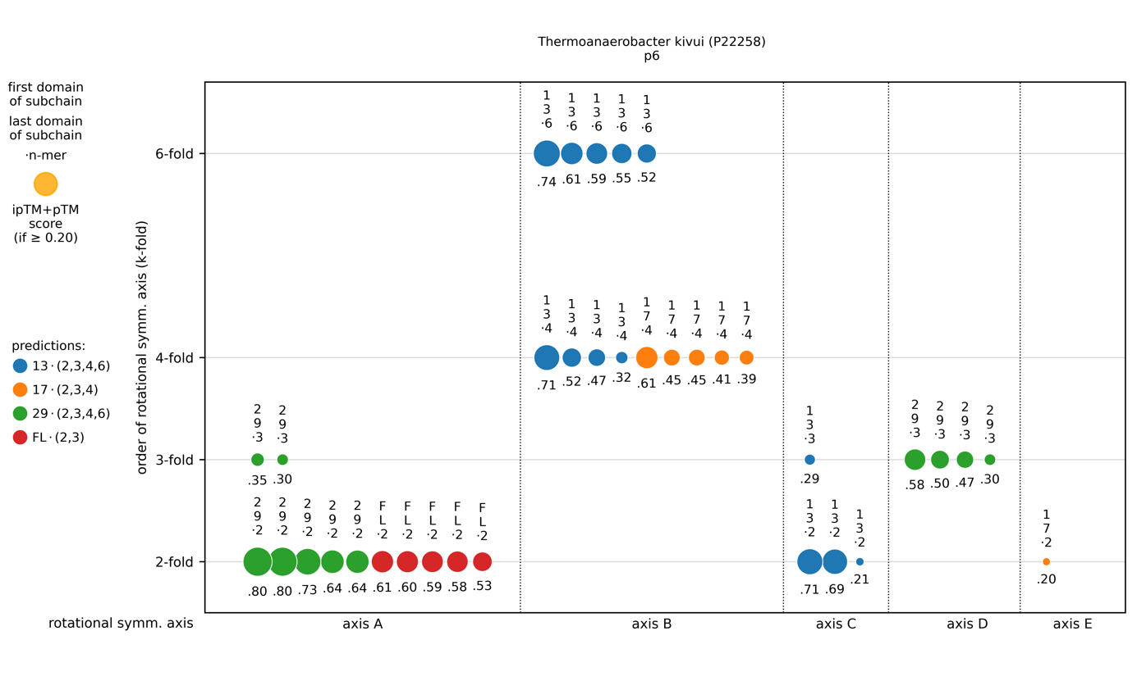Figure S17. Clustering of predicted symmetry complexes for Thermoanaerobacter kivui S-layer (P22258). The circle diameters represent the respective ipTM+pTM scores, each color represents a subchain. For axis A cluster, prediction scores clearly indicate a 2-fold symmetry axis. Axes B and C coincide, prediction scores indicate a 6-fold symmetry.

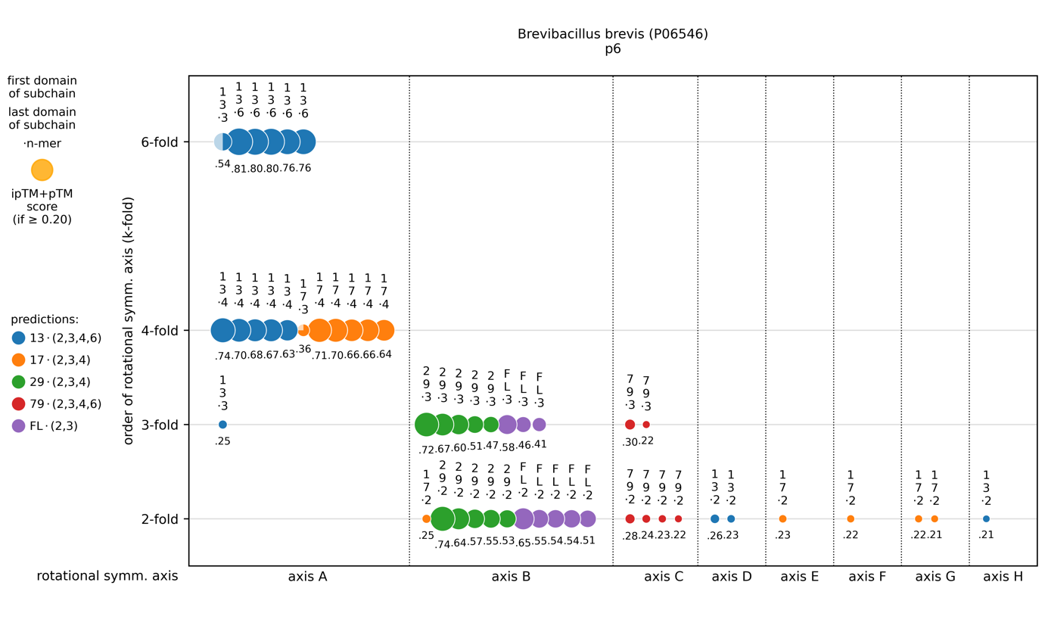Figure S18. Clustering of predicted symmetry complexes for Brevibacillus brevis S-layer (P06546). The circle diameters represent the respective ipTM+pTM scores, each color represents a subchain. For axis A cluster, prediction scores indicate a 6-fold symmetry. For axis B cluster, prediction scores indicate a 2-fold symmetry.
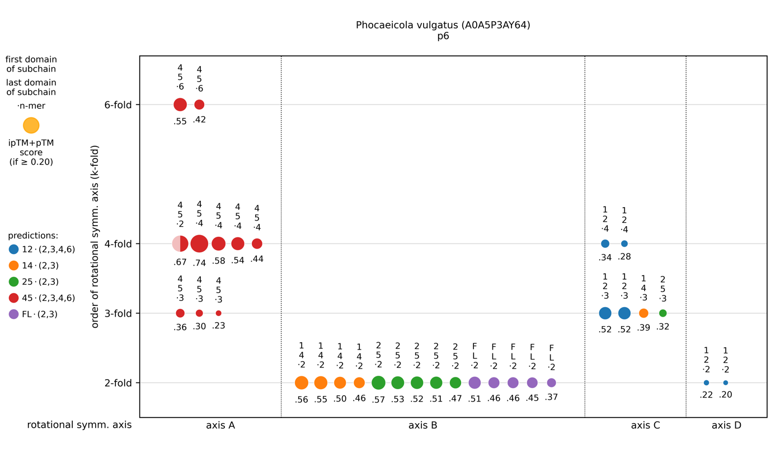Figure S19. Clustering of predicted symmetry complexes for Phocaeicola vulgatus S-layer (A0A5P3AY64). The circle diameters represent the respective ipTM+pTM scores, each color represents a subchain. For axis B cluster, prediction scores indicate a 2-fold symmetry. For axis A cluster, prediction scores indicate a 4-fold symmetry axis as first and a 6-fold symmetry as second. For axis C cluster, prediction scores indicate a 3-fold symmetry. Layer assembly is possible with a 6-fold symmetry for cluster A. Cluster B contains the 2-fold axis of rotational symmetry, cluster C the 3-fold axis of rotational symmetry in the resulting p6 lattice.
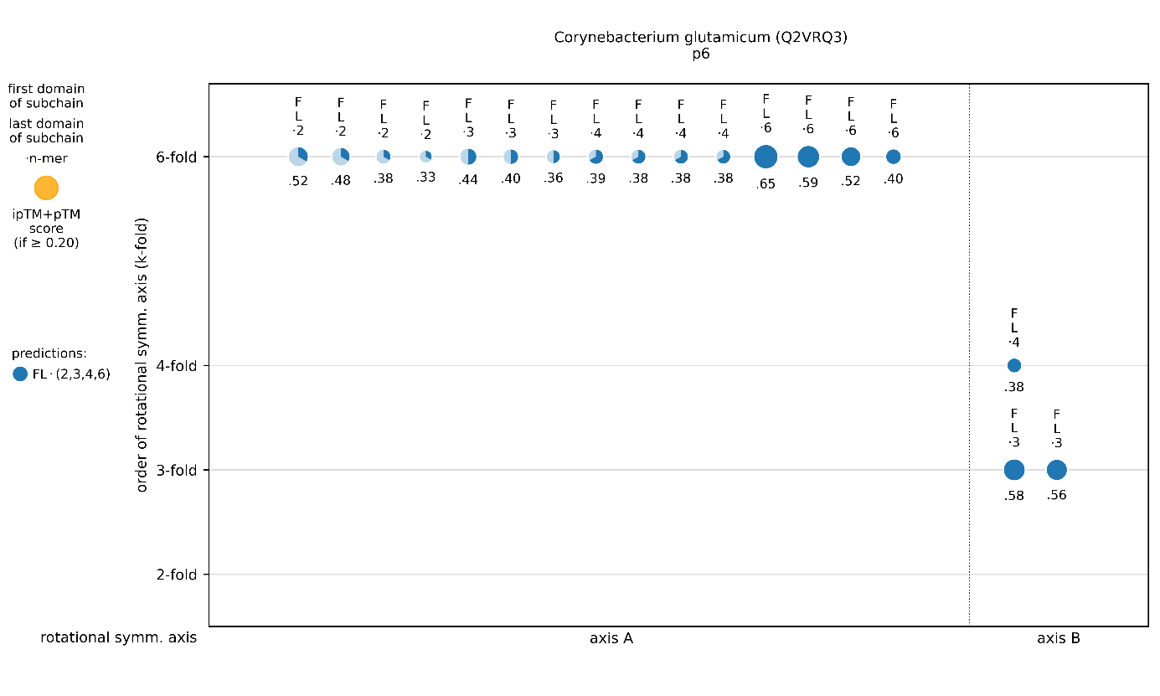Figure S20. Clustering of predicted symmetry complexes for Corynebacterium glutamicum S-layer (Q2VRQ3). The circle diameters represent the respective ipTM+pTM scores, each color represents a subchain. For axis A, prediction scores indicate a 6-fold symmetry axis. The 6-fold symmetry for cluster A is also supported insofar as the same subchain leads to the same order of symmetry (6-fold) for different molecule counts (2-mer, 3-mer, 4-mer, 6-mer) in the prediction. For axis B, prediction scores indicate a 3-fold symmetry axis.

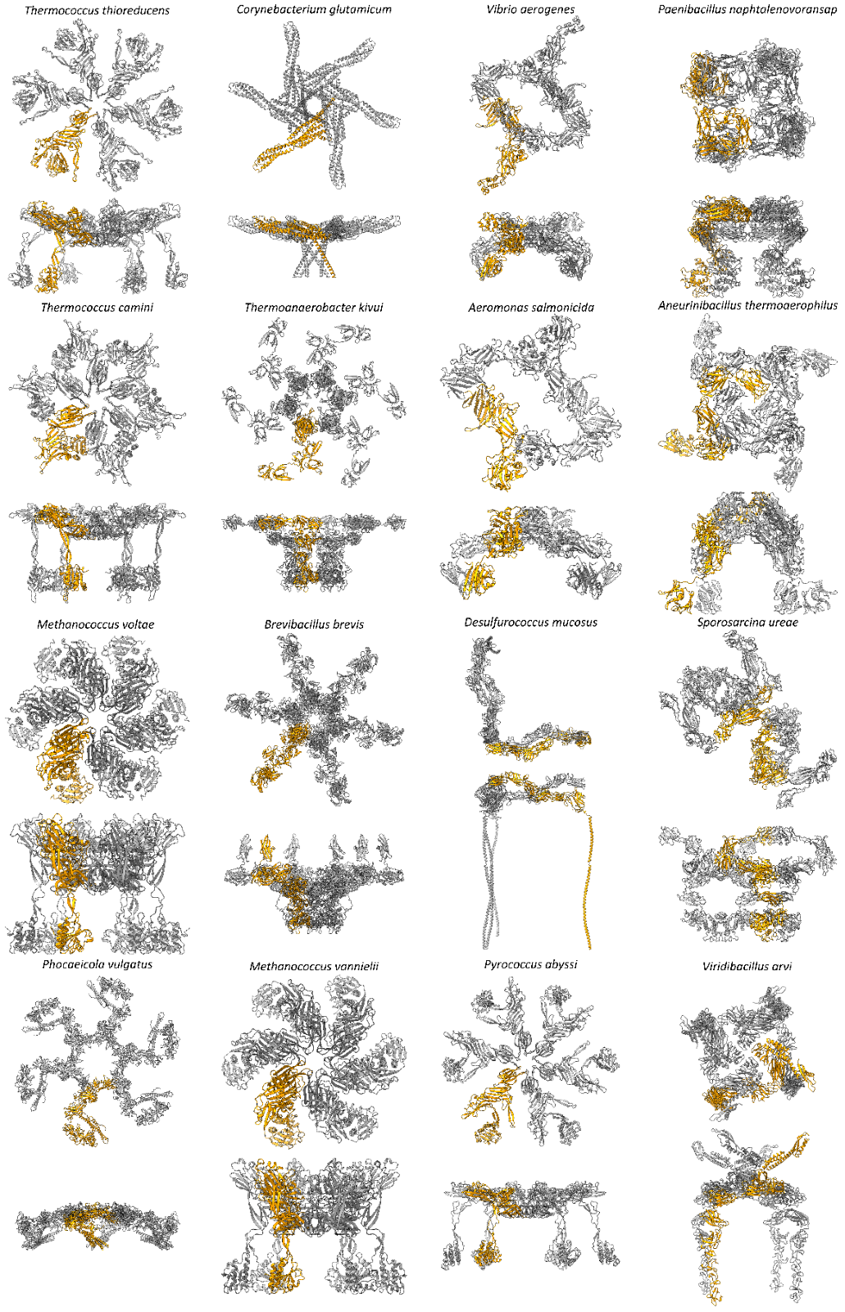
Figure S21: Primitive unit cells of the putative models as calculated by SymProFold. The models are shown as primitive unit cells of the calculated S-layer. One subunit is colored in orange. Shown in the top view and side view.

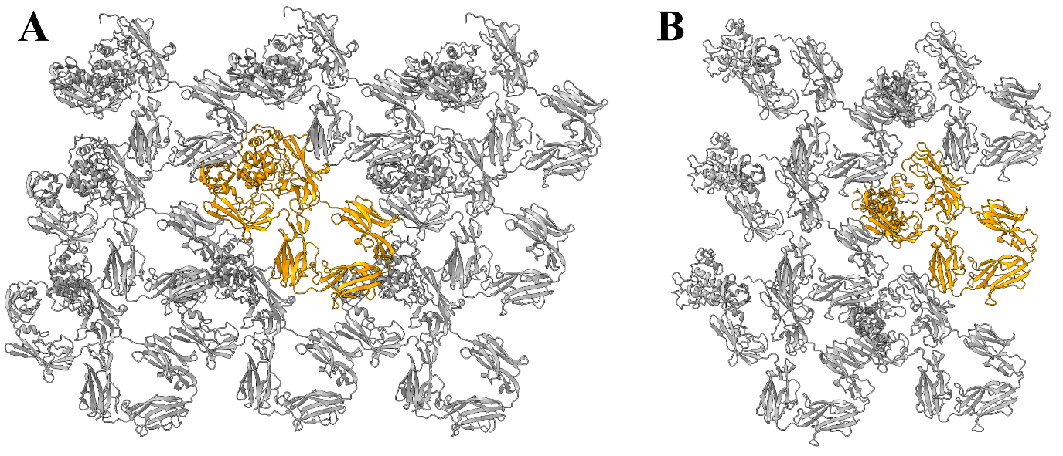
Figure S22: Top view of manually built or partial model provided by SymProFold. A) EA1 from Bacillus anthracis. B) SLP from Bacillus licheniformis.
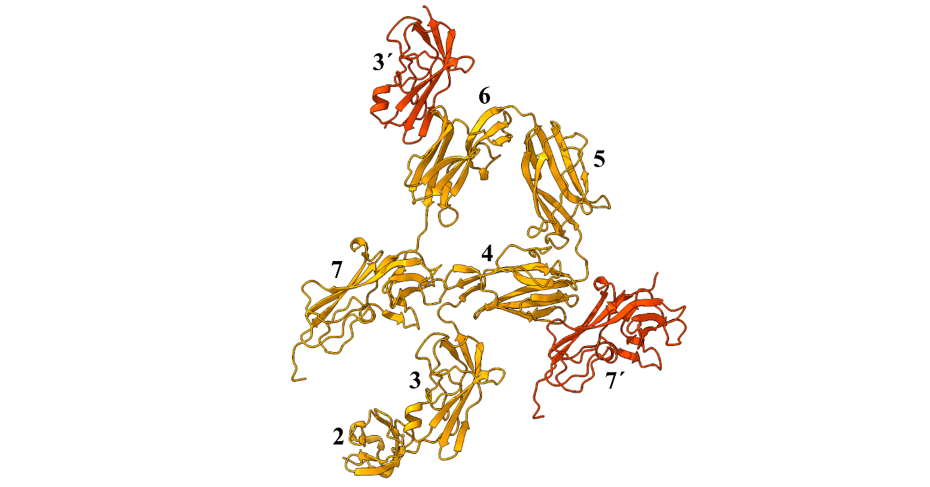
Figure S23: Domains of EA1 of Bacillus anthracis. The strongest interactions were found between domain 4 – 7´ and 6 – 3´. Domain 1 responsible for cell wall binding is not shown.
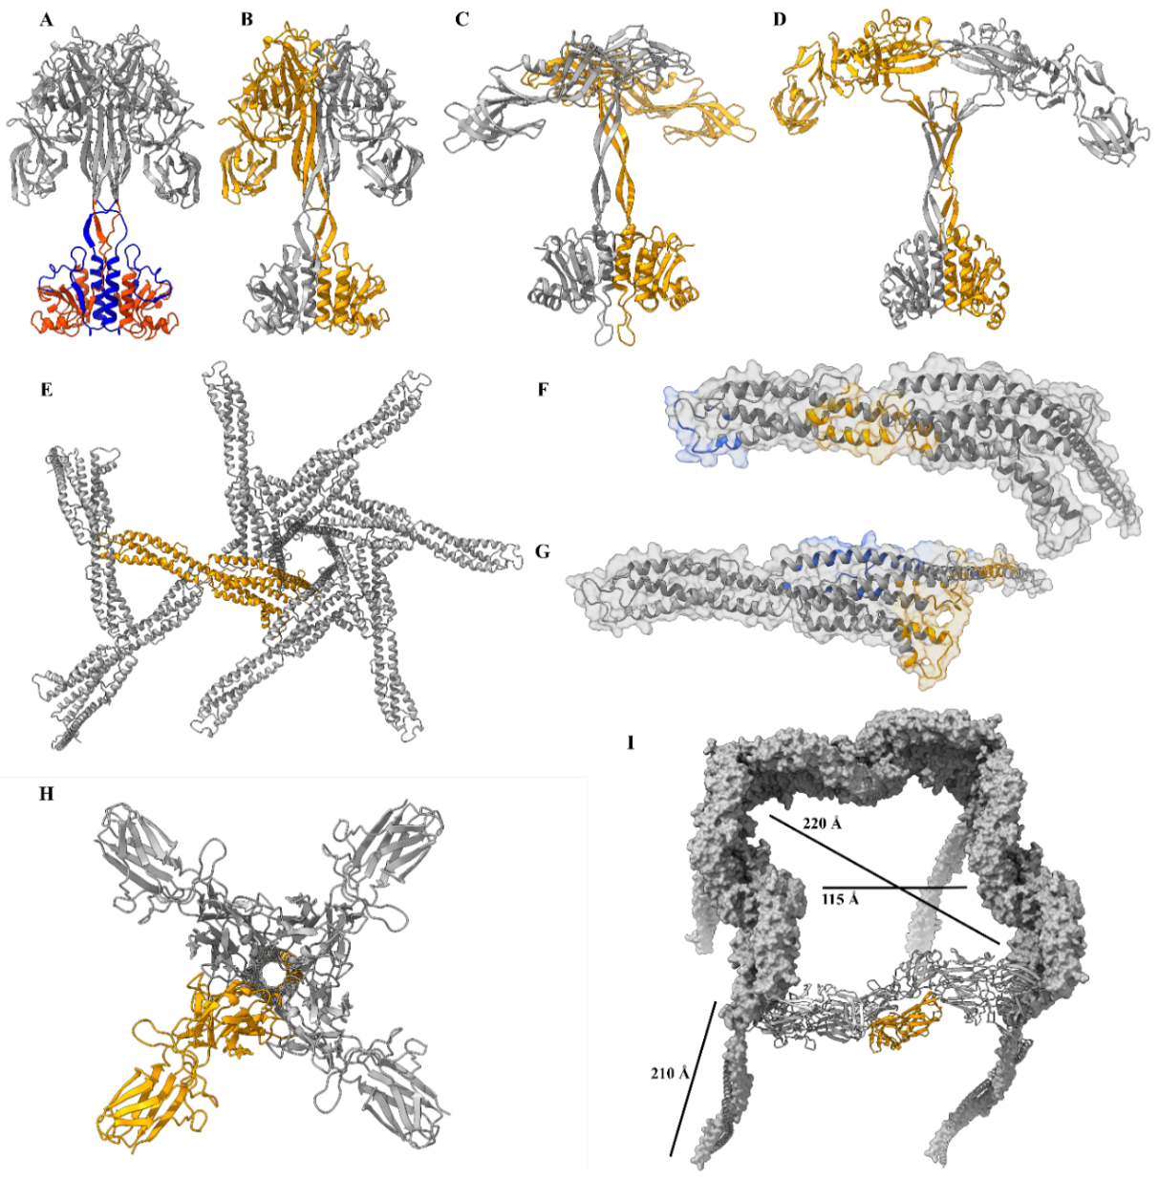
Figure S24: Functional analysis of predicted S-layers. A) The T. thioreducens S-layer anchor is built up from an intermolecular domain of the N-terminus (blue) and C-terminus (red). B) The anchor in the assembly of M. voltae comprises two subunits, grey and orange. C) Anchor of T. camini and D) P. abyssi. E) Top view of the assembly of C. glutamicum showing the 3-fold and 6-fold axis. One subunit of C. glutamicum, showing the interacting interfaces (blue interacts with orange in the next subunit) of the F) 3-fold and G) 6-fold axis. F) The trimer interface results from a strong interaction between the distal loop (aa216 – aa241, blue) of the 3-fold axis and a distinct groove along the elongated monomer (orange). Several hydrogen bonds, salt bridges, and pi-stacking interactions are observed in this area. G) The 6-fold axis is structurally maintained by interactions of the central loop region (orange) with the surface of the adjacent monomer along the C-terminally protruding helix (blue), as well as interactions of the two helices. H) Top view of the 4-fold axis of D. mucosus. The N-terminal domains 1-5 of the 2-fold arms are not shown. I) Fully assembled pore unit of D. mucosus and its long anchoring stalk. The dimeric interface is highlighted in orange.

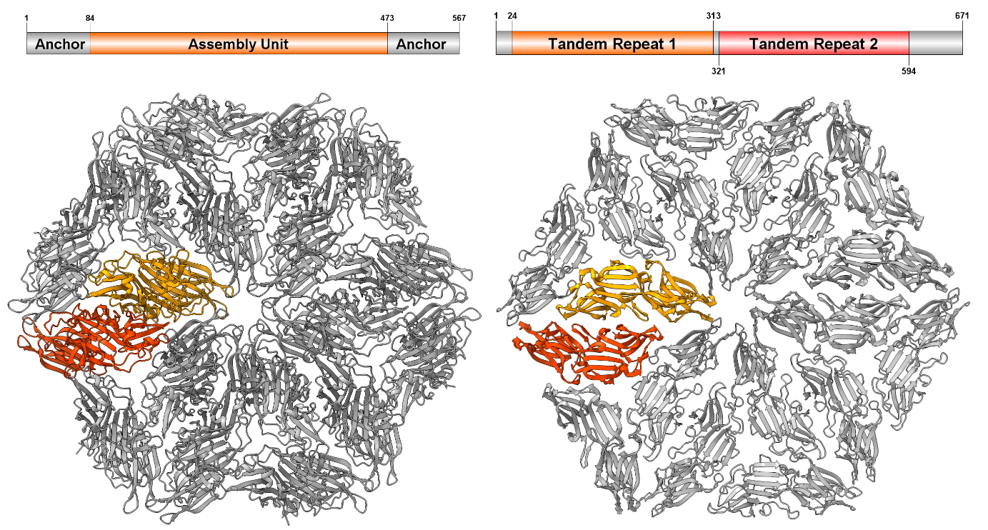
Figure S25: Comparison of the crystal structure of calculated assembled model of M. vannielii (left) and crystal structure of M. acetivorans (right). The 2-fold axis of M. vannielii is formed by a dimer compared to the single tandem repeat protein from M. acetivorans and M. vannielii has an additional N- and C-terminal domain for a putative cell-wall anchor. The overall symmetry, unit cell dimensions and surface of both species is comparable.
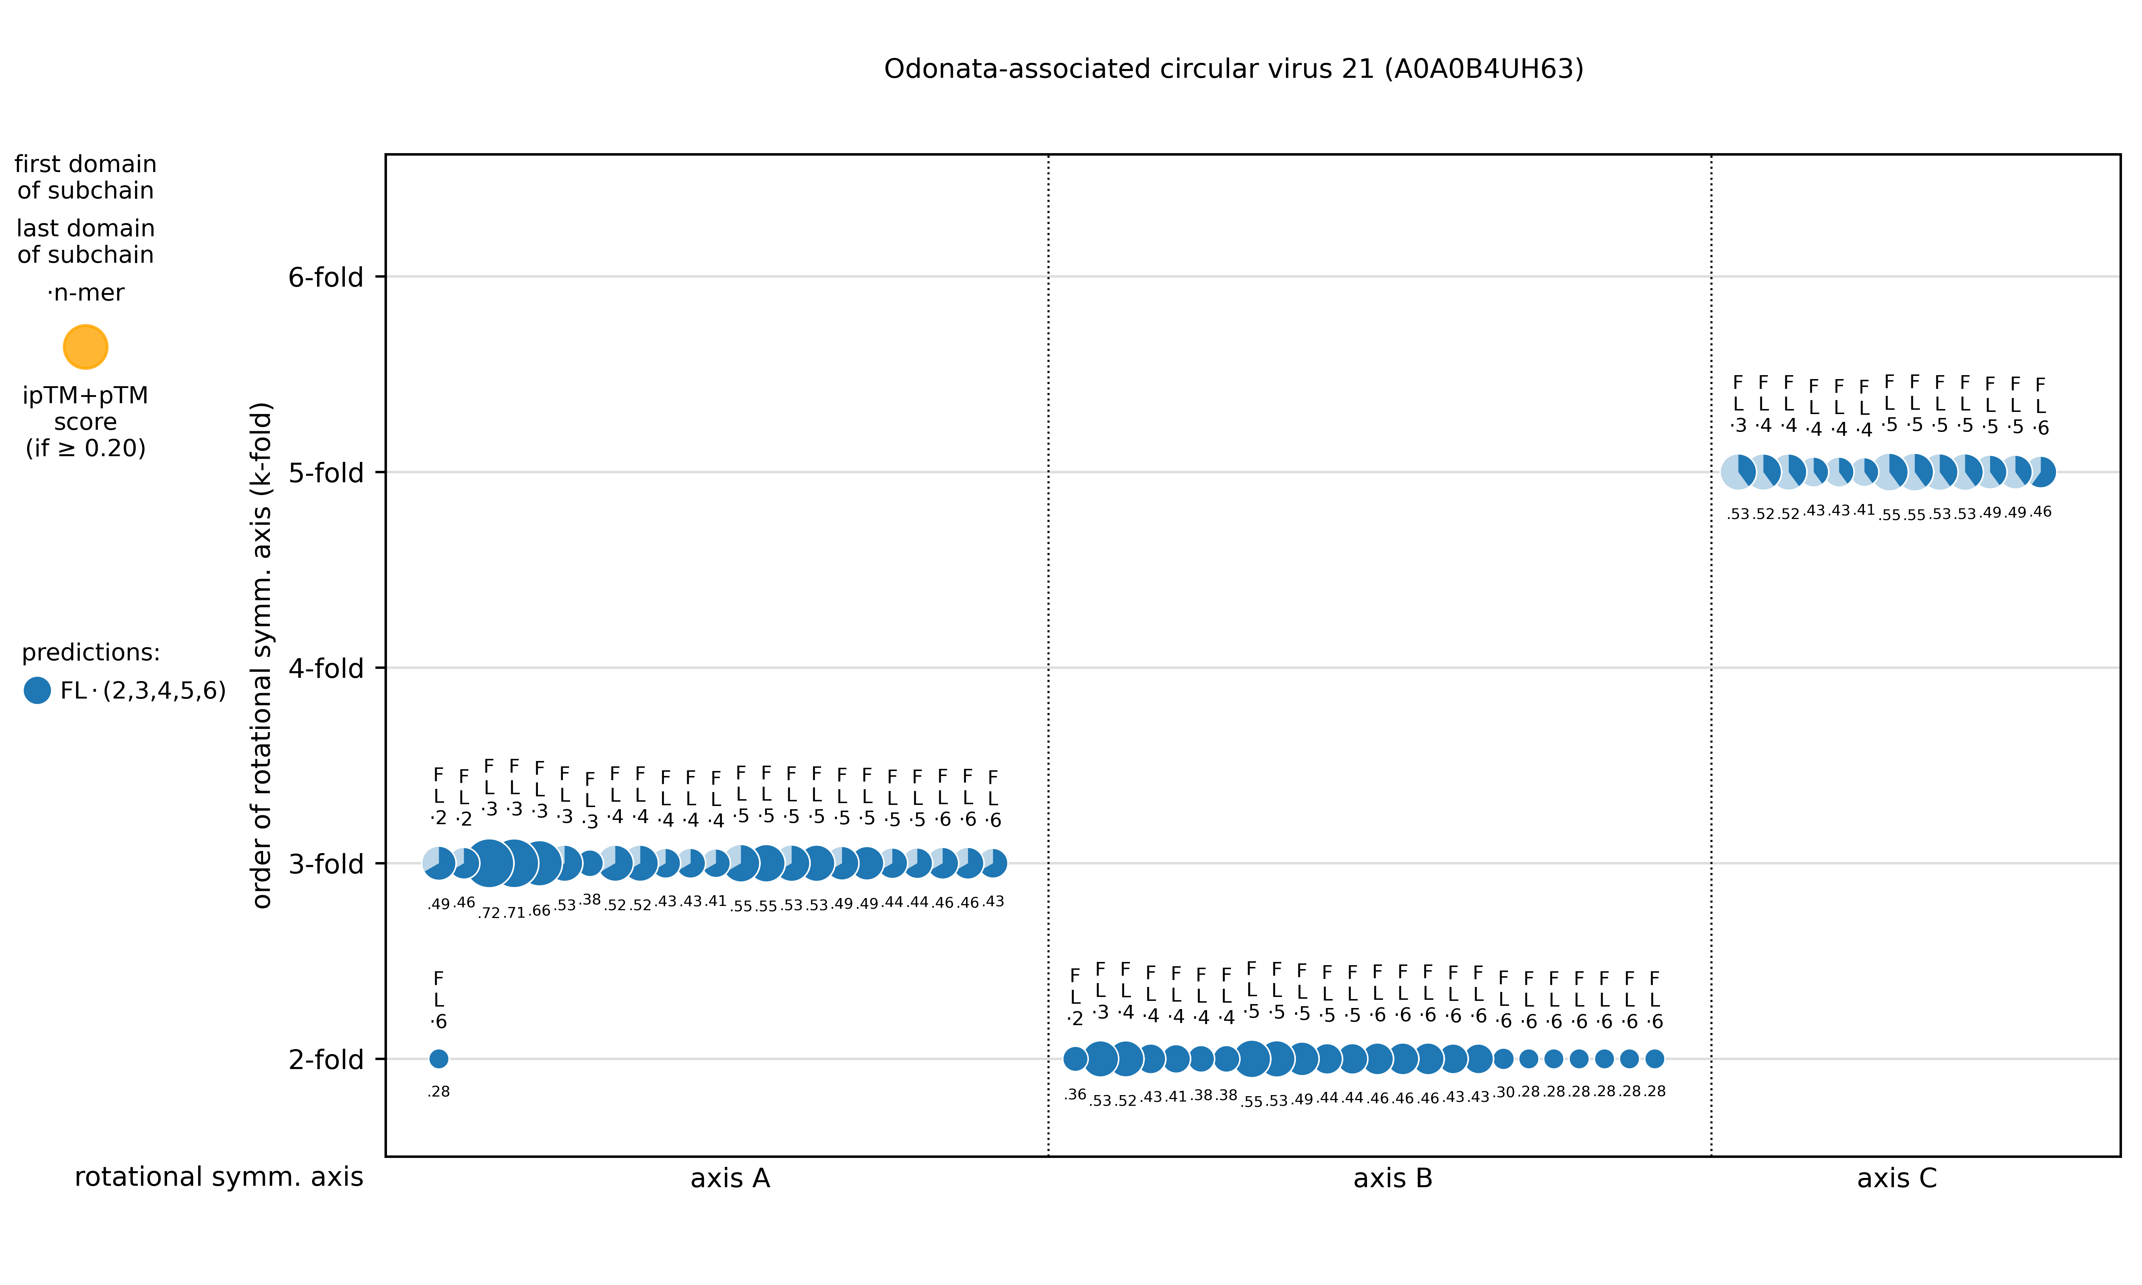Figure S26. Clustering of predicted symmetry complexes for the viral capsid of Odonata-associated circular virus 21 (A0A0B4UH63). The circle diameters represent the respective ipTM+pTM scores. A prediction can contain more than one rotational symmetry axis. In these cases, there are several data points per prediction in the diagram. For axis A cluster, prediction scores clearly indicate a 3-fold symmetry, for axis B cluster a 2-fold symmetry and for axis C cluster a 5-fold symmetry.
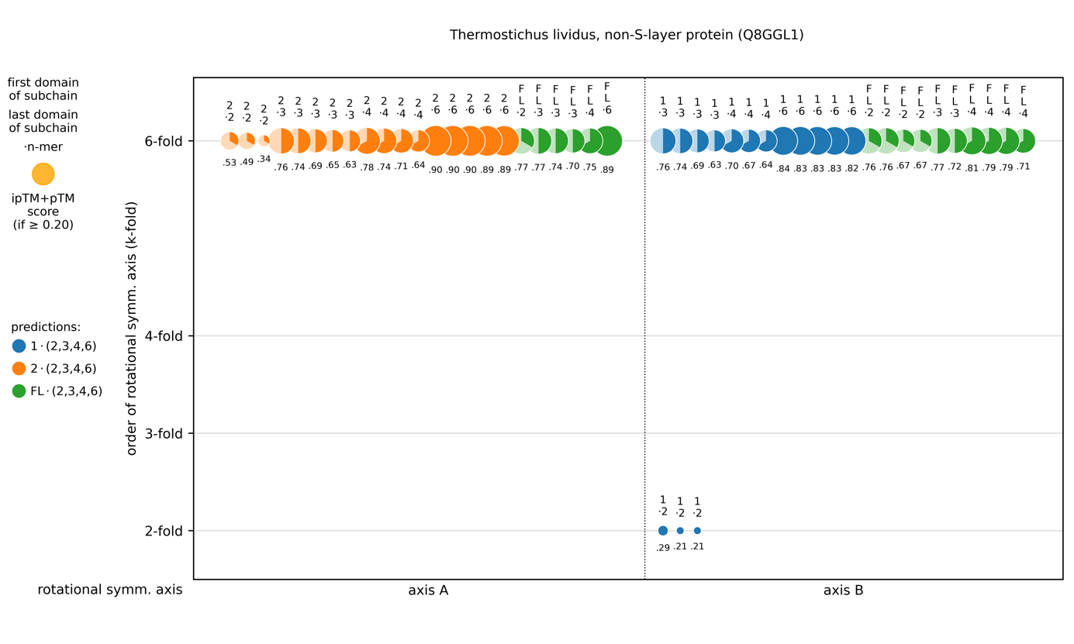Figure S27. Clustering of predicted symmetry complexes for non-S-layer protein KaiC from Thermostichus lividus (Q8GGL1). The circle diameters represent the respective ipTM+pTM scores, each color represents a subchain. Axes A and B coincide, spanning of a 2D layer is not possible.

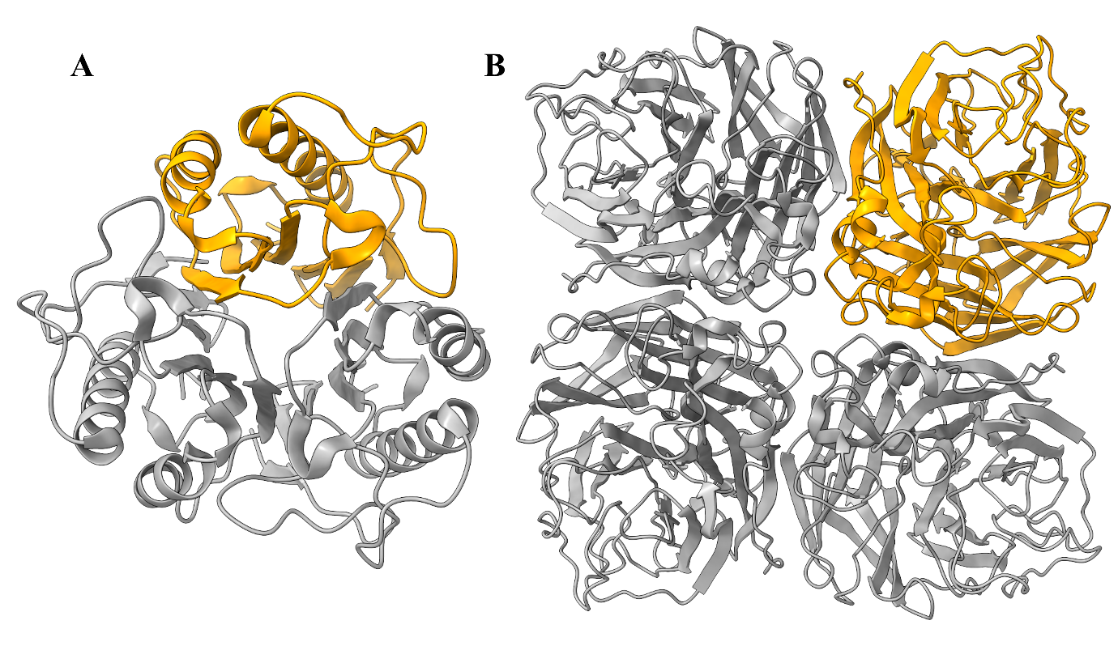Figure S28. A) Crystal structure of trimeric YabJ from Bacillus subtilis (PDB 5Y6U) ²⁴ and N9 neuraminidase from Influenza A virus (6MCX) ²⁵.
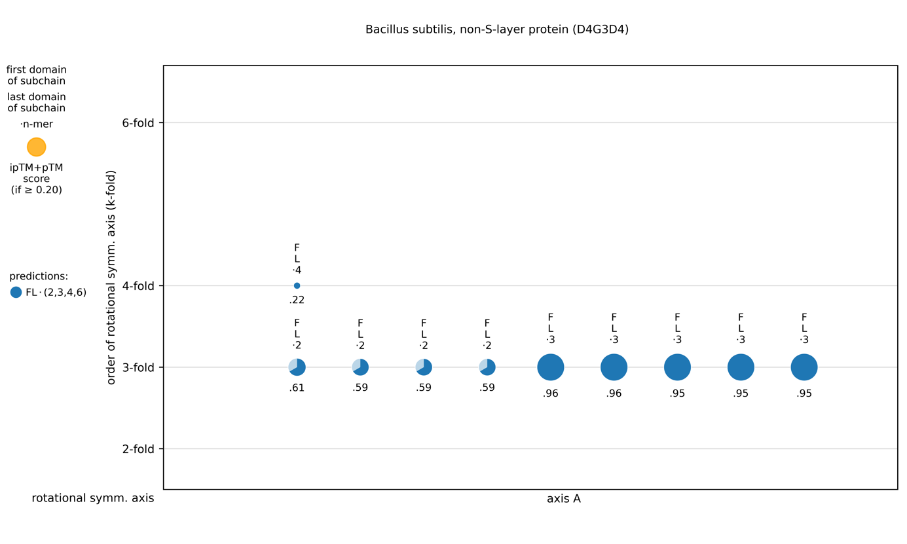Figure S29. Clustering of predicted symmetry complexes for non-S-layer protein YabJ from Bacillus subtilis (D4G3D4). The circle diameters represent the respective ipTM+pTM scores. Since there is only one axis of rotational symmetry, spanning of a 2D layer is not possible.
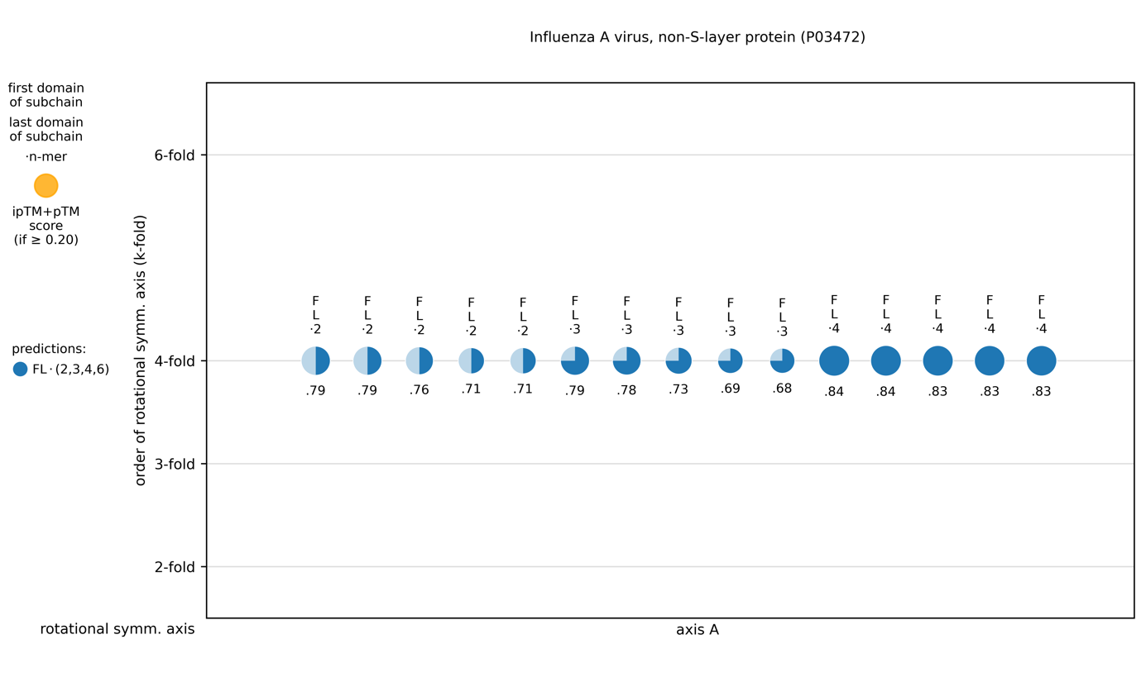Figure S30. Clustering of predicted symmetry complexes for non-S-layer protein N9 neuraminidase from Influenza A virus (P03472). The circle diameters represent the respective ipTM+pTM scores. Since there is only one axis of rotational symmetry, spanning of a 2D layer is not possible.
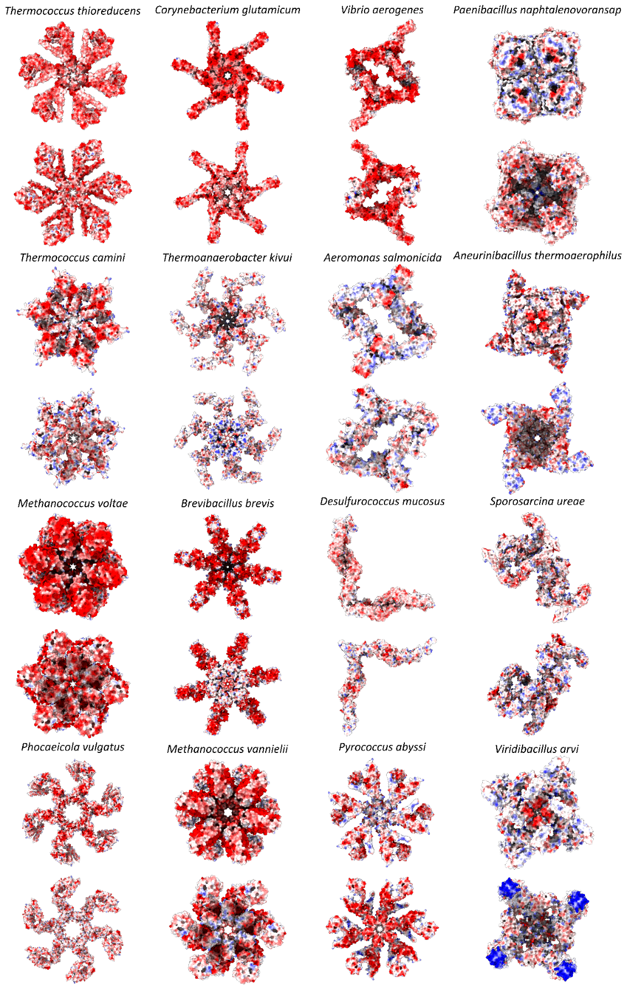
Figure S31: Coulombic electrostatic potential of the calculated S-layers primitive unit cell. Coulombic electrostatic potential was calculated with ChimeraX. Colors range from red for negative potential to white for neutral and blue for positive potential. For each S-layer, the side facing the environment (top) and cell wall facing side (bot) are shown.

References
1. Baranova, E. et al. SbsB structure and lattice reconstruction unveil Ca2+ triggered S-layer assembly. Nature 487, 119–122 (2012).
2. Pavkov, T. et al. The Structure and Binding Behavior of the Bacterial Cell Surface Layer Protein SbsC. Structure 16, 1226–1237 (2008).
3. Dordic, A. et al. Crystallization of domains involved in self-assembly of the S-layer protein SbsC. Acta Cryst F68, 1511–1514 (2012).
4. Pavkov, T. et al. Crystallization and preliminary structure determination of the C-terminal truncated domain of the S-layer protein SbsC. Acta Cryst D 59, 1466–8 (2003).
5. Kroutil, M. et al. Towards the structure of the C-terminal part of the S-layer protein SbsC. Acta Cryst F65, 1042–1047 (2009).
6. Kern, J. et al. Structure of Surface Layer Homology (SLH) Domains from Bacillus anthracis Surface Array Protein. J Biol Chem 286, 26042–26049 (2011).
7. Fioravanti, A. et al. Structure of S-layer protein Sap reveals a mechanism for therapeutic intervention in anthrax. Nat Microbiol 4, 1805–1814 (2019).
8. Sychantha, D. et al. Molecular Basis for the Attachment of S-Layer Proteins to the Cell Wall of Bacillus anthracis. Biochemistry 57, 1949–1953 (2018).
9. Lanzoni-Mangutchi, P. et al. Structure and assembly of the S-layer in C. difficile. Nat Comm 2022 13:1 13, 1–13 (2022).
10. Fagan, R. P. et al. Structural insights into the molecular organization of the S-layer from Clostridium difficile. Mol. Microbiol. 71, 1308–1322 (2009).
11. Farci, D. et al. The cryo-EM structure of the S-layer deinoxanthin-binding complex of Deinococcus radiodurans informs properties of its environmental interactions. J Biol Chem 298, 102031 (2022).
12. von Kügelgen, A., van Dorst, S., Alva, V. & Bharat, T. A. M. A multidomain connector links the outer membrane and cell wall in phylogenetically deep-branching bacteria. Proc Natl Acad Sci U S A 119, e2203156119 (2022).
13. von Kügelgen, A. et al. Interdigitated immunoglobulin arrays form the hyperstable surface layer of the extremophilic bacterium Deinococcus radiodurans. Proc Natl Acad Sci U S A 120, e2215808120 (2023).
14. Herdman, M. et al. High-resolution mapping of metal ions reveals principles of surface layer assembly in Caulobacter crescentus cells. Structure 30, 215-228.e5 (2022).
15. von Kügelgen, A. et al. In Situ Structure of an Intact Lipopolysaccharide-Bound Bacterial Surface Layer. Cell 180, 348-358.e15 (2020).
16. Herrmann, J. et al. A bacterial surface layer protein exploits multistep crystallization for rapid self-assembly. Proc Natl Acad Sci U S A 117, 388–394 (2020).
17. Bharat, T. A. M. et al. Structure of the hexagonal surface layer on Caulobacter crescentus cells. Nat Microbiol 2, 17059 (2017).
18. von Kügelgen, A., Alva, V. & Bharat, T. A. M. Complete atomic structure of a native archaeal cell surface. Cell Rep 37, 110052 (2021).
19. Jing, H., Takagi, J., Liu, J. & Springer, T. A. Archaeal Surface Layer Proteins Contain β Propeller, PKD, and β Helix Domains and Are Related to Metazoan Cell Surface Proteins. Structure 10, 1453–1464 (2002).
20. Arbing, M. A. et al. Structure of the surface layer of the methanogenic archaean Methanosarcina acetivorans. Proc Natl Acad Sci U S A 109, 11812–11817 (2012).
21. Gambelli, L. et al. Structure of the two-component S-layer of the archaeon Sulfolobus acidocaldarius. bioRxiv (2022) doi:10.1101/2022.10.07.511299.
22. Varadi, M. et al. AlphaFold Protein Structure Database: Massively expanding the structural coverage of protein-sequence space with high-accuracy models. Nucleic Acids Res 50, D439–D444 (2022).
23. Blondel, V. D., Guillaume, J.-L., Lambiotte, R. & Lefebvre, E. Fast unfolding of communities in large networks. J. Stat. Mech. 2008, P10008 (2008).
24. Fujimoto, Z., Hong, L. T. T., Kishine, N., Suzuki, N. & Kimura, K. Tetramer formation of Bacillus subtilis YabJ protein that belongs to YjgF/YER057c/UK114 family. Biosci Biotechnol Biochem 85, 297–306 (2021).
25. Streltsov, V. A., Schmidt, P. M. & McKimm-Breschkin, J. L. Structure of an Influenza A virus N9 neuraminidase with a tetrabrachion-domain stalk. Acta Cryst F75, 89–97 (2019).

