SUPPLEMENTARY MATERIAL
File S1 – Prisma checklist, search terms, and definitions
File S2 – Raw data and data overview
File S3 – Studies potentially influenced by the test manufacturer
SUPPLEMENTARY FIGURES AND TABLES
Figure S1 – Funnel Plot
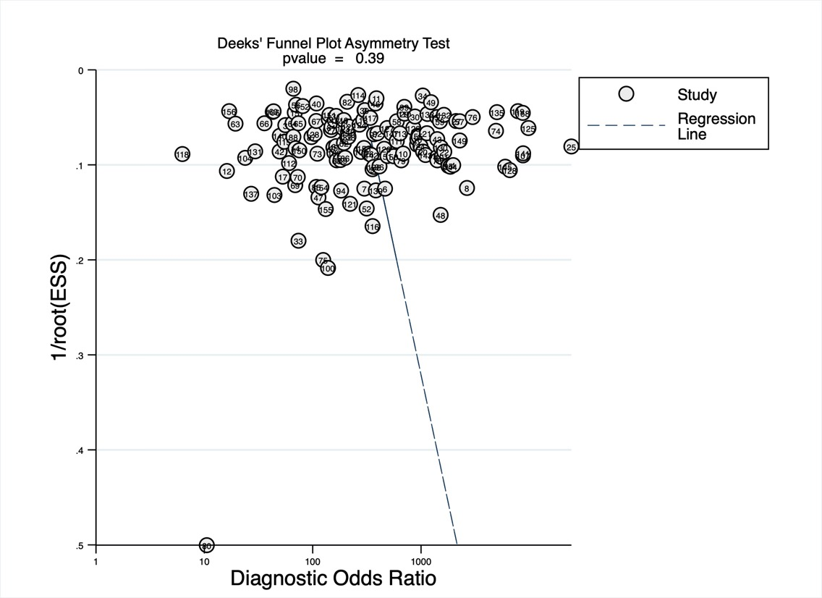

Figure S2 – Sensitivity analysis excluding case-control studies
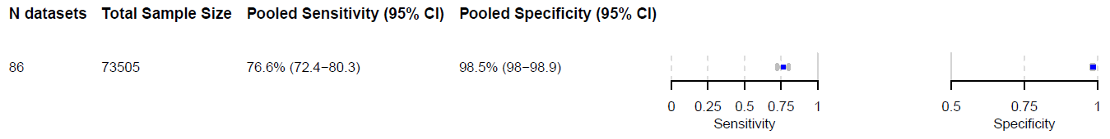
Figure S2 - Abbreviations: CI = confidence interval

Figure S3 – Sensitivity analysis excluding preprints
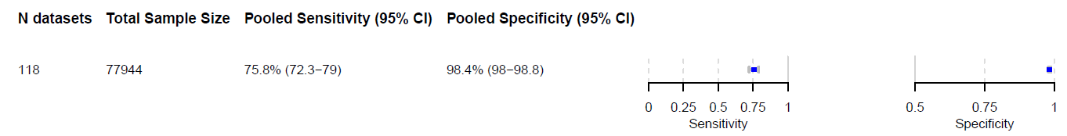
Figure S3 - Abbreviations: CI = confidence interval

Figure S4 – Sensitivity analysis excluding manufacturer-dependent studies
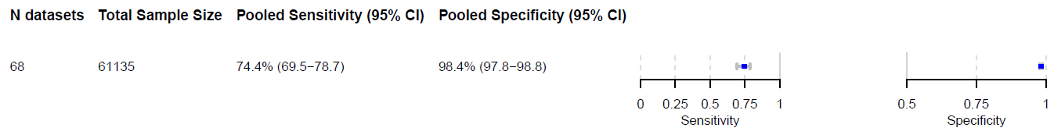
Figure S4 - Abbreviations: CI = confidence interval

Figure S5 – Sensitivity analysis based on income level
High-income countries only:
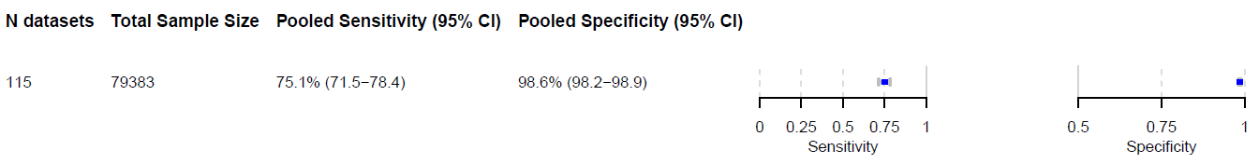
Figure S5A - Abbreviations: CI = confidence interval
Low- and middle-income countries only: 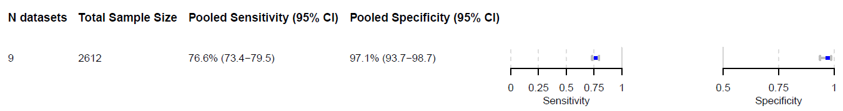
Figure S5B - Abbreviations: CI = confidence interval

Table S1. Overview of iAg tests included in the review
Short Name | Company | Platform | Assay | Technology | Intended Setting | Time-to-Result | References
ADVIA Centaur | Siemens Healthineers | ADVIA Centaur (XP/XPT) XPT Immunoassay System | ADVIA Centaur SARS-CoV-2 Antigen Assay | CLIA | Lab-based | 23 minutes | (61)
AFIAS | Boditech Med | AFIAS-6 | AFIAS COVID-19 Ag | FIA | POC | 10-30 minutes | (72), (73)
Atellica | Siemens Healthineers | Atellica® Solution | Atellica IM SARS-CoV-2 Antigen Assay | CLIA | Lab-based | 26 minutes | (67)
BD Veritor | BD (Becton, Dickinson and Company) | BD VeritorTM Plus Analyzer | BD Veritor™ System for Rapid Detection of SARS-CoV-2 | DIA | POC | 12-20 minutes | (66), (74), (75), (76), (77), (78), (41), (79), (43), (45), (80), (53), (60), (25), (81), (82)
Bioeasy | Shenzhen Bioeasy Biotechnology | Immunofluorescence Analyzer EASY-11 | Bioeasy 2019-nCoV Ag Fluorescence Rapid Test Kit | FIA | POC | 10-20 minutes | (35), (37), (83), (84)
Elecsys | Roche Diagnostics | cobas e 411, e 601, e 602, e 801 analyzers | Elecsys SARS-CoV-2 Antigen assay | ECLIA | Lab-based | 15-18 minutes | (85), (86), (47), (87), (29), (88), (59), (89)
Euroimmun | Euroimmun Medizinische Labordiagnostika | Analyzer I-2P | SARS-CoV-2 Antigen ELISA | ELISA | Lab-based | n/a | (86), (90)
Exdia | Precision Biosensor | Exdia TRF analyzer | Exdia COVID-19 Ag | FIA | POC | 15-20 minutes | (75), (53)
FIAflex | ACON Laboratories | FIAflex™ Fluorescent Immunoassay Analyzer | FIAflex™ SARS-CoV-2 Antigen FIA | FIA | POC | 15 minutes | (45)
FREND | NanoEntek | FREND™ System | FRENDTM COVID-19 Ag test | FIA | POC | 3 minutes | (91), (92)
Gazelle | Hemex Health | Gazelle Reader | Gazelle COVID-19 | FIA | POC | n/a | (93)
HISCL | Sysmex Corporation | HISCL®‐5000 / HISCL®‐800 | HISCL® SARS‐CoV‐2 Ag Assay kit | CLEIA | Lab-based | 17 minutes | (94), (65)
ichroma | Boditech Med | ichroma™ | ichroma™ COVID-19 Ag Test | FIA | POC | 15-30 minutes | (95)
LIAISON | DiaSorin S.p.A. | LIAISON® XL | LIAISON® SARS-CoV-2 Ag | CLIA | Lab-based | 45 minutes | (40), (44), (86), (96), (97), (98), (58), (62), (63)
Lumipulse G | Fujirebio | Lumipulse® G1200 | Lumipulse® G SARS-CoV-2 Ag | CLEIA | Lab-based | 30-60 minutes | (99), (100), (101), (102), (86), (72), (49), (51), (103), (104), (54), (105), (106)
LumiraDx | LumiraDx | LumiraDx™ Platform | LumiraDx SARS-CoV-2 Ag test | FIA | POC | 12-15 minutes | (107), (32), (108), (109), (91), (110), (111), (42), (112), (113), (45), (114), (115), (116), (117), (118), (27), (119), (120), (53), (56), (26)
mariPOC | ArcDia International | mariPOC® test system | mariPOC SARS-CoV-2 test | FIA | POC | 20-55 minutes | (48), (121)
PCL | PCL | n/a | PCL COVID-19 Ag Rapid FIA test | FIA | POC | <30 minutes | (122), (55)
RapidTesta | Sekisui Medical | n/a | RapidTesta SARS-CoV-2 | DIA | POC | 10 minutes | (123)
MSD S-PLEX | MesoScale Diagnostics | MESO SECTOR S 600 Reader | MSD S-PLEX SARS-CoV-2 N assay | ECLIA | Lab-based | 4-5 hours | (124), (50), (125)
Sofia | Quidel | Sofia Fluorescent Immunoassay Analyzer | Sofia SARS Antigen FIA | FIA | POC | 15 minutes | (126), (36), (127), (82), (38), (128), (129), (130), (131), (132), (124), (122), (133), (134), (135), (136), (52)
STANDARD F | SD Biosensor | STANDARDTM F2400 Analyzer / STANDARDTM F2400 Analyzer | STANDARDTM F COVID-19 Ag FIA | FIA | POC | 10-30 minutes | (137), (138), (36), (31), (139), (91), (140), (72), (141), (92), (142), (73), (143), (52), (57), (64), (144)
VITROS | Ortho Clinical Diagnostics | VITROS® 3600 Immunodiagnostic System | VITROS Immunodiagnostic Products SARS-CoV-2 Antigen test | CLIA | Lab-based | 48 minutes | (145), (102), (46), (28), (146)
Wantai | Beijing Wantai Biological Pharmacy Enterprise | n/a | Wantai SARS-CoV-2 Antigen Rapid Test (FIA) | FIA | POC | 20 minutes | (52), (147)
Table S1 - Overview of iAg tests included in the review. Abbreviations: CLIA = Chemiluminescence immunoassay, FIA = Fluorescence immunoassay, DIA = Diffusion immunoassay, CLEIA = Chemiluminescence enzyme immunoassay, ECLIA = Electrochemiluminescence immunoassay, ELISA = Enzyme-linked immunosorbent assay, POC = Point-of-care

