Supplemental Figures

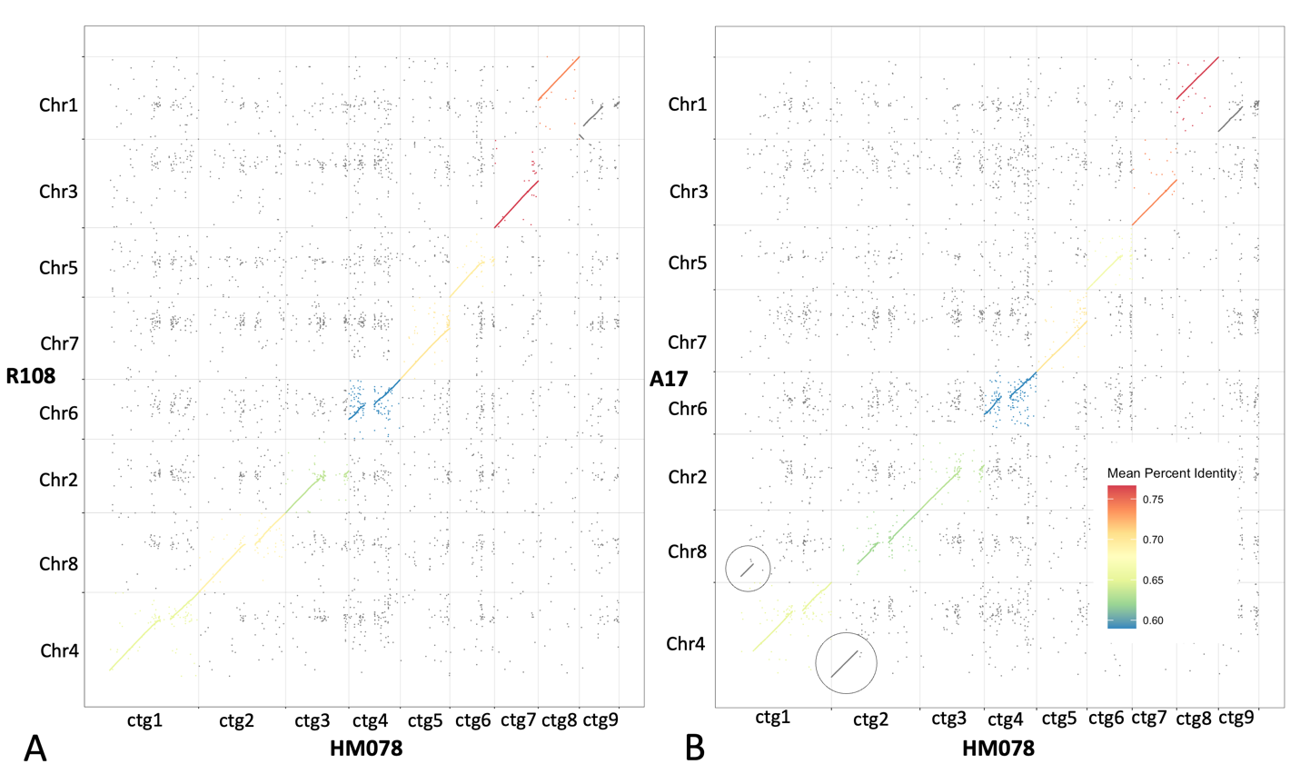

Figure S1. DNA-based alignments between chromosome-level genomes of M. truncatula and HM078 contigs. (A) Chromosomes of R108 aligned to the 9 largest contigs of HM078, and (B) chromosomes of A17 aligned to the 9 largest contigs of HM078. The alignment of the HM078 contigs to M. truncatula accessions R108 and A17 are largely similar, except for the chromosome 4-8 translocation in A17, which is not present in HM078 (circled).
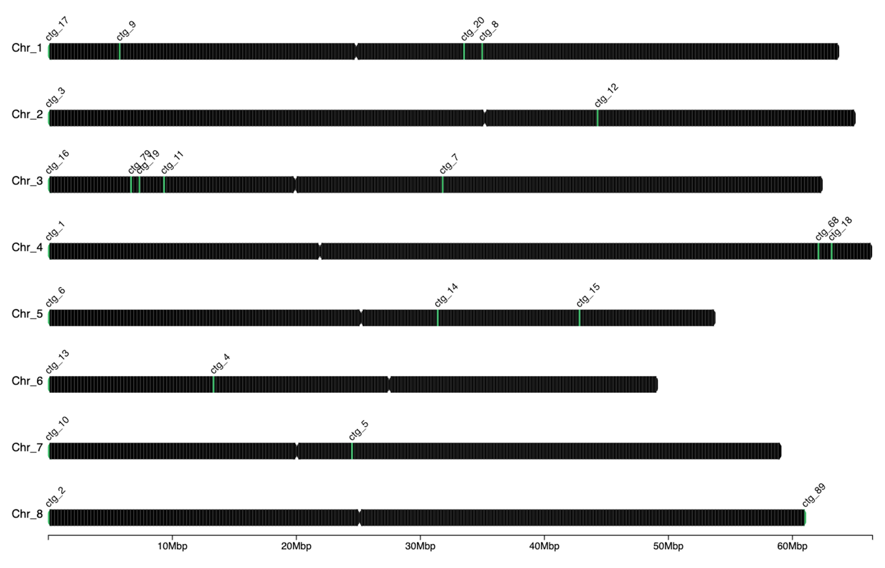
Figure S2. Anchoring of twenty-three MtHM078 primary contigs to the chromosomes of the MedtrR108_hic genome. Start sites of MtHM078 primary contigs are labelled in green.
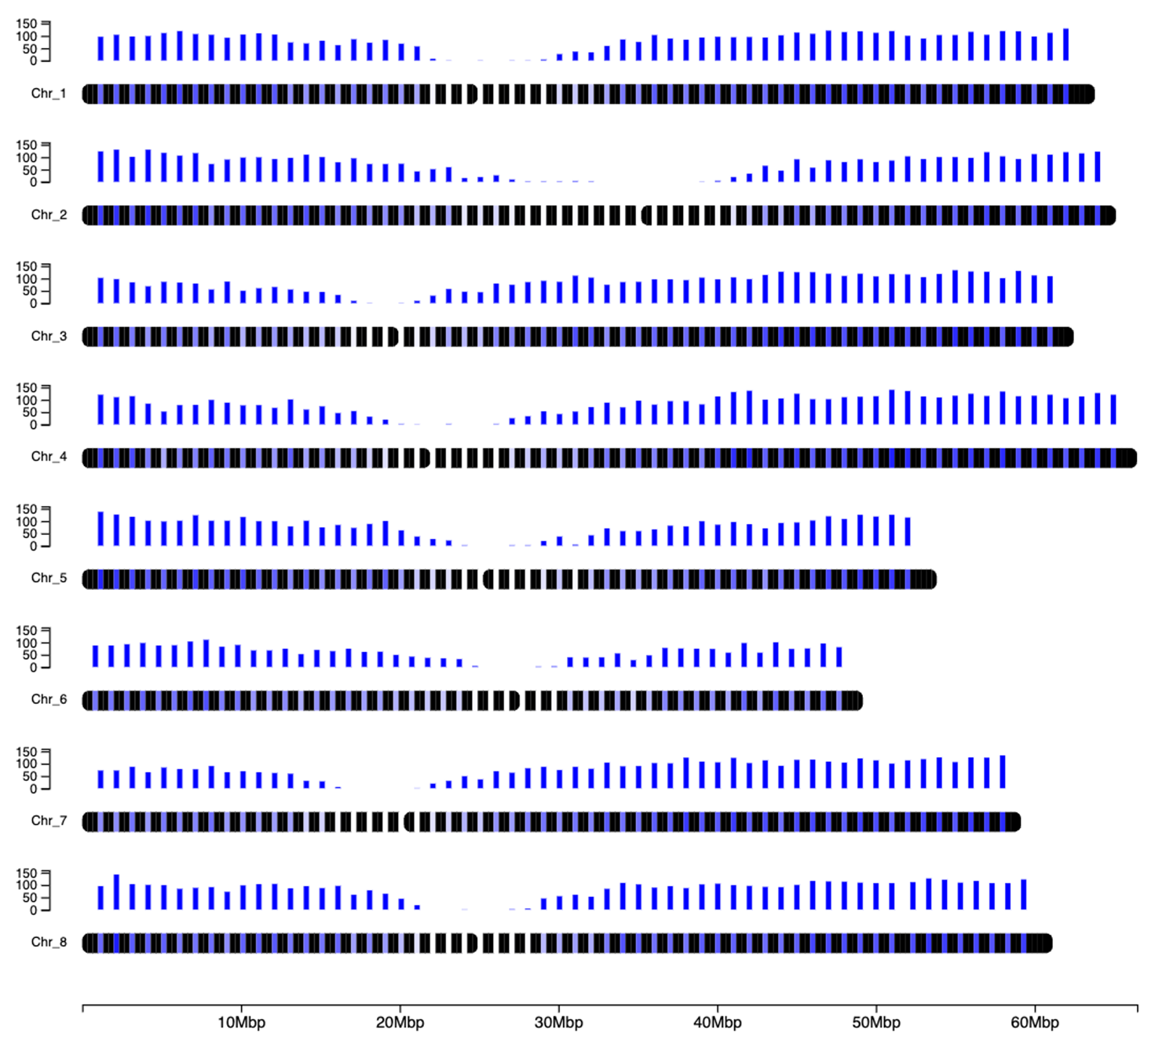
Figure S3. Gene density displayed across the MtHM078 v1.0 genome. Counts, on the Y-axis, are in genes per megabase (Mbp), which are displayed by bar plots. Dark blue regions indicate high gene density, while white regions indicate no genes are annotated. Multi-megabase gene-poor regions are located approximately in the center of each pseudo-chromosome in the MtHM078 v1.0 genome.

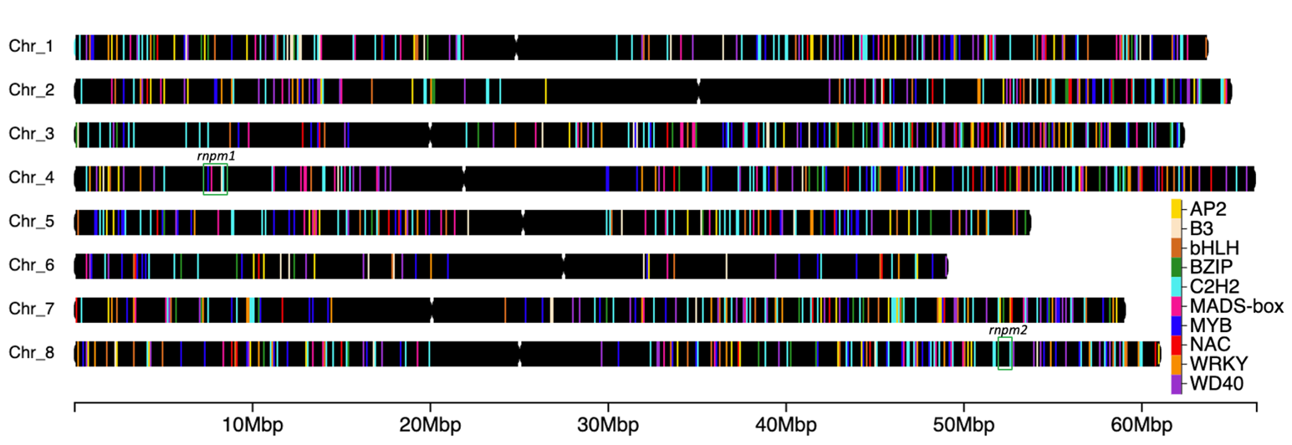

Figure S4. Transcription factor genes annotated in the MtHM078 v1.0 genome. A total of 1,232 transcription factors are visualized genome-wide from 10 of the most abundant families including AP2, B3-domain, bHLH, BZIP, C2H2, MADS-box, MYB, NAC, WRKY, and WD40. In QTL rnpm1, MYB, MADS-box, C2H2, and B3-domain transcription factors were identified. In QTL rnpm2, a C2H2 transcription factor gene was identified. QTL rnpm1 and rnpm2 are labelled in green boxes.

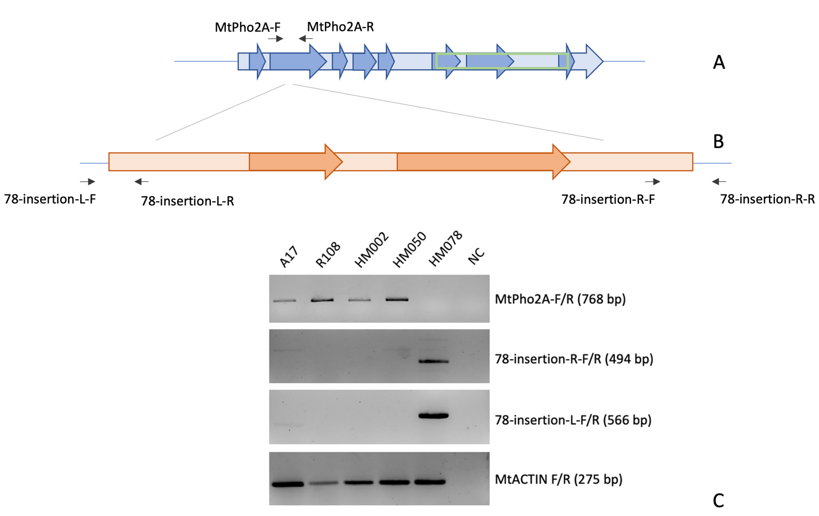
Figure S5. PCR amplification of the PHO2A locus showing LTR-RT insertion site in HM078. (A) Structure of the PHO2A gene and primer locations. A light blue arrow indicates the 6.4 kbp PHO2A gene, while dark blue arrows indicate approximate CDS locations, and the green box denotes the ubiquitin-conjugating enzyme E2 catalytic domain. (B) Structure and primer locations for an insertion of a Ty3/gypsy LTR-RT-like repeat sequence at the PHO2A gene locus in HM078. A light orange box indicates the 10.85 kbp LTR retrotransposon, while two dark orange arrows indicate putative Ribonuclease H domains. The LTR-RT-like repeat was inserted in the second CDS of PHO2A, indicated by the gray lines. (C) PCR amplification of gDNA showing the presence of the PHO2A locus in A17, R108, HM002, HM050 and absence of the of the PHO2A locus in HM078, as well as the presence of the LTR-RT-like insertion in HM078 at the PHO2A locus.

