A AA drugs |  | B Molecules targeting JNK pathway hubs
Fluoxetine¹  C₁₇H₁₈F₃NO  CAS 54910-89-3  SSRI  0.1, 1.0, 10.0 µM | 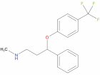 | SP600125²  C₁₄H₈N₂O  CAS 129-56-6  JNK inhibitor  (ATP-competitive)  0.1, 1.0, 10.0 µM | 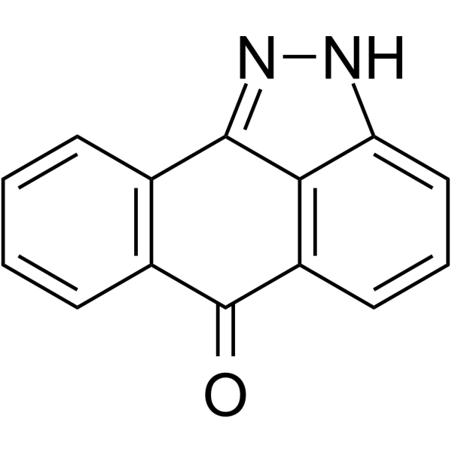 | R18³  C₁₀₁H₁₅₇N₂₇O₂₉S₃  CAS 211364-78-2  14-3-3 inhibitor  0.1, 1.0, 10.0 µM | PHCVPRDLSWLDLEANMCLP
Imipramine¹  C₁₉H₂₄N₂  CAS 50-49-7  Antidepressant  10, 100, 1000 nM | 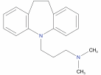 | JNK-IN-8⁴  C₂₉H₂₉N₇O₂  CAS 1410880-22-6  JNK inhibitor  (irreversible)  1, 10, 100 nM | 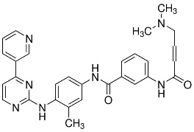 | SB-590885⁵  C₂₇H₂₇N₅O₂  CAS 405554-55-4  B-Raf inhibitor  1, 10, 100 nM | 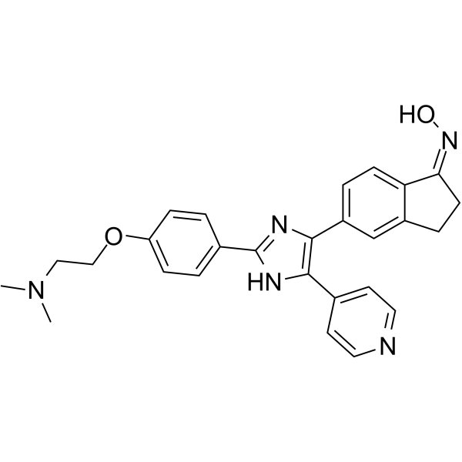
Lithium Cloride⁶  LiCl  CAS 7447-41-8  Mood stabiliser  1, 10, 100 mM |  | SB216763  C₁₉H₁₂Cl₂N₂O₂  CAS 280744-09-4  GSK-3 inhibitor  1, 10, 100 µM | 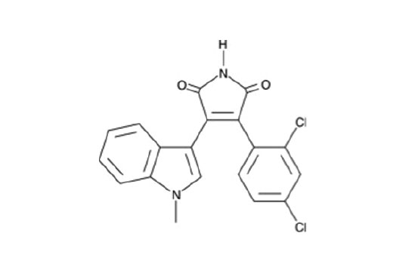 | SRC-I1⁵  C₂₂H₁₉N₃O₃  CAS 179248-59-0  SRC inhibitor  10, 100, 1000 nM | 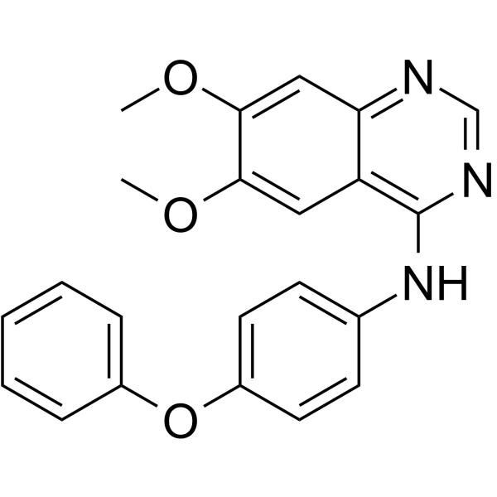
Diazepam¹  C₁₆H₁₃ClN₂O  CAS 439-14-5  benzodiazepine (anxiolytic)  0.1, 1.0, 10.0 µM | 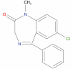 | BIM⁵  C₂₅H₂₄N₄O₂  CAS 133052-90-1  PKC inhibitor  (ATP-competitive)  0.1, 1.0, 10.0 µM | 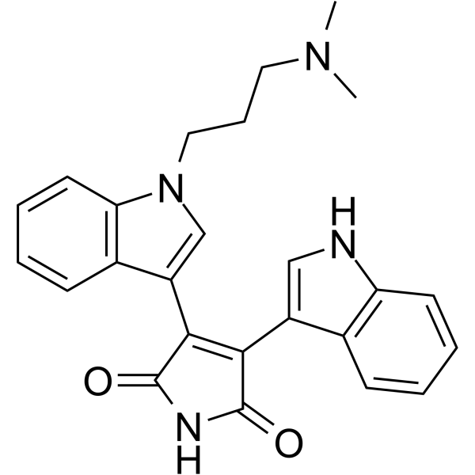 | AKTi-1/2⁵  C₃₄H₂₉N₇O  CAS 612847-09-3  Akt inhibitor  2, 10, 50 µM | 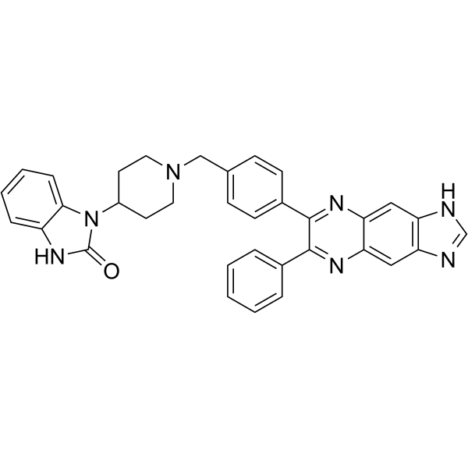
Haloperidol¹  C₂₁H₂₃ClFNO₂  CAS 52-86-8  Antipsychotic  0.1, 1.0, 10.0 µM | 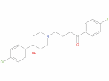 | FR236924⁷  C₂₀H₃₆O₂  CAS 28399-31-7  PKCε activator  0.1, 1.0, 10.0 µM | 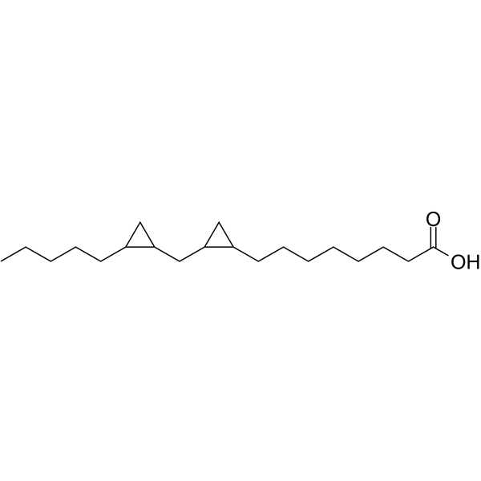 | SC79⁵  C₁₇H₁₇ClN₂O₅  CAS 305834-79-1  Akt activator  1, 2, 5 µM | 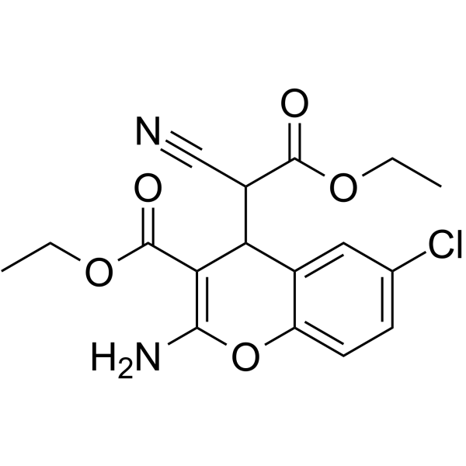
Ketamine¹  C₁₃H₁₆ClNO  CAS 6740-88-1  Anesthetic  1, 10, 100 µM | 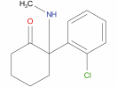 | PMA⁵  C₃₆H₅₆O₈  CAS 16561-29-8  PKC activator  (DAG mimic)  10, 100, 1000 µM | 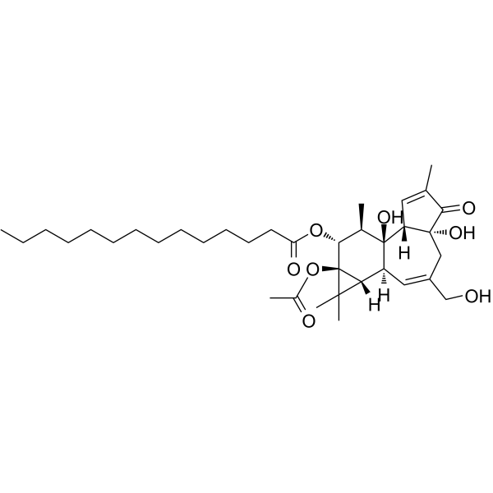 | C HPI-axis stressors
MK801⁸  C₁₆H₁₅N  CAS 77086-21-6  Psychotic  1, 10, 100 µM | 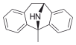 | Bryostatin-1 ⁹  C₄₇H₆₈O₁₇  CAS 83314-01-6  PKC modulator  1, 10, 100 nM | 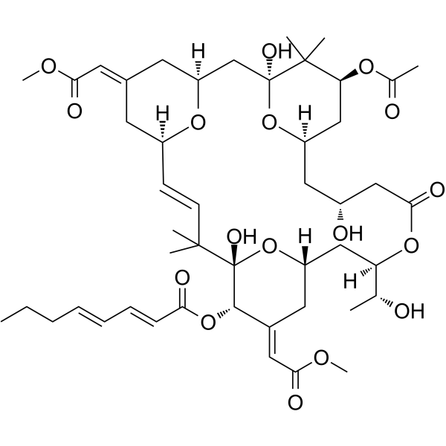 | Sodium Chloride  NaCl  CAS 7647-14-5  100, 150, 200 µM
Table 1: Drugs used in the study. Name, formula, CAS number, usage, used concentration and chemical structures are shown for (A) the antidepressant/anxiolytic (AA) drug group; (B) molecules targeting the JNK pathway hubs and (C) the known HPI axis stressors.

(1) Wishart, D. S. et al. DrugBank 5.0 Nucleic Acids Res 46, D1074-D1082 (2018). (2) Bennett, B. L. et al. Proc Natl Acad Sci U S A 98, 13681-13686 (2001). (3) Wang, B. et al. I Biochemistry 38, 12499-12504 (1999). (4) Zhang, T. et al. Chem Biol 19, 140-154 (2012). (5) Ursu, O. et al. Nucleic Acids Res 45, D932-D939 (2017). (6) Gould, T. D. & Manji, H. K. Neuropsychopharmacology 30, 1223-1237 (2005). (7) Tanaka, A. & Nishizaki, T. Bioorg Med Chem Lett 13, 1037-1040 (2003). (8) Huettner, J. E. & Bean, B. P. (9) Keenan, C., Goode, N. & Pears, C. FEBS Lett 415, 101-108 (1997).

