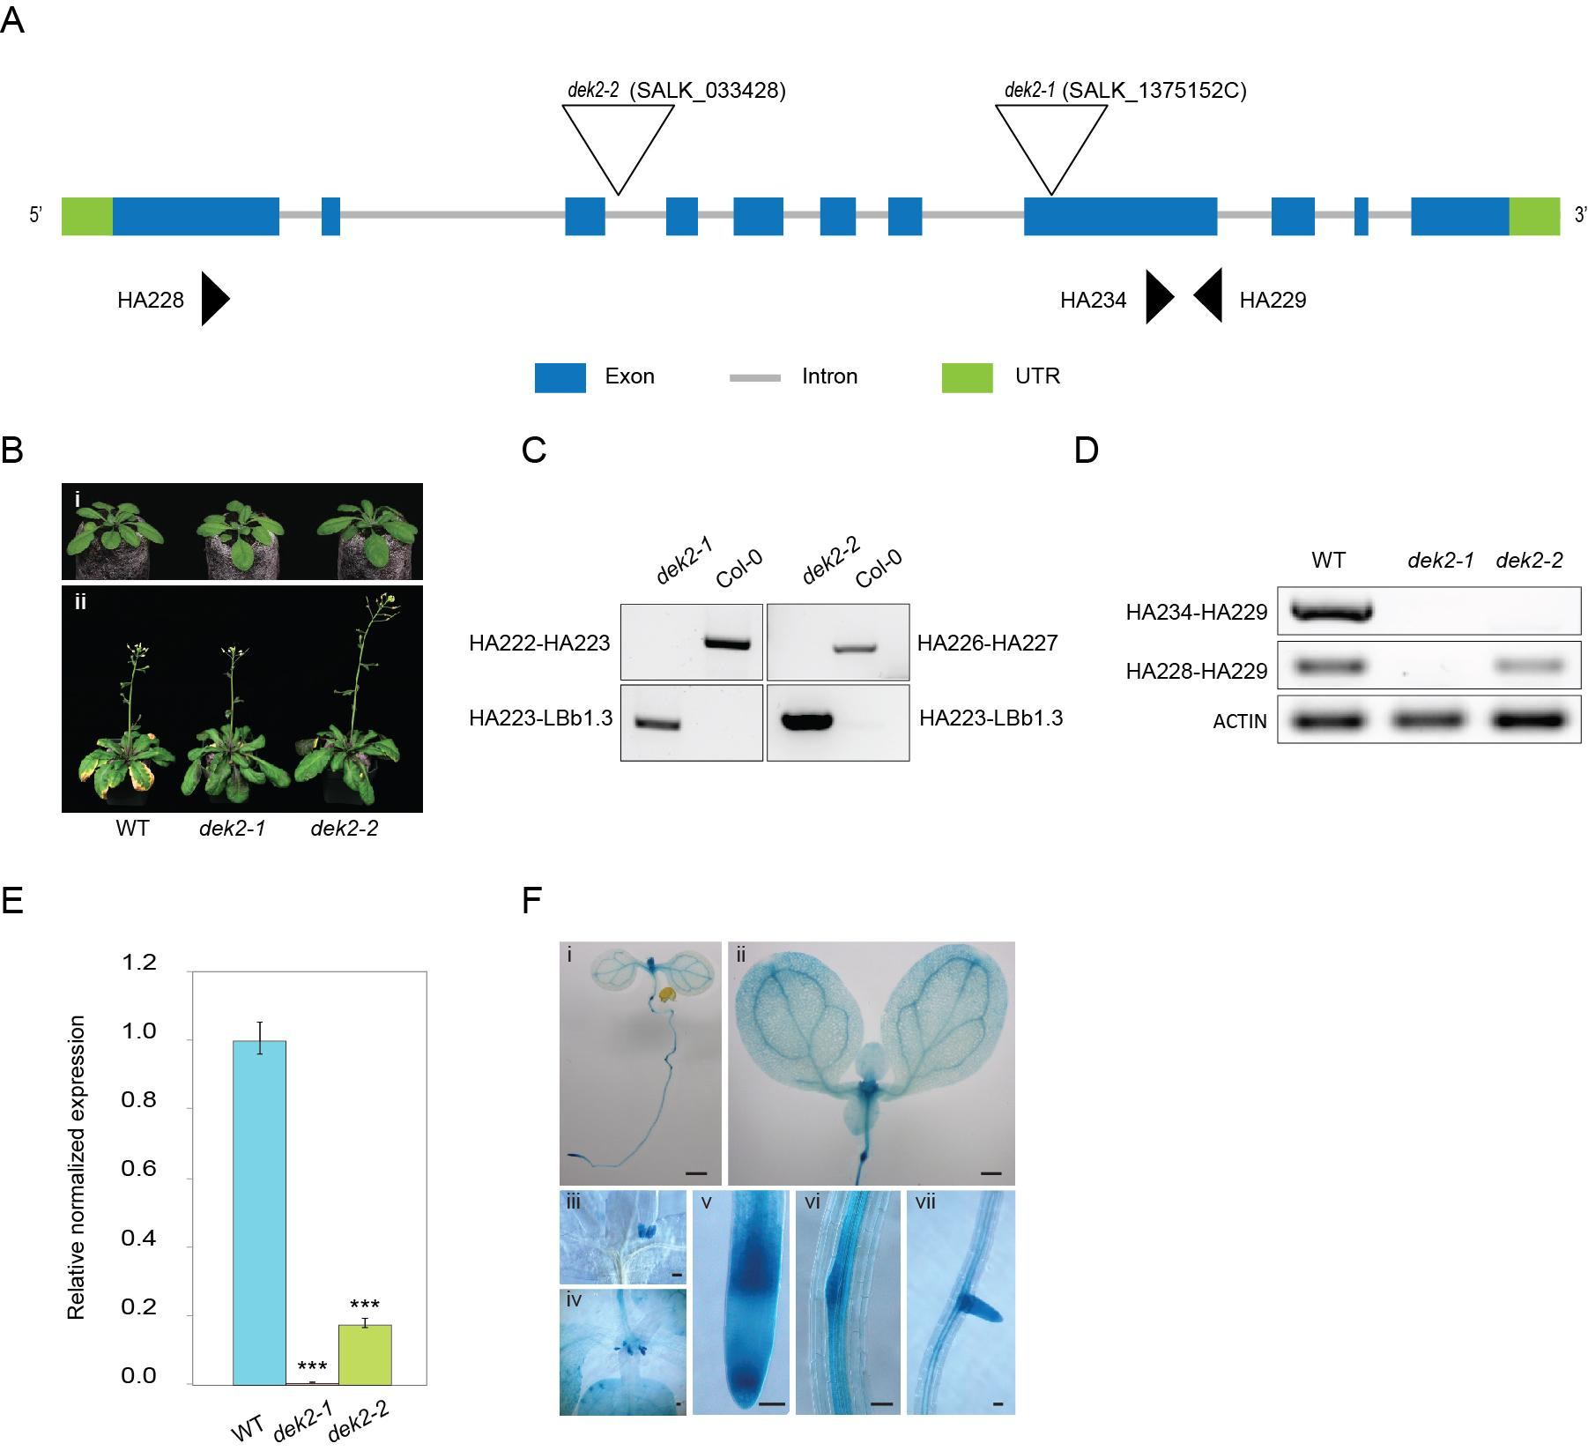
Supplementary Figure 1: Isolation and characterization of dek2 mutants. A. Schematic representation of the DEK2 locus shows the intron/exon structure, the position of each T-DNA insertion is depicted by an inverted triangle and arrows show the positions of primers used for RT-PCR and qRT-PCR. B. Morphological phenotype of WT and dek2 mutant plants. A. thaliana plants were grown in soil under long day condition (16h/8h) for 4 weeks (upper panel) and 6 weeks (lower panel). C. Genotyping of WT and dek2 mutants by gene-specific primers (upper gel panel) and T-DNA-specific primers (lower gel panel). D&E. The transcript levels of DEK2 in dek2 loss-of-function mutants assayed by semi-quantitative RT-PCR and quantitative real-time PCR. Primers for UBQ10 and ACTIN expression levels were used for normalization. Bars represent means ± SE of three independent biological replicates and each replicate is composed of three technical replicates. Asterisks indicate a significant difference to WT under the same conditions based on a two-tailed Student T-test. ***P value <0.001. F. GUS staining patterns in tissues of transgenic A. thaliana plants harboring the pDEK2::GUS transgene. GUS staining is shown in the following tissues: 5-day-old seedling (i), shoot (ii), apical meristem of 10-day-old seedlings shoot (ii-iv), root tip (v) and lateral root primordium (vi-vii). Scale bars 50 μm (i-ii), 0.5 mm (iii-vii).
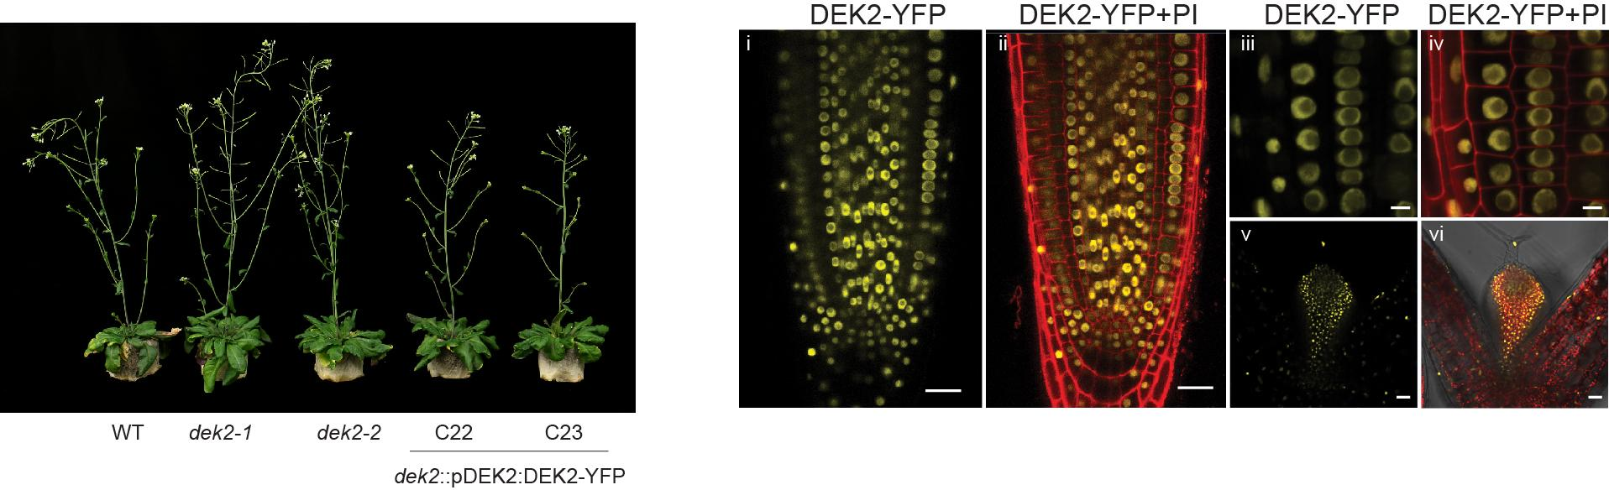

Supplementary Figure 2: Generation of YFP tagged DEK2 lines. A. Picture of 4 weeks-old WT, dek2-1, dek2-2 and two complementation lines C22 and C23 expressing pDEK2:DEK2-YFP in the dek2-1 background. B. Confocal images of the root and apical meristem of 5 days old seedlings showing the expression of DEK2-YFP in the nuclei.

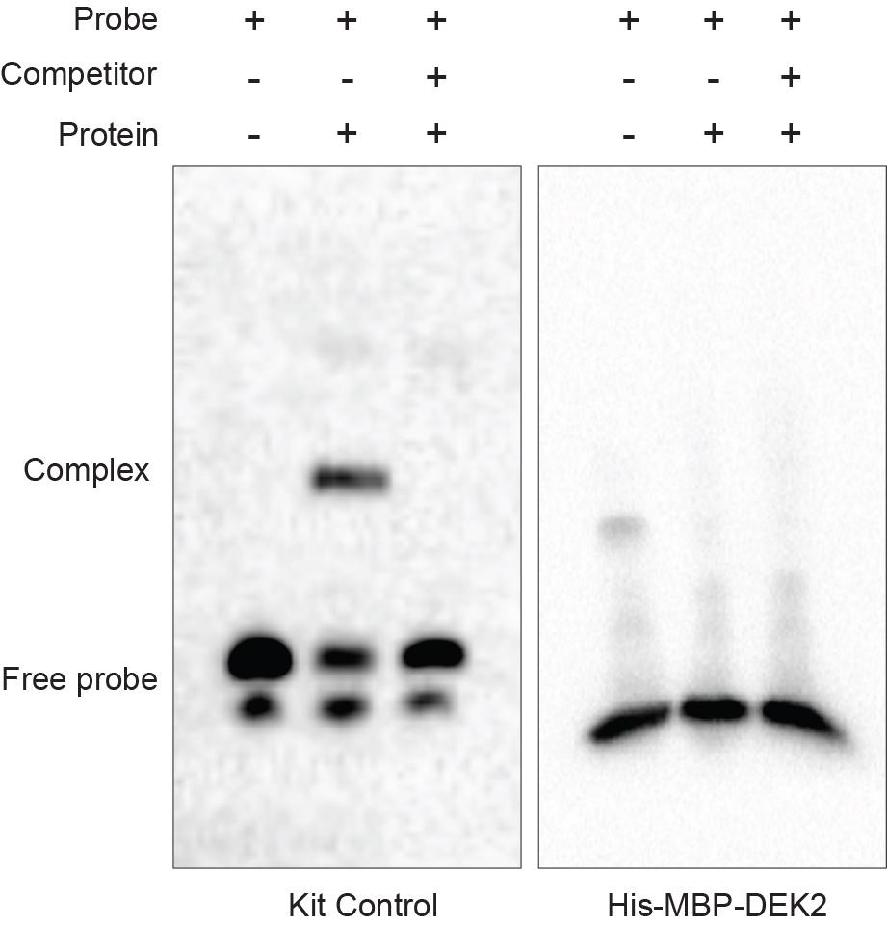

Supplementary Figure 3: Electrophoretic mobility shift assay (EMSA). EMSA was carried out with the kit controls (left panel) and with biotin labeled TCP binding sequence (GTGGGCCC) and His-MBP-DEK2 (right panel). Unlabeled TCP binding sequence was used as the competitor.

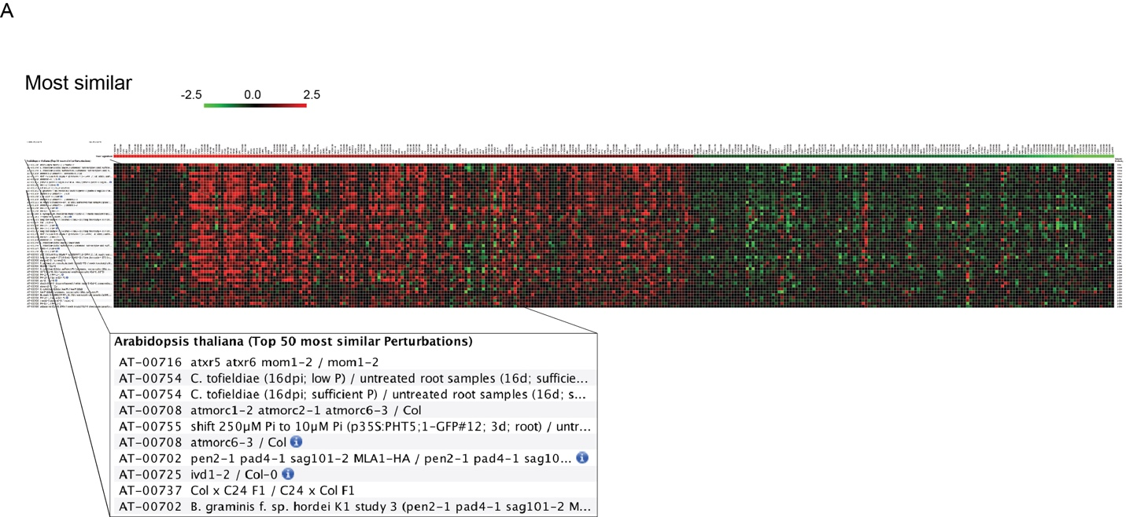

Supplementary Figure 4: Similarity between dek2 transcriptome and published transcriptome data using Genevestigator. The 200 most up- and down-regulated genes in dek2 were used as a signature to search for experiments with similar transcriptome changes. The relative similarity scores between the signature input and a particular experiment is 1.06.

