Supplementary information
Endothelial tip-cell position, filopodia formation and biomechanics require BMPR2 expression and signaling

Christian Hiepen^{1†*#}, Mounir Benamar^{1*#}, Jorge Barrasa-Fano², Mar Cóndor², Mustafa Ilhan^{1,3}, Juliane Münch⁴, Nurcan Hastar¹, Yannic Kerkhoff¹, Gregory S. Harms⁵, Thorsten Mielke⁶, Benjamin Koenig⁷, Stephan Block¹, Salim Abdelilah-Seyfried⁴, Hans Van Oosterwyck^{2, 8}, Petra Knaus^{1,7*}

¹Freie Universitaet Berlin, Institute for Chemistry and Biochemistry, Thielallee 63, 14195 Berlin, Germany
†Current affiliation: Westphalian University of Applied Sciences, August-Schmidt-Ring 10, 45665 Recklinghausen, Germany
²KU Leuven, Department of Mechanical Engineering, Biomechanics section, Leuven, Celestijnenlaan 300C, 3001 Leuven, Belgium
³Berlin School of Integrative Oncology, Augustenburger Platz 1, D-13353 Berlin, Germany
⁴Universitaet Potsdam, Institute of Biochemistry and Biology, Karl-Liebknecht Strasse 24-25, 14476 Potsdam-Golm, Germany
⁵Universitaetsmedizin, Johannes Gutenberg-Universität Mainz, Cell Biology Unit, Imaging Core Facility and the Research Center for Immune Intervention, Langenbeckstraße 1, 55131 Mainz, Germany
⁶Max-Planck-Institute for Molecular Genetics, Microscopy & Cryo-Electron Microscopy, Ihnestraße 63-73, 14195 Berlin, Germany
⁷Leibniz Forschungsinstitut für Molekulare Pharmakologie (FMP), Berlin, Germany
⁸ KU Leuven, Prometheus Division of Skeletal Tissue Engineering, Leuven, Belgium

# these authors contributed equally to this work
*Corresponding authors: Petra Knaus, Christian Hiepen
Petra.knaus@fu-berlin.de; christian.hiepen@w-hs.de

This file includes:
Supplemental Figures 1-4 and subfigures
Supplementary Table 1. Oligonucleotides used for cloning.

Figure 1- figure supplement 1

Figure 1- figure supplement 1: bmpr2b was targeted in samples consisting of Zebrafish embryos by using a splice morpholino and its expression was analyzed by semiquantitative results of reverse transcription PCR (upper) at 8 hrs post fertilization (hpf) relative to beta actin PCR (lower). Arrows indicate loss of bmpr2b transcript upon injection of morpholino E2 in two different experiments.
Figure 1- figure supplement 2

Figure 1- figure supplement 2: Representative images of kdrl-GFP reporter expressing zebrafish treated with control or BMPR2-targeting morpholinos (bmpr2b MO) at 26 hrs and 32 hrs post fertilization (hpf). Maximum projection images show the caudal vein plexus (CVP) from kdrl:GFP control and bmpr2b MO-treated embryos. Upper panel: Arrows indicate cells/ sprouts protruding from the CVP. Lower panel: Asterisks´ indicate the fenestrations of the plexus, which are reduced in bmpr2b morphant CVP. Scale bar: 50 µm.

Figure 1- figure supplement 3

Figure 1- figure supplement 3: Immunoblot against BMPR2 and beta Actin: Cell extracts of HUVECs transfected with siControl or siBMPR2 silencing-RNA (left) and BMPR2 expression in BMPR2^{wt} or BMPR2^{+/-} CRISPR/Cas9 edited EC cell line EA.hy926 (parental cell type = HUVECs) (right).

Figure 1- figure supplement 4

Figure 1- figure supplement 4: Quantification of filopodia length in HUVECs transfected with siControl or siBMPR2 siRNA and in BMPR2^{wt} or BMPR2^{+/-} ECs. n.s.: p > 0.05.
Figure 1- figure supplement 5

Figure 1- figure supplement 5: Immunofluorescence staining of HUVECS transfected with GFP control or BMPR2-GFP expression plasmids. Phalloidin (magenta), DAPI (blue), anti-GFP antibody (green). Arrows indicate BMPR2-GFP localization. Insets (II) show regions of interest. Scale bar 10 µm.

Figure 1- figure supplement 6

Figure 1- figure supplement 6: Quantification of the number of filopodia per 100 µm of cell edge in BMPR2^{wt} ECs and HUVECs overexpressing GFP or BMPR2-GFP. *p<0.05.

Figure 1- figure supplement 7

Figure 1- figure supplement 7: Immunofluorescence staining of BMPR2^{wt} ECs co-transfected with different amounts of BMPR2-GFP expression vector (1 µg and 5 µg/ 25.000 cells). Phalloidin (magenta), DAPI (blue), GFP (green). Arrowheads indicate BMPR2 localization hotspots. Insets show regions of interest. Scale bar: 10 µm.

Figure 1- figure supplement 8

Figure 1- figure supplement 8: Immunoblot against pSMAD 1/5/9 and GAPDH from HUVECs and BMPR2^{wt} ECs treated with DMSO or small molecule inhibitor LDN-193189 in EC activation medium containing 20 % Serum and angiogenic growth factors (left). Quantification of the number of filopodia per 100 µm of cell edge in BMPR2^{+/-} ECs overexpressing GFP control or BMPR2-GFP and treated with DMSO or 5 µM LDN-193189 (right). LDN treatment did not induce significant reduction in number of Filopodia per 100 µm cell edge. *p<0.05; ****p<0.0001.

Figure 1- figure supplement 9

Figure 1- figure supplement 9: Single-Particle Tracking Microscopy (SPTM) of BMPR2-HA overexpressed in Cos7 cells and labeled using control IgG-QDot antibody (top = no binding) or anti-HA-QDot antibody (bottom = BMPR2 binding). Cos7 cells were transfected with LifeAct-GFP prior to imaging and imaged by Total internal reflection fluorescence (TIRF) microscopy. Detected QDot trajectories were overlayed onto the selected cell and color-coded relative to their displacement magnitude. Insets show regions of interest. The control trajectories are much shorter (in terms of number of frames) and have much longer step lengths than the BMPR2 trajectories.

Figure 2- figure supplement 1

Figure 2- figure supplement 1: 3D reconstruction from confocal z-scan images of BMPR2^{wt} ECs or BMPR2^{+/-} ECs polarized in a gap closure assay towards the direction of migration (see directionality top right corner). Filamentous actin (F-actin) cytoskeleton was stained by Phalloidin (white), DAPI (blue). Arrows indicate cell-cell gaps at the leading edge (top) or cell-cell contact points (bottom).

Figure 2- figure supplement 2

Figure 2- figure supplement 2: (top) Immunofluorescence staining of BMPR2^{wt} ECs and BMPR2^{+/-} ECs were seeded on fibronectin coated glass. Phalloidin (magenta), DAPI (blue), Vinculin (white) stainings are indicated. Arrows indicate the localization of vinculin-rich focal adhesions (FA), particularly at the cell periphery. Insets show regions of interest. Scale bar: 10 µm. (bottom) Quantification of FA circularity index (circularity is simplified on the y-axis) for BMPR2wt ECs and BMPR2+/- ECs seeded on 1,.5 kPa PDMS substrate, 28 kPa Polydimethylsiloxan (PDMS) substrate (fibronectin fibronectin-coated) or fibronectin fibronectin-coated glass. ****p<0.0001.
Figure 2- figure supplement 3

Figure 2- figure supplement 3: Mosaic tube formation assay. Pre-labeled BMPR2^{wt} ECs (green) and BMPR2^{+/-} ECs (magenta) were seeded in Matrigel in a 1:1 ratio and imaged after 1,5 hrs, 4 hrs and 6 hrs upon seeding on soft Matrigel respectively. Insets show tubes that originated by EC adhesion and during tube- fusion.

Figure 2- figure supplement 4

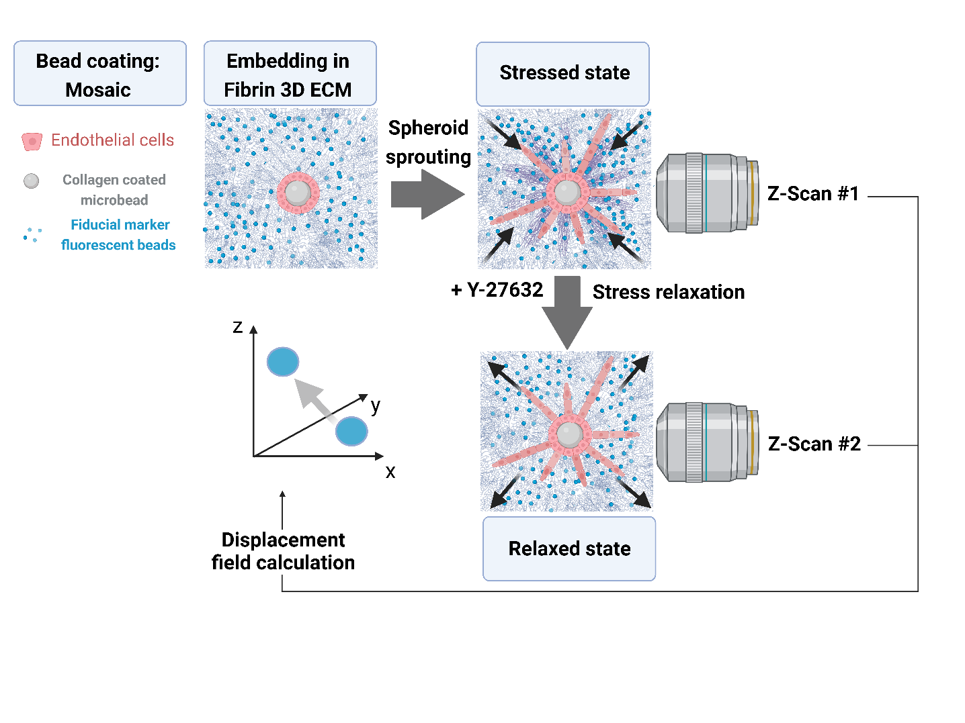
Figure 2- figure supplement 4: Schematic representation of the 3D Traction Force Microscopy (3D TFM) experimental workflow for ECM displacement calculation. Briefly, microcarrier beads (used as fiducial markers to detect vector-based displacements of ECM by EC pulling forces) are coated ECs to obtain fully coated spheroids. EC- coated spheroids are embedded in Fibrin gel polymerizing in-situ together with beads upon addition of thrombin to fibrinogen. Spheroid sprouts form during 64+ hrs, leading to ECM deformations of the Fibrin:marker beads gel by EC interaction with the fibrin ECM via integrin-transmitted pulling forces. After imaging sprouts in their stressed state, cell relaxation is induced experimentally by inhibiting ROCK activity (addition of Y-27632 small molecule inhibitor) required for phosphorylation of Myosin II, a key component of actomyosin contractility. Relaxation of ECs is leading to a relaxed matrix state and consequent ECM/fiducial marker displacement. Displacements are calculated from bead positions in stressed state versus relaxed state through Free Form Deformation (FFD)-based non-rigid image registration of 3D confocal stacks of beads (116).

Figure 2- figure supplement 5

Figure 2- figure supplement 5: Average 3D TFM displacement measured along the normalized distance of sprouts of various length for BMPR2^{wt} ECs and BMPR2^{+/-} ECs. Dashed lines represent individual sprout measurements. Colored lines represent averaged displacements for all sprouts per condition.

Figure 3- figure supplement 1

Figure 3- figure supplement 1: MOSAIC Magnified sprouts with tip cells (green) and stalk cells (magenta) upon 60 hours of sprouting. Asterisks indicate position of tip cell. Scale bar: 20µm
Figure 3- figure supplement 2

Figure 3- figure supplement 2: Left: Reverse control labelling of MOSAIC spheroids with BMPR2^{wt} ECs (red) and BMPR2^{+/-} ECs (green) to rule out dye effects for tip cell position. Cells were seeded in fibrin for sprouting and imaged at 16 hrs, 36 hrs and 48 hrs after embedding (left). Representative images of tip cells from reverse MOSAIC spheroids after 48hrs of sprouting (right). In this spheroid labelling approach, BMPR2^{wt} ECs and BMPR2^{+/-} ECs located to their respective position (BMPR2^{wt} cells always at the tip) independent of the dye color used. Magnified region of interest shows sprouts with individual tip cells in green and stalk cells in magenta upon 60 hrs of sprouting. Asterisks indicate position of TC. Scale bar: 20 µm

Figure 4- figure supplement 1

Figure 4- figure supplement 1: Immunoblot against CDC42 and GAPDH from BMPR2^{wt} ECs and BMPR2^{+/-} ECs cultured in EC activation medium containing 20% Serum and pro-angiogenic growth factors.

