Electric-field-induced crystallization of Hf_{0.5}Zr_{0.5}O₂ thin film based on phase-field modeling
Zhaobo Liu^{a,b}, Xiaoming Shi^{a,b,c}, Jing Wang^{a,b}, and Houbing Huang^{a,b}*
ªAdvanced Research Institute of Multidisciplinary Science, Beijing Institute of Technology, Beijing, 100081, China
^{b}School of Materials Science and Engineering, Beijing Institute of Technology, Beijing, 100081, China
^{c}Department of Physics, University of Science and Technology Beijing, Beijing, 100083, China
Supplementary Note 1: The crystallization of HZO film under different electric field.
We further applied varying electric field for 4000 times cycling. As it is considered that the critical electric field is 2MV/cm, the crystallization does not occur under applying electric field at 1MV/cm, which is shown in figure. S1. However, as the electric field magnitude increasing, the drive force intensified, which is manifested by the potential well at $η\left(i,j,k\right)=1$ becoming deeper in double-well model, resulting in a faster transition to the crystalline phase. Hence, the degree of crystallinity will reach 1 with fewer cycles of the electric field.
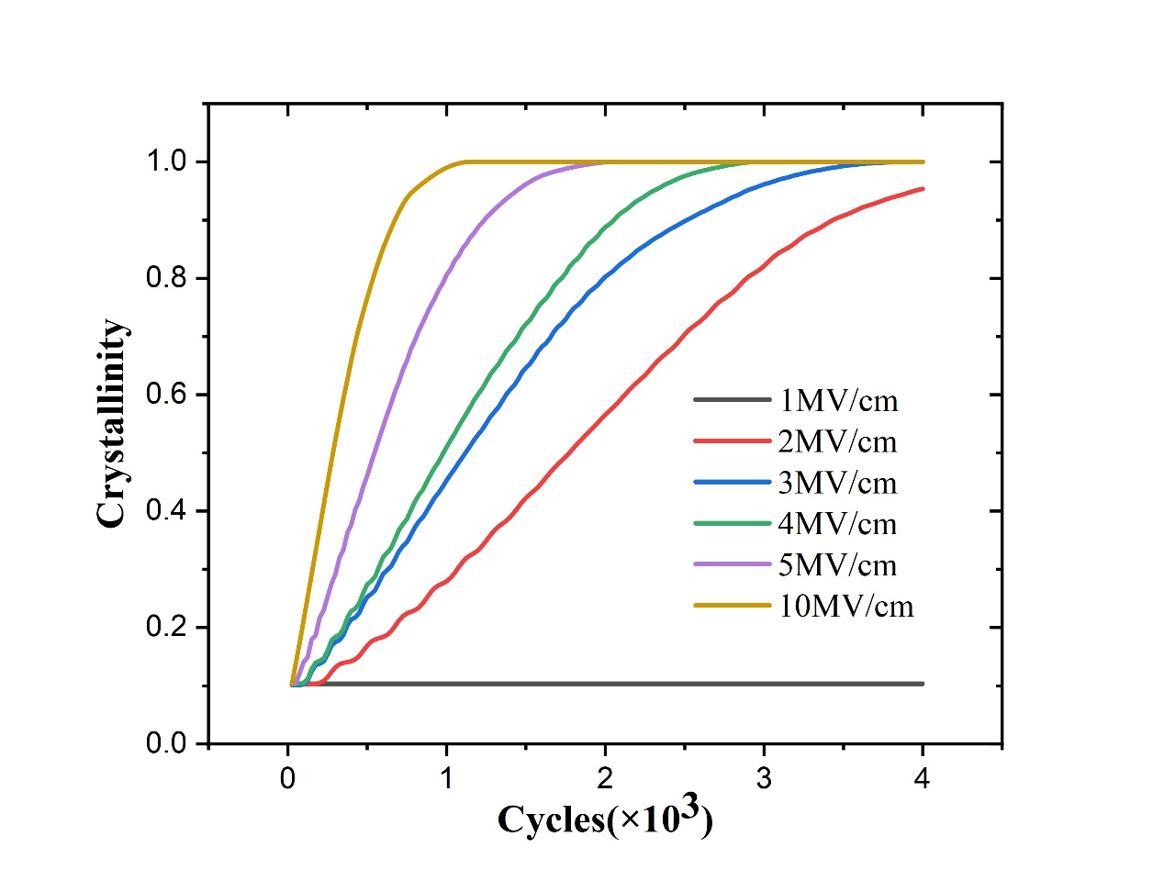
Fig. S1. Simualted crystalline volume fraction under different electric field for 4000 cycles.
Supplementary Note 2: The polarization response of different states under readout electric field signals.
To analyze the stability of the four storage states, we applied electric fields of 1MV/cm as readout signals separately for 100 cycles. And the result is depicted in figure. S2, which illustrates that at varying degrees of crystallinity, applying a readout signal smaller than the critical field can maintain the polarization in a stable state, meeting the performance requirements for artificial synapses as information storage devices.
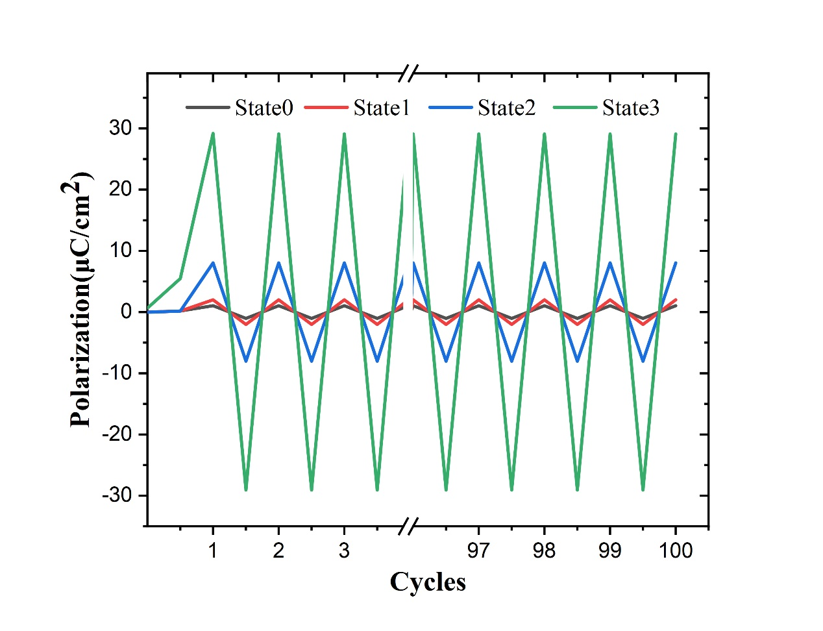
Fig. S2. The polarization response of different states under 1MV/cm electric field pulses as readout signals.

