Supplementary Materials
Distribution and extent of suitable habitats of Prince Ruspoli turaco (Tauraco ruspolii) and White-cheeked turaco (Tauraco leucotis) in times of climate change in Ethiopia
Mulatu Ayenew, Chala Adugna Kufa, Ahmed Seid Ahmed^{3, 5}, Hailu Tilahun, Misganaw Tamirat, Mesele Yihune, Anagaw Atickem, Afework Bekele and Bezawork Afework Bogale

One Table and three figures
Table S1 Study species occurrence points
Tauraco ruspolii |  | Tauraco leucotis
Longitude | Latitude | Longitude | latitude
39.52672 | 5.910117 | 38.84825 | 9.712468
39.53677 | 5.931825 | 38.798 | 7.54
39.58169 | 5.916812 | 38.44216 | 6.750394
39.63351 | 5.307099 | 38.91023 | 8.285424
39.52451 | 5.886437 | 39.96128 | 6.96715
39.5546 | 5.91764 | 37.58035 | 6.181895
39.52715 | 5.931786 | 38.64153 | 7.081995
39.52816 | 5.853797 | 37.38443 | 11.59827
39.65227 | 5.300933 | 38.81514 | 9.732567
39.76517 | 6.431527 | 38.7899 | 7.528201
39.67646 | 5.939675 | 38.8093 | 7.534874
39.53957 | 5.789737 | 39.72254 | 6.70515
39.52924 | 5.650841 | 38.77044 | 7.518675
39.52881 | 5.719846 | 38.63555 | 7.102889
39.53278 | 5.671007 | 38.63824 | 7.09303
39.53862 | 5.771613 | 39.71471 | 6.744453
39.32682 | 5.742681 | 37.57413 | 5.999894
39.53068 | 5.685662 | 37.47131 | 12.60945
39.52449 | 5.922595 | 38.6348 | 7.121674
39.45465 | 5.565416 | 38.83568 | 9.721113
38.81667 | 4.75 | 39.72315 | 6.714918
39 | 5.883333 | 37.36176 | 11.59843
39.58333 | 5.333333 | 39.73076 | 6.674495
39.11667 | 5.533333 | 38.65645 | 8.473116
40.7 | 7.133333 | 38.65896 | 8.462312
 |  | 39.16109 | 6.529362
 |  | 39.14622 | 6.509047
 |  | 37.30531 | 8.559749
 |  | 37.29649 | 8.571432

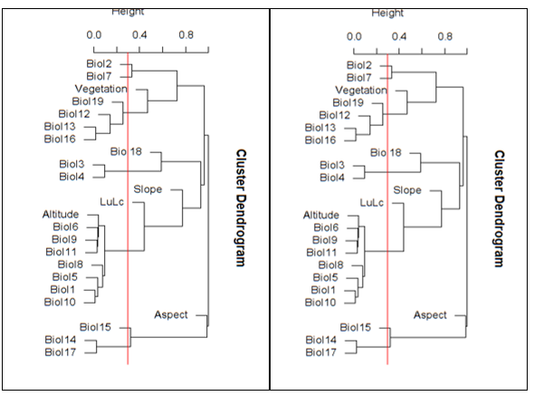
Figure S1 Pairwise Pearson correlation of environmental variables for Tauraco ruspolii (left) and Tauraco leucotis (right). Redline shows a correlation coefficient r = |0.7|. Annual Mean Temperature (Biol1), Mean Diurnal Range (mean of monthly max temp - min temp; Biol2), Isothermality (Biol3), Temperature Seasonality (Biol4), Maximum Temperature of Warmest Month (Biol5), Minimum Temperature of Coldest Month (Biol6), Temperature Annual Range (Biol7), Mean Temperature of Wettest Quarter (Biol8), Mean Temperature of Driest Quarter (Biol9), Mean Temperature of Warmest Quarter (Biol10), Mean Temperature of Coldest Quarter (Biol11), Annual Precipitation (Biol12), Precipitation of Wettest Month (Bio13), Precipitation of Driest Month (Bio14), Precipitation Seasonality (Coefficient of Variation) (Bio15), Precipitation of Wettest Quarter (Bio16), Precipitation of Driest Quarter (Bio17), Precipitation of Warmest Quarter (Bio18), Precipitation of Coldest Quarter (Bio19), Slope, Aspect, Altitude, Land use land cover change (LuLc) and Vegetation.

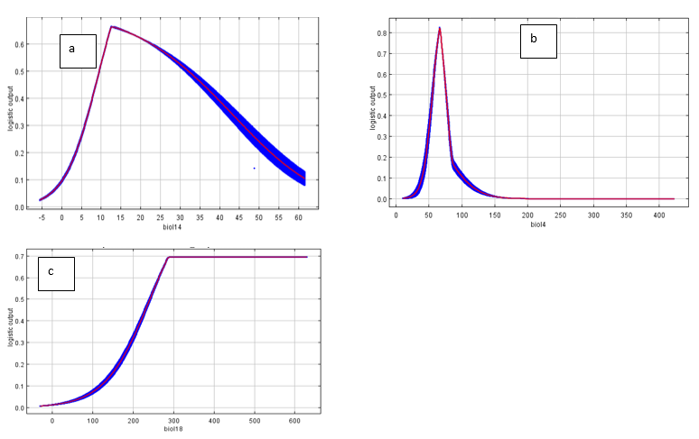
Figure S2. Response curve of the most important environmental variables on T. ruspolii: a) Precipitation of the driest month (Biol1), b) Temperature seasonality (Biol4), and c) Precipitation of the warmest quarter (Biol18)

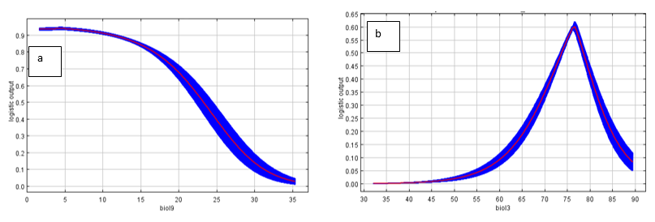
Figure S3: Response curve of the most important environmental variables on T. leucotis: a) Temperature of driest quarter (Biol9) and b) Isothermality (Biol3).

