Supplementary figures
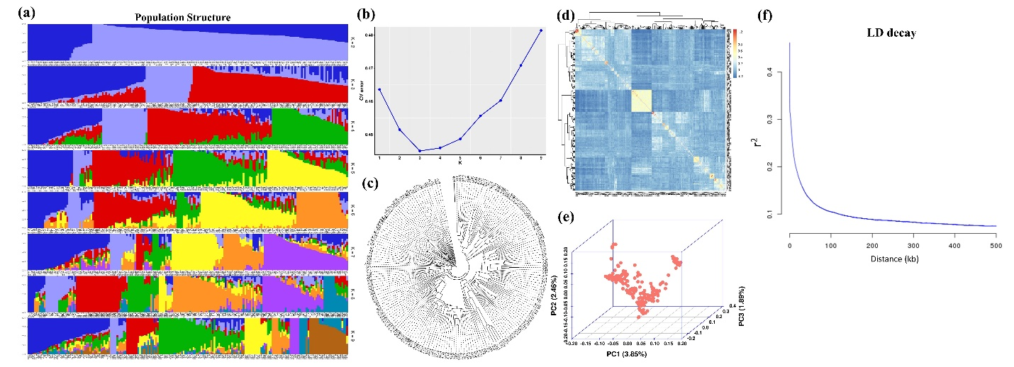

Fig. S1 Population stratification and LD analysis of the 198 oil palm individuals.
(a) Dynamics of population structure under different K (K = 2-9) values. (b) The CV error computed by Admixture. (c) Phylogenetic tree. (d) Kinship analysis. (e) PCA analysis. (f) LD decay of the population.

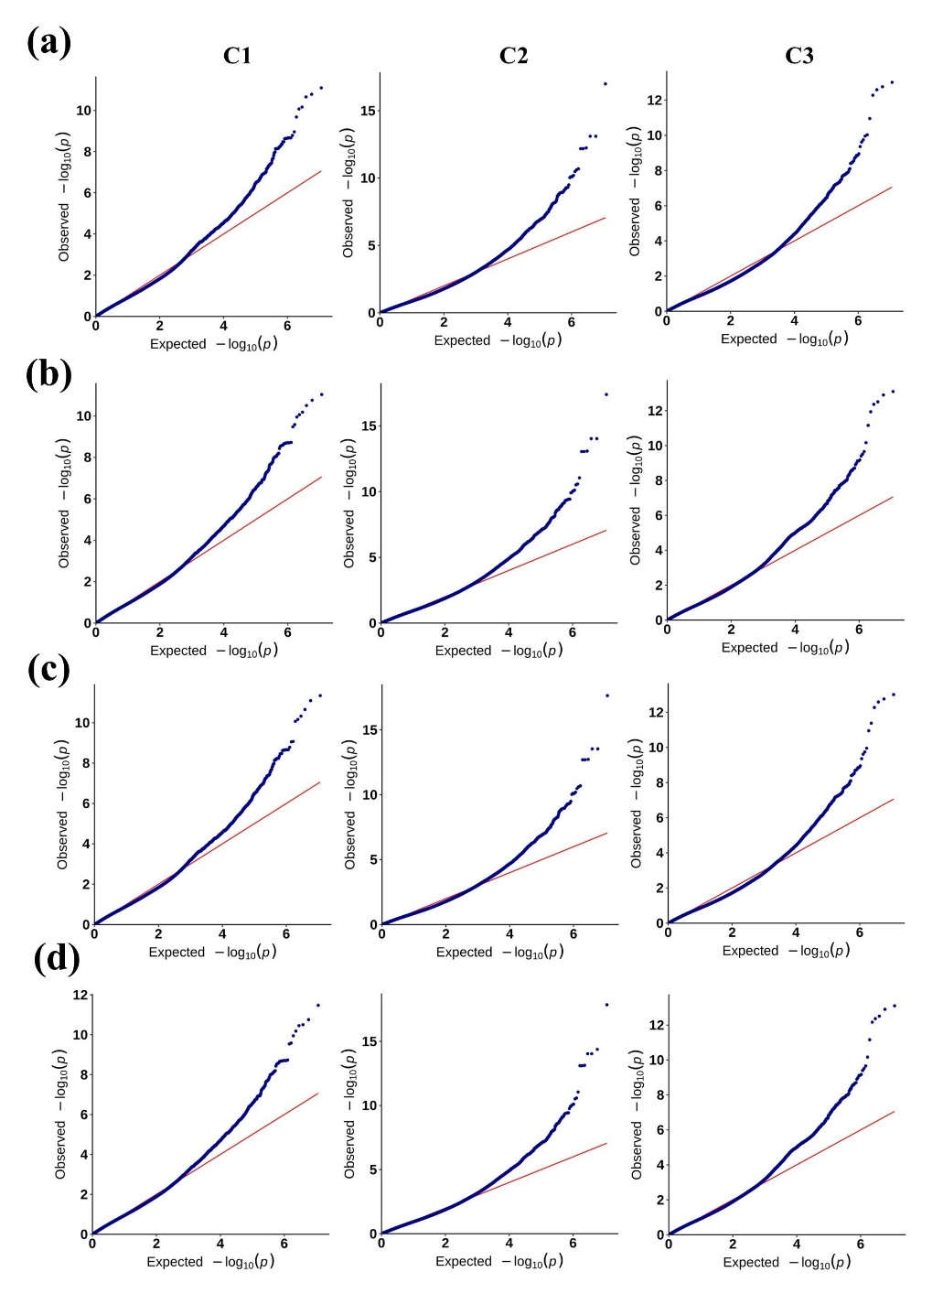
Fig. S2 Quantile-quantile (QQ) plots of the GLM (a), GLM-Q (b), MLM-K (c), and MLM-QK (d) models. The plot shows the expected vs. observed -log10(p-value) of each marker (dots). Red-line is the standard relationship among markers.

