Table 2: Interpretation of Statistically Significant Dyad Findings
Question & Participant Responses | Explanation of Results
Based on the story shared, the patient was given…  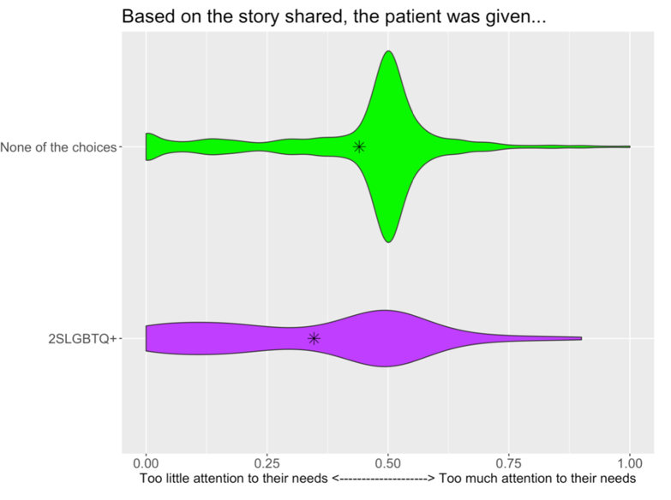 | Compared with those who did not identify as equity-deserving, 2SLGBTQQIA+ participants felt as though they were given too little attention to their needs (p<0.05).
During the visit, how much control / say did the patient have in making decisions about their care…  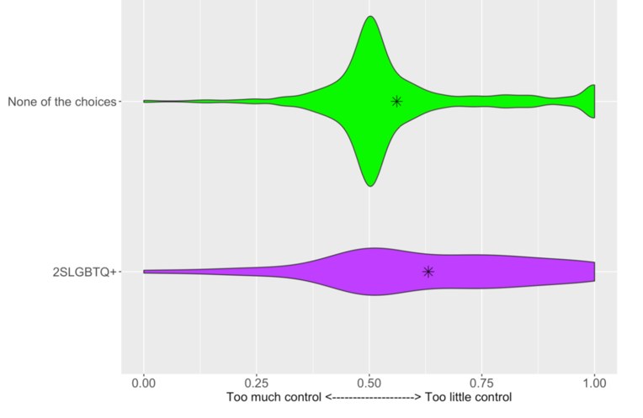 | Compared with those who did not identify as equity-deserving, 2SLGBTQQIA+ participants felt as though they were given too little control or say in making decisions about their care (p<0.05).
In the experience shared, it was more important for the patient to…  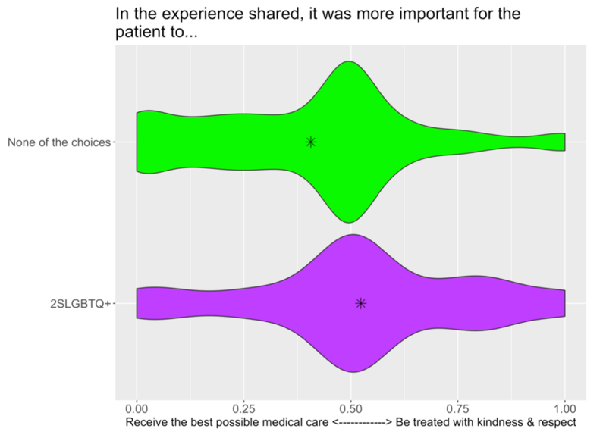 | When asked about the weighted importance of being treated with kindness and respect versus receiving the best possible medical care, compared with those who did not identify as equity-deserving, 2SLGBTQQIA+ participants placed greater value on being treated with kindness and respect than receiving the best possible medical care (p<0.05).

Table 3: Interpretation of Statistically Significant Triad Findings
During the events in the shared story, the patient was...  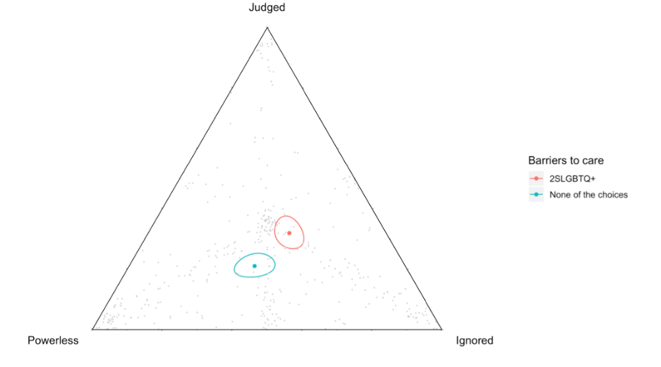 | 2SLGBTQQIA+ participants reported feeling judged and ignored, whereas those who did not identify as equity-deserving reported feeling powerless and ignored (p<0.05).
The patient’s shared experience was affected most by... 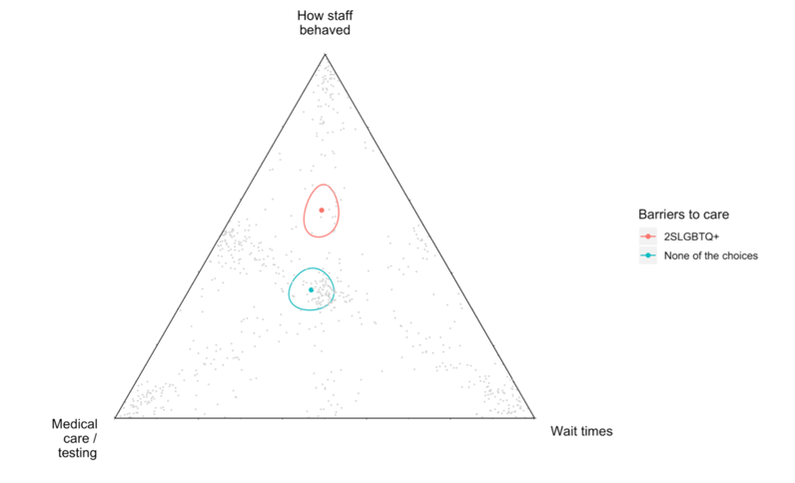 | 2SLGBTQQIA+ participants indicated that their experiences were more affected by how the staff behaved compared to those who did not identify as equity-deserving (p<0.05).
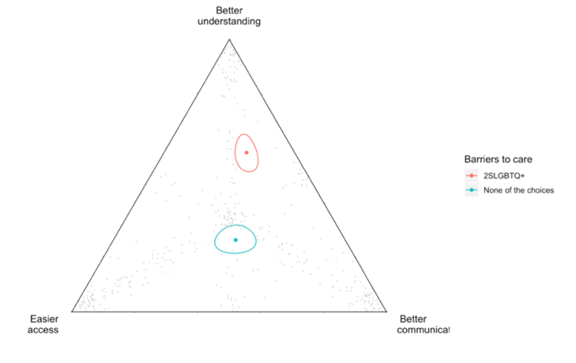  Based on the shared story, the following would improve future emergency department care: | 2SLGBTQQIA+ participants felt that a better understanding of their personal situation, identity, and culture would improve their future ED care compared with those who did not identify as equity-deserving (p<0.05).

