Supplementary information
Unveiling crystal orientation-dependent interface property in composite cathodes for solid-state batteries by in situ microscopic probe

Sunyoung Lee^{1⟊}, Hayoung Park^{2,3⟊}, Jae Young Kim¹, Jihoon Kim^{2,3}, Min-Ju Choi¹, Sangwook Han¹, Sewon Kim^{1,4}, Wonju Kim¹, Ho Won Jang^{1,6}, Jungwon Park*^{2,3,5,6} and Kisuk Kang*^{1,2,3,5}

¹ Department of Materials Science and Engineering, Institute for Rechargeable Battey Innovations, Research Institute of Advanced Materials, Seoul National University, Seoul 08826, Republic of Korea
² School of Chemical and Biological Engineering, and Institute of Chemical Process, Seoul National University, Seoul 08826, Republic of Korea
³ Center for Nanoparticle Research, Institute for Basic Science (IBS), Seoul National University, Seoul 08826, Republic of Korea
⁴ Next Generation Battery Lab, Samsung Advanced Institute of Technology, 130, Samsung-ro, Yeongtong-gu, Suwon-si, Gyeonggi-do, Republic of Korea, 443-803
⁵ Institute of Engineering Research, College of Engineering, Seoul National University, Seoul 08826, Republic of Korea
⁶ Advanced Institute of Convergence Technology, Seoul National University, Suwon 16229, Republic of Korea

*Kisuk Kang’s e-mail: matlgen1@snu.ac.kr
*Jungwon Park’s e-mail: jungwonpark@snu.ac.kr;
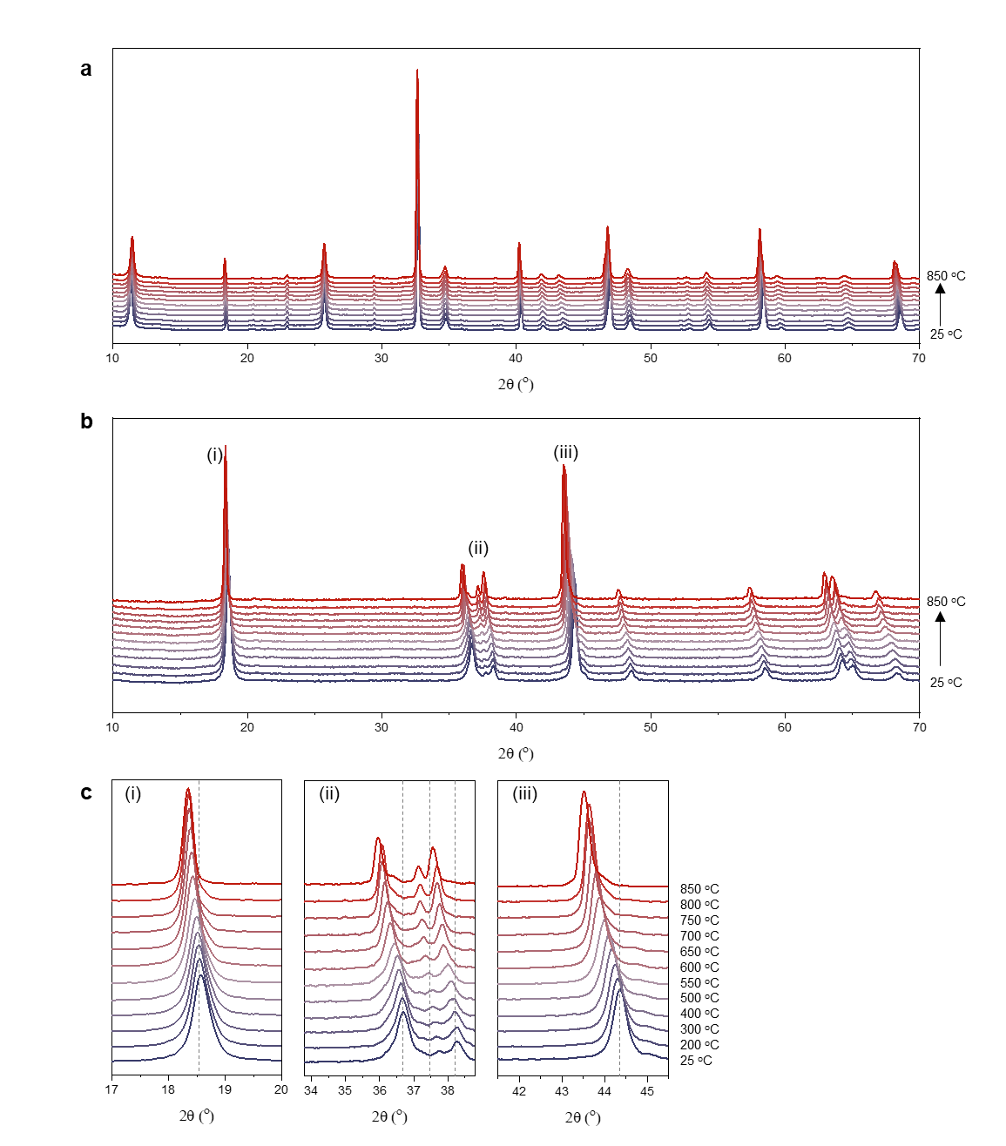
Supplementary Figure S1. a-b. In situ heating XRD of (a) LLTO and (b) NCM as a reference, respectively. c. The enlarged XRD patterns in the range of (i) 17-20 º, (ii) 35-39 º and (iii) 41-46 º for NCM(003), (101) and (104), respectively.

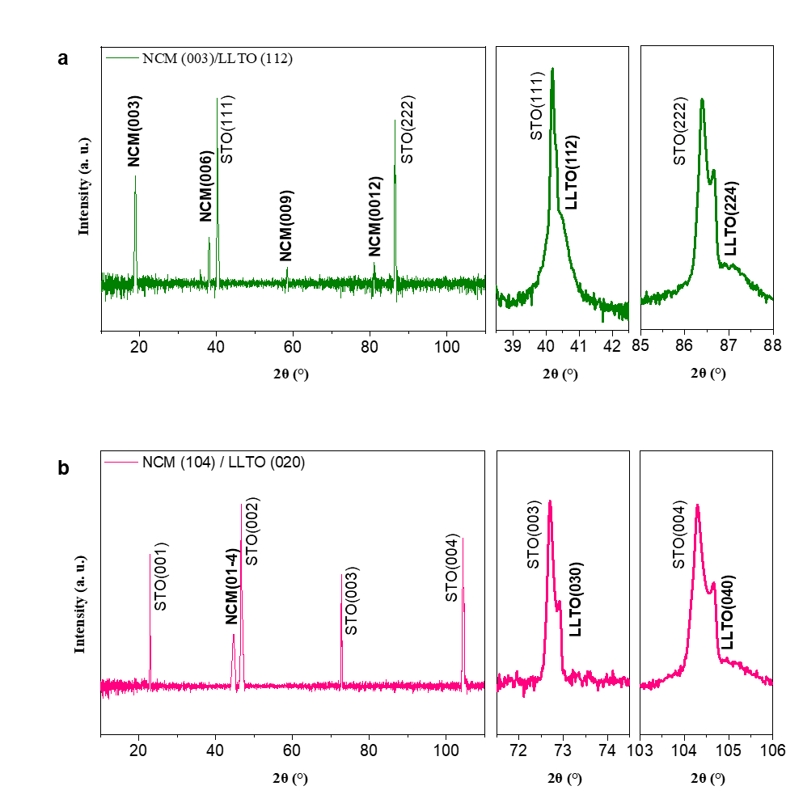
Supplementary Figure S2. XRD θ-2θ scan of the epitaxial heterostructure. a. NCM(003)/LLTO(112)/SrTiO3(111). b. NCM(104)/LLTO(020)/SrTiO3(001).

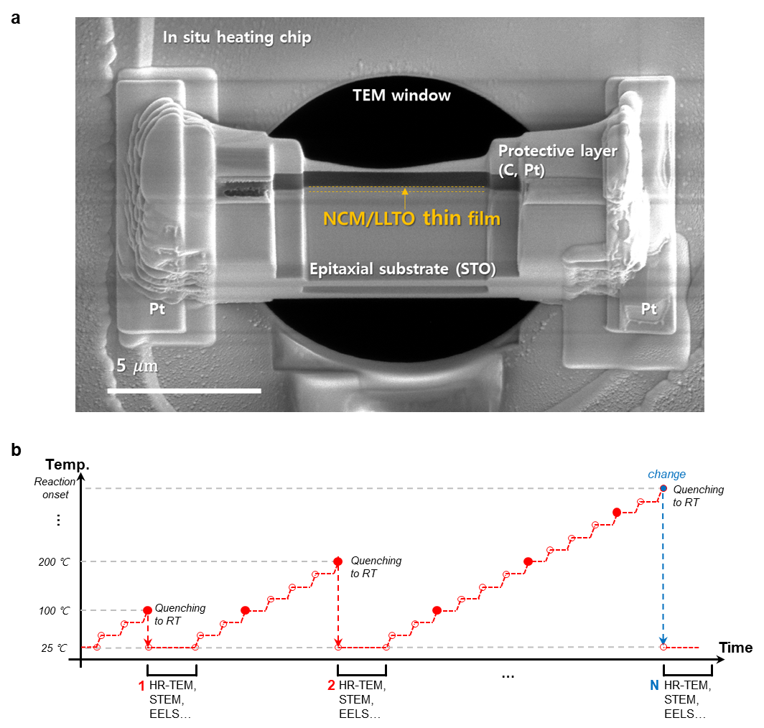
Supplementary Figure S3. a. FIB-SEM image of heating chip after sample preparation for in situ heating TEM. b. Stepwise heating profile for in situ heating TEM.

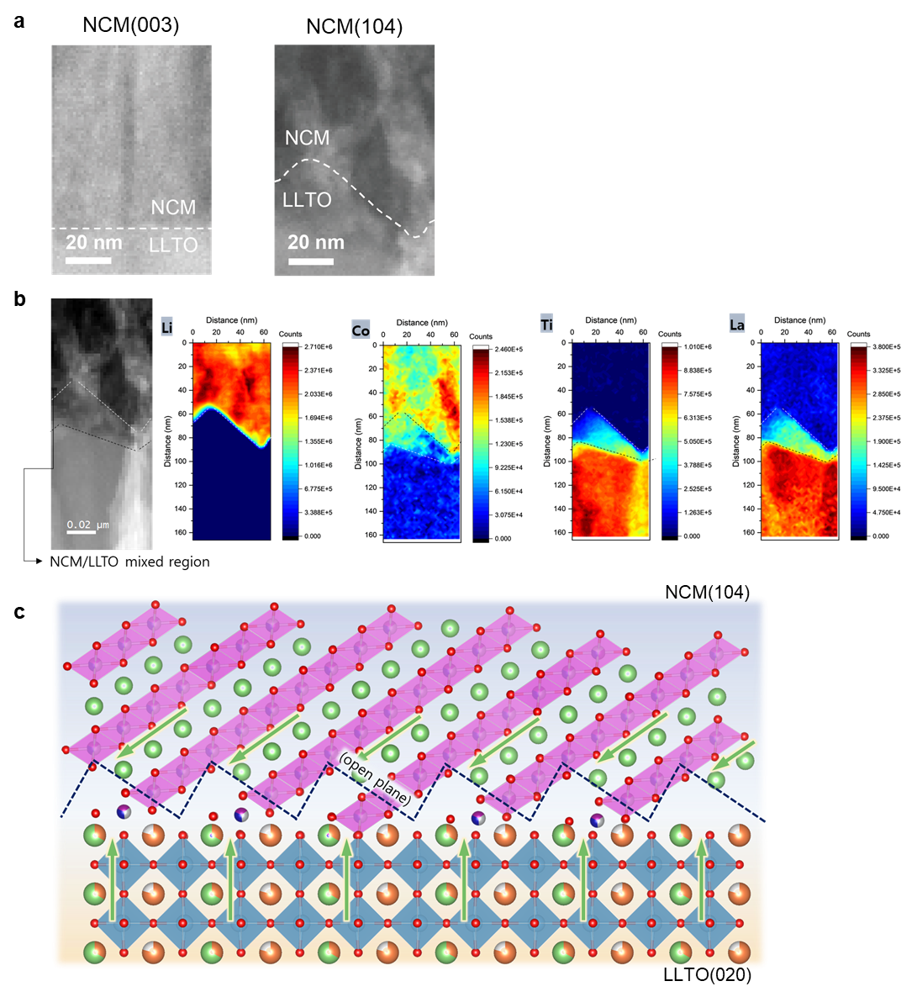
Supplementary Figure S4. a. corresponding STEM image of Li EELS maps in Figure 3a-b. b. STEM image and corresponding elemental EELS maps of pristine NCM104 before heating. c. A scheme of a sawtooth-like interfacial boundary of NCM104. NCM104 shows a sawtooth-like interfacial boundary which is the intrinsic characteristic of epitaxial growth, as explained before. This feature does not change the open ion pathway at the interface

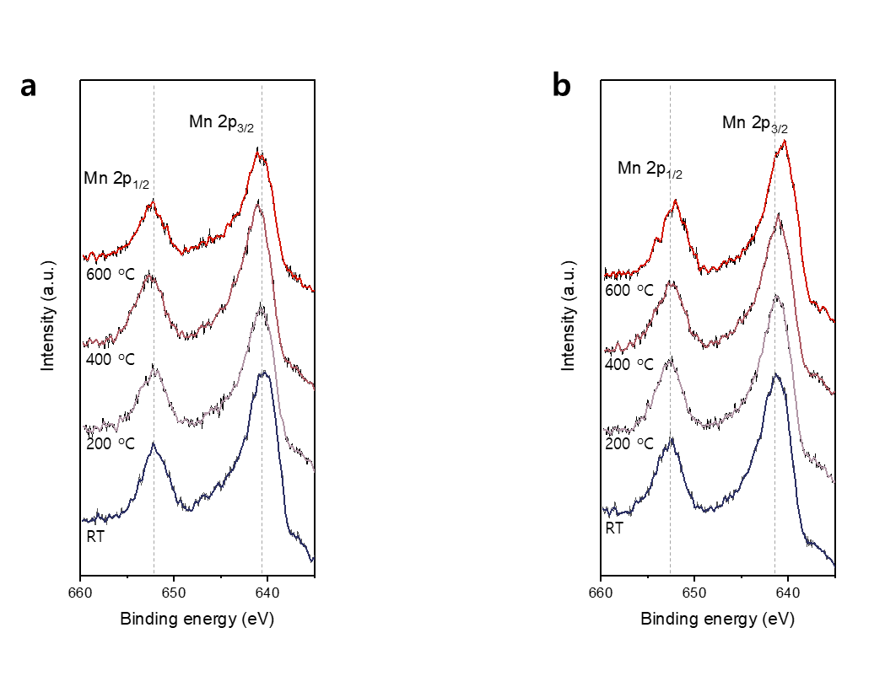
Supplementary Figure S5. XPS spectra of Mn 2p in (a) NCM104 and (b) NCM003 with increasing annealing temperature.

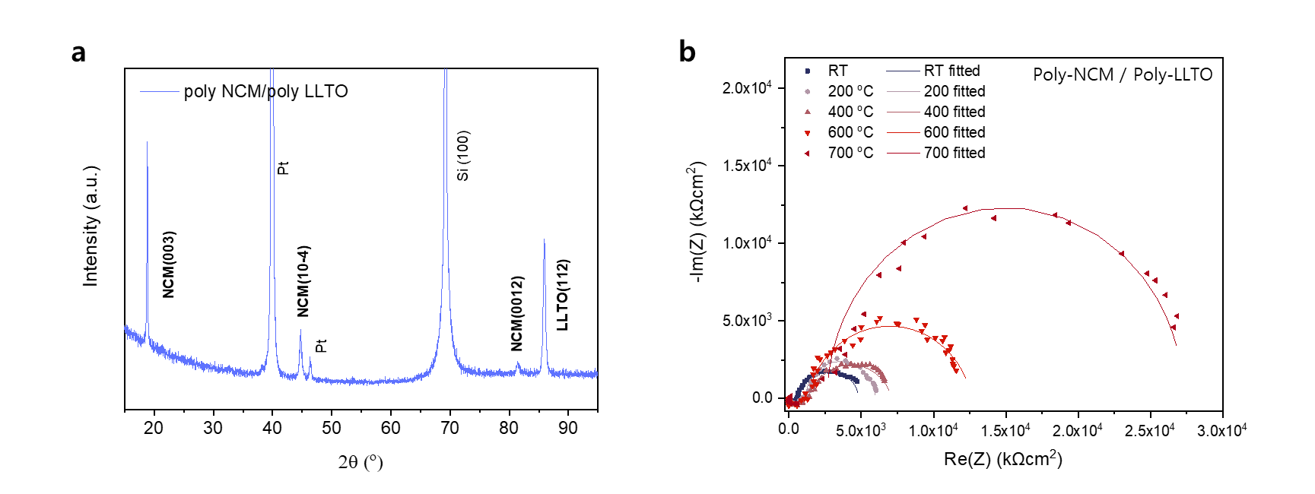
Supplementary Figure S6. a. XRD θ-2θ scan of the polycrystal NCM/polycrystal LLTO on Pt-coated Si(100) substrate. b. Comparison of the EIS spectra of polycrystal NCM/LLTO thin film at RT, 200 ℃, 400 ℃, 600 ℃, and 700 ℃.

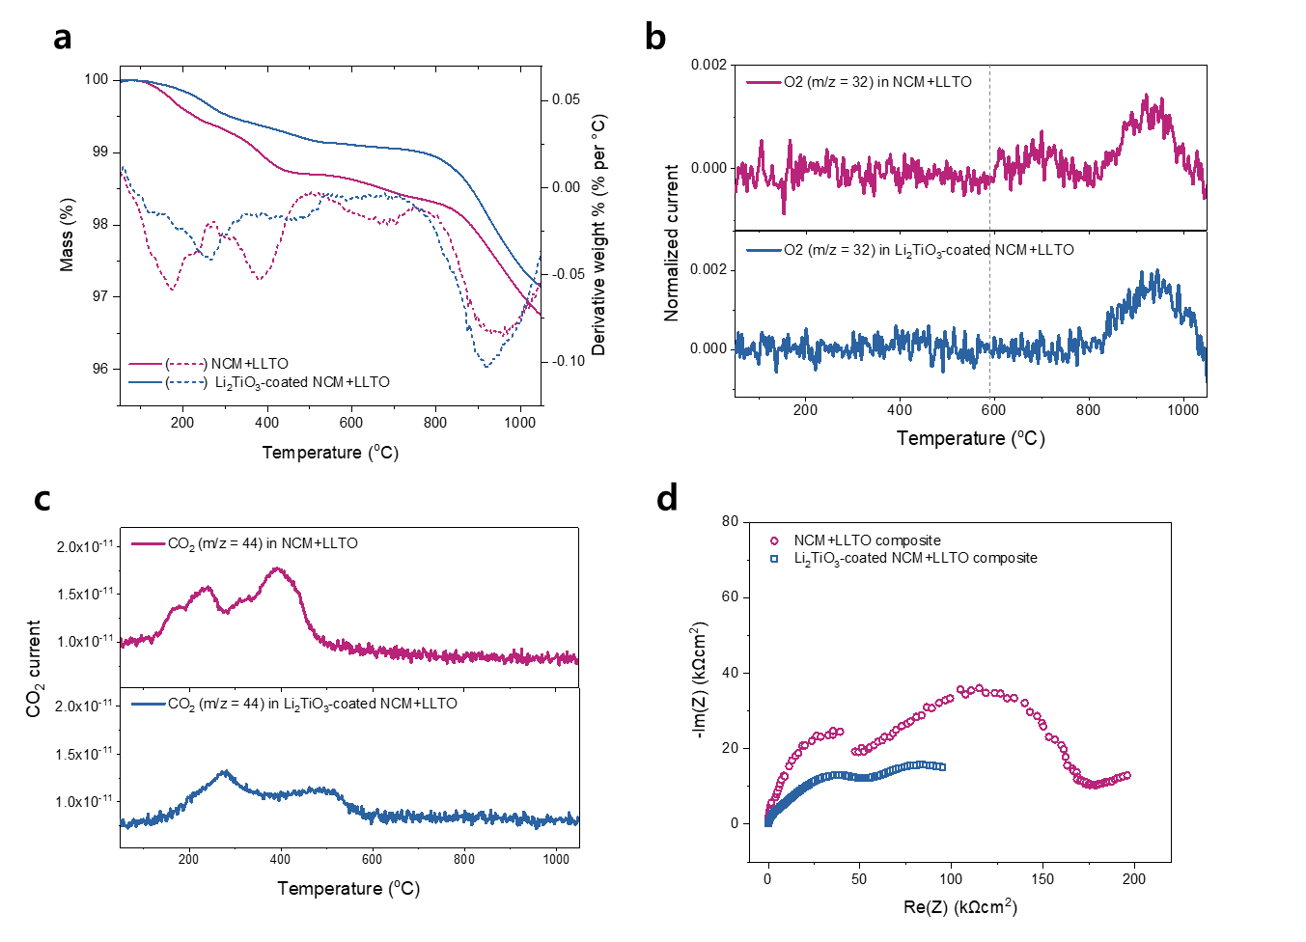
Supplementary Figure S7. Interfacial engineering with Li₂TiO₃ coating on cathode a. STA analysis of bare and LTO-coated NCM/LLTO composites. The dotted line represents the derivative weight percent. b. corresponding mass spectrometer measurements of bare and LTO-coated NCM/LLTO composites for the oxygen (m/z=32). The oxygen signal is normalized by the nitrogen signal (m/z=28) to exclude the effect of minor pressure and temperature changes. c. corresponding mass spectrometer measurements of bare and LTO-coated NCM/LLTO composites for the carbon dioxide (m/z=44). d. comparison of the EIS spectra of bare and LTO-coated NCM/LLTO composites after annealing at 600 ℃.

The mass change demonstrates that weight loss up to 500 °C is observed for both bare NCM/LLTO and LTO-coated NCM/LLTO (Figure S7a), which is related to the release of CO₂ from the overlap of the evaporation of physisorbed water and the thermal decomposition of residual Li₂CO₃ impurities as described in previous literatures (Figure S7c)^{54,61}. However, after 500 °C, further weight loss is only detected in the bare NCM/LLTO, and O₂ emission occurs, similarly to those found in the model system with closed ion pathways. (Figure S7b). The STA-MS result indicates that the interfacial side reaction related to oxygen release is effectively suppressed in the LTO-coated NCM/LLTO. We further compared the EIS of the composite cathode with coating layers (Figure S7d).

