Supplementary Information

Valence-engineered catalysis-selectivity regulation of molybdenum oxide nanozyme for acute kidney injury therapy and post-cure assessment

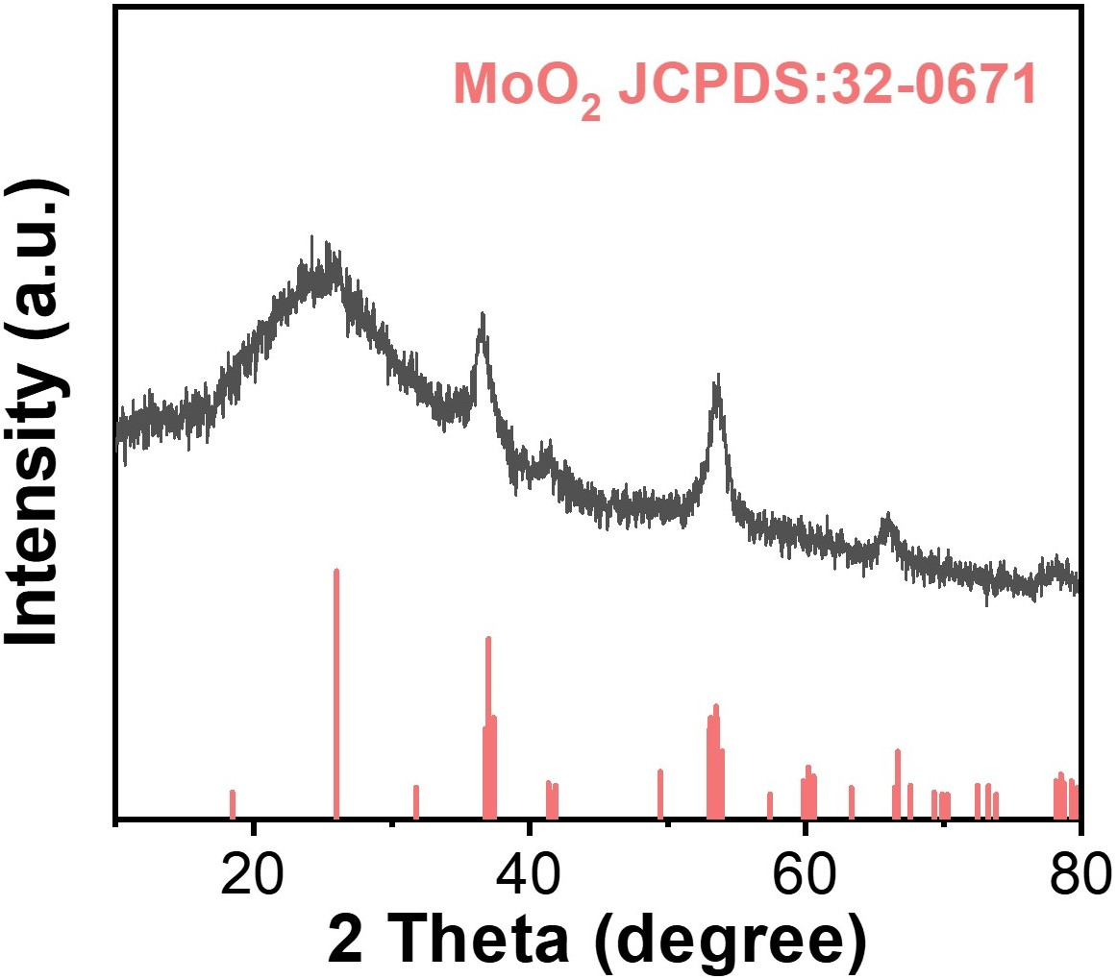
Supplementary Fig. 1. XRD pattern of MoO_{3-x}.
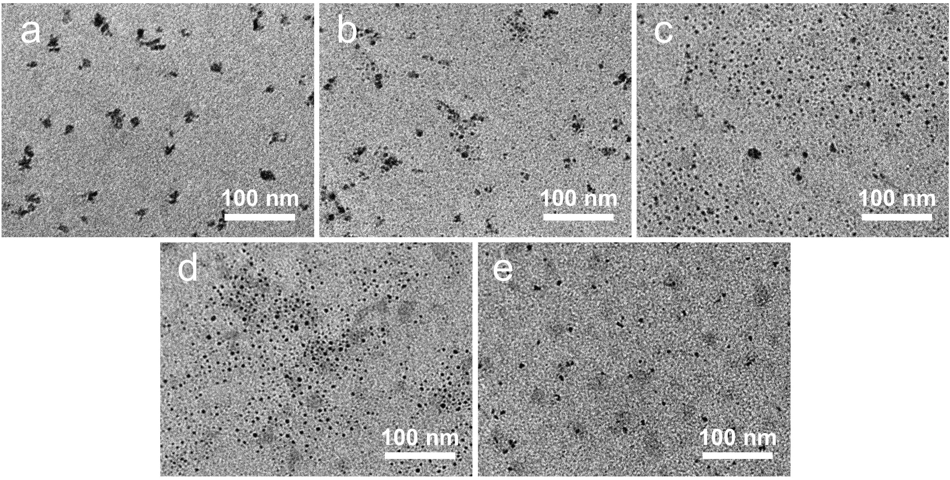
Supplementary Fig. 2. TEM images of MF-0 (a), MF-2 (b), MF-3.5 (c), MF-5 (d) and MF-10 (e).
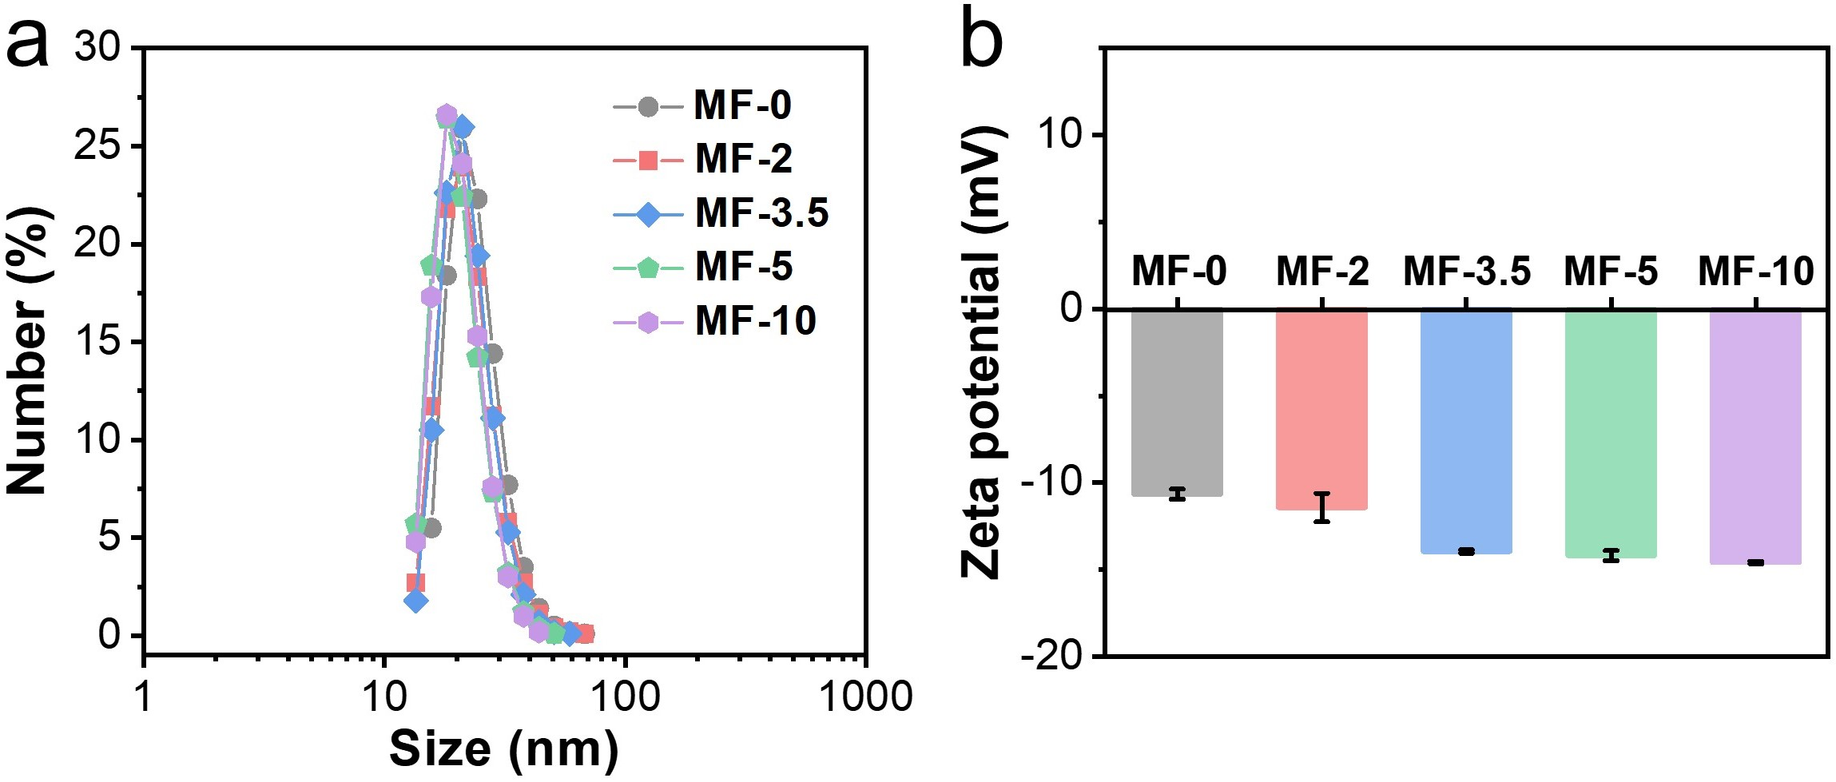
Supplementary Fig. 3. a, DLS size distribution of MF-0 (24.0 ± 6.4 nm), MF-2 (22.6 ± 6.5 nm), MF-3.5 (22.3 ± 5.6 nm), MF-5 (20.5 ± 5.2 nm), and MF-10 (20.6 ± 4.8 nm). b, Zeta potential of corresponding samples (means ± SD, n = 3).
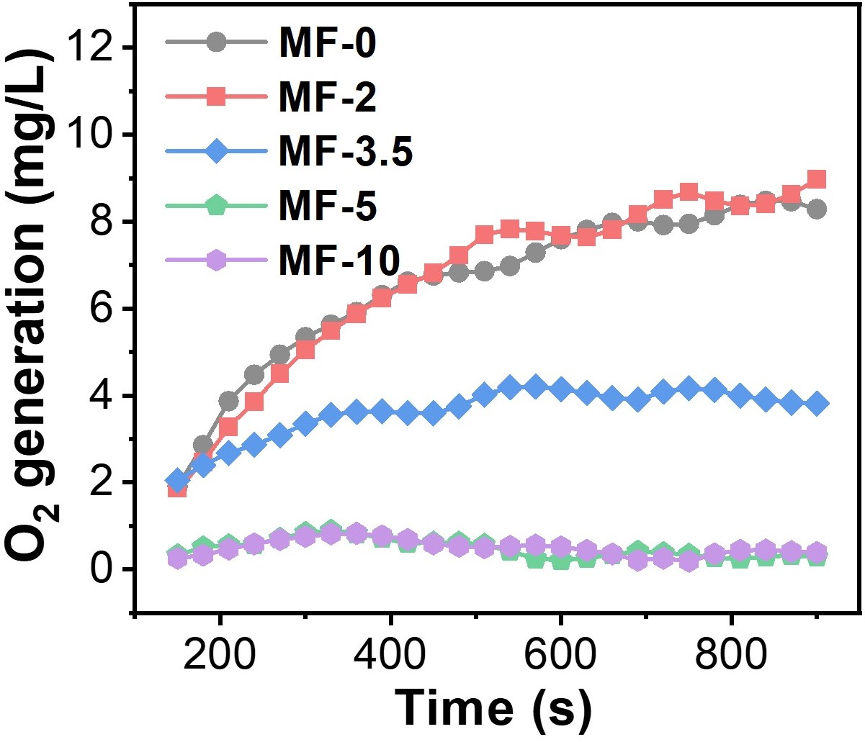
Supplementary Fig. 4. Oxygen production ability of MF-0, MF-2, MF-3.5, MF-5 and MF-10 under pH 6.5, respectively.
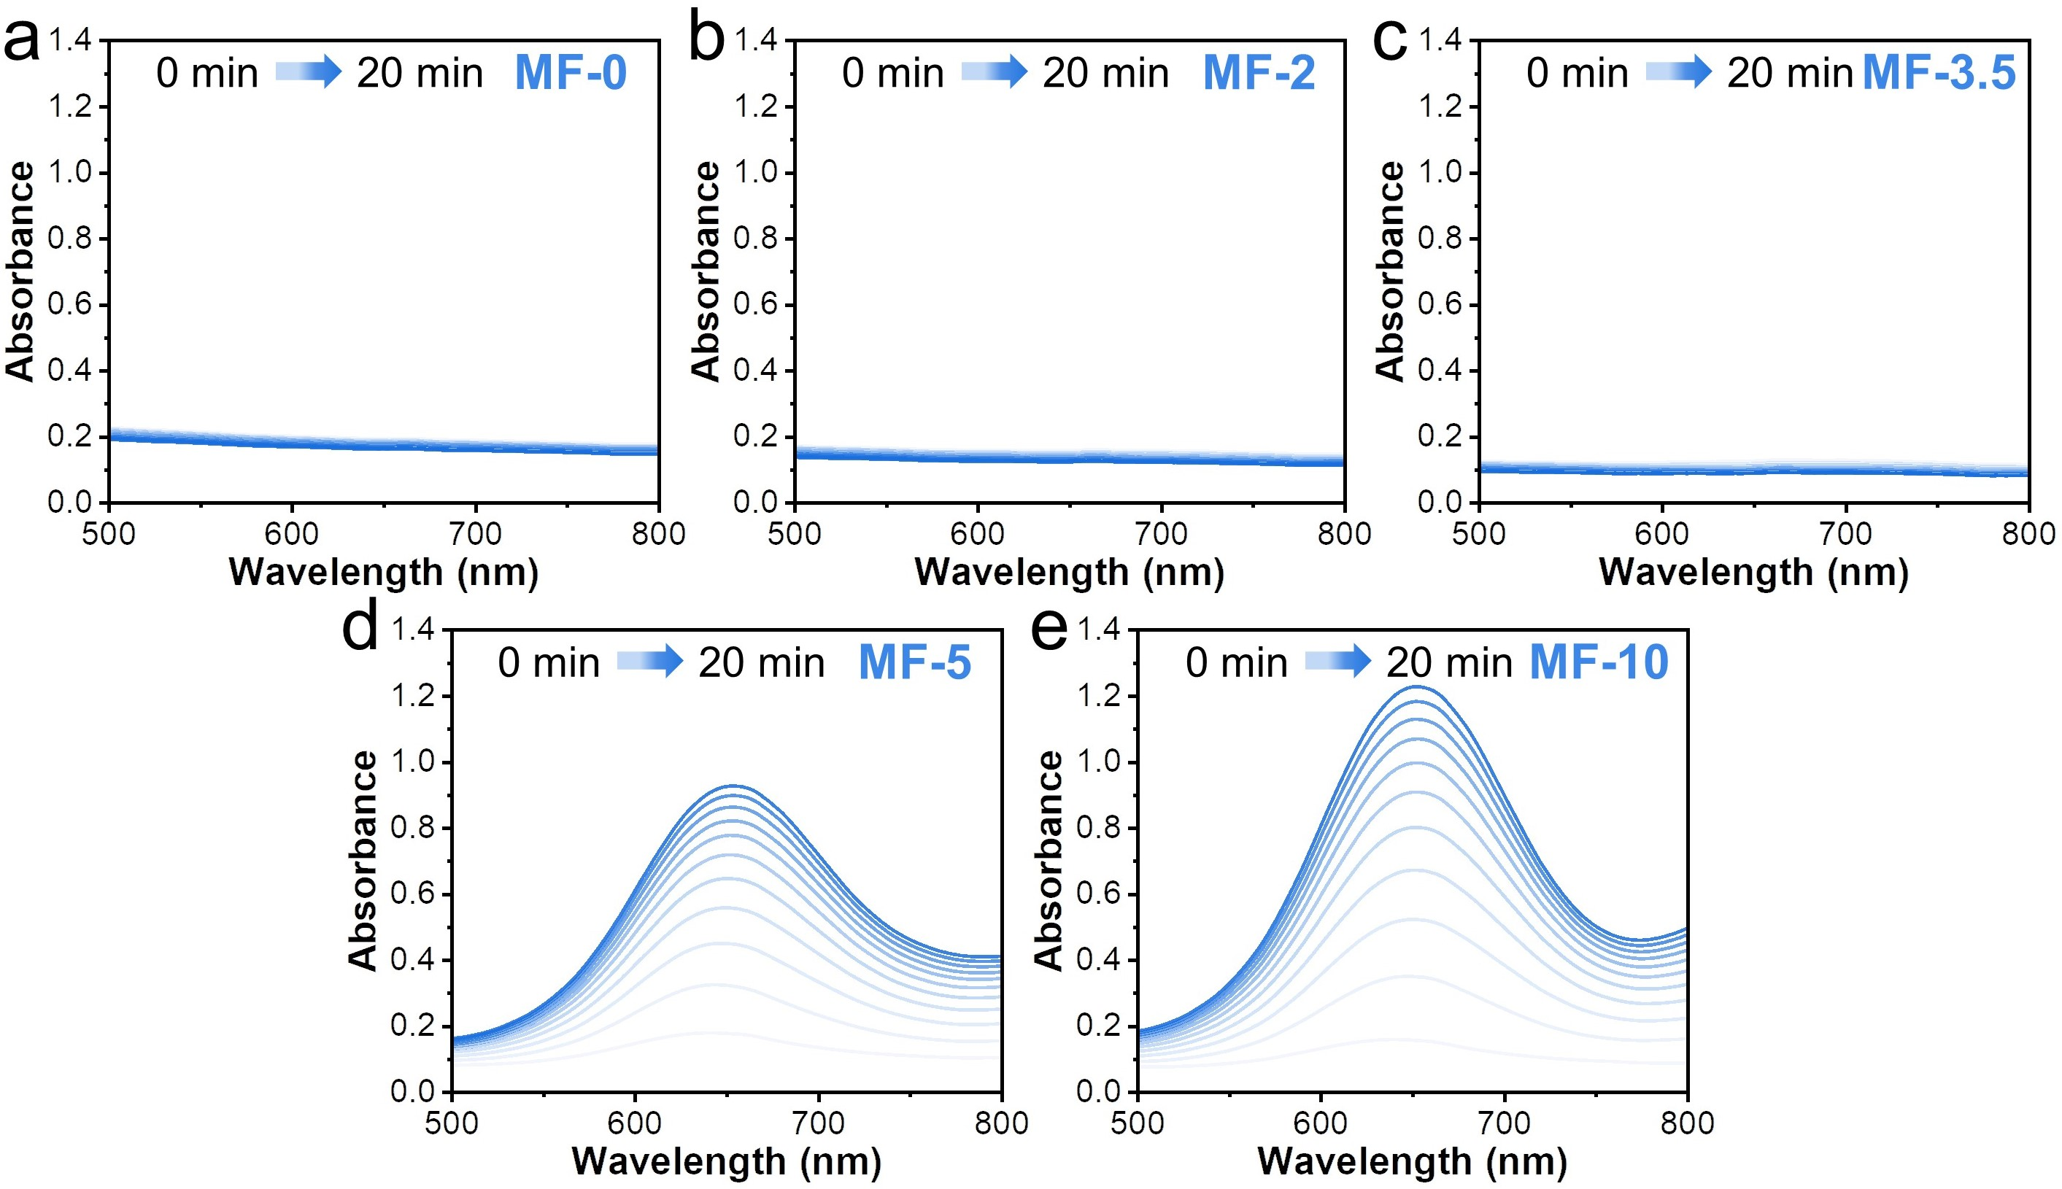
Supplementary Fig. 5. UV-vis spectra of TMB aqueous solution treated with MF-0 (a), MF-2 (b), MF-3.5 (c), MF-5 (d) and MF-10 (e) in the presence of H₂O₂ (100 μM) under pH 6.5, respectively. The concentration of Mo in each sample was 24 μg/mL.
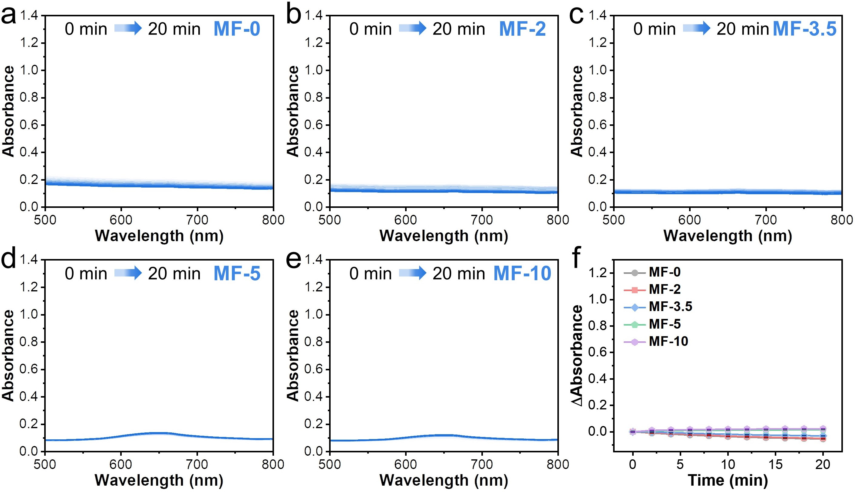
Supplementary Fig. 6. UV-vis spectra of TMB aqueous solution treated with MF-0 (a), MF-2 (b), MF-3.5 (c), MF-5 (d) and MF-10 (e) in the presence of H₂O₂ (100 μM) under pH 7.4, respectively. f, Absorbance intensity difference (at 650 nm) between different time points and 0 min of TMB aqueous solution treated with the corresponding samples with H₂O₂ (100 μM) under pH 7.4. The concentration of Mo in each sample was 24 μg/mL (n = 3).
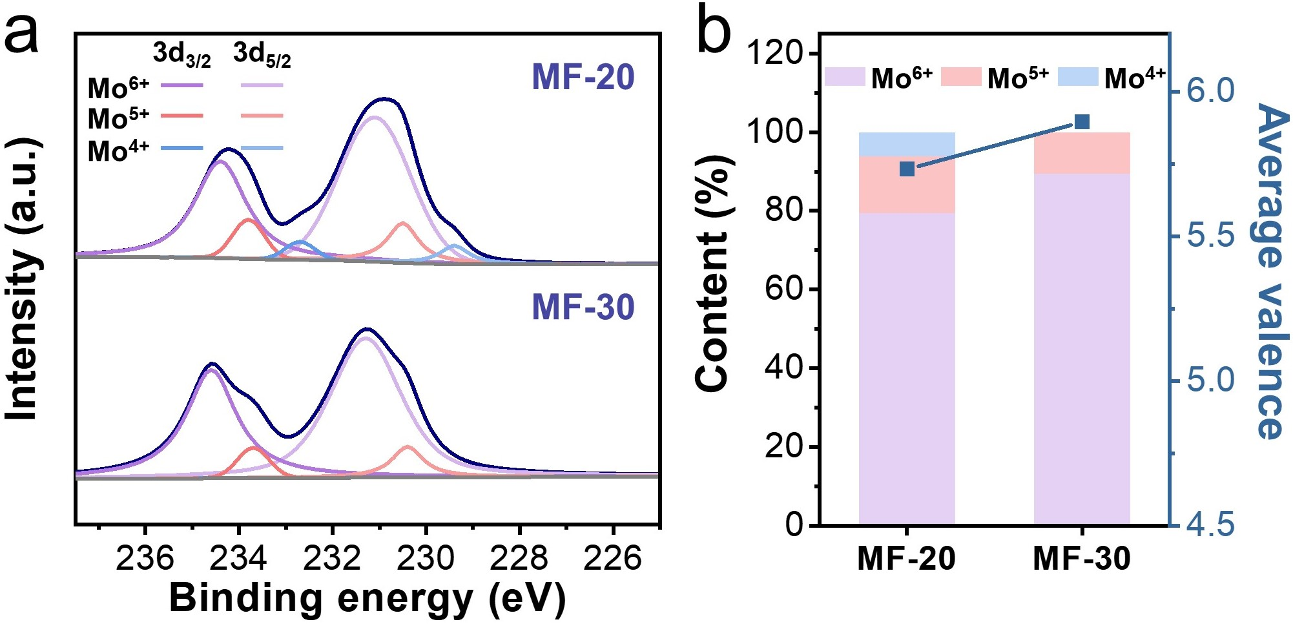
Supplementary Fig. 7. a, Mo 3d XPS spectra of MF-20 and MF-30. b, Percentage contents of Mo⁶⁺, Mo⁵⁺ and Mo⁴⁺ as well as the average valence of Mo in MF-20 and MF-30.
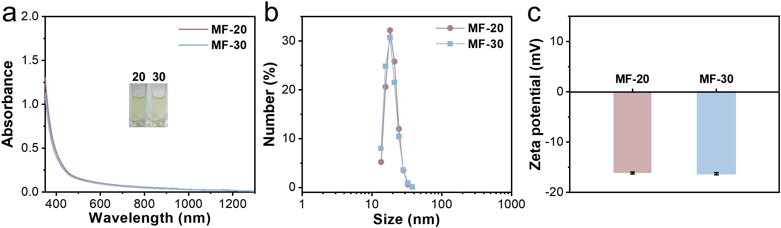
Supplementary Fig. 8. UV-vis-NIR absorption spectra (inset: photographs of the aqueous solution) (a), DLS size distribution (b) and zeta potential (n = 3) (c) of MF-20 (19.3 ± 3.5 nm) and MF-30 (19.0 ± 3.8 nm), respectively.
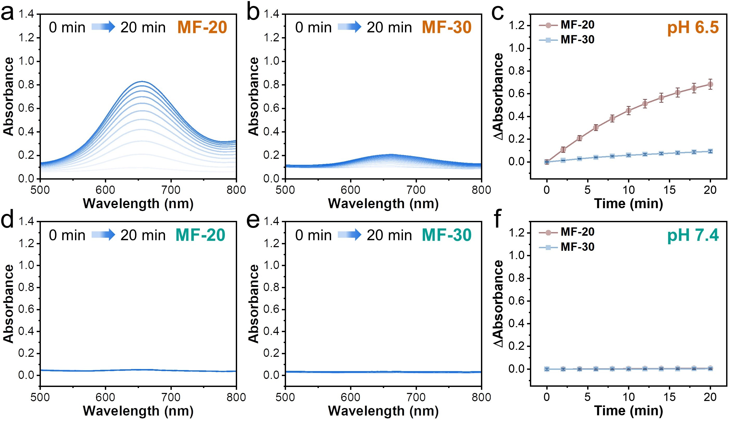
Supplementary Fig. 9. UV-vis spectra of TMB aqueous solution treated with MF-20 (a) and MF-30 (b) in the presence of H₂O₂ (100 μM) under pH 6.5. c, Absorbance intensity difference (at 650 nm) between different time points and 0 min of TMB aqueous solution treated with different samples and H₂O₂ under pH 6.5 (n = 3). UV-vis spectra of TMB aqueous solution treated with MF-20 (d) and MF-30 (e) in the presence of H₂O₂ (100 μM) under pH 7.4. f, Absorbance intensity difference (at 650 nm) between different time points and 0 min of TMB aqueous solution treated with the samples and H₂O₂ under pH 7.4 (n = 3). The concentration of Mo in each sample was 24 μg/mL.
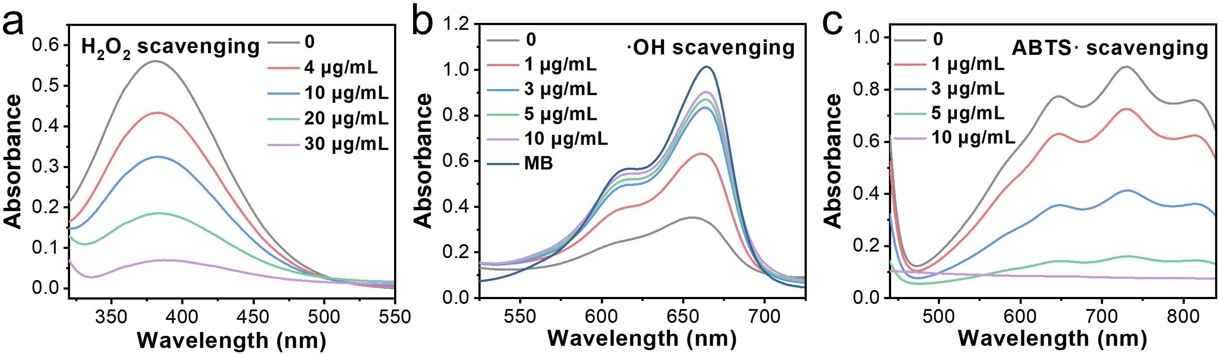
Supplementary Fig. 10. ROS scavenging capacity of MF-0. a, UV-vis spectra of PTO aqueous solution treated with MF-0 at different Mo concentrations in the presence of H₂O₂ (0.5 mM). b, UV-vis spectra of MB aqueous solution with various treatments. The group named MB indicated pure MB solution without ·OH, and the other groups (containing MF-0 with different Mo concentrations) were all treated with ·OH produced by Fenton reaction. c, UV-vis spectra of ABTS· aqueous solution treated with MF-0 at different Mo concentrations.
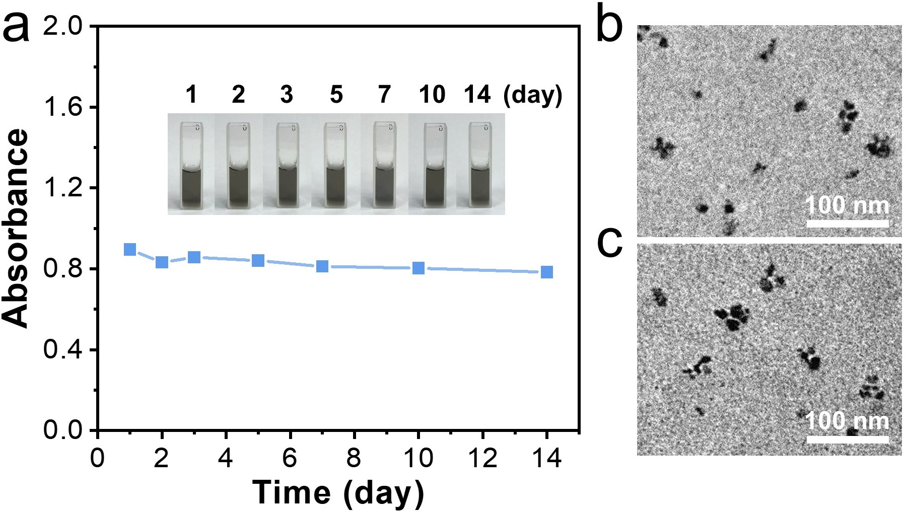
Supplementary Fig. 11. Stability test for MF-0 aqueous solution stored at 4 °C. a, Absorbance intensity of MF-0 solution at 600 nm within 14 days (inset: corresponding photographs). TEM images of MF-0 at day 1 (b) and day 14 (c).
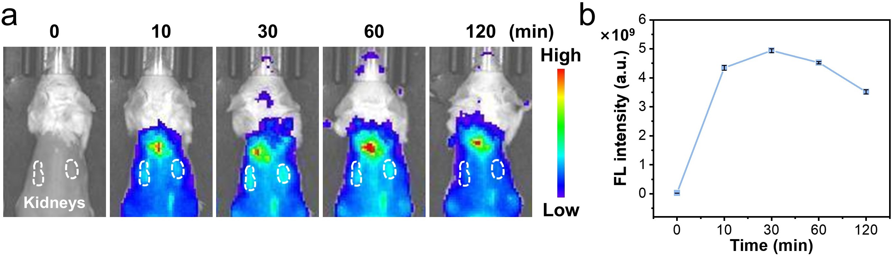
Supplementary Fig. 12. Fluorescence imaging (a) and the corresponding quantitative analysis (b) of MF-0 labeled with IR-780 in AKI mice (back hair removed) at different post-injection time points (λ_{ex} = 745 nm, λ_{em} = 820 nm, n = 3).
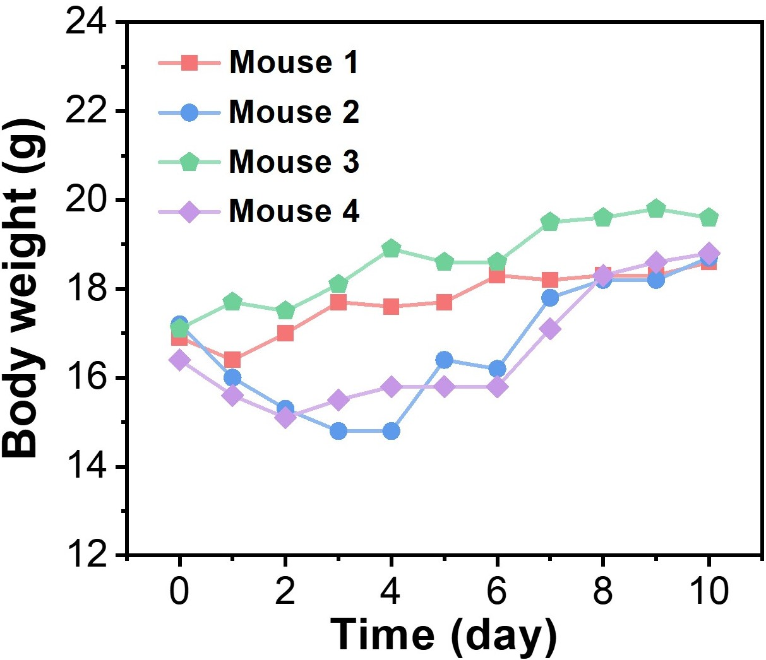
Supplementary Fig. 13. Body weight evolution curves of AKI mice treated with MF-0 (i.v. dosage: 800 μg of Mo per mL, 200 μL).
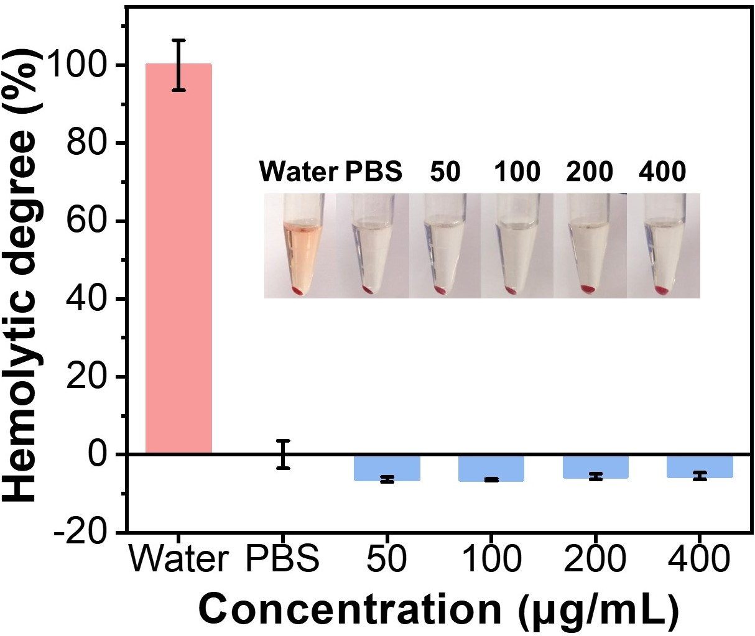
Supplementary Fig. 14. Hemolysis analysis of blood treated with water, PBS and MF-0 at different concentrations (n = 3, inset: corresponding photographs).
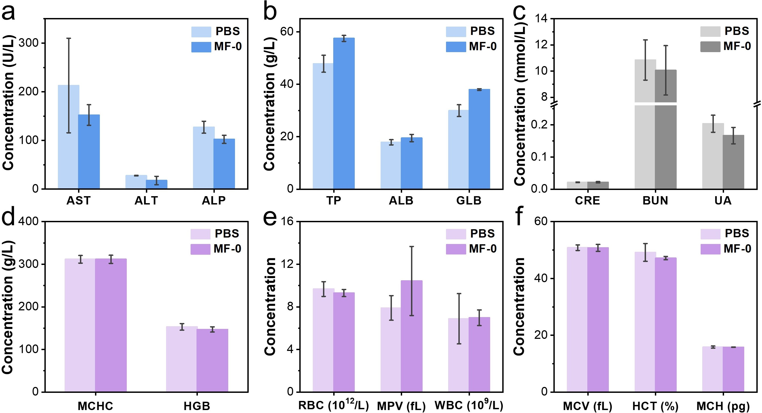
Supplementary Fig. 15. Biological toxicity study. Liver function indicators including aspartate aminotransferase (AST), alanine aminotransferase (ALT), alkaline phosphatase (ALP), total protein (TP), albumin (ALB) and globulin (GLB) (a,b), renal function indicators including CRE, BUN and uric acid (UA) (c) and hematological parameters including mean corpuscular hemoglobin concentration (MCHC), hemoglobin (HGB), red blood cells (RBC), mean platelet volume (MPV), white blood cells (WBC), mean corpuscular volume (MCV), hematocrit (HCT), and mean corpuscular hemoglobin (MCH) (d-f) collected from healthy mice treated with PBS and MF-0 (800 μg of Mo per mL) (n = 3; i.v. dosage: 200 μL). Blood serum samples were used for liver and kidney function tests, while whole blood samples were used for hematological indicators analysis. There was no significant difference between PBS and MF-0 groups for all the indicators.
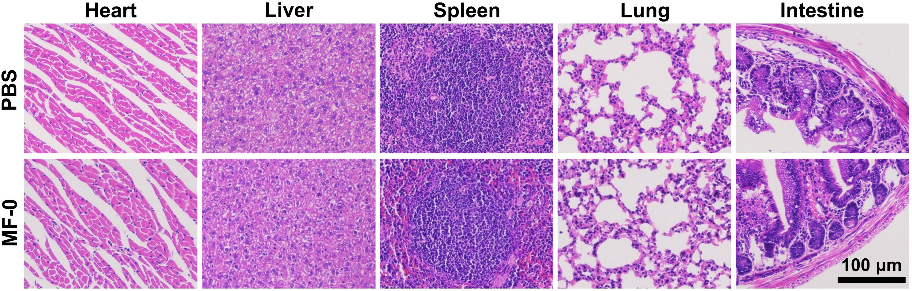
Supplementary Fig. 16. H&E staining of major organs collected from healthy mice treated with PBS and MF-0 (dosage: 800 μg of Mo per mL, 200 μL).

