Infiltrated macrophages aggravate TMJOA chronic pain via Piezo2 in IB4⁺-TG neurons
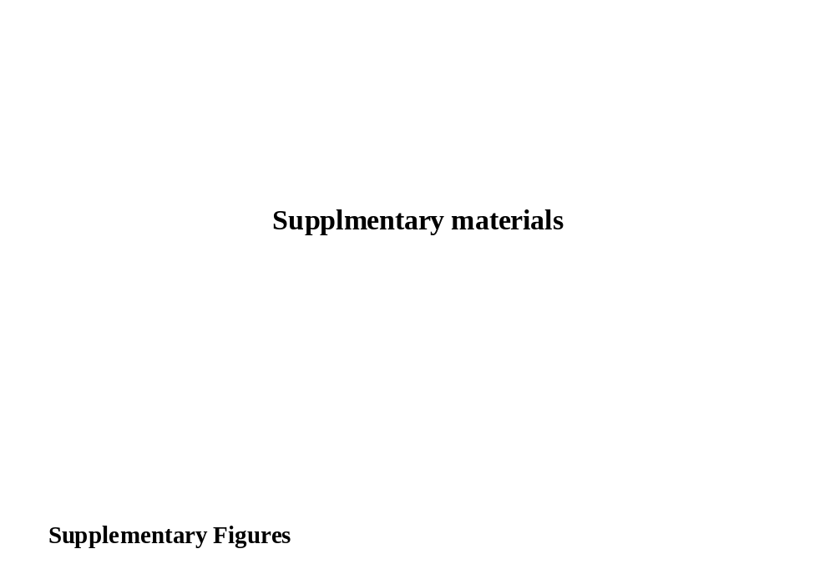

Supplementary figures

Figure S1. Correlation between Piezo2 expression in TG neurons and tissue resident-macrophages in TGs after macrophage depletion.
A-B, Immunofluorescence double staining (A) and linear correlation analysis (B) showed that Piezo2 expression in TG neurons was independent of the number of tissue-resident macrophages in the TGs. The white arrows indicate macrophages; the yellow arrows show Piezo2-positive neurons; the scare bar is 100 μm.

Figure S2. The HWT and RGS analyses two weeks after AAV9-Piezo2 injection of the intra-trigeminal ganglion.
A, Overexpression of Piezo2 in TG neurons reversed the alleviation of TMJOA chronic pain in infiltrated macrophage-depleted rats, as determined by the Head Withdrawal Threshold (HWT) for each group at the 3rd week of MIA-induced TMJOA, a Student's t-test, mean ± SEM (*p < 0.05, **p < 0.01).
B, Characteristic face images for the rat grimace scale (RGS) in rats of all groups two weeks after intra-trigeminal ganglion injection of AAV9-Piezo2. Quantitative analysis of RGS scores at the 3rd week showed that overexpression of Piezo2 in TG neurons temporarily had no effect on chronic pain in TMJOA of infiltrated macrophage-depleted rats, a Student's t-test, mean ± SEM (*p < 0.05, ns indicates no significant difference).

