Appendix
VECA system consists of 10 cognitive tasks including memory recall, attention, abstraction, computation, execution, and short-term memory/binding memory. Each task was shown in detail as below including steps, instructions and AOIs (yellow boxes).
A.1/A.11 Memory Recall Task
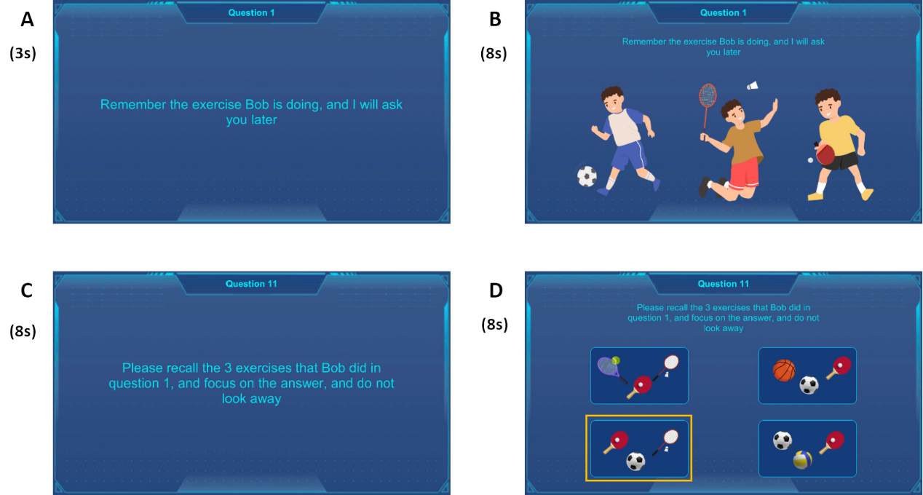
Users were asked to understand the instructions in 3 seconds (A.1 step A), to memorize three kinds of exercises in 8 seconds (A.1 step B) and to recall and fix on them separately within 8 seconds (A.11 step C and D) at the end of the assessment.
Figure A1: memory recall task steps.
A.2 Attention Task
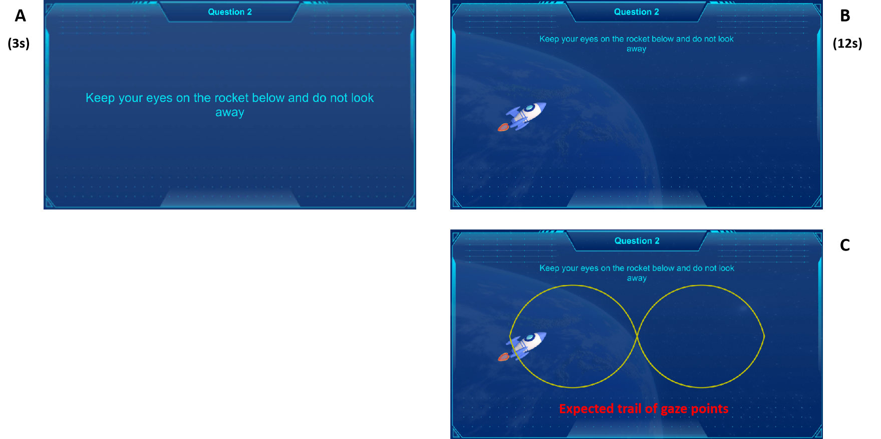
Users were asked to understand the instructions (step A) within 3 seconds and pursuit the rocket in 12 seconds. Expected track of the gaze points was shown in step C. Spear-man coefficients of coordinates along X and Y axis were calculated as the score of this task.
Figure A2: Attention task steps.
A.3 Abstraction Task
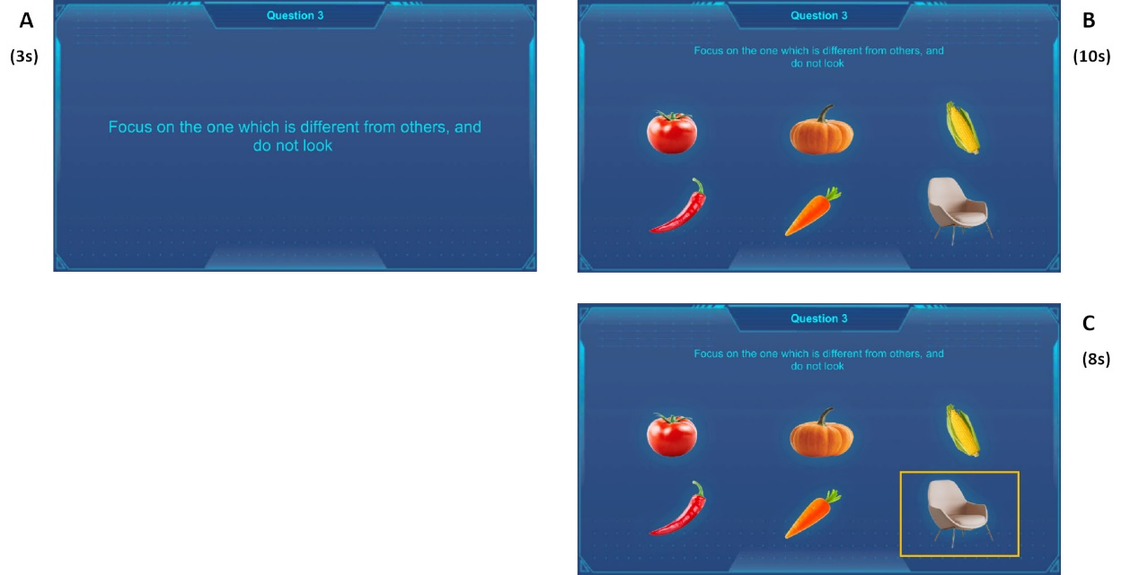
Users were asked to understand the instructions (step A) within 3 seconds. Then 10 seconds were provided to extinguish the object which is of different kind. Users should fix on the target within 8 seconds.
Figure A3: Abstraction task steps.
A.4/ A.5/ A.6 Computation Task
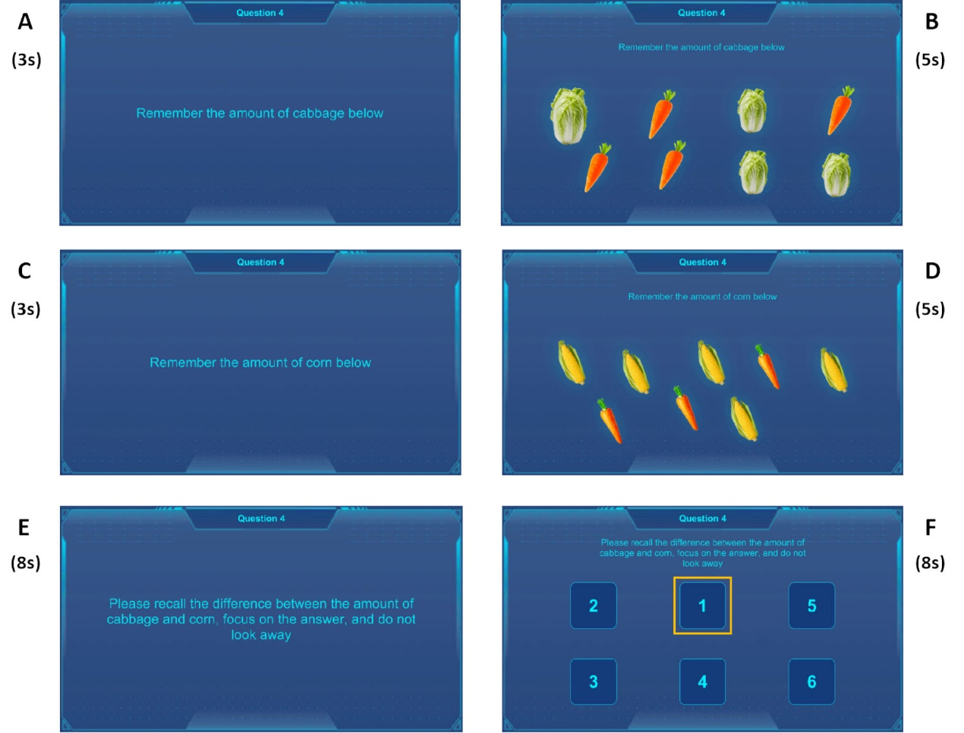
This section presents 3 sequential computation tasks. In each task, two eight-second-long stages of counting certain objects were set before users were asked to conduct computations between the two number and fix on the correct answer. target within 8 seconds.
Figure A4: Computation task-1 steps.
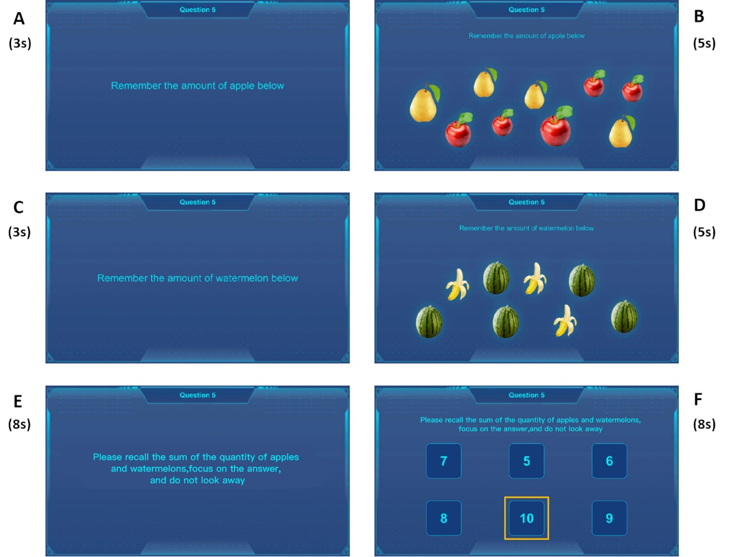
Figure A5: Computation task-2 steps.

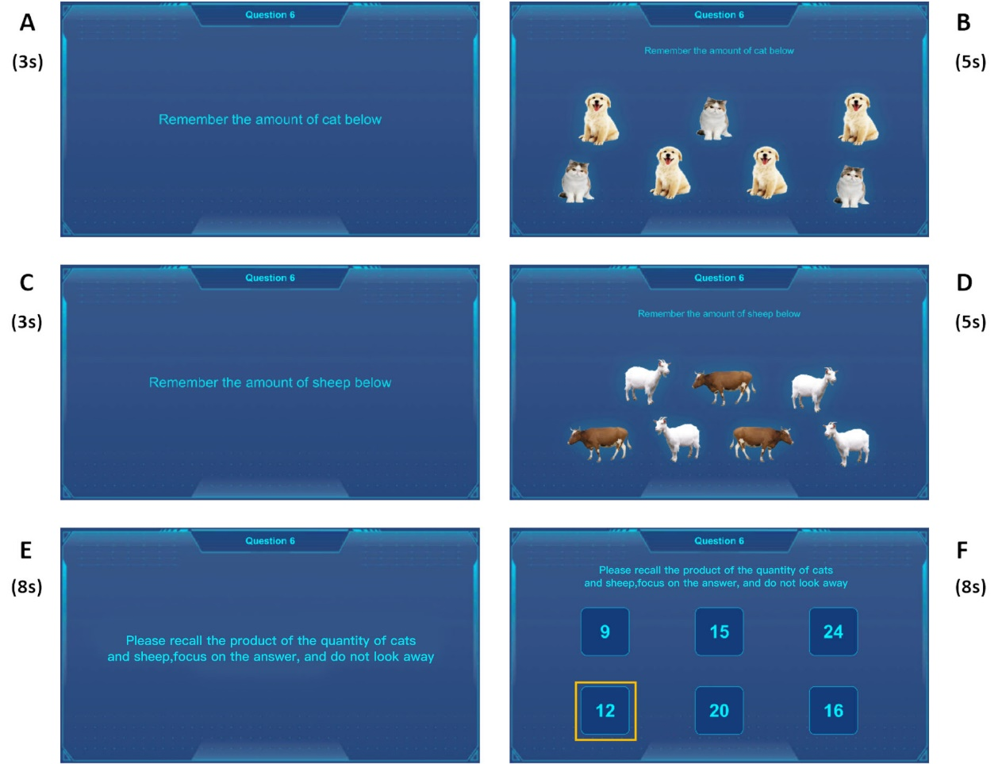Figure A6: Computation task-3 steps.

A.7 Execution Task
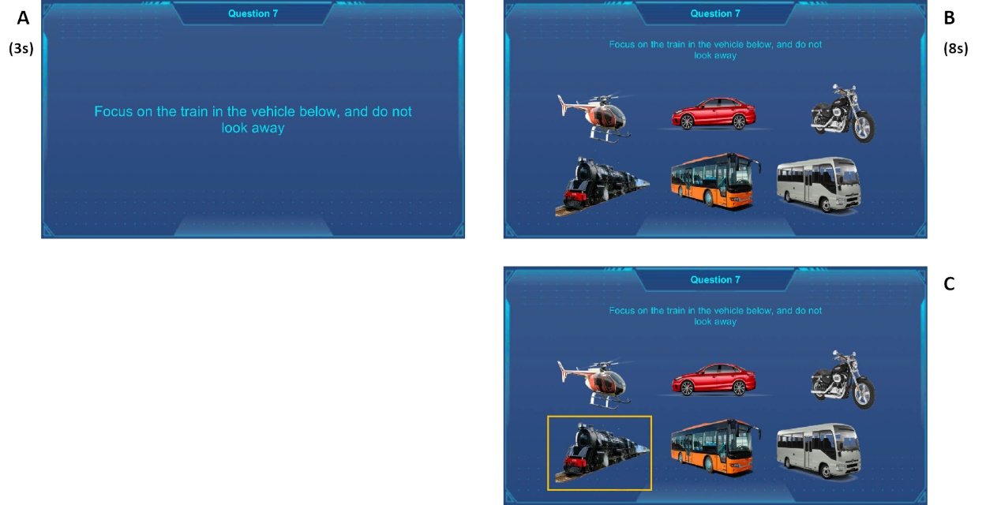
Users were asked to identify and fix on the train among various vehicle within 8 seconds.
Figure A7: Execution task steps.
A.8 Short-term Memory Task
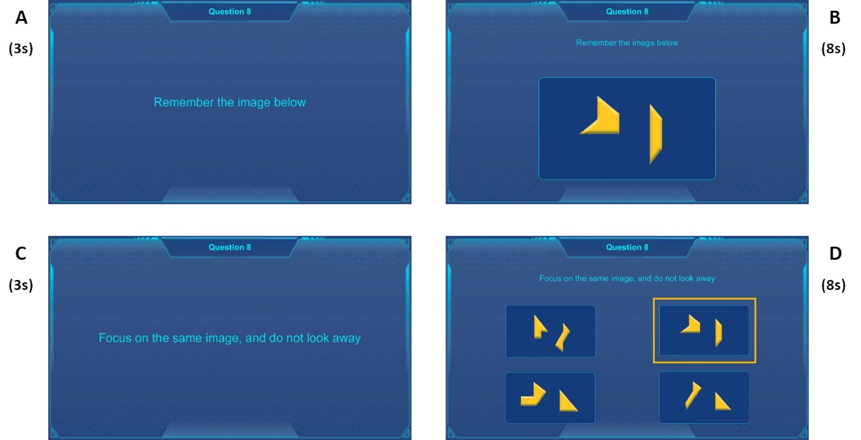
This section presents 3 sequential memory tasks. In each task, users were asked to memorize the shape or binding with color of given images in 8 seconds. Another 8 seconds were given to recall and fix on the target.
Figure A8: Short-term memory task -1 steps.

A.9/ A.10 Short-term Memory Binding Task
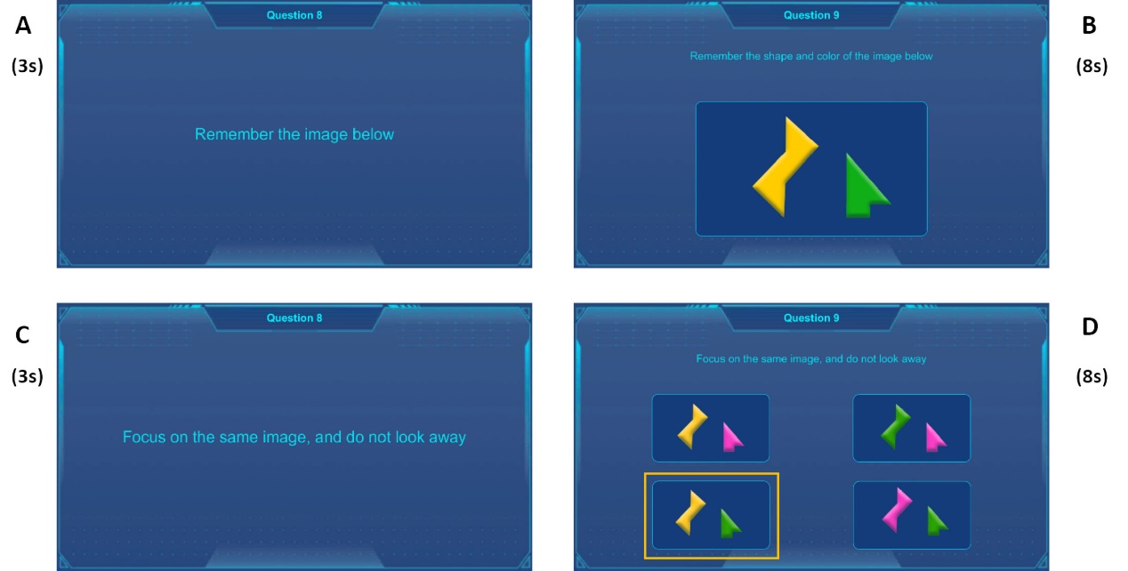
This section presents 3 sequential memory tasks. In each task, users were asked to memorize the shape binding with color of given images in 8 seconds. Another 8 seconds were given to recall and fix on the target.
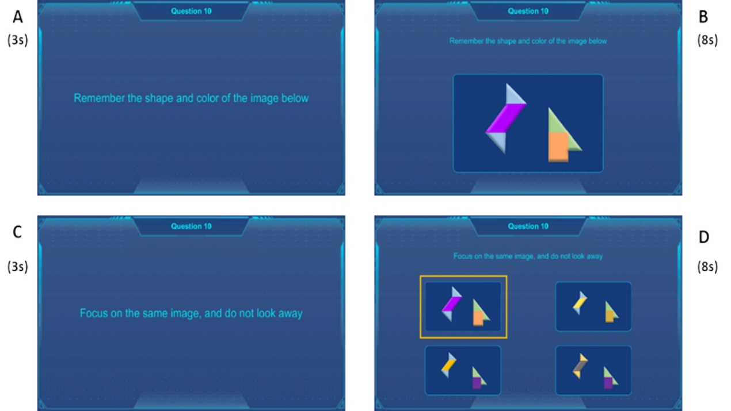
Figure A9: Short-term memory binding task-1 steps.
Figure A10: Short-term memory binding task-2 steps.

