Supporting Information

A nanofluidic chemoelectrical generator with enhanced energy harvesting by ion-electron Coulomb drag

Yisha Jiang^{1,2,#}, Tao Wang^{1,#}, Wenchao Liu¹, Yitian Wu¹, Tingting Mei¹, Li Wang¹, Guoheng Xu¹, Nannan Liu^{2,*}, Yude Wang^{3,*} and Kai Xiao^{1,*}

¹Department of Biomedical Engineering, Guangdong Provincial Key Laboratory of Advanced Biomaterials, Institute of Innovative Materials, Southern University of Science and Technology, Shenzhen, 518055, P.R. China.
²Key Laboratory of Carbon Materials of Zhejiang Province, College of Chemistry & Materials Engineering, Wenzhou University, Wenzhou, 325027, P.R. China.
³School of Materials and Energy, Yunnan University, Kunming, 650091, P.R. China.

# Yisha Jiang and Tao Wang contributed equally
*co-corresponding author
E-mail: liunannan@wzu.edu.cn;
E-mail: ydwang@ynu.edu.cn;
E-mail: xiaok3@sustech.edu.cn; xiaokai@iccas.ac.cn;

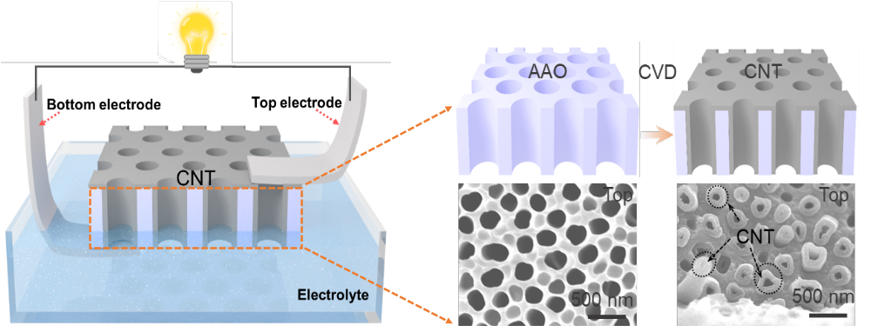
Supplementary Fig. 1 | The structure of the NCEG and the fabrication process of nitrogen-doped CNTM and the SEM images of the AAO substrate and CNTM.

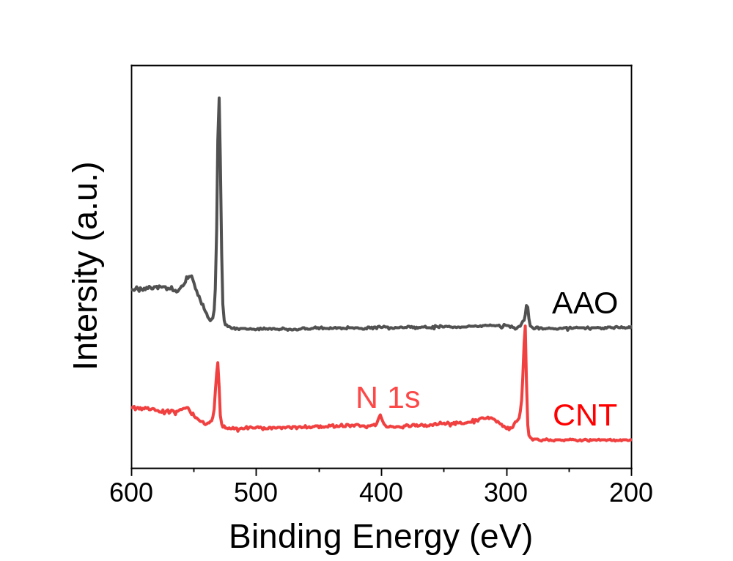
Supplementary Fig. 2 | The XPS spectra of AAO substrate and CNTM.

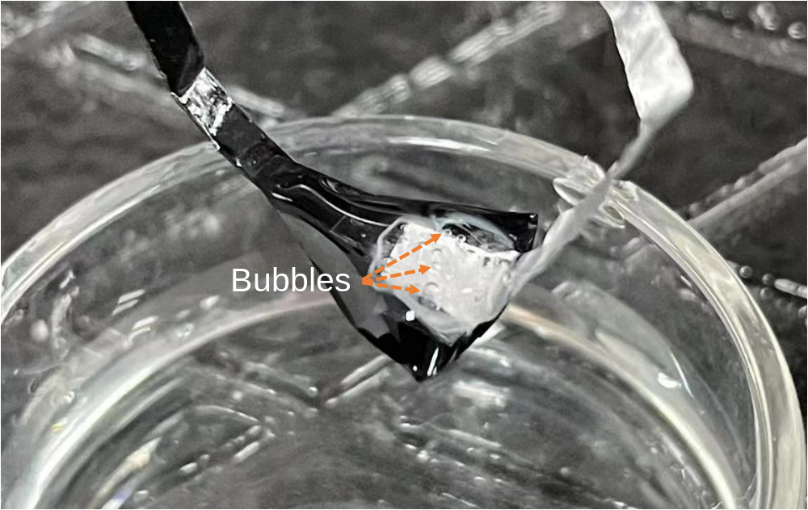
Supplementary Fig. 3 | Optical image of bubbles generated on the surface of the electrode when the electrolyte was replaced by strong acid or alkaline solution.

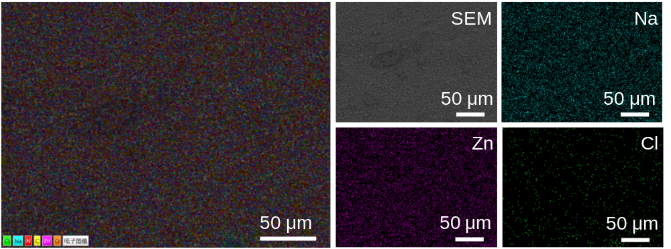
Supplementary Fig. 4 | Top surface energy dispersive spectroscopy (EDS) mapping for the CNTM without contact to the electrolyte solution after 1 h testing.

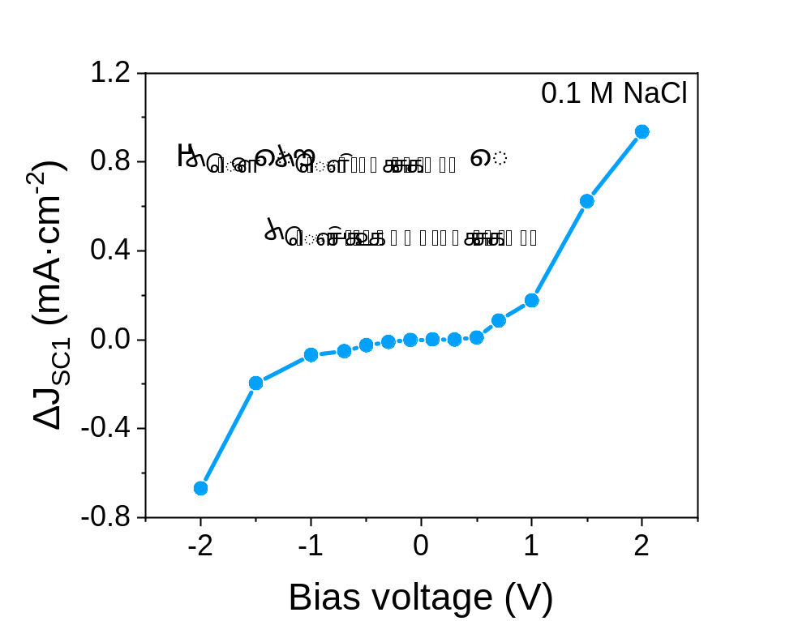
Supplementary Fig. 5 | The deviation of current density values between (ΔJ_{SC1}) with and without electrolyte solution under a range of external voltage from -2 to 2 V.

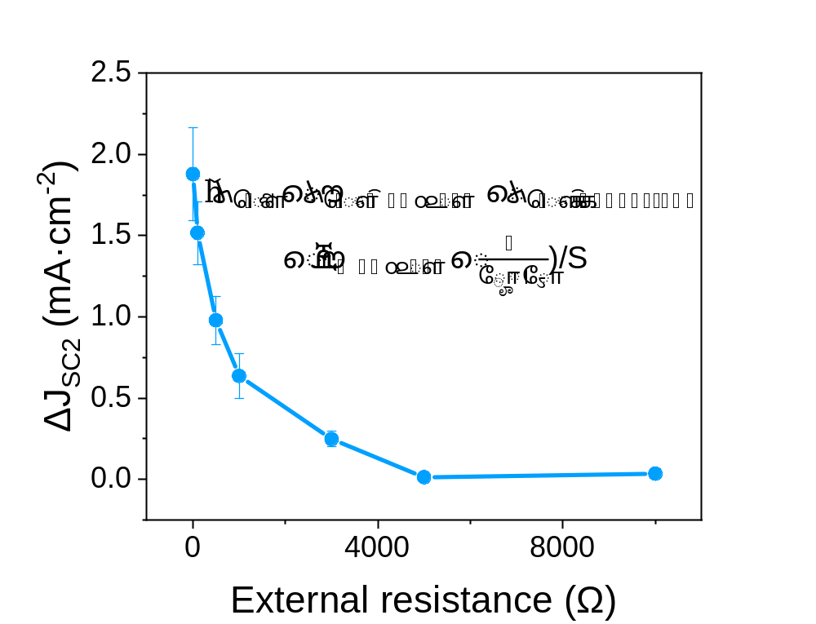
Supplementary Fig. 6 | The current density difference (ΔJ_{SC2}) between theoretical value and measured value when different resistances were loaded in the circuit. U = 0.8 V is the average voltage output of the NCEG device, R_{S} = 10000 Ω is the internal resistance of the device, determined by the maximum power output when the external resistance is equal to the internal resistance (Fig. 4a), and the R_{L} is the load resistance, including 100, 500, 1000, 3000, 5000, and 10000 Ω.

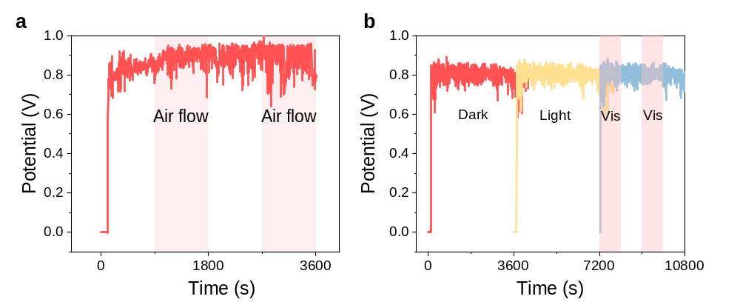Supplementary Fig. 7 | The influences of air flow (a) and light (b) on the output of the device.

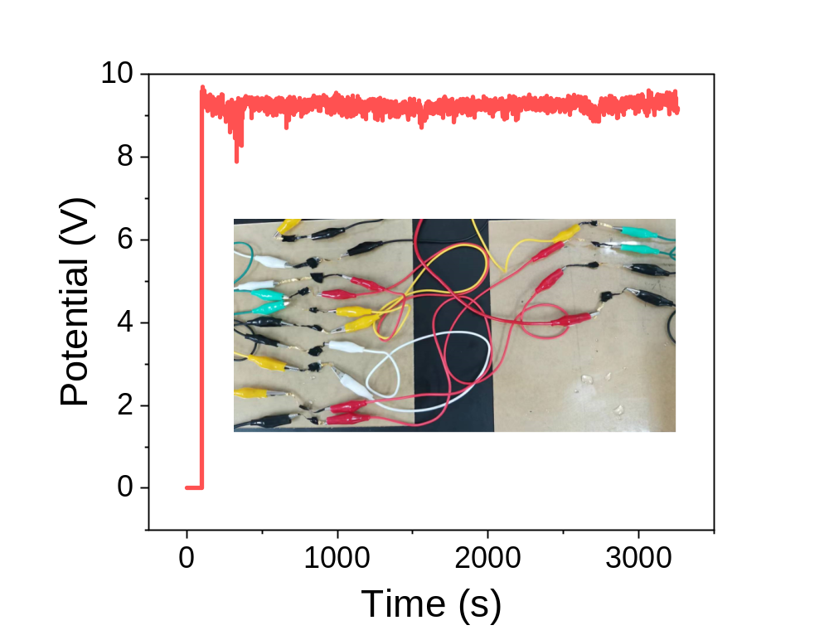
Supplementary Fig. 8 | The voltage of fourteen NCEG devices that are connected in series. The inset is the optical photograph of the fourteen NCEG devices connected in series.

Supplementary Table 1 | Performance parameter comparison of hydroelectric devices in different working environments.
Work environment | V_{OC} (V) | J_{SC} (μA·cm⁻²) | Power density (μw·cm⁻²) | Reference
Moisture (50%RH) | 0.5 | 1 | 5 | 1
Moisture (85%RH) | 1.38 | 4 | 5.52 | 2
Moisture (93%RH) | 0.76 | 11.3 | 8.58 | 3
Drop (30 μL) | 0.24 | 34.29 | 8.23 | 4
Drop (0.1 mL) | 1.5 | 0.6 | 0.9 | 5
Bulk water | 0.66 | 5.25 | 3.465 | 6
Bulk water | 0.55 | 22 | 11 | 7
2 M NaCl | 1.04 | 2.36 | 2.45 | 8
2 M NaCl | 0.72 | 360 | 259.2 | 9
0.1 M NaCl | 0.8 | 800 | 74 | This work

References
1. Liu, X. et al. Power generation from ambient humidity using protein nanowires. Nature 578, 550-554 (2020).
2. Wang, H. et al. Bilayer of polyelectrolyte films for spontaneous power generation in air up to an integrated 1,000 V output. Nat. Nanotechnol. 16, 811-819 (2021).
3. Zhang, Y. et al. Sustainable power generation for at least one month from ambient humidity using unique nanofluidic diode. Nat. Commun. 13, 3484-3494 (2022).
4. Bae, J. et al. Towards watt-scale hydroelectric energy harvesting by Ti3C2Tx-based transpiration-driven electrokinetic power generators. Energy Environ. Sci. 15, 123-135 (2022).
5. Shao, B. et al. Freestanding silicon nanowires mesh for efficient electricity generation from evaporation-induced water capillary flow. Nano Energy 94, 106917-106929 (2022).
6. Li, L. et al. Sustainable and flexible hydrovoltaic power generator for wearable sensing electronics. Nano Energy 72, 104663-104672 (2020).
7. Shao, B. et al. Bioinspired hierarchical nanofabric electrode for silicon hydrovoltaic device with record power output. ACS Nano 15, 7472-7481 (2021).
8. Li, L. et al. A novel, flexible dual-mode power generator adapted for wide dynamic range of the aqueous salinity. Nano Energy 85, 105970-105980 (2021).
9. Jiang, Z. et al. Simultaneous electricity generation and steam production from a wide range of salinity by using unique nanofluidic diode. Nano Energy 108, 108220-108231 (2023).

