Supplemental Figure 1. Rate of Vertical Transmission

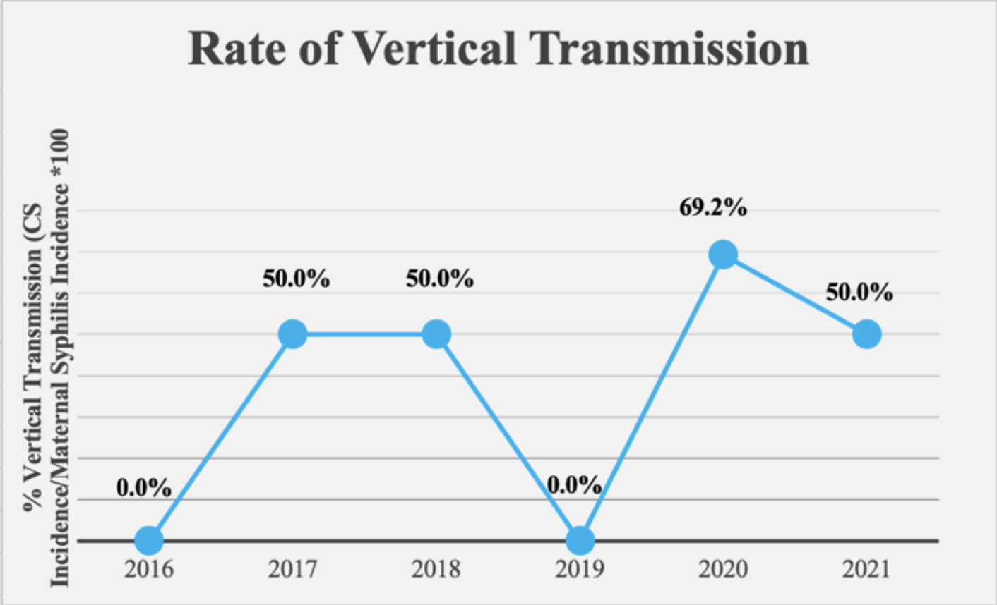

Summary: Rate of vertical transmission calculated as CS incidence/maternal syphilis incidence*100.

