Molecular Biology Reports
Supplementary Data

Optimization of the Redox-Sensitive Doxorubicin Loaded Chitosan-based Nanoparticles by Box–Behnken Experimental Design

Mahsa Babaei ¹, Soheila Kashanian ^{2,3*}, Zahra Salemi ⁴

1 Department of Biology, Faculty of Science, Razi University, Kermanshah, Iran
2 Faculty of Chemistry, Sensor and Biosensor Research Center (SBRC), Razi University, Kermanshah, Iran
3 Nanobiotechnology Department, Faculty of Innovative Science and Technology, Razi University, Kermanshah, Iran
4 Department of Biochemistry, Arak University of Medical Sciences, Arak, Iran

Corresponding Author: Kashanian_s@yahoo.com

Table A. The levels of dependent and independent variables employed in BBD
Levels |  |  | Variables
High | Middle | Low | Variables
2  1.5  3 | 1.25  1  2  Maximize | 0.5  0.5  1 | Independent variables  A-Cs-Cys Con.(mg/ml)  B-TPP Con. (mg/ml)  C-Cs-Cys/TPP  Dependent variables  Y: %EE

Table B. Different optimum conditions and predicted and observed EE% values
Optimum /No. | Cs-Cys Con.  (mg/ml) | TPP Con.  (mg/ml) | Cs-Cys/TPP ratio | Predicted %EE | Observed EE% | Error%
1 | 1.257 | 1.075 | 2.092 | 81.28% | 78.82% | 4.25%
2 | 1.255 | 1.189 | 2.052 | 82.406% | 78.63% | 4.58%
3 | 1.194 | 1.197 | 2.260 | 81.396% | 78.56% | 3.48%

Table C. Optimized NPs size, PDI, and zeta potential analysis by DLS and zeta sizer
Optimized Formulation | Size (nm) | PDI | Zeta Potential (mv)
Cs-CysNPs-DOX | 144.55 | 0.262 | +35.2

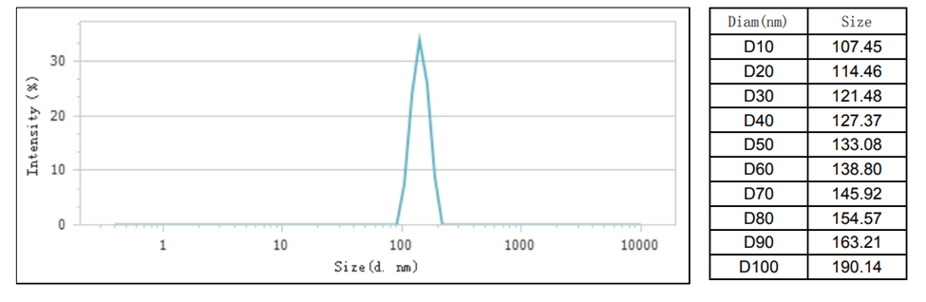
Figure A. Size distribution of NPs by DLS

