Preventive potential of Lactobacillus johnsonii YH1136 against uric acid accumulation and hyperuricemia-induced damages in rats
Supplementary Information
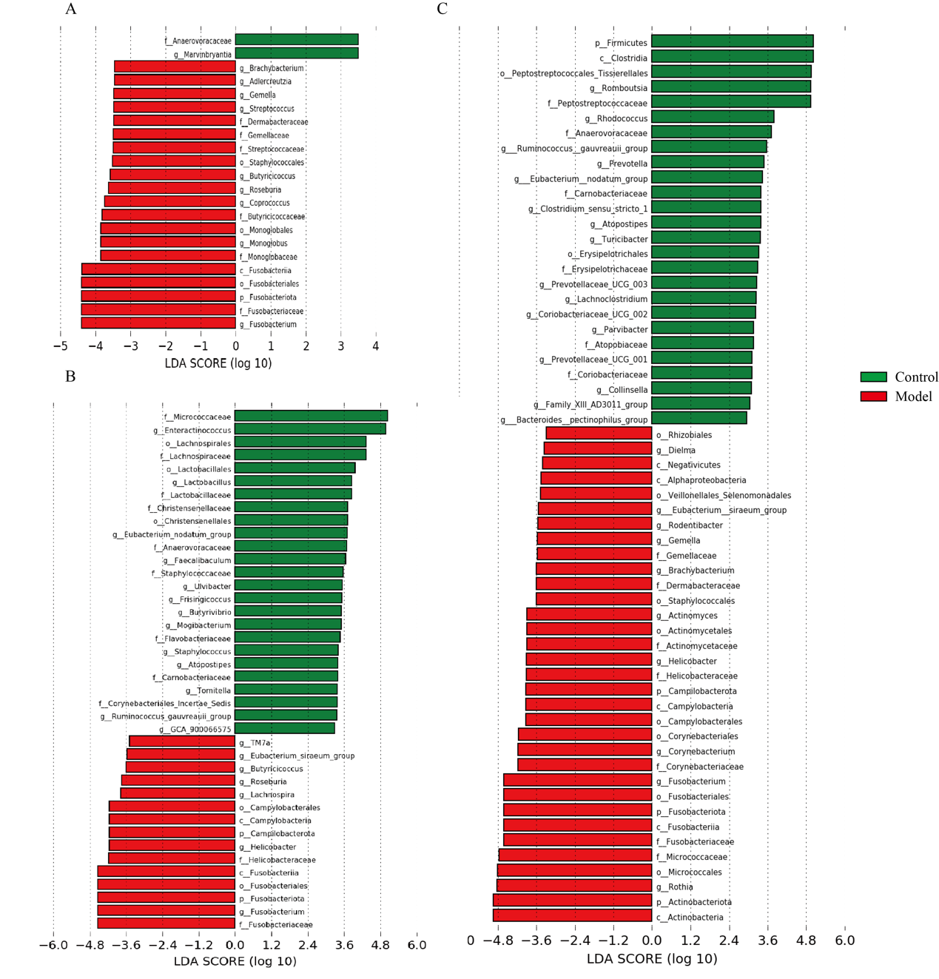
Fig. S1. Linear Discriminant Analysis Effect Size Analysis. Significantly discriminative taxa (Biomarkers) between the control and model groups of mice were displayed by LDA value distribution histogram in Duodenum(A), jejunum(B) and ileum(C). Only taxa meeting the LDA significance thresholds (>4) are shown. Different coloured bars and regions represent different groups.
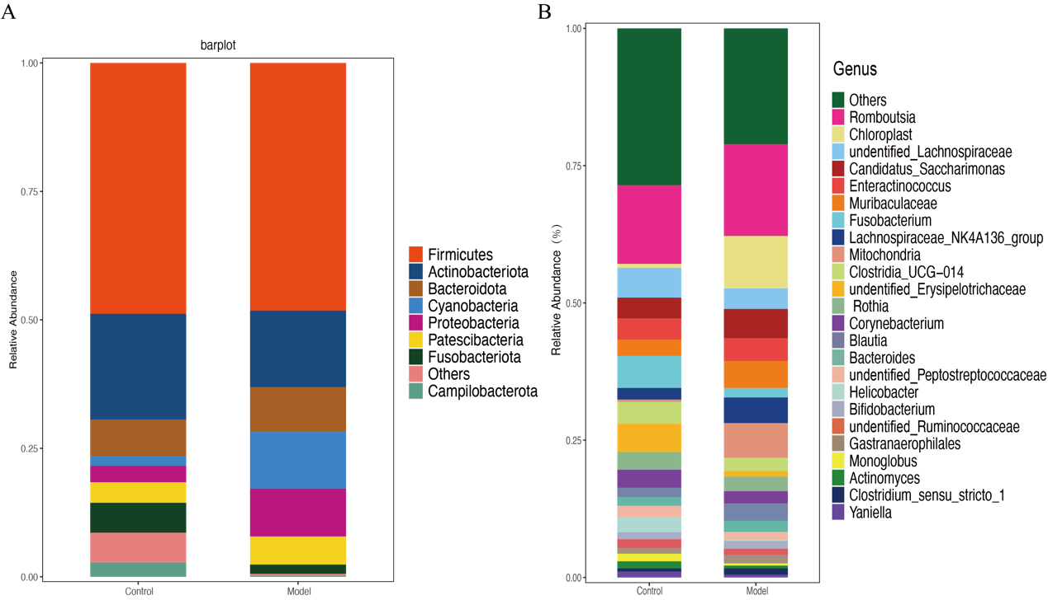
Fig. S2. The relative abundance of Bacteria from Phylum(A) and Genus(B) in the Duodenum
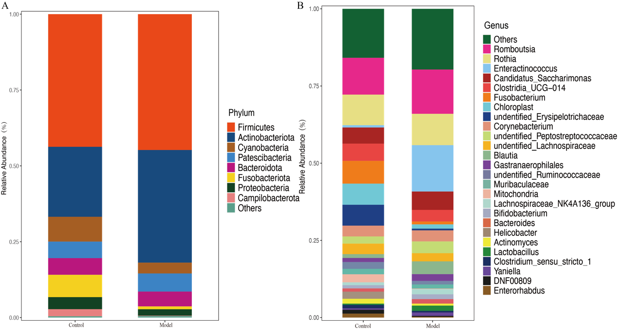
Fig. S3. The relative abundance of Bacteria from Phylum(A) and Genus(B) in the jejunum
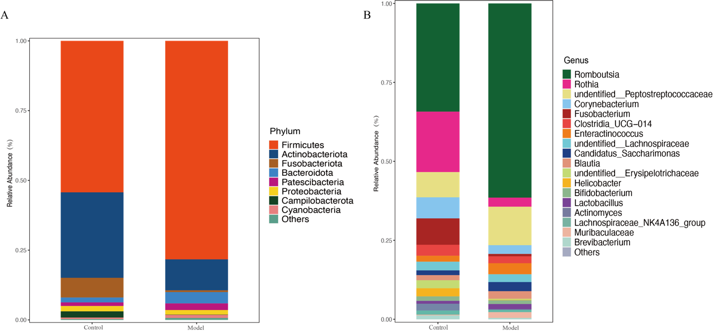
Fig. S4. The relative abundance of Bacteria from Phylum(A) and Genus(B) in the ileum
Fig. S5. The relative abundance of Bacteria from Phylum(A) and Genus(B) in the cecum
Fig. S6. The relative abundance of Bacteria from Phylum(A) and Genus(B) in the colon

