Supplemental Material

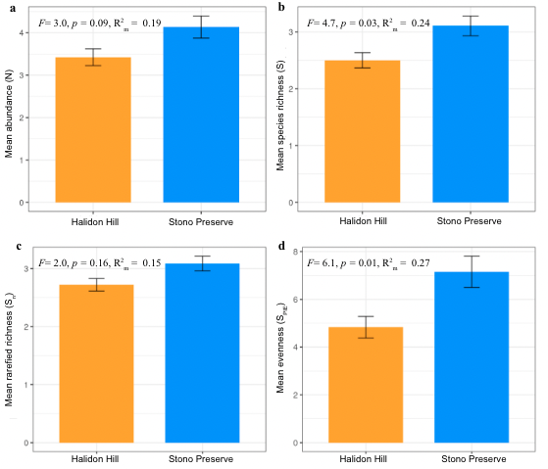

Supplementary Material Figure S1. Barplots of mean with standard error bars for: a) bird abundance (N), b) species richness (S), c) rarefied richness (S_{n}), and d) evenness (S_{PIE}) in Stono Preserve and Halidon Hill.

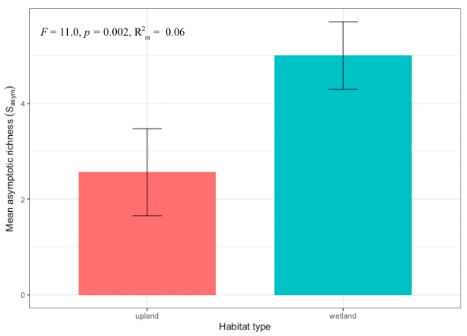
Supplementary Material Figure S2. Barplot of predicted mean with 95% CI for extrapolated asymptotic richness (S_{asym}) using the Chao1 rarefaction estimator of diversity.

Supplementary Material Table 1. Linear mixed-effect (LME) model outputs of bird abundance (N), species richness (S), rarefied richness (S_{n}), evenness (S_{PIE}), and asymptotic richness (S_{asym}) explained by site type (upland v. wetland).

Diversity Metric | Site Type | Predicted Mean | SE | 95% CI - low | 95% CI - high
N | upland | 2.50 | 0.46 | 1.61 | 3.39
N | wetland | 4.03 | 0.34 | 3.37 | 4.70
S | upland | 1.81 | 0.35 | 1.13 | 2.48
S | wetland | 2.99 | 0.28 | 2.45 | 3.53
S_{n} | upland | 2.08 | 0.25 | 1.59 | 2.56
S_{n} | wetland | 2.96 | 0.15 | 2.68 | 3.25
S_{PIE} | upland | 3.23 | 1.48 | 0.33 | 6.12
S_{PIE} | wetland | 6.97 | 0.96 | 5.08 | 8.86
S_{asym} | upland | 2.56 | 0.91 | 0.78 | 4.35
S_{asym} | wetland | 5.00 | 0.71 | 3.61 | 6.38

