Supplementary Materials for
Larger Contribution of Anthropogenic Climate Change to the Increasing Frequency of Compound Droughts and Heatwaves in Poor Countries Compared to Wealthy Ones

The PDF files includes:
Table S1
Figures S1 to S12
References

Table S1 List of the CMIP6 models used in this study
Model name | Ensemble runs | Country | Horizontal resolution (lon. by lat. in degrees) | Key references
MIROC6 | r1i1p1f1, r2i1p1f1,  r3i1p1f1 | Japan | 1.4°×1.4° | (Tatebe et al., 2019)
MRI-ESM2-0 | r1i1p1f1, r2i1p1f1,  r3i1p1f1 | Japan | 1.1°×1.1° | (Yukimoto et al., 2019)
GFDL-ESM4 | r1i1pf1 | USA | 1°×1.25° | (Dunne et al., 2020)
GFDL-CM4 | r1i1pf1 | USA | 1°×1.25° | (Held et al., 2019)
BCC-CSM2-MR | r1i1p1f1 | China | 1.1°×1.1° | (Wu et al., 2019)
ACCESS-ESM1-5 | r1i1p1f1, r2i1p1f1,  r3i1p1f1 | Australia | 1.9°×1.2° | (Law et al., 2017)
ACCESS-CM2 | r1i1p1f1, r2i1p1f1,  r3i1p1f1 | Australia | 1.9°×1.3° | (Bi et al., 2013)

Figure S1 Global association between historical trends in the occurrence of CDHWs and poverty based on the MSWEP dataset. a Historical trends in CDHWs at the subnational level during the period of 1981–2020. The slope (unit: year^{‒1}) is the linear trend based on the Sen’s slope estimator; hatching indicates regions where the trend is significant at the 0.05 level based on a MK test. b Time series of CDHWs spatially aggregated for 4 different income groups (H = high-income countries. UM = upper middle-income countries. LM = lower-middle-income countries. L = low-income countries). Dashed lines represent annual occurrences of CDHWs, and solid lines represent the linear trend (slope and p-value are the same as in a). c Global interrelationships between the share of population that is poor (<$1.90 per day) and changes in the frequency of CDHWs. Box extents are at the 25th and 75th percentiles with Tukey whiskers. The red dashed line represents the fitted linear regression between poverty rates (x-axis) and median values of CDHW change (y-axis). The correlation and p-value of the linear regression are shown.
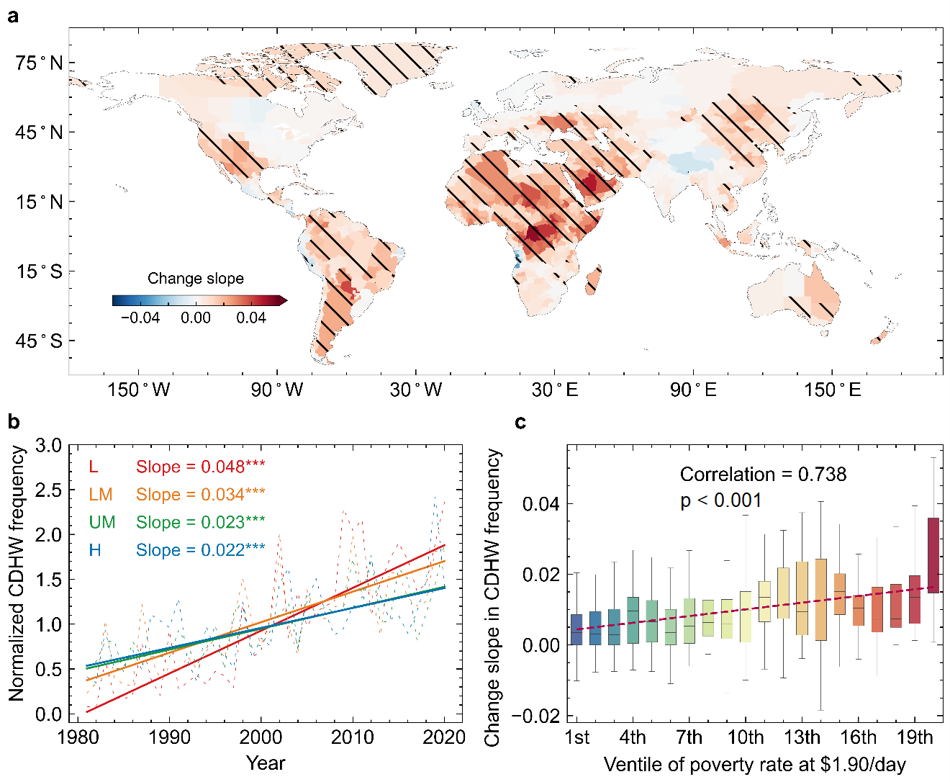

Figure S2 Significance test for the difference of historical trends in the frequency of CDHWs between a low-income (LIC) and b high-income (HIC) regions based on 500-sample bootstrap and two-tailed t-test. The red solid line in a and b represents Sen’s estimates of the linear trend while the red dashed line represents the 95% confidence interval of Sen’s estimates based on a 500-sample bootstrap analysis. c presents the density plot of the 500 bootstrap samples and the black dashed lines represent the mean values.

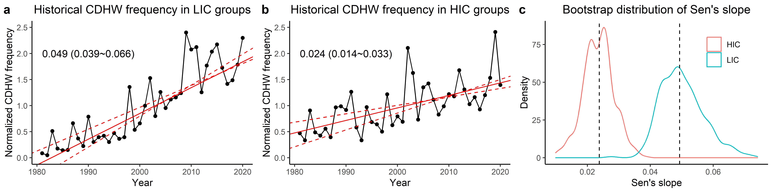

Figure S3 Global interrelationships between changes in the frequency of CDHWs and the share of population living with income below a $3.20 and b $5.50 per day. Box extents are at the 25th and 75th percentiles with Tukey whiskers. The red dashed line represents the fitted linear regression between poverty rates (x-axis) and median values of CDHW change (y-axis). The Pearson correlation coefficient and p-value of the linear regression are shown.
a b
a b
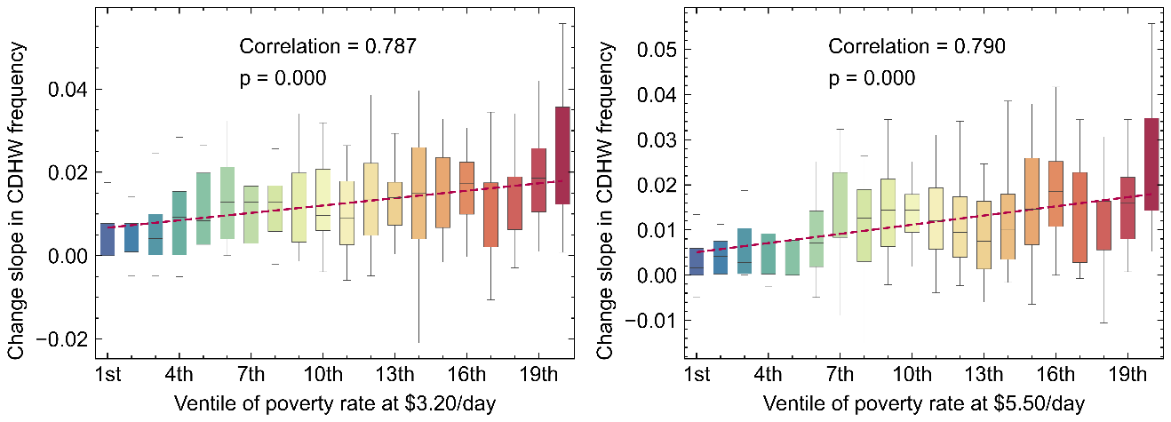

Figure S4 Global association between historical trends in CDHW severity and poverty. a Historical trends in CDHW severity generated from the ERA5 reanalysis dataset at the subnational level during the period of 1981–2020. The slope (unit: year^{‒1}) is the linear trend based on the Sen’s slope estimator. b Time series of CDHW severities spatially aggregated for 4 different income groups (H = high-income countries. UM = upper middle-income countries. LM = lower-middle-income countries. L = low-income countries). Dashed lines represent annual average severities of CDHWs, and solid lines represent the linear trend (slope and p-value are the same as in a) c Global interrelationships between the share of population that is poor ($5.50 per day) and changes in the severities of CDHWs. Box extents are at the 25th and 75th percentiles with Tukey whiskers. The red dashed line represents the fitted linear regression between poverty rates (x-axis) and median values of changes in the severities of CDHWs (y-axis). The Pearson correlation coefficient and p-value of the linear regression are shown in c.

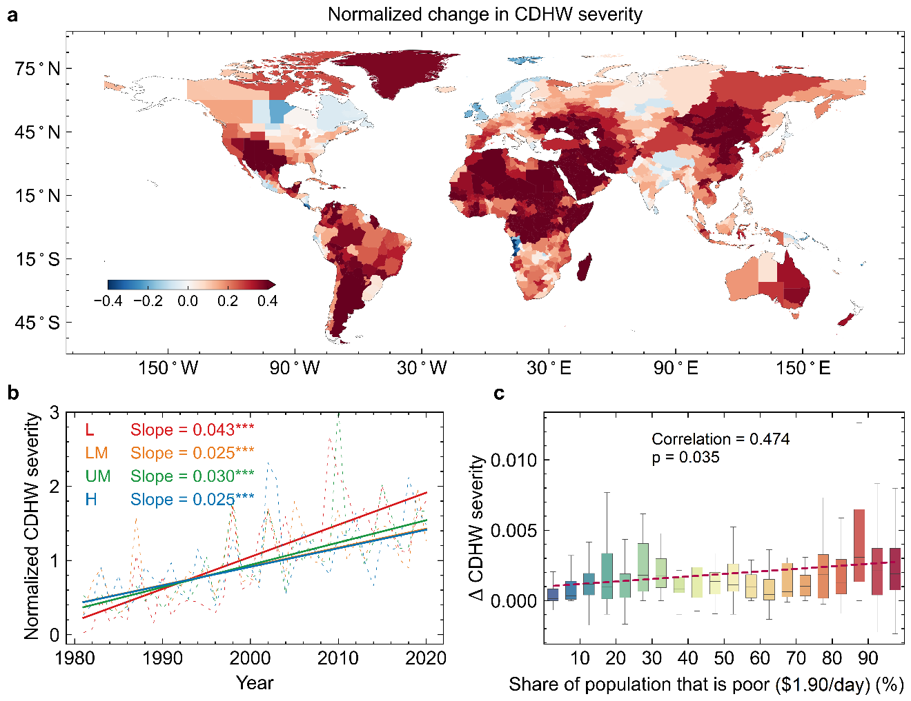

Figure S5 Same as Fig. S1 but for global interrelationships between anthropogenic climate change impacts on the frequency of CDHWs and the share of population that is poor (a <$3.20 and b <$5.50 per day).

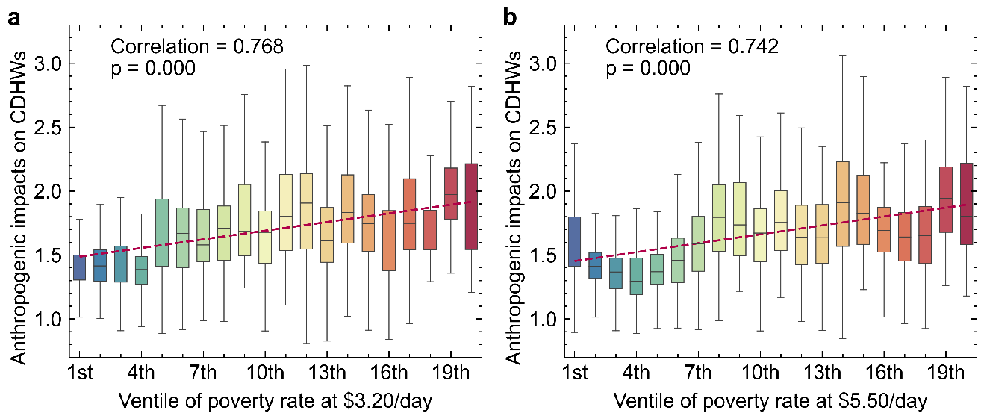

Figure S6 Comparison of independent heatwaves and droughts as well as CDHW events generated from the ERA5 reanalysis at the global scale during the period of 1981–2020. a Coincidence rate of heatwave events concurrent with an extreme drought week. b–d represent historical changes (i.e., Mann-Kendall trend) in independent heatwaves and droughts as well as CDHW events across different income groups. H = high-income countries. UM = upper middle-income countries. LM = lower-middle-income countries. L = low-income countries.

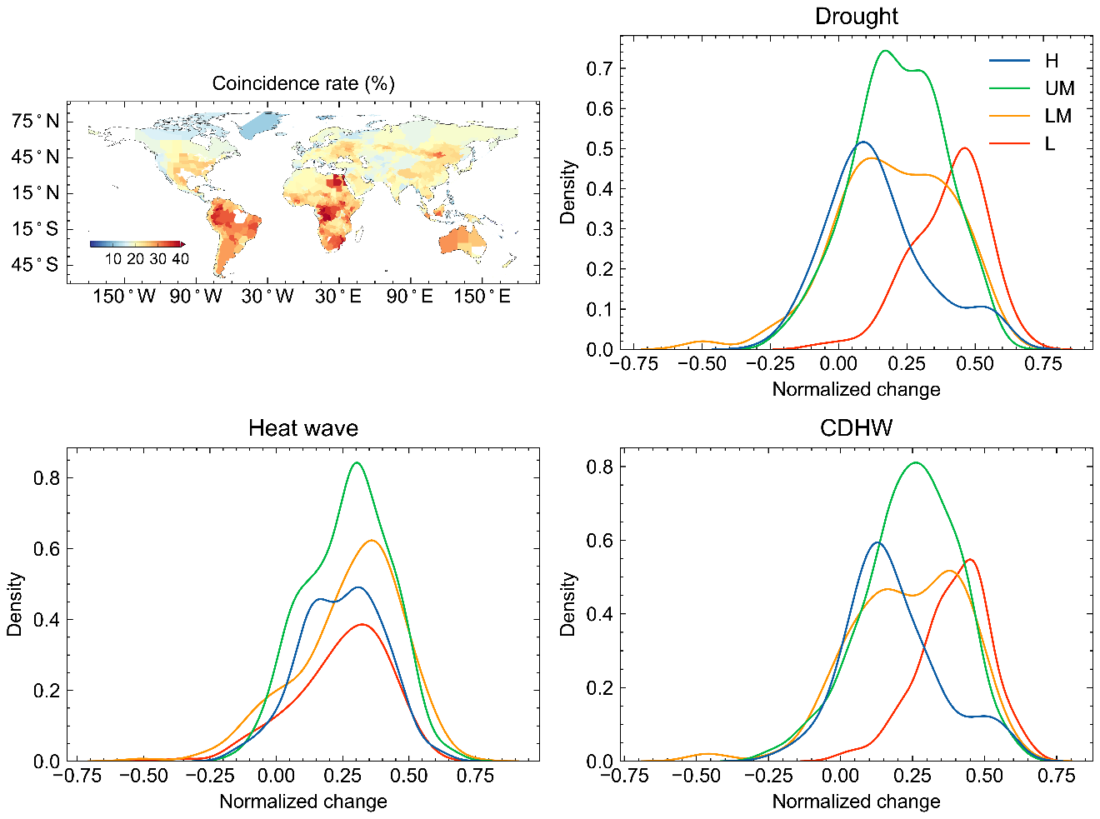
c d
a b

Figure S7 Historical changes in the frequency of heatwaves, droughts and CDHWs. a Annual time series of independent heatwaves and droughts as well as CDHW events based on the ERA5 reanalysis at the global scale during the period of 1981–2020. The time series were normalized by calculating annual values as a fraction of the 1981–2020 average. Dashed lines represent annual values and solid lines represent the linear trend. The slope (unit: year‒1) is the linear trend based on the Sen’s slope estimator; and the slope flagged with double stars (**) indicates that the trend is statistically significant at a P-value of 0.05 based on a MK test. b–d represent multiplicative changes in the normalized frequency of independent heatwaves and droughts as well as CDHWs between the earlier (1981–2000) and later (2001–2020) periods. The stippling in b−d indicates the multiplicative changes are significant at a P-value of 0.05 based on a t-test.
a b
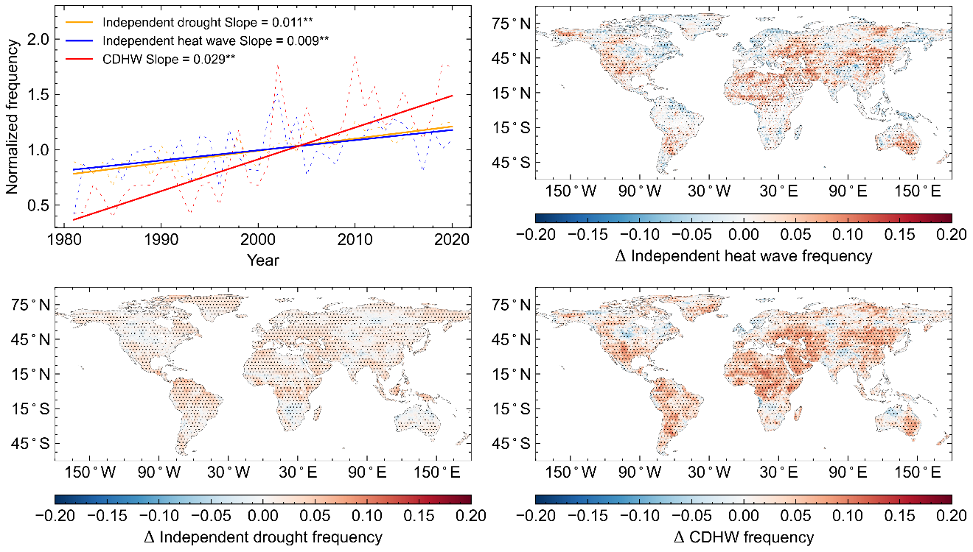
c d

Figure S8 Probability distributions of historical changes in the frequency of CDHWs for countries of the Global South and North. The slope as indicated in the x-axis is the Sen’s slope estimates (Sen, 1968). The dashed line represents the mean value of the slope.

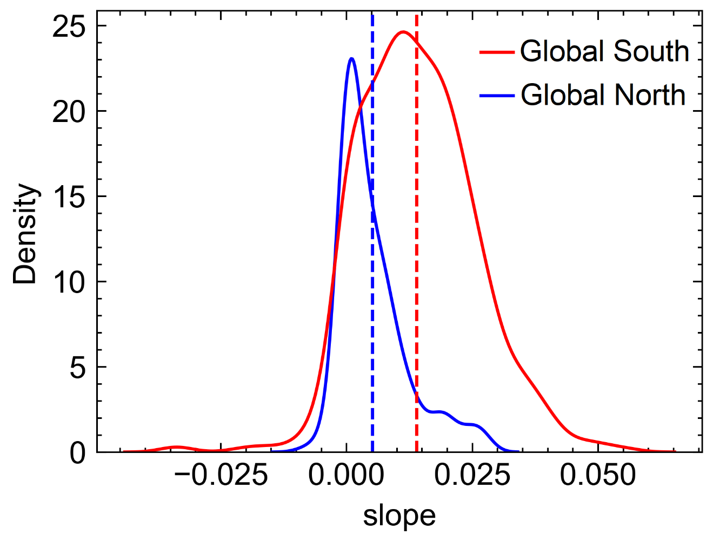

Figure S9 Comparison of the frequency and severity of CDHWs generated from the CMIP6 model simulations under anthropogenic and natural forcings.

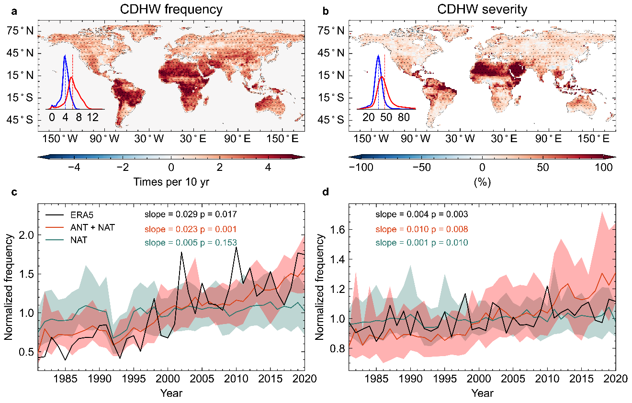

Figure S10 Anthropogenic climate change impacts on the severity of CDHWs for different income groups. Here, the probability ratio (PR) is used to quantify the impacts of anthropogenetic forcings on the frequency of CDHWs during the period of 1981–2020. a Each probability density function represents the distribution of PR for an income group. b Global interrelationships between the share of population that is poor (<$5.50 per day) and anthropogenic climate change impacts on the severity of CDHWs (i.e., the PR). Box extents are at the 25th and 75th percentiles with Tukey whiskers. The red dashed line represents the fitted linear regression between poverty rates (x-axis) and the PR (y-axis). The slope and p-value of the linear regression are shown.

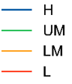
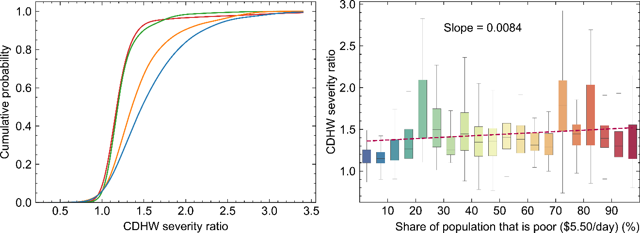

Figure S11 Spatial distribution of four income groups according to the World Bank’s country classifications by 2020 income level. H = high-income countries. UM = upper middle-income countries. LM = lower-middle-income countries. L = low-income countries.

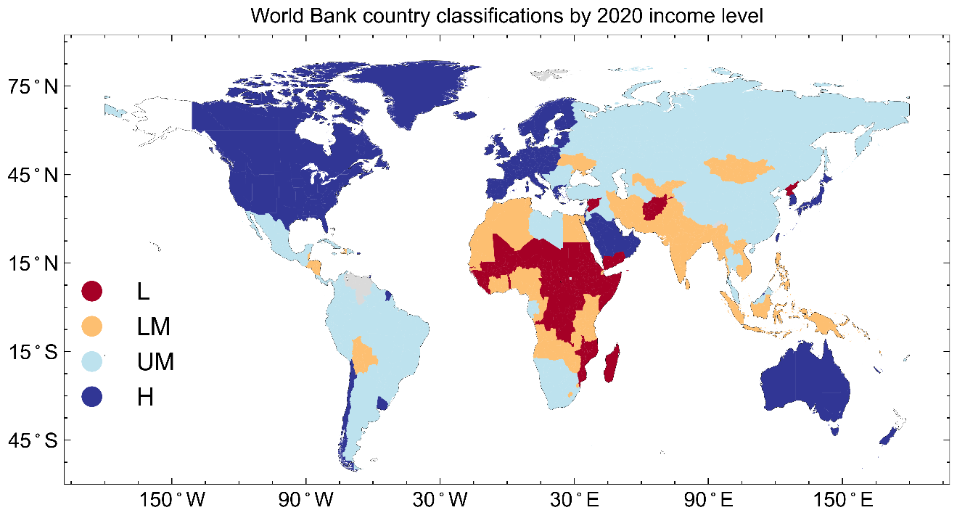

Figure S12 Spatial distributions of global potential evapotranspiration based on the CRU dataset and the ERA5 reanalysis.

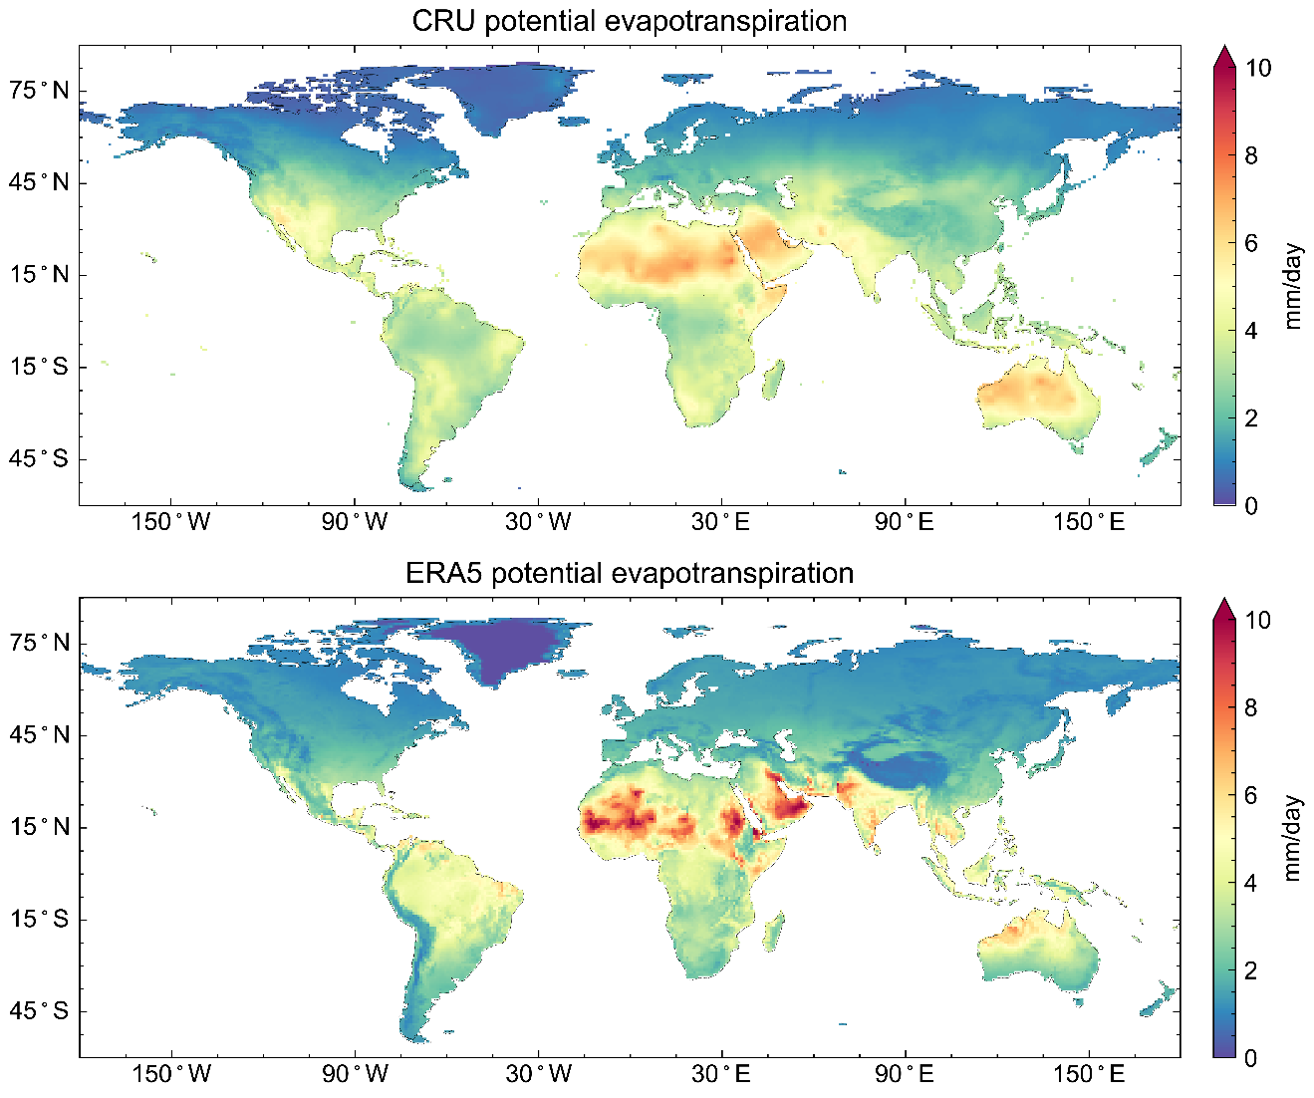

References
Bi, D., Dix, M., Marsland, S. J., O’Farrell, S., Rashid, H. A., Uotila, P., et al. (2013). The ACCESS coupled model: Description, control climate and evaluation. Australian Meteorological and Oceanographic Journal, 63(1), 41–64. https://doi.org/10.22499/2.6301.004
Dunne, J. P., Horowitz, L. W., Adcroft, A. J., Ginoux, P., Held, I. M., John, J. G., et al. (2020). The GFDL Earth System Model version 4.1 (GFDL-ESM 4.1): Overall coupled model description and simulation characteristics. Journal of Advances in Modeling Earth Systems, 12(11). https://doi.org/10.1029/2019MS002015
Held, I. M., Guo, H., Adcroft, A., Dunne, J. P., Horowitz, L. W., Krasting, J., et al. (2019). Structure and performance of GFDL’s CM4.0 climate model. Journal of Advances in Modeling Earth Systems, 11(11), 3691–3727. https://doi.org/10.1029/2019MS001829
Law, R. M., Ziehn, T., Matear, R. J., Lenton, A., Chamberlain, M. A., Stevens, L. E., et al. (2017). The carbon cycle in the Australian Community Climate and Earth System Simulator (ACCESS-ESM1) - Part 1: Model description and pre-industrial simulation. Geoscientific Model Development, 10(7), 2567–2590. https://doi.org/10.5194/gmd-10-2567-2017
Sen, P. K. (1968). Estimates of the regression coefficient based on Kendall’s Tau. Journal of the American Statistical Association, 63(324), 1379–1389. https://doi.org/10.1080/01621459.1968.10480934
Tatebe, H., Ogura, T., Nitta, T., Komuro, Y., Ogochi, K., Takemura, T., et al. (2019). Description and basic evaluation of simulated mean state, internal variability, and climate sensitivity in MIROC6. Geoscientific Model Development, 12(7), 2727–2765. https://doi.org/10.5194/gmd-12-2727-2019
Wu, T., Lu, Y., Fang, Y., Xin, X., Li, L., Li, W., et al. (2019). The Beijing Climate Center Climate System Model (BCC-CSM): The main progress from CMIP5 to CMIP6. Geoscientific Model Development, 12(4), 1573–1600. https://doi.org/10.5194/gmd-12-1573-2019
Yukimoto, S., Kawai, H., Koshiro, T., Oshima, N., Yoshida, K., Urakawa, S., et al. (2019). The meteorological research institute Earth system model version 2.0, MRI-ESM2.0: Description and basic evaluation of the physical component. Journal of the Meteorological Society of Japan, 97(5), 931–965. https://doi.org/10.2151/jmsj.2019-051

