Supplemental Material for
Glutamatergic system regulates feather pecking behaviors in laying hens: the gut-brain axis mechanism

Method S1. Analysis of non-targeted metabolomics data
The KEGG, HMDB and LIPIDMaps databases were used as reference resources for identified metabolites annotation. For the multivariate statistical analysis, the metaX software was firstly used to preprocess the metabolomics data. Then, the principal component analysis (PCA) and partial least squares discriminant analysis (PLS-DA) were performed to obtain the VIP value of each metabolite. For the univariate analysis, the t test was used to calculate statistical significance (P value) of each metabolite between the two groups, and the fold change (FC value) was also analyzed. The default criteria for differential metabolite screening are VIP > 1 and P < 0.05. The ggplot2 package in R was used to create a bubble chart, and the metabolite function and pathway were analyzed by MetaboAnalyst 5.0 (https://www.metaboanalyst.ca/). The metabolite pathway was considered to be enriched if x/n > y/n.
Method S2. Analysis of 16S rRNA gene sequencing data
According to the barcode sequence and PCR amplification primer sequence, each sample data was split from the offline data. truncate the barcode and primer sequences The FLASH software (V1.2.11) was used to splice the sample reads to obtain raw tags. The Fastp software is then used to perform quality control on the obtained raw tags to obtain high-quality clean tags. The Vsearch software is used to compare clean tags with the database to detect and remove chimeras, and to obtain the effective tags.
The DADA2 module in QLIME2 software was used to obtain the amplicon sequence variants (ASVs) and the feature table by filtering out sequences with abundance less than 5. Subsequently, the resulting ASVs were aligned to the database using the classify-sklearn module in the QIIME2 software to obtain the species information. According to the resulting feature table and ASV species annotation information, the statistical analysis was performed on two groups of data sets.
The QIIME2 software was used to calculate observed_otus, shannon, simpson, chao1, woods_coverage, dominance, and pielou_e indices, and to draw the rarefaction curve and species accumulation boxplots. The LEfSe software was used to perform significant differential species analysis.
Method S3. Analysis of eukaryotic transcriptome sequencing data.
- Gene expression analysis
Gene expression levels are generally measured by how much mRNA is transcribed. First, the featurecount software (http://subread.sourceforge.net/) was used to analyze the read information of each gene. Here, two methods (FPKM and TPM), as described below, were used for normalization analysis.
FPMK = $\frac{total exon Fragments}{mapped reads \left(Millons\right)×exon length (KB)}$
TPM = $\frac{\frac{N_{i}}{L_{i}}*{10}^{6}}{sum (\frac{N_{1}}{L1}+\frac{N_{2}}{L2}+…+\frac{N_{n}}{Ln})}$
Where, N_{i} is the number of reads aligned to the ith exon, L_{i} is the length of the ith exon.
- Differential analysis of gene expression
The edgeR package in R3.6.3 was used to calculate the statistical significance of each gene expression between the two groups. The criterion of differential gene was set as FC ≥ 1.5 and FDR ≤ 0.05.
- Differential gene annotation and enrichment analysis
The KEGG database was used for differential gene annotation. The KOBAS and Goatools software were respectively used to perform KEGG pathway enrichment analysis and GO enrichment analysis. Fisher's exact test was used to examine the significance of the association. In order to control the calculated false positive rate, multiple tests were performed using the BH (FDR) method, with a P value of 0.05 as the threshold. KEGG pathways or GO pathways that meet this condition are defined as significantly enriched in differentially expressed genes.

Table S1 Types and descriptions of FP behaviors
Types | Descriptions
SFP | One chicken grabs, pulls or tears another chicken's feathers with its beak, causing the feathers to break or be pulled out
GFP_ex | One chicken slightly touches another chicken's feathers with its beak, but not significantly changing the position of the feathers
GFP_st | A round of stereotypic FP is defined as three or more slight pecks on a single body part within one second

Table S2 Quantification of immune response markers in two groups of laying hens
Biomarkers | Feather peckers | Neutrals | P value
IL-1 (pg/mL) | 231.170 ± 6.209^{b} | 289.327 ± 6.613ª | 0.000
IL-6 (pg/mL) | 26.242 ± 1.644^{b} | 27.940 ± 0.630ª | 0.040
TNF-α (pg/mL) | 57.162 ± 5.526^{b} | 66.997 ± 3.909ª | 0.005
IgA (ng/mL) | 258.1483 ± 14.446^{b} | 274.630 ± 11.008ª | 0.050
IgG (ng/mL) | 2175.333 ± 86.814^{b} | 2540.333 ± 265.531ª | 0.018
IgM (ng/mL) | 574.022 ± 50.822^{b} | 630.392 ± 22.909ª | 0.033
CORT (pg/mL) | 110.142 ± 5.720 | 102.747 ± 19.513 | 0.408
EPI (pg/mL) | 658.240 ± 27.141ª | 551.297 ± 37.077^{b} | 0.000
NE (pg/mL) | 1316.480 ± 54.281ª | 1102.592 ± 74.157^{b} | 0.000

Table S3 The identified differential metabolite features in different biological organisms of feather peckers
Organisms | Upregulated metabolites | Downregulated metabolites | Total metabolites
hippocampus | 82 | 39 | 121
amygdala | 19 | 9 | 28
plasma | 32 | 49 | 81
cecum | 18 | 16 | 34
duodenum | 24 | 17 | 41
ileum | 60 | 12 | 72

Table S4 Differential genes in the hippocampus and amygdala of feather pecking chickens
Organisms | Upregulated genes | Downregulated genes | Differential genes | Total
hippocampus | 232 | 434 | 666 | 16643
amygdala | 243 | 202 | 445 | 16597

Fig. S1 Production performance of two groups of laying hens. TG, treatment group; CG, control group. * P < 0.05, ** P < 0.01.

Fig. S2 Egg quality of two groups of laying hens. TG, treatment group; CG, control group. * P < 0.05, ** P < 0.01.

Fig. S3 The relative abundance of gut microbiota at the phylum level. A Cecum B Duodenum C Ileum. P, feather peckers; N, neutral chickens.

Fig. S4 The relative abundance of gut microbiota at the genus level. A Cecum B Duodenum C Ileum. P, feather peckers; N, neutral chickens.

Fig. S5 The co‑occurrence network of the core bacteria in the cecum of A feather peckers and B neutral chickens, and the ileum of C feather peckers and D neutral chickens. Gut microbiota at the same phylum level are labeled as the same color.

Fig. S6 The number of identified metabolic features in biological organisms. Pos, positive ion mode; Neg, negative ion mode.

Fig. S7 The metabolic features of glutamate acid and its precursors in the hippocampus. P, feather peckers; N, neutral chickens.

Fig. S8 The metabolic features of glutamate acid and its precursors in the amygdala. P, feather peckers; N, neutral chickens.

Fig. S9 The metabolic features of glutamate acid and its precursors in the plasma. P, feather peckers; N, neutral chickens.

Fig. S10 The metabolic features of glutamate acid and its precursors in the cecum. P, feather peckers; N, neutral chickens.

Fig. S11 The metabolic features of glutamate acid and its precursors in the duodenum. P, feather peckers; N, neutral chickens.

Fig. S12 The metabolic features of glutamate acid and its precursors in the ileum. P, feather peckers; N, neutral chickens.

Fig. S13 The top 30 enriched GO terms for significantly A downregulated and B upregulated genes in the hippocampus of feather pecking chickens. BP, biological process; CC, cellular component; MF, molecular function.

Fig. S14 The top 30 enriched GO terms for significantly A downregulated and B upregulated genes in the amygdala of feather pecking chickens. BP, biological process; CC, cellular component; MF, molecular function.

Fig. S15 The correlation network of cecum microbiota and metabolites.

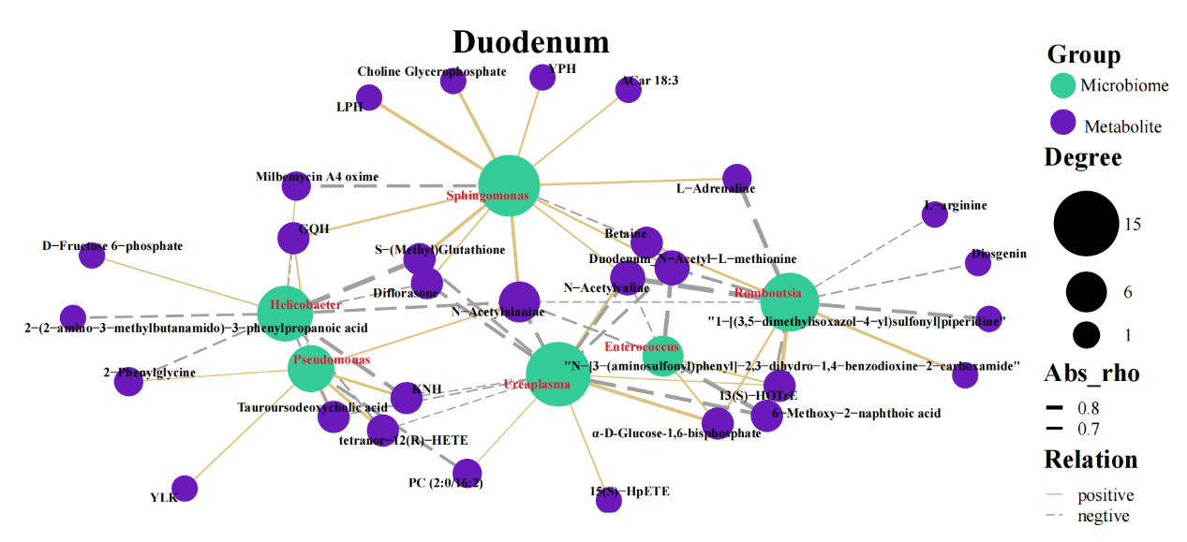
Fig. S16 The correlation network of duodenum microbiota and metabolites.

Fig. S17 The correlation network of ileum microbiota and metabolites.

