Supplementary material for “North Atlantic chlorophyll blooming enhances terrestrial primary over Europe”

Young-Min Yang^{1,2*}, Jae-Heung Park³, Jong-Yeon Park⁴, Soon-Il An⁵, Jong-Seong Kug, Sang-Wook Yeh⁶, Eun-Young Kwon^{7,8}, June-Yi Lee^{7,8} , Bin Wang^{1,2} and Tim Li^{1,2}
¹Key Laboratory of Meteorological Disaster, Ministry of Education (KLME)/Joint International Research Laboratory of Climate and Environment Change (ILCEC)/Collaborative Innovation Center on Forecast and Evaluation of Meteorological Disasters (CIC-FEMD), Nanjing University of Information Science and Technology, Nanjing, 210044, China. ²Department of Atmospheric Sciences and International Pacific Research Center, University of Hawaii, Honolulu HI 96822, USA. ³Division of Environmental Science and Engineering, Pohang University of Science and Technology, Pohang 37673, Korea. ⁴ Department of Earth and Environmental Science, Jeonbuk National University, Jeonju 54896, Korea. ⁵Department of Atmospheric Sciences and Irreversible Climate Change Research Center, Yonsei University, Seoul 03722, Korea. ⁶Department Marine Sciences and Convergent Technology, Hanyang University, ERICA, South Korea. ⁷Research Center for Climate Sciences, Pusan National University, Busan, South Korea. ⁸Center for Climate Physics, Institute for Basic Science, Busan, South Korea.. * indicates a corresponding author; e-mail: ymyang@hawaii.edu

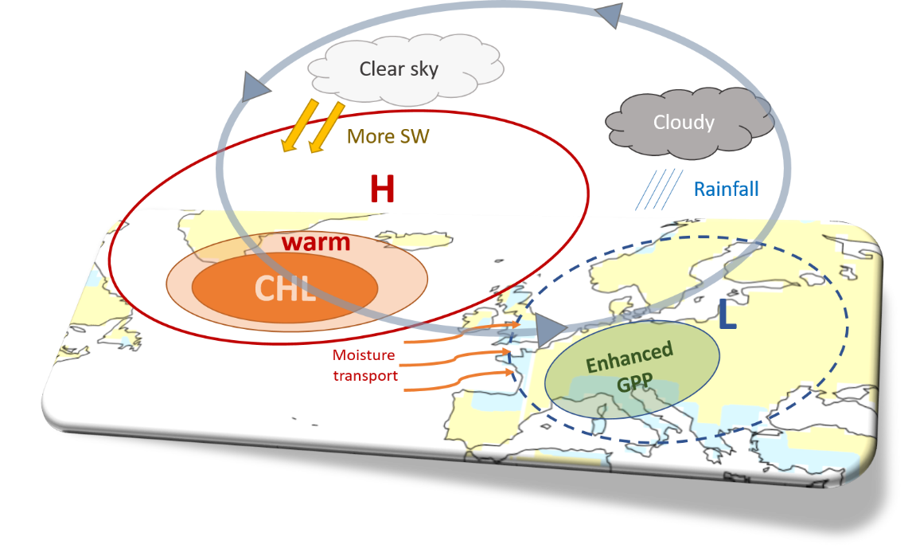

Supplementary Figure S1. Summary of the Europe GPP responses to the North Atlantic chlorophyll. Chlorophyll blooming and associated SST warming (red circle), surface wind anomalies (red curved arrow) associated with low pressure (blue dashed circle), and enhanced rain (blue hatched line) and GPP (green circle). On the upper troposphere, cloudy sky (gray circle) in Europe and a clear sky (light gray circle) in the North Atlantic Ocean.

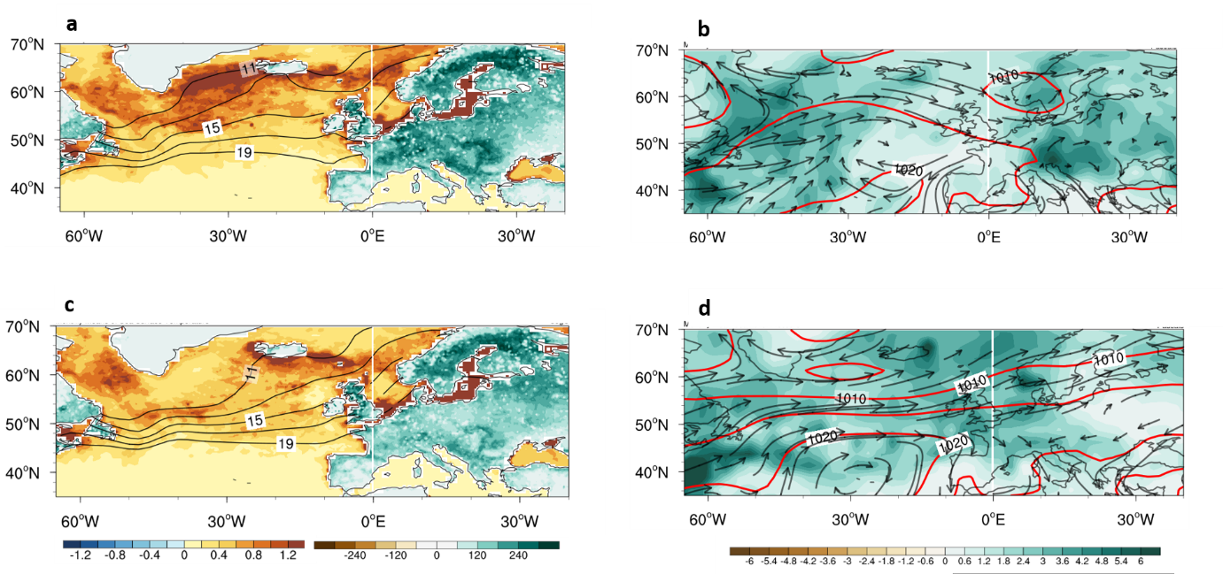

Supplementary Figure S2 | Impact of North Atlantic chlorophyll on Europe's climate and ecosystem. a,c Composite of observed August chlorophyll (mg m⁻³, ocean shading), SST (contour, 1°C intervals), and GPP (g C m⁻² month⁻¹, land shading) during (a) high and (c) low chlorophyll years. b,d Composite of observed August sea level pressure (hPa, contour, 2 hPa intervals), low-level wind (850 hPa, m s⁻¹, vectors), and precipitation (mm day⁻¹) during (b) high and (d) low chlorophyll years. High (low) chlorophyll years are defined when the chlorophyll averaged over the high latitudes of the North Atlantic (60°W-30°W, 55°N-65°N) is greater (smaller) than its one standard deviation. Data from 2003-2021 are used for the analysis. The shading represents a 95% confidence interval based on a Student's t-test.

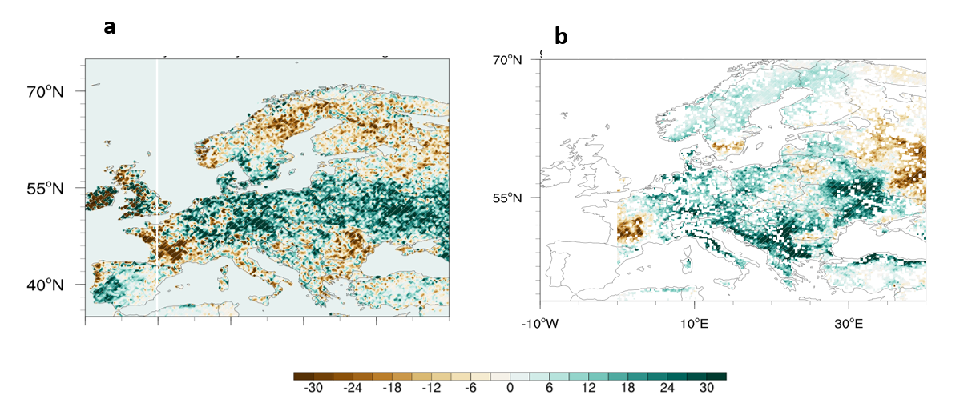

Supplementary Figure S3 | Impact of North Atlantic chlorophyll on Europe's ecosystem. a Regression coefficient of August NDVI onto September North Atlantic chlorophyll (60°W-30°W, 55°N-65°N). The 2003–2021 data are used for analysis. b same as a but for GPP from LUEM (g C m⁻² month⁻¹ ). The 2003–2016 data are used for analysis. Hatching and scale bars represent a range of 95% confidence level based on a Student’s t-test.

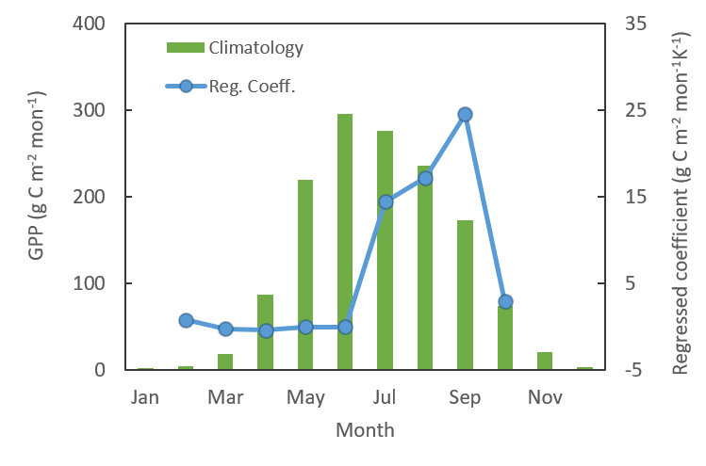

Supplementary Figure S4. Seasonal cycle of GPP anomalies related to North Atlantic Chlorophyll. The regression coefficient of the monthly GPP from LUEM over Europe (5°–30°E, 45°–55°N) with respect to the North Atlantic chlorophyll (50°W-30°W, 55°N-65°N) index (blue line) and climatological monthly GPP over Europe (green bars) based on LUE (g C m⁻² month⁻¹ ).

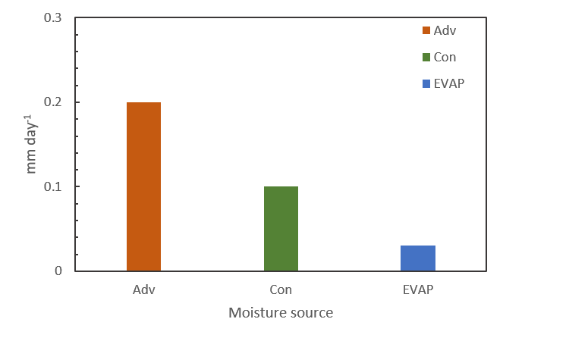

Supplementary Figure S5. Differences in dynamic and thermodynamical processes between High and low chlorophyll year. Bar chart showing the changes in the August dynamic process (DY), thermodynamic process (TH), and evaporation (EVAP) over the European region. “adv” and “con” indicate advection and convergence, respectively. The y-axis scale is mm/day. High (low) chlorophyll years are defined when the chlorophyll averaged over the high latitudes of the North Atlantic (60°W-30°W, 55°N-65°N) is greater (smaller) than its one standard deviation. Data from 2003-2021 are used for the analysis.

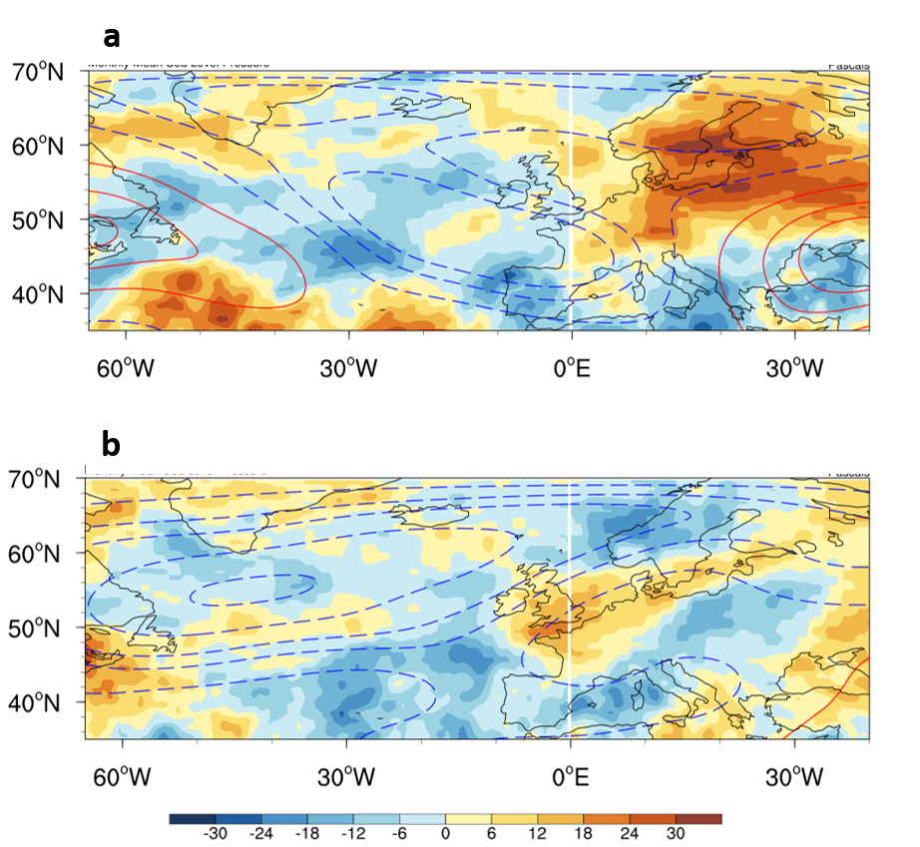

Supplementary Figure S6 | Impact of North Atlantic chlorophyll on Europe's climate. a,c Composite of observed August cloud cover (%, shading) and geopotential height at 300 hPa (contour, 2 mb) during (a) high and (c) low chlorophyll years. High (low) chlorophyll years are defined when the chlorophyll averaged over the high latitudes of the North Atlantic (60°W-30°W, 55°N-65°N) is greater (smaller) than its one standard deviation. Data from 2003-2021 are used for the analysis. The shading represents a 95% confidence interval based on a Student's t-test.

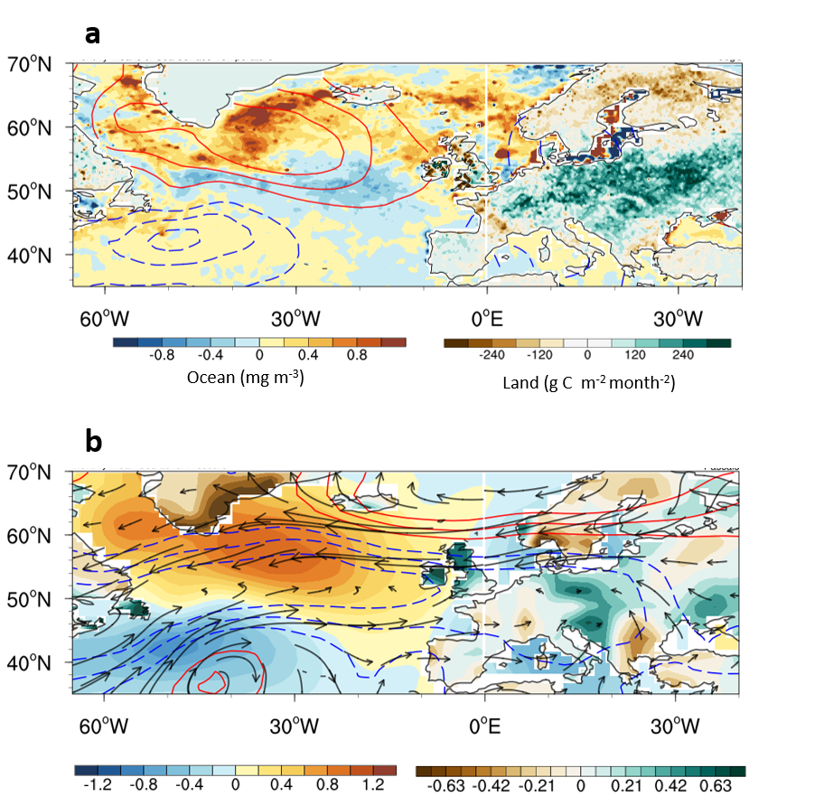

Supplementary Figure S7 | Impact of North Atlantic chlorophyll on Europe's climate and ecosystem. a Difference in the composite of observed September chlorophyll (mg m⁻³, ocean shading), SST (contour, 1°C intervals), and GPP (g C m⁻² month⁻¹, land shading) between high and low chlorophyll years. b Difference in the composite of observed September sea level pressure (hPa, contour, 2 hPa intervals), low-level wind (850 hPa, m s⁻¹, vectors), SST (°C, ocean shading), and precipitation (mm day⁻¹, land shading) between high and low chlorophyll years. High (low) chlorophyll years are defined when the chlorophyll averaged over the high latitudes of the North Atlantic (60°W-30°W, 55°N-65°N) is greater (smaller) than its one standard deviation. Data from 2003-2021 are used for the analysis. The shading represents a 95% confidence interval based on a Student's t-test.

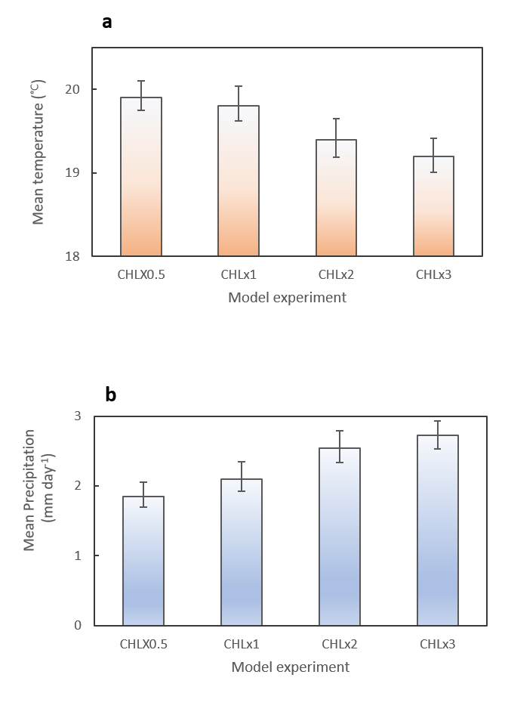

Supplementary Figure S8 | Impact of North Atlantic chlorophyll on Europe's climate and ecosystem. Sensitivity of near-surface temperature over Europe (a, 0°E-20°E, 45°N-55°N) and mean precipitation (b) to high-latitude chlorophyll from the model simulations with prescribed chlorophyll concentrations (50%, 100%, 200%, and 300% of model climatology). The black line represents the ensemble spread. 50yr simulation data are used for the analysis.

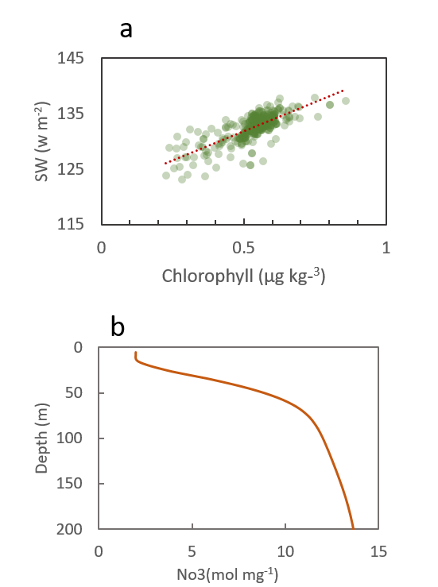

Supplementary Figure S9 | Relationship between ocean chlorophyll and sea surface temperature. a-b Scatter plots of Septembeer SST and chlorophyll over high latitude (a, 50°W-30°W, 55°N-65°N) from a data-process earth system model simulations. Red dotted lines show linear regression. b Vertical structure of September NO3 (mol mg-1) over high latitude (red line, 50°W-30°W, 55°N-65°N) from a data-process earth system model simulations.

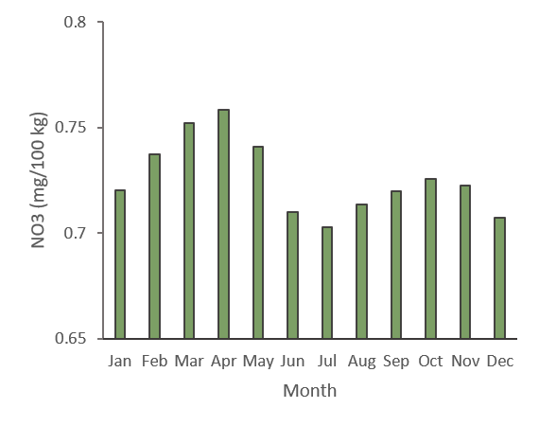

Supplementary Figure S10. Climatology of monthly chlorophyll. Climatological monthly NO3 nutrients in the high latitude of the North Atlantic Ocean (50°W-30°W, 55°N-65°N) (mg m⁻³).

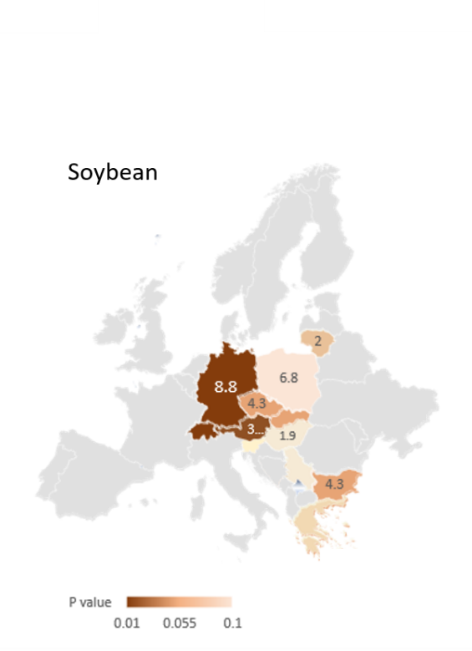

Supplementary Figure S11 | Effect of North Atlantic chlorophyll on European crop yields. Difference in national-based annual crop yield of soybean between high and low chlorophyll years. Shading indicates the P-value based on the correlation coefficient of August chlorophyll averaged over (60°W-30°W, 55°N-65°N) and annual crop yield. Gray indicates both insignificant states and undefined countries due to a lack of crop yield data. Data from 2003-2021 were used for the analysis. High (low) chlorophyll years are defined when the chlorophyll averaged over the high latitudes of the North Atlantic (60°W-30°W, 55°N-65°N) is greater (smaller) than its one standard deviation. Data from 2003-2021 are used for the analysis.

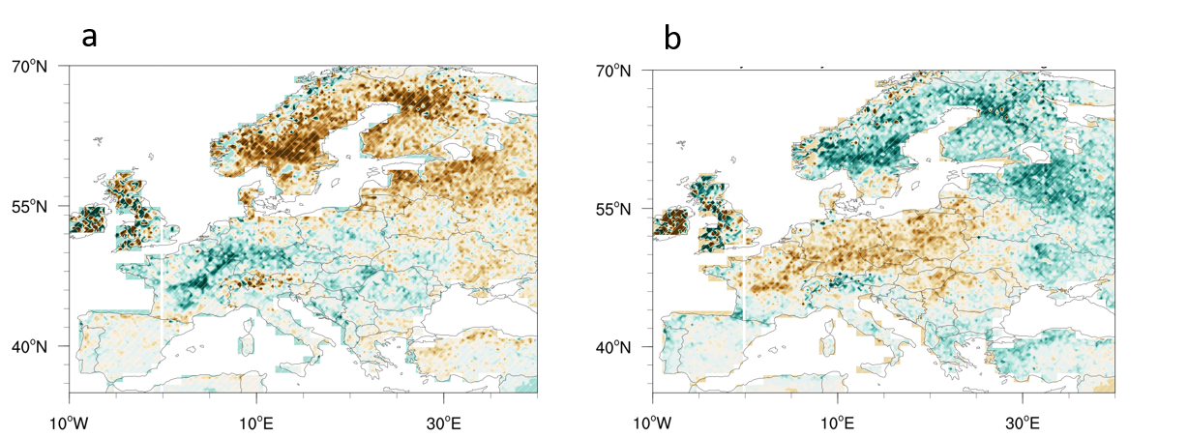

Supplementary Figure S12. Impact of climate variabilities on Europe's ecosystem. a Regression coefficient of August GPP from NIR (g C m⁻² month⁻¹ ) onto August North Atlantic Oscillation (a) and ENSO (b) from National Oceanic and Atmospheric Administration (NOAA, https://www.ncei.noaa.gov/access/monitoring/nao/). Hatching and scale bars represent a range of 95% confidence level based on a Student’s t-test. Data from 2003-2021 are used for the analysis.

