Sr  No | Name | Classification | Morphological Feature
1 | Telamonia dimidiate  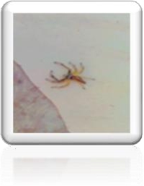 | Class – Arachnida Order - Araneae Family – Salticidae Living area – Farm | - The male is very dark, with white markings.  - Red hairs around the eyes.  - Legs I and II of the males are armed with thick brushes of bristles.  - Females are larger than male individuals.
2 | Pardosa modica  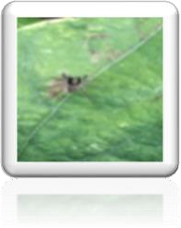 | Class – Arachnida Order - Araneae Family – Lycosidae Living area – Farm | - Females and males are nearly the same size.  - The spiders are a reddish brown with a narrow yellow median stripe on the carapace and unbroken yellow lateral bands.
3 | Cheiracanthiun maildei   | Class – Arachnida Order - Araneae Family - Cheiracanthiidae Living area – Farm | - It is often yellow and can range in color to tan, light brown, and pale green depending on location and diet.  - They have a brown stripe down the back of their abdomen over the area.  - They have long, sharp  fangs that easily pierce human skin.
4 | Saitis barbipes | Class – Arachnida Order - Araneae Family - Salticidae | - To see individual hairs in sharp focus.  - Adjacent black color patches.

 | 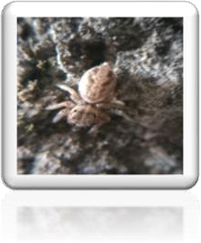 | Living area - S.M. Joshi College and basement area of same college
5 | Araneus ventricous  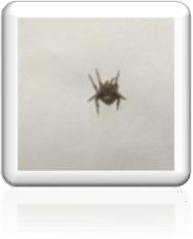 | Class – Arachnida Order - Araneae Family - Araneidae  Living area - S.M. Joshi College and basement area of same college | - Eight walking legs, six to eight eyes, and two body regions.  - The first body segment, called the prosoma, contains the eyes, mouthparts, and legs.  - The second region is the abdomen, which has spinnerets at its base that  produce silk.
6 | Pseudeuophrys erratica  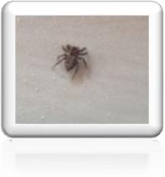 | Class – Arachnida Order - Araneae Family – Salticidae  Living area - S.M. Joshi College and basement area of same college | - Identified by their compact, robust body and four large, front-facing eyes.  - Most have hairy black, brown, tan, or grey bodies with more colorful markings.
7 | Plexippus paykulli  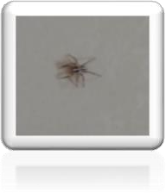 | Class – Arachnida Order - Araneae Family – Salticidae  Living area - S.M. Joshi College and basement area of same college | - It is robust, with a high carapace.  - It is covered with short greyish hairs with sometimes dramatic accents of red in the male.  - Females are 9 to 12 mm (0.35 to 0.47 in) in body length, while males are 9 to  11 mm (0.35 to 0.43 in)
8 | Araneus gemmoides | Class – Arachnida Order - Araneae Family – Araneidae | - The important predators have eight walking legs, six to eight eyes, and two body  regions.

 | 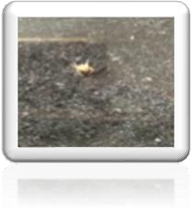 | Living area - S.M. Joshi College and basement area of same college | - The first body segment, called the prosoma, contains the eyes, mouthparts, and legs.  - The second region is the abdomen, which has spinnerets at its base that  produce silk.
9 | Pisaurina mira  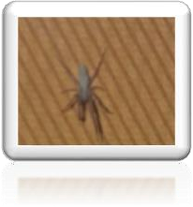 | Class – Arachnida Order - Araneae Family – Pisauridae  Living area - S.M. Joshi College and basement area of same college | - Male nursery web spiders are 9 to 15 mm long and the females are usually 12 to 15 mm long.  - Both males and females are yellowish-brown in color and sometimes have a light to dark brown band down  the middle of the back.
10 | Steatoda grossa  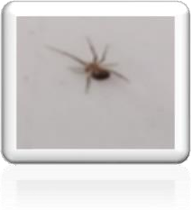 | Class – Arachnida Order - Araneae Family –Theridiidae  Living area - S.M. Joshi College and basement area of same college | - Grossa is 6-10.5 mm in length and dark colored with a round, bulbous abdomen.  - Typical coloration ranges from purplish brown to black, with light-colored markings
11 | Parasteatoda tepidariorum  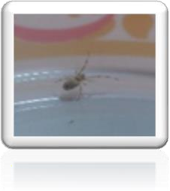 | Class – Arachnida Order - Araneae Family –Theridiidae Living area – Home | - The color varies from a dirty white to almost black.  - It is yellow brown and the legs are light yellow with brown or gray rings at the ends and middle of the joints.  - They can be an inch (2.5 cm) or more across with legs outspread.

12 | Hasarius adansoni  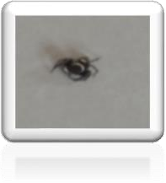 | Class – Arachnida Order - Araneae Family - Salticidae Living area – Home | - It is U- shaped, dark brown in color and flat.  - Upper anterior part of the cephalothorax containing eyes is raised.
13 | Platyoryptus undatus  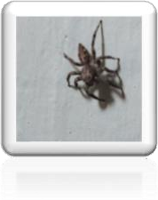 | Class – Arachnida Order - Araneae Family - Salticidae Living area – Home | - They have eight legs.  - They can shoot silk out of their abdomen and frequently use it to build elaborate webs, and they prey on insect.
14 | Olios argelasius  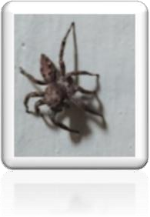 | Class – Arachnida Order - Araneae Family - Sparassidae Living area – Home | - They are large, long-legged spiders.  - They are mostly grey to brown, sometimes with banded legs.  - They have rather flattened bodies adapted for living in narrow spaces under loose bark or rock crevices.
15 | Cheiracanthium inclusum  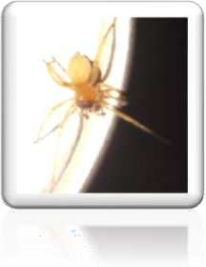 | Class – Arachnida Order - Araneae Family - Cheiracanthiidae Living area – Home | - The yellow sac spider is often yellow and can range in color to tan, light brown, and pale green depending on location and diet.  - They have a brown stripe down the back of their abdomen over the area where their heart is.  - They have long, sharp fangs that easily pierce human  skin.
16 | Heteropoda venatoria | Class – Arachnida Order - Araneae Family - Sparassidae Living area – Home | - It is 20-23 mm in length with female's body length at the upper range compared to males.  - Females have an overall brown body and a larger  abdomen with a tan

 | 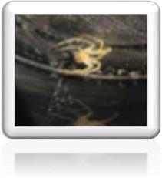 |  | marginal band on the carapace.
17 | Lycosa singoriensis  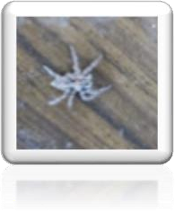 | Class – Arachnida Order - Araneae Family - Lycosidae Living area – Home | - They have a segmental pattern of alternating dark and light bands on the legs.  - It is usually buff colored, with black or dark brown femurs and underparts.
18 | Loxosceles reclusa  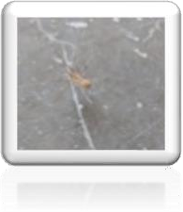 | Class – Arachnida Order - Araneae Family - Sicariidae Living area – Home | - Two body parts.  - Eight legs.  - Chelicerae or fangs.
19 | Leucauge venusta  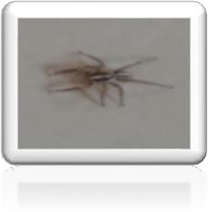 | Class – Arachnida Order - Araneae Family - Tetragnathidae Living area - Warehouses | - It has three lines on the abdomen that run parallel only about halfway across the abdomen.  - The outer two bend inward before continuing parallel.
20 | Philodromus albofrenatus  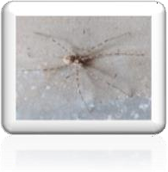 | Class – Arachnida Order - Araneae Family - Philodromidae Living area - Warehouses | - The legs are yellowish grey or brown with dark spots.  - It is very variably colored, brown or yellowish brown, mostly spotted
21 | Tegenaria domestica | Class - Arachnida Order - Araneae Family - Agelenidae | - Long legs.  - Black Paches.  - Large Abdomen.

 | 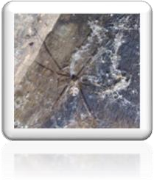 | Living area - Warehouses | - Six legs.
22 | Phalangium opilio  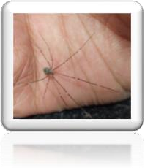 | Class - Arachnida Order - Opiliones Family - Phalangiidae Living area - Warehouses | - They are the long, slender legs and short, globular body.  - Adult body length is approximately 3.5–9 mm, with males generally smaller  than females.
23 | Latrodectus geomericus  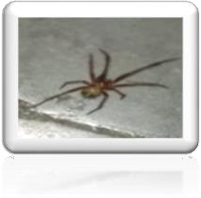 | Class - Arachnida Order - Araneae Family - Theridiidae Living area - Warehouses | - Its four pairs of eyes positioned in two parallel rows.  - A comb-feet arranged in a comb-like row bristles on the tarsi of the hind legs.  - Distinctive paired sperm thecae with coiled copulatory  ducts.
24 | Araneus angulatus  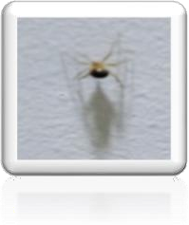 | Class - Arachnida Order - Araneae Family - Araneidae Living area - Warehouses | - It has eight walking legs, six to eight eyes, and two body regions.  - The first body segment, called the prosoma, contains the eyes, mouthparts, and legs.  - The second region is the abdomen, which has spinnerets at its base that  produce silk.
25 | Leiobunum rotundum  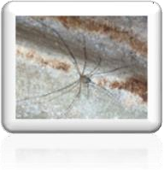 | Class - Arachnida Order - Opiliones Family - Sclerosomatidae Living area - Warehouses | - Spiders usually have eight eyes (some have six or fewer), but few have good eyesight.  - They instead on touch, vibration and taste stimuli to navigate and find their prey.

26 | Nesticus cellulanus  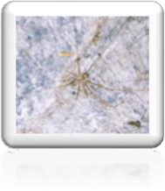 | Class - Arachnida Order - Araneae Family - Nesticidae Living area - Warehouses | - The bodies divided into two tagmata (sections or segments).  - eight jointed legs.  - No wings or antennae.
27 | Oecabius navus  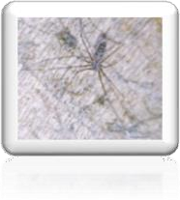 | Class - Arachnida Order - Araneae Family - Oecobiidae Living area - Warehouses | - It has eight legs.  - They have eight eyes.
28 | Holocnemus pluchei  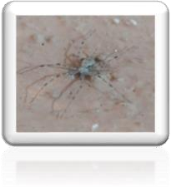 | Class - Arachnida Order - Araneae Family - Pholcidae Living area - Warehouses | - They have eight legs.  - Two main body parts (a cephalothorax and abdomen) and fangs that produce venom.  - They can also make silk from their spinnerets at the tip of  their abdomen.
29 | Pholcus opilionoides  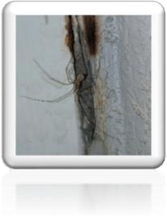 | Class - Arachnida Order - Araneae Family - Pholcidae Living area - Warehouses | - They have two body segments.  - long legs.  - Which can range from 5 to 6 times the size of their bodies.
30 | Scytodes globula  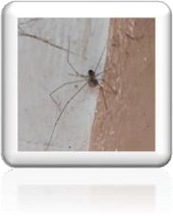 | Class - Arachnida Order - Araneae Family - Scytodidae Living area - Warehouses | - size varies from 30 up to 70 mm.  - Its body is small.  size of its legs, which are usually between three and four times the size of its body.  - It has slow movements and it hunts only at night.

Table No 2: Collected the Spider species at research area

