Palladium(II) halide complexes of N,N,S-tridentate Schiff bases. Synthesis, structural studies in solution and solid state, and analysis of Hirshfeld surfaces
Jesús-Alberto Alvarez-Hernández, Noemí Andrade-López*, José G. Alvarado-Rodríguez, Oscar Muñoz-Granados, Gloria Sánchez-Cabrera, and Diego Martínez-Otero

Supplementary Material

Table of Contents
Fig. 1S ¹H NMR (δ, ppm, DMSO-d6) at room temperature of 2, 2a and 2b 3
Fig. 2S ¹H NMR (δ, ppm, DMSO-d6) at room temperature of bromo palladium complexes 1a–4a 4
Fig. 3S ¹H NMR (δ, ppm, DMSO-d6) at room temperature of iodo palladium complexes 1b–4b 5
Fig. 4S ¹³C{¹H} NMR (δ, ppm, DMSO-d6) at room temperature of bromo palladium complexes1a–4a 6
Fig. 5S ¹³C{¹H} NMR (δ, ppm, DMSO-d6) at room temperature of iodo palladium complexes1b–4b 7

NMR Spectra

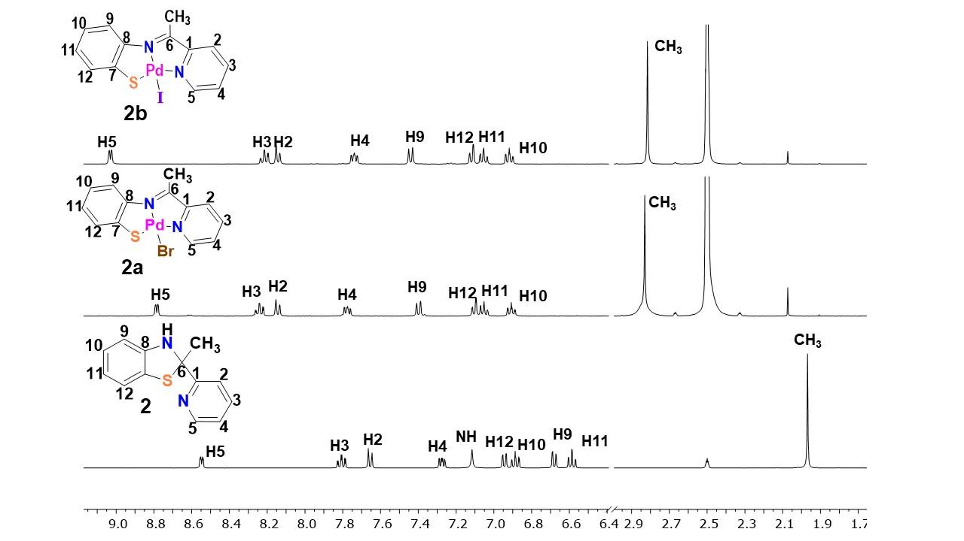

Fig. 1S ¹H NMR (δ, ppm, DMSO-d6) at room temperature of 2, 2a and 2b

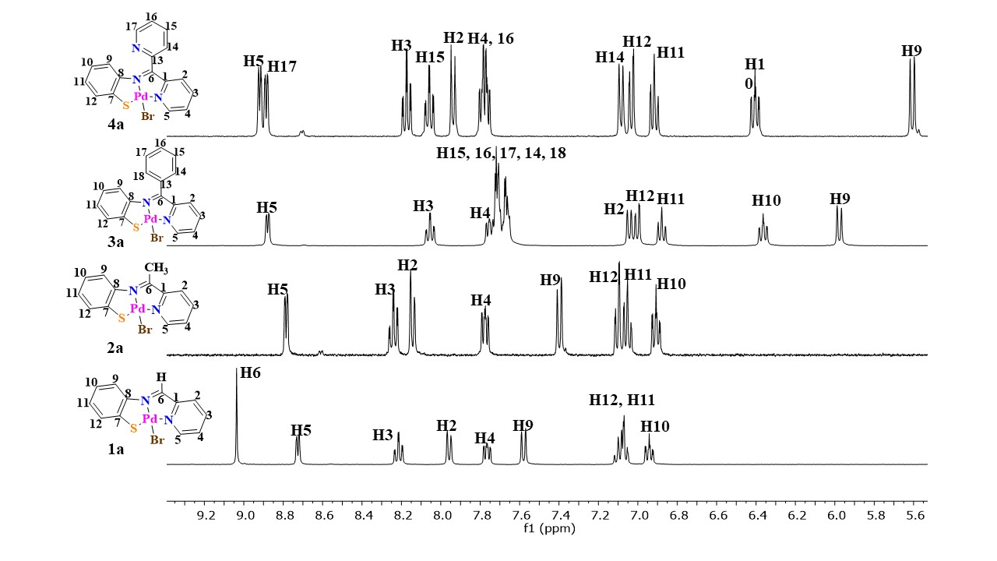

Fig. 2S ¹H NMR (δ, ppm, DMSO-d6) at room temperature of bromo palladium complexes 1a–4a

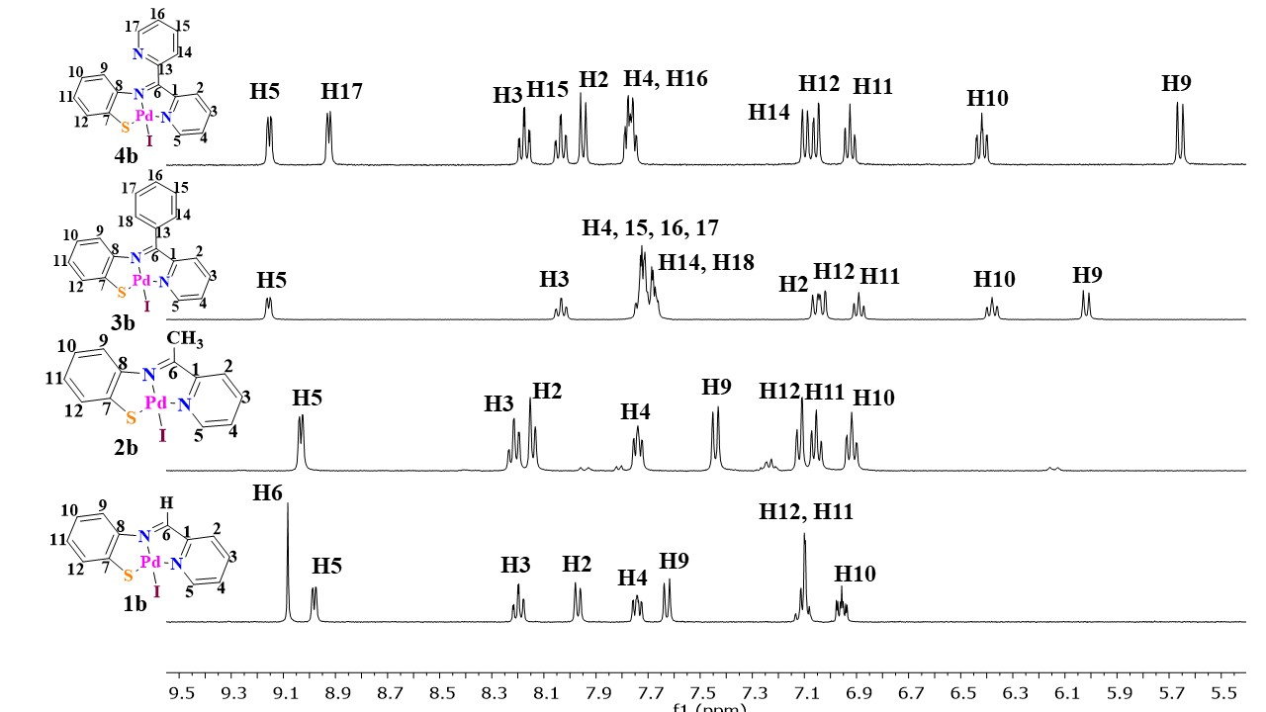

Fig. 3S ¹H NMR (δ, ppm, DMSO-d6) at room temperature of iodo palladium complexes 1b–4b

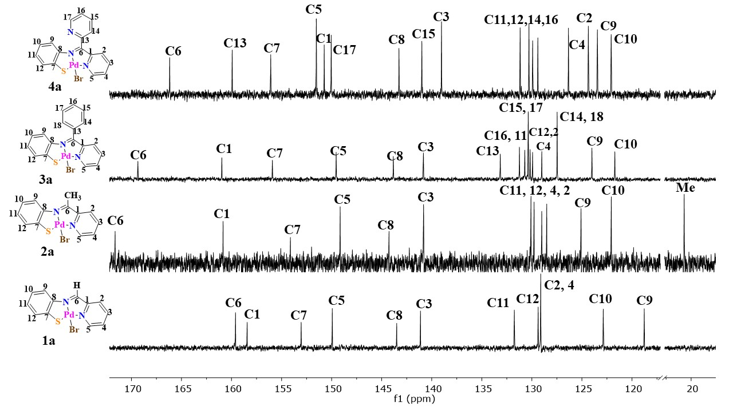

Fig. 4S ¹³C{¹H} NMR (δ, ppm, DMSO-d6) at room temperature of bromo palladium complexes1a–4a

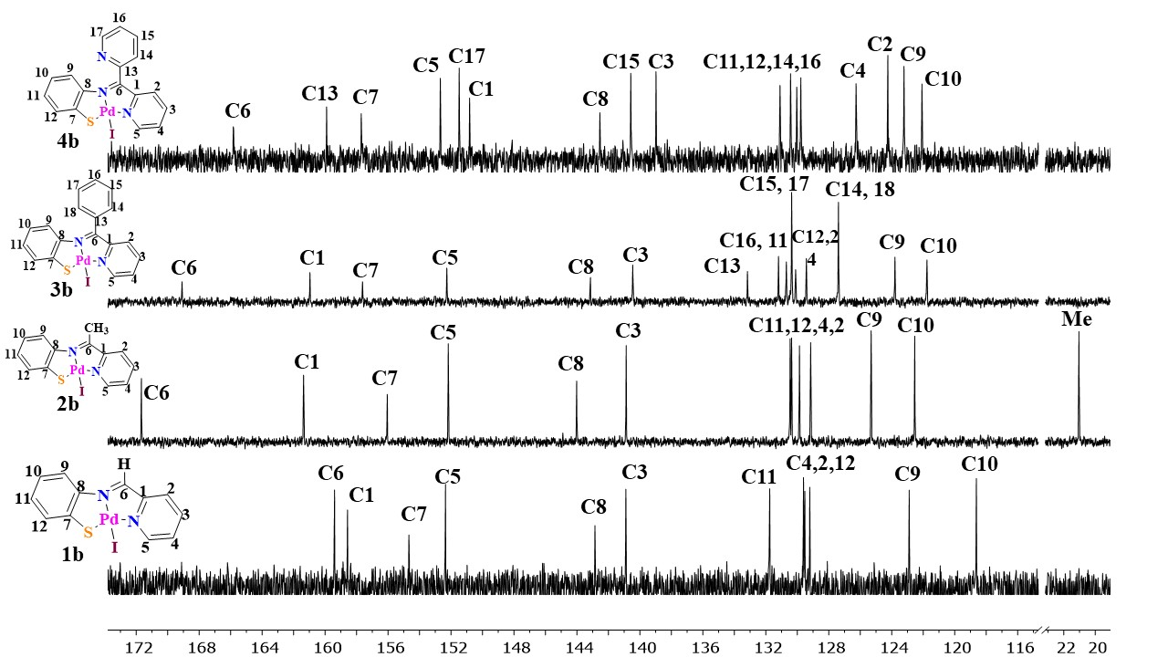

Fig. 5S ¹³C{¹H} NMR (δ, ppm, DMSO-d6) at room temperature of iodo palladium complexes1b–4b

