Supplementary Table 1. The characteristics of patients and controls samples used in the functional analyses
Number | SAMPLE ID | AGE | SEX | skin sample site | genotype
P1 | 11 | 4 | F | tight | ALOXE3:p.Arg234Ter/Pro630Leu
P2 | 19 | 25 | F | arm | ALOX12B: p.Ty521Cys/p.Tyr521Cys
P3 | 43 | 18 | M | arm | TGM1: p.Val379Leu/Trp193Ter
P4 | 56 | 17 | F | arm | ALOXE3:p.Arg234Ter/p.Arg234Ter;  DSP: p.Arg1400Ter/-
P5 | 41 | 30 | F | arm | TGM1:p.Val379Leu/p.Glu497Val
P5 | 54 | 26 | F | arm | ALOX12B: p.Tyr521Cys/p.Phe485Ser
P7 | 24 | 10 | M | arm | STS: c.(?_-1)_(*1_?)del
P8 | 58 | 13 | F | arm | TGM1: p.Trp193Ter/p.Trp193Ter
P9 | 57 | 7 | M | arm | SPINK5: p.Phe606Leu/c.1816_1820+21delinsCT
P10 | 39 | 19 | F | back | ALOX12B: p.Tyr521Cys/Pro422Leu  FLG: p.Ser761CysfsTer36/-,
P11 | 53 | 37 | M | knee | LOR:c.639_642dup (p.Thr215GlyfsTer122)/-
P12 | 45 | 49 | M | arm, back | TGM1: Arg126His/Arg126His
P13 | 55 | 9 | M | arm | TGM1:p.Arg315Cys/ex10-14dup
P14 | 52 | 15 | F | back | ALOX12B:p.Tyr521Cys/p.Tyr521Cys
P15 | 36 | 9 | M | back | TGM1:p.Arg126His/c.877-2A>G
P16 | 10 | 50 | M | arm | TGM1: p.Arg126His/p.Arg126His
P17 | 34 | 30 | F | unknown | ABCA12: p.Asn1380Ser/p.Asn2034Asp  FLG:p.Arg2447Ter/-
P18 | 38 | 19 | F | unknown | ALOX12B:p.His158CysfsTer20 (c.467_470dup)/p.Tyr521Cys
C1 | 23 | 3 | male | abdomen
C2 | 42 | 9 | F | tight
C3 | 21 | 37 | F | arm
C4 | 26 | 10 | U | back
C5 | 20 | 50 | F | breast
C6 | 40 | 52 | F | breast
C7 | 30 | 52 | F | breast
C8 | 51 | ND | ND | tight
C9 | 27 | 39 | M | knee
C10 | 32 | ND | ND | ND
C11 | 35 | 50 | F | abdomen
C12 | 50 | 56 | F | abdomen
C13 | 37 | 56 | F | abdomen
C14 | 33 | 30 | F | abdomen
C15 | 44 | 65 | F | abdomen
C16 | 22 | 65 | F | abdomen
C17 | 29 | 42 | F | abdomen
C18 | 49 | 3 | ND | tight
C19 | 48 | 3 | M | tight
C20 | 25 | 4 | M | tight
C21 | 31 | 51 | F | breast
C22 | 28 | ND | F | arm
ND – no data , ? – variant in one allele not found

Table 2 Summary of variant distribution
Gene | number of variants (n=150) | total number of alleles (includes also variants detected as secondary findings) (n=415)
ALOX12B* | 22 | 113
TGM1* | 23 | 68
FLG | 8 | 39
ALOXE3* | 15 | 37
STS | 2 | 27
SPINK5 | 12 | 20
ABCA12* | 13 | 19
KRT10 | 7 | 15
KRT9 | 3 | 14
NIPAL4* | 3 | 11
KRT1 | 7 | 7
CYP4F22* | 3 | 6
SLC27A4* | 3 | 4
PNPLA1* | 2 | 4
GJB2 | 3 | 3
KRT2 | 3 | 3
AAGAB | 2 | 2
DSP | 2 | 2
ERCC2 | 2 | 2
ALDH3A2 | 1 | 2
CERS3* | 1 | 2
LORICRIN | 1 | 2
POMP | 1 | 2
DSG1 | 1 | 1
GJA1 | 1 | 1
GJB3 | 1 | 1
GJB4 | 1 | 1
KRT16 | 1 | 1
ST14 | 1 | 1
ERCC3 | 1 | 1
ERCC3 | 1 | 1
GTF2H5 | 1 | 1
VPS33B | 1 | 1
WNT10A | 1 | 1
* Autosomal Recessive Congenital Ichthyosis genes

Table 3 Supplement. The list of recurrent variants detected in the study Supplement
Gene | Variant name | Number of alleles
ALOX12B | c.1562A>G (p.Tyr521Cys) | 52 (1 as SF)
STS | c.(?_-1)_(*1_?)del (p.1Met_583Terdel) | 26
ALOXE3 | c.700C>T (p.Arg234Ter) | 22
FLG | c.2282_2285delCAGT (p.Ser761CysfsTer36) | 19 (6 as SF)
TGM1 | c.377G>A (p.Arg126His) | 18 (1 as SF)
TGM1 | c.1135G>C (p.Val379Leu) | 12
ALOX12B | c.1790C>A (p.Ala597Glu) | 11
FLG | c.1501C>T (p.Arg501Ter) | 11
KRT9 | c.488G>A (p.Arg163Gln) | 10
ALOX12B | c.1A>G (p.Met1Val) | 9
NIPAL4 | c.341C>A (p.Ala114Asp) | 9 (1 as SF)
TGM1 | c.(1402+1_1401-1)_(2225+1_2226-1)dup (p.?) | 9
ALOX12B | c.2094C>A (p.Ser698Arg) | 7
ALOX12B | c.467_470dup (p.His158CysfsTer20) | 7
KRT10 | c.467G>A (p.Arg156His) | 7
ALOX12B | c.1265C>T (p.Pro422Leu) | 6
TGM1 | c.579G>A (p.Trp193Ter) | 4
TGM1 | c.877-2A>G (p.?) | 4
ABCA12 | c.4543C>T (p.Arg1515Ter) | 3
ALOX12B | c.1163C>T (p.Ala388Val) | 3
CYP4F22 | c.667C>T (p.Gln223Ter) | 3
FLG | c.7339C>T (p.Arg2447Ter) | 3 (2 as SF)
KRT10 | c.466C>T (p.Arg156Cys) | 3
KRT9 | c.482A>G (p.Asn161Ser) | 3
SPINK5 | ex1-16del | 3
SPINK5 | ex1-5del | 3
ABCA12 | c.2140C>T (p.Arg714Ter) | 2
ABCA12 | c.4139A>G (p.Asn1380Ser) | 2
ABCA12 | c.179G>C (p.Arg60Pro) | 2 (1 as SF)
ABCA12 | c.6611G>A (p.Arg2204Gln) | 2 (1 as SF)
ALDH3A2 | c.734A>C (p.Asp245Ala) | 2
ALOX12B | c.1579G>A (p.Val527Met) | 2
ALOX12B | c.1454T>C (p.Phe485Ser) | 2
ALOX12B | c.962T>A (p.Met321Lys) | 2
ALOXE3 | c.680+1G>A (p.?) | 2
CERS3 | ex12del | 2
CYP4F22 | c.59dupG (p.(Ile21HisfsTer59) | 2
DSP | c.7096C>T (p.Arg2366Cys) | 2
FLG | c.6109C>T (p.Arg2037Ter) | 2
LORICRIN | c.639_642dup (p.Thr215GlyfsTer122) | 2
PNPLA1 | c.275delC (p.Pro92ArgfsTer8) | 2
PNPLA1 | c.301A>G (p.Arg101Gly) | 2
POMP | c.-95delC (p.?) | 2
SLC27A4 | c.931C>T (p.Arg311Trp) | 2
SPINK5 | c.2098G>T (p.Gly700Ter) | 2
SPINK5 | c.1431-12G>A (p.?) | 2
SPINK5 | c.1530C>A (p.Cys510Ter) | 2
SPINK5 | c.410+1G>A (p.?) | 2
TGM1 | c.2059C>T (p.Arg687Cys) | 2
TGM1 | c.1166G>C (p.Arg389Pro) | 2
TGM1 | c.1500T>A (p.Ser500Arg) | 2

Fig 1 Supplementary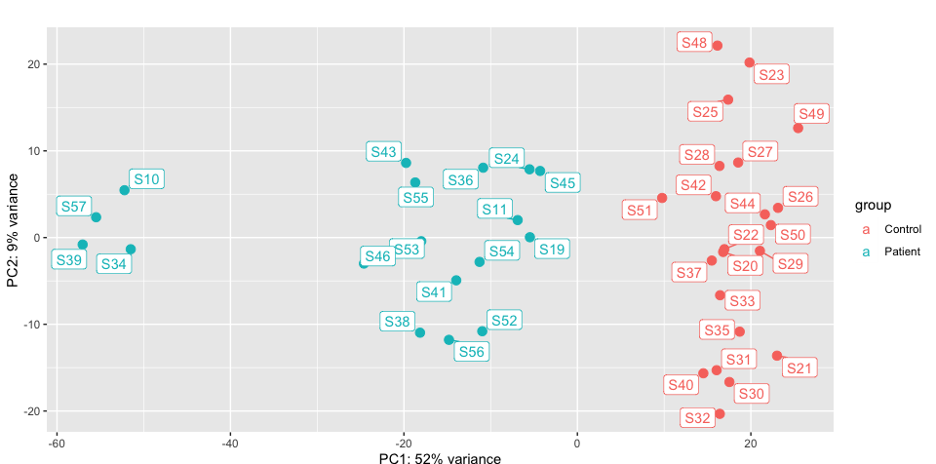

Table 4 Supplementary – oddzielny plik
Pathway name | Entities found | EntitiesTotal | Entities ratio | Entities pValue | Entities FDR | Reactions found | Reactions total | Reactions ratio
Keratinization | 55 | 226 | 0.015 | 1.11E-16 | 5.46E-14 | 29 | 34 | 0.002
Formation of the cornified envelope | 54 | 138 | 0.009 | 1.11E-16 | 5.46E-14 | 22 | 27 | 0.002
Interleukin-36 pathway | 5 | 7 | 0 | 2,00E-05 | 6.23E-3 | 3 | 3 | 0
Metal sequestration by antimicrobial proteins | 5 | 13 | 0.001 | 3.37E-4 | 8.29E-2 | 4 | 5 | 0
TP53 Regulates Transcription of Genes Involved in G2 Cell Cycle Arrest | 5 | 21 | 0.001 | 2.77E-3 | 4.56E-1 | 6 | 11 | 0.001
Gap junction assembly | 7 | 41 | 0.003 | 2.78E-3 | 4.56E-1 | 8 | 16 | 0.001
Polo-like kinase mediated events | 5 | 23 | 0.001 | 4.07E-3 | 5.69E-1 | 11 | 15 | 0.001
Phosphorylation of Emi1 | 3 | 8 | 0.001 | 5.82E-3 | 6.97E-1 | 2 | 2 | 0
Post-translational modification: synthesis of GPI-anchored proteins | 12 | 115 | 0.007 | 6.49E-3 | 6.97E-1 | 1 | 16 | 0.001
Interferon gamma signaling | 16 | 177 | 0.011 | 7.11E-3 | 6.97E-1 | 2 | 23 | 0.002
Gap junction trafficking | 7 | 52 | 0.003 | 9.73E-3 | 7.67E-1 | 8 | 20 | 0.001
G1/S-Specific Transcription | 6 | 43 | 0.003 | 1.38E-2 | 7.67E-1 | 6 | 28 | 0.002
Regulation of TP53 Expression | 2 | 4 | 0 | 1.42E-2 | 7.67E-1 | 4 | 5 | 0
Interferon alpha/beta signaling | 12 | 129 | 0.008 | 1.49E-2 | 7.67E-1 | 2 | 25 | 0.002
Gap junction trafficking and regulation | 7 | 57 | 0.004 | 1.54E-2 | 7.67E-1 | 8 | 24 | 0.002
Neutrophil degranulation | 32 | 478 | 0.031 | 1.71E-2 | 7.67E-1 | 9 | 10 | 0.001
Antimicrobial peptides | 11 | 123 | 0.008 | 2.46E-2 | 7.67E-1 | 17 | 58 | 0.004
Regulation of HMOX1 expression and activity | 2 | 6 | 0 | 3.01E-2 | 7.67E-1 | 4 | 4 | 0
OAS antiviral response | 3 | 16 | 0.001 | 3.59E-2 | 7.67E-1 | 6 | 15 | 0.001
FCGR activation | 9 | 103 | 0.007 | 4.46E-2 | 7.67E-1 | 6 | 6 | 0

