(Supplementary Data)
Untargeted massspectrometry based lipidomics analysis reveals altered lipid profiles in a scribble knockdown-induced colorectal cancer model of Drosophila
Rohit Kumar¹, Zeeshan Fatima*^{2,3}, Pradeep Kumar¹, Prabhat Kumar¹, Brijesh Singh Chauhan¹, Saripella Srikrishna*¹
- Cancer and Neurobiology laboratory, Department of Biochemistry, Institute of Science, Banaras Hindu University, Varanasi-221005.
- Amity Institute of Biotechnology, Amity University, Manesar, Gurugram, Haryana-122413, India.
- Department of Medical Laboratory Sciences, College of Applied Medical Sciences, University of Bisha, Bisha 61922, Saudi Arabia.

*Address for correspondence:
1. Saripella Srikrishna, Ph.D.
Cancer and Neurobiology Laboratory
Department of Biochemistry, Institute of Science
Banaras Hindu University, Varanasi 221005, Uttar Pradesh, India
E-mail: skrishna@bhu.ac.in

2. Zeeshan Fatima, Ph.D.
Amity Institute of Biotechnology
Amity University, Manesar, Gurugram, Haryana-122413, India
E-mail: drzeeshanfatima@gmail.com

Fig. S1. Crossing scheme for generating Scribble knockdown in hindgut. UAS-ScribRNAi/bynGAL4 flies were denoted as CRC flies. bynGAL/+ flies representing Wild type flies.
Fig. S2. representing Scrib mRNA level in hindgut of three days old adult female fly. The data represented in SEM, **p< 0.01

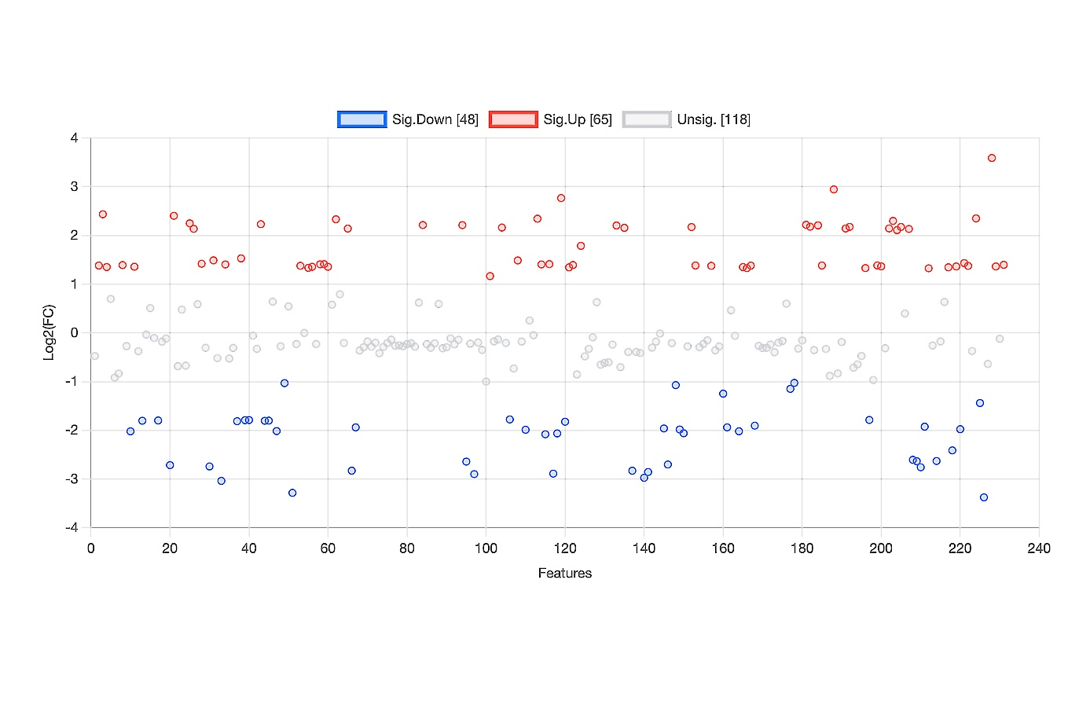
A

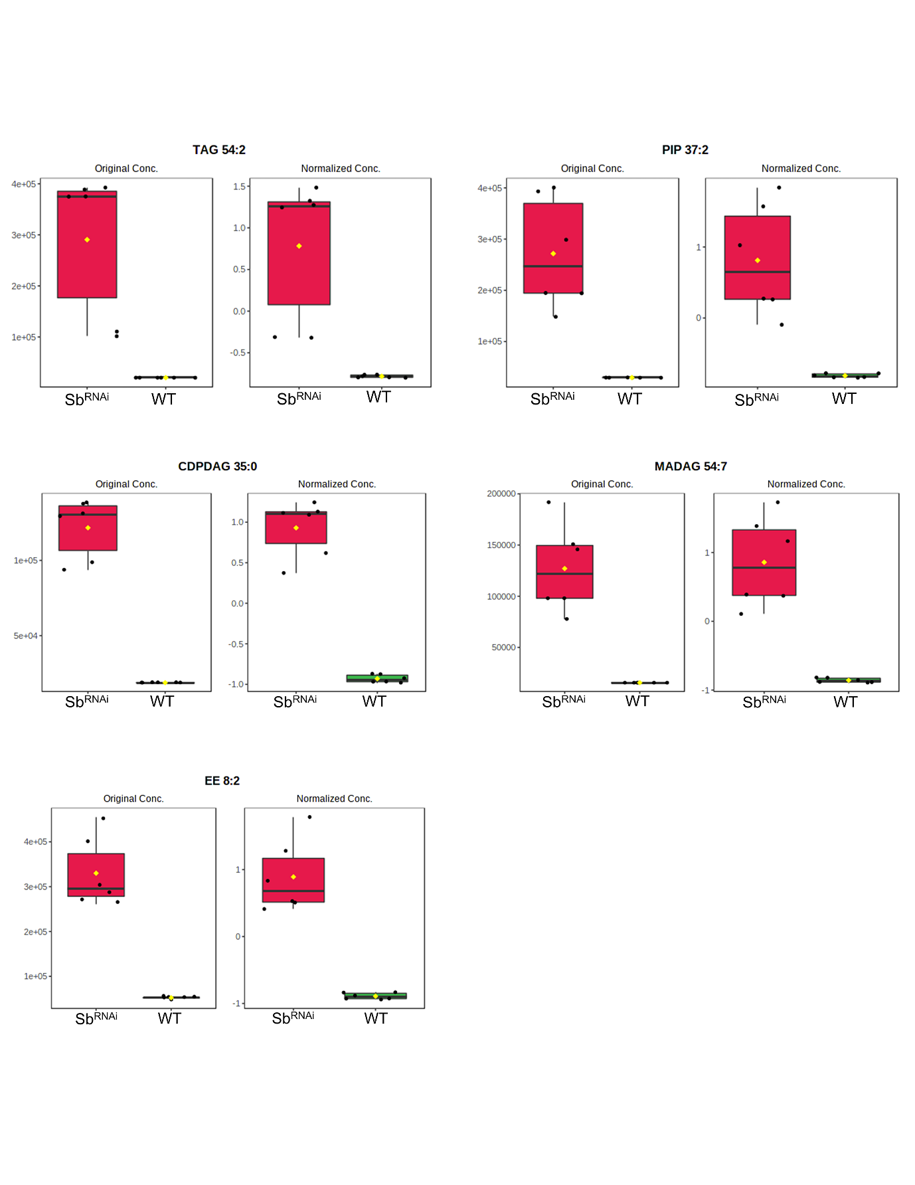
B

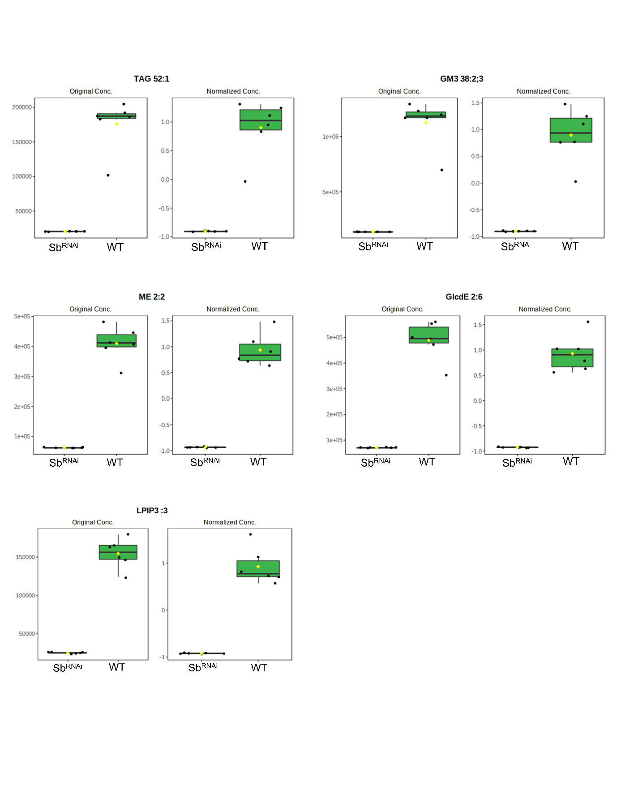
C

Fig. S3. Graph representing fold change analysis of significantly up and down-regulated lipid species obtained from LC-MS data (A). There were 48 significantly downregulated and 65 upregulated lipid species while 118 were unaltered. The top five significantly upregulated and downregulated lipid species were TAG 54:2, PIP37:2, MADAG 54:7, CPDDAG 35:0, and EE 8:2 (panel B), and GM38:2;3, TAG 52:1, GlcdE 2:6, LPIP3:3 and ME 2:2 respectively (panel C).

Fig. S4. The Variable importance in projection (VIP) score is a weighted sum of squares of sPLS-DA loadings taking into account the amount of explained Y-variation in each dimension (Top 20 features).

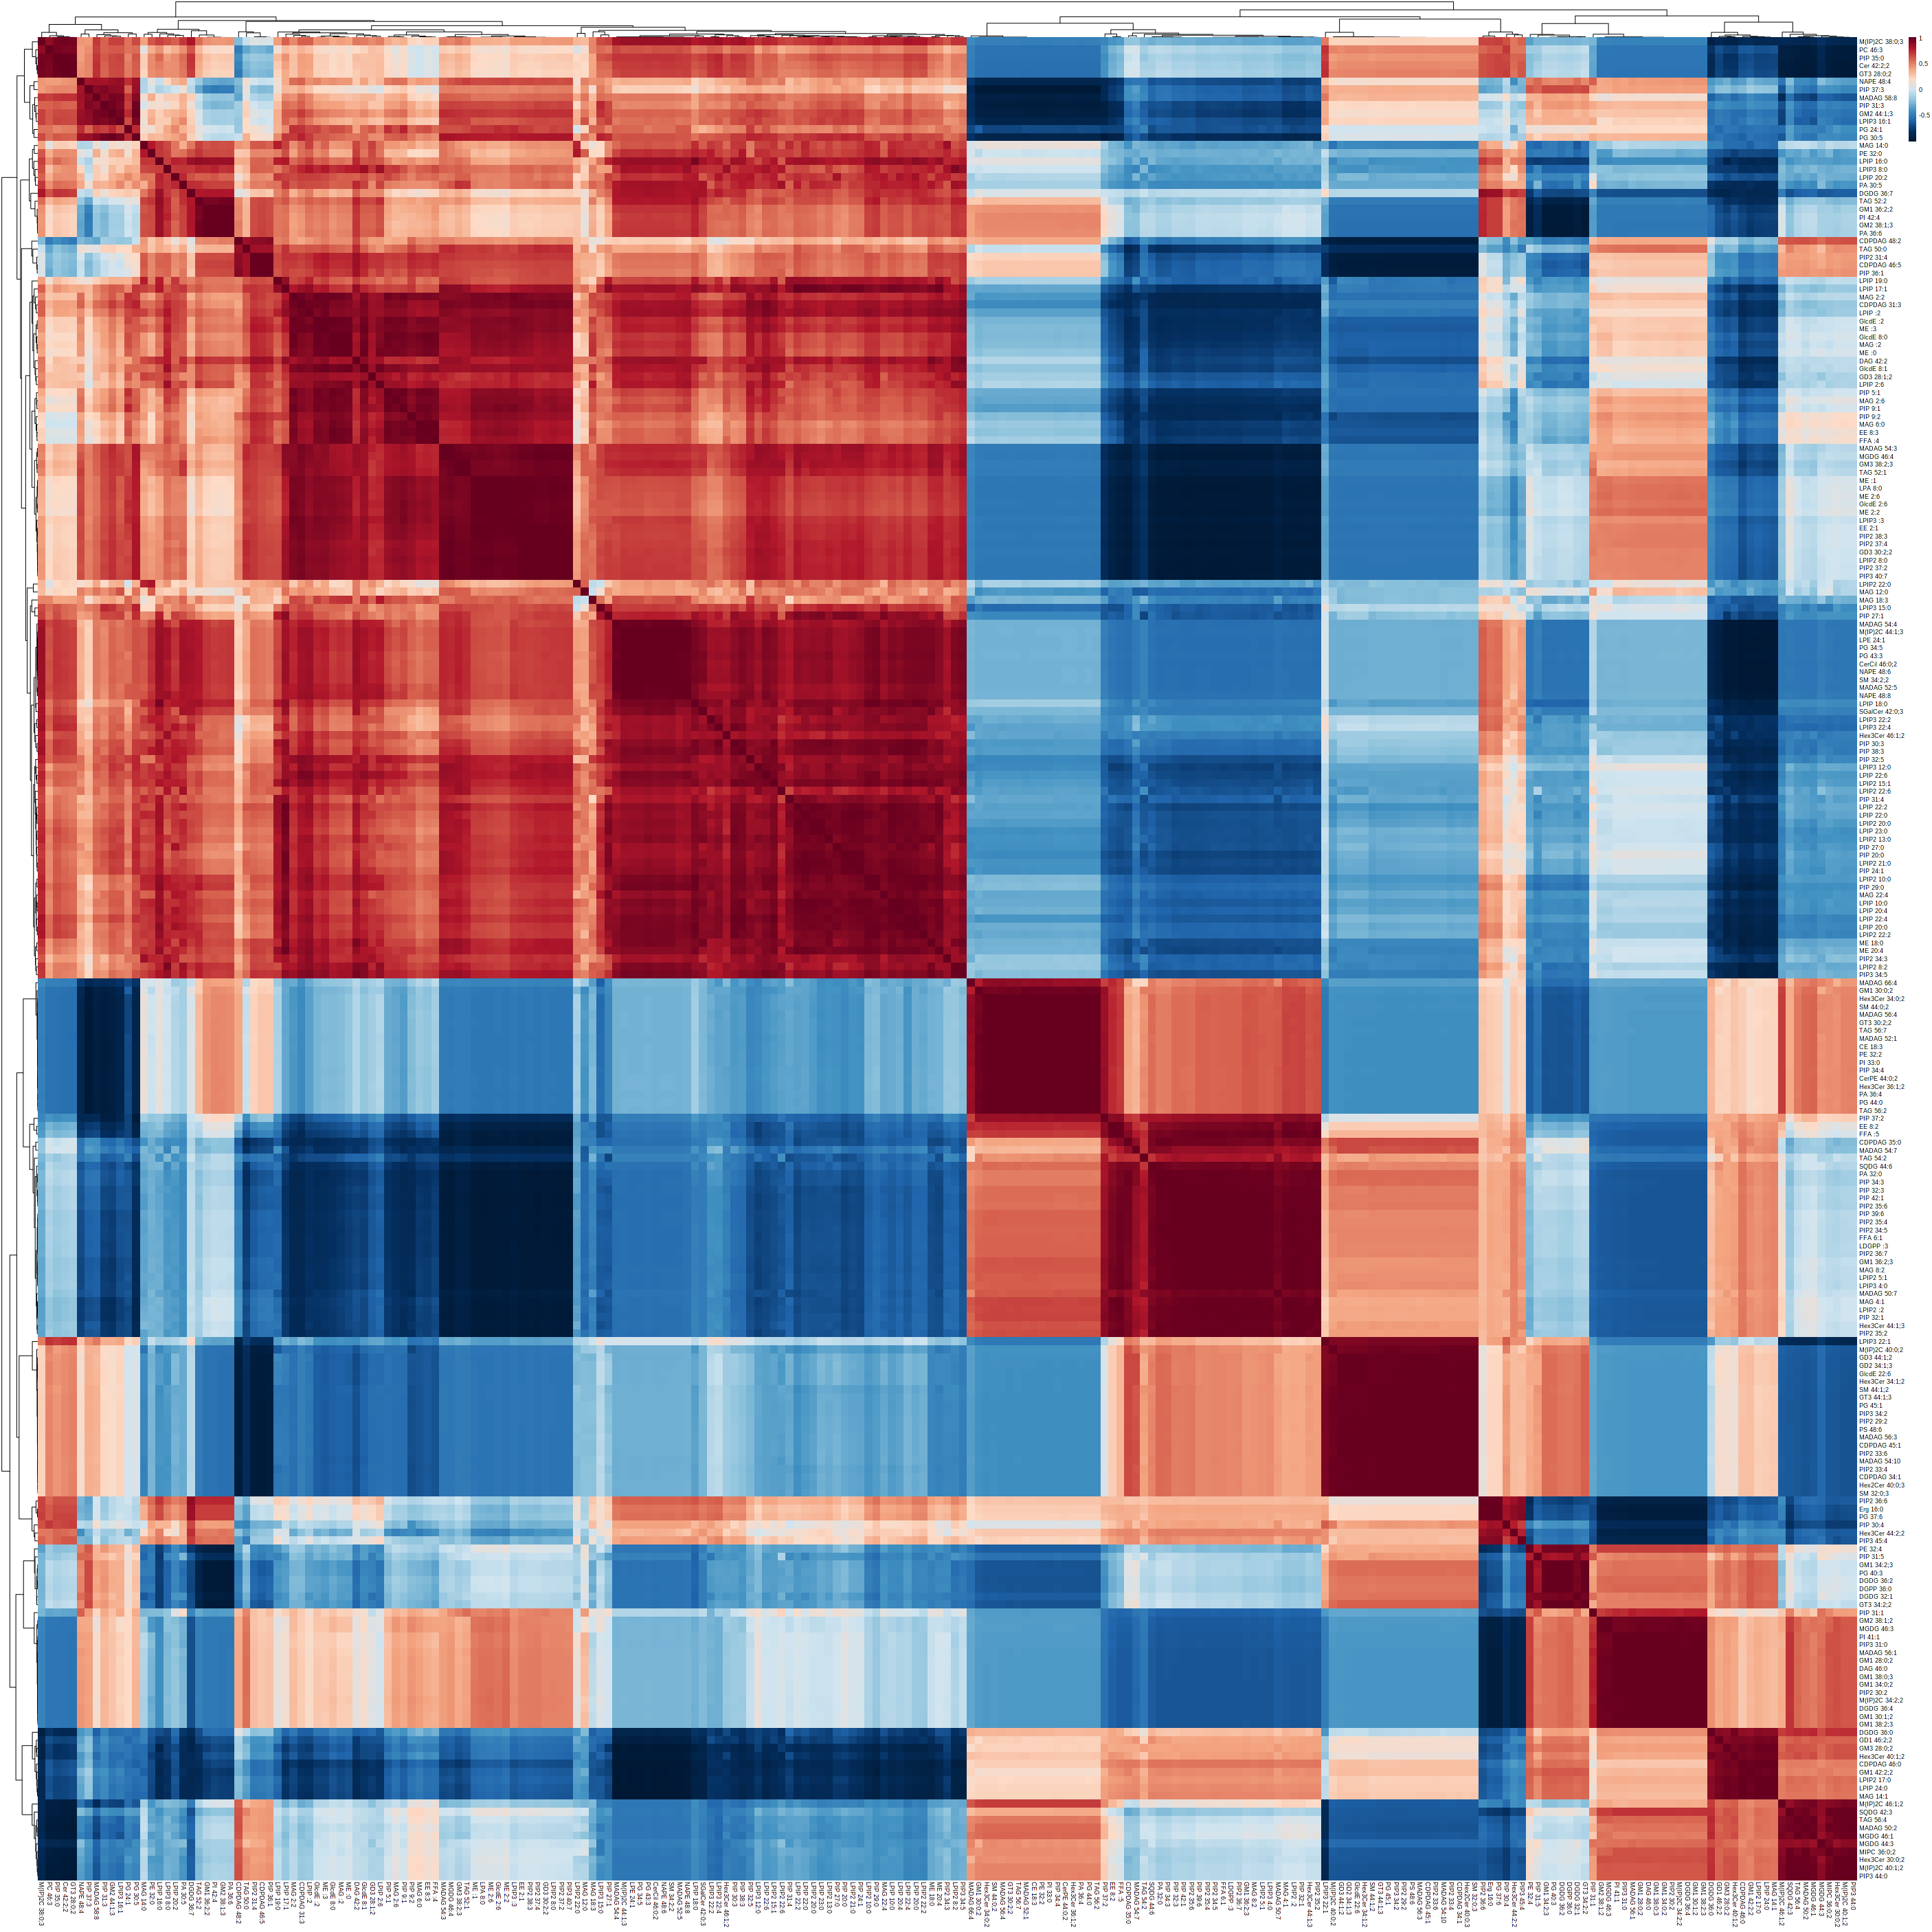
Fig. S5. Representing correlation heat map. The lower the signal of intensities the bluer the heatmap color and the higher signal intensities are denoted in red color.

Table 1: Top 50 lipid species identified from Volcano plot
Sr. No. | Peaks(mz/rt) | FC | log2(FC) | raw.pval | -log10(p)
1 | PIP2 35:6 | 4.5118 | 2.1737 | 6.43E-13 | 12.192
2 | PIP 42:1 | 4.5154 | 2.1748 | 7.24E-13 | 12.14
3 | PIP2 34:5 | 4.4182 | 2.1435 | 2.39E-12 | 11.622
4 | FFA 6:1 | 4.3891 | 2.1339 | 4.70176-12 | 11.328
5 | LDGPP :3 | 4.4093 | 2.1406 | 7.2880-12 | 11.137
6 | PIP2 36:7 | 4.3827 | 2.1318 | 9.69E-12 | 11.014
7 | PIP2 35:4 | 4.3129 | 2.1087 | 1.23E-11 | 10.911
8 | PA 32:0 | 4.504 | 2.1712 | 1.72E-11 | 10.766
9 | PIP 39:6 | 4.4128 | 2.1417 | 7.25E-11 | 10.14
10 | LPIP3 4:0 | 4.4715 | 2.1608 | 1.41E-10 | 9.8506
11 | PIP 32:3 | 4.5266 | 2.1784 | 2.75E-10 | 9.5605
12 | GM1 36:2;3 | 4.691 | 2.2299 | 2.80E-10 | 9.5533
13 | MAG 8:2 | 4.454 | 2.1551 | 2.88E-10 | 9.5403
14 | PIP 34:3 | 4.6152 | 2.21E+00 | 3.68E-10 | 9.4342
15 | LPIP2 5:1 | 4.63E+00 | 2.211 | 4.86E-10 | 9.3133
16 | PIP2 37:4 | 0.16114 | -2.6336 | 1.7562E-09 | 8.7554
17 | PIP2 37:2 | 1.64E-01 | -2.6063 | 3.7284c-09 | 8.43E+00
18 | PIP3 40:7 | 0.16165 | -2.6291 | 8.19E-09 | 8.0866
19 | PIP2 35:2 | 4.913 | 2.2966 | 4.15E-09 | 8.38E+00
20 | PIP 32:1 | 4.65 | 2.2172 | 1.32450-08 | 7.878
21 | LPIP2:2 | 4.6366 | 2.2131 | 1.34E-08 | 7.8714
22 | LPIP2 8:0 | 1.60E-01 | -2.642 | 1.35696-08 | 7.8674
23 | LPA 8:0 | 1.41E-01 | -2.8293 | 1.43716-08 | 7.8425
24 | EE 2:1 | 0.15234 | -2.7146 | 1.6856c-08 | 7.7732
25 | ME 2:2 | 0.12722 | -2.9746 | 4.20E-08 | 7.3763
26 | ME 2:6 | 0.13824 | -2.8548 | 4.42346-08 | 7.3542
27 | PIP2 38:3 | 0.14784 | -2.7578 | 4.8785c-08 | 7.3117
28 | MAG 4:1 | 4.6031 | 2.2026 | 5.22E-08 | 7.2819
29 | Hex3Cer 44:1;3 | 5.0274 | 2.3298 | 6.49E-08 | 7.1877
30 | GD3 30:2;2 | 0.14954 | -2.7414 | 6.63E-08 | 7.1784
31 | ME :1 | 0.14062 | -2.8301 | 6.89E-08 | 7.1619
32 | CDPDAG 35:0 | 5.4052 | 2.4343 | 1.41E-07 | 6.8518
33 | MGDG 46:4 | 0.15368 | -2.702 | 1.69E-07 | 6.7715
34 | GlcdE 2:6 | 0.12177 | -3.0378 | 1.98550-07 | 6.7021
35 | SQDG 44:6 | 5.0942 | 2.3489 | 3.37E-07 | 6.4723
36 | LPIP3 :3 | 0.13405 | -2.8992 | 3.50E-07 | 6.4557
37 | FFA :5 | 4.7465 | 2.2469 | 4.18E-07 | 6.3784
38 | MADAG 54:3 | 0.13501 | -2.8888 | 6.39E-07 | 6.1945
39 | MADAG 50:7 | 5.0751 | 2.3434 | 1.10E-06 | 5.9598
40 | TAG 52:1 | 0.096344 | -3.3757 | 4.27236-06 | 5.3693
41 | GM3 38:2:3 | 0.1027 | -3.2834 | 5.84E-06 | 5.2333
42 | EE 8:2 | 5.2874 | 2.4026 | 1.13E-05 | 4.9484
43 | MADAG 54:7 | 6.8024 | 2.766 | 7.92E-05 | 4.1014
44 | PIP 37:2 | 7.6977 | 2.9444 | 0.00049246 | 3.3076
45 | TAG 54:2 | 12.029 | 3.5884 | 0.00117 | 2.9318
46 | PG 30:5 | 0.42104 | -1.248 | 0.0018574 | 2.7311
47 | TAG 50:0 | 0.3687 | -1.4395 | 0.0030954 | 2.5093
48 | GM2 44:1;3 | 0.48914 | -1.0317 | 0.0093353 | 2.0299
49 | PIP 31:3 | 0.49052 | -1.0276 | 0.013862 | 1.8582
50 | NAPE 48:4 | 0.47556 | -1.0723 | 0.021921 | 1.6591

