Supplementary Material for

Switching, fast and slow: Deciphering the dynamics of memory search, its brain connectivity patterns, and its role in creativity

Marcela Ovando-Tellez¹, Yoed N. Kenett², Mathias Benedek³, Thomas T. Hills⁴, Benoit Beranger⁵, Alizée Lopez-Persem¹, Theophile Bieth^{1,6}, & Emmanuelle Volle¹

Affiliation
¹ Sorbonne University, FrontLab at Paris Brain Institute (ICM), INSERM, CNRS, Paris, France
² Faculty of Data and Decision Sciences, Technion – Israel Institute of Technology, Haifa, Israel
³ Institute of Psychology, University of Graz, Graz, Austria
⁴ Department of Psychology, University of Warwick, University Road, Coventry CV4 7AL, UK.
⁵ Sorbonne University, CENIR at Paris Brain Institute (ICM), INSERM, CNRS, Paris, France
⁶ Neurology department, Pitié-Salpêtrière Hospital, AP-HP, F-75013, Paris, France

Corresponding authors
Emmanuelle Volle (emmavolle@gmail.com) & Marcela Ovando-Tellez (marcela.ovandot@gmail.com)

Keywords
Creativity– semantic foraging – fluency – executive control- semantic memory- functional connectivity

Supplementary Methods

The relatedness judgment task (RJT)
Participants performed The RJT task inside the scanner during the MRI session. This task was developed to build the individual semantic networks in a previous study (Bernard et al., 2019; Ovando-Tellez et al., 2021). This task consisted of 595-word pairs that were all possible pairwise combinations of 35 words selected based on linguistic and semantic properties (see Bernard et al., 2019, for details about the method for selecting the words). For each trial, the pair of words was displayed on the screen with a visual scale ranging from 0 to 100 for four seconds. During the first two seconds (thinking time), participants were asked to think about the relatedness between the words. During the last two seconds (response time), a slider appeared on the screen, and participants could move it using a trackball to provide their response. Participants were instructed to judge how related the concepts were by using all the scale values and to validate their responses by clicking on the left button of the trackball within two seconds. The lower values of the scale indicate poorly related words (0 for unrelated words), while the higher values indicate strongly related words (100 for strongly related words). For each participant and each pair of words, we considered the relatedness rating as the value on the scale at the moment of the validation. When participants did not validate, we considered the value on the scale at the end of the two seconds as the relatedness judgment for the given word pair.
The task was divided into six runs of 100 trials (except for the 6th run with 95 trials). An inter-trial interval jittered from 0.3 to 0.7 seconds (mean 0.5; interval: 0.05) separated two successive trials. Each run comprised four blocks of 25 trials (except for the last block of the 6th run with 20 trials), separated by a 20-second cross fixation on the screen. Participants were presented with a 10-second cross-fixation at the beginning and end of each run. Between the runs, participants had a self-paced break in the scanner.
Before performing the RJT task, participants performed a motor and task training on a computer outside and inside the scanner. The motor training allowed participants to get familiar with the visual scale and the trackball. Within 25 trials, they were presented with a number and a visual scale ranging from 0 to 100. They were instructed to position the slider on the scale at the value of this number and to validate their response by pressing the left button of the trackball. After validation, they had visual feedback indicating the value of the position they had validated on the scale. The task training allowed participants to become familiar with the actual task. The parameters were the same as described for the RJT task, but we presented 15 trials to the participants with different words. For more details reading the training, see the Supplementary Material in Ovando-Tellez et al. (2021).

Supplementary Tables

Supplementary Table S1. Statistical tests for IRTr and IRSr. Values represent the W value for Wilcoxon signed rank tests between each retrieval position in relation to a cluster switch. ** p < .01; *** p < .001

Position relative to the switch position
IRTr | Position -2 | Position -1 | Position 1 | Position 2 | Position 3
Position -2 | .
Position -1 | 1496 | .
Position 1 | 282 *** | 301 *** | .
Position 2 | 2119 | 1794 | 3703 *** | .
Position 3 | 1520 | 1794 | 3187 *** | 1058 ** | .
IRSr | Position -2 | Position -1 | Position 1 | Position 2 | Position 3
Position -2 | .
Position -1 | 1710 | .
Position 1 | 3107 *** | 3231 *** | .
Position 2 | 2335 ** | 790 *** | 25 *** | .
Position 3 | 1671 | 1750 | 89 *** | 2751 *** | .

Supplementary Table S2. Statistical tests for IRTr and IRSr in Slow-Switching and Fast-Switching. Values represent the W value for Wilcoxon signed rank tests between each retrieval position in relation to a cluster switch. * p < .05; ** p < .01; *** p < .001

Position relative to the switch position in Slow-Switching
IRTr | Position -2 | Position -1 | Position 1 | Position 2 | Position 3
Position -2 | .
Position -1 | 1411* | .
Position 1 | 21 *** | 9 *** | .
Position 2 | 1182 ** | 1419 | 3704 *** | .
Position 3 | 1158 ** | 1434 | 3500 *** | 1750 | .
IRSr | Position -2 | Position -1 | Position 1 | Position 2 | Position 3
Position -2 | .
Position -1 | 2063 | .
Position 1 | 3567 *** | 3543 *** | .
Position 2 | 1441 | 1189 ** | 163 *** | .
Position 3 | 1950 | 1676 | 297 *** | 2266 * | .

Position relative to the switch position in Fast-Switching
IRTr | Position -2 | Position -1 | Position 1 | Position 2 | Position 3
Position -2 | .
Position -1 | 1842 | .
Position 1 | 2299 ** | 2493 ** | .
Position 2 | 1170 * | 1007 *** | 468 *** | .
Position 3 | 786 *** | 712 *** | 113 *** | 1305 * | .
IRSr | Position -2 | Position -1 | Position 1 | Position 2 | Position 3
Position -2 | .
Position -1 | 1358 | .
Position 1 | 2821 *** | 3366 *** | .
Position 2 | 1458 | 1789 | 252 *** | .
Position 3 | 2056 | 2676 *** | 823 *** | 2636 *** | .

Supplementary Table S3. Relationship between Fast and Slow Clustering and Switching and Executive function and creative abilities. Spearman coefficient correlations are presented. In bold are the correlations that remain significant after FDR correction for multiple comparison. * p < .05; ** < .01; *** p < .001

 | Fast-Clustering | Fast-Switching | Slow-Clustering | Slow-Switching
Backward-span | .158 | -.065 | 5e10-4 | .261*
TMT-shifting | -.189 | -.125 | -.067 | -.232*
Stroop-interference | -.081 | -.107 | .028 | -.257*
CAT_CR | -.244* | .260* | -.154 | .092
CAT_eureka | .098 | -.123 | .160 | -.176
AUT-fluency | .455*** | .040 | .315** | .213*
AUT-ratings | .135 | -.014 | .037 | -.043
AUT-uniqueness | .381*** | -.096 | .370*** | .048

Supplementary Figures

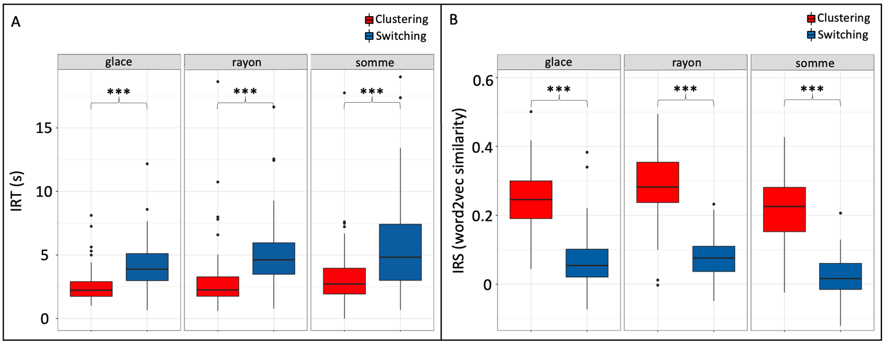

Supplementary Figure S1. Mean Inter-item Response Time and Semantic Similarity for clustering and switching for each cue word. (A) The y-axis shows the mean IRT (seconds) for each color-coded process in the x-axis. (B) The y-axis shows the mean IRS (word2vec similarity) for each color-coded process in the x-axis. *** p < .001
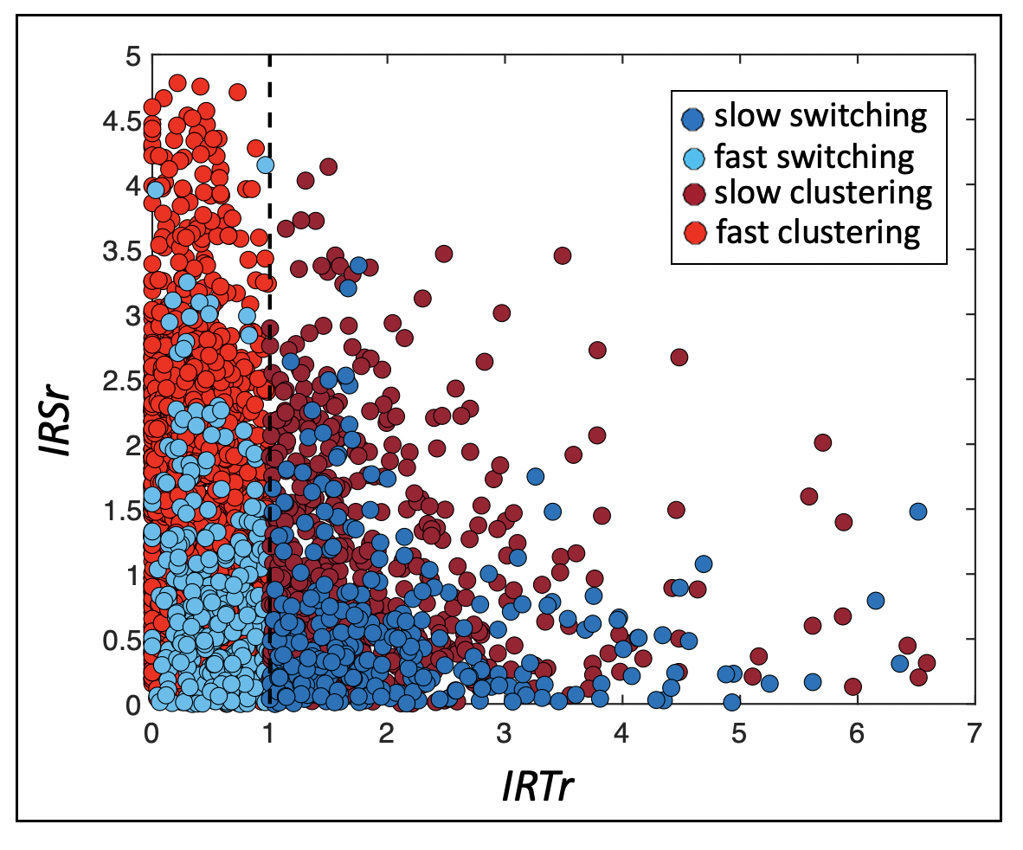
Supplementary Figure S2. Subdivision of clustering and switching responses based on IRTr. For each clustering (reddish) and switching response (bluish), we plot the relationship between time (IRTr) and semantic similarity (IRSr) between the retrieved concepts for Slow-Switching, Fast-Switching, Slow-Clustering, and Fast-Clustering. The vertical dashed line represents the individual long-term IRT. Items retrieved faster than the long-term IRT are represented by lighter dots on the left of the vertical dashed line (IRTr > 1); those produced slower are darker dots on the right.

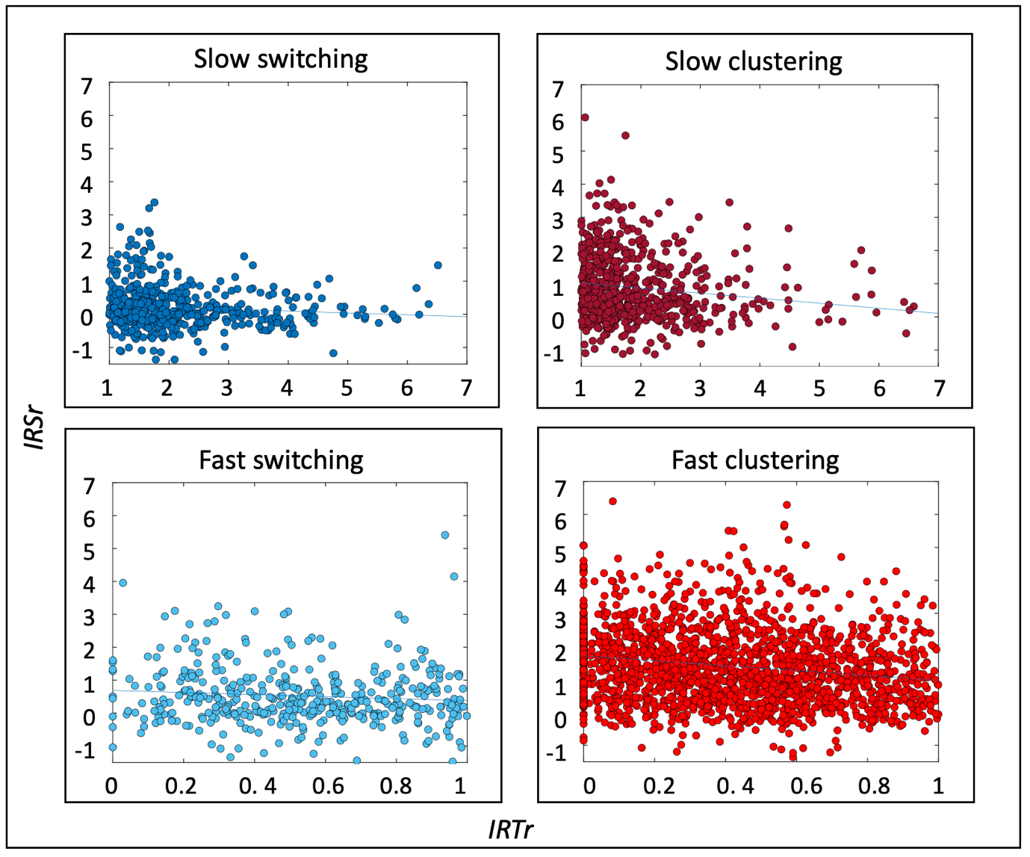
Supplementary Figure S3. Relationship between time and similarity during semantic retrieval in fast and slow processes. For each trial of clustering (reddish) and switching (bluish), we plot the relationship between time (IRTr) and semantic similarity (IRSr) between the retrieved concepts for Slow-Switching, Fast-Switching, Slow-Clustering, and Fast-Clustering.

Supplementary Results

Supplementary Results S1: IRTr and IRSr reach individual’s marginal value in pre-switch responses during Slow-switching
To explore if participants reached their marginal values (their long-term values) for IRT and IRS before Slow-switching (i.e., if IRTr and IRSr equal to 1), we ran Wilcoxon tests between participants’ long-term values and their IRT and IRS values in the -1 position, respectively. The Wilcoxon test indicated that the retrieval time and semantic similarity for the item before Slow-switching did not significantly differ from the long-term IRT and IRS (long-term RT versus mean IRT in position -1: W = 2293, p = .069; long-term word2vec similarity versus mean IRS in position -1: W = 1897, p = .911) values. In contrast, the retrieval time and semantic similarity for responses before Fast-switching significantly differed from the long-term IRT and IRS (long-term RT versus mean IRT in position -1: W = 3046, p < .001; and long-term word2vec similarity versus mean IRS in position -1: W = 2329, p < .05). Thus, during slow switches, participants reach their own mean IRT and IRS values before switching to a new cluster, consistently with the OFT. However, this is not the case for fast switching.

