Supplementary Information
Deficiency of astrocytic TWIK-1 displays increased susceptibility to kainic acid-induced seizures

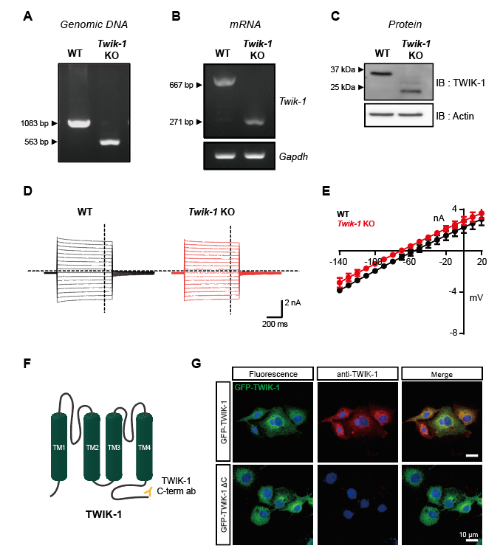
Supplementary Fig. 1
(A) Genotypes of mice were identified using genomic DNA PCR. (B) RT-PCR analysis was performed with mRNA from whole brain samples of WT and Twik-1 KO mice. GAPDH was used as the loading control. (C) Protein samples from brain of WT and Twik-1 KO mice were tested for the protein expression of TWIK-1 through western blotting. Actin was used as the loading control. (D) Whole-cell currents evoked by command voltages stepped from $-$140 mV to $+$20 mV in 20 mV increments in hippocampal astrocytes of WT and Twik-1 KO mice. (E) The corresponding current–voltage (I–V) relationships for the recordings shown in ‘d’ as indicated. (F) Schematic structures of the TWIK-1 protein and targeting region of the TWIK-1-specific nanobody (yellow). (G) Immunofluorescence of GFP and TWIK-1 in COS-7 cells transfected with GFP-TWIK-1 or GFP-TWIK-1 ΔC. Cells were stained with TWIK-1-specific nanobody targeting the C-terminus of the channel.
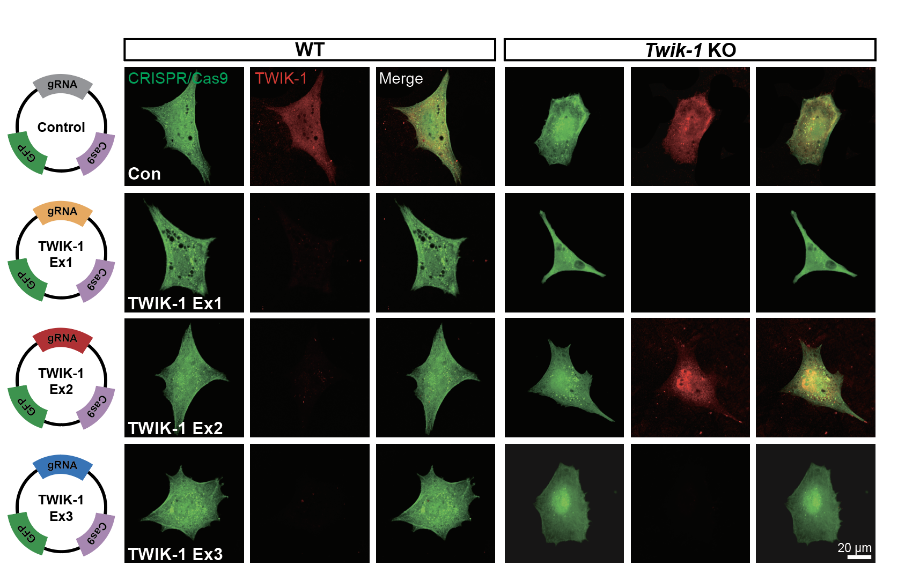
Supplementary Fig. 2
Vector diagrams showing the CRISPR/Cas9 targeting exons of the mouse Twik-1 gene. Confocal immunofluorescence staining of TWIK-1 in CRISPR/Cas9 transfected astrocytes from WT and Twik-1 KO mice. Scale bar, 20 μm.

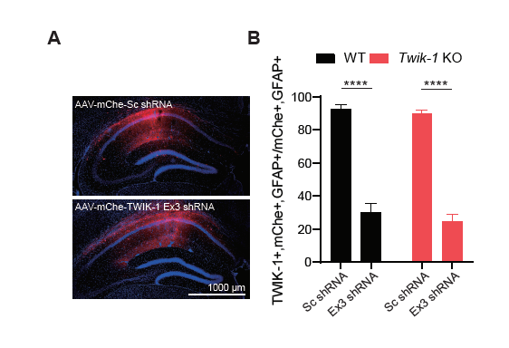

Supplementary Fig. 3
(A) Coronal image of the brain showing infected regions with AAV-mChe-Sc shRNA or AAV-mChe-TWIK-1 Ex3 shRNA in WT and Twik-1 KO mice, respectively. (B) A summary bar graph showing reduced TWIK-1 positive astrocytes among mCherry and GFAP positive cells in TWIK-1 Ex3 shRNA-injected mice. All values are presented as mean±s.e.m. P-values were obtained with one-way ANOVA followed by Tukey’s post hoc test. ****P<0.0001.

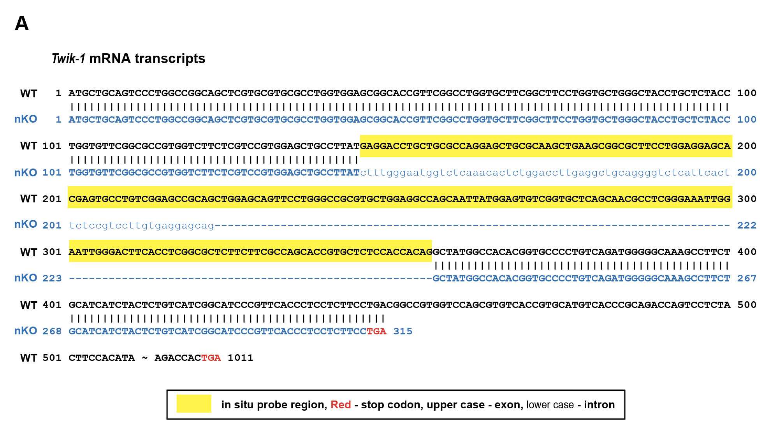
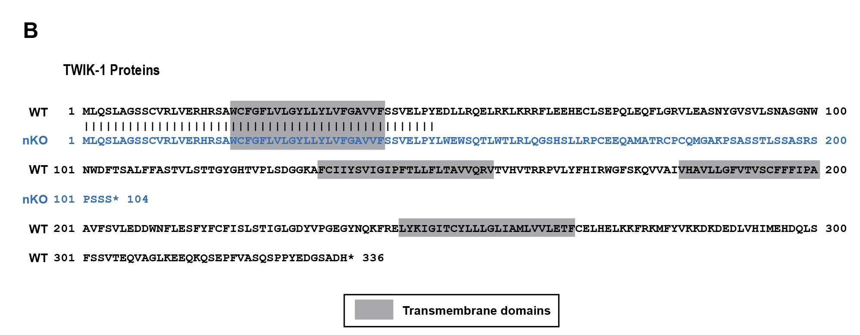

Supplementary Fig. 4
(A) The nucleotide sequences of WT and Twik-1 nKO alleles are shown. In situ hybridization probe is indicated using the yellow box. The conventional stop codon (TGA) is indicated in red. (B) The amino acid sequences of WT and Twik-1 nKO alleles are shown. Transmembrane domains are indicated using the gray box.

