Journal
Applied Microbiology and Biotechnology

Title
Statistical study of the feeding factor in samples of Iberian pig microbiome.

Authors
Rafael Vazquez Caldito ^{1*}, Eva María Vazquez Amaro ², Alicia Gallego Aguilera ², Javier Gómez Román ², Ángela Lacombe Antonelli ², Pedro Rodríguez Medina³

¹ Technical Director, Servacal SPV Veterinaries, Metapig Project, Enrique Segura Otaño, 5; 7ºA; 06004; Badajoz, Extremadura, (Spain). ORCID: 0009-0000-9895-984X
² Laboratorios Larrasa, Metapig Project (Spain), La Albuera, (Badajoz) Extremadura (Spain)
³ Department of Animal Nutrition, School of Veterinary Science, Cáceres, University of Extremadura (Spain)
* srvcl@outlook.es ; malteado.cincuenta0m@icloud.com

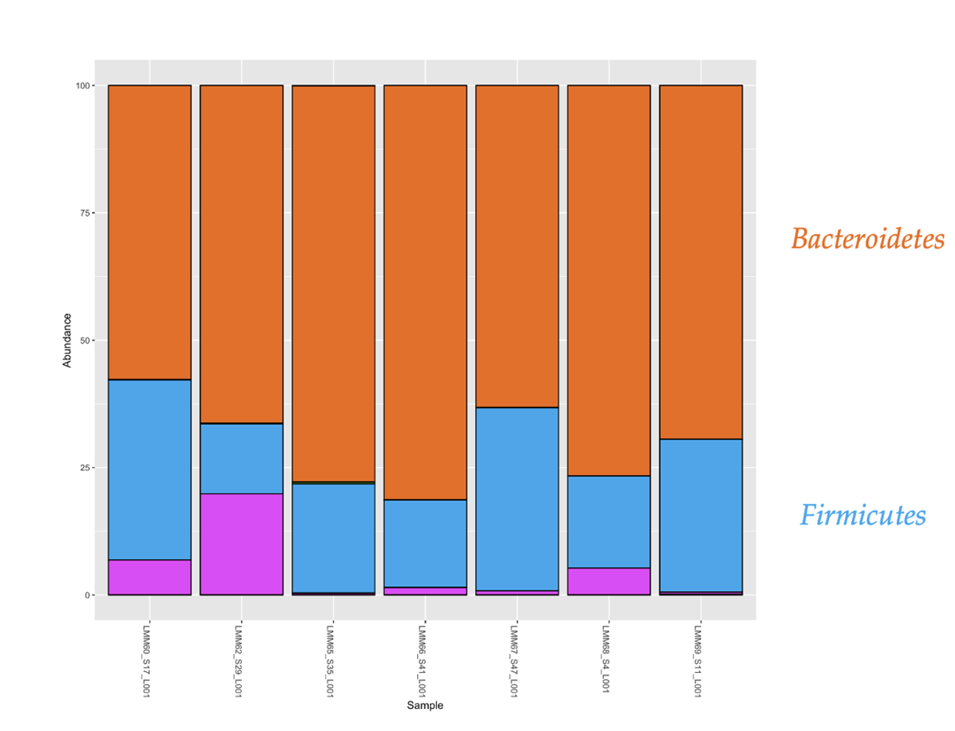
Figure s 1 Phylum composition of the sample of the level barley (C)

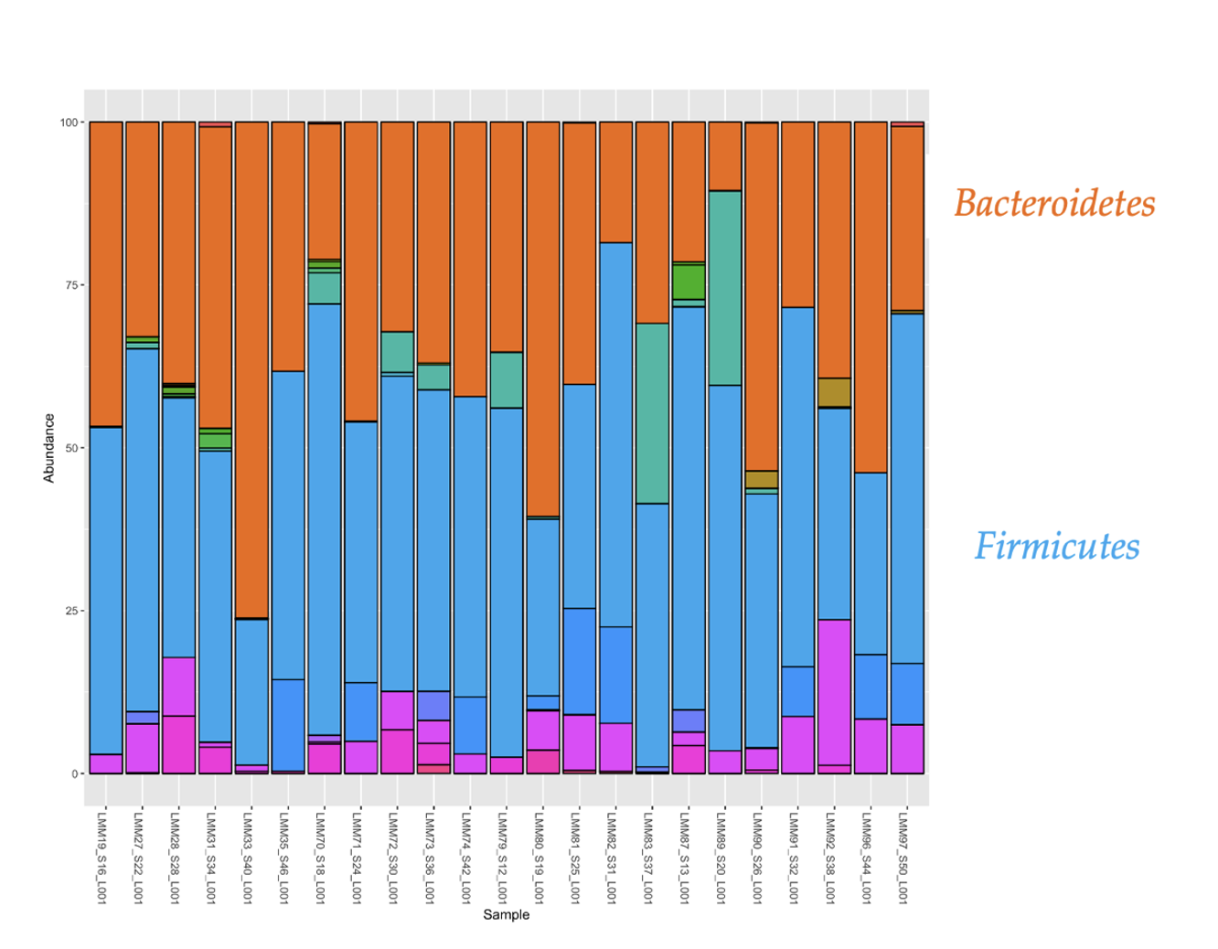
Figure s 2 Phylum composition of the samples of the level commercial feed plus lactation (IL)

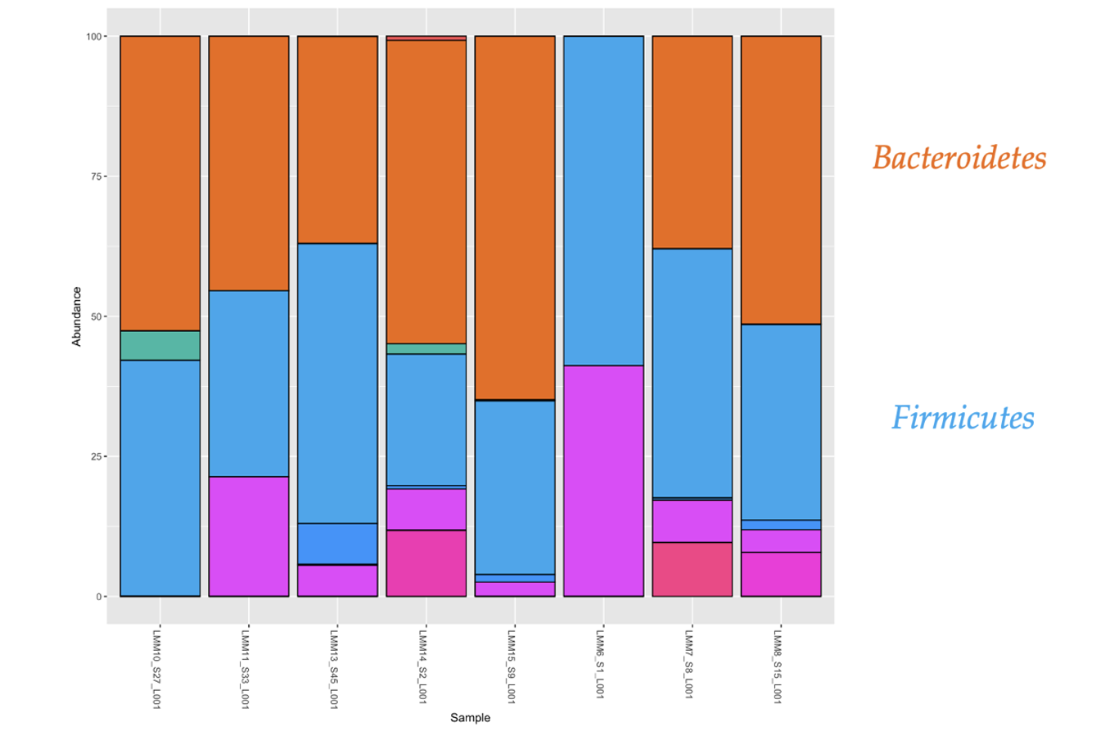
Figure s 3 Phylum composition of samples of the level lactation (L)

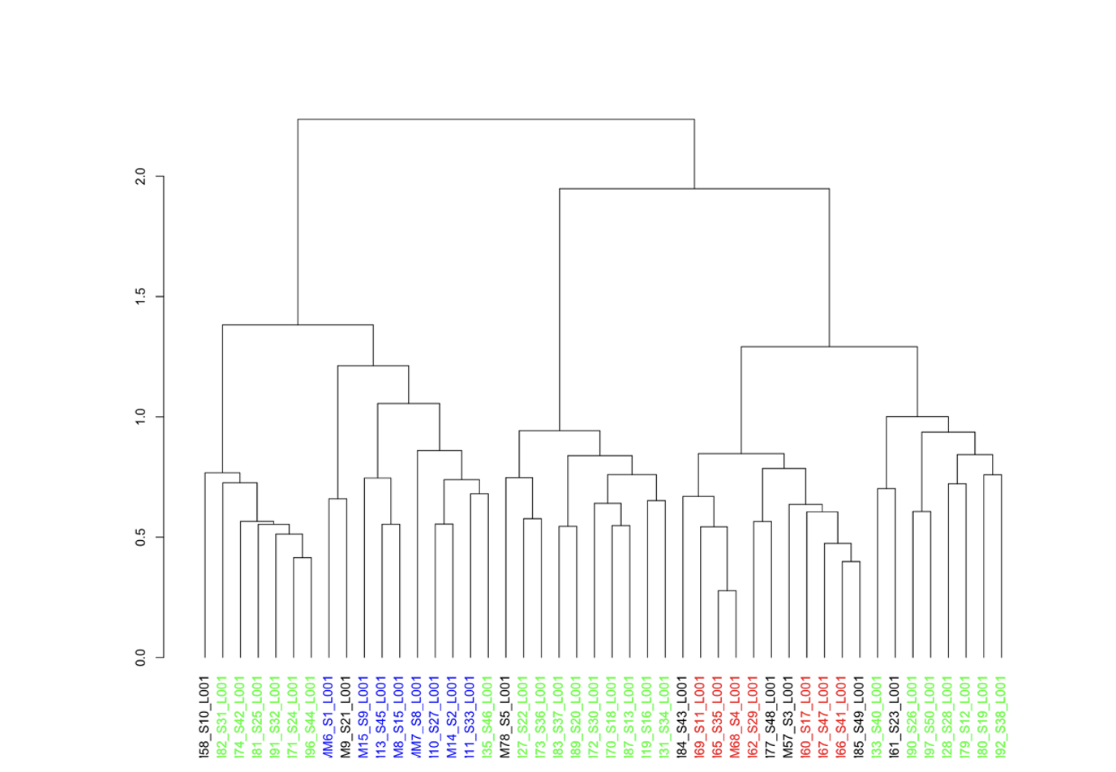
Figure s 4 Dendogram of feed levels; Red: Barley (C); Green: Commercial feed plus lactation (IL); Blue: Lactation (L)

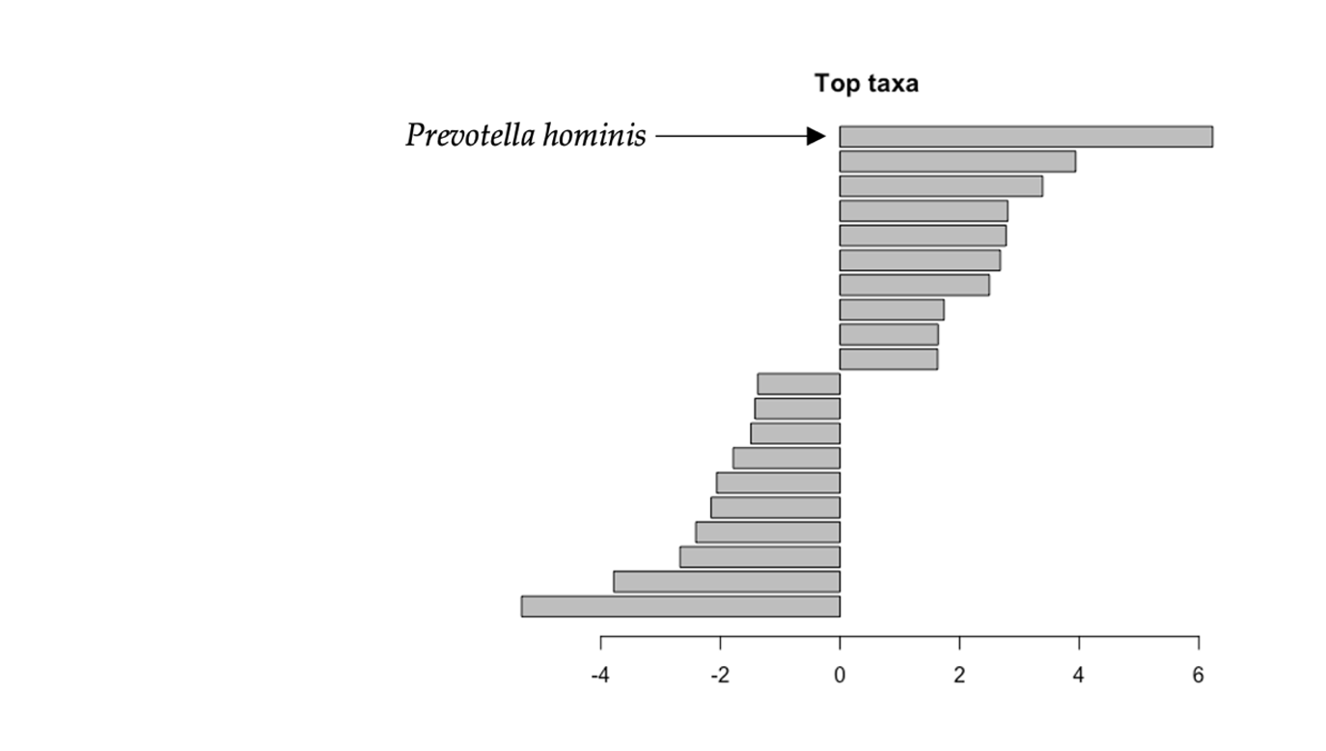
Figure s 5 Species generating the greatest differences according to beta dispersion of samples between barley (C) and lactation (L) levels
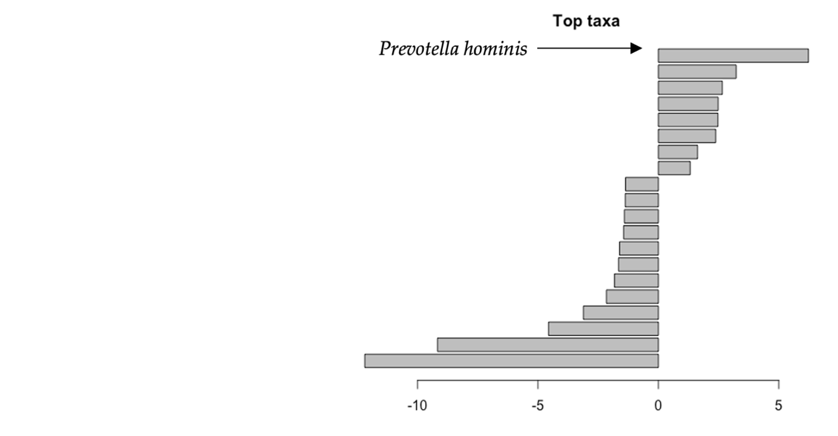
Figure s 6 Species generating the greatest differences according to beta dispersion of samples barley (C) and commercial feed plus lactation (IL) levels

(A) Sow’s DIET | %
CORE | 3
Barley | 45
Corn | 30
Durum Wheat | 5
Bran | 3
Fat | 2
Soybean 44 | 12
(B) Piglet’s FEED | %
CORE | 5
Barley | 24
Corn | 32
Durum Wheat | 17
Soybean 44 | 17
Lacticum serum | 5

Table s 1. (A) Diet corresponding to the mother’s feeding of the piglets. (B) Composition of the commercial feed of the piglets that accompanied the maternal lactation

OTU | p_value | BH_FDR | Specie
OTU178 | 9.824147755182239e-7 | 9.824147755182239e-7 | s__Prevotella_hominis
OTU177 | 1.866588073484625e-5 | 1.866588073484625e-5 | s__Prevotella_copri_clade_B
OTU187 | 6.483937518420276e-5 | 6.483937518420276e-5 | s__GGB1239_SGB1657
OTU125 | 1.7781707436879848e-4 | 1.7781707436879848e-4 | s__Prevotella_sp_P3_120
OTU170 | 1.7781707436879848e-4 | 1.7781707436879848e-4 | s__Prevotella_copri_clade_A
Table s 2 (A) Hypothesis testing of abundances by Wilcoxon test. Comparison between barley and lactation.

OTU | p_value | BH_FDR | Specie
OTU58 | 3.108003108003108e-4 | 3.108003108003108e-4 | s__Veillonella_caviae
OTU21 | 3.108003108003108e-4 | 3.108003108003108e-4 | s__Butyricimonas_virosa
OTU125 | 3.108003108003108e-4 | 3.108003108003108e-4 | s__Prevotella_sp_P3_120
OTU27 | 3.108003108003108e-4 | 3.108003108003108e-4 | s__Enterocloster_clostridioformis
OTU35 | 3.108003108003108e-4 | 3.108003108003108e-4 | s__Pseudoflavonifractor_sp_Marseille_P3106
OTU2 | 3.108003108003108e-4 | 3.108003108003108e-4 | s__Bacteroides_fragilis
OTU127 | 3.108003108003108e-4 | 3.108003108003108e-4 | s__Prevotella_copri_clade_C
OTU33 | 3.108003108003108e-4 | 3.108003108003108e-4 | s__Lactobacillus_delbrueckii
OTU51 | 3.108003108003108e-4 | 3.108003108003108e-4 | s__Bacteroides_thetaiotaomicron
OTU52 | 3.108003108003108e-4 | 3.108003108003108e-4 | s__Fusobacterium_varium
OTU65 | 3.108003108003108e-4 | 3.108003108003108e-4 | s__Intestinimonas_massiliensis
OTU19 | 3.108003108003108e-4 | 3.108003108003108e-4 | s__Parabacteroides_distasonis
OTU177 | 3.108003108003108e-4 | 3.108003108003108e-4 | s__Prevotella_copri_clade_B
OTU178 | 3.108003108003108e-4 | 3.108003108003108e-4 | s__Prevotella_hominis
Table s 2 (B) Hypothesis testing of abundances by Wilcoxon test. Comparison between levels of barley versus commercial feed plus lactation.

