Table 5 Welding sequence scheme
Number | Description of the welding sequence | Scheme
Original  scheme | Weld6→Weld7→Weld5→Weld8→Weld2→Weld3→Weld1→Weld4  Overturn:1 | 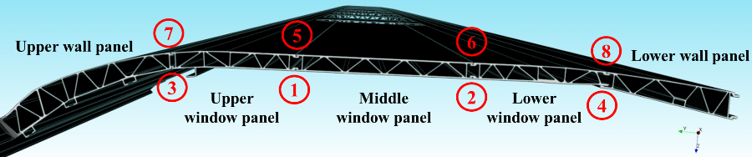
Scheme one | Weld1→Weld2→Weld3→Weld4→Weld5→Weld6→Weld7→Weld8  Overturn:2 | 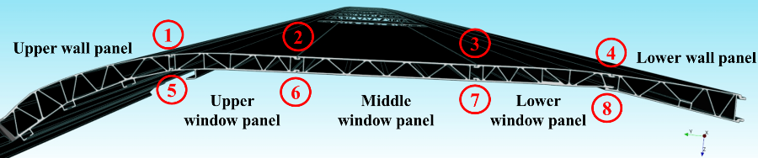
Scheme two | Weld1→Weld6→Weld5→Weld2→Weld3→Weld8→Weld7→Weld4  Overturn:4 | 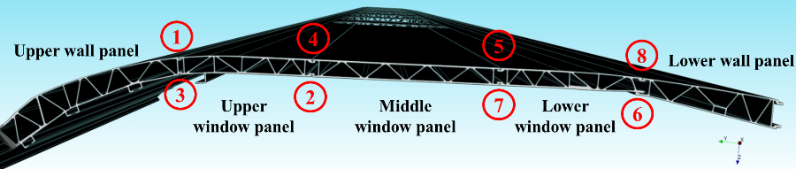
Scheme three | Weld2→Weld6→Weld3→Weld7→Weld1→Weld5→Weld4→Weld8  Overturn:7 | 