SUPPLEMENTARY INFORMATION
- Linear Model Construction in R Studio (R Core Team, 2021)

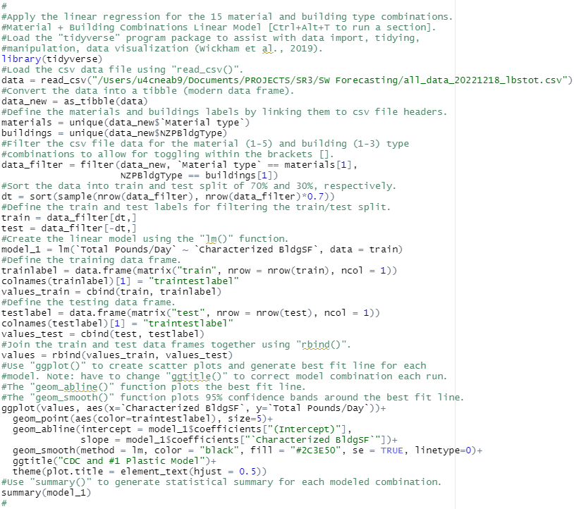

- Solid Waste Characterization Raw Data for Modeling Input

Installation | Characterized BldgSF | Material type | Total Pounds/Day | LBS/DAY/SF | NZPBldgType | BldgType Installation Total SF | BldgTypeLb/DaySF | All Materials Total LBS/DAY | All Materials Total LBS/DAY/SF
Installation I | 11565 | #1 | 0.40 | 3.46E-05 | DFAC | 47498 | 1.64 | 335.60 | 2.91E-02
Installation I | 11565 | Corr. Cardboard | 2.90 | 2.51E-04 | DFAC | 47498 | 11.91 | 335.60 | 2.91E-02
Installation I | 11565 | Food | 304.80 | 2.64E-02 | DFAC | 47498 | 1251.83 | 335.60 | 2.91E-02
Installation I | 11565 | Soiled Paper | 26.80 | 2.32E-03 | DFAC | 47498 | 110.07 | 335.60 | 2.91E-02
Installation I | 11565 | White Paper | 0.70 | 6.05E-05 | DFAC | 47498 | 2.87 | 335.60 | 2.91E-02
Installation D | 13618 | #1 | 11.03 | 8.10E-04 | DFAC | 27263 | 22.08 | 378.01 | 2.78E-02
Installation D | 13618 | Corr. Cardboard | 25.14 | 1.85E-03 | DFAC | 27263 | 50.33 | 378.01 | 2.78E-02
Installation D | 13618 | Food | 301.94 | 2.22E-02 | DFAC | 27263 | 604.48 | 378.01 | 2.78E-02
Installation D | 13618 | Soiled Paper | 39.90 | 2.93E-03 | DFAC | 27263 | 79.88 | 378.01 | 2.78E-02
Installation D | 13618 | White Paper | 0.00 | 0.00E+00 | DFAC | 27263 | 0.00 | 378.01 | 2.78E-02
Installation B | 14354 | #1 | 6.24 | 4.35E-04 | DFAC | 14354 | 6.24 | 144.05 | 1.00E-02
Installation B | 14354 | Corr. Cardboard | 2.88 | 2.01E-04 | DFAC | 14354 | 2.88 | 144.05 | 1.00E-02
Installation B | 14354 | Food | 110.44 | 7.69E-03 | DFAC | 14354 | 110.44 | 144.05 | 1.00E-02
Installation B | 14354 | Soiled Paper | 23.53 | 1.64E-03 | DFAC | 14354 | 23.53 | 144.05 | 1.00E-02
Installation B | 14354 | White Paper | 0.96 | 6.69E-05 | DFAC | 14354 | 0.96 | 144.05 | 1.00E-02
Installation F | 15306 | #1 | 12.20 | 7.97E-04 | DFAC | 233621 | 186.21 | 1075.30 | 7.02E-02
Installation F | 15306 | Corr. Cardboard | 2.20 | 1.44E-04 | DFAC | 233621 | 33.58 | 1075.30 | 7.02E-02
Installation F | 15306 | Food | 967.70 | 6.32E-02 | DFAC | 233621 | 14770.35 | 1075.30 | 7.02E-02
Installation F | 15306 | Soiled Paper | 92.60 | 6.05E-03 | DFAC | 233621 | 1413.39 | 1075.30 | 7.02E-02
Installation F | 15306 | White Paper | 0.60 | 3.92E-05 | DFAC | 233621 | 9.16 | 1075.30 | 7.02E-02
Installation J | 20326 | #1 | 6.20 | 3.05E-04 | DFAC | 123698 | 37.71 | 956.48 | 4.71E-02
Installation J | 20326 | Corr. Cardboard | 2.15 | 1.06E-04 | DFAC | 123698 | 13.10 | 956.48 | 4.71E-02
Installation J | 20326 | Food | 818.57 | 4.03E-02 | DFAC | 123698 | 4981.56 | 956.48 | 4.71E-02
Installation J | 20326 | Soiled Paper | 107.37 | 5.28E-03 | DFAC | 123698 | 653.42 | 956.48 | 4.71E-02
Installation J | 20326 | White Paper | 22.19 | 1.09E-03 | DFAC | 123698 | 135.04 | 956.48 | 4.71E-02
Installation H | 21126.3 | #1 | 1.60 | 7.57E-05 | DFAC | 69672 | 5.28 | 1471.20 | 6.96E-02
Installation H | 21126.3 | Corr. Cardboard | 250.60 | 1.19E-02 | DFAC | 69672 | 826.45 | 1471.20 | 6.96E-02
Installation H | 21126.3 | Food | 1138.30 | 5.39E-02 | DFAC | 69672 | 3754.00 | 1471.20 | 6.96E-02
Installation H | 21126.3 | Soiled Paper | 77.20 | 3.65E-03 | DFAC | 69672 | 254.60 | 1471.20 | 6.96E-02
Installation H | 21126.3 | White Paper | 3.50 | 1.66E-04 | DFAC | 69672 | 11.54 | 1471.20 | 6.96E-02
Installation E | 24223 | #1 | 0.30 | 1.25E-05 | DFAC | 260220 | 3.26 | 101.52 | 4.20E-03
Installation E | 24223 | Corr. Cardboard | 3.64 | 1.50E-04 | DFAC | 260220 | 39.06 | 101.52 | 4.20E-03
Installation E | 24223 | Food | 72.12 | 2.98E-03 | DFAC | 260220 | 774.78 | 101.52 | 4.20E-03
Installation E | 24223 | Soiled Paper | 24.85 | 1.03E-03 | DFAC | 260220 | 266.94 | 101.52 | 4.20E-03
Installation E | 24223 | White Paper | 0.61 | 2.50E-05 | DFAC | 260220 | 6.51 | 101.52 | 4.20E-03
Installation K | 26780 | #1 | 6.29 | 2.35E-04 | DFAC | 238421 | 55.96 | 1533.32 | 5.73E-02
Installation K | 26780 | Corr. Cardboard | 243.13 | 9.08E-03 | DFAC | 238421 | 2164.62 | 1533.32 | 5.73E-02
Installation K | 26780 | Food | 1244.26 | 4.65E-02 | DFAC | 238421 | 11077.62 | 1533.32 | 5.73E-02
Installation K | 26780 | Soiled Paper | 35.90 | 1.34E-03 | DFAC | 238421 | 319.66 | 1533.32 | 5.73E-02
Installation K | 26780 | White Paper | 3.73 | 1.39E-04 | DFAC | 238421 | 33.24 | 1533.32 | 5.73E-02
Installation A | 28400 | #1 | 13.73 | 4.83E-04 | DFAC | 629348 | 304.19 | 1763.93 | 6.21E-02
Installation A | 28400 | Corr. Cardboard | 87.30 | 3.07E-03 | DFAC | 629348 | 1934.61 | 1763.93 | 6.21E-02
Installation A | 28400 | Food | 1516.70 | 5.34E-02 | DFAC | 629348 | 33610.25 | 1763.93 | 6.21E-02
Installation A | 28400 | Soiled Paper | 146.00 | 5.14E-03 | DFAC | 629348 | 3235.37 | 1763.93 | 6.21E-02
Installation A | 28400 | White Paper | 0.20 | 7.12E-06 | DFAC | 629348 | 4.48 | 1763.93 | 6.21E-02
Installation G | 30225 | #1 | 0.77 | 2.56E-05 | DFAC | 209302 | 5.36 | 48.41 | 1.60E-03
Installation G | 30225 | Corr. Cardboard | 0.00 | 0.00E+00 | DFAC | 209302 | 0.00 | 48.41 | 1.60E-03
Installation G | 30225 | Food | 28.46 | 9.42E-04 | DFAC | 209302 | 197.07 | 48.41 | 1.60E-03
Installation G | 30225 | Soiled Paper | 19.18 | 6.35E-04 | DFAC | 209302 | 132.81 | 48.41 | 1.60E-03
Installation G | 30225 | White Paper | 0.00 | 0.00E+00 | DFAC | 209302 | 0.00 | 48.41 | 1.60E-03
Installation L | 120718 | #1 | 237.86 | 1.97E-03 | DFAC | 224719 | 442.79 | 9545.53 | 7.91E-02
Installation L | 120718 | Corr. Cardboard | 1033.42 | 8.56E-03 | DFAC | 224719 | 1923.74 | 9545.53 | 7.91E-02
Installation L | 120718 | Food | 6971.94 | 5.78E-02 | DFAC | 224719 | 12978.41 | 9545.53 | 7.91E-02
Installation L | 120718 | Soiled Paper | 1302.31 | 1.08E-02 | DFAC | 224719 | 2424.27 | 9545.53 | 7.91E-02
Installation L | 120718 | White Paper | 0.00 | 0.00E+00 | DFAC | 224719 | 0.00 | 9545.53 | 7.91E-02

