Supplemental Table S1 Relative abundance of top 10 abundant gut microbiota in children.
Variables | Total (N=236) | Girls (N=91) | Boys (N=145) | Student t-test P | Adjusted P | FDR-corrected P
Phylum
Bacteroidetes | 34.90 ( 20.62 ) | 35.40 ( 19.05 ) | 34.90 ( 22.06 ) | 0.353 | 0.363 | 0.688
Firmicutes | 56.15 ( 19.58 ) | 54.60 ( 17.83 ) | 56.80 ( 20.10 ) | 0.738 | 0.710 | 0.897
F:B | 1.60 ( 1.49 ) | 1.58 ( 1.32 ) | 1.63 ( 1.69 ) | 0.497 | 0.501 | 0.819
Actinobacteria | 3.02 ( 4.59 ) | 2.47 ( 3.93 ) | 3.15 ( 4.82 ) | 0.068 | 0.354 | 0.688
Proteobacteria | 2.41 ( 2.01 ) | 2.29 ( 2.03 ) | 2.47 ( 2.04 ) | 0.469 | 0.427 | 0.734
Fusobacteria | 0.15 ( 0.35 ) | 0.20 ( 0.49 ) | 0.13 ( 0.30 ) | 0.428 | 0.576 | 0.833
Class
Bacteroidia | 34.90 ( 20.55 ) | 35.40 ( 19.00 ) | 34.90 ( 22.06 ) | 0.352 | 0.363 | 0.688
Clostridia | 49.90 ( 18.27 ) | 49.90 ( 18.12 ) | 49.90 ( 18.40 ) | 0.920 | 0.971 | 0.986
Unidentified-Actinobacteria | 1.93 ( 3.74 ) | 1.74 ( 3.10 ) | 2.10 ( 3.78 ) | 0.203 | 0.243 | 0.677
Negativicutes | 1.04 ( 1.60 ) | 0.86 ( 1.15 ) | 1.16 ( 1.81 ) | 0.067 | 0.053 | 0.616
Gammaproteobacteria | 0.56 ( 0.80 ) | 0.49 ( 0.81 ) | 0.58 ( 0.79 ) | 0.774 | 0.681 | 0.892
Fusobacteriia | 0.15 ( 0.35 ) | 0.20 ( 0.49 ) | 0.13 ( 0.30 ) | 0.428 | 0.427 | 0.734
Unidentified-Firmicutes | 0.93 ( 0.79 ) | 1.00 ( 1.03 ) | 0.86 ( 0.76 ) | 0.474 | 0.516 | 0.825
Betaproteobacteria | 1.31 ( 1.38 ) | 1.33 ( 1.40 ) | 1.26 ( 1.35 ) | 0.566 | 0.539 | 0.826
Coriobacteriia | 0.58 ( 1.02 ) | 0.48 ( 0.91 ) | 0.63 ( 1.05 ) | 0.043 | 0.020 | 0.616
Order
Bacteroidales | 34.90 ( 20.55 ) | 35.40 ( 19.00 ) | 34.90 ( 22.06 ) | 0.352 | 0.363 | 0.688
Clostridia-Clostridiales | 49.90 ( 18.27 ) | 49.90 ( 18.12 ) | 49.90 ( 18.40 ) | 0.921 | 0.972 | 0.986
Bifidobacteriales | 1.92 ( 3.74 ) | 1.74 ( 3.10 ) | 2.10 ( 3.78 ) | 0.204 | 0.242 | 0.677
Selenomodales | 1.04 ( 1.60 ) | 0.86 ( 1.15 ) | 1.16 ( 1.81 ) | 0.067 | 0.053 | 0.616
Enterobacteriales | 0.37 ( 0.58 ) | 0.39 ( 0.65 ) | 0.35 ( 0.51 ) | 0.337 | 0.276 | 0.677
Fusobacteriales | 0.15 ( 0.35 ) | 0.20 ( 0.49 ) | 0.13 ( 0.30 ) | 0.428 | 0.427 | 0.734
Unidentified-Firmicutes-Clostridiales | 0.86 ( 0.79 ) | 0.96 ( 0.90 ) | 0.84 ( 0.76 ) | 0.540 | 0.572 | 0.833
Burkholderiales | 1.30 ( 1.38 ) | 1.33 ( 1.40 ) | 1.26 ( 1.36 ) | 0.566 | 0.537 | 0.826
Coriobacteriales | 0.58 ( 1.02 ) | 0.48 ( 0.91 ) | 0.63 ( 1.05 ) | 0.043 | 0.020 | 0.616
Family
Bacteroidaceae | 26.65 ( 17.44 ) | 28.70 ( 20.51 ) | 26.20 ( 17.00 ) | 0.195 | 0.165 | 0.677
Prevotellaceae | 0.72 ( 0.92 ) | 0.72 ( 0.76 ) | 0.69 ( 1.18 ) | 0.747 | 0.874 | 0.973
Lachnospiraceae | 26.85 ( 9.53 ) | 27.00 ( 11.35 ) | 26.80 ( 9.10 ) | 0.392 | 0.295 | 0.677
Ruminococcaceae | 21.10 ( 10.77 ) | 20.50 ( 10.30 ) | 21.20 ( 11.00 ) | 0.521 | 0.325 | 0.688
Bifidobacteriaceae | 1.92 ( 3.74 ) | 1.74 ( 3.10 ) | 2.10 ( 3.78 ) | 0.204 | 0.242 | 0.677
Veillonellaceae | 0.70 ( 1.53 ) | 0.61 ( 0.85 ) | 0.80 ( 1.63 ) | 0.052 | 0.028 | 0.616
Rikenellaceae | 1.25 ( 1.81 ) | 1.21 ( 1.64 ) | 1.27 ( 1.88 ) | 0.685 | 0.859 | 0.973
Enterobacteriaceae | 0.37 ( 0.58 ) | 0.39 ( 0.65 ) | 0.35 ( 0.51 ) | 0.337 | 0.276 | 0.677
Fusobacteriaceae | 0.15 ( 0.33 ) | 0.19 ( 0.47 ) | 0.13 ( 0.30 ) | 0.262 | 0.132 | 0.677
Porphyromodaceae | 2.18 ( 2.01 ) | 2.35 ( 1.95 ) | 2.16 ( 1.82 ) | 0.215 | 0.253 | 0.677
Genus
Bacteroides | 26.65 ( 17.44 ) | 28.70 ( 20.51 ) | 26.20 ( 17.00 ) | 0.195 | 0.165 | 0.677
Prevotella-9 | 0.47 ( 0.71 ) | 0.53 ( 0.61 ) | 0.44 ( 0.79 ) | 0.576 | 0.949 | 0.986
Bifidobacterium | 1.92 ( 3.74 ) | 1.74 ( 3.10 ) | 2.10 ( 3.78 ) | 0.204 | 0.242 | 0.677
Faecalibacterium | 11.88 ( 7.90 ) | 11.20 ( 8.13 ) | 12.00 ( 7.97 ) | 0.093 | 0.050 | 0.616
Megamos | 0.26 ( 0.71 ) | 0.20 ( 0.46 ) | 0.31 ( 0.92 ) | 0.207 | 0.221 | 0.677
Alistipes | 1.25 ( 1.81 ) | 1.21 ( 1.64 ) | 1.27 ( 1.88 ) | 0.684 | 0.858 | 0.973
Escherichia-Shigella | 0.25 ( 0.39 ) | 0.30 ( 0.49 ) | 0.21 ( 0.36 ) | 0.093 | 0.069 | 0.616
Pseudobutyrivibrio | 3.34 ( 3.25 ) | 2.74 ( 3.31 ) | 3.61 ( 3.11 ) | 0.198 | 0.470 | 0.787
Fusobacterium | 0.15 ( 0.33 ) | 0.19 ( 0.47 ) | 0.13 ( 0.29 ) | 0.262 | 0.132 | 0.677
Ruminococcus-2 | 1.35 ( 1.76 ) | 1.24 ( 1.65 ) | 1.44 ( 1.87 ) | 0.325 | 0.270 | 0.677
Species
Bacteroides-plebeius | 1.08 ( 1.96 ) | 1.06 ( 1.96 ) | 1.09 ( 1.68 ) | 0.429 | 0.428 | 0.734
Bacteroides-uniformis | 2.08 ( 2.41 ) | 2.18 ( 2.68 ) | 1.95 ( 2.15 ) | 0.215 | 0.201 | 0.677
Bacteroides-dorei | 0.63 ( 1.12 ) | 0.63 ( 1.02 ) | 0.63 ( 1.27 ) | 0.491 | 0.922 | 0.986
Bacteroides-vulgatus | 4.83 ( 5.36 ) | 4.38 ( 5.71 ) | 4.91 ( 5.29 ) | 0.861 | 0.957 | 0.986
Bifidobacterium-kashiwanohense | 1.13 ( 2.60 ) | 1.05 ( 2.31 ) | 1.32 ( 2.70 ) | 0.225 | 0.195 | 0.677
Bacteroides-ovatus | 2.04 ( 2.62 ) | 2.24 ( 2.69 ) | 2.02 ( 2.55 ) | 0.983 | 0.902 | 0.984
Escherichia-coli | 0.25 ( 0.39 ) | 0.30 ( 0.49 ) | 0.21 ( 0.36 ) | 0.093 | 0.069 | 0.616
Bacteroides-fragilis | 0.90 ( 1.33 ) | 1.04 ( 1.60 ) | 0.84 ( 1.23 ) | 0.405 | 0.164 | 0.677
Fusobacterium-mortiferum | 0.15 ( 0.34 ) | 0.19 ( 0.47 ) | 0.12 ( 0.29 ) | 0.262 | 0.132 | 0.677
Bacteroides-stercoris | 1.05 ( 1.60 ) | 1.11 ( 1.72 ) | 1.02 ( 1.58 ) | 0.186 | 0.119 | 0.677
F:B: the ratio of Firmicutes-to-Bacteroidetes. The relative abundance are shown as median (interquartile range). Adjusted P value was adjusted for sex, age, weight, physical activity, use of calcium supplement, use of multivitamin supplement, delivery mode, parent educational levels, household income, daily energy intake, daily fiber intake. Bold indicates P < 0.05.

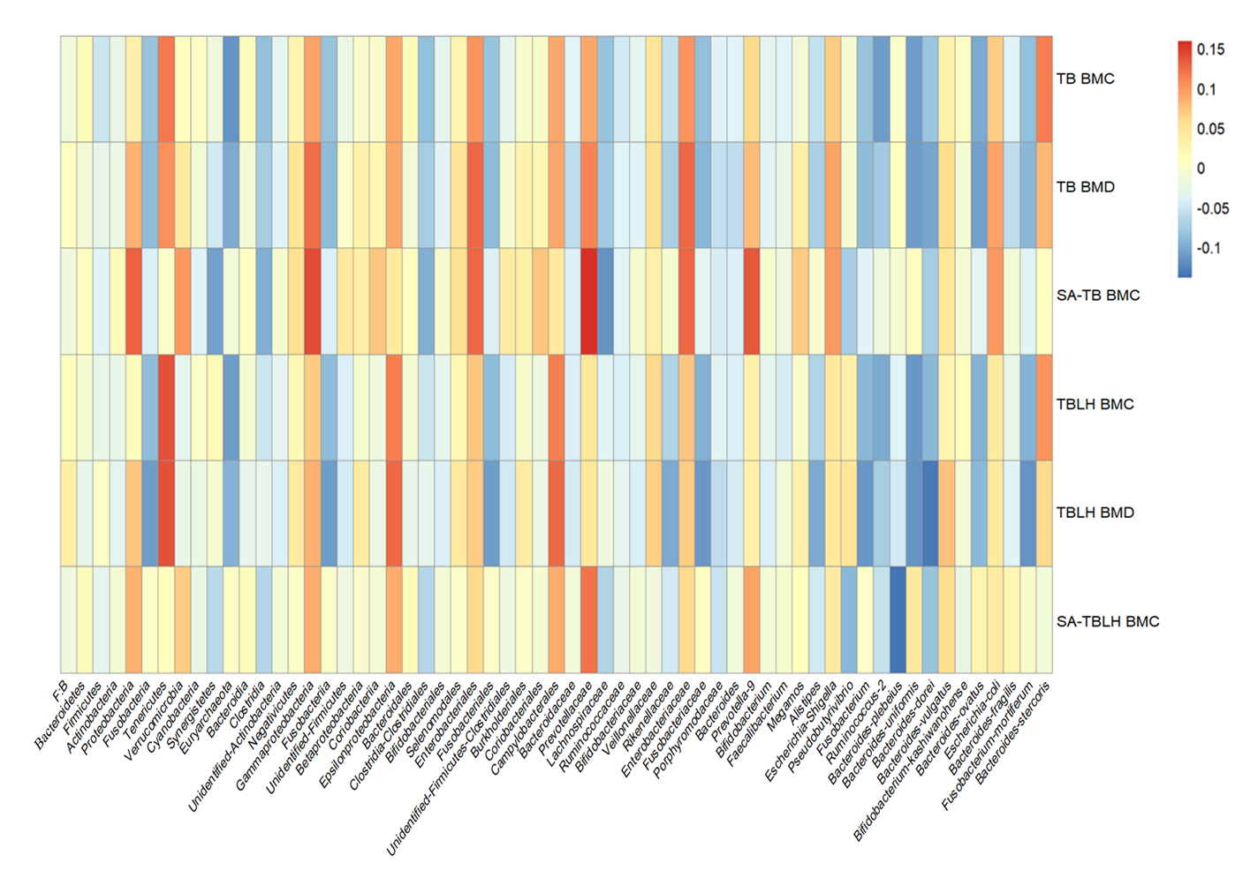
Supplemental Figure S1. The spearman correlation of the bone mass with the gut microbiota. TB BMC: total body bone mineral content; TB BMD: total body bone mineral density; SA- TB BMC: Size-adjusted total body bone mineral content; TBLH BMC: total body less head bone mineral content; TBLH BMD: total body less head bone mineral density; SA-TBLH BMC: Size-adjusted total body less head bone mineral content.

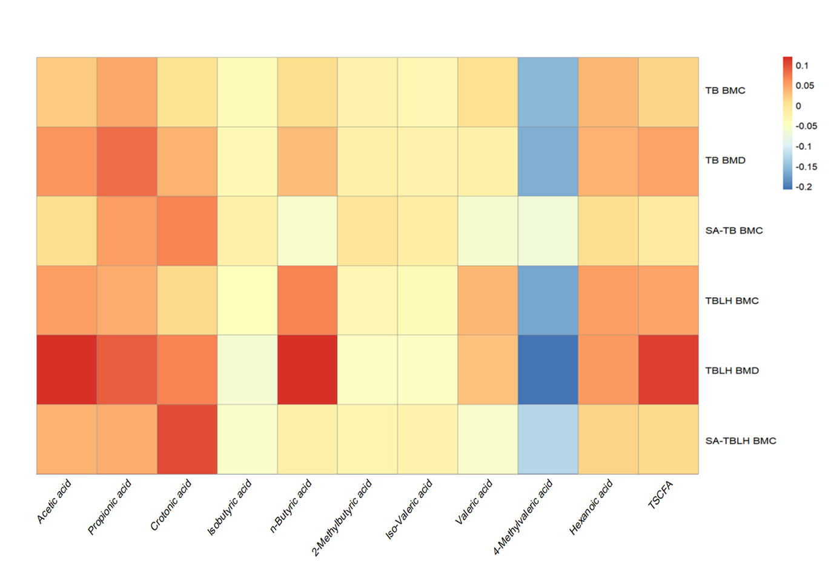
Supplemental Figure S2 The spearman correlation between the bone mass and the levels of fecal short chain fatty acids. TSCFA: total short chain fatty acids; TB BMC: total body bone mineral content; TB BMD: total body bone mineral density; SA- TB BMC: Size-adjusted total body bone mineral content; TBLH BMC: total body less head bone mineral content; TBLH BMD: total body less head bone mineral density; SA-TBLH BMC: Size-adjusted total body less head bone mineral content.

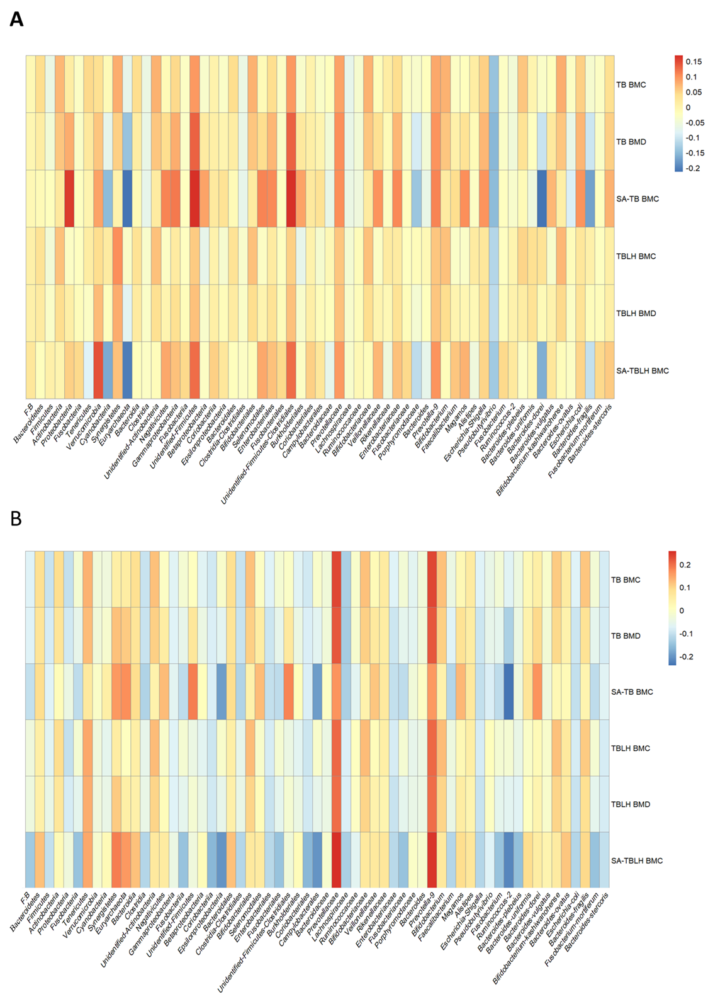
Supplemental Figure S3. The multiple linear regression analysis of the associations between gut microbiota richness and bone mass. (A) boys and (B) girls. Results were adjusted for weight, age, sex, delivery mode, household income, parental education, physical activity, use of calcium and multivitamin supplements, dietary energy intake, and dietary fiber intake and multiple comparisons correction. TB BMC: total body bone mineral content; TB BMD: total body bone mineral density; SA- TB BMC: Size-adjusted total body bone mineral content; TBLH BMC: total body less head bone mineral content; TBLH BMD: total body less head bone mineral density; SA-TBLH BMC: Size-adjusted total body less head bone mineral content.

Supplemental Figure S4. The multiple linear regression analysis of the associations between fecal SCFAs and bone mass. (A) boys and (B) girls. Results were adjusted for weight, age, sex, delivery mode, household income, parental education, physical activity, use of calcium and multivitamin supplements, dietary energy intake, and dietary fiber intake and multiple comparisons correction. TSCFA: total short chain fatty acids; TB BMC: total body bone mineral content; TB BMD: total body bone mineral density; SA- TB BMC: Size-adjusted total body bone mineral content; TBLH BMC: total body less head bone mineral content; TBLH BMD: total body less head bone mineral density; SA-TBLH BMC: Size-adjusted total body less head bone mineral content.

