Accounting for center-level effects in multicenter randomized control trials

Shofiqul Islam and Shrikant I Bangdiwala

Appendix A:
Models associated with a continuous or binary outcome are presented below:
Continuous outcome:
Let us suppose Y_{ij} is a continuous outcome corresponding to the i^{th} subject and j^{th} center. $θ_{j}$ (fixed) or γ _{j} (random) represents the j^{th} center-level effects. T_{ij} is an indicator variable, that represents the treatment or intervention to which the i^{th} subject from the j^{th} center has been allocated. Thus, models associated with a continuous outcome can be written as:
No center-effect:
$$Y_{ij}=α +β T_{ij}+ e_{ij}, i=1,2,3…n_{i}, j=1,2,3,…,J ,$$
where $e_{ij} are i.i.d. \sim N\left(0,σ_{e}^{2}\right)$.
Fixed center-effect:
$Y_{ij}=α + β T_{ij}+θ_{j} C_{j}+ e_{ij}, i=1,2,3…n_{i}, j=1,2,3,…,J$,
where $e_{ij} are i.i.d. \sim N\left(0,σ_{e}^{2}\right)$ and $C_{j}$ is a dummy indicator variable for the j^{th} center.
Random center-effect:
$$Y_{ij}=α + β T_{ij}+γ_{j}+ e_{ij}, where i=1,2,3…n_{i}, j=1,2,3,…,J,$$
where $e_{ij}\sim N\left(0,σ_{w}^{2}\right) and γ_{j} \sim N\left(0,σ_{b}^{2}\right)$ are independent.

Binary outcome:
Assuming $p_{i}$ as the probability of an event given treatment or intervention and using similar notations, models associated with a binary outcome can be written as:
- No center-effect:
$$\log{(}\frac{p_{i}}{1-p_{i}})=α + β T_{ij}, i=1,2,3…n_{i}, j=1,2,3,…,J$$
- Fixed center-effect:
$$\log{(}\frac{p_{i}}{1-p_{i}})=α + β T_{ij}+θ_{j} C_{j}, i=1,2,3…n_{i}, j=1,2,3,…,J$$
where $C_{j}$ is a dummy indicator variable for the j^{th} center.
- Random center-effect:
$$\log{(}\frac{p_{i}}{1-p_{i}})=α + β T_{ij}+γ_{j}, i=1,2,3…n_{i}, j=1,2,3,…,J$$
where$γ_{j} \sim N\left(0,σ_{b}^{2}\right)$.

Appendix Table 1: Simulation Scenarios
Simulation Parameters
Continuous Outcome: Blood Pressure (BP) | Binary Outcome: Hypertension
Vary effect estimates  - Reduction in Blood Pressure (BP): 0, 1, 2, …, 10 mmHg  - Number of centers: 12 (50 subjects/center)  - ICC = 0.05  - Type I error rate = 0.05; Type II Error Rate = 0.14 | Vary effect estimates  - Odds Ratio (Treatment vs Hypertension): 0.7, 0.72, …, 1.0  - Number of centers: 60 (60 subjects/center)  - ICC = 0.05  - Type I error rate = 0.05; Type II Error Rate = 0.10
Vary sample size by a varying number of centers  - Effect estimate: 5 mmHg  - Number of centers: 2, 4, 6, …, 20 (50 subjects/center)  - ICC = 0.05  - Type I error rate = 0.05; Type II Error Rate = 0.14 | Vary sample size by a varying number of centers  - Effect estimate: Odds Ratio = 0.8  - Number of centers: 10, 20, 30, …, 100 (60 subjects/center)  - ICC = 0.05  - Type I error rate = 0.05; Type II Error Rate = 0.10
Vary the distribution of variances and corresponding ICC  - Effect estimate: 5 mmHg  - Consider the ICC: 0.01, 0.02, …, 0.3  - Fixed total variance but with increasing ICC  - Increasing total variance with increasing ICC  - Number of centers: 12 (50 subjects/center)  - Type I error rate = 0.05; Type II Error Rate = 0.14 | Vary the distribution of variances and corresponding ICC  - Effect estimate: Odds Ratio = 0.8  - Consider the ICC: 0.01, 0.02, …, 0.3  - Increasing total variance with increasing ICC  - Number of centers: 60 (60 subjects/center)  - Type I error rate = 0.05; Type II Error Rate = 0.10

Appendix Table 2: Summary of current literature search
Search criteria: ‘randomized controlled trial’ in the New England Journal of Medicine and the Lancet during last five years, from January 01, 2017 to June 15, 2023
- New England Journal of Medicine.jn (128486)
- Lancet.jn. (468620)
- Randomized controlled traial (1074425)
- Multicenter/Multi-center/Multicentre/Multi-centere (539134)
- Year 2017 – today (June 15, 2023)
- Random effect/Random center effect (516120)
- Fixed effect/ Fixed center effect (1250817)
- 1 and 3 and 4 and 5 and 6 (135)
- 1 and 3 and 4 and 5 and 7 (91)
- 2 and 3 and 4 and 5 and 6 (36)
- 2 and 3 and 4 and 5 and 7 (12)

Appendix Figure 1: Probability density curve of systolic blood pressure (SBP) by the control and intervention group from a simulated sample.
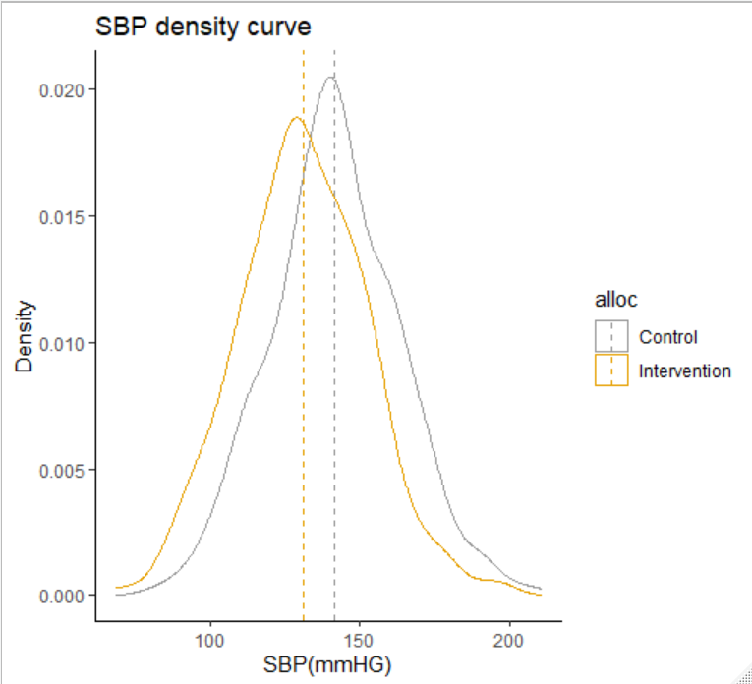

Appendix Figure 2: Effects on Type I and Type II error rates using within-center randomization with increasing between-center variability (Increasing ICC) but with fixed total variance.
[ Same as Figure 2 in the article but Y-axis restricted up to 0.10 ICC]
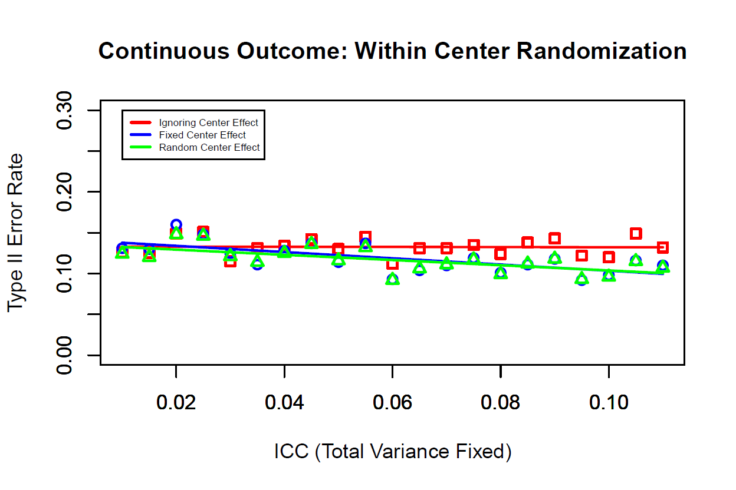

Corresponding author: Shofiqul Islam, Department of Health Research Methods, Evidence and Impact, McMaster University

