SUPPLEMENTARY DATA
Design, synthesis, and biological and computational evaluation of novel oxindole derivatives as inhibitors of Aurora A Kinase and SARS-CoV-2 Spike/Host ACE2 Interaction

Donatus B. Eni^{1,2*}, Joel Cassel³, Cyril T. Namba-Nzanguim^{1,2}, Conrad V. Simoben¹, Ian Tietjen³, Ravikumar Akunuri³, Joseph M. Salvino^{3*}, Fidele Ntie-Kang^{1,2,4*}
¹Center for Drug Discovery, Faculty of Science, University of Buea, Buea, Cameroon. ²Department of Chemistry, Faculty of Science, University of Buea, Buea, Cameroon.
³The Wistar Institute, Philadelphia, Pennsylvania, PA, USA
⁴Institute of Pharmacy, Martin-Luther University Halle-Wittenberg, Halle (Saale), Germany

*Corresponding author: jsalvino@wistar.org (JMS); fidele.ntie-kang@ubuea.cm (FNK)

Author ORCID
Donatus B. Eni: 0000-0002-4148-6372
Joel Cassel: 0000-0001-8465-8739
Cyril T. Namba-Nzanguim: 0000-0002-8404-7214
Conrad V. Simoben: 0000-0002-5958-6961
Ian Tietjen: 0000-0002-8991-6490
Ravikumar Akunuri: 0000-0003-4898-5753
Joseph M. Salvino: 0000-0002-2184-5980
Fidele Ntie-Kang: 0000-0003-0795-394X

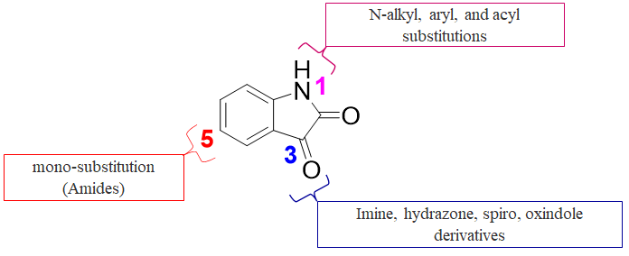
Fig. S1: The various targets modification positions on the isatin scaffold

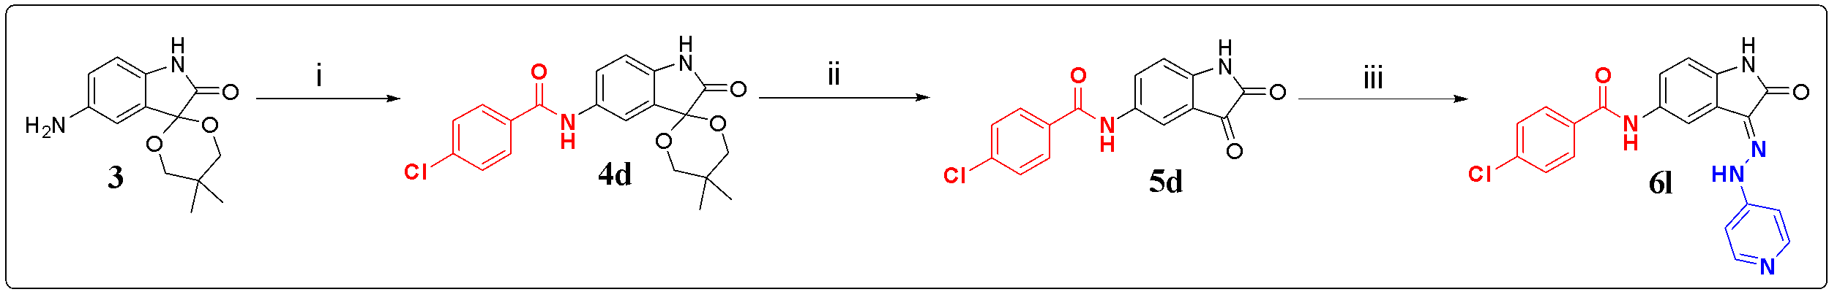
Scheme S1: Synthesis of compound 6m.

CODES IN THE LAB NOTEBOOK AND THE ARTICLE
S/N | CODE IN LAB NOTEBOOK | CODE IN ARTICLE
1 | DBE-01-023 or DBE-Glyol | 2
2 | DBE-01-025 | 3
3 | DBE-01-027 | 4a
4 | DBE-01-045 | 4b
5 | DBE-01-053 | 4c
6 | DBE-01-033 | 4d
7 | DBE-01-041 | 4e
8 | DBE-01-031 | 6a
9 | DBE-01-043 | 6b
10 | DBE-01-037 | 6c
11 | DBE-01-049 | 6d
12 | DBE-01-051 | 6e
13 | DBE-01-061 | 6g
14 | DBE-01-063 | 6h
15 | DBE-01-065 | 6i
16 | DBE-01-067 | 6j
17 | DBE-01-071 | 6k
18 | DBE-01-069 | 6l
19 | DBE-01-039 | 6m

C-13 NMR DATA

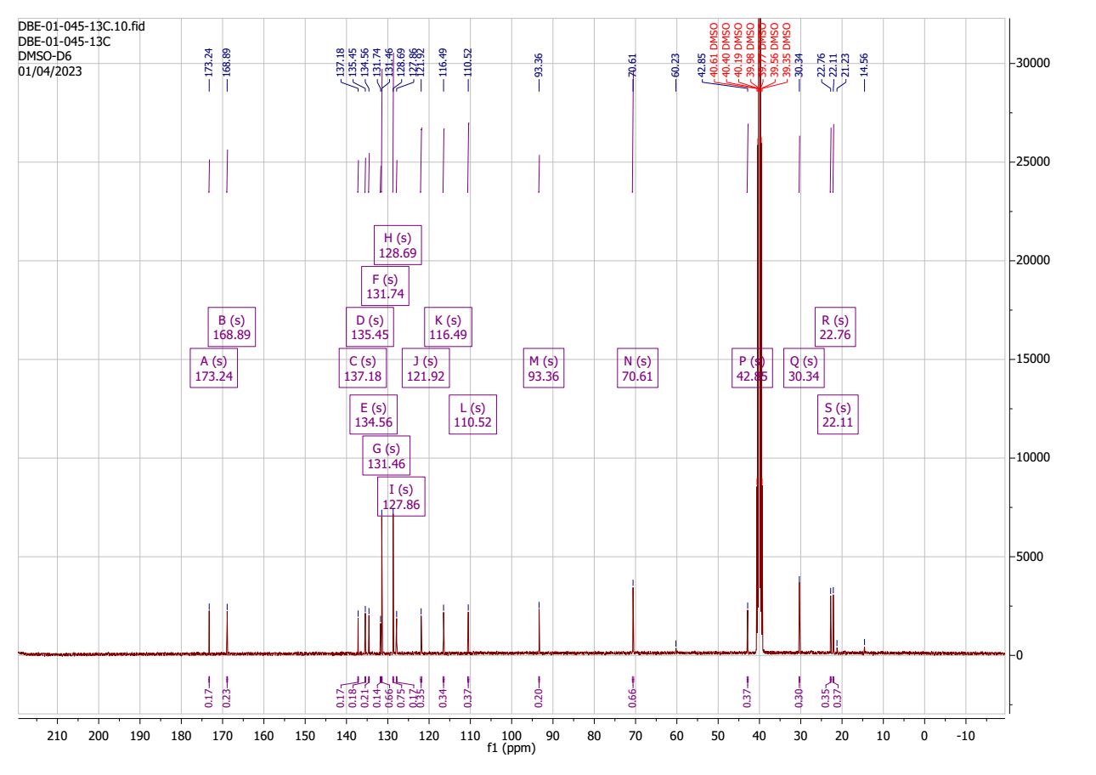

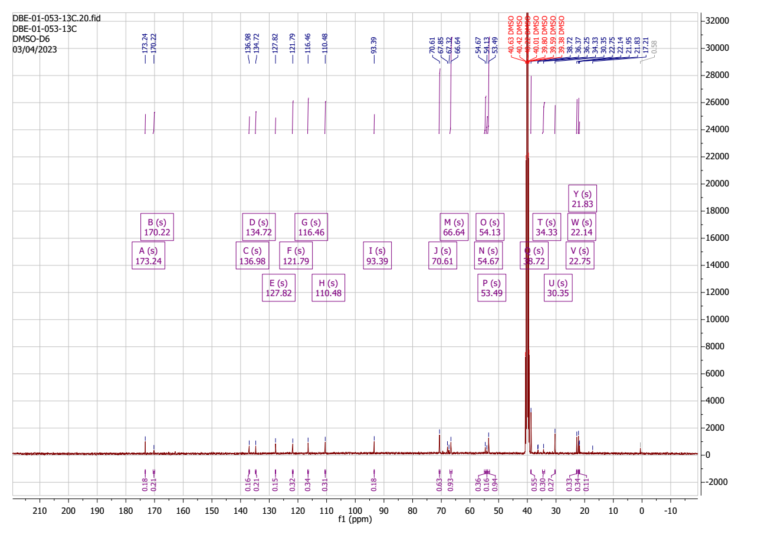
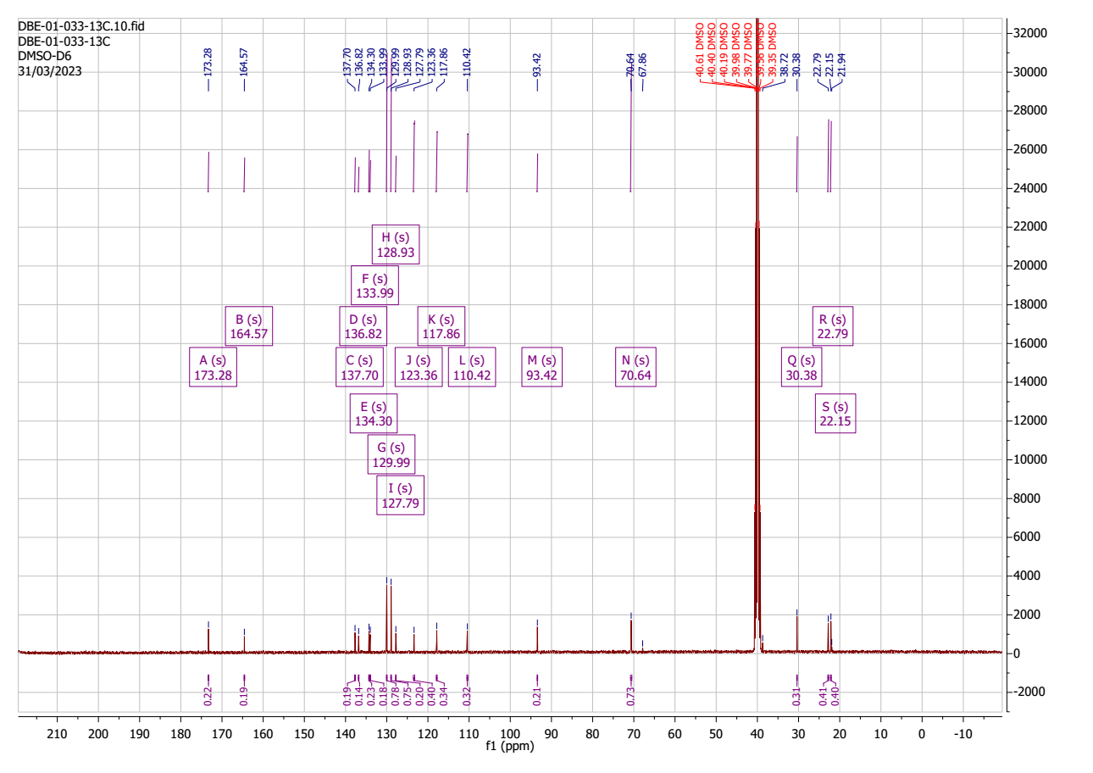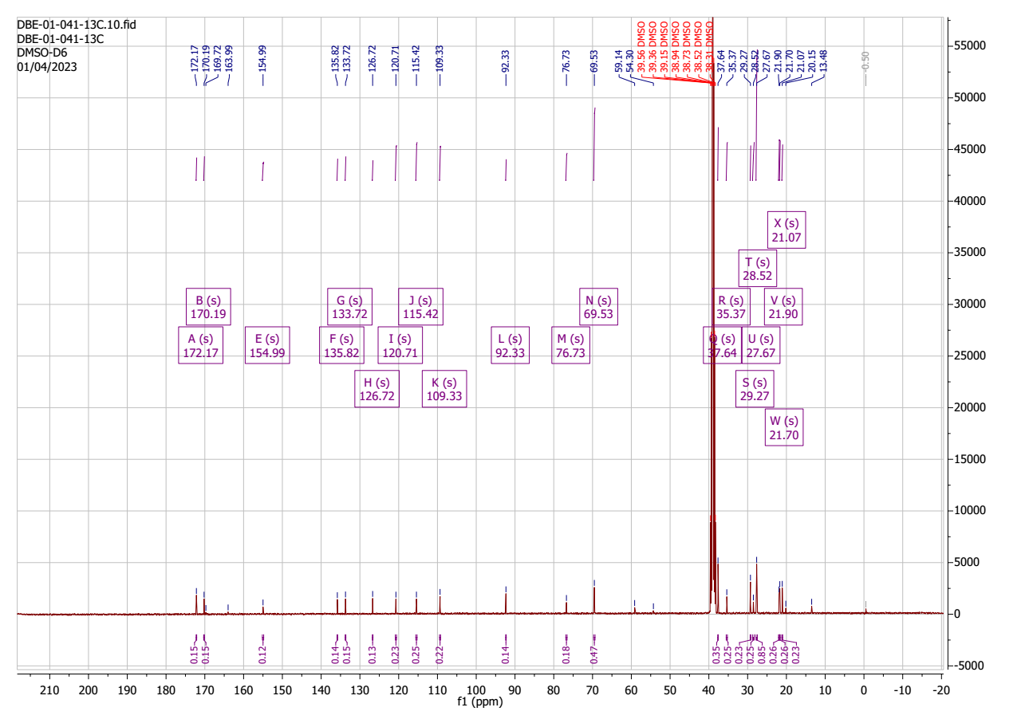
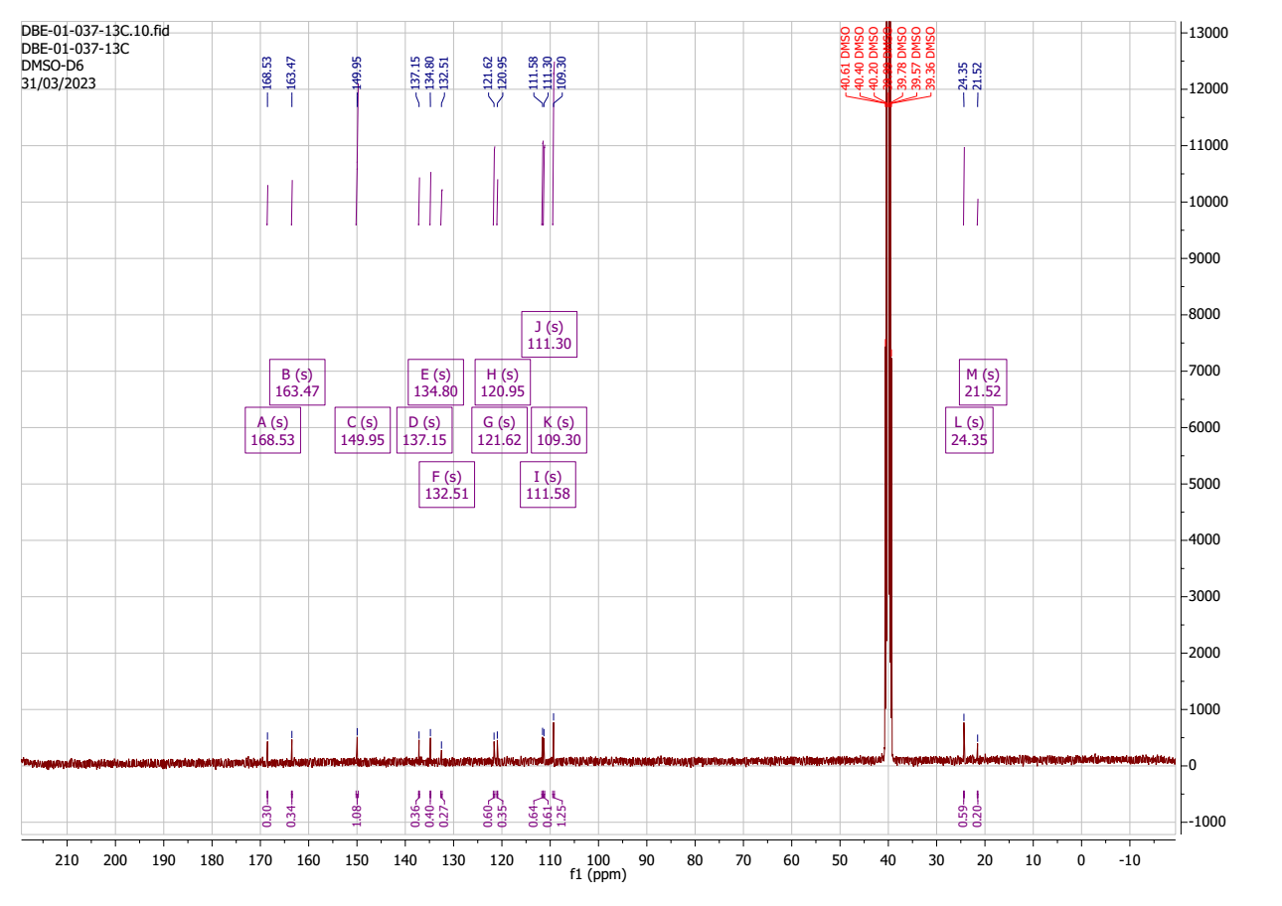
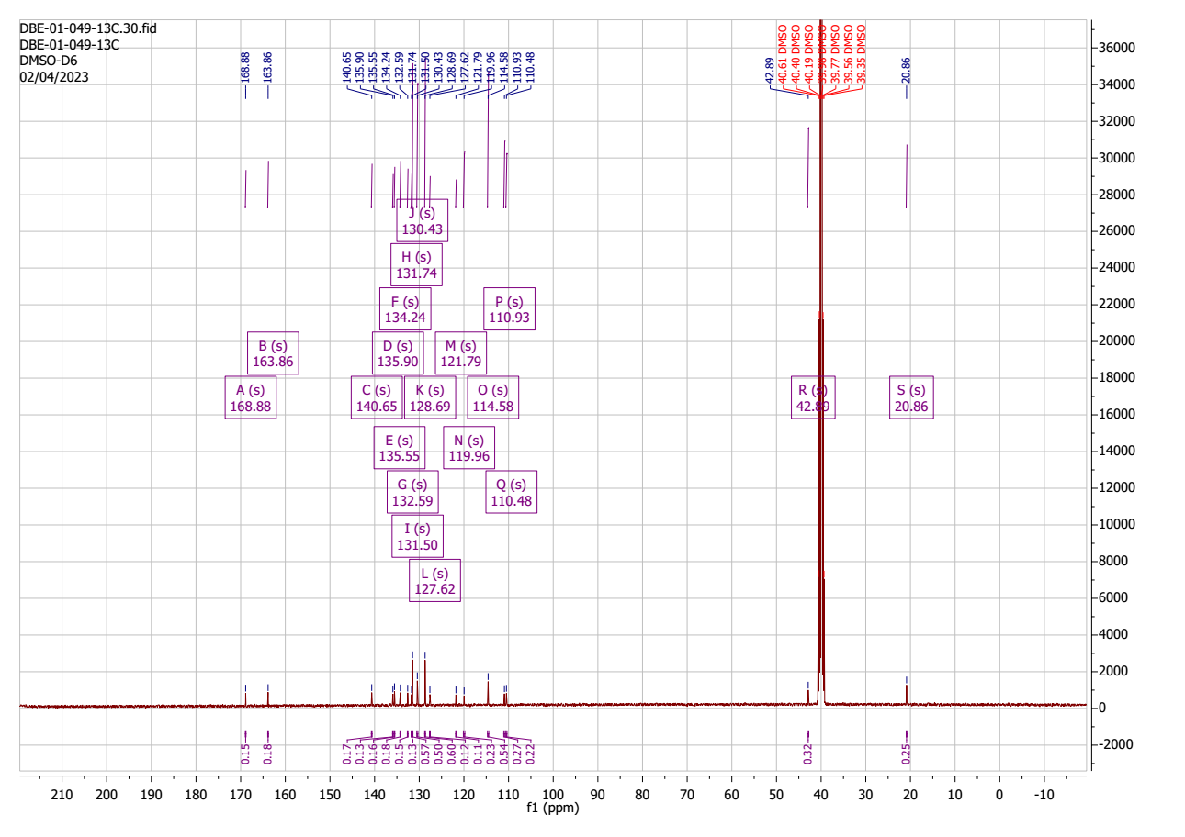
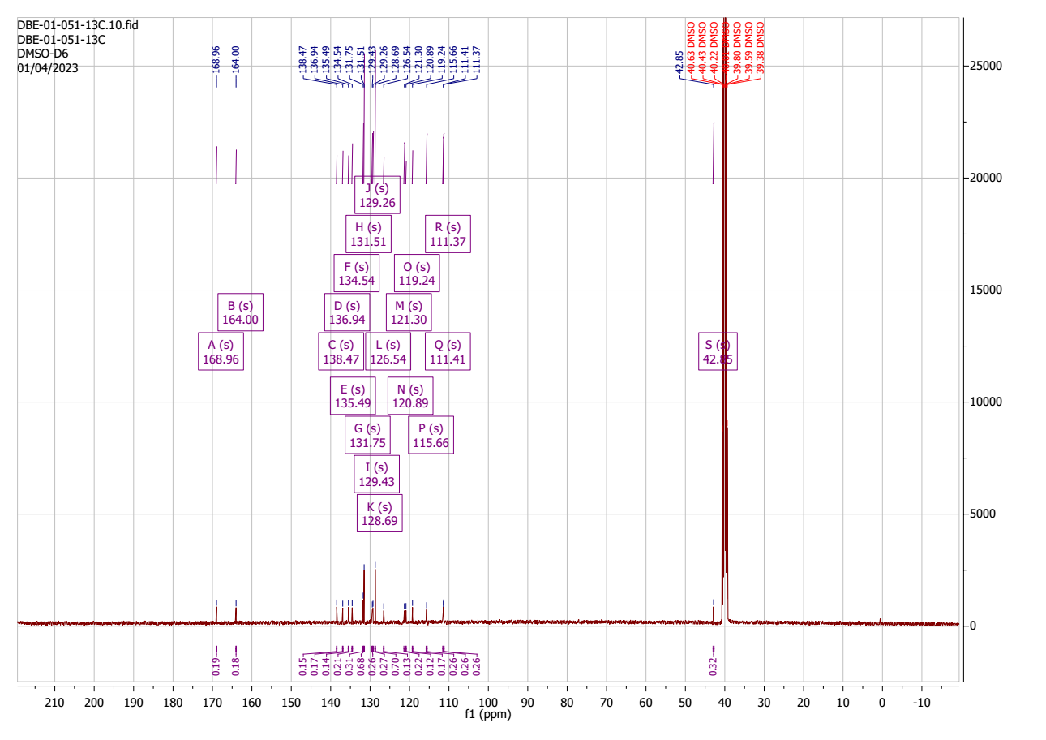
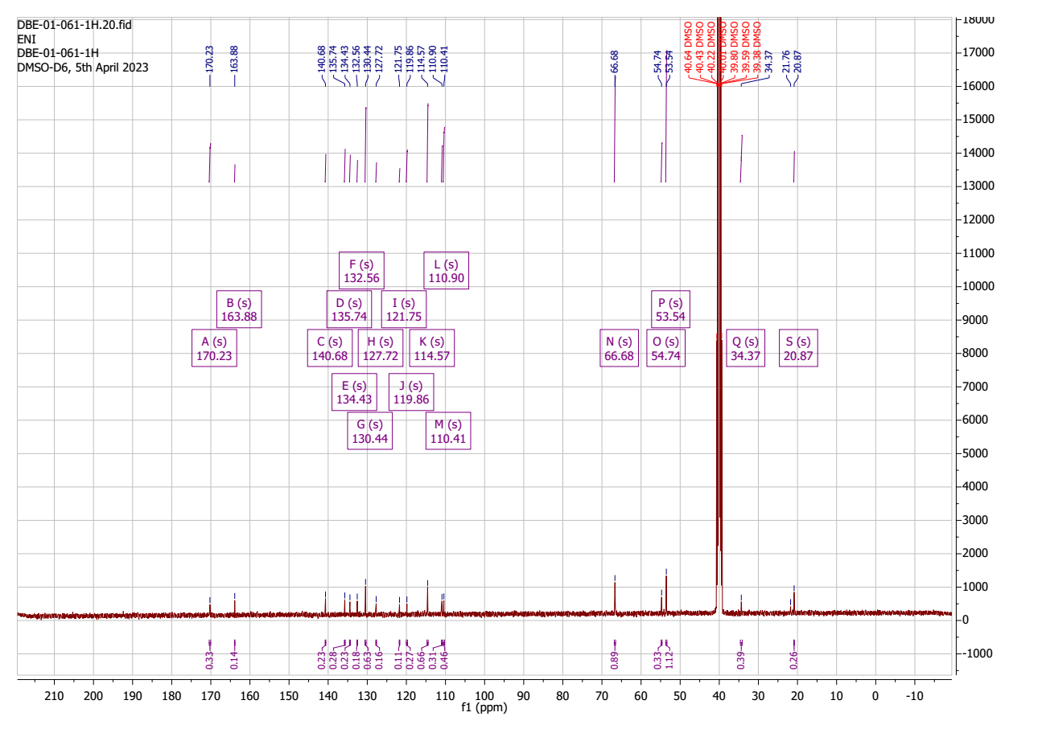
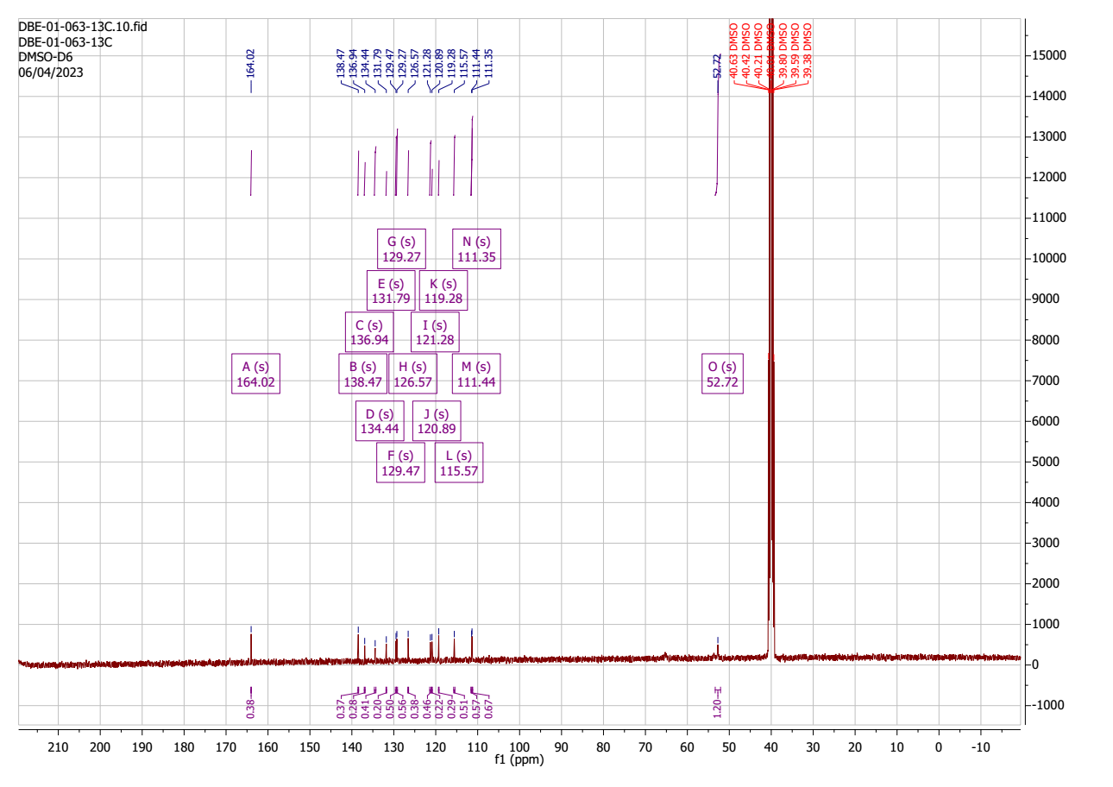
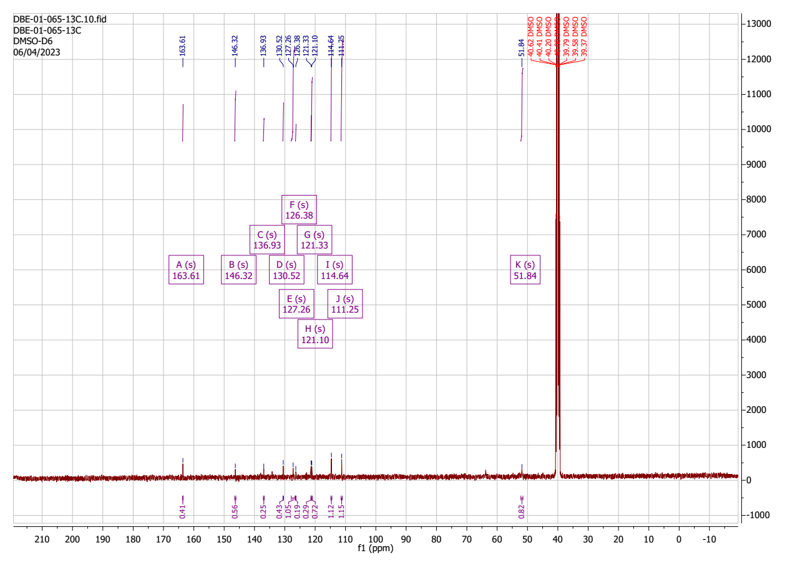
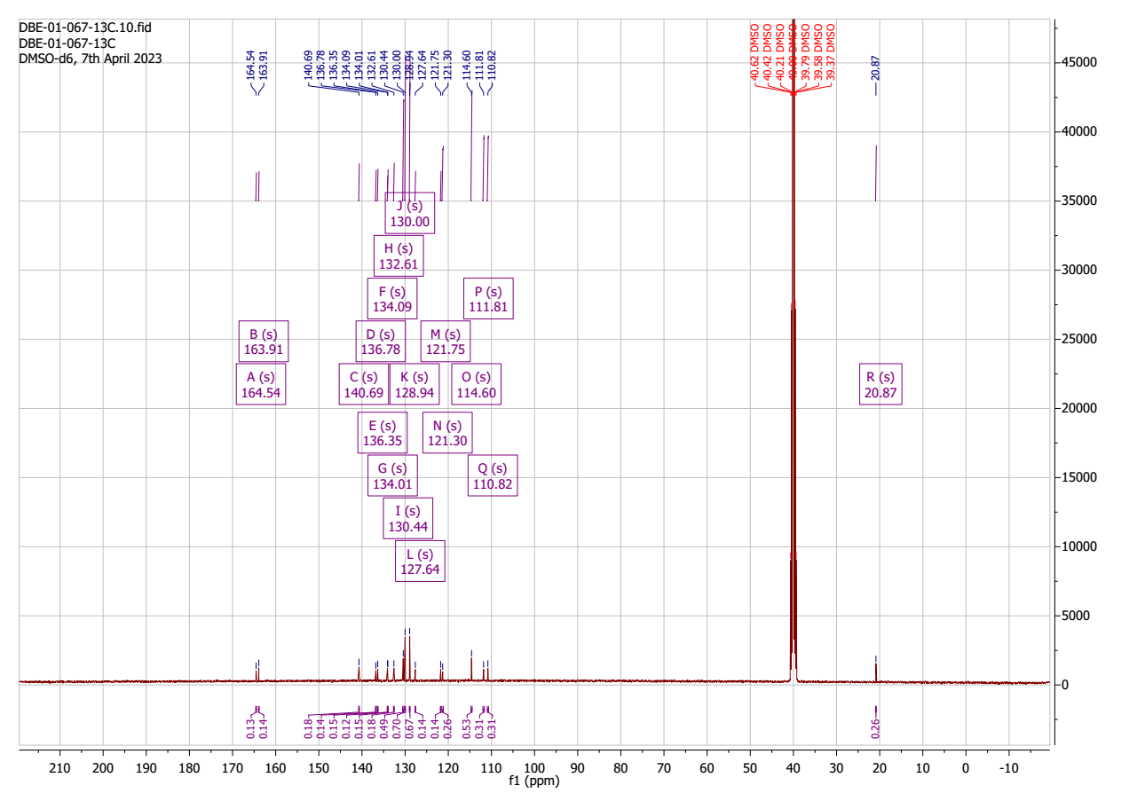
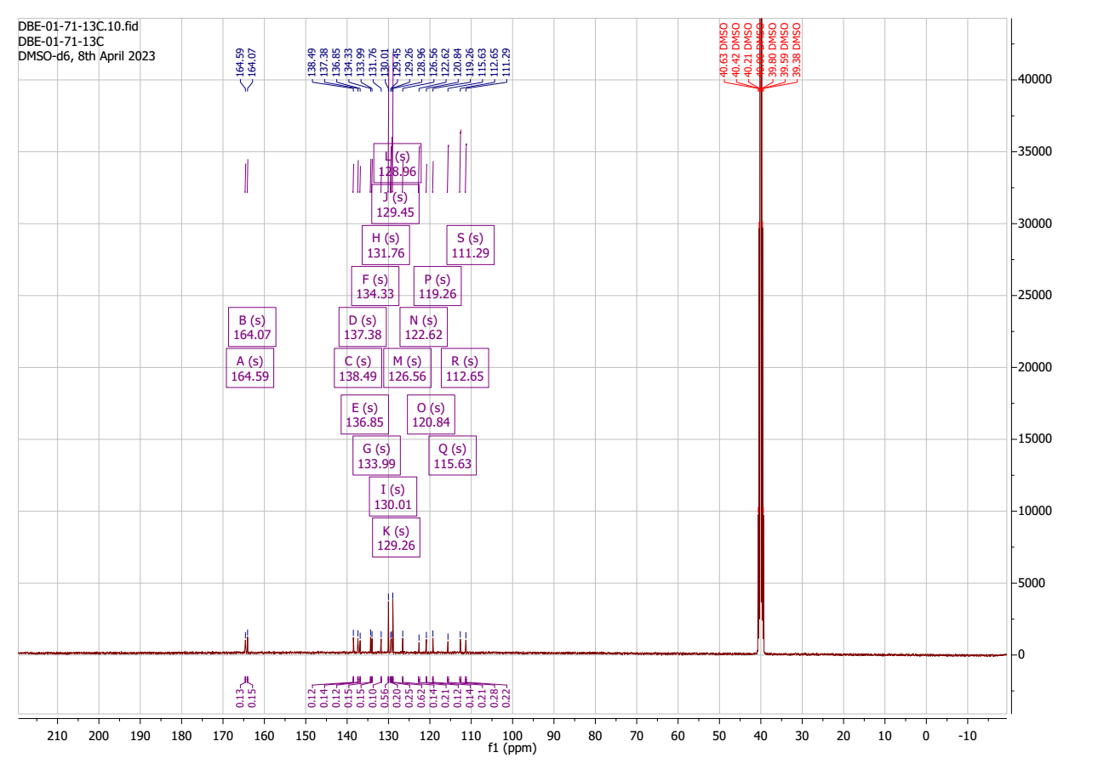
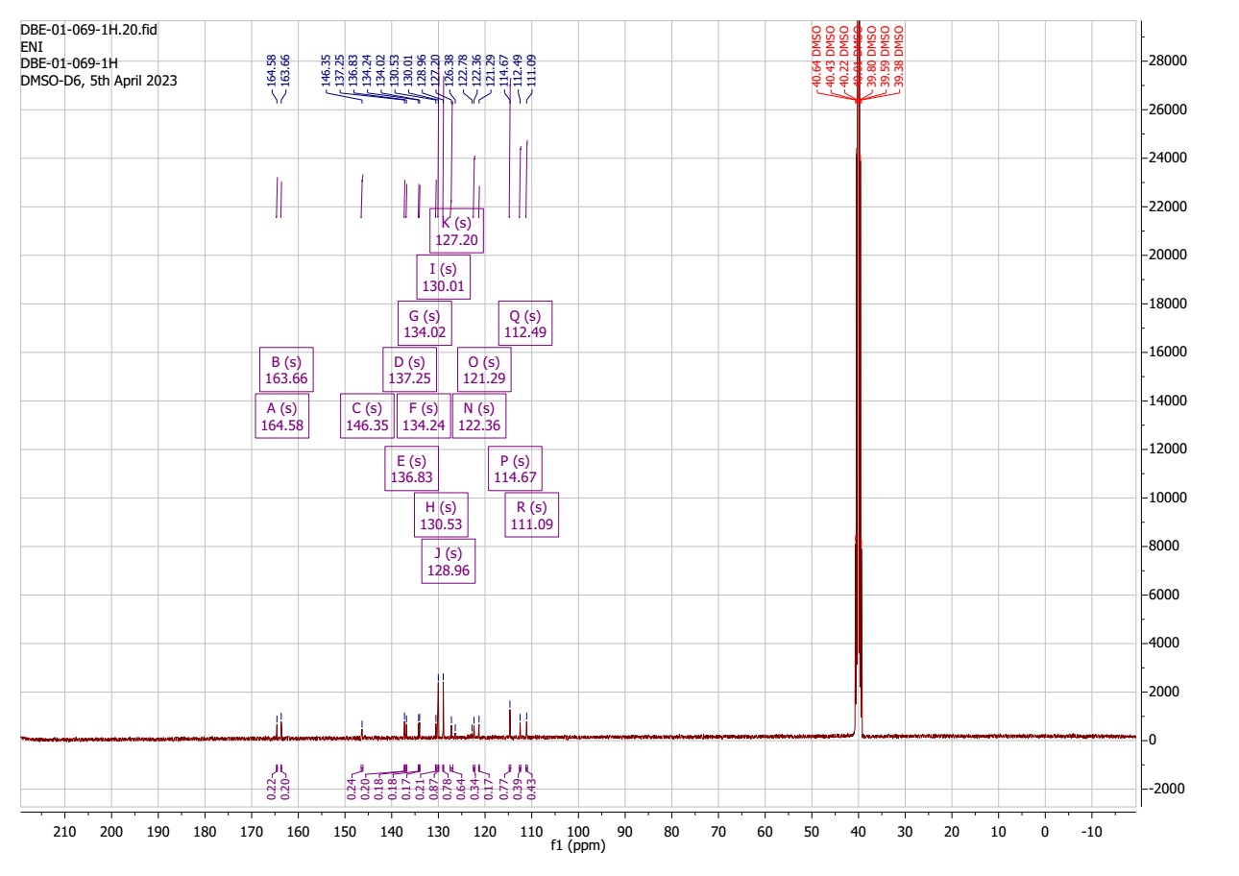
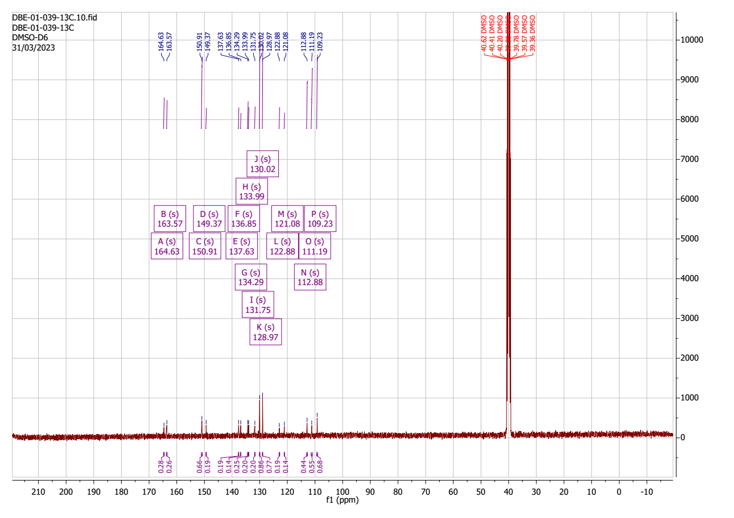

LC-MS DATA
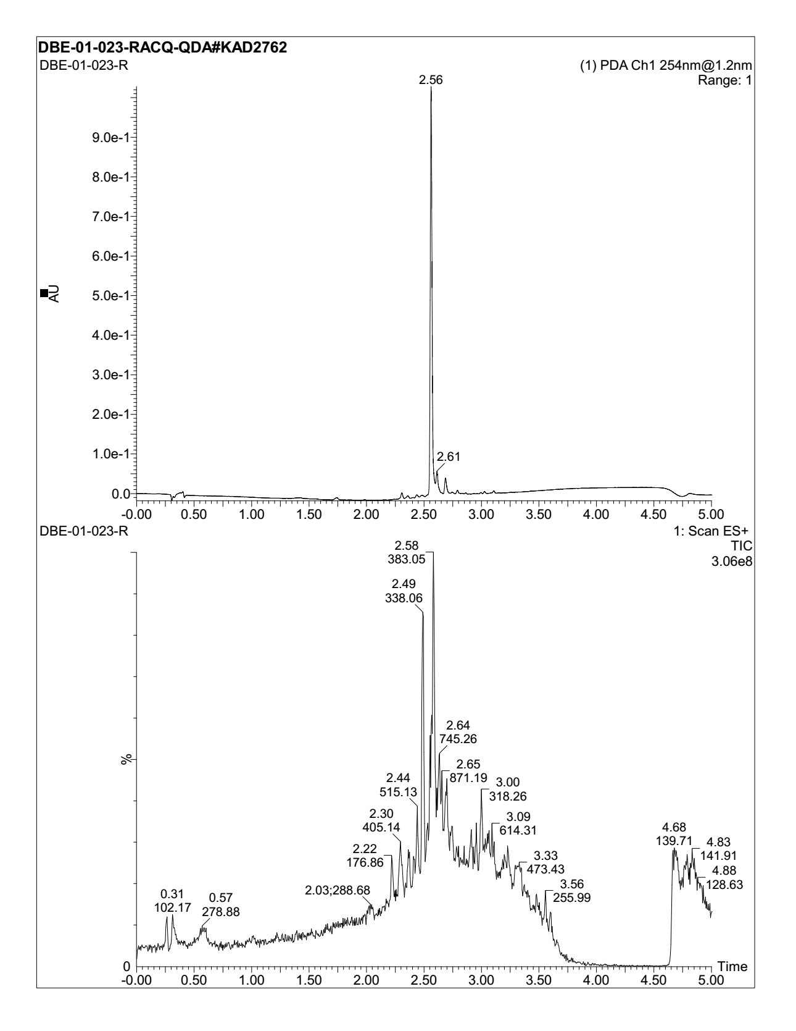
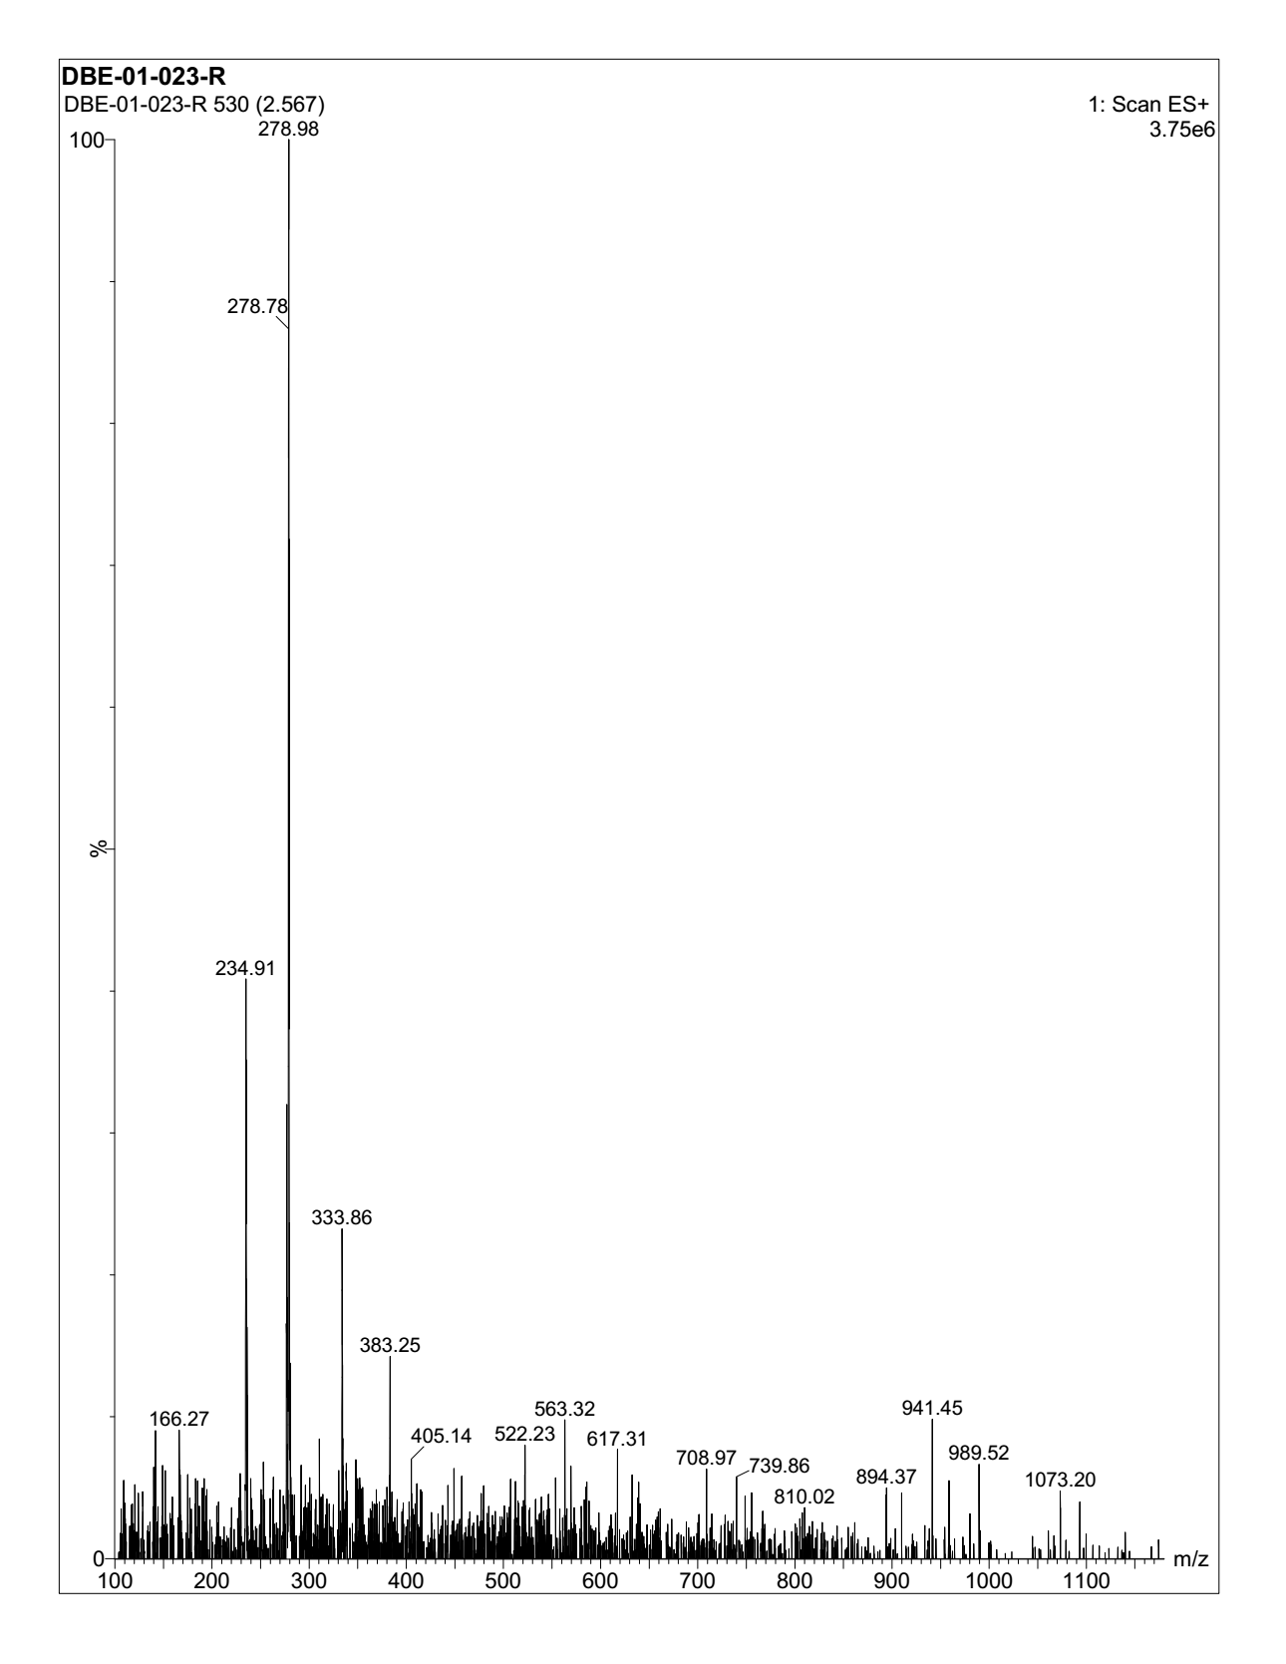
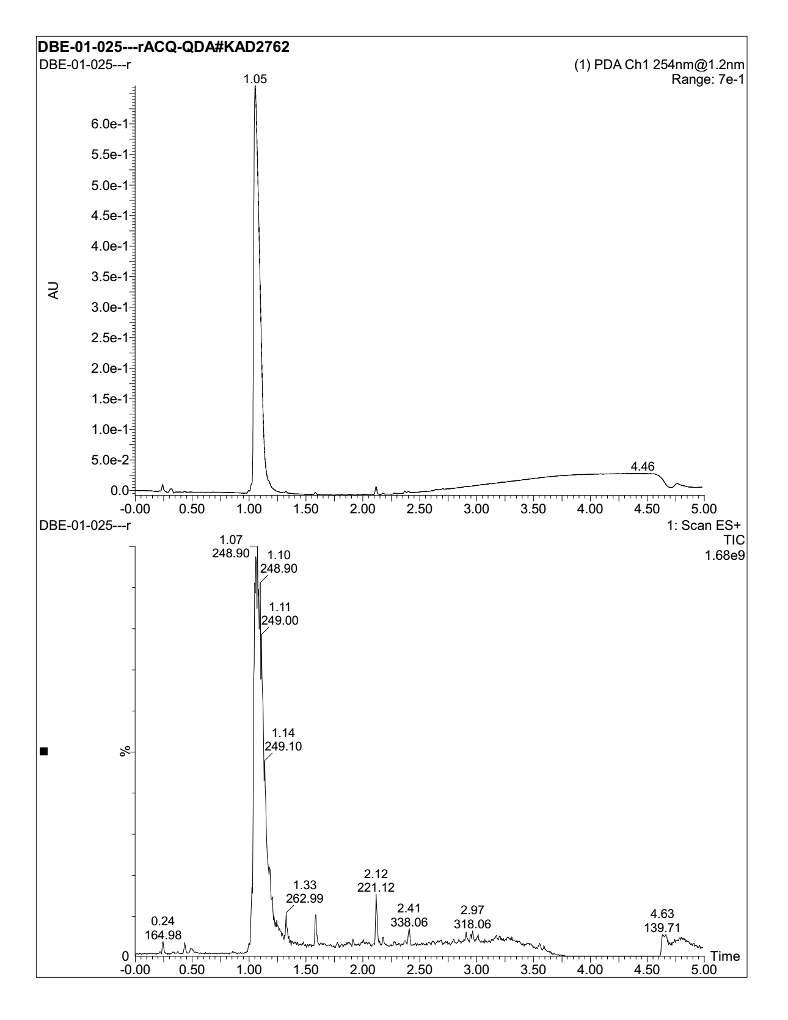
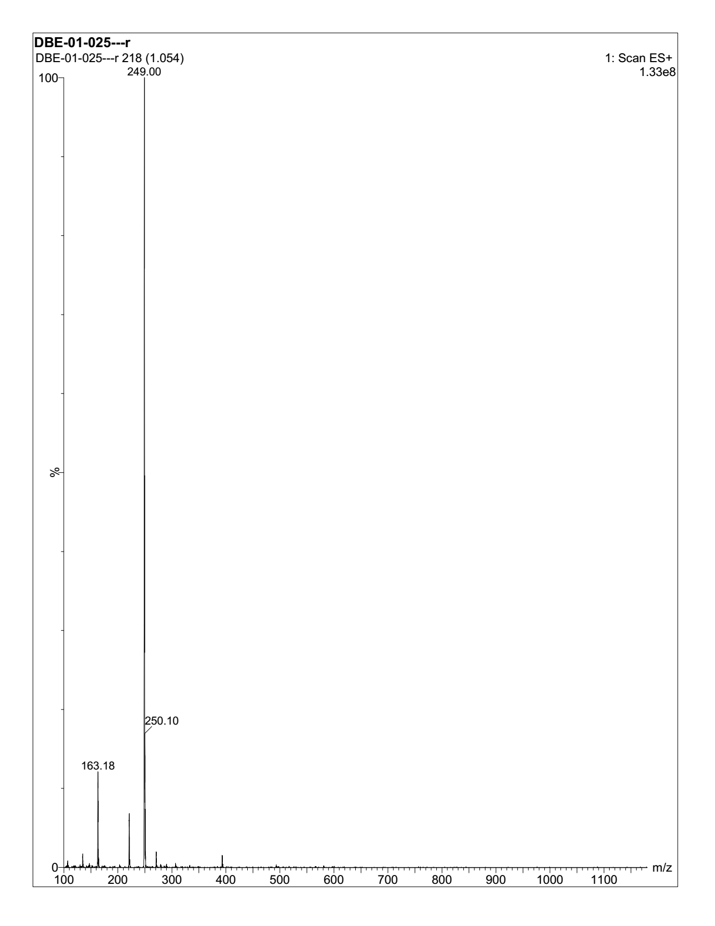
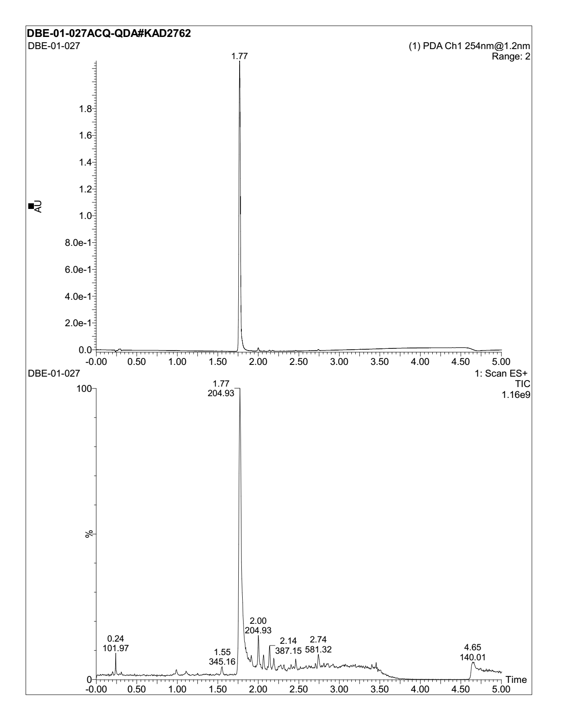
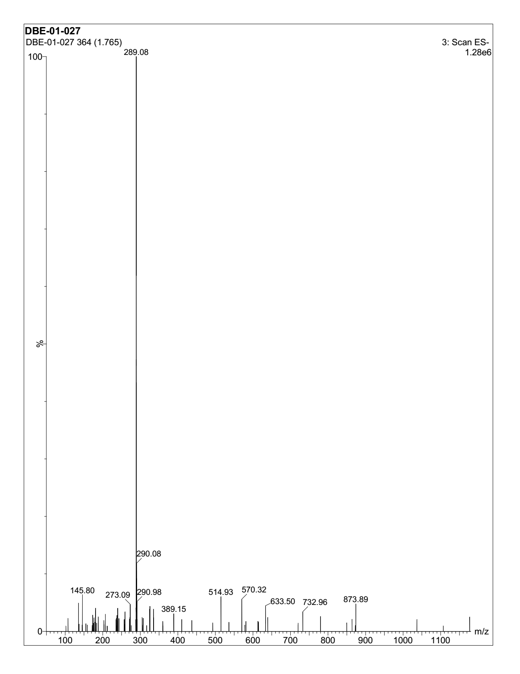
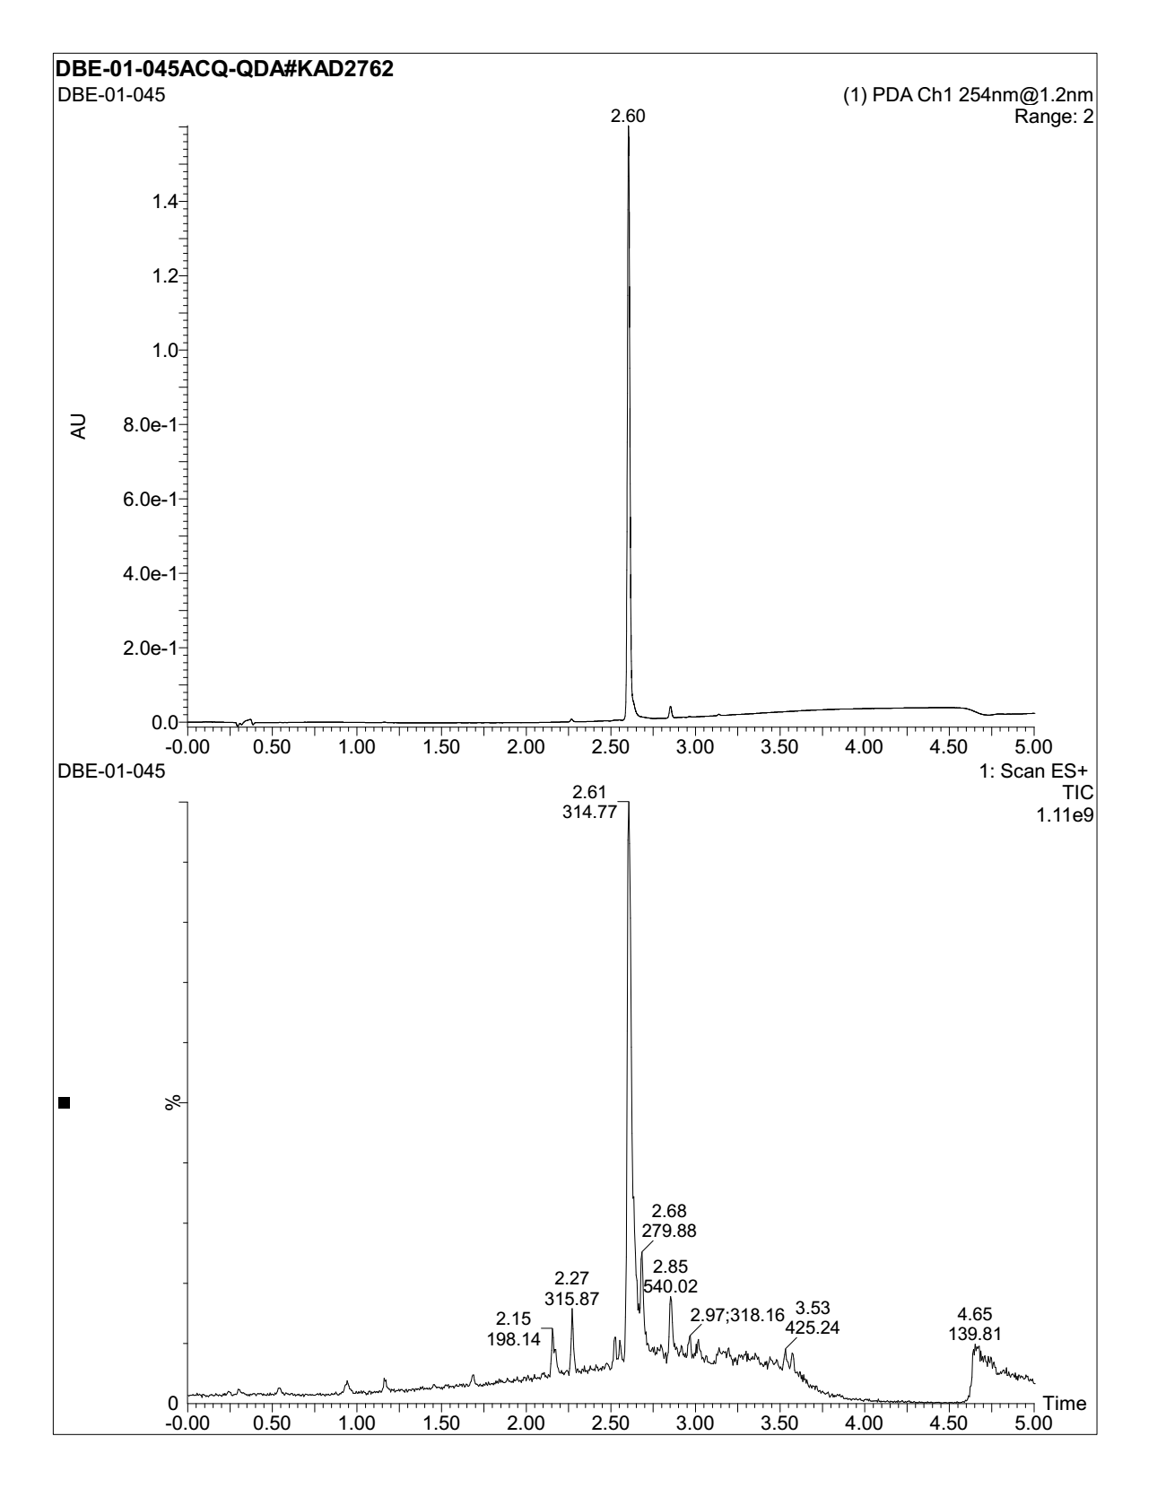
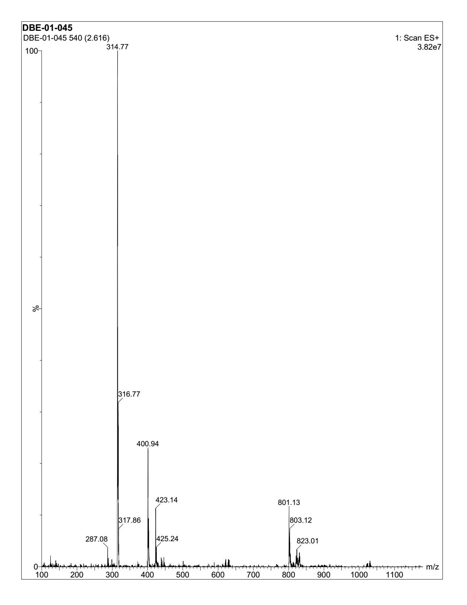
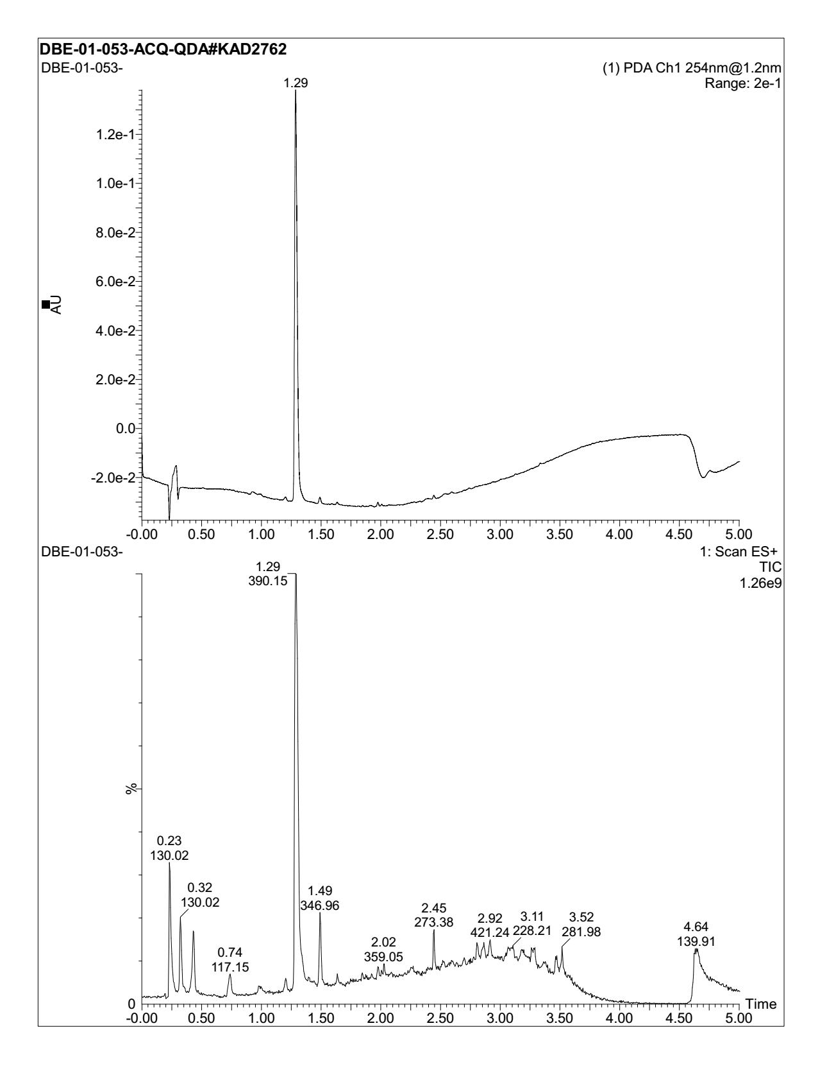
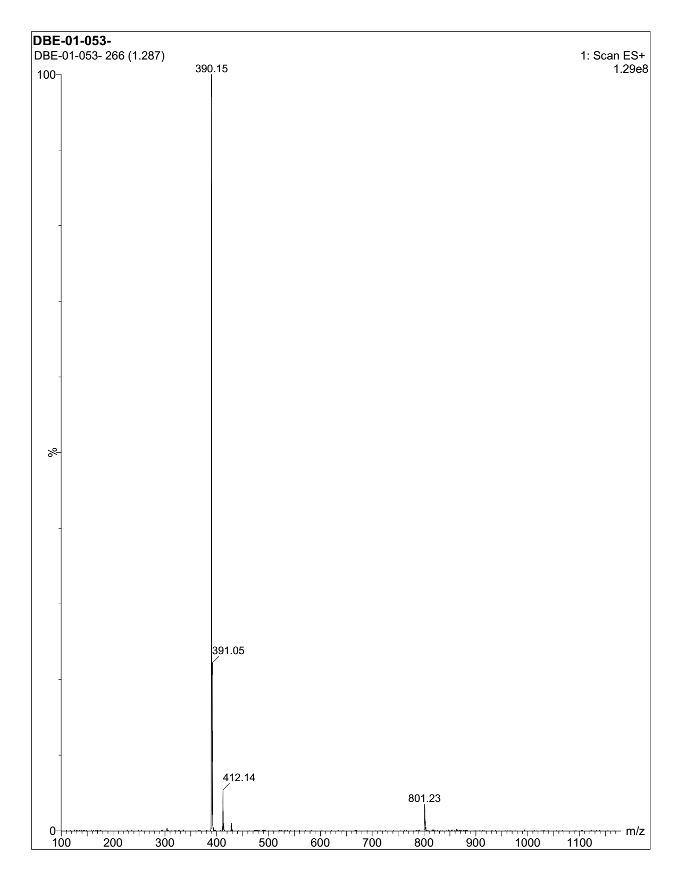
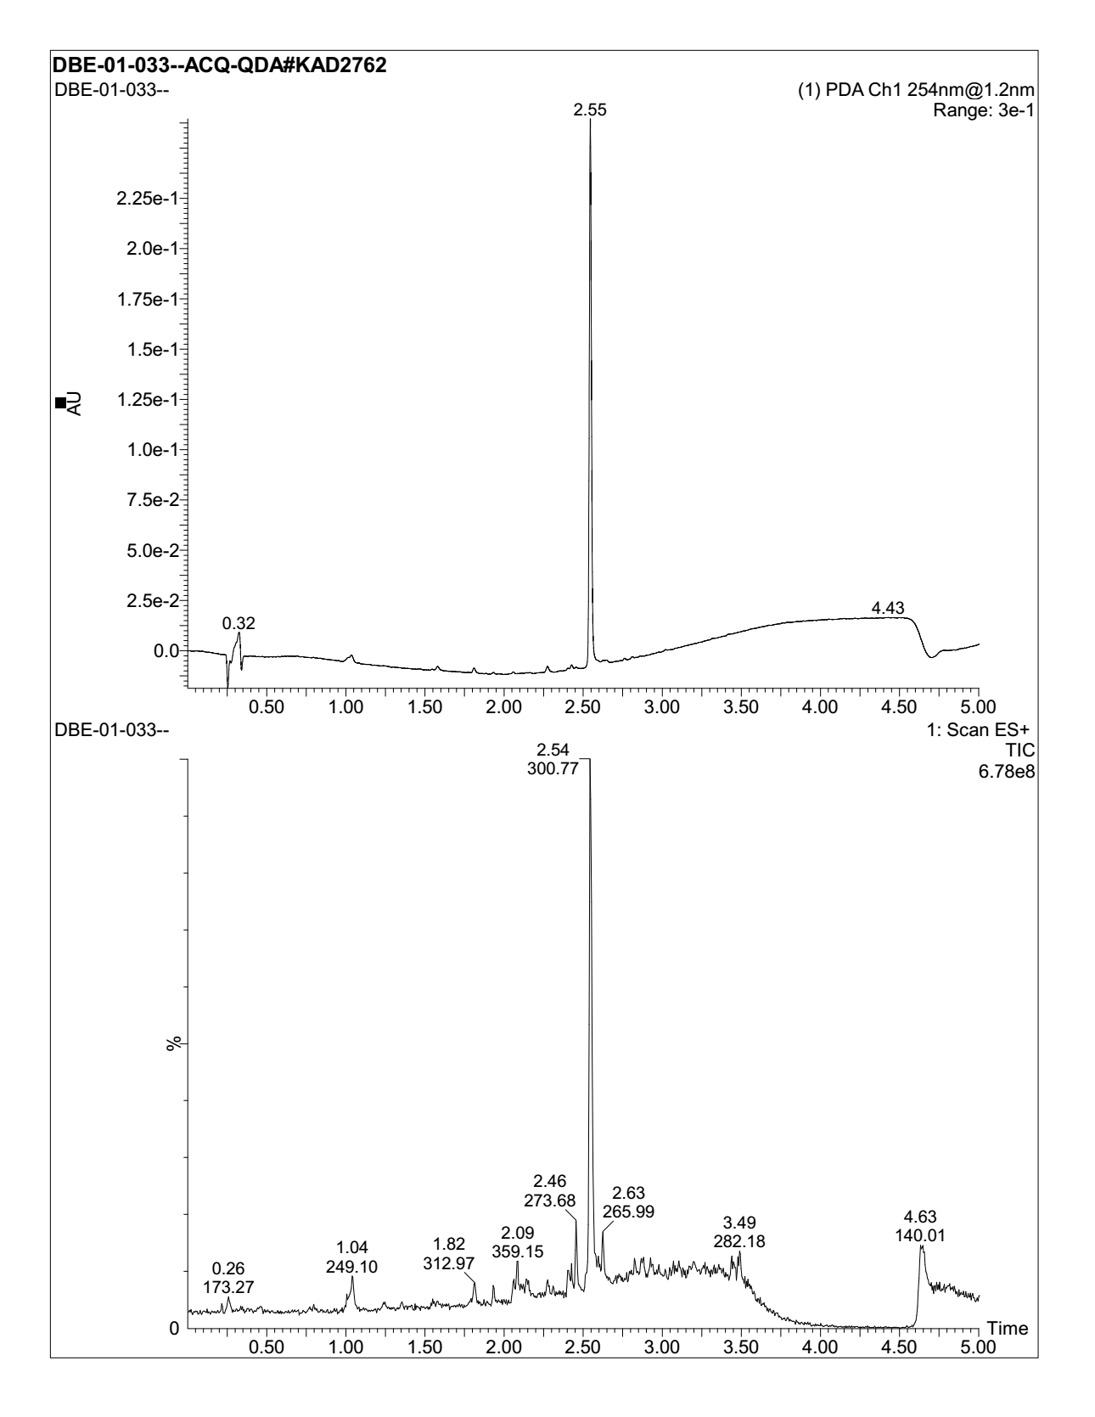
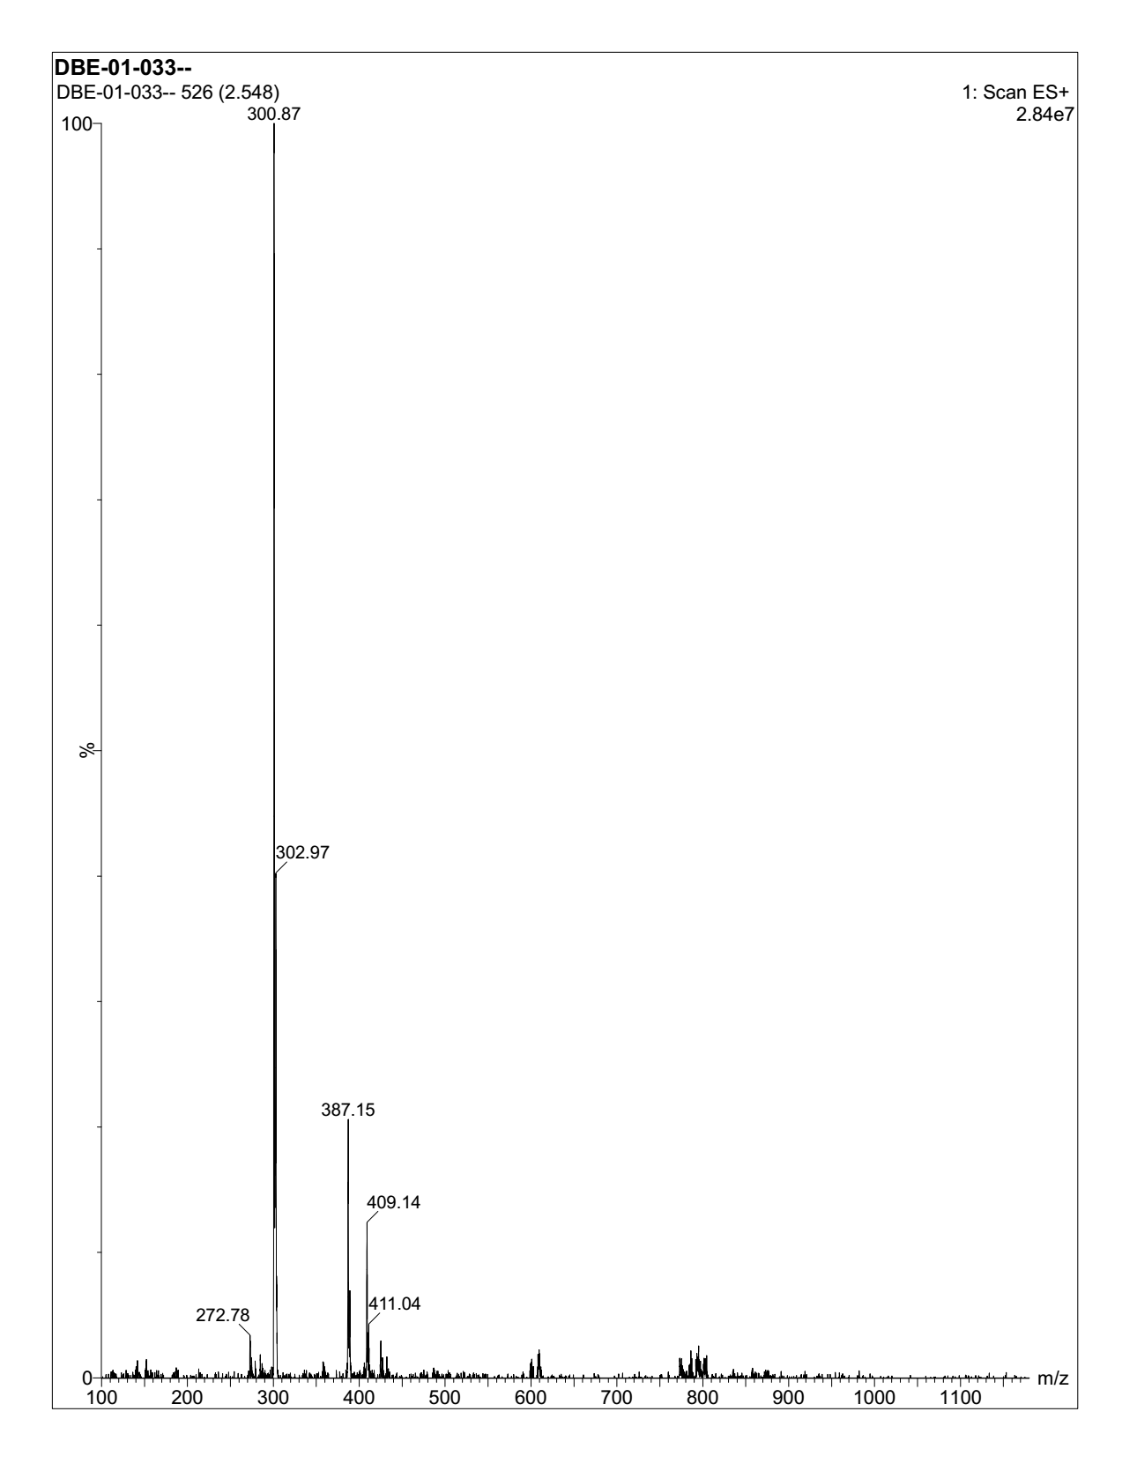
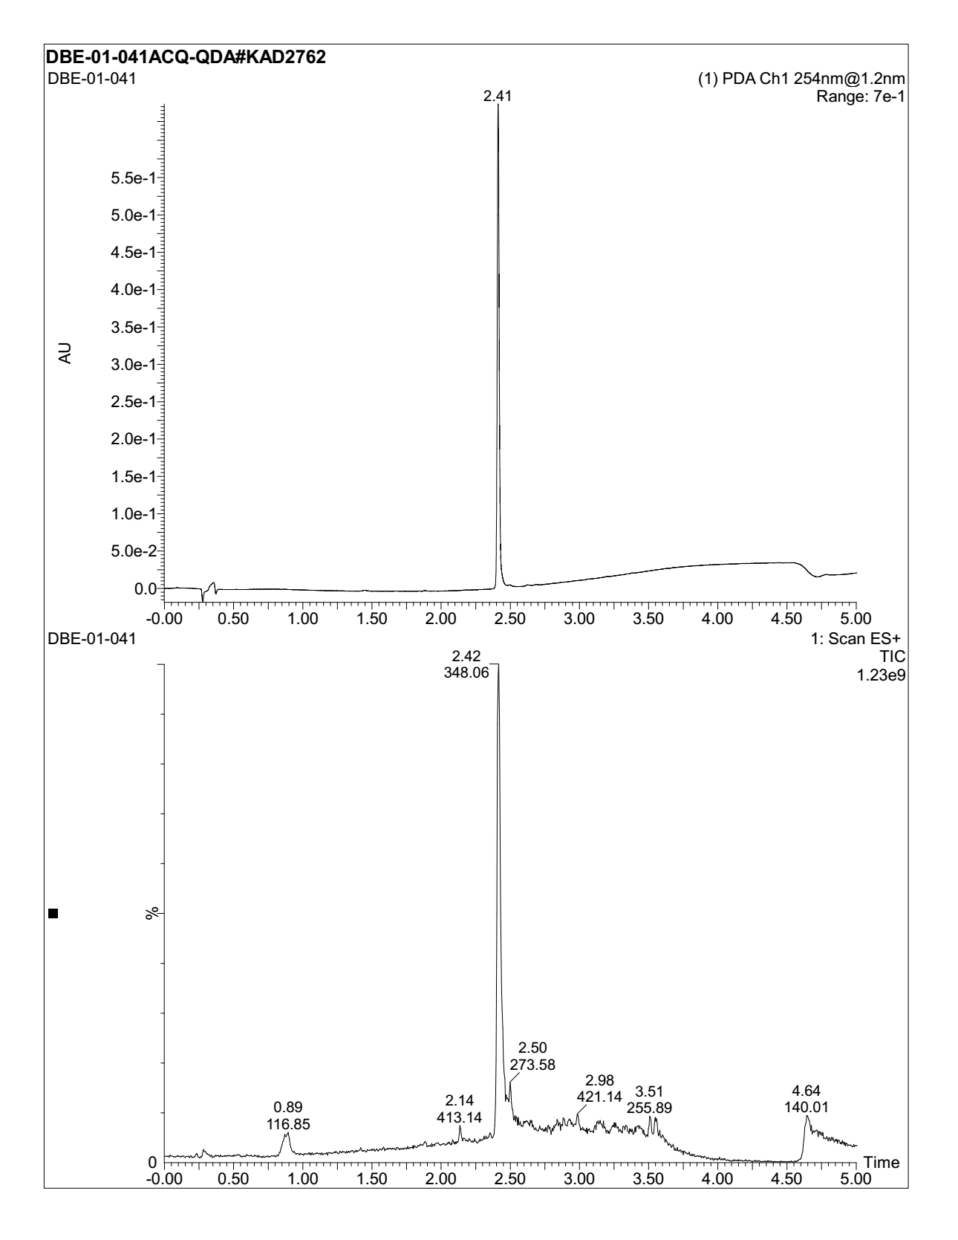
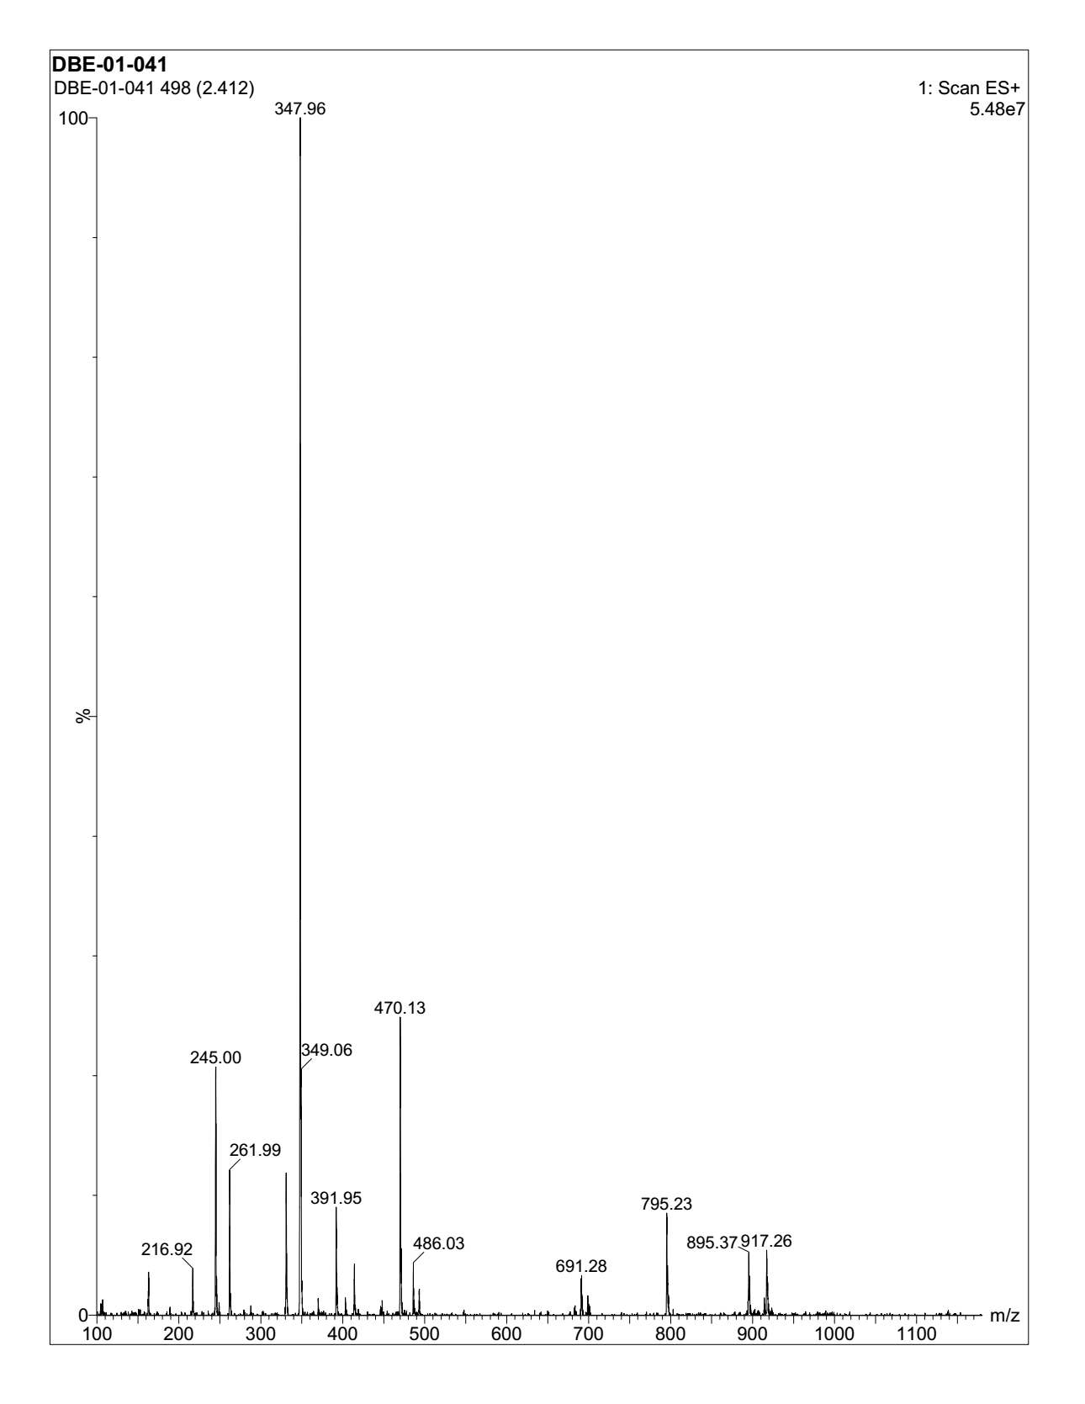
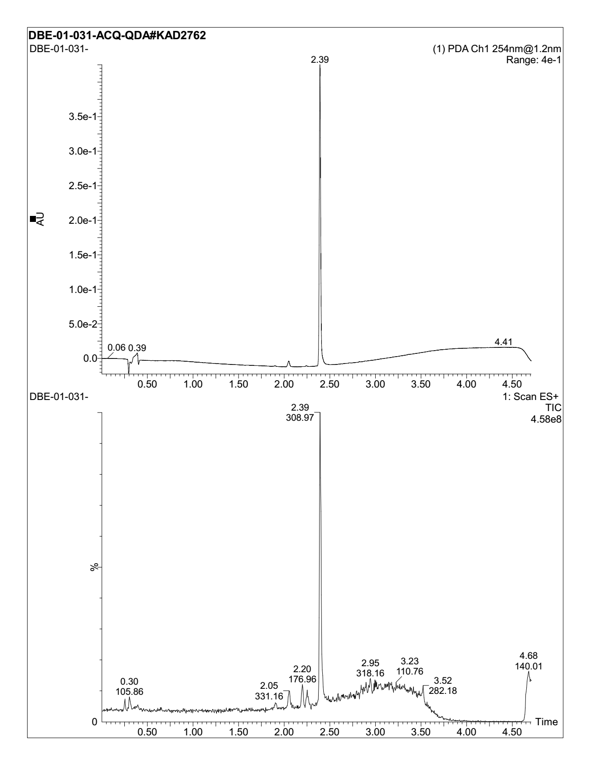
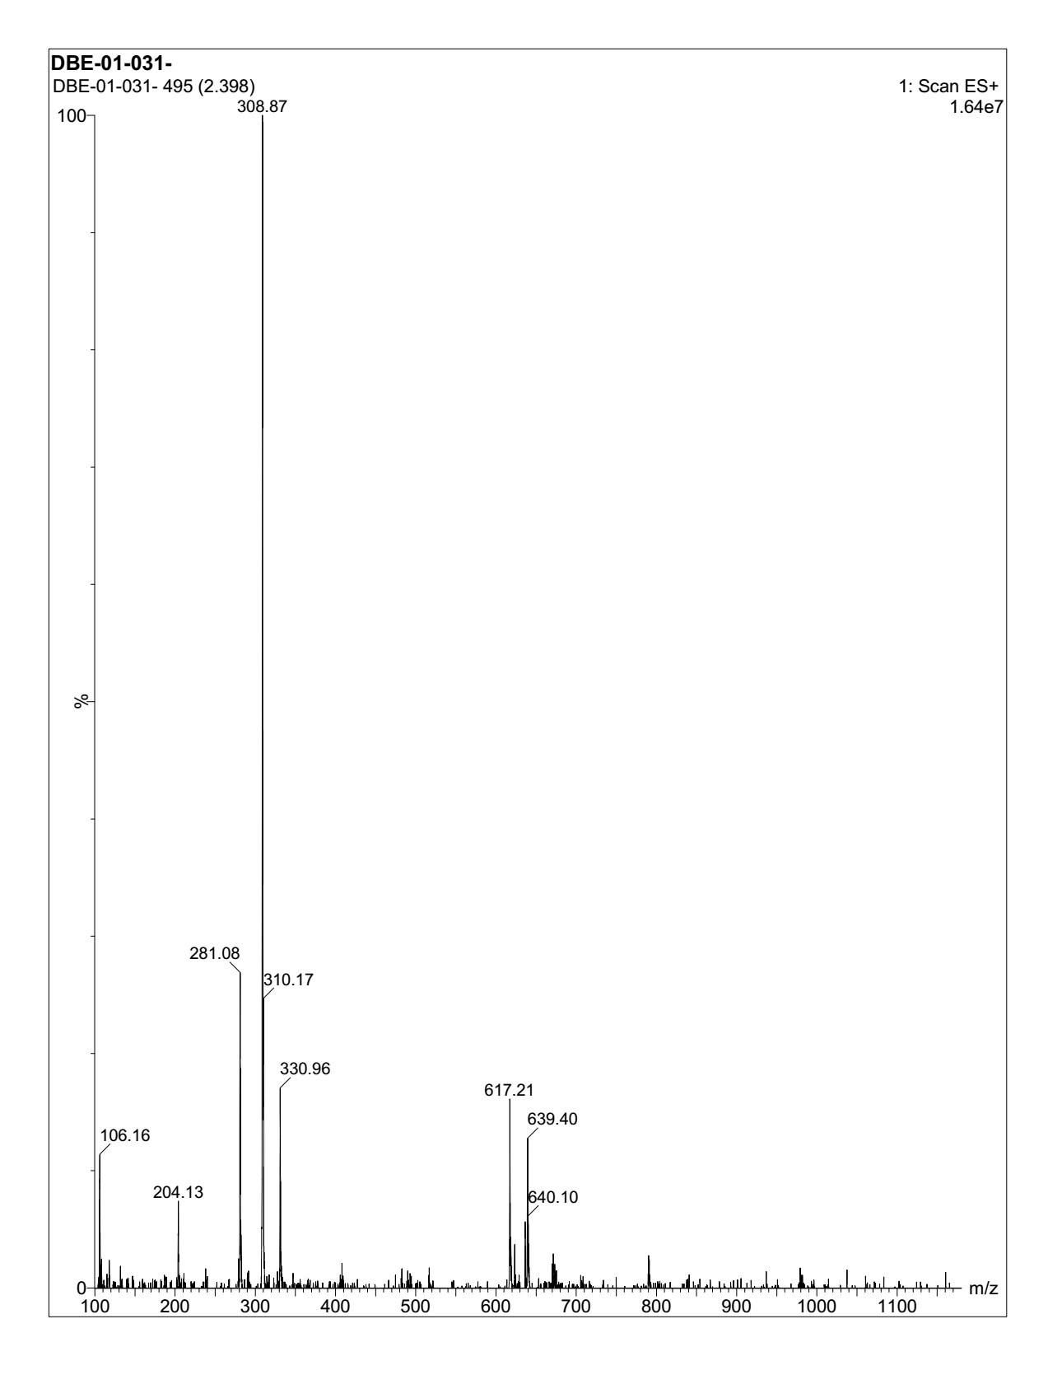
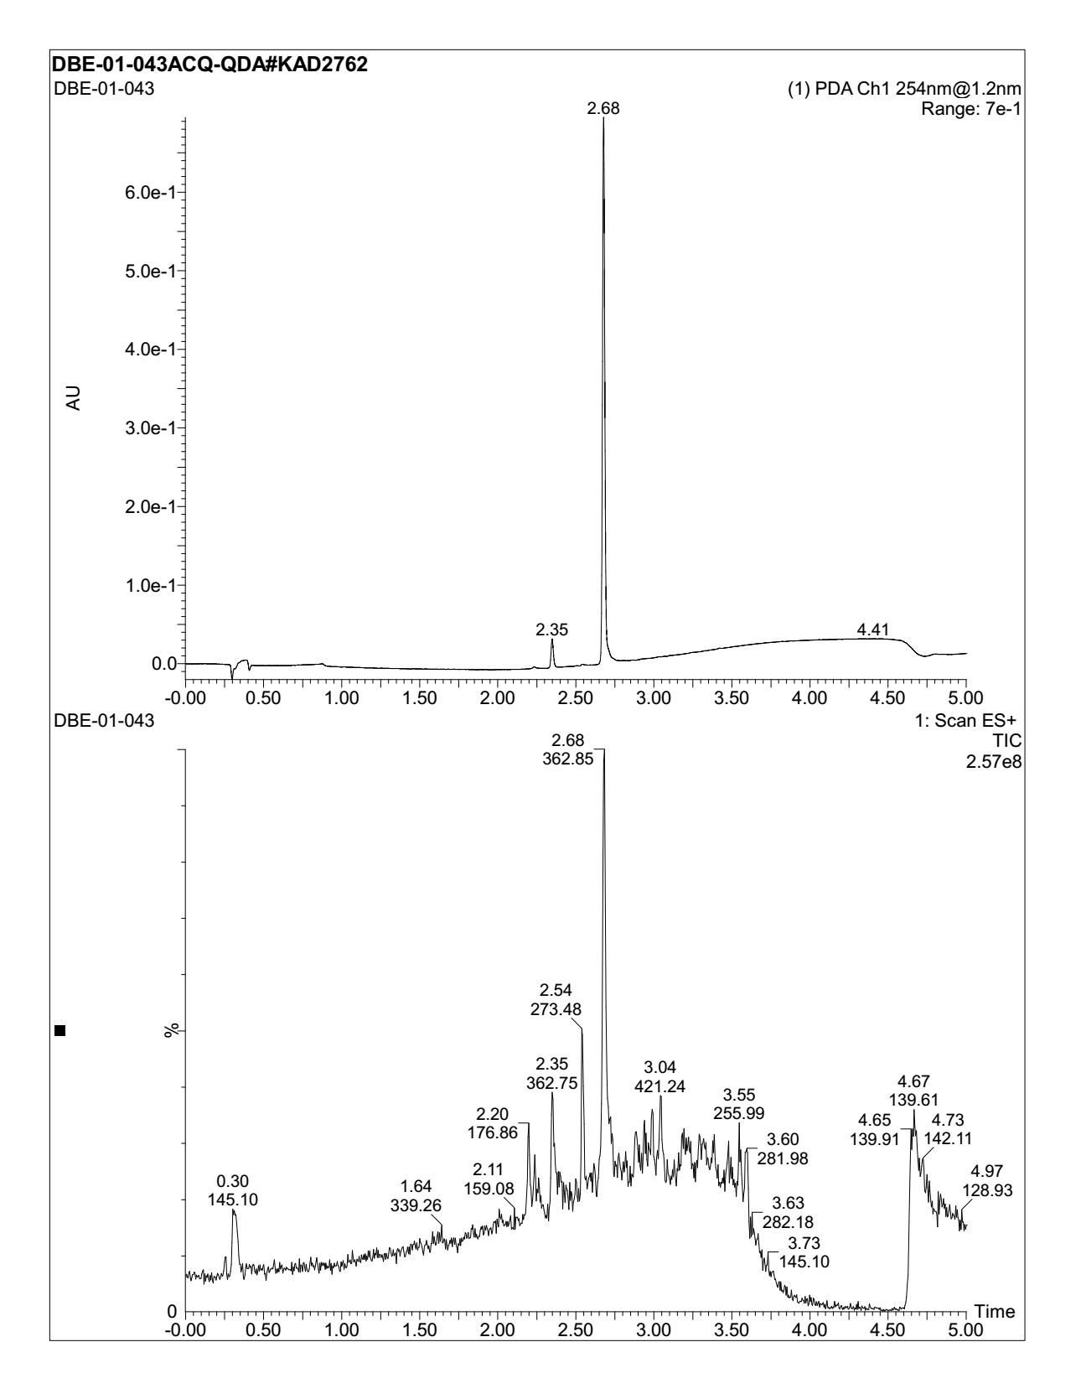
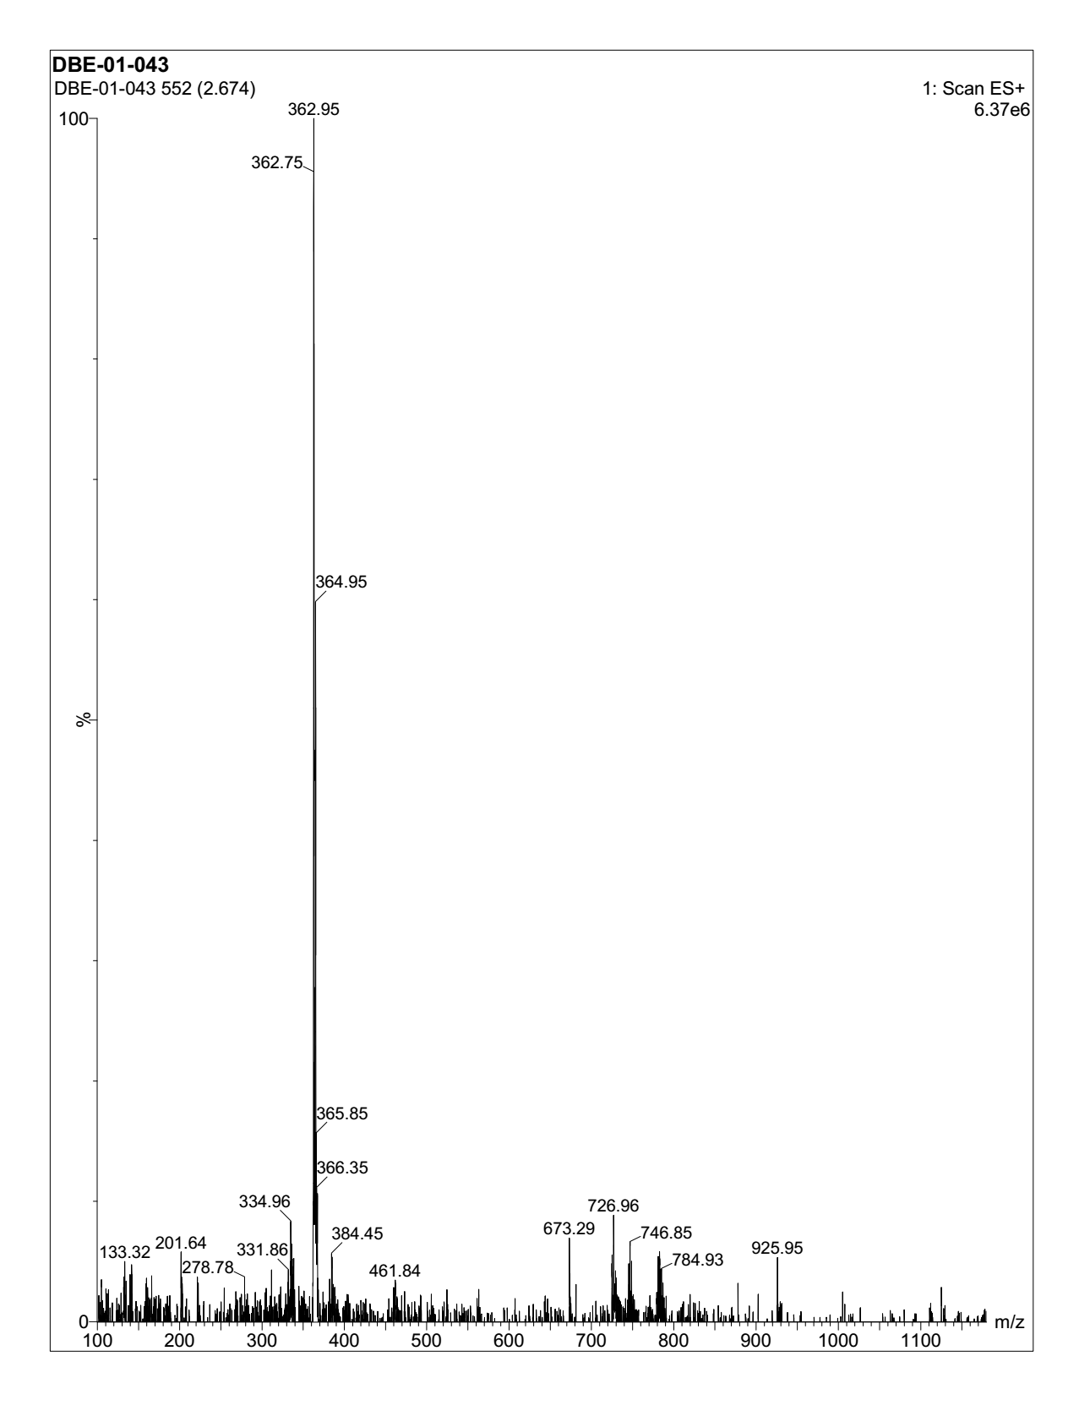
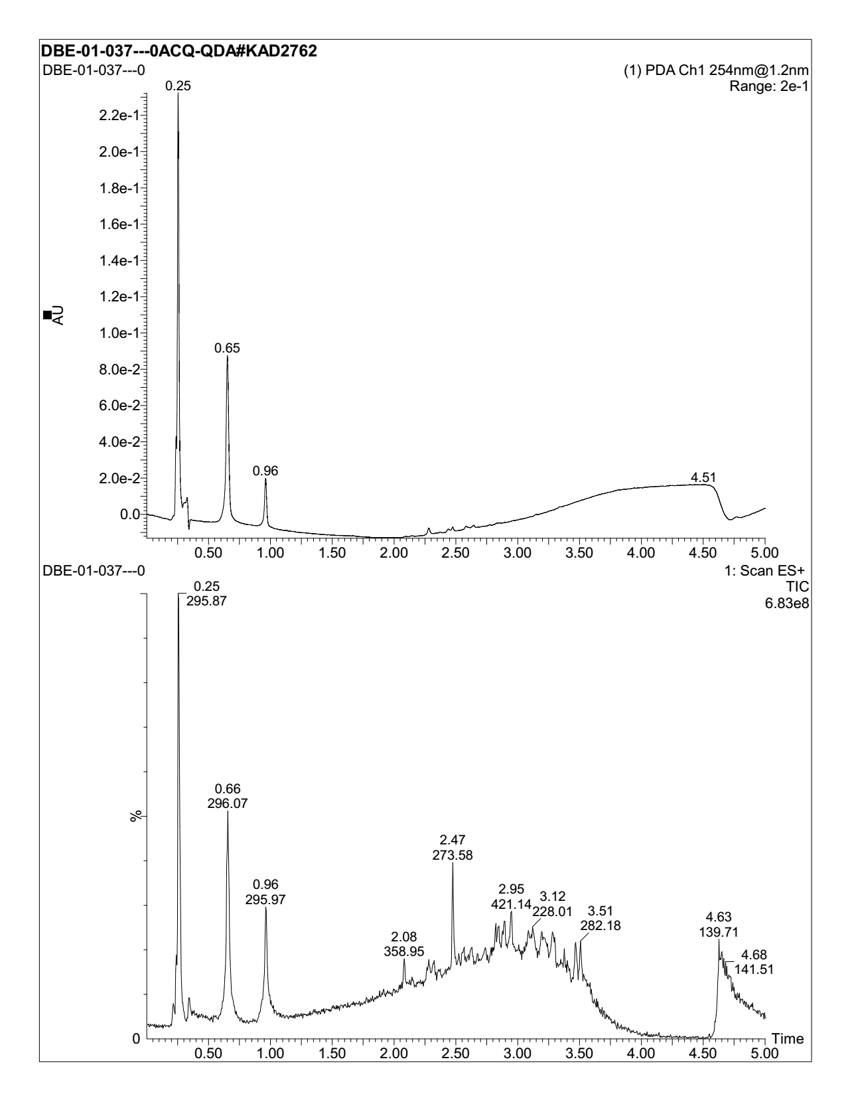
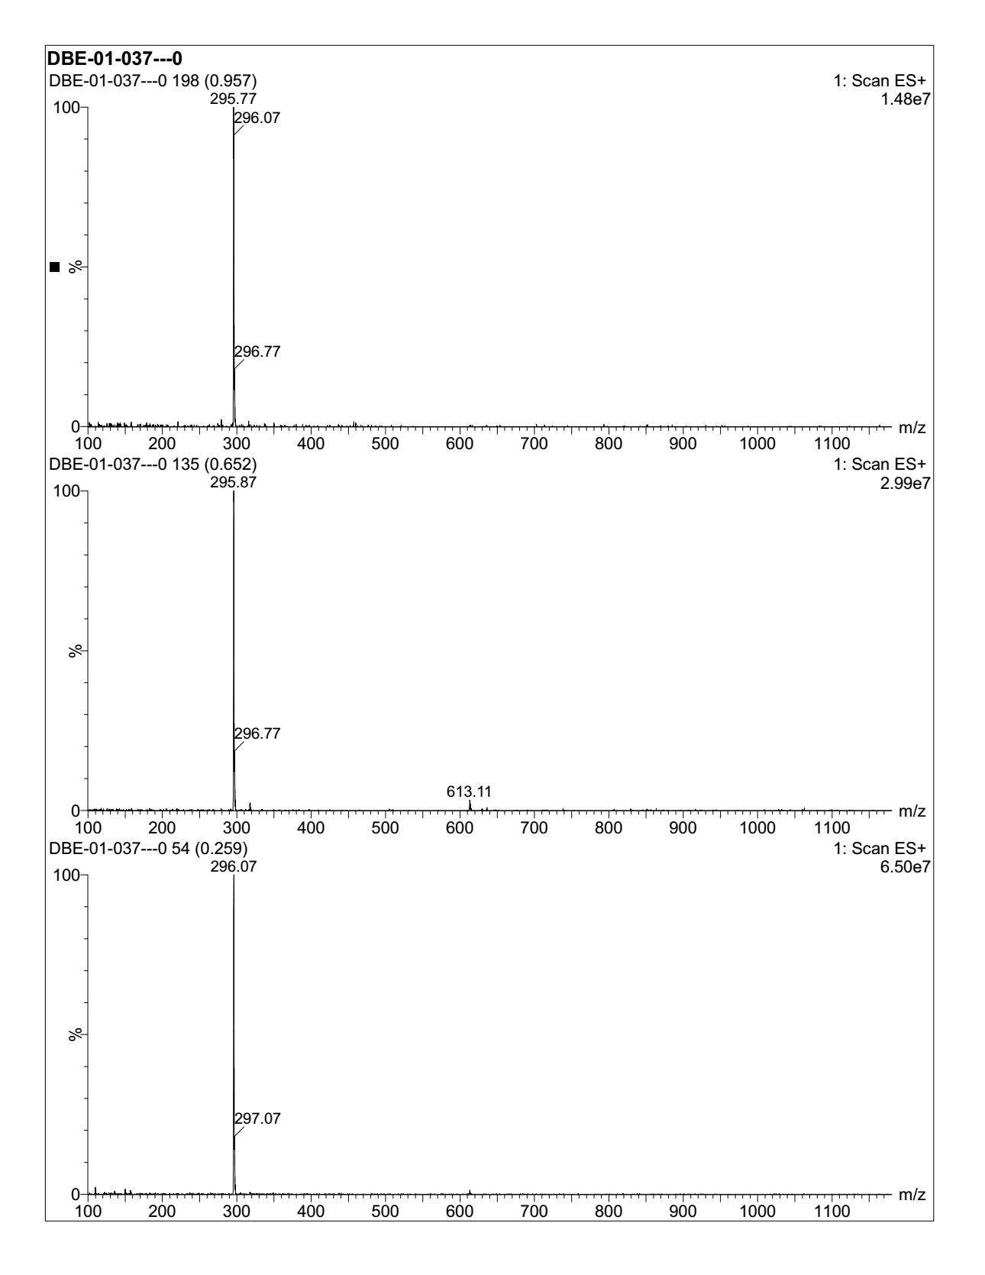
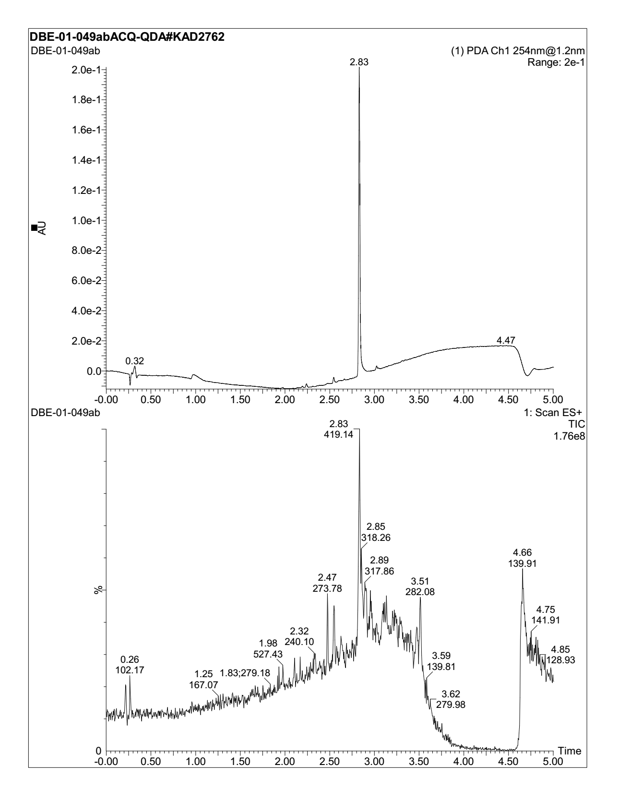
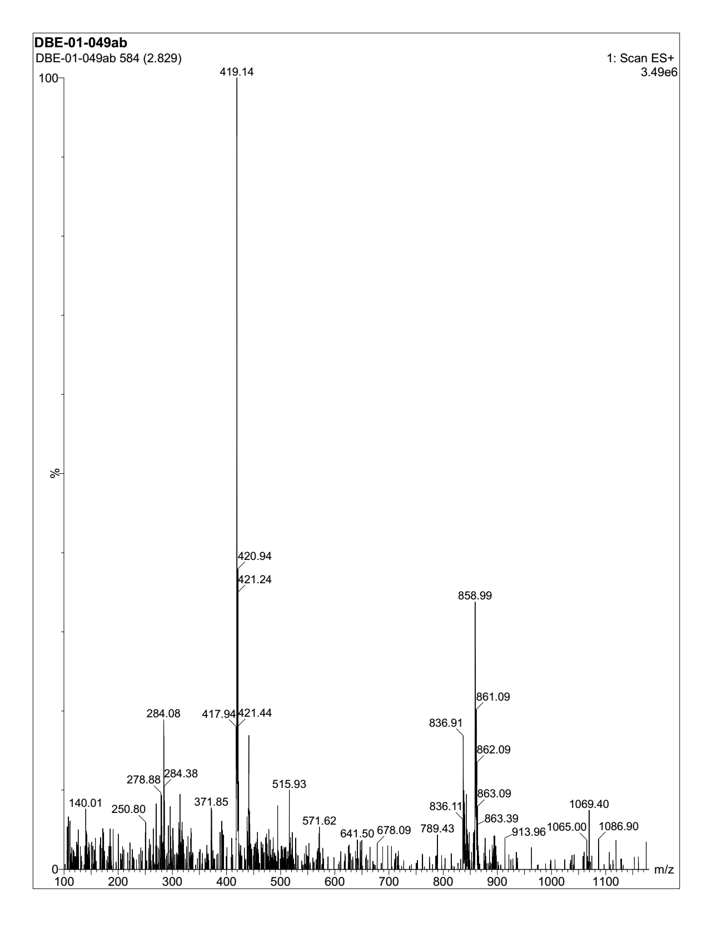
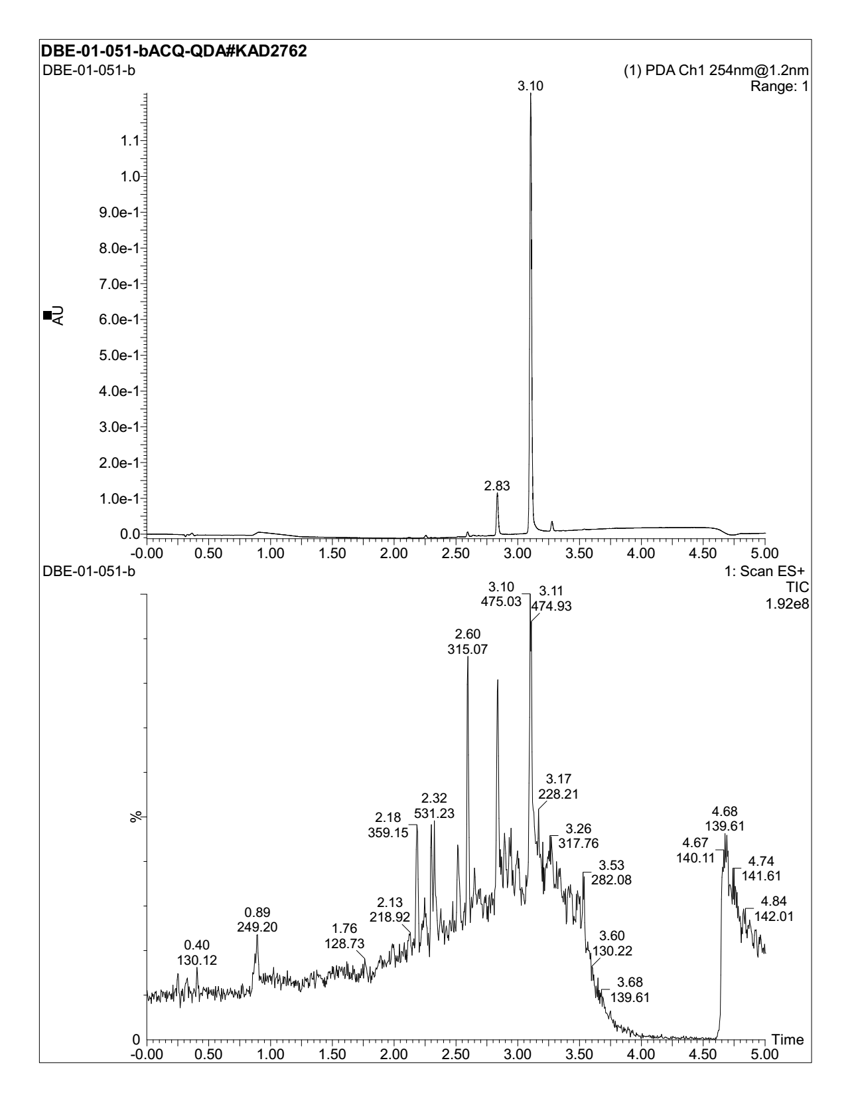
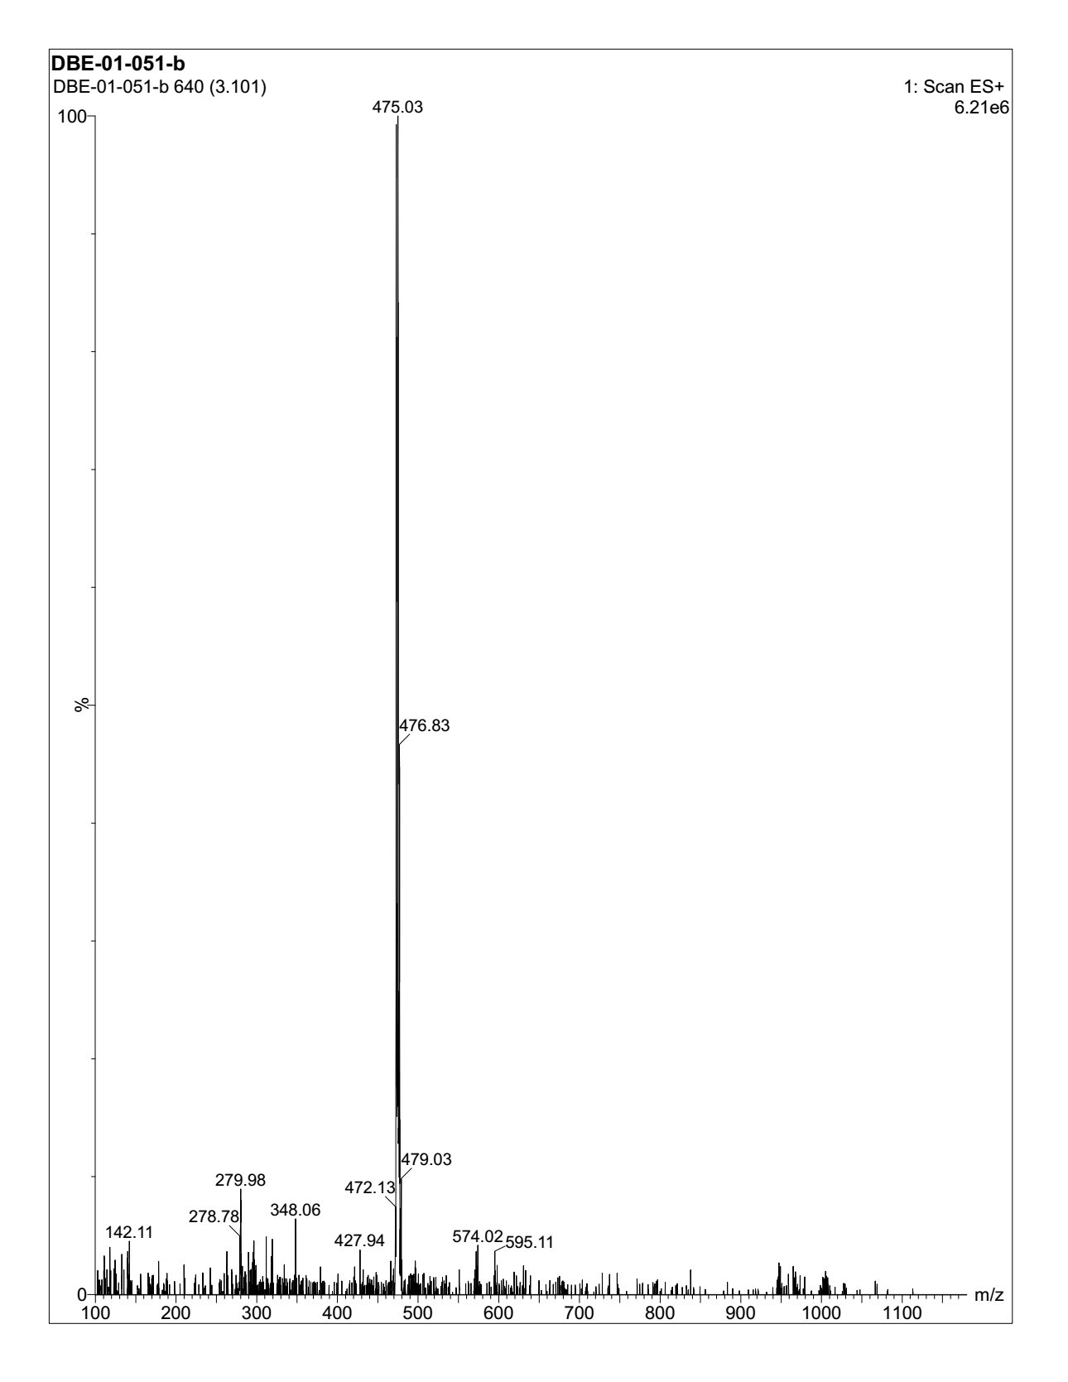
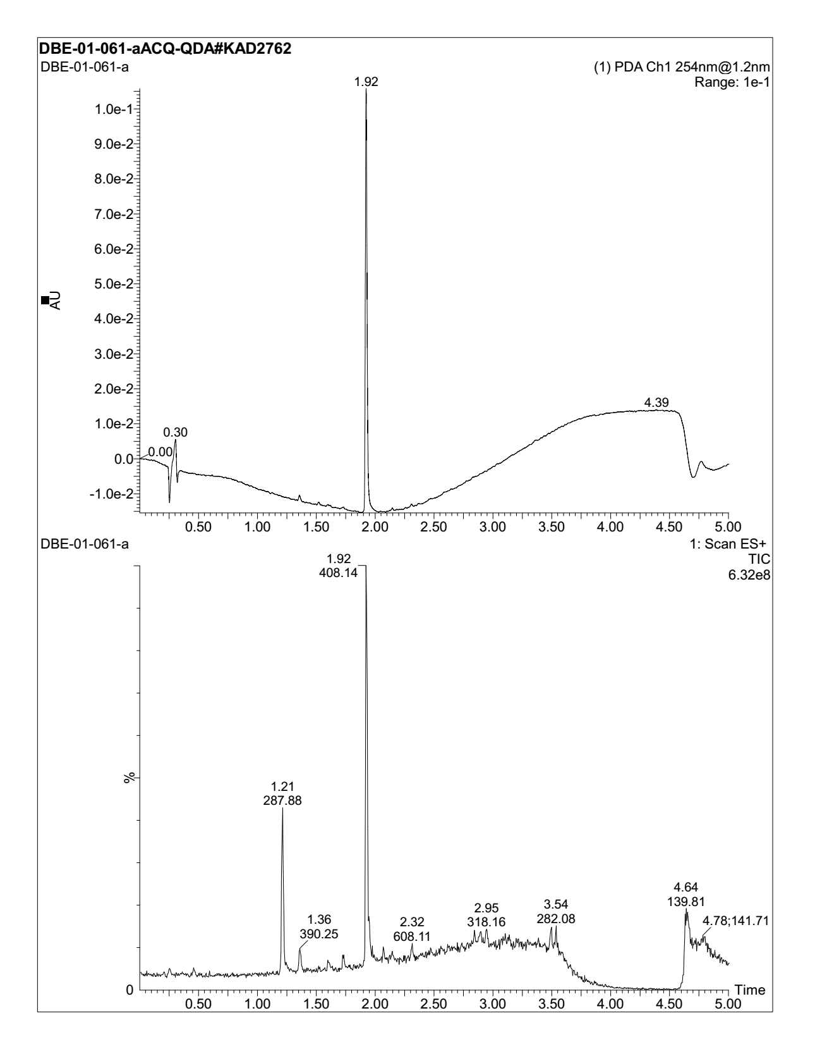
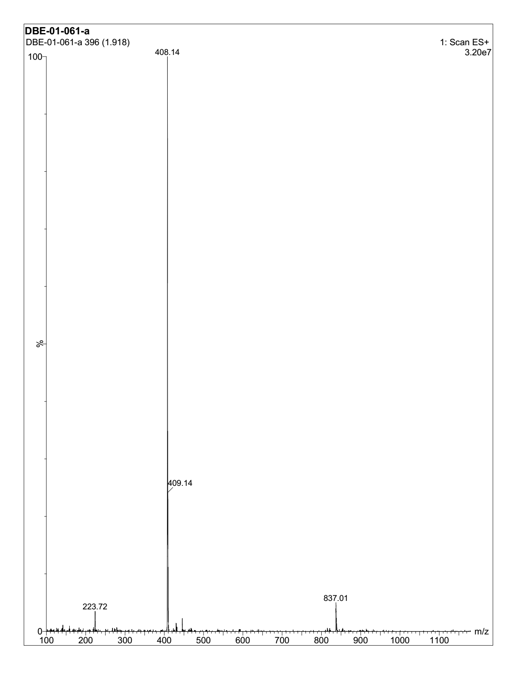
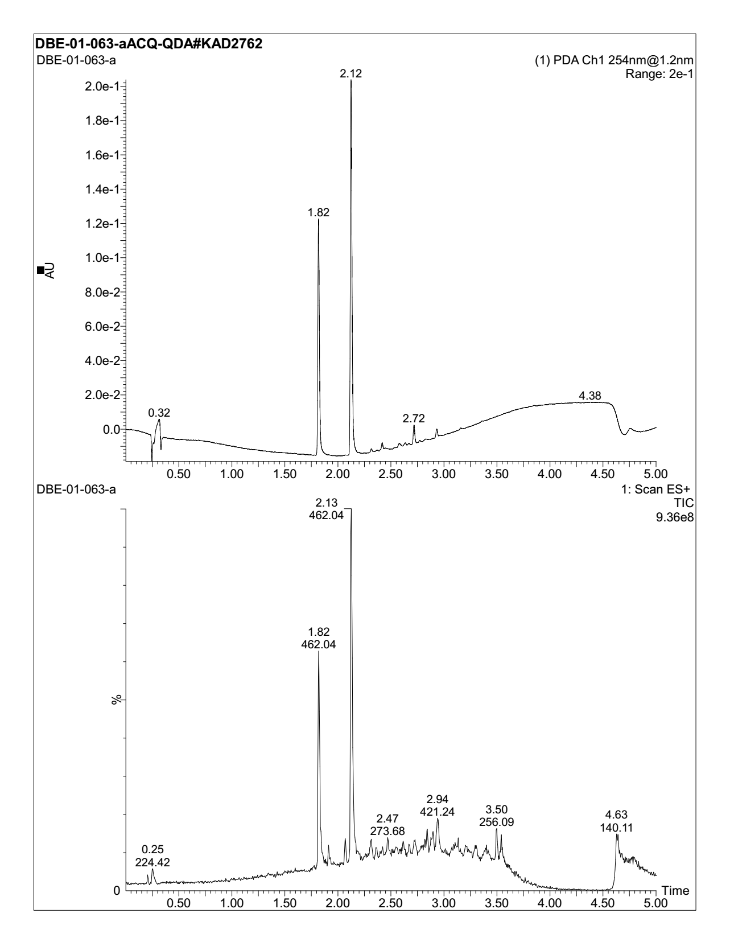
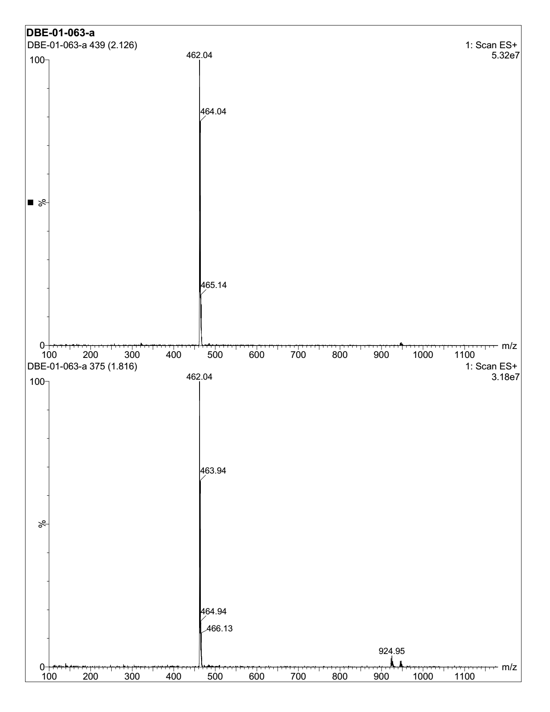
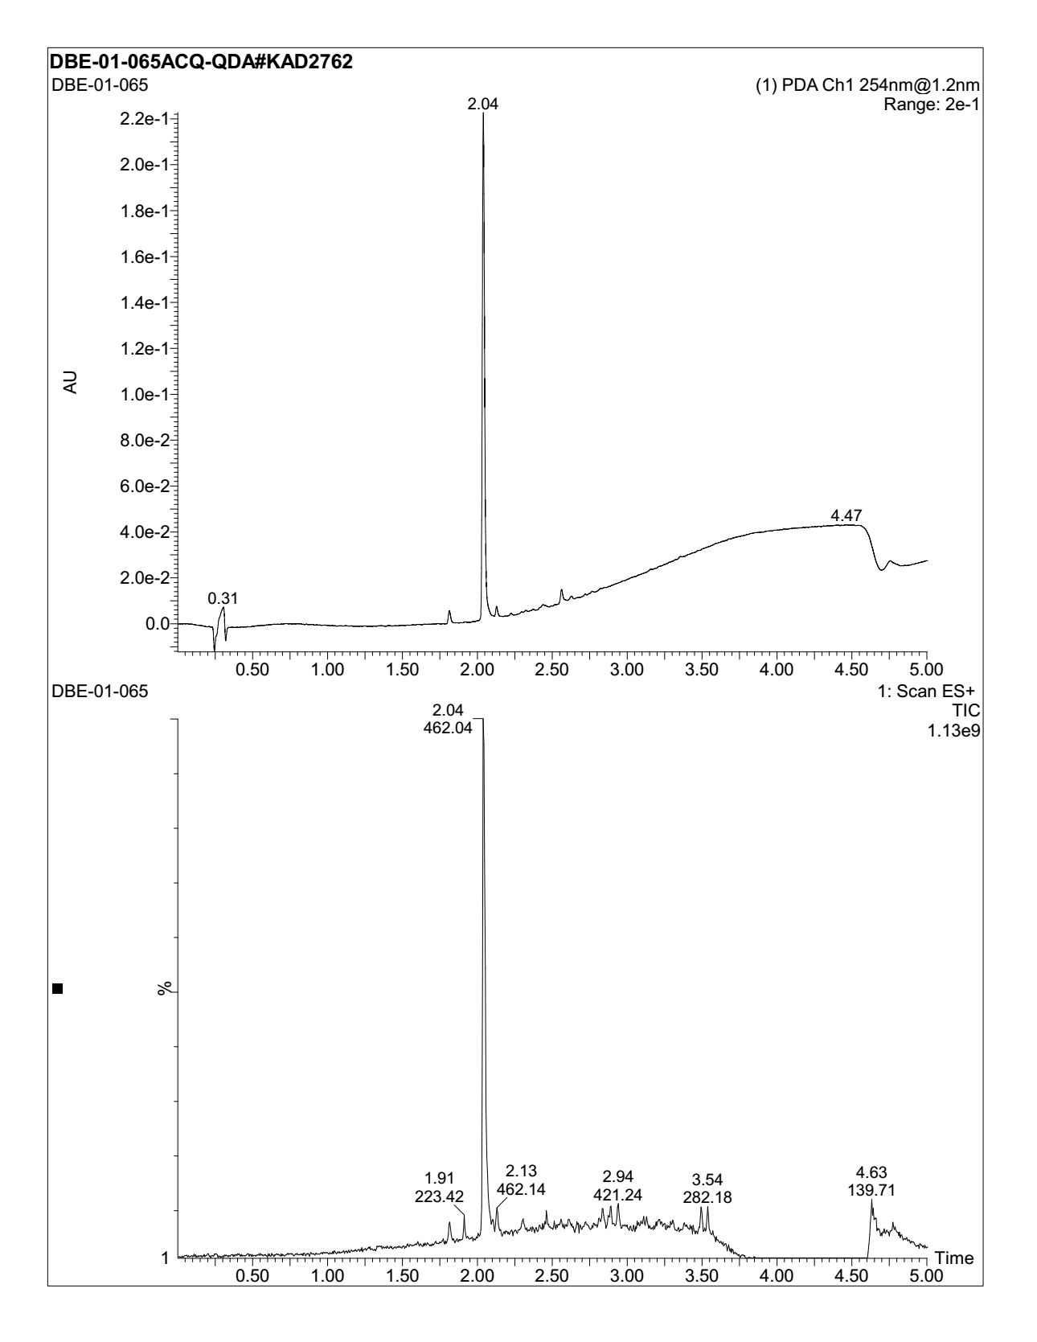
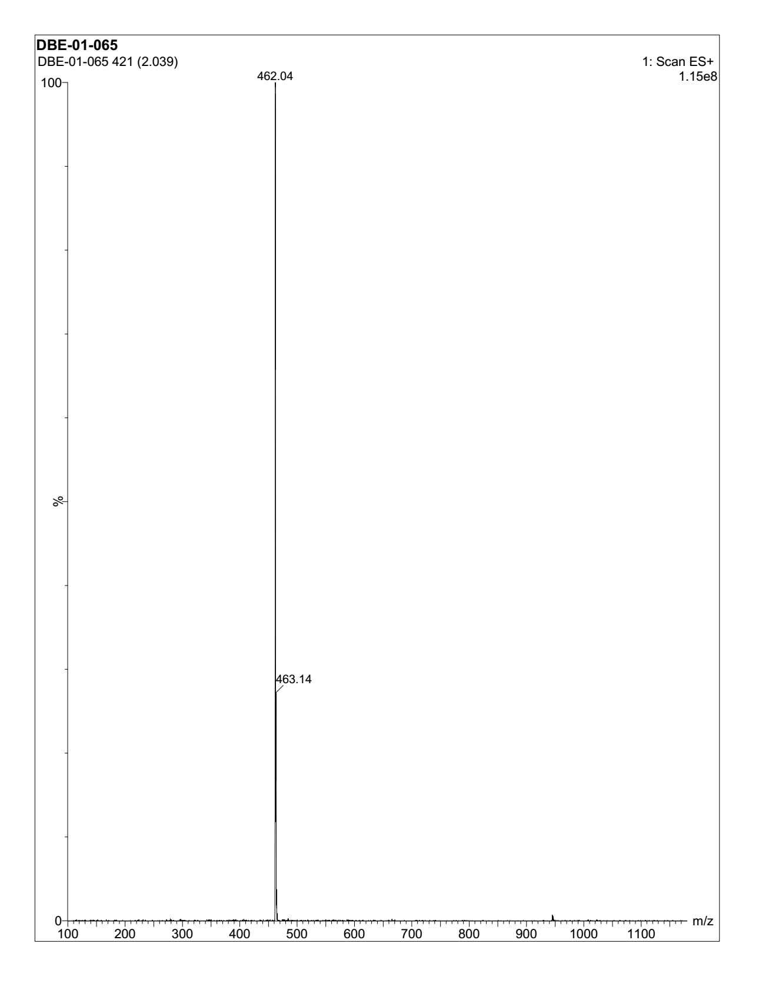
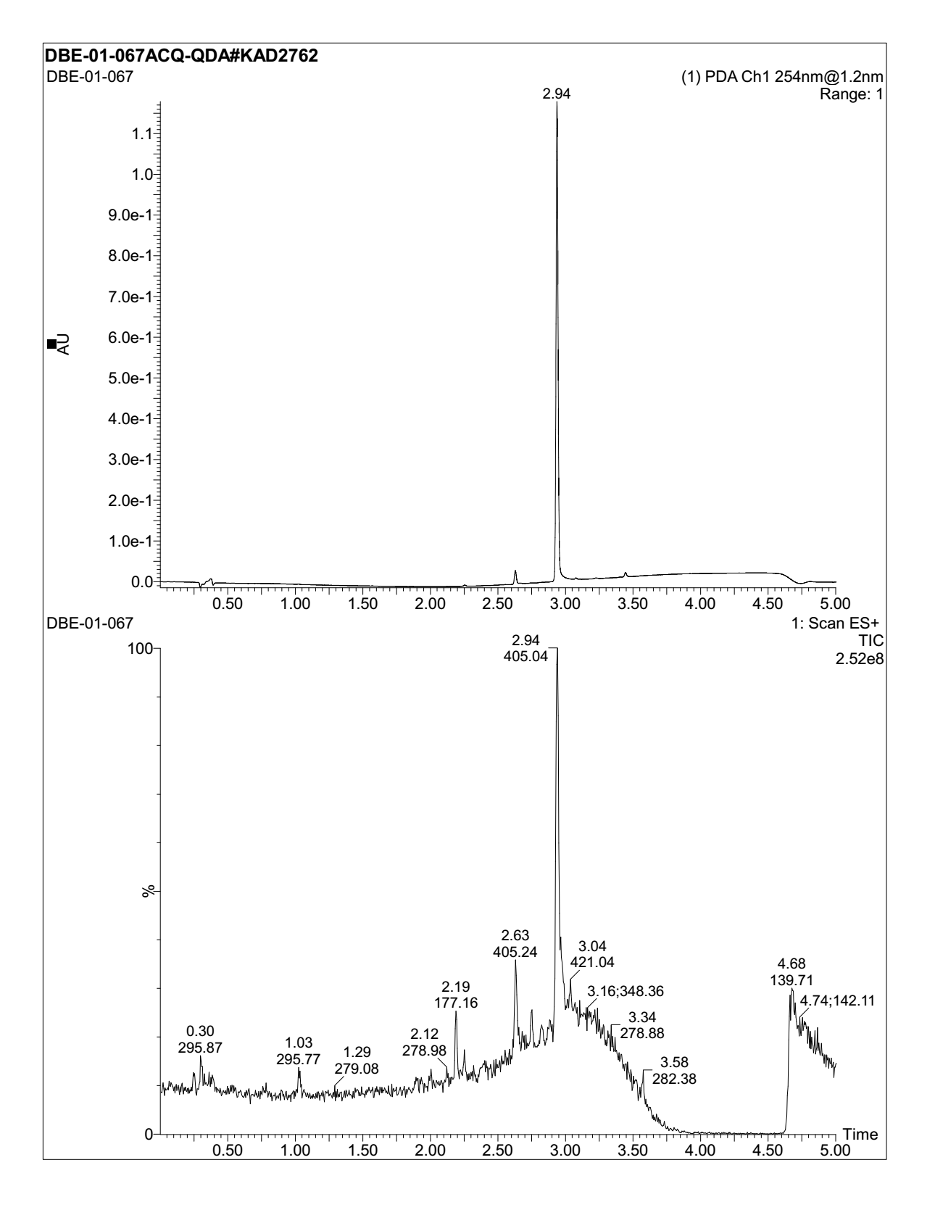
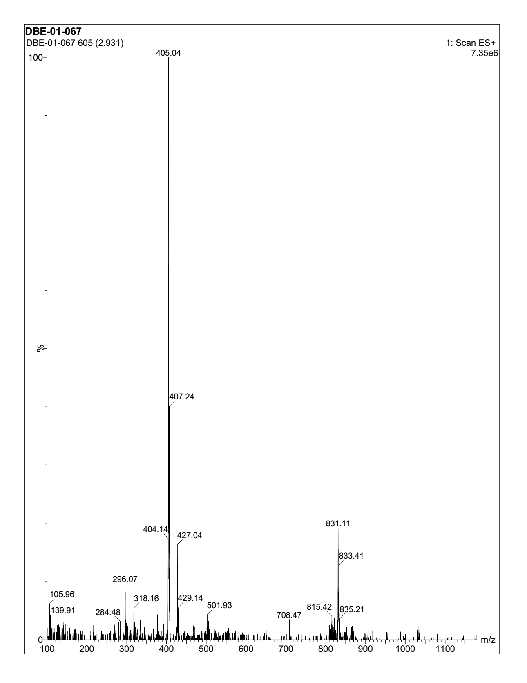
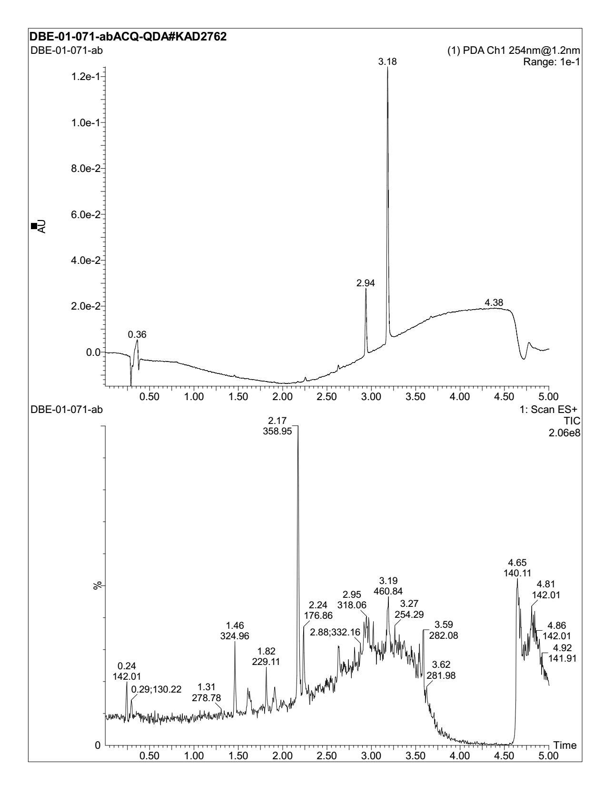
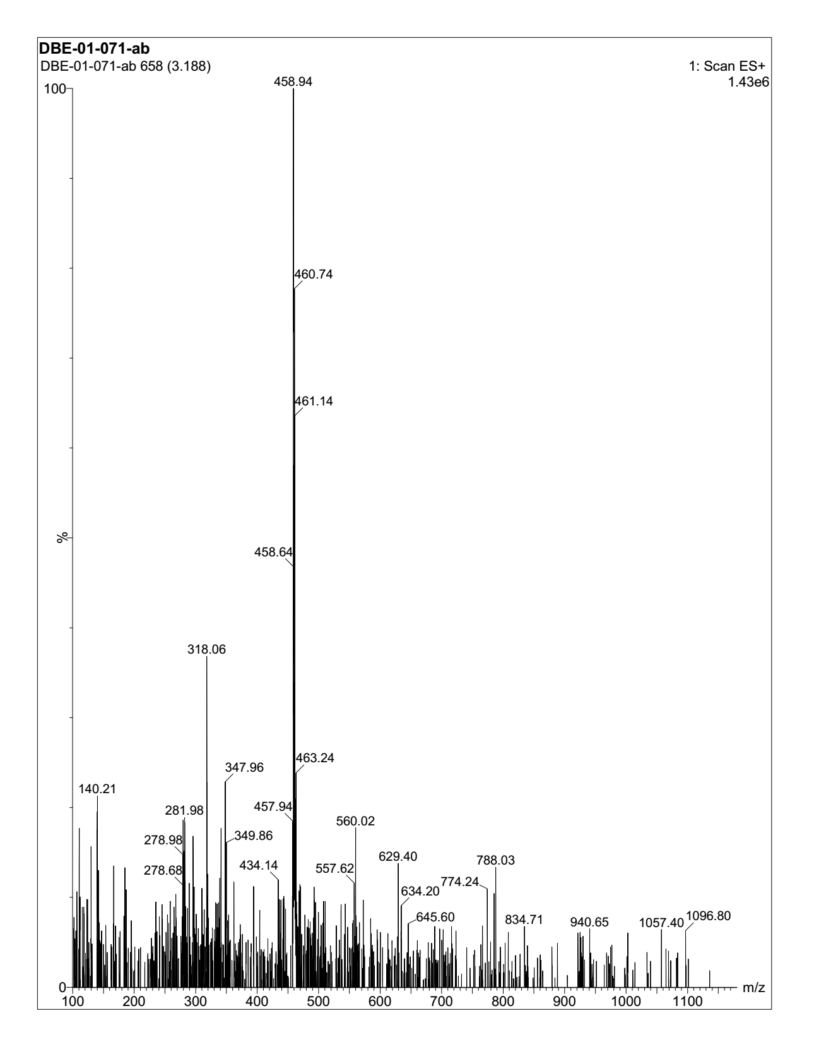
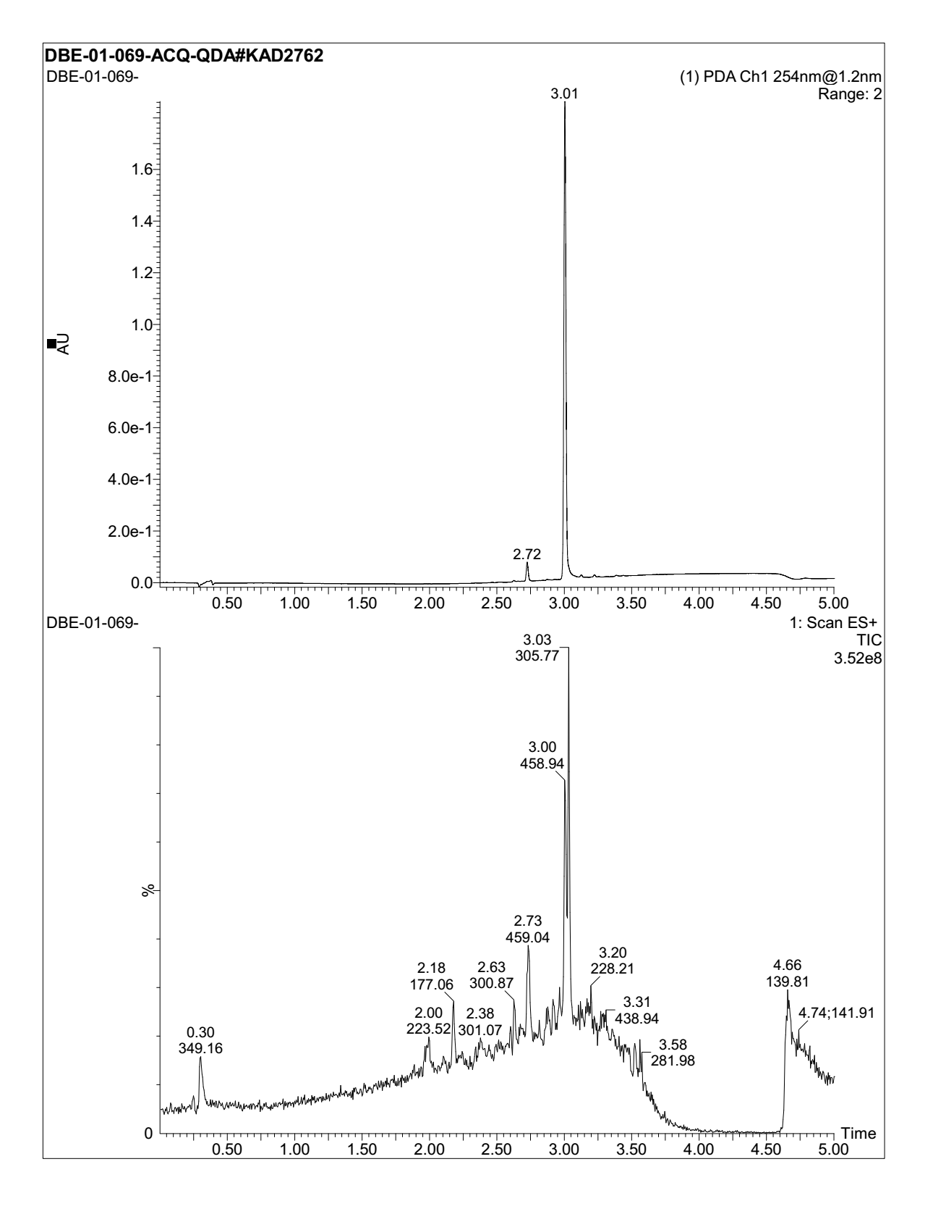
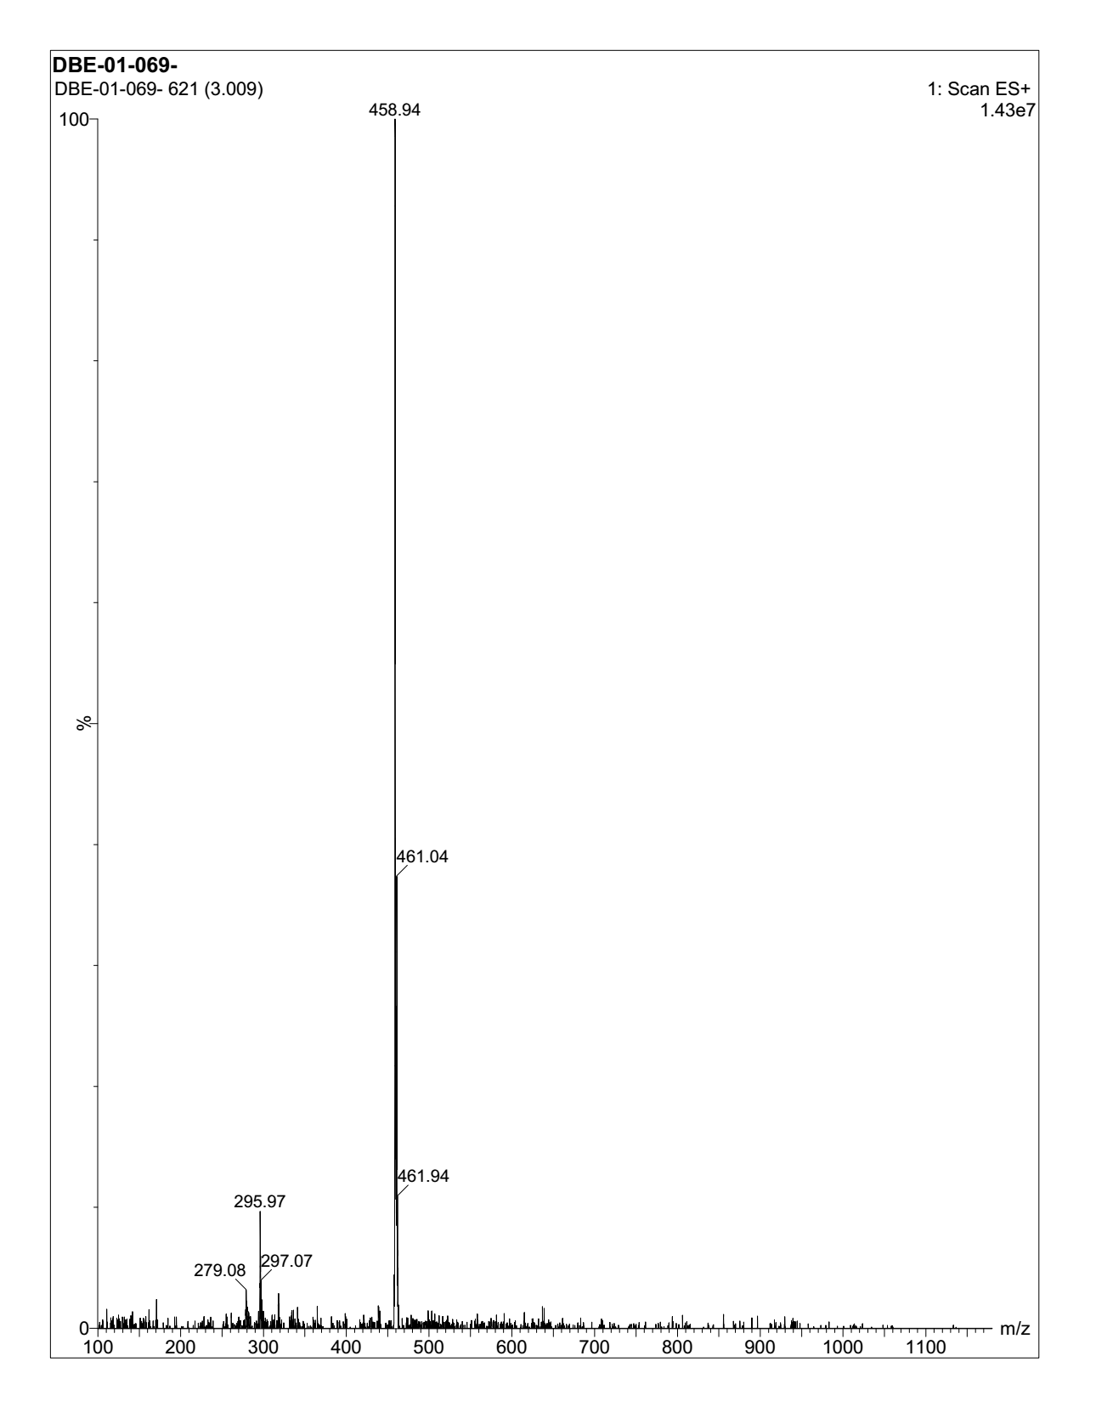
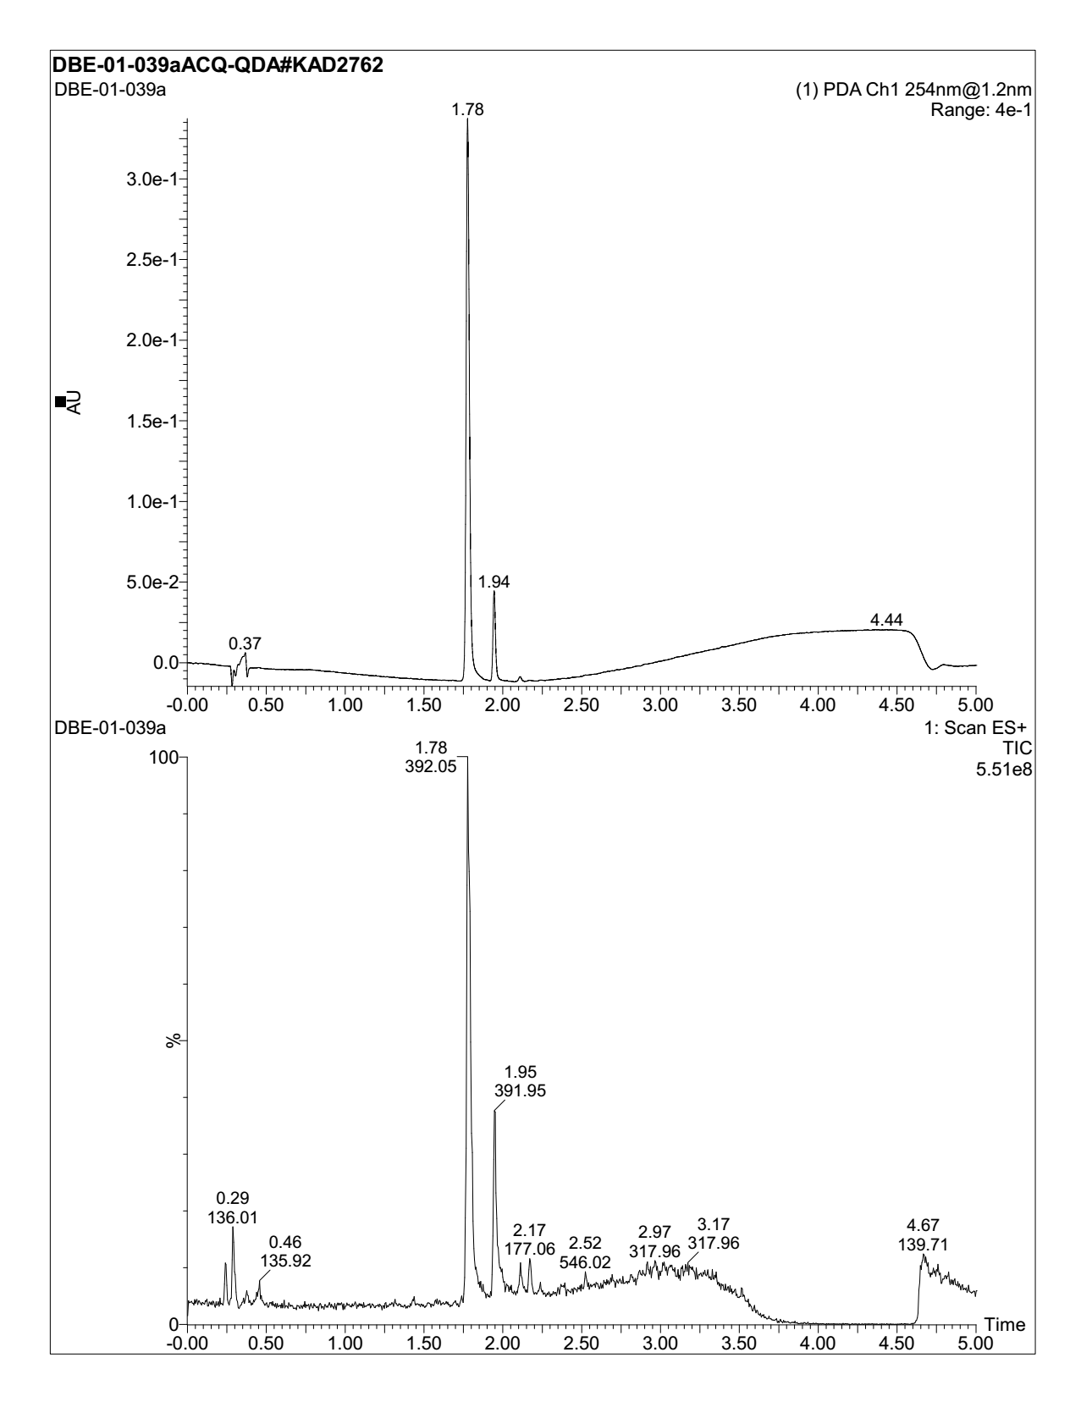

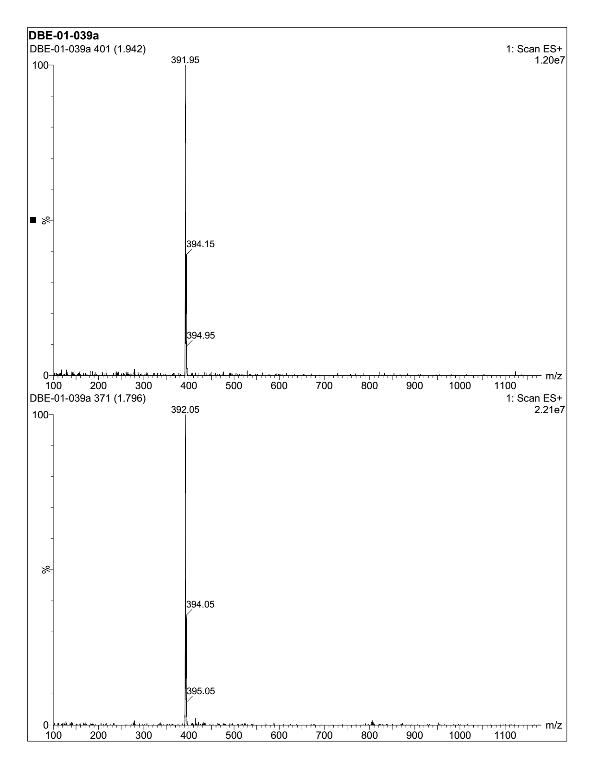

PROTON-NMR
