Luminescent Au-Ag nanoclusters entrapped in protein matrix: Conditions of sample maturing influencing Au-Ag synergistic effect
Veronika Svačinová¹, Tomáš Pluháček², Martin Petr³, Karolína Šišková¹*

¹ Dept. of Experimental Physics, Faculty of Science, Palacký University Olomouc, Czech
Republic, veronika.svacinova02@upol.cz, karolina.siskova@upol.cz
² Dept. of Analytical Chemistry, Faculty of Science, Palacký University Olomouc, Czech Republic, tomas.pluhacek@upol.cz
³ RCPTM, Catrin, Palacký University Olomouc, Czech Republic, martin.petr@upol.cz

*Corresponding author: Dept. of Experimental Physics, Faculty of Science, Palacký
University Olomouc, 17. Listopadu 12, 771 46 Olomouc, CZ, Central Europe, Phone:
+420 585 634 175; karolina.siskova@upol.cz; orcid no.: 0000-0003-1417-0919

Keywords: bimetallic nanocluster; gold-silver nanocluster; protein template; luminescent nanocomposite; fluorescent nanocomposite; gold-silver synergism.

Table SI-1
Sample | Theoretical |  | Experimental
Sample | Au | Ag | Au | Ag
Sample | c [mg/ml] | c [mg/ml] | c [mg/ml] | c [mg/ml]
GSNC 0min RT | 0.478 | 0.052 | 0.368 ± 0.004 | 0.040 ± 0.002
GSNC 2.5h RT | 0.478 | 0.052 | 0.381 ± 0.006 | 0.042 ± 0.001
GSNC 2.5h 50°C | 0.478 | 0.052 | 0.385 ± 0.001 | 0.040 ± 0.003
AuNCs 0min RT | 0.478 | - | 0.370 ± 0.007 | -
AuNCs 2.5h RT | 0.478 | - | 0.378 ± 0.013 | -
AuNCs 2.5h 50°C | 0.478 | - | 0.380 ± 0.014 | -

Table SI-2
Sample | Theoretical | Experimental
GSNC 0min RT | 5.00 : 1 | 5.07 : 1
GSNC 2.5h RT | 5.00 : 1 | 5.02 : 1
GSNC 2.5h 50°C | 5.00 : 1 | 5.24 : 1

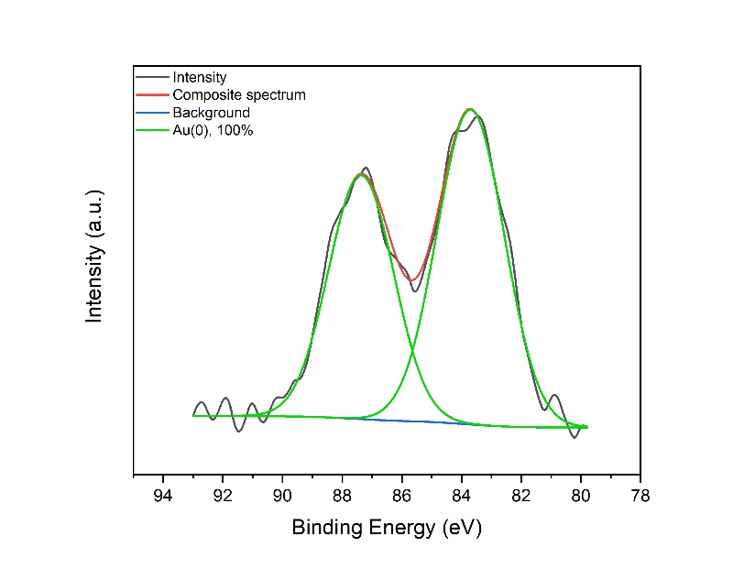A
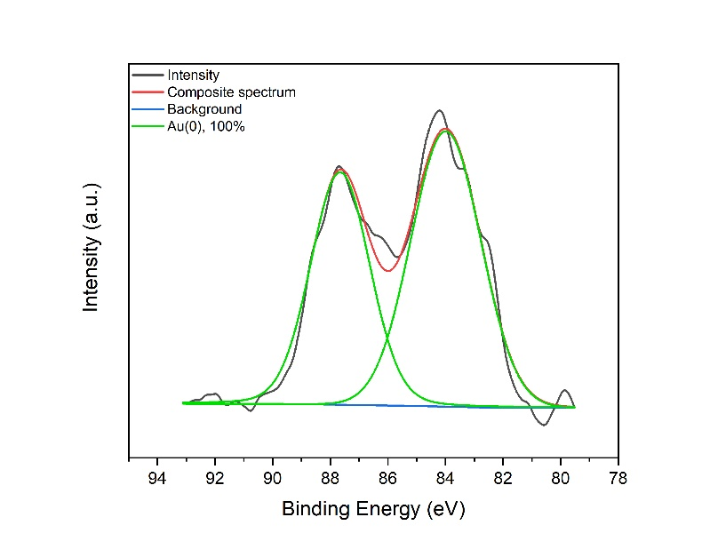B
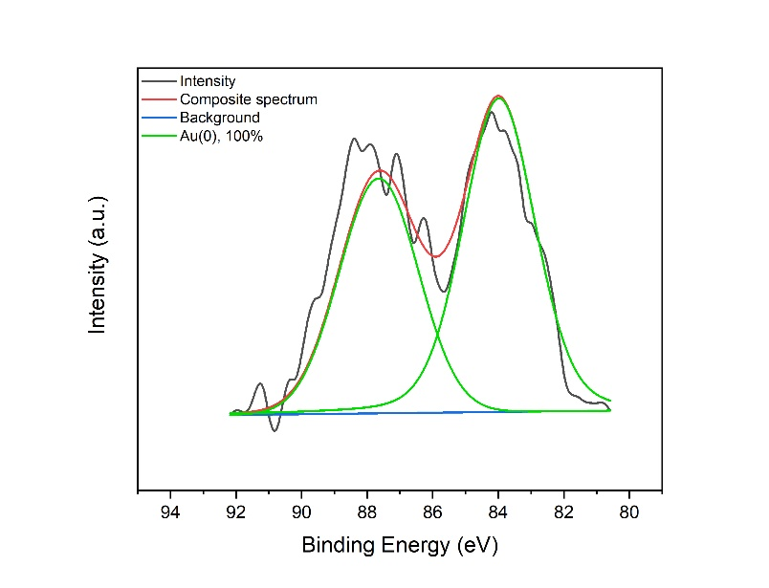C
Figure SI-1: XPS of AuNCs samples matured under different conditions: (A) 0 min RT, (B) 2.5h RT, (C) 2.5h 50°C.
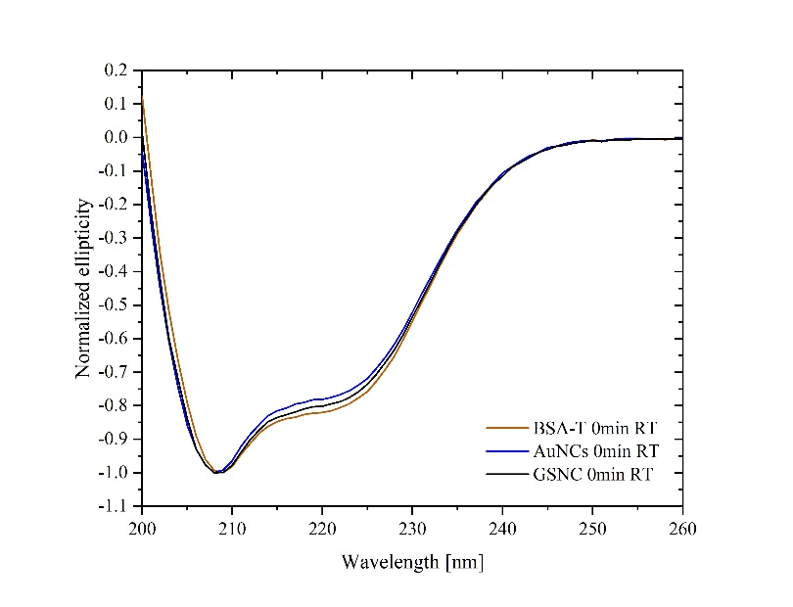A
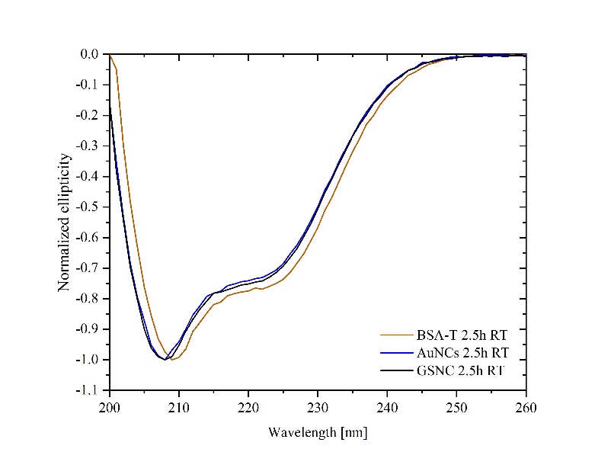B
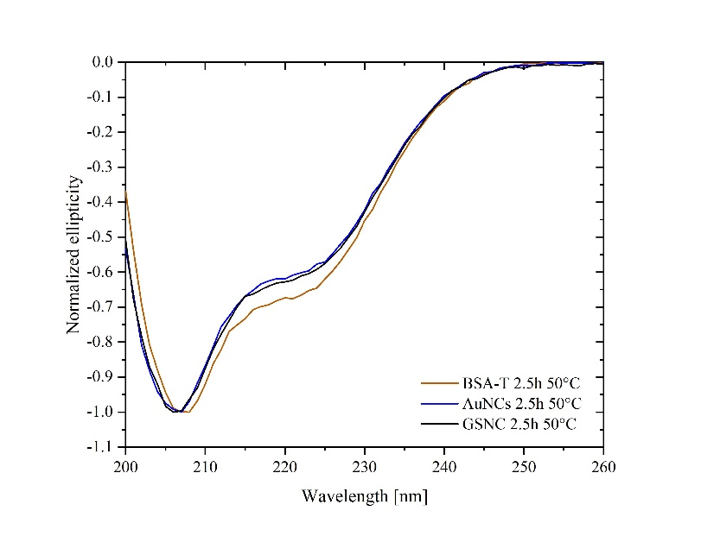C
Figure SI-2: CD spectra of non-, mono-, and bi-metallic samples under differing maturing conditions: (A) 0 min RT, (B) 2.5h RT, (C) 2.5h 50°C.
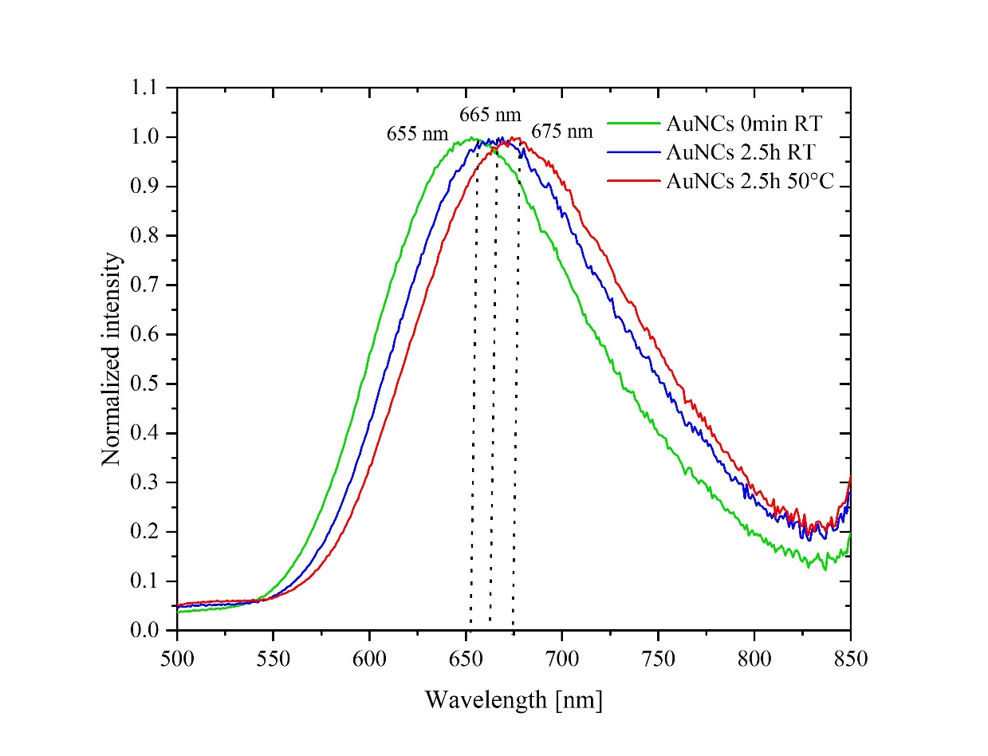
Figure SI-3 – Normalized fluorescence emission of AuNCs samples matured under different conditions: 0 min RT (green curve), 2.5h RT (blue curve), 2.5h 50°C (red curve). Excitation used 460 nm in all three cases.

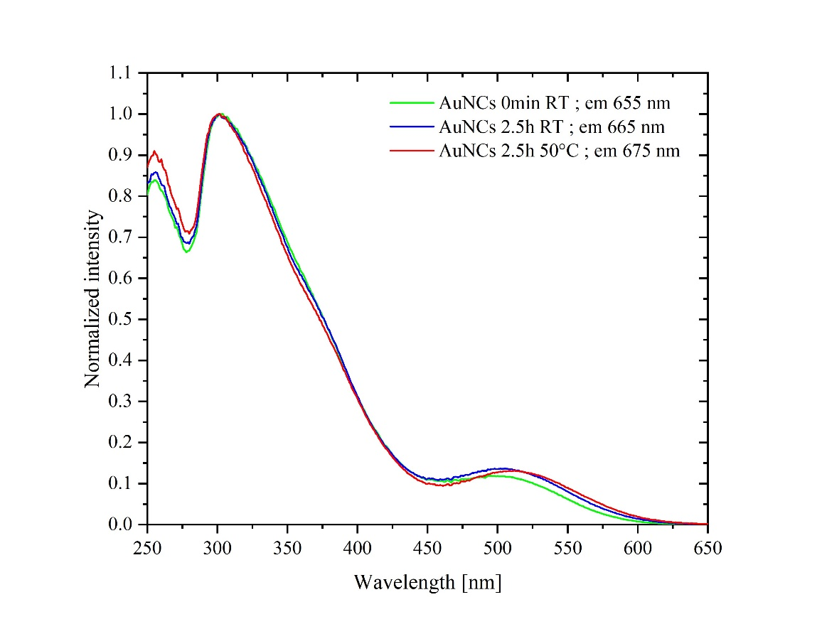A
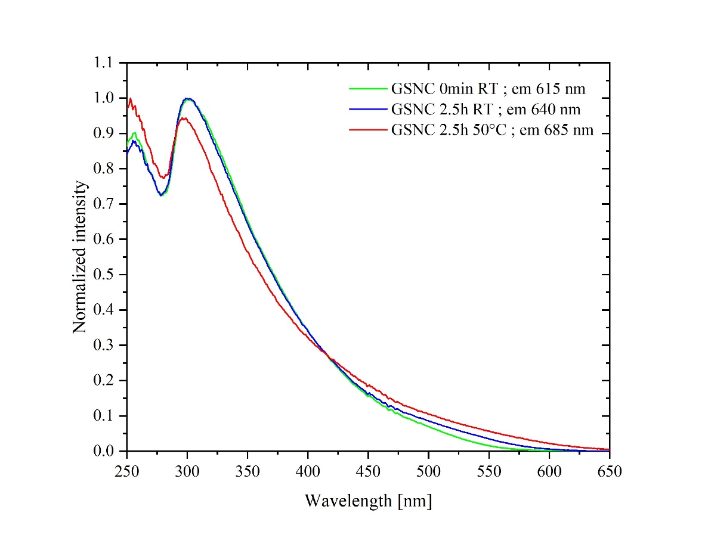B
Figure SI-4 – Normalized (with respect to the most intensive band within the particular spectrum) excitation spectra (recorded using appropriate emission maxima) of metallic samples (GSNC in A, AuNCs in B) matured under different conditions: 0 min RT (green curve), 2.5h RT (blue curve), 2.5h 50°C (red curve).

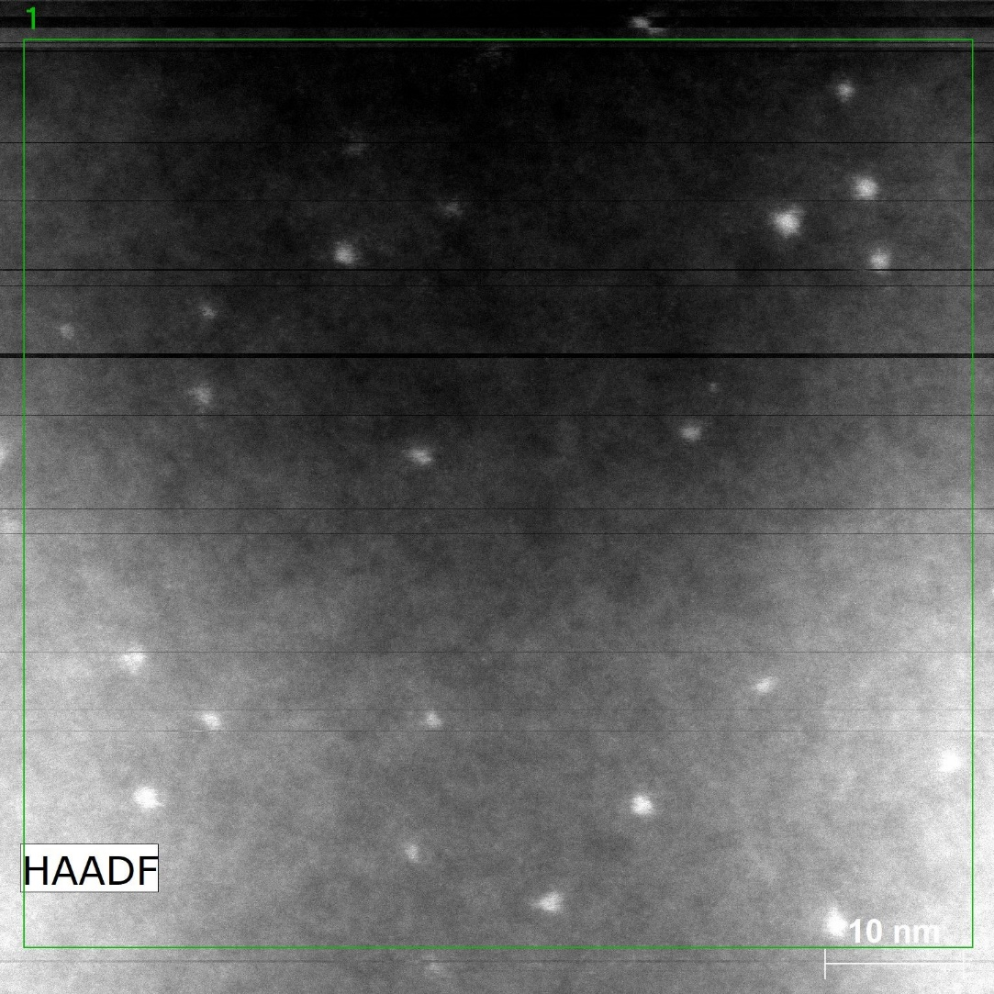
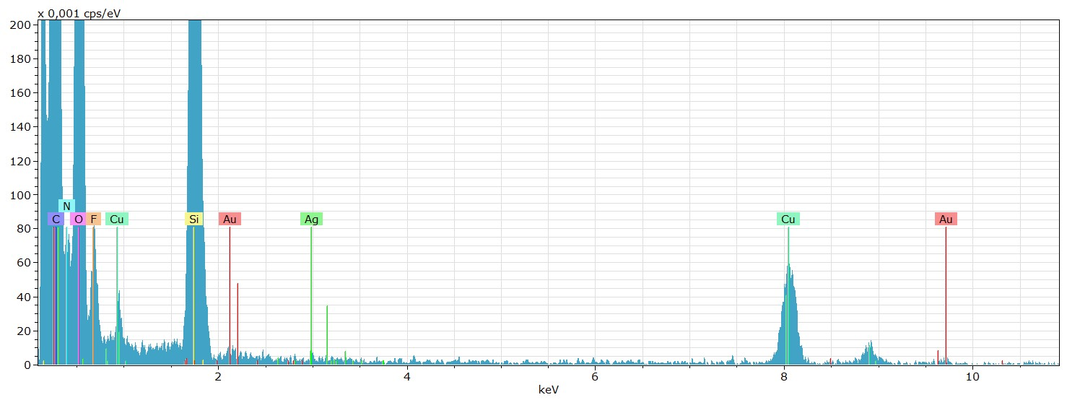
Figure SI-5 – Representative EDS spectra based on STEM measurements of a GSNC sample.

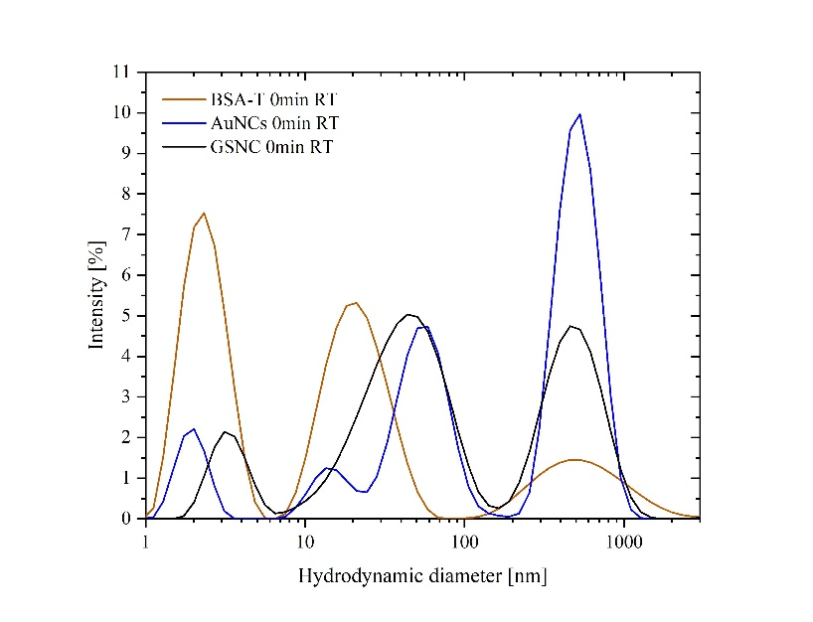A
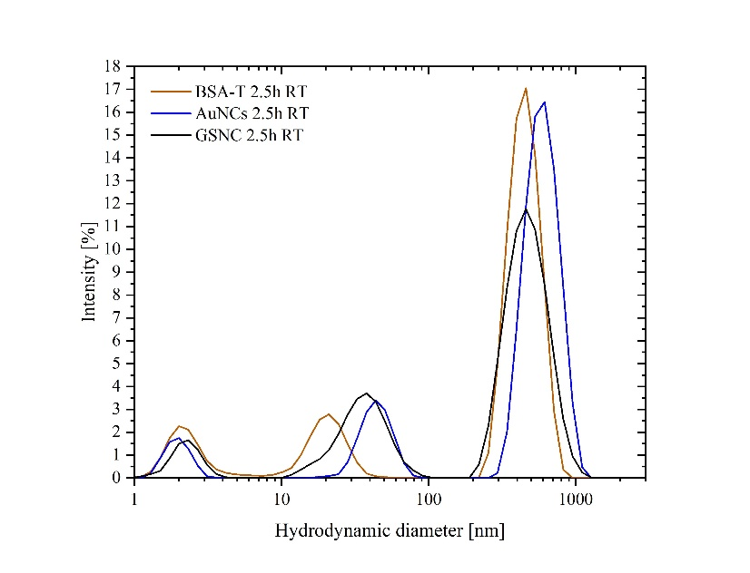B
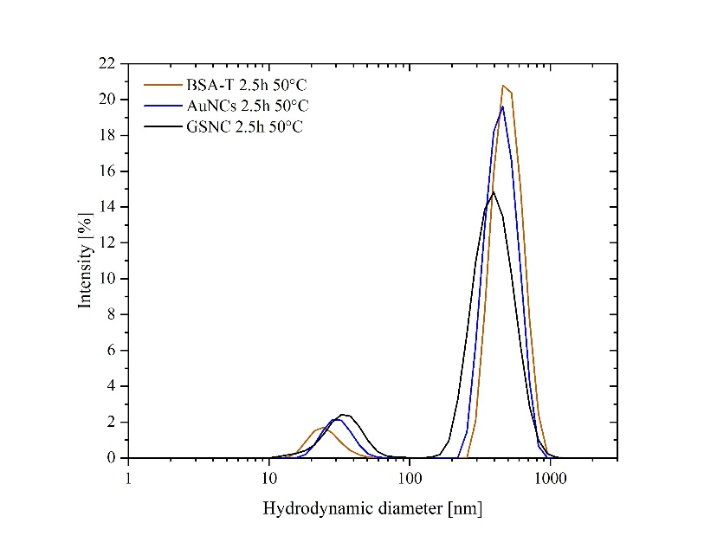C
Figure SI-6: Graphs of PSD (based on intensity changes) of metallic and non-metallic samples as a function of hydrodynamic diameter when using the following maturing conditions: (A) 0 min RT, (B) 2.5h RT, (C) 2.5h 50°C.

