Phytochemical Profiling and Molecular Docking Investigation of Avocado Leaves and Seeds: Implications for Antioxidant Activity and Health Benefits

SUPPLEMENTARY DATA
SD 1: Avocado SEED compounds identified via GC-MS analysis.
Peak | Retention Time (mins) | Area(%) | Library/ID
1 | 3.41 | 0.93 | 1,2,3-trimethyl-benzene
2 | 3.78 | 0.33 | (E) - 3 (10)-Caren-4-ol
3 | 3.9 | 0.25 | 1,5-Dimethyl-3-(prop-1-yn-1-yl)pyrazole
4 | 4.26 | 0.25 | 2-formylmethyl-4,6,6-trimethyl-bicyclo [3,1,1] hept-3-ene
5 | 4.45 | 1.11 | Prop-1-en-2-yl tetradecyl ester carbonic acid
6 | 4.72 | 0.6 | 1,2,3,4-tetramethyl-5-methylene-1,3-cyclopentadiene
7 | 4.82 | 0.32 | Lysergamide
8 | 5.32 | 0.43 | Decamethyl-cyclopentasiloxane
9 | 5.84 | 0.45 | Hexadecyl prop-1-en-2-yl ester carbonic acid
10 | 7.66 | 0.59 | 4-bromo-3-chloro-N-(4-methylthiobenzyldene)-benzenamine
11 | 9.83 | 0.34 | 2-benzo [1,3] dioxol-5-yl-8-methoxy-3-nitro-2H-chromene
12 | 9.98 | 0.31 | 2,6-bis(1,1-dimethylethyl)phenol
13 | 11.79 | 0.32 | 6-Amino-2-(fluoromethylidene)-3-(2-methylphenyl)-2,3-dihydroquinazolin-4(1H)-one
14 | 12.12 | 0.61 | 2-allylaminomethylene-5,5-dimethyl-cyclohexane-1,3-dione
15 | 12.29 | 0.76 | Isobutyl undec-10-enyl ester carbonic acid
16 | 12.92 | 0.59 | 3-methoxy-1,3,4-hexatriene
17 | 13.19 | 0.3 | 2-allylaminomethylene-5,5-dimethyl-cyclohexane-1,3-dione
18 | 14.67 | 0.55 | 2-Myristynoyl-glycinamide
19 | 14.9 | 28.03 | n-Hexadecanoic acid
20 | 15.32 | 0.48 | 17-Octadecynoic acid
21 | 15.85 | 0.45 | 2-Myristynoyl-glycinamide
22 | 16.49 | 14.7 | (Z) -9,17-Octadecadienal
23 | 16.73 | 5.01 | (4a.alpha.,7.beta.,8a.beta.)-2(1H)-Naphthalenone, octahydro-4amethyl-7-(1-methylethyl)-
24 | 18.04 | 0.27 | 2-Myristynoyl-glycinamide
25 | 18.39 | 0.23 | 1-methyl-4-[4,5-dihydroxyphenyl]-hexahydropyridine
26 | 18.87 | 0.64 | (R)-(-)-14-Methyl-8-hexadecyn-1-ol
27 | 19.67 | 0.75 | 2-Methyl-Z,Z-3,13-octadecadienol
28 | 19.96 | 8.68 | Ergost-5-en-3-ol
29 | 20.25 | 1.03 | 2,2,5a-trimethyl-1a-[3-oxo-1-butenyl] perhydro-, methyl ester 1-benzazirene-1-carboxylic acid
30 | 20.37 | 1.17 | 7,7,9,9,11,11-Hexamethyl-3,6,8,10,12,15-hexaoxa-7,9,11-trisilaheptadecane
31 | 20.45 | 1.75 | 2-(2-benzothiazolylthio)-1-(3,5-dimethylpyrazolyl)-ethanone
32 | 20.7 | 1.01 | 2-Myristynoyl-glycinamide
33 | 20.92 | 22.76 | Stigmastan-3,5,22-trien
34 | 21.2 | 3.55 | 4,7-dihydro-7-imino-, ethyl ester [1,2,4]triazolo[1,5-a]pyrimidine-6-carboxylic acid
35 | 21.43 | 0.47 | 1,1,1,3,5,5,5-Heptamethyltrisiloxane

SD 2: Avocado SEED compounds identified via GC-MS analysis, classification and biological activities associated with the compounds.
Retention time | Compound | Classification | Biological activities
4.820 | Lysergamide | Alkaloid
7.664 | Nordazepam, TMS derivative |  | Anti-convulsive, muscle relaxant
7.664 | Quinoline, 4-(4-chlorophenoxy)-8-fluoro-2-trifluoromethyl- | Alkaloid | Anti-microbial, anti-malaria
9.830 | 2-Benzo[1,3]dioxol-5-yl-8-methoxy-3-nitro-2H-chromene | Flavone
9.975 | Phenol, 2,6-bis(1,1-dimethylethyl) | Phenolic compound | Antioxidant
11.786 | Pyrido[2,3-d]pyrimidine, 4-phenyl- | Alkaloid | Anti-microbial, anti-tumor, anti-inflammatory, anti-viral
14.896 | n-Hexadecanoic acid | Fatty acid | Anti-inflammatory, anti-microbial, antioxidant, mosquito larvicide
15.852 | 2-Myristynoyl-glycinamide | Amino compound | Antioxidant, 5-Alpha reductase inhibitor, antimicrobial
16.485 | 9,12-Octadecadienoic acid (Z,Z)- | Fatty acid | Anti-arrhythmias
16.485 | 6-Octadecenoic acid | Fatty acid | Anti-ageing, anti-inflammatory
16.485 | 9,17-Octadecadienal, (Z)- | Aldehyde | Anti-microbial
16.485 | 9,12-Octadecadien-1-ol, (Z,Z)- | Fatty acid | Antioxidant
16.729 | 13-Octadecenal, (Z)- | Aldehyde | Anti-microbial
19.674 | Ergost-5-en-3-ol, (3.beta.)- | Steroid | Anti-fungal
19.674 | Campesterol | Steroid | Anti-inflammatory, reduced cholesterol
20.251 | Dodecahydropyrido[1,2-b]isoquinolin-6-one | Alkaloid | Antioxidant
20.918 | Stigmasterol | Triterpene | Anti-diabetic
20.918 | Stigmastan-3,5,22-trien | Triterpene
20.918 | Stigmasta-5, 22-dien-3-ol, acetate, (3.beta.)- | Triterpene | Anti-microbial, anti-mutagenic
SD 3: Avocado LEAVE compounds identified via GC-MS analysis.
Peak | Retention Time (mins) | Area (%) | Library/ID
1 | 3.31 | 14.87 | Octamethyl-cyclotetrasiloxane
2 | 4.3 | 3.84 | 1-methyl-2-pyrrolidinone
3 | 4.35 | 2.1 | 1-methyl-pyrrolidinone
4 | 4.5 | 1.7 | 2,2-diethyl-, (R*,S*)-4,4-bi-1,3,2-dioxaborolane
5 | 4.86 | 1.92 | 1-methyl-2-pyrrolidinone
6 | 5.1 | 0.6 | Methyl-imidosulfurous diflouride
7 | 5.35 | 1.97 | Decamethyl-cyclopentasiloxane
8 | 6.54 | 0.44 | Butyl-3-hydroxy-2-methylene-butanoate
9 | 6.75 | 0.48 | Acetylcodein
10 | 7.66 | 0.58 | Dodecamethyl-cyclohexasiloxane
11 | 9.83 | 0.47 | 1-(tert-butyl dimethylsilyl)-5-chloro-, 3-(O-ethyloxime)- 1H-Indole-2,3-dione
12 | 11.8 | 0.36 | 3-[2-(3, 5-dimethylphenyl)diazenyl]-4-hydroxy-2-naphthalenesulfonamide
13 | 13.5 | 0.31 | 6-(4- ethoxyphenyl)-3-methyl-4-oxo-4,5,6,,7-tetrahydro-1H-Indole-2-carboxylic acid, isopropyl ester
14 | 13.95 | 0.31 | 2-Azatricyclo[4.3.1.1(4,8)]undecan
15 | 14.69 | 0.33 | Cyclobarbital
16 | 14.85 | 7.65 | n-Hexadecanoic acid
17 | 15.95 | 0.27 | 2-allylamin omethylene-5,5-dimethyl-cyclohexane-1,3-dione
18 | 16.49 | 8.55 | Linoelaidic acid
19 | 16.72 | 1.75 | 2,4-dimethyl-1,3-pentadiene
20 | 19.93 | 17.08 | (3.beta.)- Ergost-5-en-3-ol
21 | 20.25 | 2.32 | 2-Myristynoyl-glycinamide
22 | 20.91 | 28.96 | Stigmasterol
23 | 21.19 | 2.3 | 2-Myristynoyl-glycinamide
24 | 21.87 | 0.83 | N-Acetoacetyl-deacetylcolchicine

SD 4: Avocado LEAVE compounds identified via GC-MS analysis, classification and biological activities associated with the compounds.
Retention time | Compound | Classification | Biological activities
6.753 | Acetylcodein | Morphinans | Urinary marker
6.753 | Morphinan-6-ol, 7,8-didehydro-4,5-epoxy-3-methoxy-17-methyl-, acetate (ester), (5.alpha.,6.alpha.)- | Morphinans | Analgesic
14.685 | Cyclobarbital |  | Treating insomnia
14.852 | n-Hexadecanoic acid | Fatty acid | Anti-inflammatory, anti-microbial, antioxidant, mosquito larvicide
14.852 | 2-Myristynoyl-glycinamide | Amino compound | Antioxidant, 5-Alpha reductase inhibitor, antimicrobial
16.485 | Linoelaidic acid | Omega-6 fatty acid | Reduce risk of heart disease
16.485 | 9,12-Octadecadienoic acid (Z,Z)- | Fatty acid | Antioxidant, anti-arrhythmics
16.719 | 1H-Pyrazol-4-ylmethanamine |  | Anti-cancer, anti-bacterial, anti-pyrine, anti-inflammatory
19.929 | Ergost-5-en-3-ol, (3.beta.)- | Steroid | Anti-fungal
19.929 | Campesterol | Steroid | Anti-inflammatory, reduced cholesterol
20.907 | Stigmasterol | Triterpene | Anti-diabetic
20.907 | Stigmasta-5,22-dien-3-ol, acetate, (3.beta.)- | Triterpene | Anti-microbial, anti-mutagenic
SD 5: The code names, nomenclature and 2D-structure of prevalent compounds extracted from avocado leaves and seed sample. Standard drugs were introduced for comparative validation.
CODE NAME | 2D STRUCTURE | NOMENCLATURE
AVOCADO LEAVE
L01 | 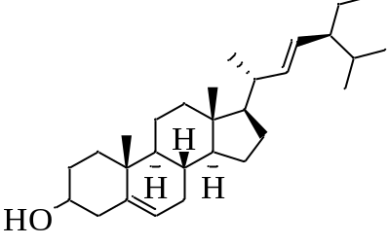 | Stigmasta-5,22-dien-3-ol
L02 | 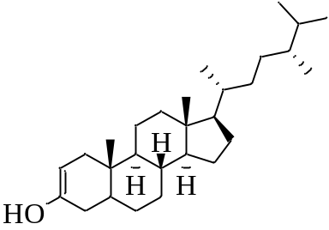 | campestenol
L03 | 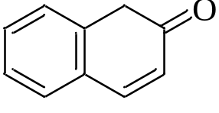 | 2(1H)-Naphthalenone
L04 | 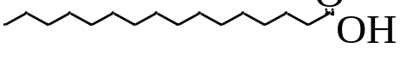 | n-Hexadecanoic acid
L05 | 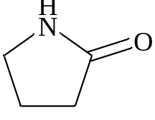 | 2-Pyrrolidinone
*L06 | 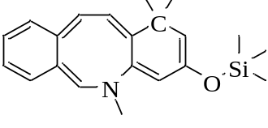 | 1,1,1,5,5,5-hexamethyl-3-[(trimethylsilyl)oxy]-dibenz[b,f]azocine
*L07 | 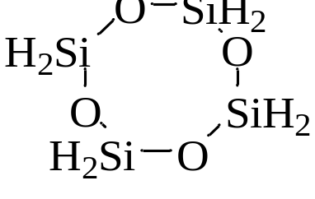 | Cyclotetrasiloxane
AVOCADO SEED
S01 | 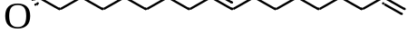 | 9,17-Octadecadienal
S02 | 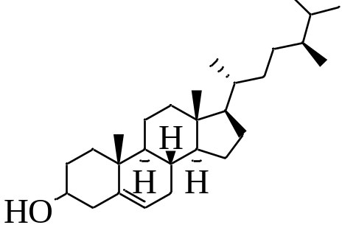 | Ergost-5-en-3-ol
S03 | 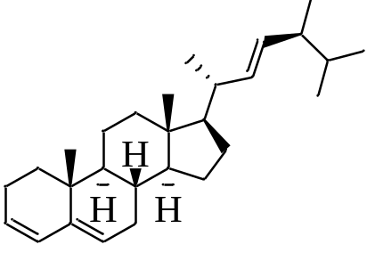 | Stigmastan-3,5,22-trien
S04 |  | n-Hexadecanoic acid
STANDARD DRUGS
STD-2RGU | 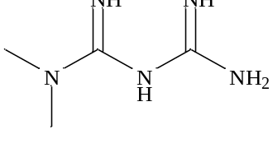 | Metformin
STD-3MNG | 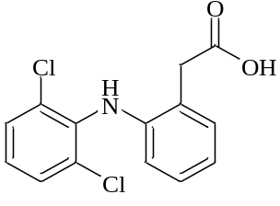 | Diclofenac
STD-2VWI | 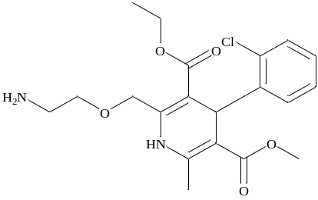 | Amlodipine
*Excluded from the docking process.
SD 6: A 3D binding interaction at the binding site of the human DPP4 (2rgu.pdb), human PrxV (3mng.pdb) and Human serine/threonine kinase (2vwi.pdb) protein targets.
COMP | 2RGU | 2VWI | 3MNG
L01 | 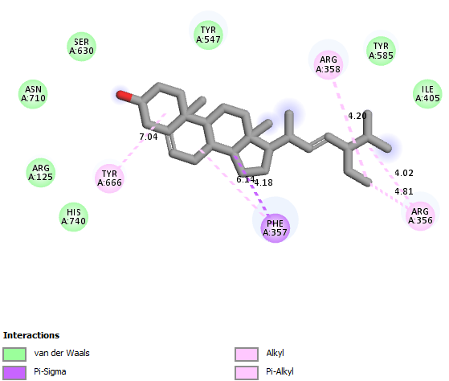 | 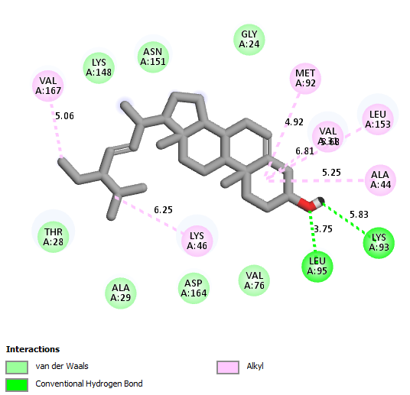 | 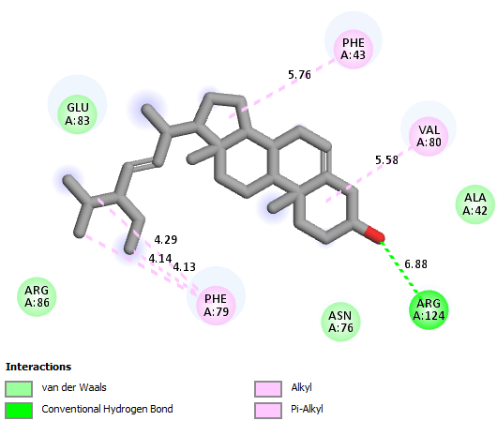
L02 | 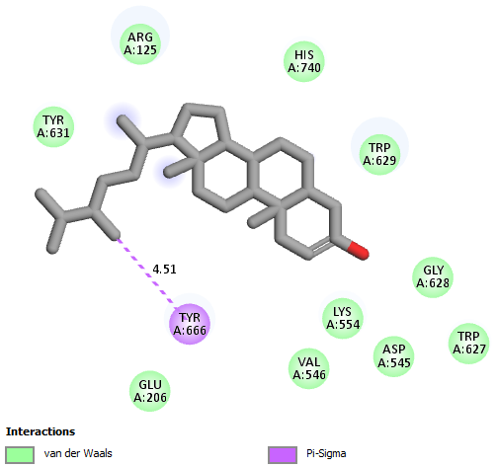 | 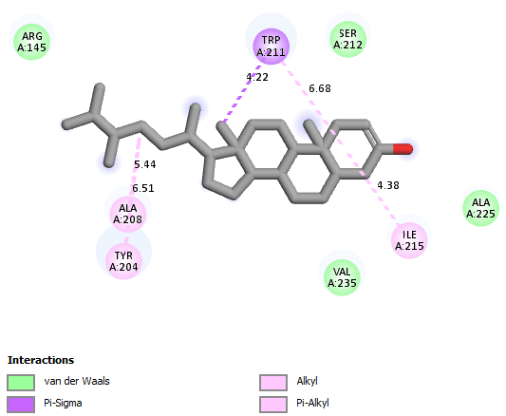 | 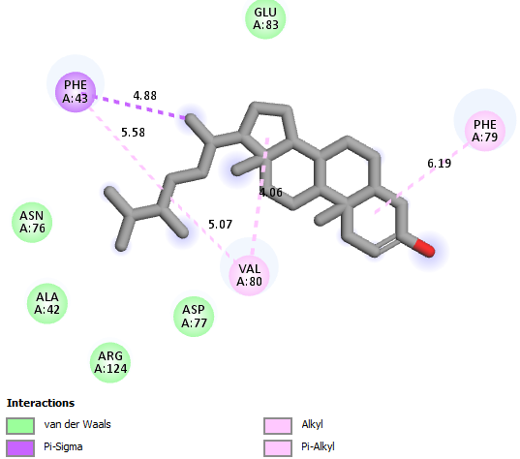
L03 | 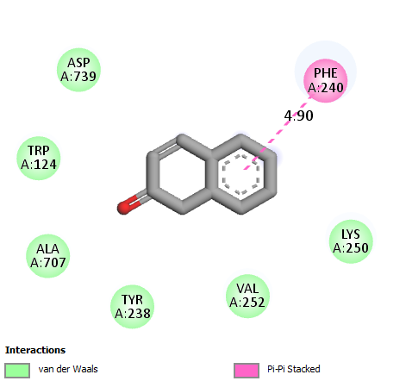 | 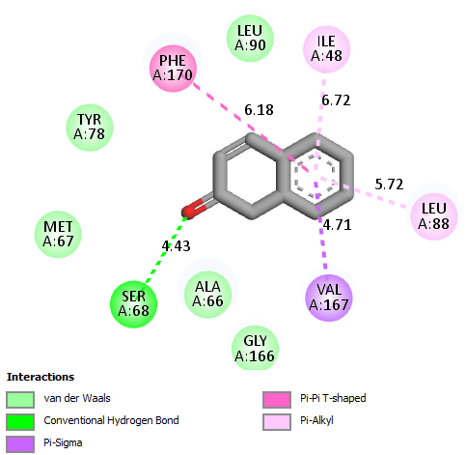 | 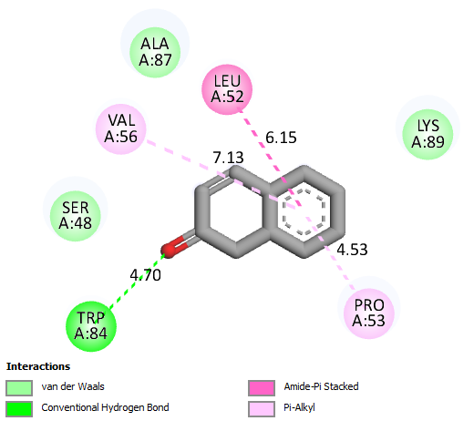
L04 | 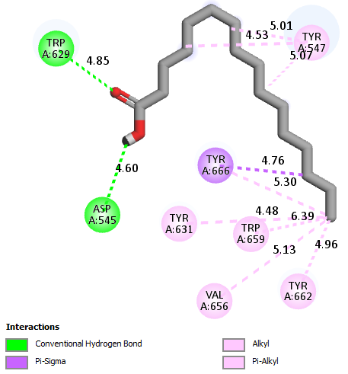 | 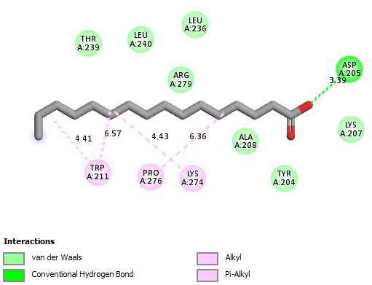 | 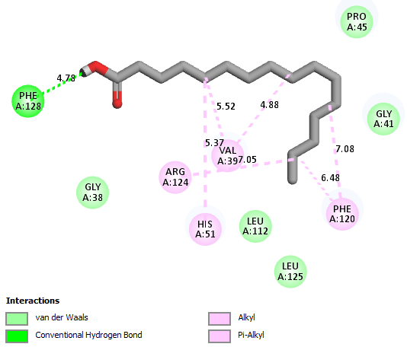
L05 | 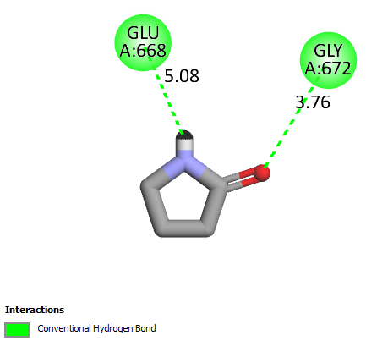 | 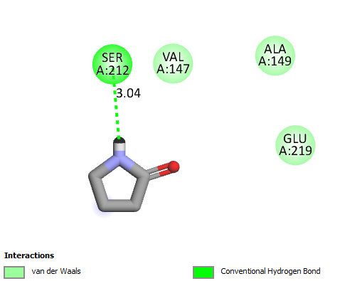 | 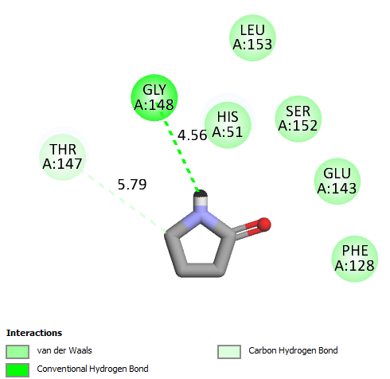
S01 | 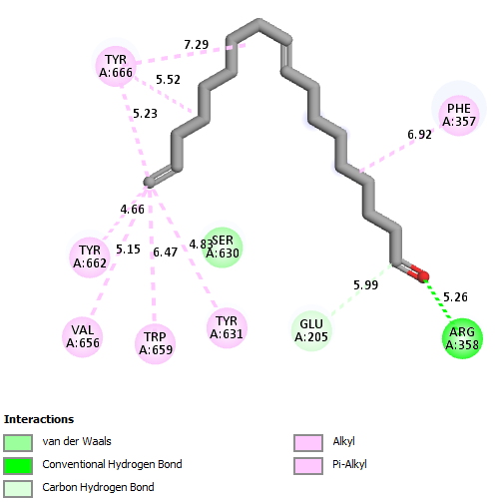 | 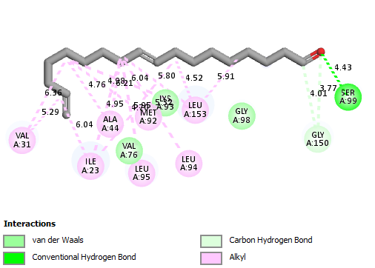 | 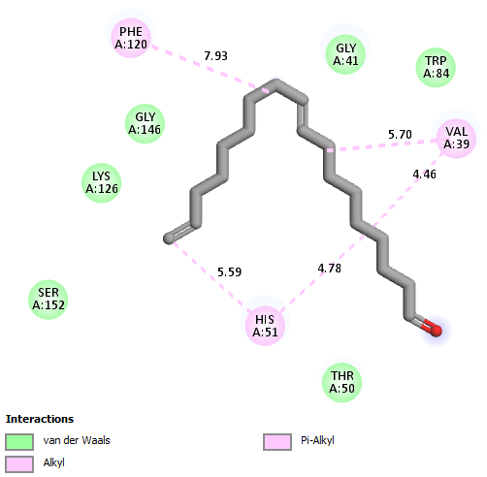
S02 | 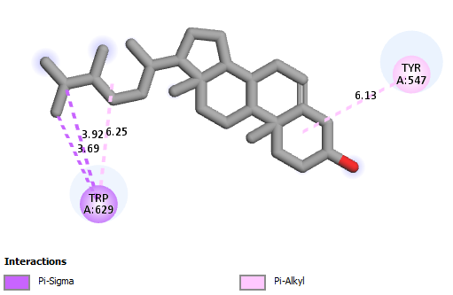 | 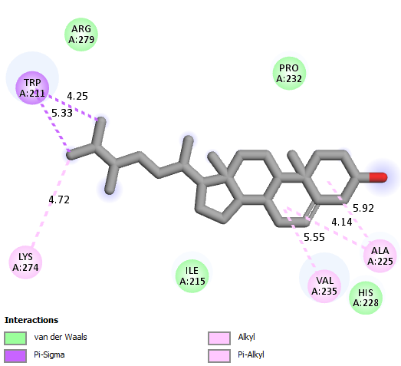 | 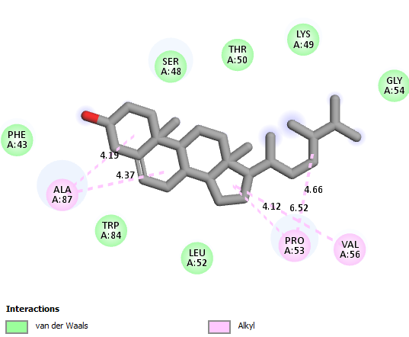
S03 | 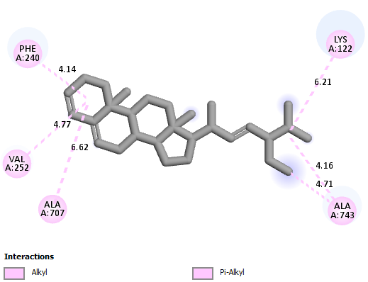 | 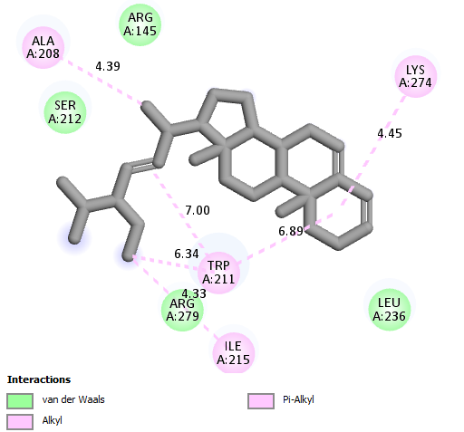 | 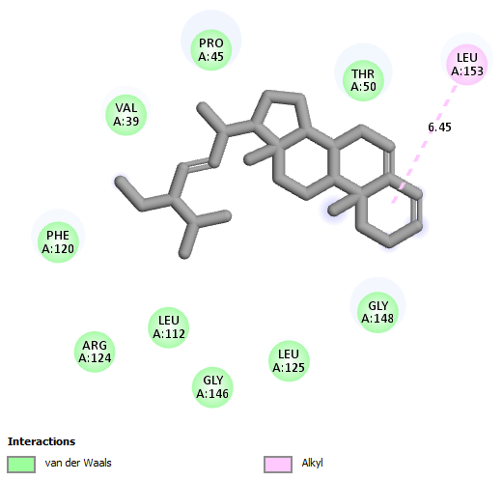
S04 | 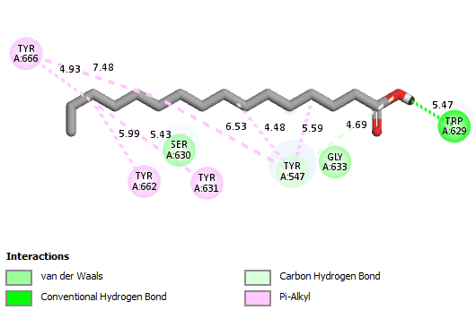 | 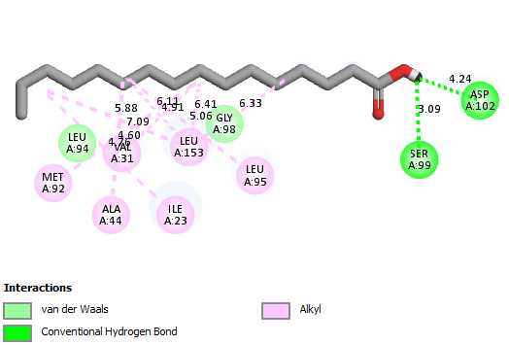 | 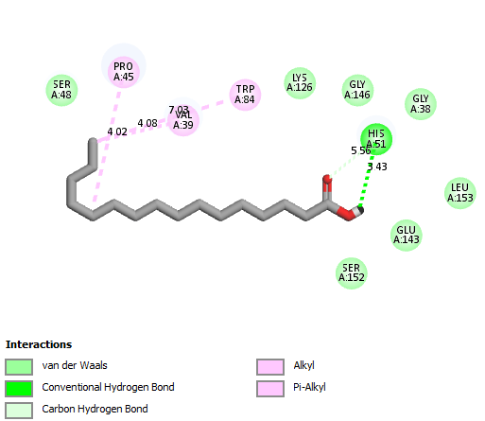
STD | 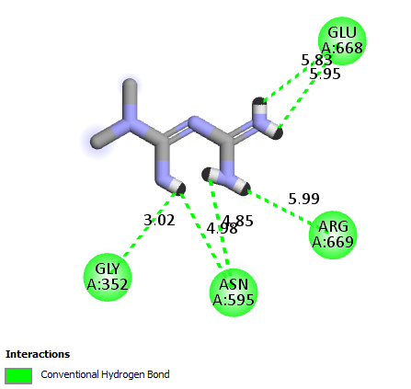 | 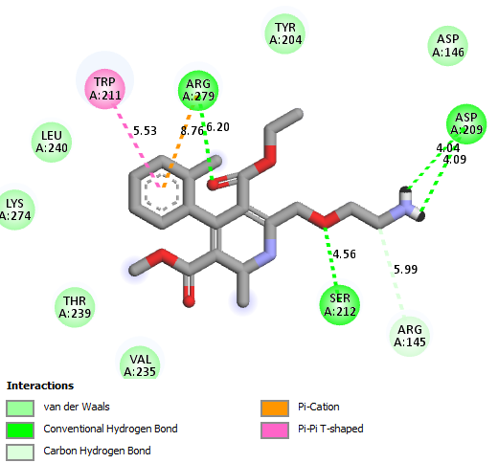 | 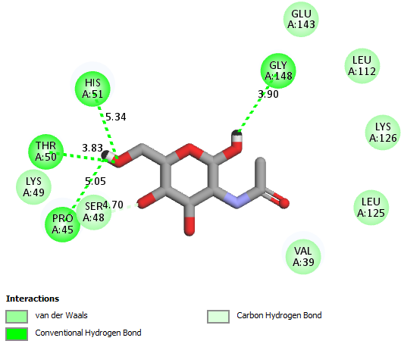
*VDATE | 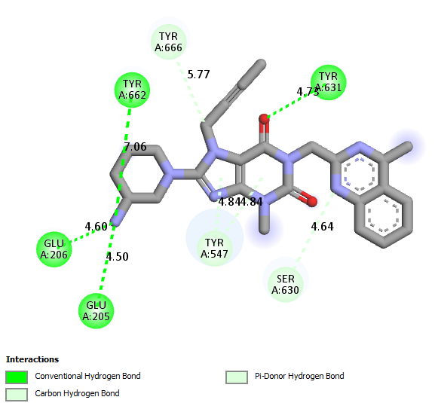 | 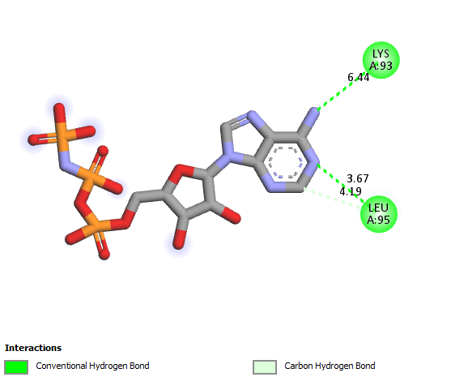 | 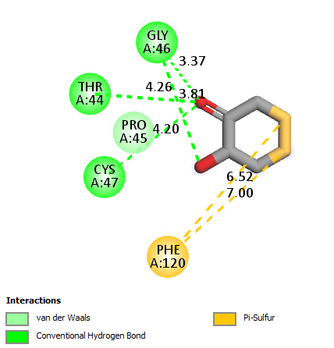
*VDATE = Validation compounds used to confirm the binding site of the protein structure
SD 7: GC-MS analysis plot for (A) AVL and (B) AVS samples
