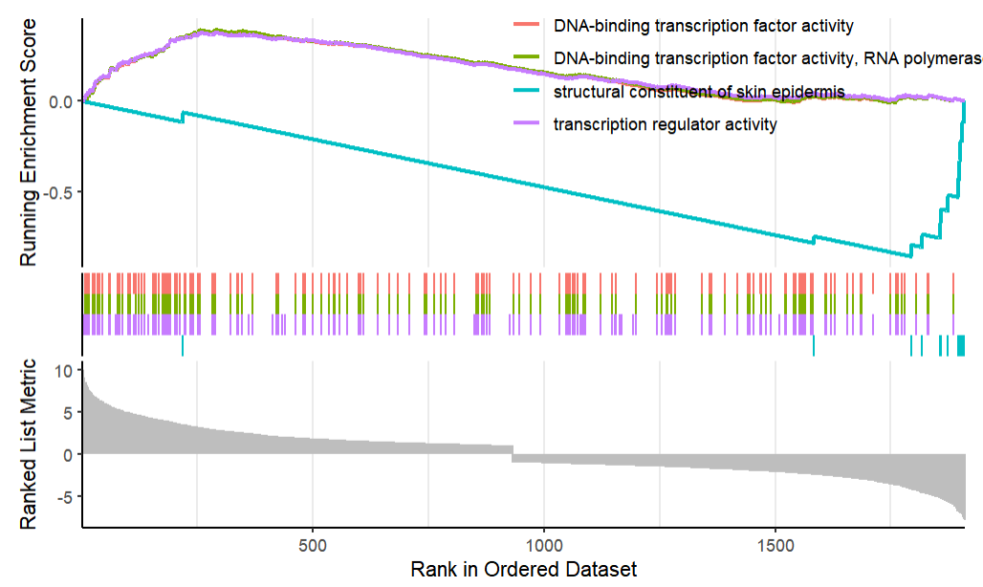  A | 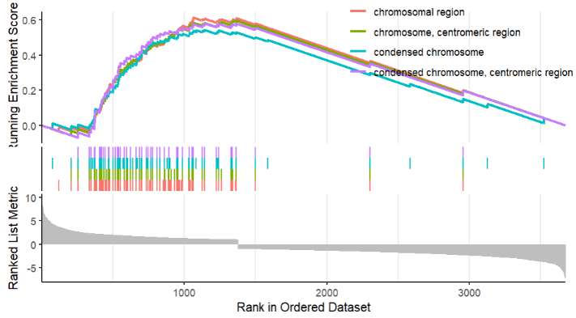  B
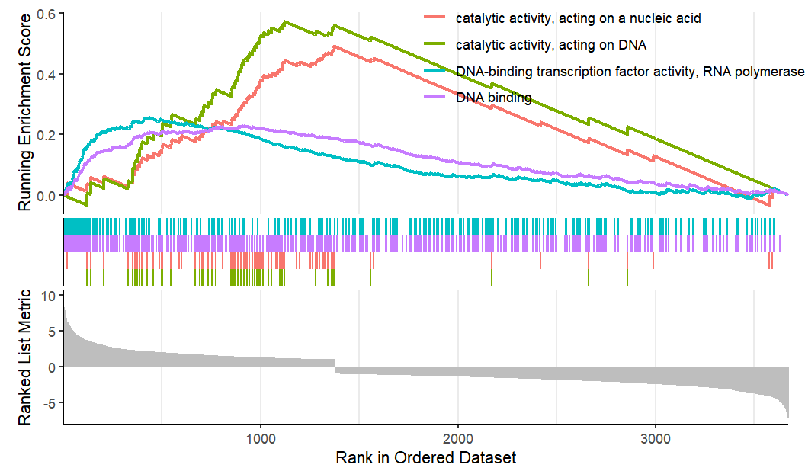  C | 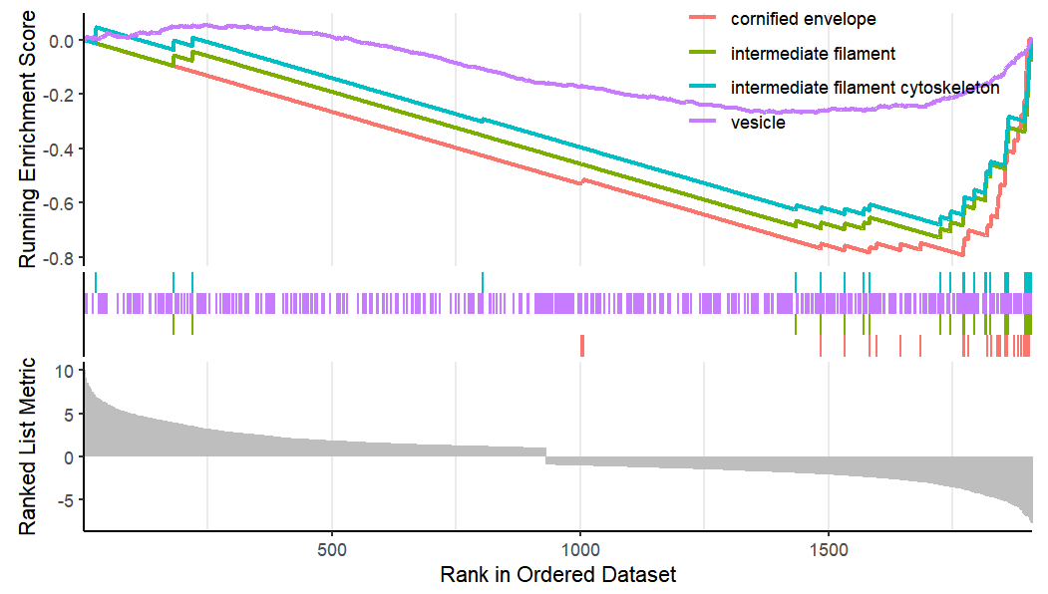  D
Figure S1 Functional enrichment analysis between high-risk and low-risk groups (A) GO-enriched MF terms in GSEA analysis of the high-risk group. (B) GO-enriched CC terms in GSEA analysis of the high-risk group. (C) GO-enriched MF terms in the GSEA analysis of the low-risk group. (D) GO-enriched CC terms in GSEA analysis of the high-risk group.

