Supplementary information to
Multi-compartment chemical characterization and risk assessment of chemicals of emerging concern in freshwater systems of western Kenya
Faith Jebiwot Kandie ^{a,b,c,d}, Martin Krauss ª, Riccardo Massei ^{a+}, Akbar Ganatra ^{b,e}, Ulrike Fillinger^{b} Jeremias Becker^{f,g} , Matthias Liess ^{f,g}, Baldwyn Torto ^{b}, Werner Brack^{a,c*}
ª Department of Effect-Directed Analysis, Helmholtz Centre for Environmental Research (UFZ), Permoserstrasse 15, 04318 Leipzig, Germany.
^{b} International Centre of Insect Physiology and Ecology (icipe), P.O. Box 30772-00100, Nairobi, Kenya.
^{c} Department of Evolutionary Ecology and Environmental Toxicology, Faculty of Biological Sciences, Goethe University Frankfurt, Max-von-Laue-Strasse. 13 60438 Frankfurt am Main, Germany.
^{d} Department of Biological Sciences, Moi University, P.O. Box 3900-30100, Eldoret, Kenya.
^{e} Department of Biological Sciences, Egerton University, P.O. Box 536 Egerton, Kenya.
^{f} Department of System Ecotoxicology, Helmholtz Centre for Environmental Research (UFZ), Permoserstrasse 15, 04318 Leipzig, Germany.
^{g}Department of Ecosystem Analysis, RWTH—Aachen University, Institute for Environmental Research, Worringerweg 1, 52074 Aachen, Germany
⁺Current address: Zebrafishlab, Veterinary Physiology and Biochemistry, Department of Veterinary Sciences, University of Antwerp, Universiteitsplein 1, 2610 Wilrijk, Belgium

* Corresponding author. E-mail address: werner.brack@ufz.de
Table of contents

Table SI-1: List of target compounds analyzed in all samples (in Excel file) 3
SI-2: Analysis of total organic carbon performed on sediment samples. 3
SI-3: LC program for the extract clean-up by flash column chromatography. 3
Table SI-4: List of compounds concentrations found in snail tissue samples (in Excel file) 3
Table SI-5: List of compounds concentrations found in sediment samples (in Excel file) 3
Figure SI-2: Compound concentrations and spatial distribution in water samples 5
Table SI-6: Toxic unit of compounds in sediment samples calculated for fish (in Excel file) 8
Table SI-7: Toxic unit of compounds in sediment samples calculated for crustaceans (in Excel file) 8
Table SI-8: Toxic unit of compounds in sediment samples calculated for algae (in Excel file) 8

Figure SI-1: Compound concentrations and spatial distribution in snail tissue samples. 4
Figure SI-2: Compound concentrations and spatial distribution in water samples 5
Figure SI-3: Map showing selected sites with dominant land use within the study area 6
Figure SI-4: Distribution of risk of toxicity for fish from compounds present in sediment extract based equilibrium water concentrations 7

Table SI-1: List of target compounds analyzed in all samples (in Excel file)

SI-2: Analysis of total organic carbon performed on sediment samples.
Based on the assumption that contaminants adsorb to the organic carbon phase rather than the inorganic components, the total organic carbon (TOC) analysis was essential to normalize the contaminant content on the organic carbon content. For the analysis, triplicate 5 mg sediment samples were folded completely in aluminum foil to remove any air spaces. The samples were then combusted at 1000⁰C on a Flash 200 organic elemental analyzer coupled to a Delta V Advantage Isotope Ratio mass spectrometer (Thermo). A temperature conducting detector (TCD) was used to measure the signal after the gas chromatography. Six level calibration points between 0.1 and 2 mg was used to develop the calibration curve with acetanilide as the standard.

SI-3: LC program for the extract clean-up by flash column chromatography.
Prior to extract clean up using flash column chromatography, 10.5 mL of dichloromethane (DCM, LC grade) was used to condition the flash column for 2.1 minutes. Sediment clean-up was first performed using DCM followed by methanol and collected separately in 20 mL pre-cleaned evaporation vials.
Channel | Time (min) | Flow rate (mL min⁻¹)
DCM | 0 - 0.5 | 0 - 5
DCM | 0.5 – 3.5 | 5
DCM | 5.5 - 5 | 5 - 0

Channel | Time (min) | Flow rate (mL min⁻¹)
Methanol | 0 - 0.5 | 0 - 5
Methanol | 0.5 – 3.5 | 5
Methanol | 3.5 – 3.6 | 5 - 0

Table SI-4: List of compounds concentrations found in snail tissue samples (in Excel file)

Table SI-5: List of compounds concentrations found in sediment samples (in Excel file)

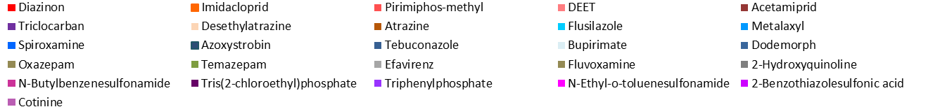
BA: Bulinus africanus (nasutus); BF: Bulinus forskalii; BT: Bulinus truncates; BP: Biomphalaria pfeifferi; BG: Bulinus globusus; CT: Ceratophallus sp.; LN:Lymnea natalensis; MT: Melanoides tuberculata; PO: Pila ovata; PA: Physa acuta.
Figure SI-1: Compound concentrations and spatial distribution in snail tissue samples.
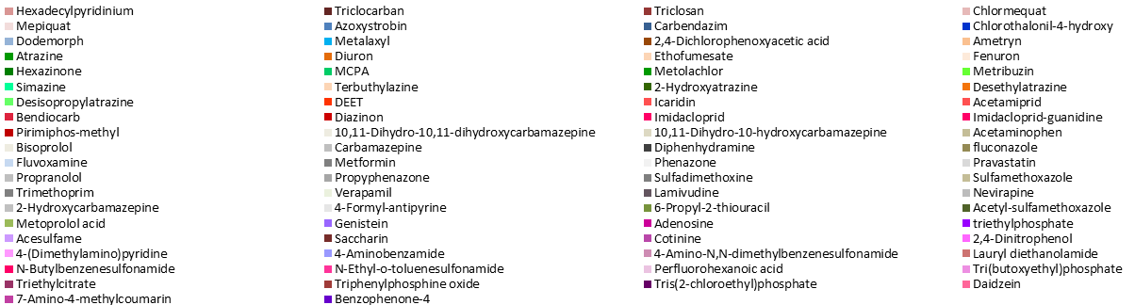

Figure SI-2: Compound concentrations and spatial distribution in water samples
Figure SI-3: Map showing selected sites with dominant land use within the study area
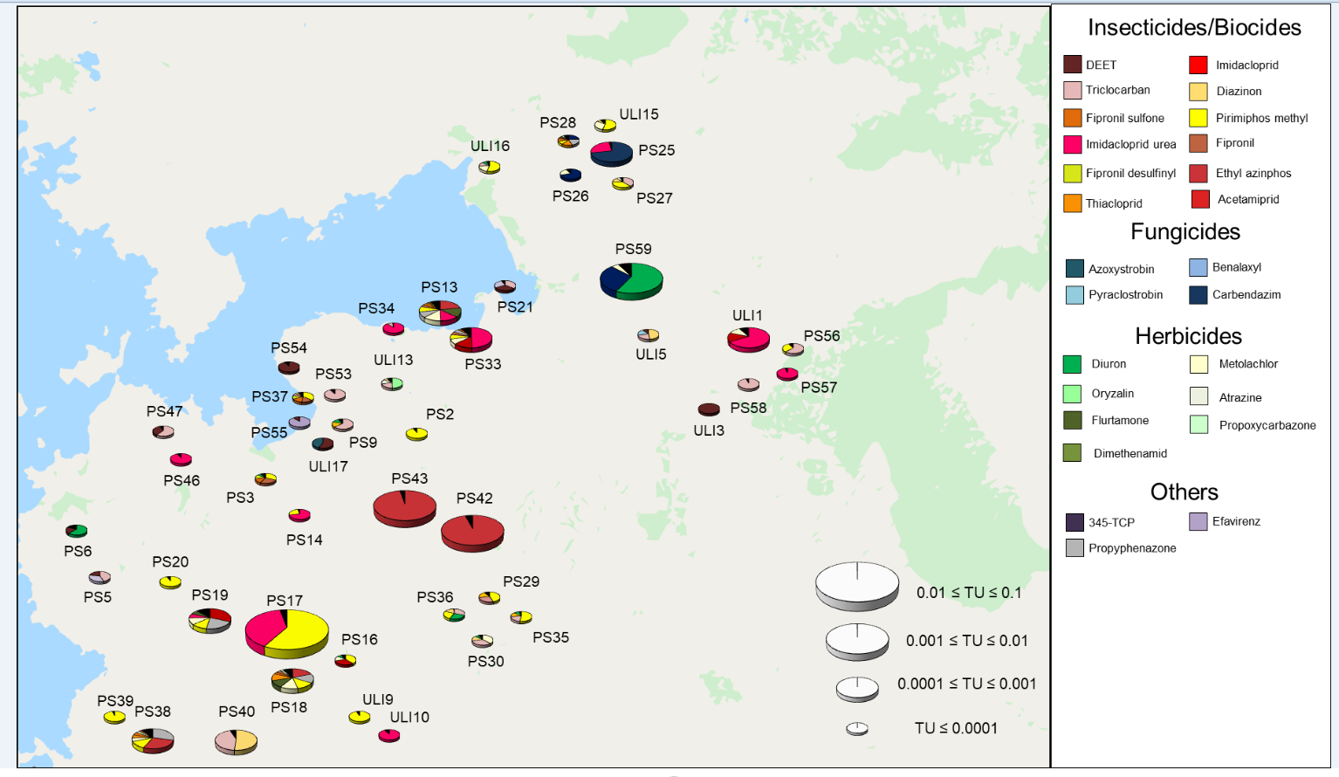
Figure SI-4: Distribution of risk of toxicity for fish from compounds present in sediment extract based equilibrium water concentrations

Table SI-6: Toxic unit of compounds in sediment samples calculated for fish (in Excel file)

Table SI-7: Toxic unit of compounds in sediment samples calculated for crustaceans (in Excel file)

Table SI-8: Toxic unit of compounds in sediment samples calculated for algae (in Excel file)

