Figure S1
Figure S2

Figure S3
Figure S4
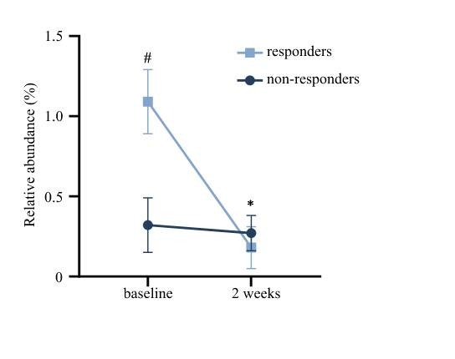

Figure S1 The microbiota profile and abundance. (a) Rank-abundance curves. (b) Refraction curves. (c) Pan analysis. (d) Core analysis. HC: health control; PBT: positive breath test; SIBO: small intestinal bacterial overgrowth.
Figure S2 The relative abundance at the KEGG BRITE level 3 pathways.
Figure S3 The correlation heatmap of differential toxonomic and functional relative abundance. * p<0.05; ** p<0.01; *** p<0.001.
Figure S4 The relative abundance of Coprococcus before and after medication of berberine in responders and non-responders. * a significant difference before and after medication of berberine in responders; # a significant difference at baseline in two groups.

