Phosphate-grafted polyethyleneimine-induced multifunctional cerium oxide as an antioxidant for simultaneously enhancing the proton conductivity and durability of proton exchange membranes
Shengqiu Zhao^{a, &}, Yucong Liao^{a, &}, Rui Wangª, Yao Liª, Jiaqi Shuaiª, Letian Wangª, Bingxuan Liuª, Rui Chenª, Tian Tian^{a, b}, Haining Zhang^{a, b, c}, Haolin Tang^{a, b, c∗}

ª State Key Laboratory of Advanced Technology for Materials Synthesis and Processing, Wuhan University of Technology, Wuhan 430070, China
^{b} National Energy Key Laboratory for new hydrogen-ammonia energy technologies, Foshan Xianhu Laboratory, Foshan 528200, P. R. China
^{c} Hubei Key Laboratory of Fuel Cells, Wuhan University of Technology, Wuhan, 430070, China

* Corresponding author. E-mail: thln@whut.edu.cn (Haolin Tang)
& These authors contributed equally to this work.

Structure and morphology characterization
Attenuated Total Reflection Fourier Transform Infrared Spectroscopy (ATR-FTIR, Bruker Vertex 70v) and X-ray photoelectron spectroscopy (XPS, Thermo Fisher Scientific Escalab 250Xi) were employed to determine the chemical structure of the samples. The UV-vis spectra were recorded on a PerkinElmer Lambda 750S UV-Visible Near Infrared Spectrophotometer with a resolution of 0.15 nm. The hydrodynamic size of the prepared nanostructures was analyzed by dynamic light scattering (DLS, Malvern, Zetasizer Nano ZSE), and the samples were dispersed in deionized water before testing. The morphology of membranes was examined by a field emission scanning electron microscope (FE-SEM, Zeiss Ultra Plus) equipped with an X-ray energy spectrometer (X-Max 50). The morphology of the membranes was examined by Atomic Force Microscope (AFM, Seiko SPA400) in tapping mode. The mechanical performance of membranes was evaluated with a multifunctional electronic tester (SASTest, CMT6202). Differential scanning calorimetry (DSC) was conducted using a differential scanning calorimeter (TA-DSC2500). Small-angle X-ray scattering spectroscopy (SAXS, Xeuss3.0, Xennocs) was used to analyze the ion clusters domain spacing of the hybrid membranes. Before this measurement, samples were stored in a vacuum dryer for one night and then moisturized under 80% RH for 6 hours. The average hydrophilic ion clusters domain spacing (d, nm) was calculated from the Eq. 1：
$d=\frac{2π}{q}$ (1)
and q is the scattering vector.

Water uptake and dimensional swelling
Water uptake (WU) and dimensional swelling (DS) of the membranes were measured by the weight and area difference under dry and hydrated state. The weight and area of the dried membranes were determined after drying the films in an oven at 90°C overnight. The weight and area of the wet membranes were determined after soaking the membrane in deionized water for 24 hours. The WU and DS of PEMs were calculated by the Eq. 2 and Eq. 3:
$WU \left(\%\right)=\frac{M_{wet}-M_{dry}}{M_{dry}}$ (2)
$DS \left(\%\right)=\frac{A_{wet}-A_{dry}}{A_{dry}}$ (3)
where M_{dry} and M_{wet} were the weight of the membrane in the dry and hydrated states, respectively. A_{dry} and A_{wet} were the areas of the membrane in the dry and hydrated states, respectively.

Proton conductivity
The proton conductivity of PEMs under varying temperatures and RH conditions was investigated by employing the conductivity measurement system consisting of an electrochemical workstation (Autolab, PGSTA302N) and an environmental chamber (Giant Force, ETH-080ST-SSP). Before testing the conductivity of the PEM at each specific temperature and humidity, the samples were equilibrium in an environmental chamber for one hour. The membrane resistance is obtained from the impedance spectrum. The conductivity of the PEMs was calculated from Eq. 4:
$σ=\frac{L}{R×S}$ (4)
where L (cm), S (cm), and R (Ω) stand for the distance between the collectors, the cross-sectional area, and the resistance, respectively.
The activation energy (Ea) values for each membrane were calculated according to the following Eq. 5:
$σ\left(S/cm\right)=Aexp\left(\frac{{-E}_{a}}{R×T}\right)$ (5)
Where σ, A, R, and T represent the proton conductivity, pre-exponential factor, molar gas constant, and temperature, respectively.

Ex-situ Chemical Durability
The ex-situ chemical endurance experiments were conducted by subjecting PEMs to Fenton's reagent (30 wt% H₂O₂ and 20 ppm FeSO₄⋅7H₂O) at 85°C for 24 hours. To maintain the reactivity of the Fenton reagent, the solution was collected every 0.5 hours and replaced with a fresh Fenton reagent. Fluoride emission was determined quantitatively using an ion chromatograph (DIONEX, DX-320). The collected solution was concentrated to 30 mL before the test. The fluoride emission of samples was calculated from the Eq. 6：
$Fluoride emission(mg F^{-} g^{-1} membrane)=\frac{Fluoride ion concentration(mg/mL)*30(mL) }{m_{membrane} (g)}$ (6)
In this equation, Fluoride ion concentration represents the concentration of fluoride ions in the Fenton reagent after concentration, and m_{membrane} is the weight of the membrane sample.

Fabrication of membrane electrode assembly (MEA) and fuel cell tests
The MEA was manufactured using the conventional decal transfer method. The cathode and anode commercial catalyst layer (CL, WUT Hydrogen Power Co., Ltd.) were hot pressed on both sides of PEMs to obtain a catalyst-coated membrane (CCM) with a Pt/C catalyst loading of 0.15 mg/cm² and 0.4 mg/cm² for the anode and cathode, respectively. The gas diffusion layer (GDL, SGL, 235 μm) was attached to both sides of the CCM, forming MEA with an active area of 25 cm². A fuel cell test system (HTS-125s, Hephas Energy Company) was employed to determine performance at 80°C and 100% RH. In the polarization curve test, the single cell was subjected to a back pressure of 100 kPa, and H₂ and Air were delivered to the anode and cathode of the cell at stoichiometric ratios of 1.5 for H₂ and 3 for Air, with minimum flow rates of 0.8 L/min and 1.5 L/min for H₂ and Air, respectively. The H₂ crossover of PEMs was monitored using linear scanning voltammetry (LSV) at 25°C without back pressure at room temperature, H₂ and N₂ were delivered to the anode and cathode with the same gas flow rate of 0.2 L min⁻¹.

Accelerated degradation tests of MEA
The chemical durability of the PEMs was investigated by open-circuit voltage (OCV) holding in accelerated degradation testing (ADT). The MEAs were maintained at 80°C and feeding H₂/air at 0.5/1 L/min under a humidity cycle (dry H₂ and Air were delivered to the cells for 8 minutes, then switched to 100% RH for 2 minutes) without back-pressure to the anode and cathode. Moreover, the reliability was investigated by the polarization curves, H₂ crossover value, and thickness retention of each MEA before and after ADT.

Synthesis of phosphate-grafted polyethyleneimine
The phosphoric acid grafted polyethyleneimine (Ph-PEI) synthesis is based on the Michael addition reaction principle. Specifically, 1 g (0.55 mmol) of polyethyleneimine (PEI) was dissolved into a round-bottomed flask containing 50 mL of deionized water, followed by the addition of 7.57 g (23.25 mmol) of cesium carbonate, and the temperature was raised to 80°C after complete dissolution with stirring. Then 4.274 g (17.44 mmol) of 2-bromoethylphosphonate was slowly dripped into the flask through a dropping funnel, and after 48 hours of reaction under N₂ atmosphere, the liquid was removed and poured into 80 mL of 3 M HCl and stirred for 24 hours to fully hydrolyze the diethylphosphate. To remove excess monomer and small molecule impurities, the crude product was poured into a dialysis bag (M_{w} cutoff = 1000 Da) and dialyzed in deionized water for 72 h. The process was repeated three times, and finally, the liquid was freeze-dried to obtain the solid Ph-PEI product.

Characterization of Ph-PEI
The chemical structures of polyethyleneimine (PEI) and phosphoric acid grafted polyethyleneimine (Ph-PEI) were characterized by Varian 400 MHz NMR spectrometry using DMSO-d6 as solvent and tetramethylsilane (TMS) as internal standard. Figure S1 a,b illustrates ¹H and ¹³C NMR spectrum of PEI and Ph-PEI. Compared with the ¹H NMR spectrum of PEI, the peaks at 3.21, 3.43, and 3.59 ppm (assigned to N- CH₂-CH₂-PO₃H₂) appeared, and the peak at 1.79 ppm (assigned to -CH₂-CH₂-NH-) was moved to around 2.18 ppm, implying that the NH groups have been reacted with the diethyl 2-bromoethylphosphonateand, and new N-C bonds were generated. The peaks at 35.3, 37.2, 46.9, and 51.9 ppm (assigned to - CH₂-CH₂-PO₃H₂) have appeared in the ¹³C NMR spectrum of obtained Ph-PEI, indicating that the -PO₃H₂ were introduced. Moreover, a peak at 26.1 ppm appeared in the ³¹P NMR spectrum of Ph-PEI, further confirming the successful introduction of -PO₃H₂ (Figure S1 c).

Figure S1. (a) ¹H, (b) ¹³C NMR spectrum of PEI and Ph-PEI. (c) ³¹P NMR spectrum of Ph-PEI.

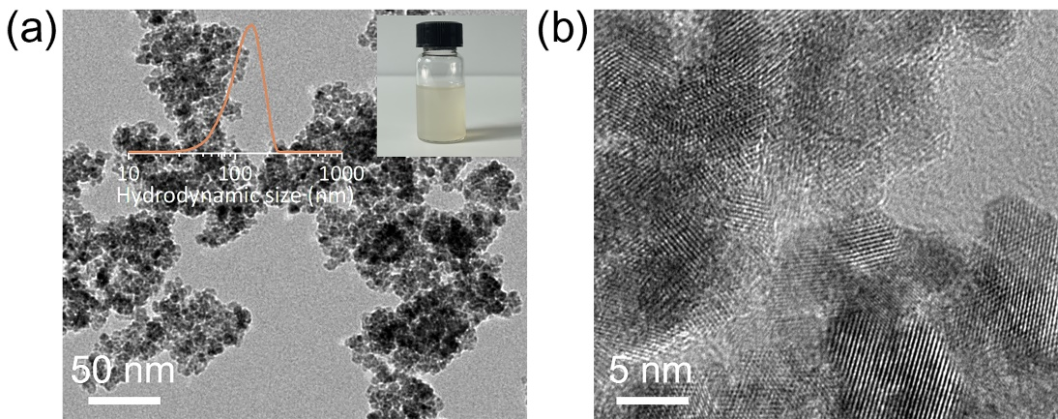
Figure S2. (a) TEM images of bare CeO₂ nanoparticles. The insets are hydrodynamic dimensions of bare CeO₂ (left) and optical photographs of bare CeO₂ dispersed in DMF (right). (b) HRTEM images of bare CeO₂.

Figure S3. Raman spectra of bare CeO₂ and CeO₂@Ph-PEI.
Figure S4. (a) O1s and (b) Ce 3d XPS spectra of bare CeO₂ and CeO₂@Ph-PEI.

Table S1. O 1S XPS analysis parameters of CeO₂ and CeO₂@Ph-PEI.
Sample | State | Peak position | FWHM | Area | O_{V}=O_{β}/(O_{α}+O_{β}+O_{γ})
CeO₂ | O_{α} | 529.5 | 1.17 | 54.4% | 37.3%
CeO₂ | O_{β} | 531.5 | 1.93 | 37.3% | 37.3%
CeO₂ | O_{γ} | 532.7 | 5.02 | 8.3% | 37.3%
CeO₂@Ph-PEI | O_{α} | 529.5 | 1.41 | 7.2% | 48.5%
CeO₂@Ph-PEI | O_{β} | 531.6 | 2.07 | 48.5% | 48.5%
CeO₂@Ph-PEI | O_{γ} | 532.7 | 1.88 | 44.3% | 48.5%

Table S2. Ce 3d XPS analysis parameters of CeO₂ and CeO₂@Ph-PEI.
State | Peak position | CeO₂ |  | CeO₂@Ph-PEI
State | Peak position | FWHM | Area | FWHM | Area
Ce(Ⅲ) | 884.62 | 2.03 | 5.7% | 2.39 | 14.7%
Ce(Ⅲ) | 888.92 | 2.93 | 10.9% | 1.58 | 1.9%
Ce(Ⅲ) | 898.88 | 2.21 | 4.1% | 0.99 | 2.1%
Ce(Ⅲ) | 903.6 | 1.89 | 3.0% | 3.08 | 18.4%
Ce(Ⅳ) | 882.39 | 1.77 | 15.3% | 2.04 | 18.5%
Ce(Ⅳ) | 886.37 | 2.07 | 2.9% | 2.29 | 15.9%
Ce(Ⅳ) | 898.04 | 1.61 | 12.8% | 0.58 | 2.1%
Ce(Ⅳ) | 900.85 | 1.89 | 12.0% | 1.88 | 10.6%
Ce(Ⅳ) | 907.23 | 5.56 | 16.9% | 3.86 | 9.5%
Ce(Ⅳ) | 916.66 | 2.48 | 16.4% | 1.62 | 6.3%
Ce(Ⅲ)/Ce(Ⅲ)+Ce(Ⅳ) |  | 23.7% |  | 37.1%

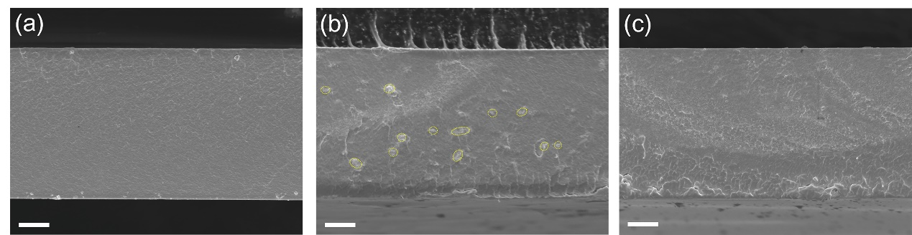
Figure S5 Cross-sectional SEM of (a) pristine, (b) CeO₂-based, and (c) CeO₂@Ph-PEI-based membrane. The scale bar above is 4 um.

Figure S6. Cross-sectional SEM-EDS Ce elemental mapping of (a) CeO₂-based and (b) CeO₂@Ph-PEI-based membrane.
Figure S7. Water uptake and dimensional swelling of pristine, CeO₂-based, and CeO₂@Ph-PEI-based membranes.

Figure S8. I-V curves of PEMFCs before and after durability test. (a) Pristine, (b) CeO₂-based, and (c) CeO₂@Ph-PEI-based membranes, respectively.
Figure S9 I-V curves of PEMFCs before and after the durability test. (a) Pristine, (b) CeO₂-based, and (c) CeO₂@Ph-PEI-based membranes, respectively.

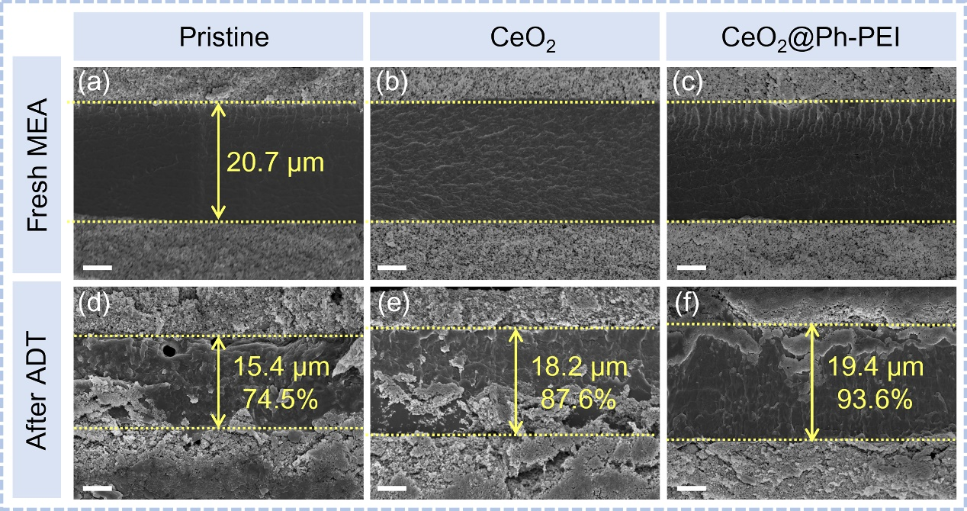
Figure S10 Cross-sectional SEM images of MEAs (a-c) before, (d-f) after the ADT. (a, d) pristine, (b, e) CeO₂-based, and (c, f) CeO₂@Ph-PEI-based membranes, respectively. The scale bar above is 5 um.

