Supplementary Material

Using granular activated carbon for enhanced phosphate removal by aerobic granular sludge development with propionate as carbon source
Manjunath Sarvajith ^{a,b} , Gangidi Kiran Kumar Reddy ª , Yarlagadda Venkata Nancharaiah ^{a,b*}
ªBiofouling and Biofilm Processes Section, WSCD, Chemistry Group, Bhabha Atomic Research Centre, Kalpakkam 603102, Tamil Nadu, India.
^{b} Homi Bhabha National Institute, BARC Training School Complex, Anushaktinagar,
Trombay, Mumbai 400 094, India.

*Corresponding author:
Y.V. Nancharaiah
Biofouling and Biofilm Processes Section, WSCD, Chemistry Group,
Bhabha Atomic Research Centre, Kalpakkam 603102, Tamil Nadu, India.
Email: yvn@igcar.gov.in; venkatany@gmail.com
Phone: 044 27480500 23342

Supplementary Fig. 1. Variations in the strength of aerobic granules during granulation.

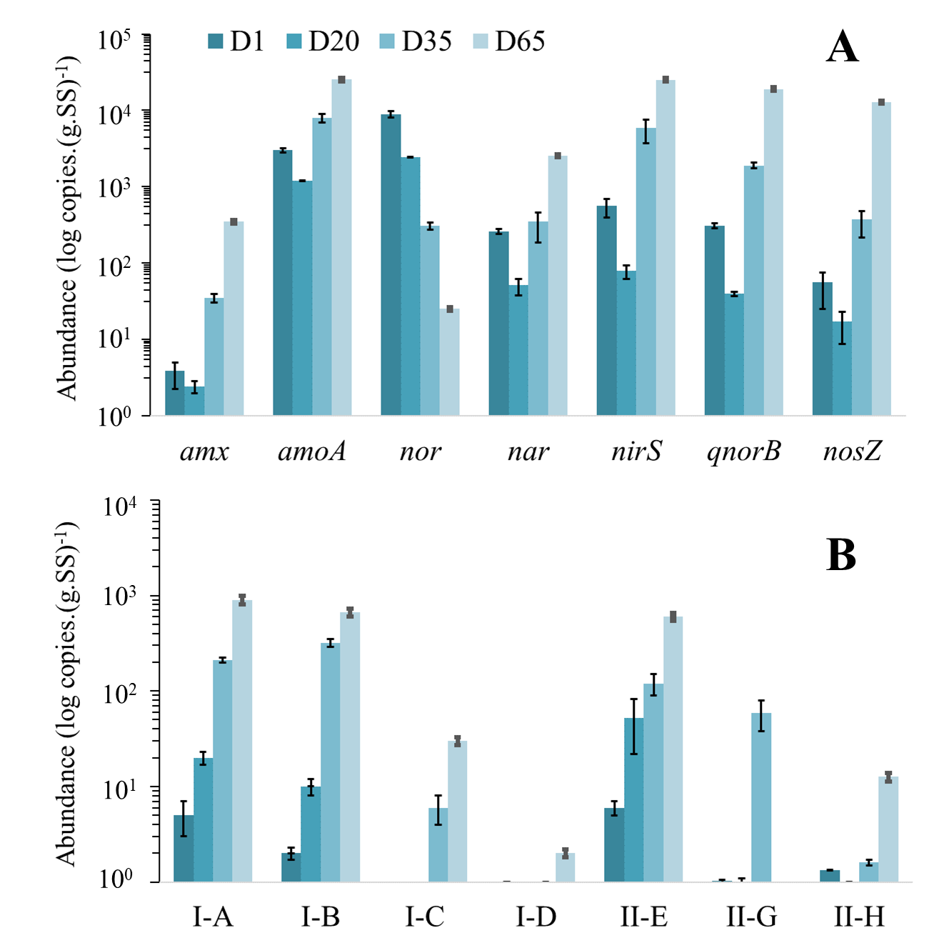
Supplementary Fig. 2. Variations of the abundance of functional genes participating in N and P removal in aerobic granular sludge. Genes involved in nitrogen metabolism (A), and PAO clades (B).

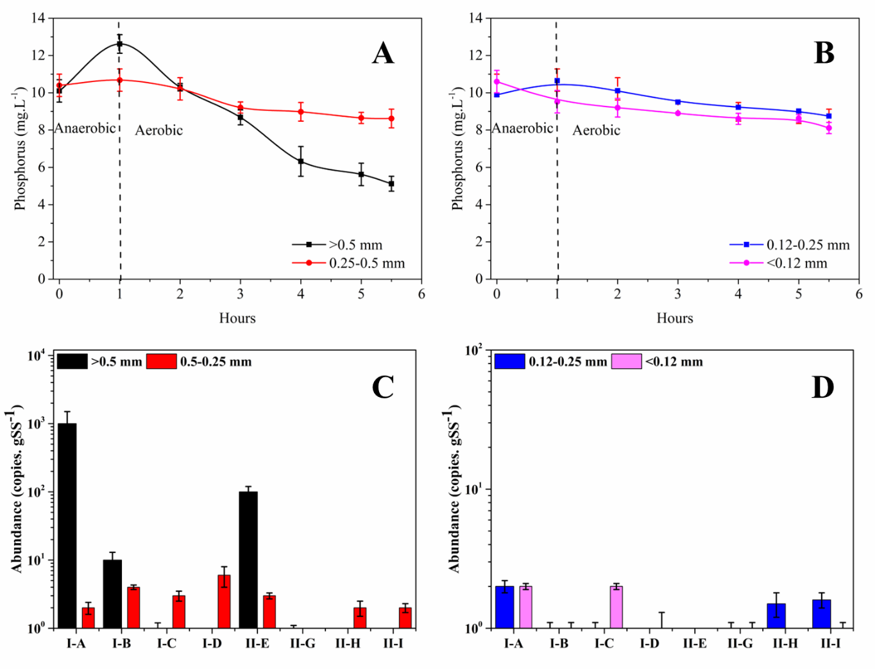
Supplementary Fig. 3. Phosphorus removal profiles (A and B) and PAO clade-level abundance in biomass separated based on size (C and D).

