Assessing Primary Productivity in Temperate Benthic Communities Using a novel in-situ Methodology - BIC

Bianca Reis^{1,2,3}*; João N. Franco³; Friederike Peiffer⁴; Oscar Babé Gómez¹; Hugo Sainz Meyer¹; Isabel Sousa-Pinto¹²; Francisco Arenas¹

1 CIIMAR‑Interdisciplinary Centre of Marine and Environmental Research, University of Porto, Avenida General Norton de Matos, S/N, 4450‑208 Matosinhos, Portugal
2 Faculty of Sciences, Department of Biology– University of Porto, Rua do Campo Alegre 1021 1055, 4169-007 Porto, Portugal
3 MARE-Marine and Environmental Sciences Centre & ARNET—Aquatic Research Network Associated Laboratory - CETEMARES, Av. do Porto de Pesca 30, 2520-620 Peniche, Portugal
4 MARE - Marine and Environmental Sciences Centre/ARNET - Aquatic Research Network, Faculdade de Ciências da Universidade de Lisboa, ISPA, Instituto Universitário, Rua jardim do tabaco, 34, 1149-041 Lisbon, Portugal

*Corresponding author r.biancareis@gmail.com

Keywords: primary productivity, kelp forests, turf, net community production (NCP)

Journal: Marine Biology (Springer)

Supplementary Information

Section I – BIC composition and materials

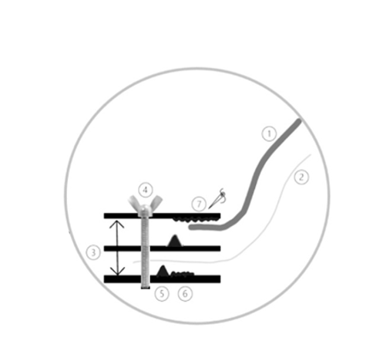
Fig. 8 -Schematic representation of the Benthic Incubation Chamber (BIC) rubber frames: 1- Blackout cover attached with a Velcro to the top rubber frame; 2- Polyethylene (PE) bag attached with bolts and silicon glue to the top rubber frame; 3- Rubber frames, 4- Bolts that tight the rubber frames together and attach PE bag; 5- Rubber O-ring, 6- Silicon that seals the PE bag, 7- Velcro stitched to the rubber frame and that will connect to the Velcro stitched to the base part of the blackout cover.

Table 1 - List of materials needed to build and use one Benthic Incubation Chamber (BIC) and its different steps and components such as fluorescein injection and water sampling, weight bags, and biomass sampling.
BIC | Quantity for chamber
Polyethylene (PE) bag (sleeve) – ~150cm height, diameter 50cm | 1
Blackout fabric cover (sleeve) - diameter 60cm | 1
1cm thickness rubber plate – 75x75cm. Central hole 50cm diameter | 1
0.5cm thickness rubber plate 75x75cm. Central hole 50cm diameter | 2
Rubber O-ring - diameter 50cm | 1
Inox tightening bolts 4cm heigh | 20
Circular polyvinyl chloride (PVC) plastic pieces diameter 10cm | 20
Ring of foam 60cm diameter | 1
PVC canvas with a hole in a center - diameter 50cm | 1
Weight bags 15kg | 2
Pegs (large size) | 6
Small buoys | 4
Open/close PVC valve | 1
Quick connect PVC tube – 0.5cm interior diameter 5cm length | 3
Table duct (quick connect) 6mm diameter | 1
Velcro circle 60cm diameter | 1
Line to stich leather and hole maker | 1
Cable ties (fluorescent) | 3
INOX Carabiner | 6
Oxygen sensor | 1
Light sensor | 1
Fluorescein injection and water sampling | Quantity for each incubation
100ml graduated plastic syringe | 4
Cable ties (thin) | 8
Cable ties (large) | 1
Quick connect PVC tube – 0.5cm diameter, 5cm length | 8
Malleable rubber tube 5mm diameter, 3cm length | 4
Quick connect PVC tube valves (open/close) – 0.6cm diameter | 4
Falcon tubes 100ml | 3
Aluminum foil | 3 pieces to wrap each falcon tube
Weight bags | Quantity for each weight bag
Running pants made of a thick material | 2
Small sized gravel or large grained sand | 30 kg
Thick cable ties | 7
Fluorescent thin rope | 40cm
INOX carabiner | 2
Biomass sampling | Quantity for each biomass collection
Fabric bag | 1
Scraper | 1
Waterproof paper for labels | 1
Plastic bag for samples | 1

Section II – preparation and deployment of the Benthic Incubation Chamber (BIC)

Fluorescein solution for chamber volume estimation.
This solution is used to determine the volume of each individual BIC and it follows (Peleg et al. 2020). A saltwater solution containing fluorescein 3g l⁻¹ must be prepared and well homogenized prior to deployment. It should be enfolded in aluminum foil (due to light sensitivity) and stored for as minimum time as possible in a cool, dark place. Right before the incubations, 60 ml of the solution must be placed in labelled plastic syringes with a valve at the end tip (Fig. 9). Syringes should remain closed for underwater transport until the moment of the injection inside the chamber (details of this moment below). Each chamber requires four dedicated syringes, one to inject the fluorescein solution and other three to collect a water sample from the inside of the BIC. If the PE bag is predicted to be longer than 1.20 meters when closed, more than 60 ml of the solution can be injected into the incubation chamber. The initial concentration and the volume of the solution must always be known. After injecting the fluorescein through the built-in valve, several in- and outward movements must be done with the syringe to ensure that all the solution is injected and to promote water movement.
After the fluorescein solution is homogenized with the water inside the chamber, three samples must be taken per chamber into clean syringes, and these must be sealed with a valve at the tip to avoid changes of the final concentration. In order to ensure that none of the water contained initially at the built-in valve goes into the samples’ syringes, the first collection must be discarded, storing starting only at the second one. Once at the surface, samples must be transferred to labelled plastic flasks, again covered in aluminum foil, and stored in a cool, dark container until processed in the lab. Analyzing the water samples will allow the calculation of the volume inside the chamber through the absorbance. Absorbance analysis must be done following (Peleg et al. 2020).
When absorbance values are known, the chamber volume can be asserted with the following formula: $Ci . Vi=Cf . Vf$
Where Ci stands for initial concentration of fluorescein solution injected in the BIC; Vi represents the water volume contained in the syringe; and Cf is calculated through a linear regression with the absorbance values. This will provide us with Vf values, which represent the volume inside each BIC.
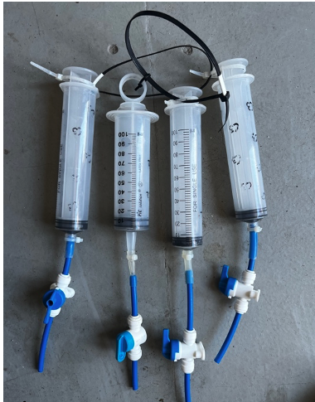
Fig. 9 - 100ml graduated plastic syringes used to inject fluorescein into the BIC and to collect water samples. These have a connected valve that allows to retain the solution inside the syringe.

Setting underwater loggers.
For each chamber one Photosynthetic Active Radiation (PAR, μmol m-2 s-1) Logger (Odyssey®) and one optical dissolved oxygen-temperature (mg/L - ºC) logger (HOBO® U26) (Fig.10) were launched prior to the deployment with a logging frequency = 1min.
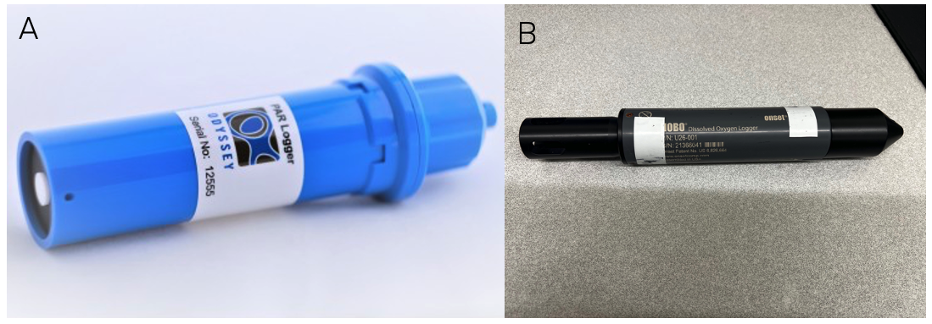
Fig. 10 - A-Photosynthetic Active Radiation (PAR, μmol m-2 s-1) Logger (Odyssey®) and B -one optical dissolved oxygen-temperature (mg/L - ºC) logger (HOBO® U26) used in each BIC.

In-situ BIC deployment procedures

Once the appropriate location has been identified, ideally on flat areas without steep slopes or crevices that represent the target habitat, the deployment of the BIC and the weight bags from the boat must be performed by at least two divers. BIC must be dropped down with the PVC canvas, blackout cover, and PE bag wholly folded in and secured by large pegs to prevent damage and drag.
The boat crew gently pulls down the BIC and the set of weights, with divers ready to receive the system at the bottom. When at the bottom, the PVC canvas of the chamber must be unfolded, and the weights immediately placed on top of it and attached to carabiners at the base of the chamber.
Once the BIC is settled, the dissolved oxygen/temperature and PAR sensors (Fig.11) can be placed. PAR sensors are mounted facing upwards (not shaded by canopy-forming algae) next to the BIC. Dissolved oxygen/temperature loggers are attached to the dedicated eyebolt inside the BIC with a carabiner.
The incubation process starts with the dark phase (Fig. 3C), followed by the light phase (Fig. 3A,B,D), each one for one hour. Dark cycles are applied first to reduce dissolved oxygen concentration as low as possible (Nielsen 2001; Martins et al. 2007) and are made artificially by draping a blackout cover over them.
The plastic bag and the blackout cover are manually folded and individually closed on the top with large pegs connected to small buoys to support the upright position (Fig. 1). The cylindrical-shaped PE bag is large and adjustable enough to accommodate different community heights.
Also, the bag’s flexibility allows kelp blades to move naturally and external turbulence to be propagated inside the chamber (Barrón and Duarte 2009).
After the dark phase, the blackout cover is manually rolled down and attached to the base of the chamber with large pegs. The light phase starts and goes identically for another hour.

When incubation phases are finished, 60ml of a known concentration of fluorescein solution (3g/l) is injected inside the BIC using a syringe (Fig. 11) through the valve and Quick Connect PVC tube installed in the PE bag. After the water inside the chamber is thoroughly mixed with the fluorescein (1 minute after, if necessary, the divers can move the bag), another three water samples of 60ml are collected from the chamber with new syringes.
The last step before retrieving the BIC system is the collection of all the benthic coverage (fauna and flora) within the chamber-enclosed area by gently scraping the rock bottom (Franco et al. 2020; de Azevedo et al. 2023) and keeping it in tagged fabric bags. For this, the PE bag needs to be folded down and secured by the clamps. Samples must be stored in a cool box until reaching the lab and then frozen until processed.
When incubations are finished and samples collected, the BIC system should be wrapped up. Sensors should be stored in dedicated bags, the blackout cover and PE bag must be completely folded inwards, as well as the PVC canvas, which must be secured with clamps. Weighs must be placed again inside bags to be lifted.
For the lifting process of the BIC system, a lifting balloon can be used rather than pulled by the boat crew.

Section III – Results

Table 2 - Algal assemblages among the different case study habitats
Species assemblage (Tuya et al. 2012) | Incubation | Species | %
North PT | 1 | Laminaria ochroleuca | 29.36
North PT | 1 | Chondracantus acicularis | 00.06
North PT | 1 | Laminaria hyperborea | 62.89
North PT | 1 | Palmaria palmata | 05.56
North PT | 1 | Delesseria sanguinea | 00.86
North PT | 1 | Rhodimenia pseudopalmata | 01.17
North PT | 1 | Dyctiota dychotoma | 00.11
North PT | 2 | Laminaria hyperborea | 91.00
North PT | 2 | Chondracantus acicularis | 09.00
Centre PT | 1 | Sacchorizza polyschides | 96.55
Centre PT | 1 | Ulva sp. | 00.40
Centre PT | 1 | Gelidium sp. | 00.99
Centre PT | 1 | Pterosyphonia sp. | 00.89
Centre PT | 1 | Phylopora crispa | 00.02
Centre PT | 1 | Haloptheria sp. | 00.01
Centre PT | 1 | Jania sp. | 0.22
Centre PT | 1 | Lithophyllum sp. | 0.44
Centre PT | 1 | Symphocladia marchantioides | 0,16
Centre PT | 1 | Furcellaria lumbricalis | 0.31
Centre PT | 2 | Laminaria ochroleuca | 98.06
Centre PT | 2 | Dictiota dichotoma | 0.12
Centre PT | 2 | Plocamium cartilagineus | 1.83
South | 1 | Codium tormentosum | 38.19
South | 1 | Asparagopsis armata | 30.72
South | 1 | Phylliaropsis sp. | 0.37
South | 1 | Plocamium muticum | 30.72
South | 2 | Codium tormentosum | 59.20
South | 2 | Asparagopsis armata | 23.89
South | 2 | Cryptopleura ramosa | 3.42
South | 2 | Plocamium muticum | 13.17
South | 2 | Dyctiota dichotoma | 0.32

