Contents

Figures S1 to S12
Tables S1 to S11

Additional Information (Files uploaded separately)

Fig. S1. Chi and Kendall plots of the pairwise drought characteristics (duration (D)-severity(S), severity(S)-peak (P) and peak (P)-duration (D)) of NSPI for Upper Godavari River basin for 3-month time scale: 1st column represents the Chi-plots of pairwise characteristics and 2nd column represents the Kendall plots of the pairwise drought characteristics
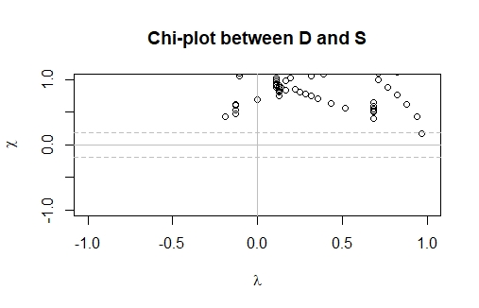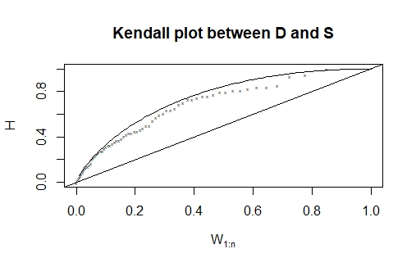
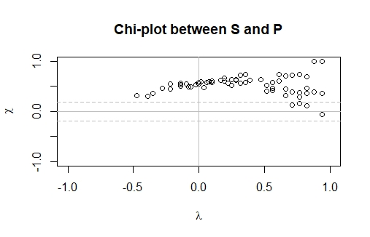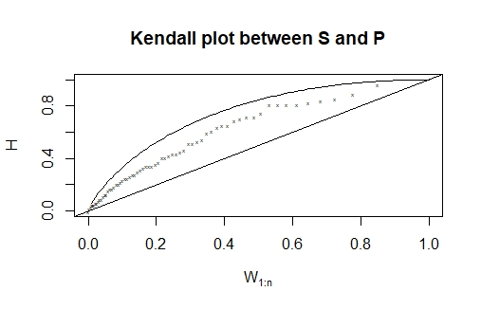
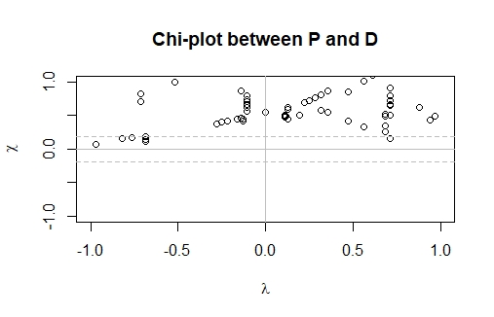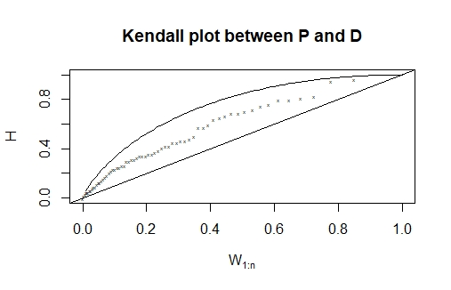

Fig. S2. Chi and Kendall plots of the pairwise drought characteristics (duration (D)-severity(S), severity(S)-peak (P) and peak (P)-duration (D)) of NSPI for Lower Godavari River basin for 3-month time scale: 1st column represents the Chi-plots of pairwise characteristics and 2nd column represents the Kendall plots of the pairwise drought characteristics

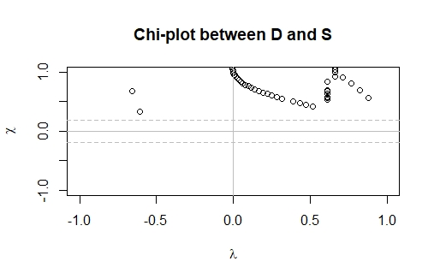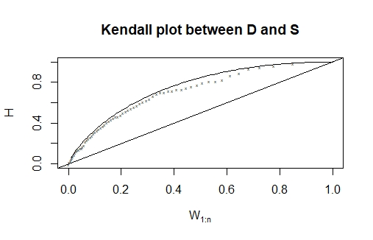
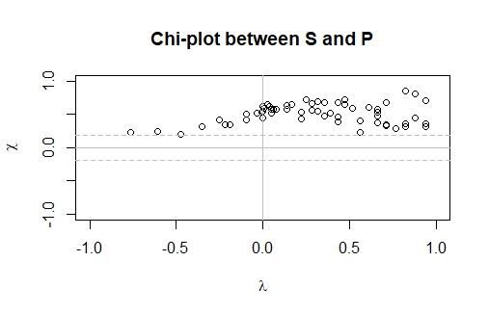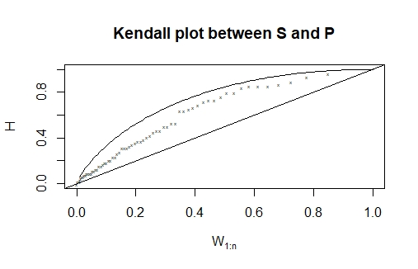
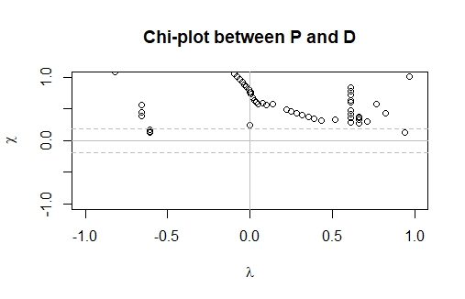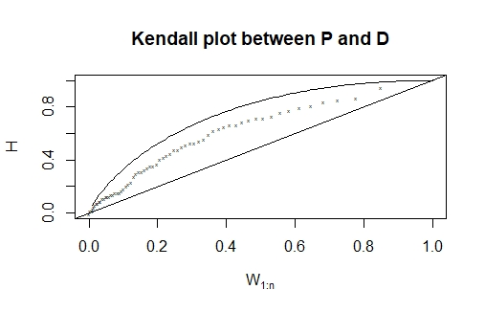

Fig. S3. Chi and Kendall plots of the pairwise drought characteristics (duration (D)-severity(S), severity(S)-peak (P) and peak (P)-duration (D)) of NSPI for Upper Godavari River basin for 6-month time scale: 1st column represents the Chi-plots of pairwise characteristics and 2nd column represents the Kendall plots of the pairwise drought characteristics

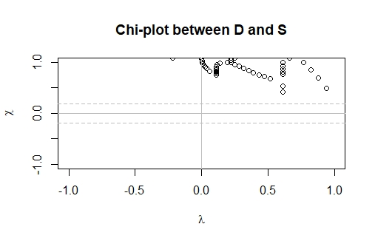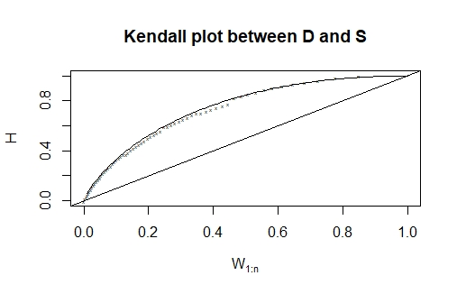
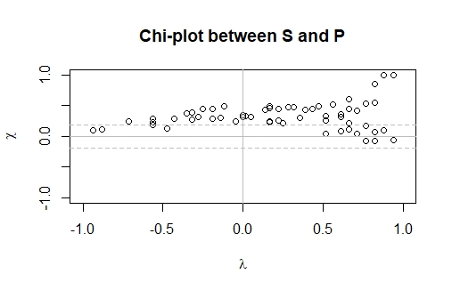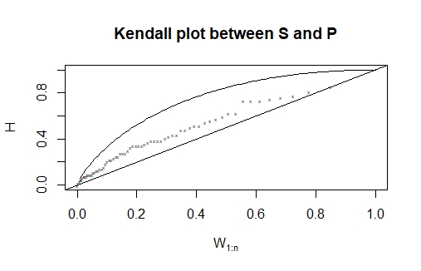
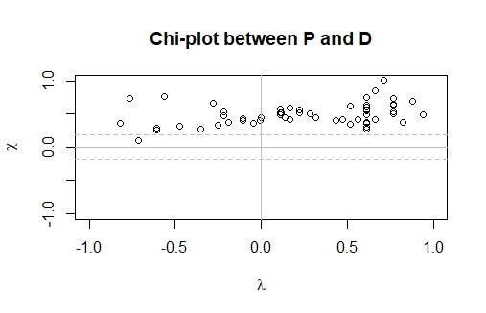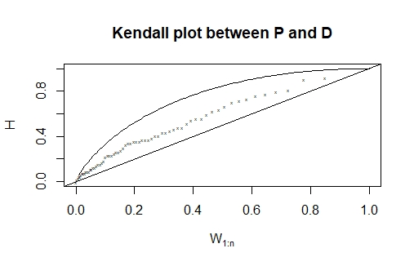

Fig. S4. Chi and Kendall plots of the pairwise drought characteristics (duration (D)-severity(S), severity(S)-peak (P) and peak (P)-duration (D)) of NSPI for Lower Godavari River basin for 6-month time scale: 1st column represents the Chi-plots of pairwise characteristics and 2nd column represents the Kendall plots of the pairwise drought characteristics

Fig. S5. Chi and Kendall plots of the pairwise drought characteristics (duration (D)-severity(S), severity(S)-peak (P) and peak (P)-duration (D)) of NSPI for Upper Godavari River basin for 12-month time scale: 1st column represents the Chi-plots of pairwise characteristics and 2nd column represents the Kendall plots of the pairwise drought characteristics
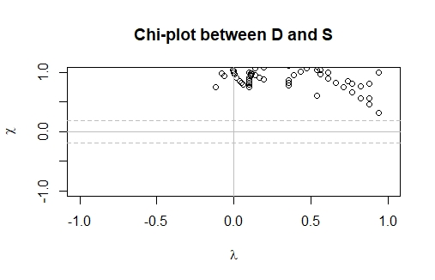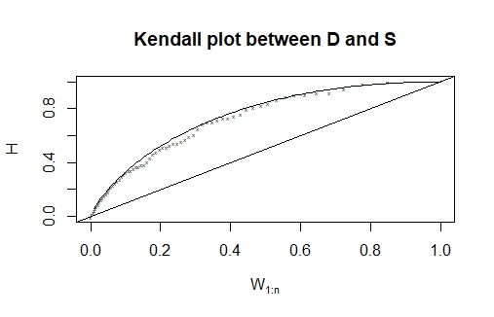
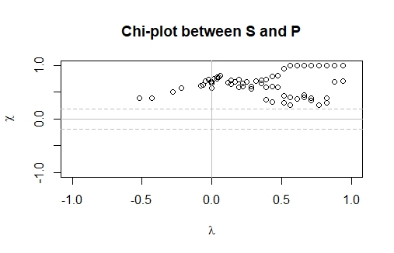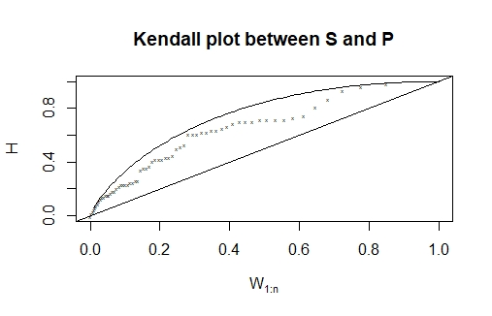
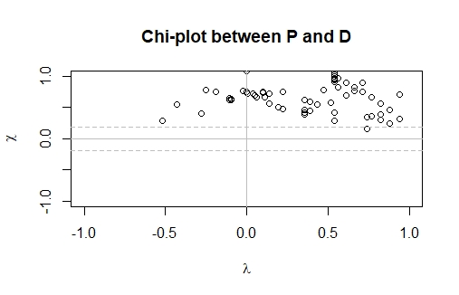

Fig. S6. Chi and Kendall plots of the pairwise drought characteristics (duration (D)-severity(S), severity(S)-peak(P) and peak(P)-duration(D)) of NSPI for Lower Godavari River basin for 12-month time scale: 1st column represents the Chi-plots of pairwise characteristics and 2nd column represents the Kendall plots of the pairwise drought characteristics

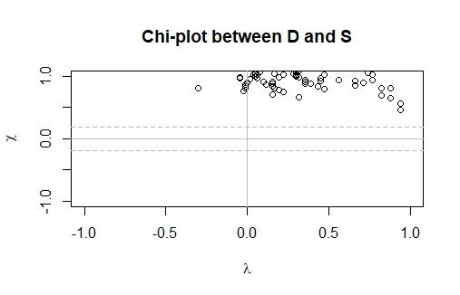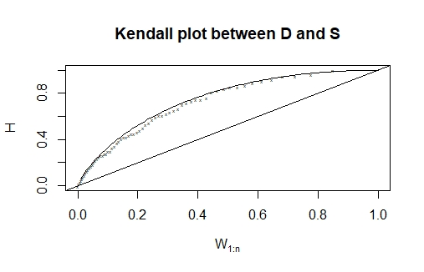
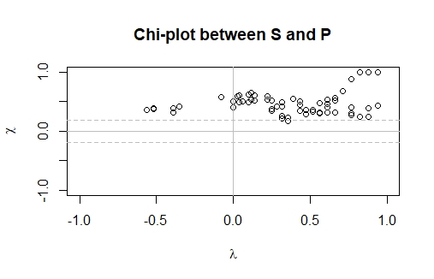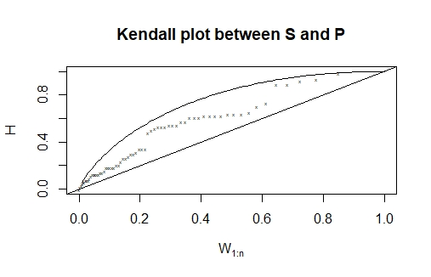
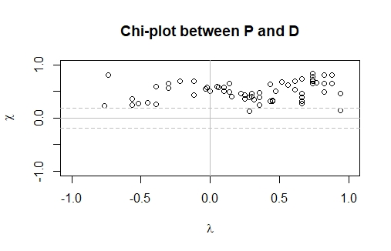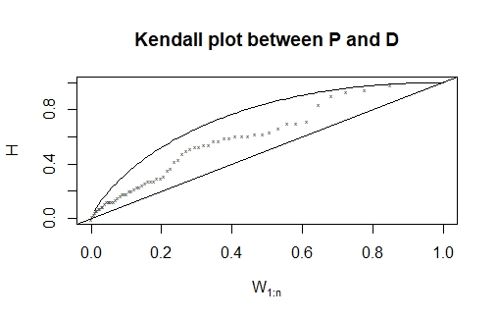

Fig. S7. Chi and Kendall plots of the pairwise drought characteristics (duration (D)-severity(S), severity(S)-peak (P) and peak (P)-duration (D)) of NRDI for Upper Godavari River basin for 3-month time scale: 1st column represents the Chi-plots of pairwise characteristics and 2nd column represents the Kendall plots of the pairwise drought characteristics

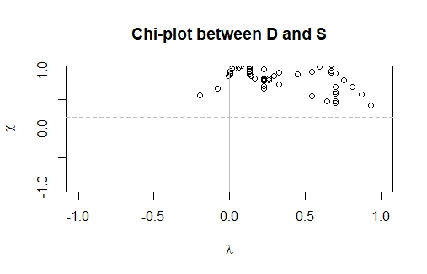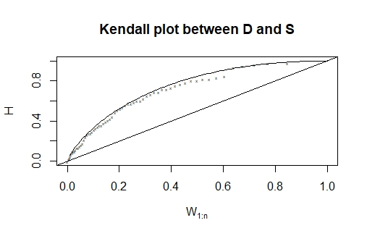
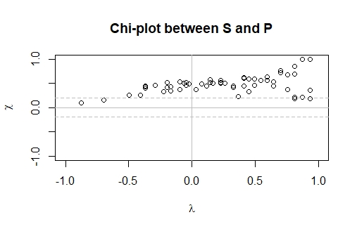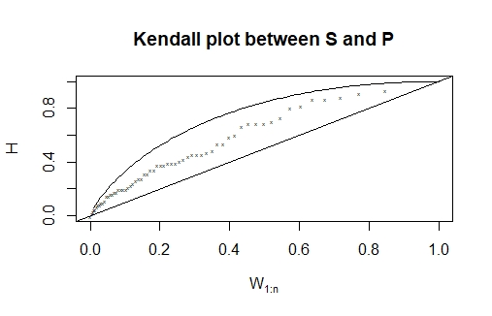
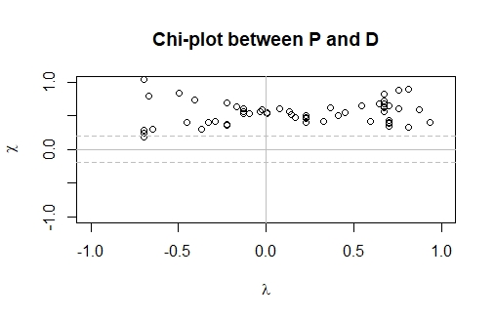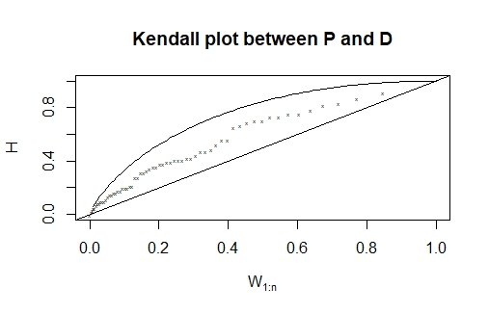

Fig. S8. Chi and Kendall plots of the pairwise drought characteristics (duration (D)-severity(S), severity(S)-peak(P) and peak(P)-duration(D)) of NRDI for Lower Godavari River basin for 3-month time scale: 1st column represents the Chi-plots of pairwise characteristics and 2nd column represents the Kendall plots of the pairwise drought characteristics

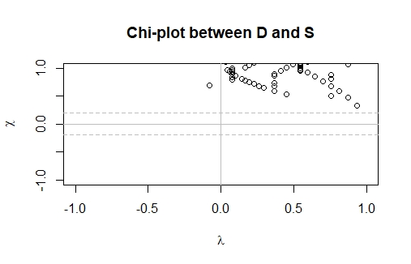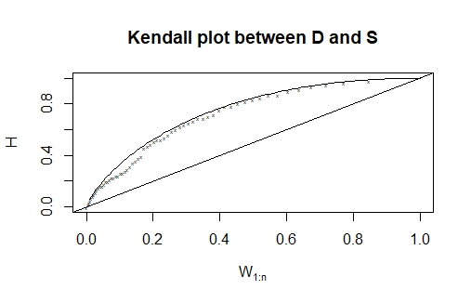
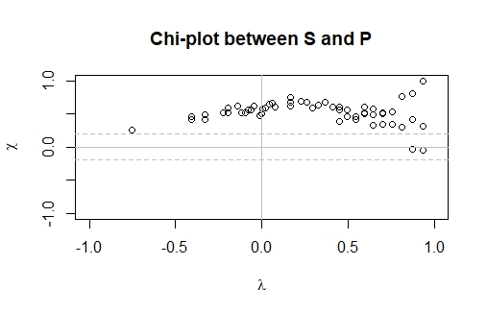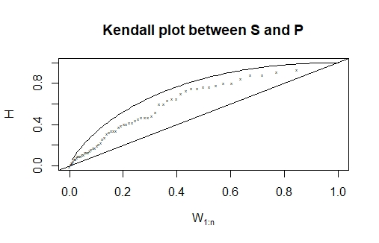
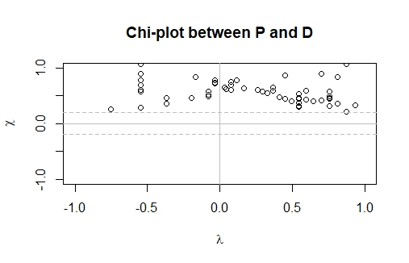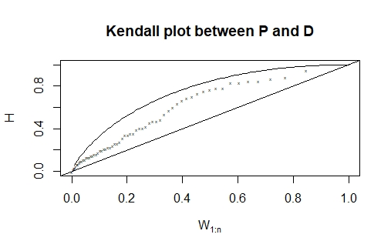

Fig. S9. Chi and Kendall plots of the pairwise drought characteristics (duration (D)-severity(S), severity(S)-peak (P) and peak (P)-duration (D)) of NRDI for Upper Godavari River basin for 6-month time scale: 1st column represents the Chi-plots of pairwise characteristics and 2nd column represents the Kendall plots of the pairwise drought characteristics

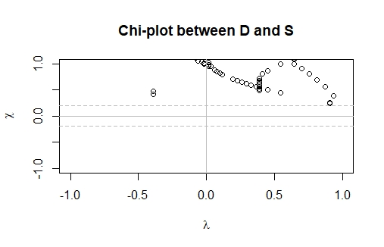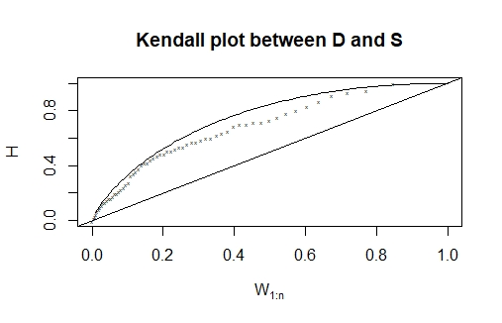
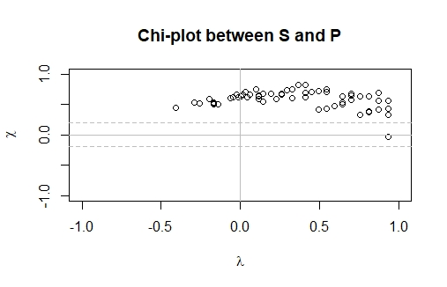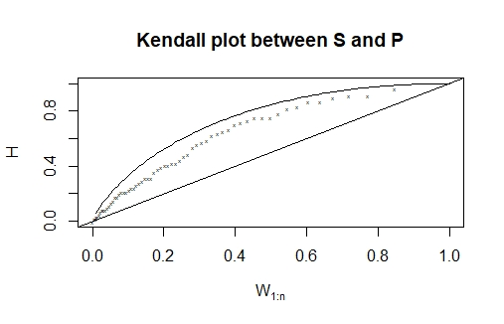
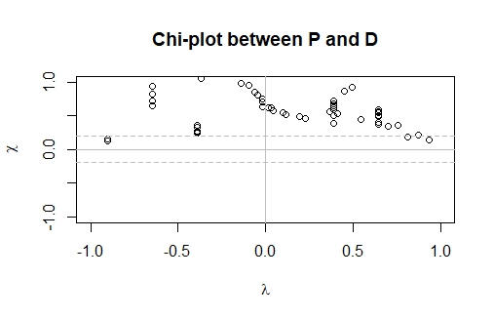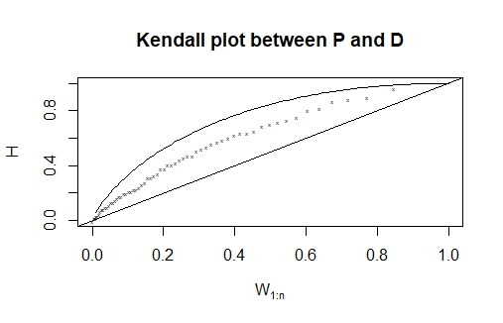

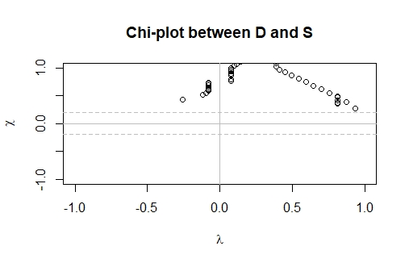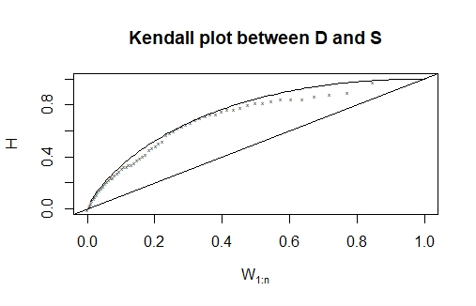
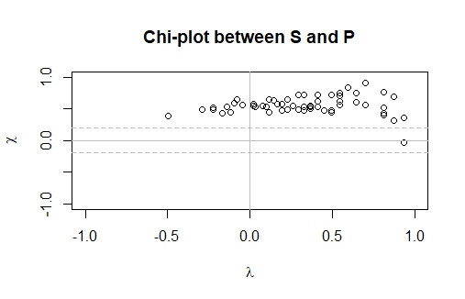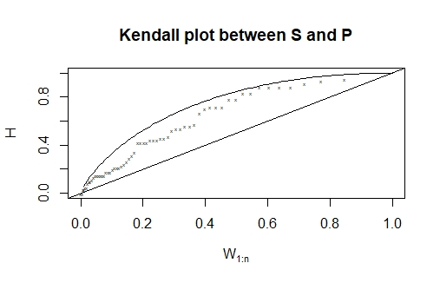
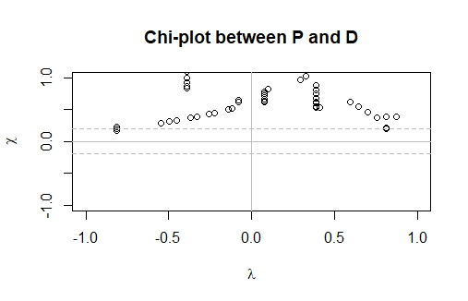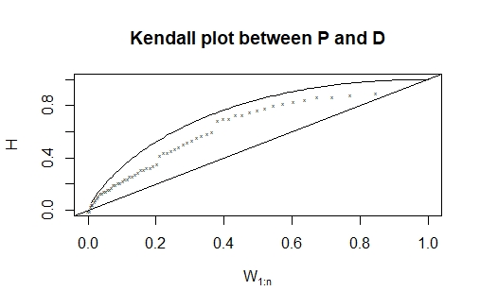

Fig. S10. Chi and Kendall plots of the pairwise drought characteristics (duration (D)-severity(S), severity(S)-peak(P) and peak(P)-duration(D)) of NRDI for Lower Godavari River basin for 6-month time scale: 1st column represents the Chi-plots of pairwise characteristics and 2nd column represents the Kendall plots of the pairwise drought characteristics

Fig. S11. Chi and Kendall plots of the pairwise drought characteristics (duration (D)-severity(S), severity(S)-peak (P) and peak (P)-duration (D)) of NRDI for Upper Godavari River basin for 12-month time scale: 1st column represents the Chi-plots of pairwise characteristics and 2nd column represents the Kendall plots of the pairwise drought characteristics

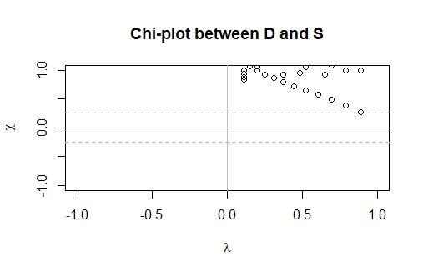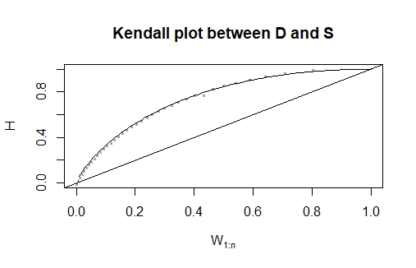
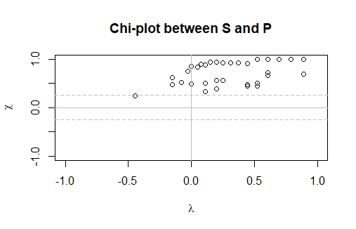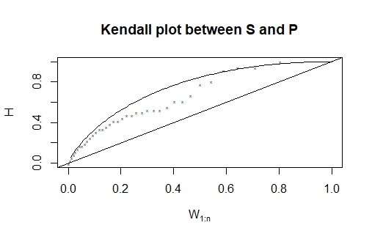
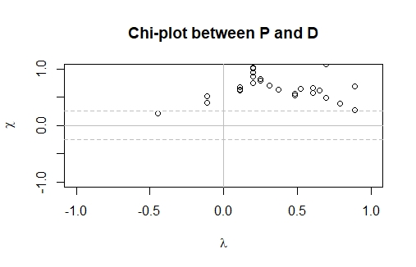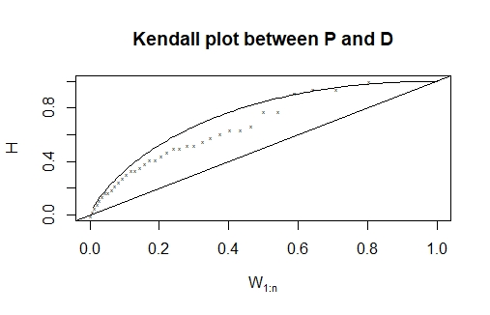

Fig. S12. Chi and Kendall plots of the pairwise drought characteristics (duration (D)-severity(S), severity(S)-peak (P) and peak (P)-duration (D)) of NRDI for Lower Godavari River basin for 12-month time scale: 1st column represents the Chi-plots of pairwise characteristics and 2nd column represents the Kendall plots of the pairwise drought characteristics

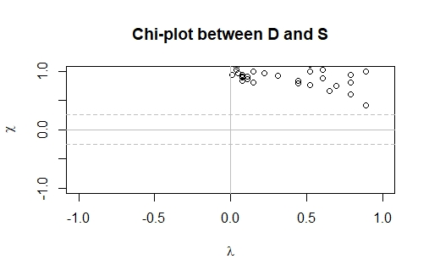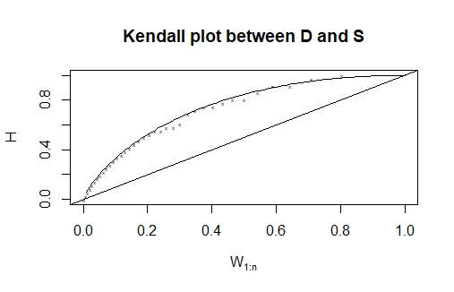

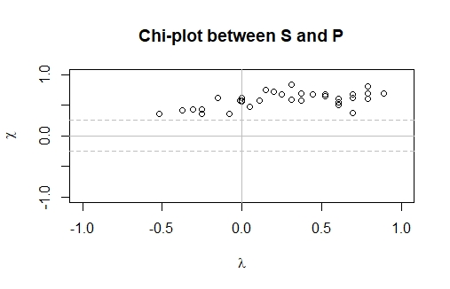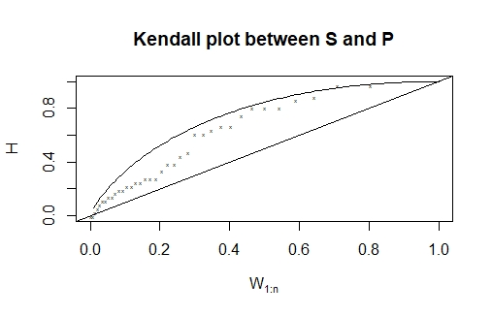
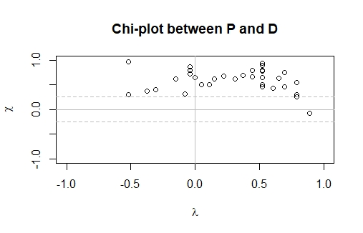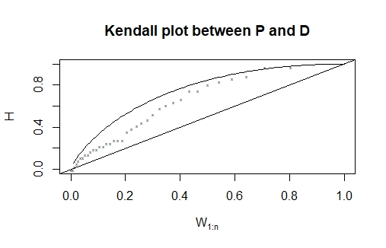

Table S1. The fitted probability distribution functions, AIC and Log-likelihood for duration of NSPI series under different time scales and periods for Upper and Lower Godavari River basins.

Upper sub basin | 3-month |  | 6-month |  | 12-month
Distribution | AIC | Log-likelihood | AIC | Log-likelihood | AIC | Log likelihood
Gumbel | 190 | -93.39 | 236.68 | -116.34 | 335.86 | -165.93
Gamma | 188.41 | -92.205 | 233.87 | -114.93 | 318.24 | -157.12
Lognormal | 192.62 | -94.31 | 239.89 | -117.94 | 302.9 | -149.49
Weibull | 186.72 | -91.36 | 229.31 | -112.65 | 321.4 | -158.7
Exponential | 251.51 | -124.75 | 281.32 | -139.66 | 320.45 | -159.22
Lower sub basin | 3-month |  | 6-month |  | 12-month
Distribution | AIC | Log likelihood | AIC | Log likelihood | AIC | Log likelihood
Gumbel | 165.45 | -80.72 | 231.5 | -113.75 | 346.53 | -171.26
Gamma | 155.52 | -75.76 | 229.03 | -112.51 | 334.18 | -165.09
Lognormal | 163.8 | -79.9 | 236.09 | -116.04 | 328.35 | -162.17
Weibull | 146.82 | -71.41 | 223.5 | -109.75 | 337.2 | -166.6
Exponential | 276.14 | -137.07 | 280.68 | -139.34 | 341.62 | -169.81

Table S2. The fitted probability distribution functions, AIC and Log-likelihood for peak of NSPI series under different time scales and periods for Upper and Lower Godavari River basins.

Upper sub basin | 3-month |  | 6-month |  | 12-month
Distribution | AIC | Log likelihood | AIC | Log likelihood | AIC | Log likelihood
Gumbel | 133.43 | -64.71 | 43.52 | -19.76 | 91.78 | -43.89
Gamma | 131.34 | -63.67 | 29.72 | -12.86 | 94.35 | -45.17
Lognormal | 132.74 | -64.373 | 33.96 | -14.98 | 91.03 | -43.51
Weibull | 131.23 | -63.61 | 38.02 | -17.01 | 102.75 | -49.37
Exponential | 217.61 | -107.8 | 187.1 | -92.55 | 177.5 | -87.75
Lower sub basin | 3-month |  | 6-month |  | 12-month
Distribution | AIC | Log likelihood | AIC | Log likelihood | AIC | Log likelihood
Gumbel | 85.816 | -40.9 | 78.65 | -37.32 | 83.73 | -39.86
Gamma | 90.623 | -43.31 | 76.22 | -36.11 | 83 | -39.5
Lognormal | 87.62 | -41.81 | 77.25 | -36.62 | 82.9 | -39.45
Weibull | 103.18 | -49.59 | 78.58 | -37.29 | 86.81 | -41.4
Exponential | 205.82 | -101.91 | 187.22 | -92.61 | 183.53 | -90.769

Table S3. The fitted probability distribution functions, AIC and Log-likelihood for severity of NSPI series under different time scales and periods for Upper and Lower Godavari River basins.

Upper sub basin | 3-month |  | 6-month |  | 12-month
Distribution | AIC | Log likelihood | AIC | Log likelihood | AIC | Log likelihood
Gumbel | 273.74 | -134.87 | 294.89 | -145.44 | 394.94 | -195.47
Gamma | 272.69 | -134.34 | 293.06 | -144.53 | 364.01 | -180
Lognormal | 278.61 | -137.3 | 300.88 | -148.441 | 347.51 | -171.75
Weibull | 272.05 | -134.02 | 289.29 | -142.64 | 363.43 | -179.71
Exponential | -155.24 | 312.49 | 327.99 | -162.99 | 362.05 | -180.02
Lower sub basin | 3-month |  | 6-month |  | 12-month
Distribution | AIC | Log likelihood | AIC | Log likelihood | AIC | Log likelihood
Gumbel | 241.33 | -118.66 | 287.233 | -141.61 | 393.384 | -194.69
Gamma | 239 | -117.5 | 285.64 | -140.82 | 375.87 | -185.93
Lognormal | 247.83 | -121.91 | 291.72 | -143.86 | 371.56 | -183.78
Weibull | 235.19 | -115.59 | 284.31 | -140.15 | 377.42 | -186.71
Exponential | 324.94 | -161.47 | -158.56 | 319.13 | 377.85 | -187.92

Table S4. The fitted probability distribution functions, AIC and Log-likelihood for duration of NRDI series under different time scales and periods for Upper and Lower Godavari River basins.

Upper sub basin | 3-month |  | 6-month |  | 12-month
Distribution | AIC | Log likelihood | AIC | Log likelihood | AIC | Log likelihood
Gumbel | 221.22 | -108.61 | 159.3 | -77.65 | 203.23 | -99.61
Gamma | 218.25 | -107.12 | 157.32 | -76.66 | 175.59 | -85.79
Lognormal | 222.19 | -109.09 | 159.86 | -77.93 | 155.79 | -75.89
Weibull | 216.22 | -106.11 | 158.33 | -77.16 | 173.39 | -84.69
Exponential | 258.16 | -128.08 | 223.4 | -110.7 | 173.94 | -85.97
Lower  sub basin | 3-month |  | 6-month |  | 12-month
Distribution | AIC | Log likelihood | AIC | Log likelihood | AIC | Log likelihood
Gumbel | 214.03 | -105.01 | 138.47 | -67.23 | -110.57 | 225.14
Gamma | 210.27 | -103.13 | 134.62 | -65.31 | -100.87 | 205.74
Lognormal | 210.79 | -103.39 | 136.69 | -66.34 | -97.58 | 199.16
Weibull | 211.4 | -103.7 | 138.42 | -67.21 | -100.86 | 205.72
Exponential | 244.32 | -121.16 | 250.34 | -124.17 | -100.88 | 203.76

Table S5. The fitted probability distribution functions, AIC and Log-likelihood for peak of NRDI series under different time scales and periods for Upper and Lower Godavari River basins.

Upper sub basin | 3-month |  | 6-month |  | 12-month
Distribution | AIC | Log likelihood | AIC | Log likelihood | AIC | Log likelihood
Gumbel | 90.76 | -43.38 | 172.49 | -84.24 | 41.83 | -18.91
Gamma | 76.42 | -36.21 | 170.39 | -83.19 | 48.96 | -22.48
Lognormal | 85.63 | -40.81 | 169.9 | -82.953 | 43.25 | -19.62
Weibull | 42.23 | -19.116 | 172.24 | -84.12 | 61.01 | -28.5
Exponential | 199.13 | -98.56 | 222.75 | -110.37 | 96.24 | -47.12
Lower sub basin | 3-month |  | 6-month |  | 12-month
Distribution | AIC | Log likelihood | AIC | Log likelihood | AIC | Log likelihood
Gumbel | 128.87 | -62.43 | 133.47 | -64.73 | 48.51 | -22.25
Gamma | 126.96 | -61.48 | 138.08 | -67.04 | 49.48 | -22.74
Lognormal | 127.46 | -61.73 | 132.83 | -64.41 | 48.28 | -22.14
Weibull | 127.424 | -61.712 | 149.66 | -72.83 | 53.37 | -24.68
Exponential | 194.32 | -96.16 | 208.92 | -103.46 | 100.63 | -49.31

Table S6. The fitted probability distribution functions, AIC and Log-likelihood for severity of NRDI series under different time scales and periods for Upper and Lower Godavari River basins.

Upper sub basin | 3-month |  | 6-month |  | 12-month
Distribution | AIC | Log likelihood | AIC | Log likelihood | AIC | Log likelihood
Gumbel | 292.67 | -144.33 | 271.4 | -133.7 | 247.01 | -121.5
Gamma | 290.31 | -143.15 | 268.58 | -132.29 | 202.69 | -99.34
Lognormal | 297.06 | -146.53 | 269.22 | -132.61 | 177.55 | -86.77
Weibull | 287.88 | -141.94 | 271.47 | -133.73 | 196.23 | -96.11
Exponential | 317.36 | -157.68 | 296.99 | -147.49 | 206.67 | -102.33
Lower sub basin | 3-month |  | 6-month |  | 12-month
Distribution | AIC | Log likelihood | AIC | Log likelihood | AIC | Log likelihood
Gumbel | 298.1 | -147.05 | 248.33 | -122.16 | 254.08 | -125.04
Gamma | 288.77 | -142.38 | 248.31 | -122.15 | 226.92 | -111.46
Lognormal | 285.84 | -140.92 | 249.69 | -122.84 | 218.84 | -107.42
Weibull | 291.06 | -143.53 | 251.55 | -123.77 | 225.98 | -110.99
Exponential | 301.67 | -149.83 | 307.73 | -152.86 | 225.78 | -111.89

NSPI
Upper sub basin | 3-month |  |  | 6-month |  |  | 12-month
 | P-D | D-S | S-P | P-D | D-S | S-P | P-D | D-S | S-P
Kendall | 0.31 | 0.697 | 0.601 | 0.2679 | 0.861 | 0.374 | 0.562 | 0.859 | 0.701
Spearman | 0.403 | 0.83 | 0.782 | 0.353 | 0.954 | 0.5179 | 0.726 | 0.956 | 0.87
Lower sub basin
 | P-D | D-S | S-P | P-D | D-S | S-P | P-D | D-S | S-P
Kendall | 0.21 | 0.619 | 0.59 | 0.317 | 0.815 | 0.5 | 0.415 | 0.874 | 0.532
Spearman | 0.265 | 0.737 | 0.76 | 0.412 | 0.923 | 0.664 | 0.569 | 0.96 | 0.737
NRDI
Upper sub basin
 | P-D | D-S | S-P | P-D | D-S | S-P | P-D | D-S | S-P
Kendall | 0.34 | 0.81 | 0.53 | 0.28 | 0.604 | 0.67 | 0.51 | 0.81 | 0.73
Spearman | 0.47 | 0.93 | 0.69 | 0.37 | 0.73 | 0.85 | 0.609 | 0.9 | 0.84
Lower sub basin
 | P-D | D-S | S-P | P-D | D-S | S-P | P-D | D-S | S-P
Kendall | 0.38 | 0.77 | 0.61 | 0.31 | 0.65 | 0.644 | 0.43 | 0.78 | 0.7
Spearman | 0.5 | 0.89 | 0.79 | 0.4 | 0.79 | 0.83 | 0.52 | 0.84 | 0.81
Table S7. The dependence measurements among drought characteristics (Peak (P) - Duration (D), Duration (D) - Severity (S) and Severity (S) - Peak (P)) using Kendall’s $τ$ and Spearman’s $ρ$ methods for NSPI and NRDI series under different time scales and periods for Upper and Lower Godavari River basins.

Table S8. Comparison of ‘AND ‘return periods for drought characteristics of NRDI computed based on trivariate student’s t copula (T_{ST}) and pair-copula model (T_{PC}) for Upper and Lower sub basin

Upper  sub basin | 3-month | T_{ST} | T_{PC} | 6-month | T_{ST} | T_{PC} | 12-month | T_{ST} | T_{PC}
 | 5 | 5.31 | 6.36 | 5 | 5.58 | 5.76 | 5 | 6.93 | 7.96
 | 10 | 13.14 | 14.89 | 10 | 12.45 | 14.61 | 10 | 15.85 | 18.02
 | 20 | 27.04 | 32.02 | 20 | 22.82 | 29.88 | 20 | 42.01 | 54.99
 | 50 | 68.74 | 77.54 | 50 | 57.55 | 66.25 | 50 | 76.55 | 91.27
Lower  sub basin | 3-month | T_{ST} | T_{PC} | 6-month | T_{ST} | T_{PC} | 12-month | T_{ST} | T_{PC}
 | 5 | 5.86 | 6.41 | 5 | 5.26 | 6.11 | 5 | 6.83 | 8.41
 | 10 | 17.04 | 18.48 | 10 | 12.99 | 14.57 | 10 | 16.17 | 19.34
 | 20 | 32.08 | 38.5 | 20 | 25.42 | 31.84 | 20 | 36.74 | 48.11
 | 50 | 73.78 | 89.04 | 50 | 52.74 | 56.17 | 50 | 86.21 | 113.46

Table S9. Comparison of ‘OR’ return periods for drought characteristics of NRDI computed based on trivariate student’s t copula (T_{ST}) and pair-copula model (T_{PC}) for Upper and Lower sub basin

Upper sub basin | 3-month | T_{ST} | T_{PC} | 6-month | T_{ST} | T_{PC} | 12-month | T_{ST} | T_{PC}
 | 5 | 3.37 | 4.06 | 5 | 3.21 | 3.97 | 5 | 4.17 | 5.74
 | 10 | 7.95 | 8.04 | 10 | 6.99 | 7.48 | 10 | 8.74 | 9.31
 | 20 | 15.25 | 16.87 | 20 | 13.43 | 14.78 | 20 | 16.01 | 17.55
 | 50 | 35.28 | 41.09 | 50 | 29.08 | 36.01 | 50 | 38.29 | 44.88
Lower sub basin | 3-month | T_{ST} | T_{PC} | 6-month | T_{ST} | T_{PC} | 12-month | T_{ST} | T_{PC}
 | 5 | 3.54 | 3.95 | 5 | 3.21 | 3.55 | 5 | 4.14 | 4.68
 | 10 | 7.822 | 8.06 | 10 | 6.98 | 7.77 | 10 | 9.71 | 10.04
 | 20 | 13.99 | 14.96 | 20 | 12.09 | 13.57 | 20 | 17.21 | 19.71
 | 50 | 41.81 | 45.67 | 50 | 34.18 | 40.77 | 50 | 41.99 | 48..98
Table S10. Comparison of ‘AND’ return periods for drought characteristics of NSPI computed based on trivariate student’s t copula (T_{ST}) and pair-copula model (T_{PC}) for Upper and Lower sub basin

Upper sub basin | 3-month | T_{ST} | T_{PC} | 6-month | T_{ST} | T_{PC} | 12-month | T_{ST} | T_{PC}
 | 5 | 5.91 | 6.04 | 5 | 5.6 | 6.92 | 5 | 5.13 | 5.43
 | 10 | 13.87 | 14.31 | 10 | 11.96 | 13.16 | 10 | 11.29 | 15.23
 | 20 | 32.58 | 29.2 | 20 | 26.99 | 28.25 | 20 | 21.84 | 29.23
 | 50 | 73.8 | 78.96 | 50 | 69.08 | 71.28 | 50 | 62.71 | 69.9
Lower sub basin | 3-month | T_{ST} | T_{PC} | 6-month | T_{ST} | T_{PC} | 12-month | T_{ST} | T_{PC}
 | 5 | 5.52 | 5.91 | 5 | 6.47 | 7.62 | 5 | 6.65 | 6.79
 | 10 | 10.18 | 10.99 | 10 | 15.4 | 14.54 | 10 | 13.39 | 17.81
 | 20 | 23.81 | 25.24 | 20 | 35.28 | 38.41 | 20 | 22.4 | 37.43
 | 50 | 54.75 | 57.48 | 50 | 74.19 | 81.577 | 50 | 61.45 | 87.15

Table S11. Comparison of ‘OR’ return periods for drought characteristics of NSPI computed based on trivariate student’s t copula (T_{ST}) and pair-copula model (T_{PC}) for Upper and Lower sub basin

Upper sub basin | 3-month | T_{ST} | T_{PC} | 6-month | T_{ST} | T_{PC} | 12-month | T_{ST} | T_{PC}
 | 5 | 3.54 | 4.84 | 5 | 3.32 | 4.12 | 5 | 4.041 | 4.76
 | 10 | 8.81 | 9.77 | 10 | 7.89 | 9.02 | 10 | 6.47 | 9.87
 | 20 | 17.91 | 19.53 | 20 | 16.45 | 17.41 | 20 | 15.65 | 17.05
 | 50 | 44.42 | 48.33 | 50 | 38.88 | 40.18 | 50 | 36.05 | 45.21
Lower sub basin | 3-month | T_{ST} | T_{PC} | 6-month | T_{ST} | T_{PC} | 12-month | T_{ST} | T_{PC}
 | 5 | 4.16 | 4.85 | 5 | 3.99 | 4.99 | 5 | 3.07 | 4.71
 | 10 | 7.88 | 8.97 | 10 | 7.75 | 9.57 | 10 | 7.58 | 8.05
 | 20 | 16.84 | 14.02 | 20 | 14.87 | 16.88 | 20 | 13.52 | 17.99
 | 50 | 34.77 | 41.21 | 50 | 29.68 | 32.04 | 50 | 30.04 | 38.85

